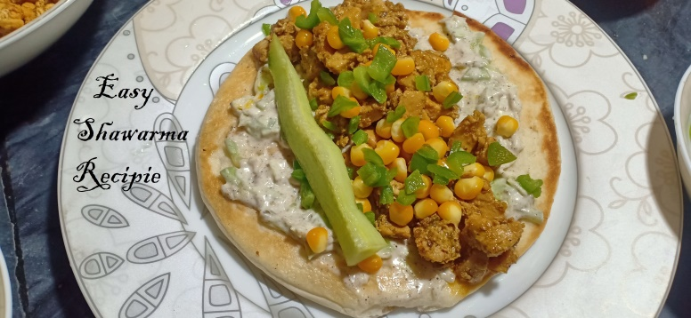**Ingredients**

Easy Shawarma Recipie

* 500 gram boneless chicken
* 1 Tablespoon soya sauce
* 2 Tablespoon tikka masala
* 1 Tablespoon mayonnaise
* 2 tablespoon ginger , garlic , green chilli paste
* Half cup Capsicum
* 1 cup corn

**For Sauce**

* 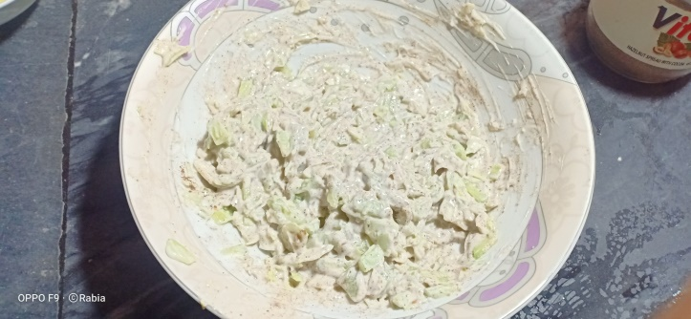250 gram of mayonnaise.
* 1 tablespoon black pepper .
* Half tablespoon salt.
* 1 cup cucumber finely shopped .
* 1 cup cabbage chopped .

**Recipe**

* Add ginger garlic , green chilli paste to 1 cup oil in a frying pan ‘roast it .
* Add chicken and roast it until it turns white.
* Add takka masala , soya sauce to it and roast for 2 minutes .
* Add mayonnaise now its ready
* Add 2 tablespoon oil , capsicum , 1/4 tablespoon salt and roast it

For sauce Add black pepper , salt , cucumber , cabbage to mayonnaise

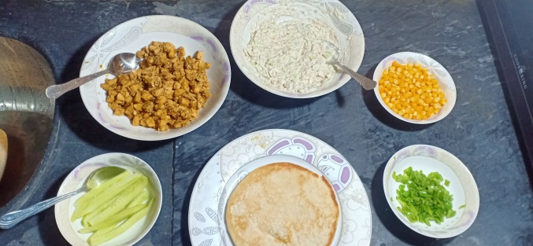**Assembling**

* Add sauce to shawarma bread.
* Add chicken , Corn , Capsicum on bread .