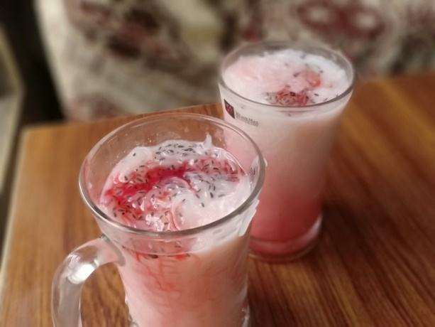 **Ingredients**

* 4 liter water
* 2 liter baraf
* 0.5 kg nakhasta
* 1/4 cup optional tuk malanga
* 1 liter thanda dood
* 1 cup jam-e-shiri

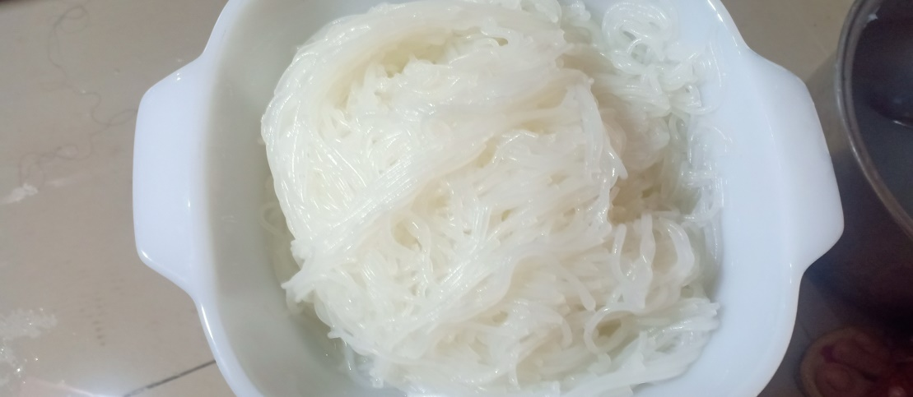

**Recipe**

2 liter water aur baraf aik bartan ma daal kr side p rakh dyn .

Ab nakhasta aur water pan ma daal kr achi tara haal kryn jb tk wo glue jesa na ho jy .

ab is ko baaraf aur paani wali bartan pa chanpni rkh kr us ma sa guzar dyn .

ab dood , cheni , jam-e-shiri ,tuk malanga , falooda noodles ko aik glass ma daal k haal kr lyn