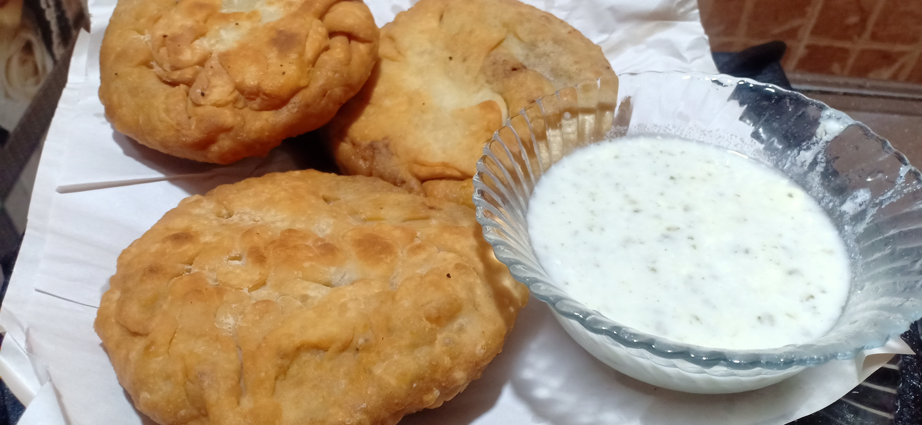

**Ingredients**

**For dough**

* 1/2 kg All purpose flour
* 1/2 cup oil
* 2/3 cup lukewarm water

**For filling**

* 1 kg qeema beef
* 1 tablespoon salt
* ½ tablespoon haldee / turmuric
* 1 tablespoon Red chilli powder
* 1 tablespoon dried parsley
* 1 tablespoon garam masala / hot spice mixture
* 1 cup chopped onion

**Recipe**

* Add oil , water to all purpose flour and knead the dough until firm add one tablespoon of oil on dough then make small dough ball 5-7 out of it .
* Add onion and oil in a pan stir it until it becomes translucent .
* Add chilli powder , haldee/ turmeric , salt to it and roast it for 2 minutes then add qeema to it .
* Cook qeema for 10 minutes .
* Now keep qeema aside for 10 minute to room tempreture add DRIED CORIENDER and hot spice micture to it .
* Make roti of dough ball add 4 spoon qeema mixture on top and again make the ball .
* Now fry it until it forms crispy and serve it with sause