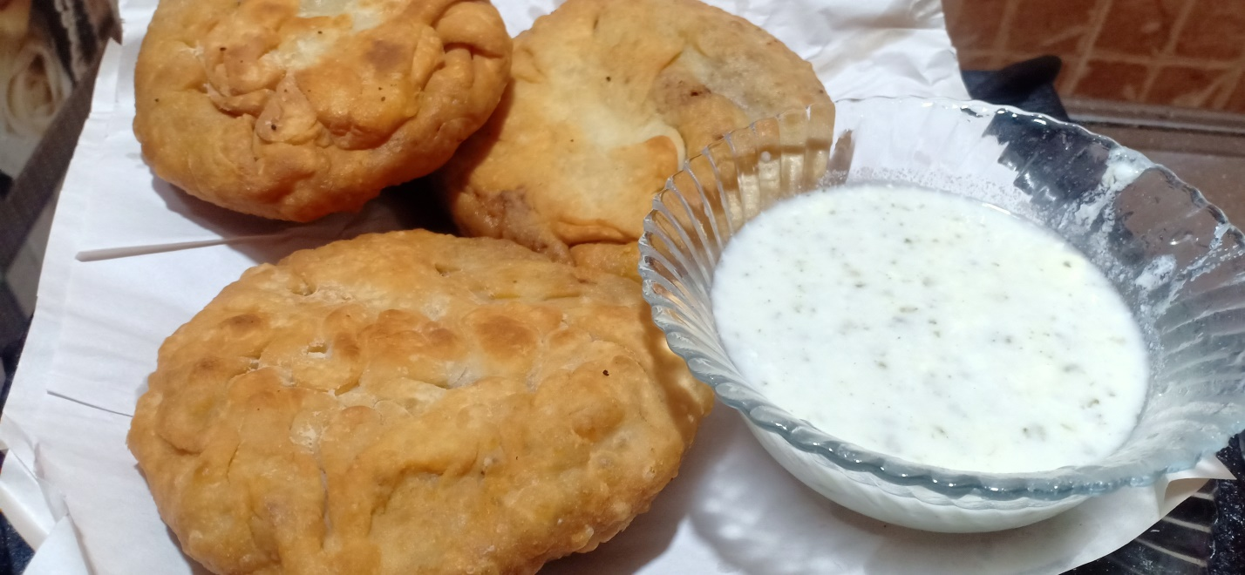

**Ingredients**

**For dough**

* 1/2 kg maida
* 1/2 cup oil
* 2/3 cup lukewarm/ neem garam paani

**For filling**

* 1 kg qeema beef
* 1 tablespoon salt
* ½ tablespoon haldee
* 1 tablespoon Red chilli powder
* 1 tablespoon sookha dahnia
* 1 tablespoon garam masala
* 1 cup chopped pyaaz

**Recipe**

* Oil , neem garam pani ko maida ma daal k acha sa goond layn or us ka 5-7 balls bna lyn
* Oil ma pyaaz daal k bhoonayn jb tk wo brown hna shuru ho jy .
* Ab us ma chilli powder , haldee/ turmeric , salt us ma daal ka 2 minute tk bhoonayn
* Phir qeema daal k 10 minute tk pakayn
* Qeema ko 10 minute tk thanda hna rkhayn or us ma khusk dhaniya aur garam masala daalyn .
* Ab dough ki roti bna kr us ma 4 chamach qeema daal kr usko band kr dyn .
* Ab usko fry kr k sause k sath serve kryn .