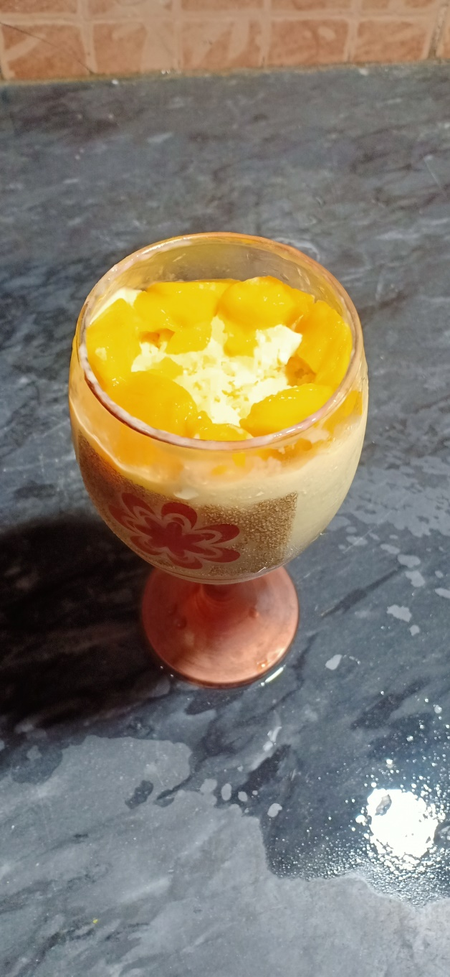**Ingredients**

Mango Dessert

* Mango pulp 1 cup
* Mango chunks small ½ cup
* Mango chunks large ½ cup
* Milk pack cream 1.5 cup
* Sugar 3 tablespoon

**Recipe**

* Add milk pack cream in a bowl and whisk until form soft peaks.
* Add mango pulp and whisk .
* Add mango chunks small and sugar and whisk.
* Now freeze it for 7-9 hours and then give it a mix with spoon .
* Add it to glass and add large mango chunks on top of it .
* Our summer special mango dessert is ready to serve