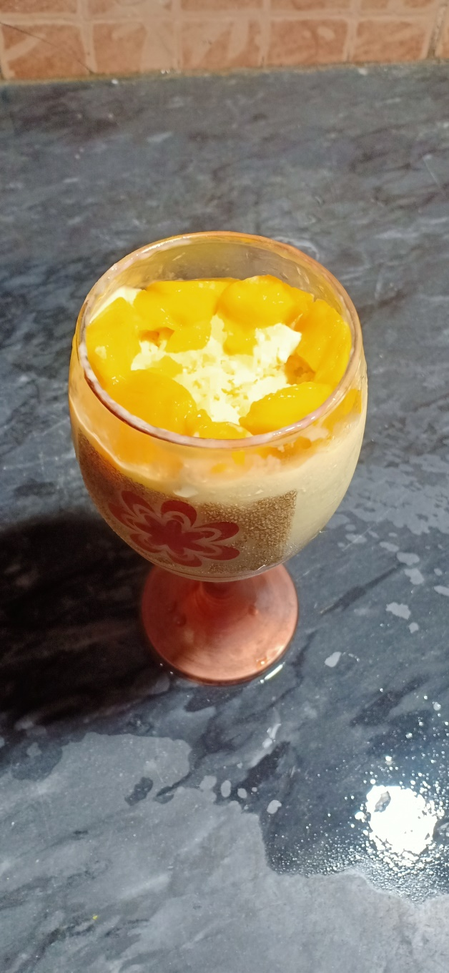**Ingredients**

Aam Dessert

* 1 cup Aam ka raas
* Adha cup Aam chota size ma kata hua
* Adha cup Aam normal size ma kata hua
* 1.5 cup Milk pack cream
* 3 chamach cheeni

**Recipe**

* Milk pack cream ko aik bowl ma daal ka mix kryn jb tk thori gaari na ho jy .
* Ab Aam ka rus daala aur mix kryn .
* Ab Aam ka chota tukra aur cheeni daal k mix kryn .
* Ab 7-9 ghanta freeze krna ka baad usko acha sa chamach sa mic kryn
* Ab isko glass ma daal ka aam ka baara tukra upper daal dyn
* Mango dessert paish kryn k lia tyaar h