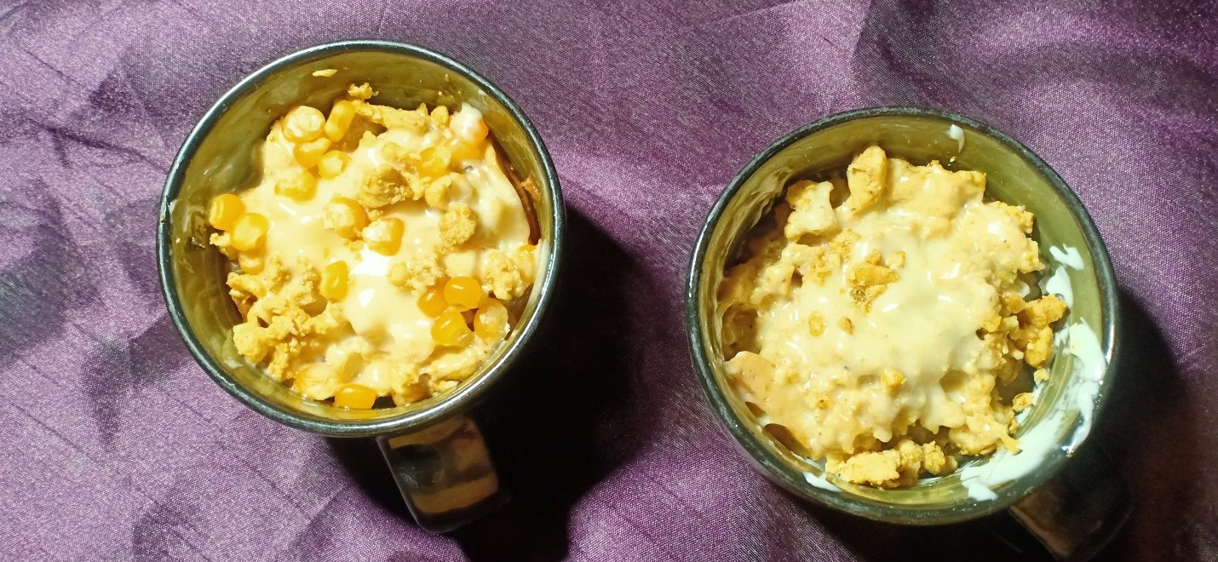

**Ingredients**

Serving 5-7

**For fries**

* 2 kg aloo
* 3 kg paani
* 1.5 chamach naamak

**For chicken filling**

* 1 chamach adrak , lehsan ka paste
* ½ kg chicken
* 1- 2 chamach soya sauce
* 1 chamach tikka masala

**For Assembling**

* 1 cup sitta
* Cheese slice
* Pizza sauce

**Directions**

**For fries**

* Paani ka ubalna tk ka intezar kryn phir us ma fries daal dyn or 4 minute baad newspaper p nikal k pankha k neecha aik ghanta sookhayn .
* Phir usko golden hna tk pakayn

**For chicken filling**

* Add ginger garlic paste in oil and sauté it then add chicken and fry until it turns white
* Adrak , lehsan ka paste tail ma daal k bhoonayn phir chicken daal dyn jb chicken ka paani khusk ho jy to andr tikka masala aur soya sause daal dyn
* Phir thori deer bhoon k daam da dyn

**For Assembling**

* Fries ko aik cup ma daalayn aur us pa pizza sause daal ka mix kryn
* Phir chicken aur sitta 2 2 chamach aal k mix kryn
* Phir cheese slice us k upper rkh k usko oven m 1 min daal dyn
* Mug cheese fries pizza serve hna k lia tyaar h