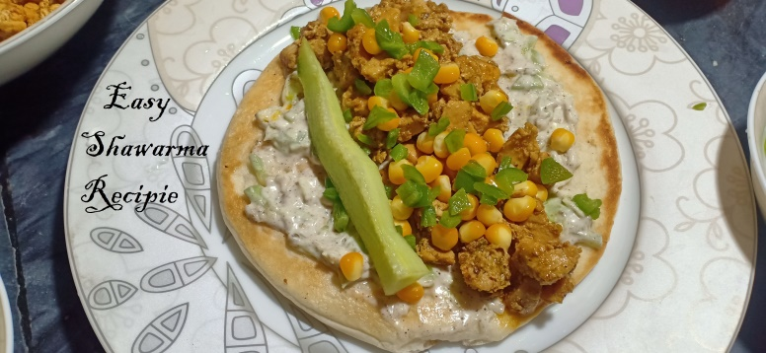**Ingredients**

Easy Shawarma Recipie

* 500 gram boneless chicken
* 1 chamach soya sauce
* 2 chamach tikka masala
* 1 chamach mayonnaise
* 2 chamach adrak lehsan haari mirch ka paste
* aadha cup Shimla mirch
* 1 cup sitta

**For Sauce**

* 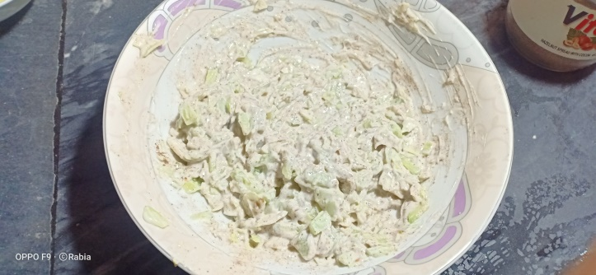250 gram of mayonnaise.
* 1 chamach kaali mirch .
* Half chamach namak.
* 1 cup kheera bareek kata hua .
* 1 cup band goobi bareek kati hua.

**Recipe**

* Pan ma aik cup tail or adrak , lehsan aur haaari mirch ka paste daal k bhoono .
* Chicken daal k safaid hna tk bhoono .
* Tikka masala , soya sause , mayonnaise daal ka 2 minute tk bhoono .
* Ab do chamach tail ma namak ¼ chamach , Shimla mirch daal ka bhono
* Sauce ka lia Kaali mirch , namak , kheera , band goobi mayonnaise ma daal ka mix kro

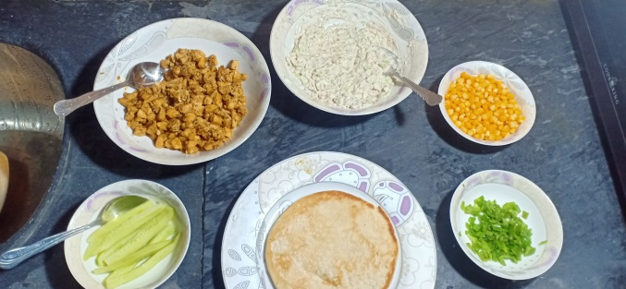**Assembling**

* shawarma bread par sause lgao .
* chicken , sitta , band goobi bread pa daalo .