**Ingredients**

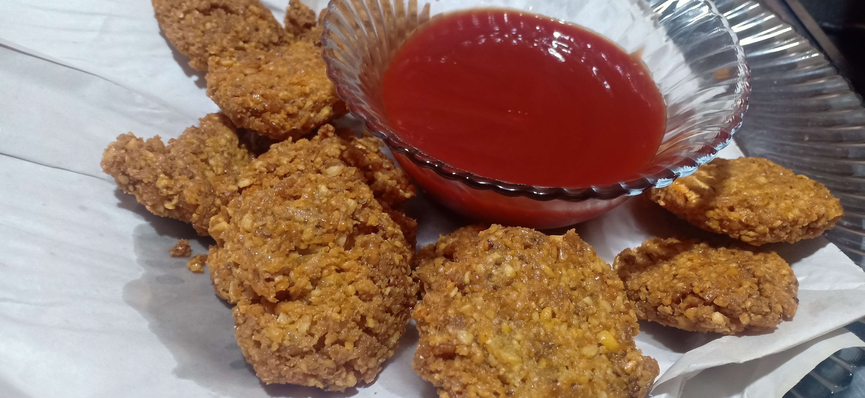

* 1/2 kg gram lentils / chaana daal
* 1/8 kg white lentils / maa ki daal
* 1 tablespoon salt or to taste
* 1 tablespoon Red chilli powder
* 1 tablespoon dried parsley
* 1 tablespoon cumin / zeera powder
* 1/2 tablespoon baking soda

**Recipe**

* Add gram lentils / chaana daal and white lentils / maa ki daal and soak it into water for overnight / 4 hours.
* Grind the mixture to paste.
* Add salt or to taste, Red chilli powder ,dried parsley , cumin powder / zeera , baking soda to mixture .
* Make small balls of the mixture and fry it untill brown .
* Now Serve it with kitchup .