**Ingredients**

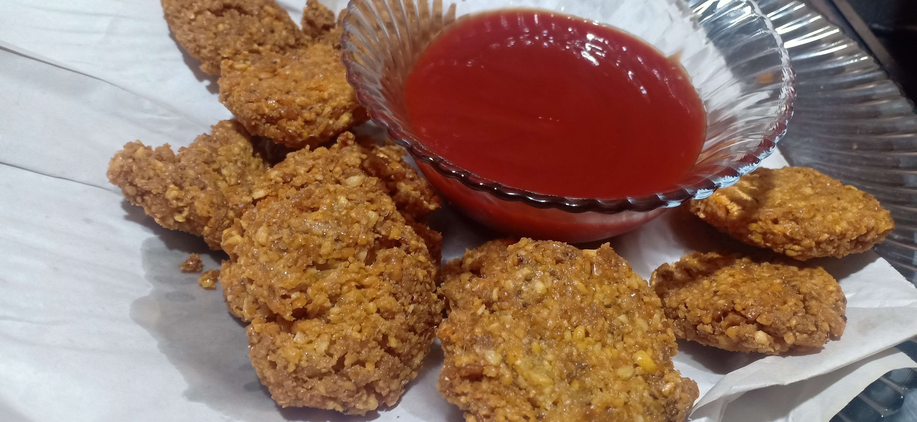

* chaana daal 1/2 kg
* maa ki daal 1/8 kg
* salt 1 chmach ya hasab-e-zaiqa
* Laal mirch powder 1 chmach
* khusk dhania 1 chmach
* zeera powder 1 chmach

**Recipe**

Aik bartan ma chana aur maa ki daal daalayn or paani sa bhaar kr usko 4 ghanta ya raat bhar bhigo k rkhayn .

Ab us daal ka acha sa paste bna lyn .

Ab us ma namak , laal mirch , zeera , khusk dhania aur baking soda daal k mix kryn aur uski tikkiya bnayn .

Ab unha brown hna tk fry kryn aur ketchup k sath serve kryn .