#ms#English

#dd#Directions (Q.1 to Q.2): Study the following information carefully and answer the following questions given below.
- #qq# What is the distance between R and V?
#oo#(a) 25m #oo#(b) 35m #oo#(c) 40m #oo#(d) Can not be determined
#ans# Option1 # 25m

- #qq#If ‘R’ denotes ‘–’ ; ‘Q’ denotes ‘×’ ; ‘W’ denotes ‘÷’ and ‘A’ denotes ‘+’ , then
42 W 7 R 8 A 6 Q 4 = ?
#oo#(a) 22 #oo#(b) 168 #oo#(c) 22 #oo#(d) 28
#ans# Option1 # 22

- #qq#Statements: Vitamin E tablets improve circulation and keep your complexion in a glowing condition.
Assumptions: I. People like a glowing complexion.
II. Complexion becomes dull in the absence of circulation.
#oo#(a) If only assumption I is implicit #oo#(b) If only assumption II is implicit #oo#(c) If both assumptions I and II are implicit #oo#(d) If neither assumptions I nor II is implicit
#ans# Option2 # If only assumption II is implicit

- #qq#Today is Varun’s birthday. 1 year from today he will be twice as old as he was 12 years ago. How old is Varun today ?
#oo#(a) 20 years #oo#(b) 22 years #oo#(c) 25 years #oo#(d) 27 years
#ans# Option1 # 20 years
#exp#(a) 20 years

- #qq#If ab (a + b) = 1, then the value of $\frac{1}{a^{3} b^{3}}- a^{3}-b^{3}$ is -
#oo#(a) 3 #oo#(b) -3 #oo#(c)2 #oo#(d) 0
#ans# Option1 # 3
#exp#(a)
Let Varun’s preset age be x year
After 1 year, Varun’s age will be (x + 1) year
A.T.Q.
x +1 = 2 (x – 12) Or, x + 1 = 2x – 24 Or, x = 25 years

- #qq#Two angles of a triangle are $\frac{1}{2}$ radian and $\frac{1}{3}$ radian. The measure of the third angle in degree (taking $π=\frac{22}{7}$) is-
#oo#(a) ${ ( \frac{30}{11} )}^{°}$ #oo#(b) (47 $\frac{30}{11} )^{°}$ #oo#(c) (131 $\frac{3}{11} )^{°}$ #oo#(d) (132 $\frac{3}{11} )^{°}$

#ans# Option2 # (47 $\frac{30}{11} )^{°}$
#exp#(a) 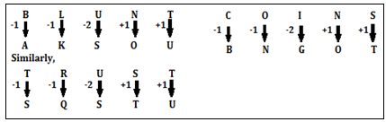

- #qq#Value of $\sec^{2}{θ}-$ $\frac{\sin^{2}{θ - 2\sin^{4}{θ}}}{2\cos^{4}{θ} - \cos^{2}{θ}}$ is –
#oo#(a) 0 #oo#(b) 1 #oo#(c) -1 #oo#(d) 2
#ans# Option2 # 1

#exp#(b) 1
$\sec^{2}{θ}-$ $\frac{\sin^{2}{θ - 2\sin^{4}{θ}}}{2\cos^{4}{θ} - \cos^{2}{θ}}$
Or, $\sec^{2}{θ}-$ $\frac{\sin^{2}{θ (1 - 2\sin^{2}{θ)}}}{\cos^{2}{θ }( 2\cos^{2}{θ - 1)}}$
Or, $\sec^{2}{θ}-$ $\frac{\sin^{2}{θ (\cos^{2}{θ + \sin^{2}{θ}} - 2\sin^{2}{θ)}}}{\cos^{2}{θ }( 2\cos^{2}{θ - \cos^{2}{θ - \sin^{2}{θ}})}}$
Or, $\sec^{2}{θ}-$ $\frac{\sin^{2}{θ (\cos^{2}{θ - \sin^{2}{θ}})}}{\cos^{2}{θ }( \cos^{2}{θ - \sin^{2}{θ)}}}$
Or, $\sec^{2}{θ}-$ $\tan^{2}{θ=1}$

- #qq#If ${\left(x+\frac{1}{x}\right)}^{2}=2,$ then find the value of $x^{104}+x^{100}+x^{84}+x^{80}+x^{44}+x^{40}+x^{24}+x^{20}.$
#oo#(a) 104 #oo#(b) 84 #oo#(c) 0 #oo#(d) 5
#ans# Option3 # 0
#mrk# 1

#dd#Answer these questions based on the following pie charts :
#pp#
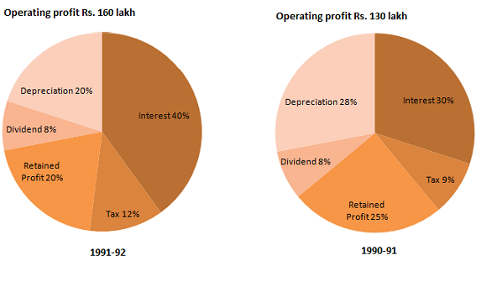
#hpp#


9 #qq#The operating profit in 1991-92 increased over than in 1990-91?
#oo#(a) 23% #oo#(b) 22% #oo#(c) 25% #oo#(d) 24%
#ans# Option1 # 23%
#mrk# 1

10 #qq#The interest burden in 1991-92 was higher than that in 1990-91 by :
#oo#(a) 50% #oo#(b) Rs. 25 lakh #oo#(c) 90% #oo#(d) Rs. 41 lakh
#ans# Option3 # 90%

#dd#Directions(11-12): Read the following passage carefully and answer the questions given below it. Certain words/ phrases have been printed in bold to help you locate them while answering some of the questions.
#pp#Mihir and Mahadev lived in the same village. While Mahadev owned the largest shop in the village. Mihir was a poor farmer. Both had large families, with many sons, daughter-in-law and grandchildren. One day, Mihir, tired of not being able to make ends meet, decided to leave the village and move to the city where they were sure to make enough to feed everyone. They said their goodbyes, packed their few belongings and set off. When night fell, they stopped under a large tree. There was a stream running nearby, where they cold refresh themselves. Mihir told his sons to clear the area below the tree. He told his wife to fetch water. He instructed his dauthters-in-law to make up the fire and started cutting wood from the tree himself. Now, in that branches of the tree sat a thief. He watched as Mihir's family worked together. He also noticed they had nothing to cook. Mihir's wife too thought the same, for she said to her husband, "Everything is ready. But what shall we eat ?" Mihir raised his hands to heaven and said, "Don't worry. Heis watching all this from above. He will help us."At this the thief jumped down from the tree, knife in hand. Seeing him, everyone started running helter skelter to save themselves. The thief stole everything. Mahadev and his family had to return to the village empty handed, having lost all the jewellery and gold they had taken with them.
11 #qq#Which of the following cannot be said about Mihir's family?
(A) They respected and obeyed Mihir.
(B) They were so poor that they sometimes had to starve.
(C) They had no friends in the village when they were poor.
#oo#(a) None #oo#(b) Only (C) #oo#(c) Only (B) and (C) #oo#(d)Only (B) #oo#(d) All (A), (B) and (C)
#ans# Option1 # None

12 #qq#Which of the following cannot be said about Mihir's family?
(A) They respected and obeyed Mihir.
(B) They were so poor that they sometimes had to starve.
(C) They had no friends in the village when they were poor.
#oo#(a) None #oo#(b) Only (C) #oo#(c) Only (B) and (C) #oo#(d) Only (B) #oo#(d) All (A), (B) and (C)
#ans# Option1 # None
#mrk# 1
#ndd#
#npp#

13#qq#Which of the following Answer figure is the exact mirror image of the given Question figure, when the mirror is held on the line AB?
Question figure
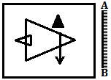

#oo#(a) 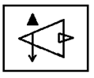 #oo#(b) 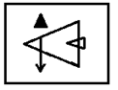 #oo#(c) 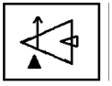 #oo#(d) 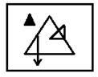

#ans# Option2 # 

