#ms#Math MCQ online test
#dd#Directions (Q.1 to Q.2): Study the following information carefully and answer the following questions given below.
#pp# Pole M is 50m to the west of P, which is 35m to the south of K. Pole V is exactly between the Pole M and P. R is to the west of K and to the north of V.
- #qq# What is the distance between R and V?
#oo#(a) 25m #oo#(b) 35m #oo#(c) 40m #oo#(d) Can not be determined
#ans# Option1 # 25m

- #qq#If ‘R’ denotes ‘–’ ; ‘Q’ denotes ‘×’ ; ‘W’ denotes ‘÷’ and ‘A’ denotes ‘+’ , then
42 W 7 R 8 A 6 Q 4 = ?
#oo#(a) 22 #oo#(b) 168 #oo#(c) 22 #oo#(d) 28
#ans# Option1 # 22
#ndd#
#npp#

- #qq#If ${\left(x+\frac{1}{x}\right)}^{2}=2,$ then find the value of $x^{104}+x^{100}+x^{84}+x^{80}+x^{44}+x^{40}+x^{24}+x^{20}.$

#oo#(a) 104 #oo#(b) 84 #oo#(c) 0 #oo#(d) 5
#ans# Option3 # 0

- #qq#Value of $\sec^{2}{θ}-$ $\frac{\sin^{2}{θ - 2\sin^{4}{θ}}}{2\cos^{4}{θ} - \cos^{2}{θ}}$ is –

#oo#(a) 0 #oo#(b) 1 #oo#(c) -1 #oo#(d) 2

#ans# Option2 # 1
#exp#(b) 1
$\sec^{2}{θ}-$ $\frac{\sin^{2}{θ - 2\sin^{4}{θ}}}{2\cos^{4}{θ} - \cos^{2}{θ}}$
Or, $\sec^{2}{θ}-$ $\frac{\sin^{2}{θ (1 - 2\sin^{2}{θ)}}}{\cos^{2}{θ }( 2\cos^{2}{θ - 1)}}$
Or, $\sec^{2}{θ}-$ $\frac{\sin^{2}{θ (\cos^{2}{θ + \sin^{2}{θ}} - 2\sin^{2}{θ)}}}{\cos^{2}{θ }( 2\cos^{2}{θ - \cos^{2}{θ - \sin^{2}{θ}})}}$
Or, $\sec^{2}{θ}-$ $\frac{\sin^{2}{θ (\cos^{2}{θ - \sin^{2}{θ}})}}{\cos^{2}{θ }( \cos^{2}{θ - \sin^{2}{θ)}}}$
Or, $\sec^{2}{θ}-$ $\tan^{2}{θ=1}$
5 #qq#The operating profit in 1991-92 increased over than in 1990-91?
#oo#(a) 23% #oo#(b) 22% #oo#(c) 25% #oo#(d) 24%
#ans# Option1 # 23%
#mrk# 1

#dd#Answer these questions based on the following pie charts :
#pp#
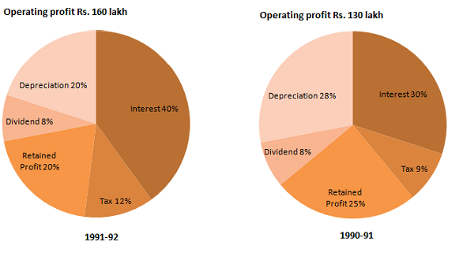
#hpp#


9 #qq#The operating profit in 1991-92 increased over than in 1990-91?
#oo#(a) 23% #oo#(b) 22% #oo#(c) 25% #oo#(d) 24%
#ans# Option1 # 23%
#mrk# 1

