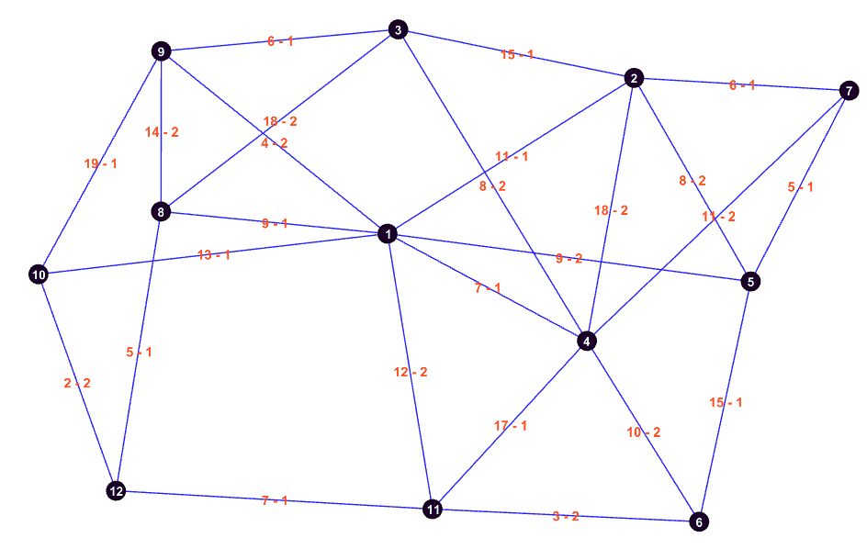

NAME : gdb10

VERTICES : 12

DEPOT : 1

REQUIRED EDGES : 25

NON-REQUIRED EDGES : 0

VEHICLES : 4

CAPACITY : 10

TOTAL COST OF REQUIRED EDGES : 252

NODES COST DEMAND

1 8 9 1

1 9 4 2

1 10 13 1

1 11 12 2

2 1 11 1

2 3 15 1

2 4 18 2

2 5 8 2

3 4 8 2

3 8 18 2

3 9 6 1

4 1 7 1

4 6 10 2

4 11 17 1

5 1 9 2

5 6 15 1

6 11 3 2

7 2 6 1

7 4 11 2

7 5 5 1

8 9 14 2

8 12 5 1

9 10 19 1

10 12 2 2

11 12 7 1

END

NAME : gdb10

VERTICES : 12

DEPOT : 1

REQUIRED EDGES : 25

NON-REQUIRED EDGES : 0

VEHICLES : 4

CAPACITY : 10

TOTAL COST OF REQUIRED EDGES : 252

NODES COST DEMAND

1 8 9 1

1 9 4 2

1 10 13 1

1 11 12 2

2 1 11 1

2 3 15 1

2 4 18 2

2 5 8 2

3 4 8 2

3 8 18 2

3 9 6 1

4 1 7 1

4 6 10 2

4 11 17 1

5 1 9 2

5 6 15 1

6 11 3 2

7 2 6 1

7 4 11 2

7 5 5 1

8 9 14 2

8 12 5 1

9 10 19 1

10 12 2 2

11 12 7 1

END

NAME : gdb10

VERTICES : 12

DEPOT : 1

REQUIRED EDGES : 25

NON-REQUIRED EDGES : 0

VEHICLES : 4

CAPACITY : 10

TOTAL COST OF REQUIRED EDGES : 252

NODES COST DEMAND

1 8 9 1

1 9 4 2

1 10 13 1

1 11 12 2

2 1 11 1

2 3 15 1

2 4 18 2

2 5 8 2

3 4 8 2

3 8 18 2

3 9 6 1

4 1 7 1

4 6 10 2

4 11 17 1

5 1 9 2

5 6 15 1

6 11 3 2

7 2 6 1

7 4 11 2

7 5 5 1

8 9 14 2

8 12 5 1

9 10 19 1

10 12 2 2

11 12 7 1

END