Heart Disease Risk Prediction
End-to-end MLOps: training, tracking, CI/CD, containerisation, Kubernetes and monitoring
Course | Machine Learning Operations (AIMLCZG523) — Assignment 1
Student | Aditya Kumar
BITS ID | [BITS ID]
Code repository | https://github.com/onlyaditya/ml_ops_assignment_1
Demo video | [video link]
Date | 20 October 2026

1. Summary
I built a classifier that predicts the presence of heart disease from 13 routinely collected patient attributes (UCI Heart Disease, Cleveland subset) and took it all the way to a monitored API running on Kubernetes. Every stage is reproducible from the repository: one script downloads and cleans the data, one trains and tracks the models, GitHub Actions re-runs everything on each push, and two kubectl apply -k commands deploy the API plus its monitoring stack.
Area | What I delivered | Key result
Data & EDA | Download/clean script, EDA notebook, 7 figures | 303 patients, 54/46 class balance, <2% missing
Modelling | 3 model families tuned with 5-fold stratified CV | Logistic Regression, CV ROC-AUC 0.907 ± 0.019
Tracking | MLflow with SQLite backend + model registry | 4 runs per training, model heart-disease-classifier v1
CI/CD | GitHub Actions: lint → test → train / docker | 51 tests, 91% coverage, quality gate ROC-AUC ≥ 0.85
Serving | FastAPI /predict, Docker image (non-root, health check) | p95 latency ≈ 15 ms
Deployment | Kubernetes Deployment (2 pods) + LoadBalancer | 0 failed requests during a rolling restart
Monitoring | JSON logs, Prometheus metrics, Grafana dashboard, 5 alerts | Per-pod scraping, drift indicator

2. Architecture
The system has three stages (Figure 1). Training happens offline and produces a versioned, packaged model. CI/CD guards every change and proves the model and the container still work. The packaged model is baked into a slim serving image that runs as two pods behind a load balancer, with Prometheus scraping each pod and Grafana visualising the results.
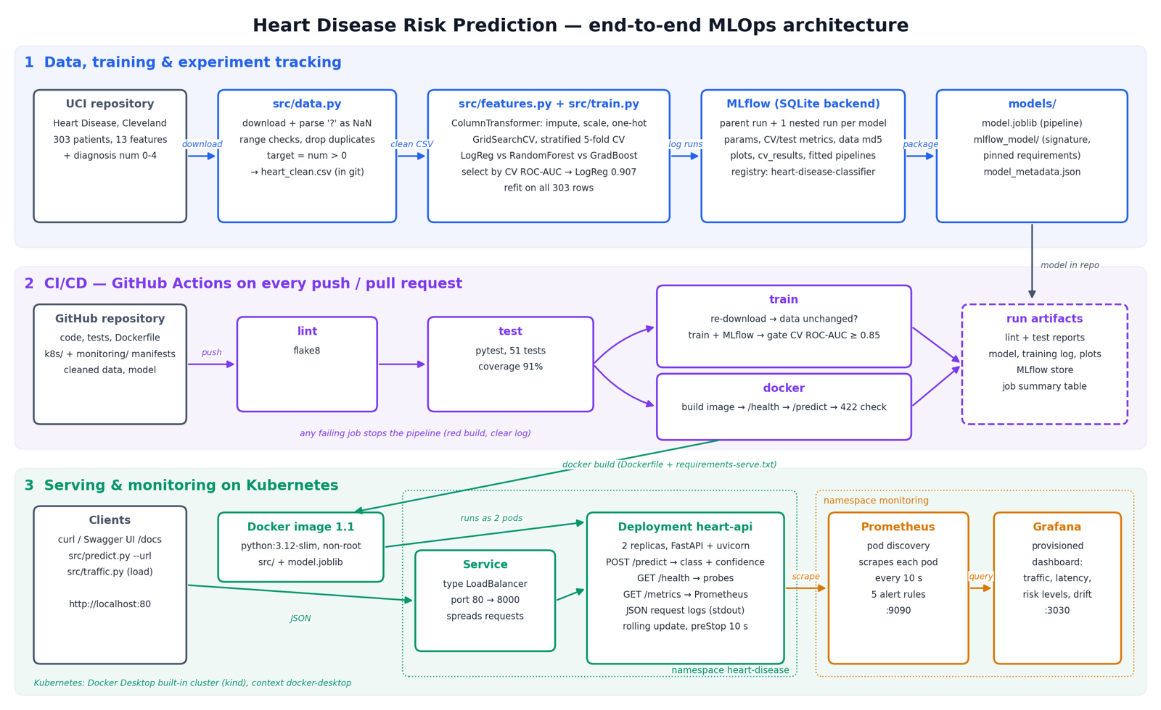
Figure 1. End-to-end architecture (generated by reports/architecture_diagram.py).

3. Setup and access instructions
Requirements: Python 3.12, Docker Desktop with Kubernetes enabled. All Python dependencies are pinned in requirements.txt (training/dev) and requirements-serve.txt (container).
git clone https://github.com/onlyaditya/ml_ops_assignment_1 && cd ml_ops_assignment_1
python3.12 -m venv venv && source venv/bin/activate && pip install -r requirements.txt
python -m src.data # download + clean -> data/processed/heart_clean.csv
python -m src.train # tune, evaluate, log to MLflow, package models/
pytest # 51 unit tests
mlflow ui --backend-store-uri sqlite:///mlflow.db # http://127.0.0.1:5000

docker build -t heart-disease-api:1.1 .
kubectl apply -k k8s/ && kubectl apply -k monitoring/
python -m src.predict samples/patients.json --url http://localhost
python -m src.traffic --url http://localhost --rate 8 --duration 300
Local endpoint | Purpose
http://localhost/predict (POST) | prediction API via the Kubernetes LoadBalancer; Swagger UI at /docs
http://localhost:9090 | Prometheus (targets, alert rules, queries)
http://localhost:3030 | Grafana dashboard (anonymous viewer; admin / heart-mlops)
There is no public URL: the assignment allows local Kubernetes, and I used the cluster built into Docker Desktop. Grafana runs on port 3030 because port 3000 was already used by another application on my machine.

4. Data acquisition and EDA
src/data.py downloads processed.cleveland.data from the UCI repository, parses ? as missing, removes duplicates, nulls physiologically impossible values (age, blood pressure, cholesterol, heart rate, ST depression and ca ranges) and converts the 0–4 diagnosis into a binary target = num > 0 (164 without / 139 with disease). Only ca (4 rows) and thal (2 rows) have missing values.
Design decision: I keep the missing values in the cleaned CSV and impute them inside the model pipeline. This way imputation statistics are learned on training folds only (no leakage) and the API applies exactly the same imputation. Dropping the 6 rows was the alternative, but it would also make the API unable to handle a patient with a missing test result.
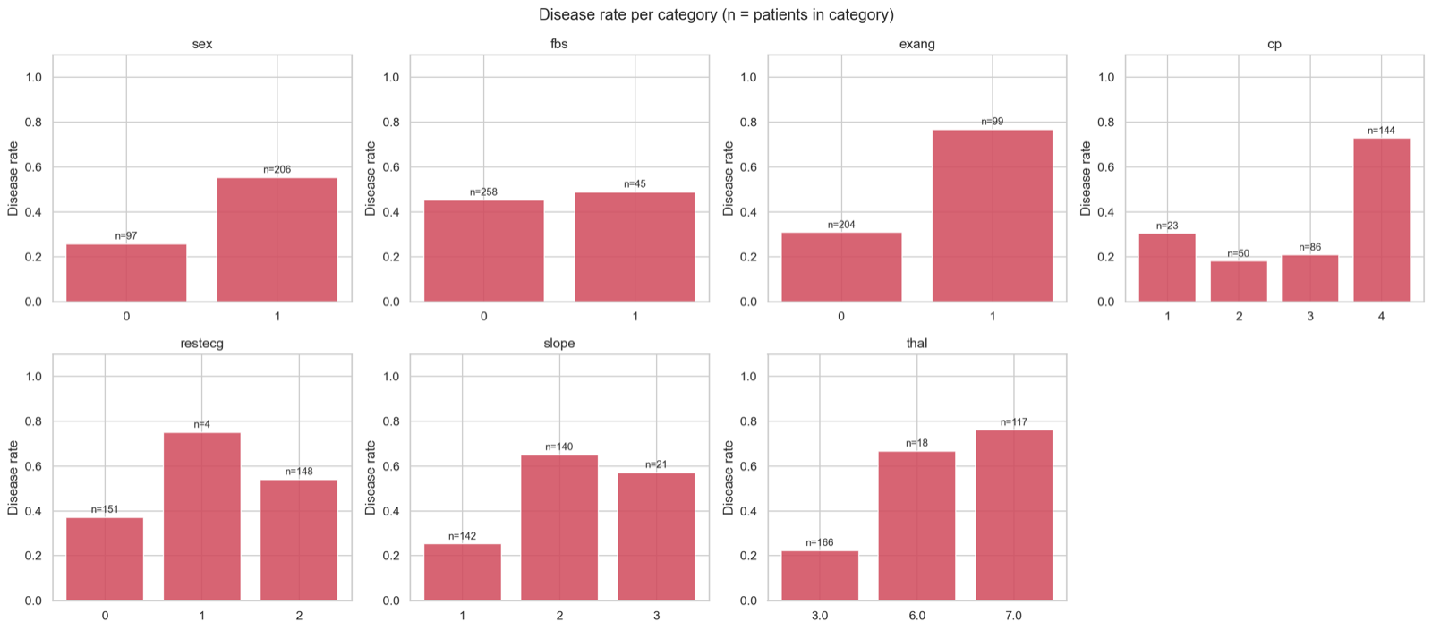
Figure 2. Disease rate per category of the nominal features — asymptomatic chest pain (cp=4), exercise angina and reversible thal defect stand out.
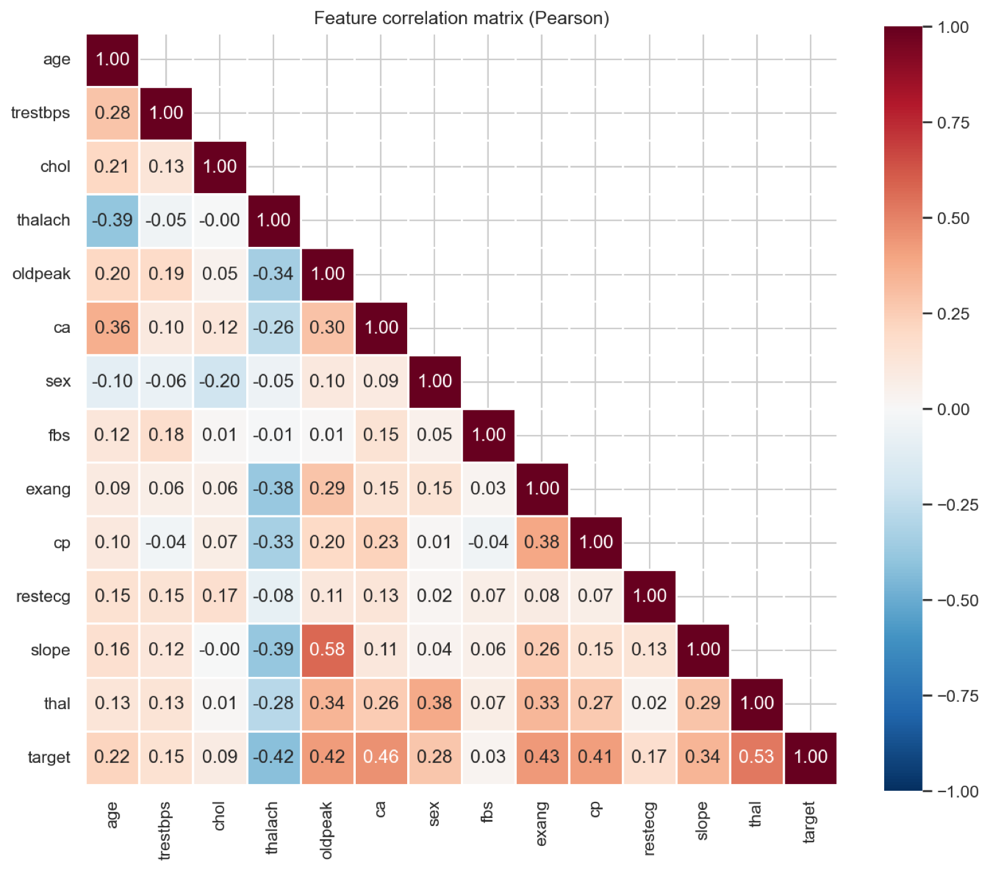
Figure 3. Correlation heatmap: no pair of inputs is strongly correlated (max |r| = 0.58).
EDA finding | Decision carried into modelling
Strongest signals: thal 0.53, ca 0.46, exang 0.43, oldpeak 0.43, cp 0.41, thalach −0.42; weakest fbs 0.03, chol 0.09 | Keep all 13 features — weak ones are cheap and regularisation handles them
Classes balanced (54% / 46%) | No resampling; stratified splits; report accuracy, precision, recall, ROC-AUC
Very different feature scales (e.g. chol vs oldpeak) | StandardScaler on numeric features
cp, restecg, slope, thal are nominal codes; rare levels (restecg=1, n=4) | One-hot encoding with handle_unknown="ignore"
Outliers (chol 564) are clinically plausible | Kept; median imputation is robust to them
Mix of linear and threshold-like effects | Compare a linear model with tree ensembles

5. Feature engineering and model development
src/features.py builds one ColumnTransformer that is saved inside the model pipeline: numeric features (age, trestbps, chol, thalach, oldpeak, ca) get median imputation and standard scaling; binary features (sex, fbs, exang) most-frequent imputation; nominal features (cp, restecg, slope, thal) most-frequent imputation and one-hot encoding. Because preprocessing lives in the pipeline, raw patient records can be sent directly to the model in training, in the CLI and in the API.
Validation design. Stratified 80/20 split (242 / 61 rows, seed 42). Hyper-parameters were tuned with GridSearchCV and stratified 5-fold CV on the training set only, scoring accuracy, precision, recall, F1 and ROC-AUC and refitting on ROC-AUC. I chose the model by mean CV ROC-AUC, not by test score: the test set stays an unbiased final check, and ROC-AUC is threshold-independent, which suits a risk score. Grids: Logistic Regression 24 combinations (C, L1/L2, class weight), Random Forest 36, Gradient Boosting 16.
Model (best parameters) | CV ROC-AUC | CV acc. | CV prec. | CV recall | Test ROC-AUC | Test acc.
Logistic Regression (C=0.3, L2, balanced) | 0.907 ± 0.019 | 0.855 | 0.882 | 0.801 | 0.961 | 0.869
Random Forest (400 trees, min_leaf=3, sqrt) | 0.901 ± 0.026 | 0.818 | 0.825 | 0.774 | 0.952 | 0.885
Gradient Boosting (lr=0.03, depth=2, 100 trees) | 0.884 ± 0.027 | 0.822 | 0.851 | 0.756 | 0.960 | 0.902

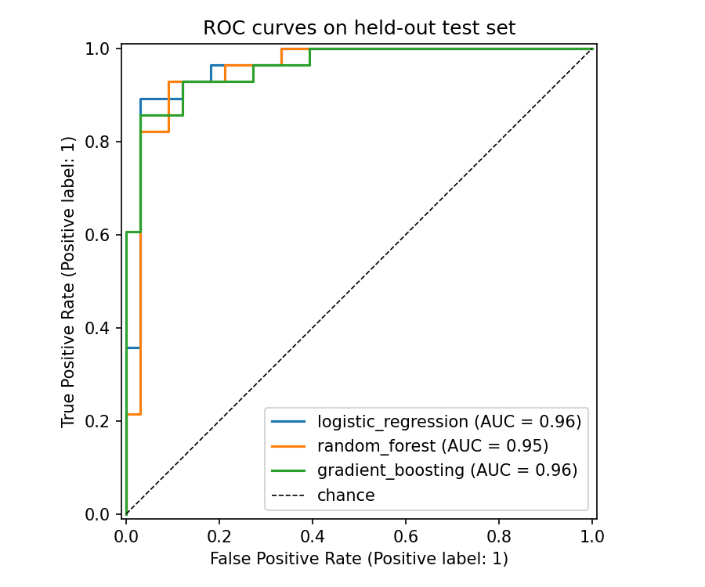
Figure 4. Test-set ROC curves of the three tuned models.
Why Logistic Regression. It has the highest CV ROC-AUC and the lowest variance across folds, and it is the simplest and most interpretable model — a useful property for a medical risk score. The gap to Random Forest (0.006) is smaller than one standard deviation, so the two are effectively tied and simplicity breaks the tie. Tuning consistently preferred strong regularisation (C=0.3, depth-2 boosting, min_leaf=3 forests), which is what I expected with only 242 training rows.
Test scores above CV scores. The test set has only 61 patients, so one patient moves accuracy by 1.6 points; the CV mean ± std is the more reliable estimate, and I report both. A tuning detail worth noting: two Logistic Regression candidates score exactly 0.5 ROC-AUC — with C=0.01 and an L1 penalty every coefficient is shrunk to zero and the model predicts a constant.
Final model. After selection I refit the winning configuration on all 303 rows (25% more data). The trade-off is that the shipped artifact has no untouched test score of its own; its expected performance is the CV/test estimate above, which I store in model_metadata.json.

6. Experiment tracking (MLflow)
Every python -m src.train run is logged to MLflow with a SQLite backend (needed for the model registry). A parent run model-selection records the data path and its MD5 fingerprint (a light form of data versioning), split sizes, CV setup, the comparison table, the combined ROC plot and the final packaged model. One nested run per model family logs its best hyper-parameters, CV mean/std and test metrics, confusion matrix, tuning plot, the full cv_results table and the fitted pipeline with an input signature and example. The final model is registered as heart-disease-classifier.
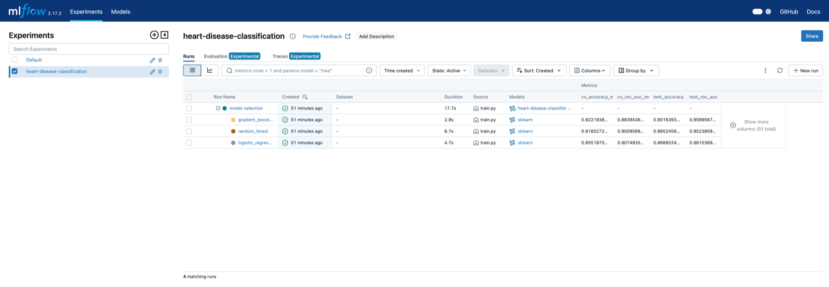
Figure 5. MLflow experiment: parent run with three nested model runs and their CV/test metrics.
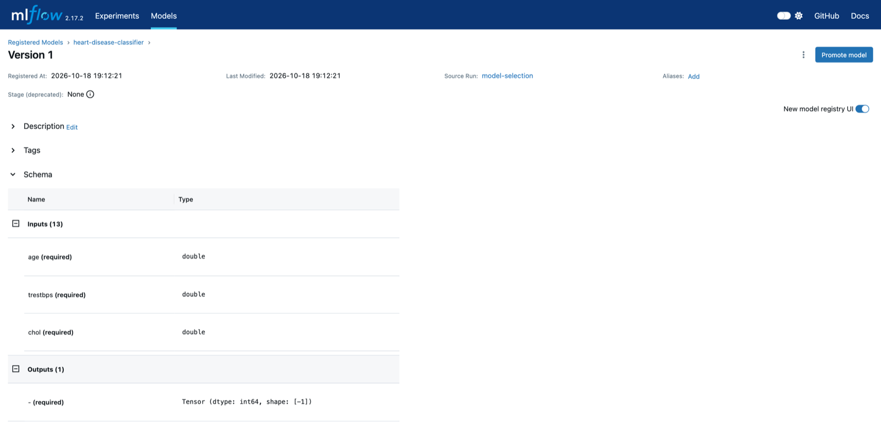
Figure 6. Model registry entry heart-disease-classifier v1 with its 13-feature input schema.

7. Model packaging and reproducibility
- models/model.joblib — the complete preprocessing + classifier pipeline, loaded by the API (no MLflow needed at serving time).
- models/mlflow_model/ — MLflow format with MLmodel, signature, input example, conda.yaml and pinned requirements.
- models/model_metadata.json — hyper-parameters, feature order, data MD5, performance estimate, MLflow run id and registry version, scikit-learn version.
- All versions pinned, including important transitive dependencies (SQLAlchemy, Alembic, joblib, Starlette, AnyIO) after real breakages; the serving image installs the same scikit-learn 1.5.2 so the pickle loads identically.
- I verified that the joblib file, the MLflow folder and models:/heart-disease-classifier/1 give identical predictions, and that missing values and an unseen category code predict without errors.

8. CI/CD pipeline and automated testing
The test suite (51 tests, 91% coverage) uses small synthetic datasets so it needs no network: data parsing and cleaning, preprocessing (no NaNs after imputation, one-hot width, unseen categories), metric helpers, an end-to-end training run in a temporary directory, checks on the packaged model (including a behavioural test that a high-risk patient scores higher than a low-risk one), the API contract, the monitoring metrics and log format, and the traffic generator.
Job | Steps | Artifacts
lint | flake8 (max line length 100) | lint-report
test | pytest with JUnit XML and coverage | test-results
train | re-download data → git diff --exit-code proves the cleaned CSV is reproducible → train with MLflow → quality gate fails the build if CV ROC-AUC < 0.85 → model table in the job summary | model, training-reports, mlflow-tracking
docker | build image → run → wait for /health → POST a high-risk sample (expects class 1) → invalid input must return 422 | container logs
Jobs are chained with needs:, so any lint error, failing test, data change or below-threshold model stops the pipeline with a red build and the failing step's log. Bash runs with pipefail, so a crash inside python -m src.train | tee training.log still fails the step. Runners are pinned to ubuntu-24.04 because GitHub announced that ubuntu-latest moves to Ubuntu 26.
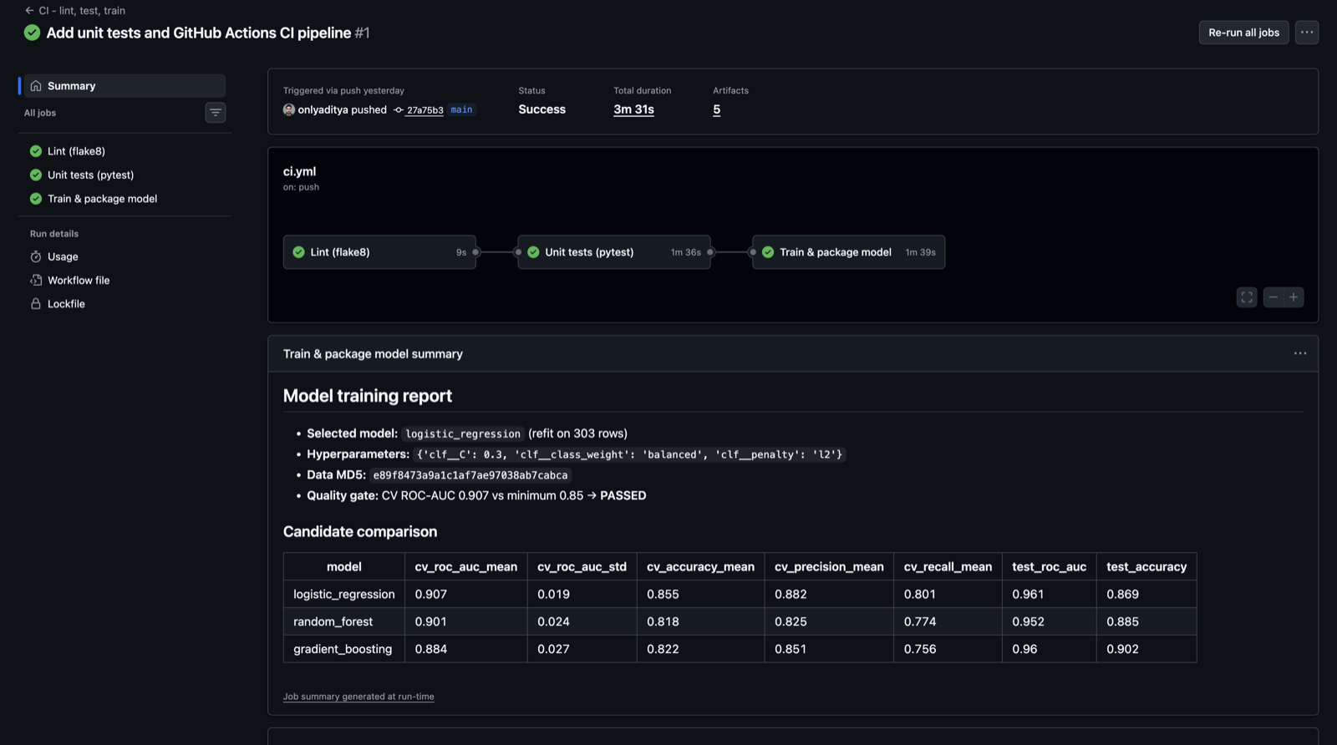
Figure 7. Green run (run #1, before the docker job was added): lint → test → train, and the generated model report with the passed quality gate.

9. Model serving API and containerisation
src/api.py (FastAPI) loads the model once at start-up and exposes POST /predict, GET /health, GET /model-info and GET /metrics. The response contains prediction, label, confidence (probability of the predicted class), probability_disease, a risk_level band (< 0.3 low, < 0.7 moderate, otherwise high) and model_version. A single function, score_records, is shared by the API and the command-line inference script src/predict.py, so the two can never disagree.
Strict input validation. Numeric ranges reuse the plausible clinical ranges from the cleaning step, categorical codes must be valid UCI codes, unknown fields are rejected, and only ca/thal may be null. The model itself would tolerate garbage, but silently imputing it would return a confident wrong answer, so the API returns HTTP 422 with a field-level message instead.
Docker image. python:3.12-slim, only requirements-serve.txt (no MLflow, Jupyter or plotting), dependencies installed before the code is copied (layer caching), an allow-list .dockerignore, a non-root user and a HEALTHCHECK. Local verification: the container reported healthy, the high-risk sample returned class 1 with confidence 0.996, and an invalid chest-pain code returned 422.
Figure 8. POST /predict against the running container with the high-risk sample: class 1, confidence 0.9961, risk level high.

10. Production deployment on Kubernetes
I deployed to the Kubernetes cluster built into Docker Desktop (kind-based, v1.36.1) using plain manifests applied with Kustomize (kubectl apply -k k8s/): a namespace, a ConfigMap (decision threshold and log level), a Deployment and a LoadBalancer Service exposed on localhost:80.
- 2 replicas with RollingUpdate (maxUnavailable: 0, maxSurge: 1), so capacity never drops during an update.
- Readiness probe on /health (traffic only after the model is loaded) and a liveness probe that restarts a hung container.
- CPU/memory requests and limits based on measured usage; non-root, read-only root filesystem, all Linux capabilities dropped.
Verification: requests were spread over both pods, and a deleted pod was replaced within 8 seconds. The most interesting result came from a rolling restart under continuous traffic (about 7 requests/s):
preStop delay | Requests during the rollout | Failed
none | 239 | 5 (≈ 2%)
sleep 5 s | 338 | 1
sleep 10 s (final) | 868 over two rollouts | 0
A terminating pod stops accepting connections immediately, but the load balancer needs a few seconds to remove it from its endpoints. A preStop sleep keeps the old pod serving during that window, giving a genuinely zero-downtime rollout.
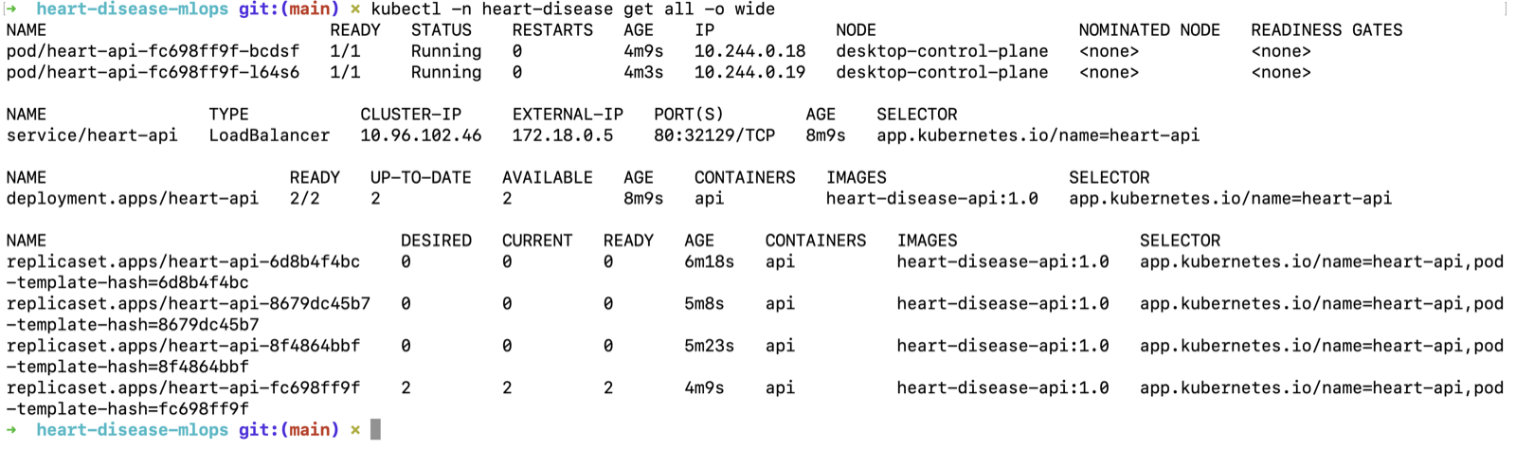
Figure 9. kubectl get all: two running pods, the Deployment (2/2) and the LoadBalancer Service.
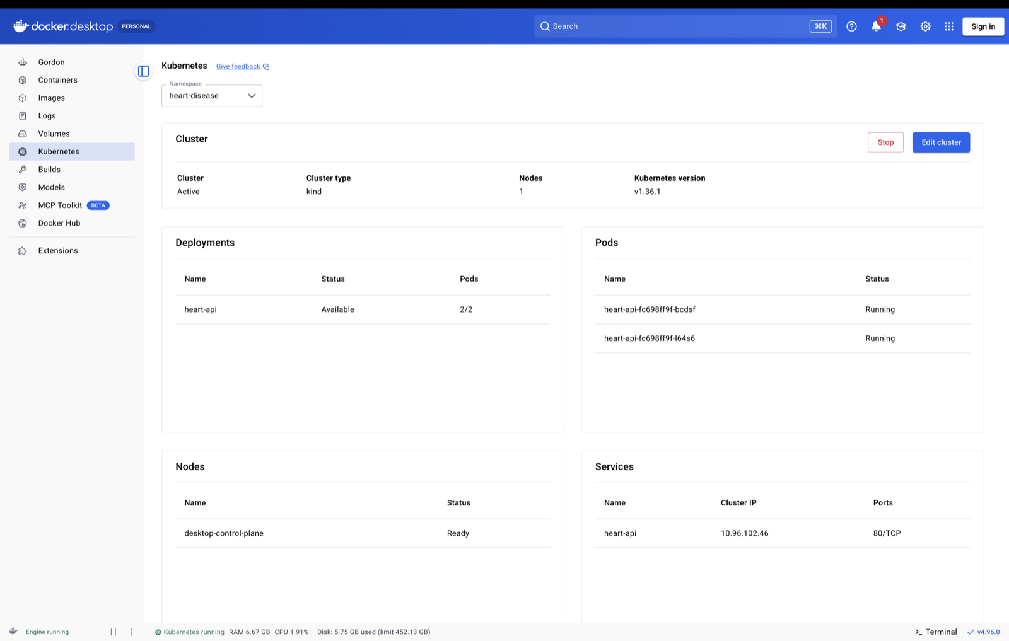
Figure 10. Docker Desktop's Kubernetes view of the deployment, pods, node and service.

11. Monitoring and logging
Logging. Each request produces one JSON line on stdout with a request id (reused from an incoming X-Request-ID header or generated and returned), method, path, status and latency; each prediction adds the model output and risk level. Patient feature values are never logged. Health checks and scrapes are only logged at DEBUG level so they do not bury real traffic.
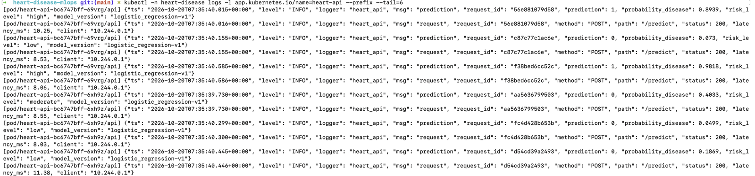
Figure 11. Structured request and prediction logs from both pods (kubectl logs).
Metrics. /metrics exposes request counts and latency histograms per endpoint, predictions by class and risk level, a histogram of the predicted probability, rejected inputs per field and the model version. Unknown URLs are counted under one other label so random requests cannot create unlimited time series.
Prometheus and Grafana run in their own namespace. Prometheus discovers the API pods through the Kubernetes API and scrapes each pod individually (a dead pod shows up as down instead of being hidden behind the Service); it only has a namespaced role to list pods. Five alert rules cover a pod being down, server errors, slow predictions, a high share of rejected inputs and prediction drift. Grafana's data source and dashboard are provisioned from files in the repository.
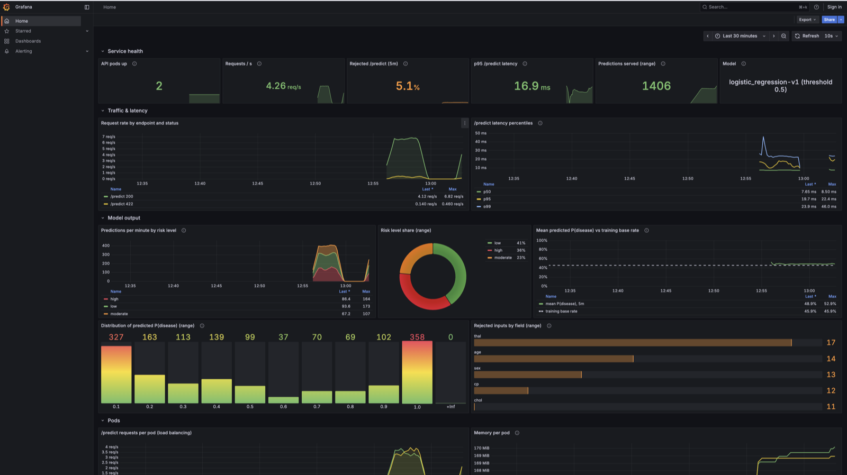
Figure 12. Grafana dashboard under generated traffic: 2 pods up, 4.3 req/s, 5.1% rejected (deliberately invalid requests), p95 latency 16.9 ms, risk-level mix and the mean predicted probability (48.9%) next to the 45.9% training base rate.
The drift panel compares the mean predicted probability with the share of patients with disease in the training data (139/303 = 45.9%). The generated traffic replays real patients, so the two lines stay close — exactly what the indicator should show when nothing has drifted.
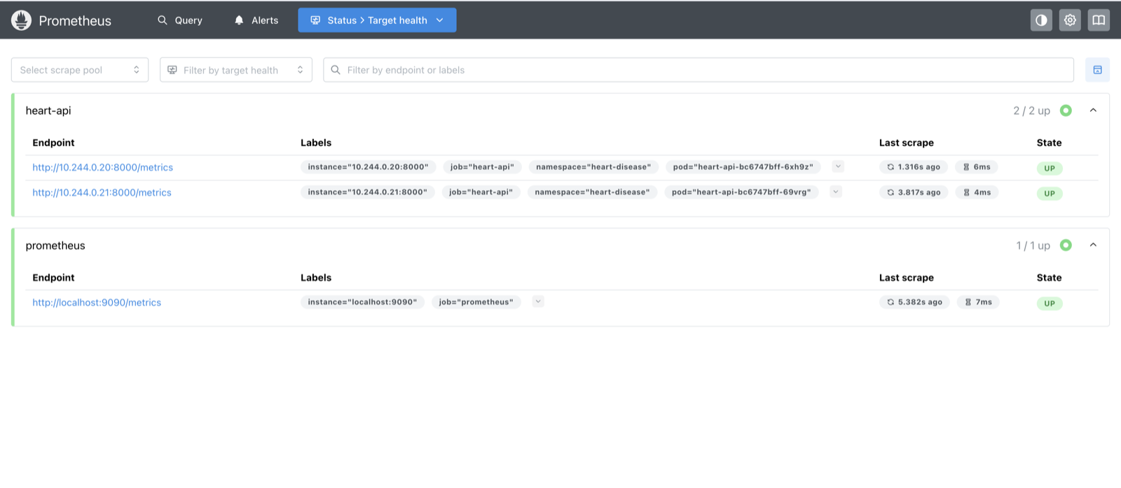
Figure 13. Prometheus target health: one target per API pod, discovered automatically.

12. Challenges and lessons learned
Problem | Cause | Fix / lesson
ImportError in MLflow after a clean install | pip pulled SQLAlchemy 2.1, too new for MLflow 2.17 | Pinned SQLAlchemy 2.0.36 and Alembic — pin important transitive dependencies
Training logs disappeared with a fresh MLflow DB (always the case in CI) | MLflow's database migrations reconfigure Python logging | Configure logging after MLflow setup with force=True
Process spam at exit during grid search | joblib 1.4.2 worker cleanup on Python 3.12 | Upgraded to joblib 1.5.2; removed nested parallelism
Precision warnings in some CV folds | Extremely regularised candidates predict no positives | zero_division=0; explained as the C=0.01 + L1 constant model
Docker Desktop would not start | Its disk image was owned by root and its filesystem was corrupted | Fixed ownership, read the VM logs, reset Docker Desktop and updated it
≈ 2% failed requests during rolling updates | Pods stop before the load balancer stops routing to them | preStop sleep of 10 s → 0 failures
LoadBalancer IP not reachable; Grafana <pending> | kind publishes services on localhost; port 3000 already in use | Use localhost; moved Grafana to 3030

13. Conclusion and future work
The project delivers a reproducible path from raw UCI data to a monitored, load-balanced prediction API, with every step automated and checked: data reproducibility and a quality gate in CI, a container smoke test, health-checked zero-downtime deployment, and metrics, logs and alerts in production. With more time I would push the image to a registry (GHCR) from CI and deploy it automatically, add a HorizontalPodAutoscaler (needs metrics-server), connect Alertmanager, give Prometheus persistent storage, and add input-level drift detection (comparing incoming feature distributions with the training data) on top of the current output-level indicator.
Code repository: https://github.com/onlyaditya/ml_ops_assignment_1

