ICT 283
ASSIGNMENT 2
Done by: Syafiq Danial Bin Sulaimi
Student ID: 35119712

Table of Contents
1. UML 3
2. Data Dictionary 4
3. PSEUDOCODE 13
4. Testing 17
5. Test Cases 21

UML
High Level UML
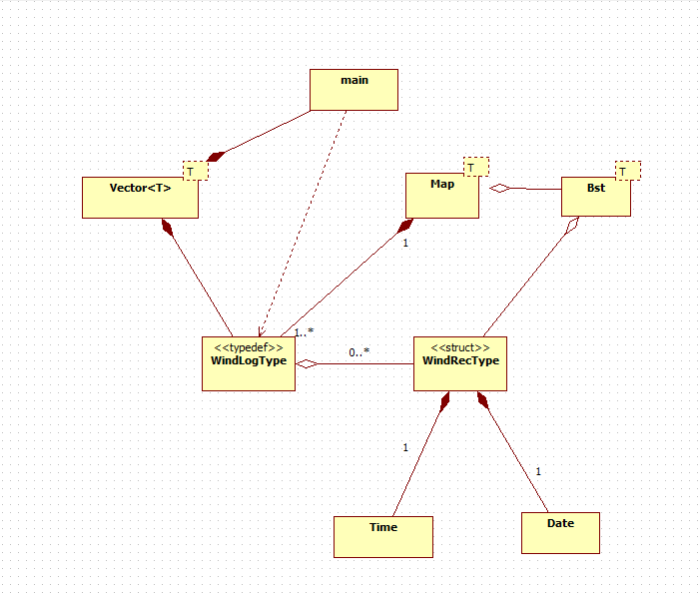

Data Dictionary
Date
Data | Type | Description | Constraints
day | Int | Day of the month | Must be between 1-31
month | Int | Month of the year | Must be between 1-12
year | int | year | Must be a positive integer
operator< | bool | Compares if the current date is earlier than another date | Returns true if this date is earlier; otherwise false.
operator> | bool | Compares if the current date is later than another date | Returns true if this date is later; otherwise false.
operator== | bool | Compares if two dates are equal | Returns true if day, month, and year are all equal.
operator<< | ostream& | Outputs the date to a stream | Format: customizable, e.g., DD/MM/YYYY.
operator>> | istream& | Inputs the date from a stream | Ensures valid day, month, and year during parsing.

Time
Data | Type | Description | Constraints
m_hour | Int | Hour of the day | Must be between 0-23
m_minute | Int | Minute of the hour | Must be between 0-59
operator< | bool | Checks if the current time is earlier than another time | Compares m_hour first, then m_minute
operator> | bool | Checks if the current time is later than another time | Compares m_hour first, then m_minute
operator== | bool | Checks if two time objects are equal | Returns true if both m_hour and m_minute are identical
operator<< | ostream& | Outputs the time to a stream | Format: customizable, e.g., hh:mm
operator>> | istream& | Inputs the time from a stream | Ensures valid hour and minute values during parsing

Vector<T>
Data | Type | Description | Constraints
m_array | std::vector<T> |  | None
  The underlying container to store elements of type T.
Method | Description | Constraints
 |  | Always returns true
  bool Add(const T& item)
  Adds an item of type T to the vector
int GetSize() const | Returns the current number of elements in the vector | N/A
bool Insert(int index, const T& item) | Inserts an item of type T at the specified index | Index must be in the range [0, size()]
bool Remove(const T& item) | Removes the first occurrence of an item of type T from the vector | Returns true if an item is successfully removed; false otherwise
bool Delete(int index) | Deletes an item at the specified index. | Index must be valid
bool Modify(int index, const T& item) | Modifies the item at the specified index with a new item | Index must be valid
T& At(int index) | Returns a reference to the item at the specified index | Index must be valid
const T& At(int index) const | Returns a constant reference to the item at the specified index | Index must be valid
typename std::vector<T>::iterator begin() | Returns an iterator pointing to the first element in the vector | N/A
typename std::vector<T>::iterator end() | Returns an iterator pointing past the last element in the vector | N/A
typename std::vector<T>::const_iterator begin() const | Returns a constant iterator pointing to the first element in the vector | N/A
typename std::vector<T>::const_iterator end() const | Returns a constant iterator pointing past the last element in the vector | N/A
Vector class: In this program, the Vector class is used to handle dynamic collections of data, providing an efficient way to manage elements like headers and records. It encapsulates a std::vector, offering functionality to add, remove, and access elements while ensuring safety through bounds-checked access. For instance, when reading data from a CSV file, the Vector<string> is employed to store column headers or individual records, allowing the collection to grow dynamically. The Add() method appends elements, and the At() method provides safe access. By abstracting memory management and resizing, the Vector class simplifies data manipulation and enhances the program's flexibility, ensuring that changes to the underlying data structure won't impact other areas of the code.

WindRecType
Data | Type | Description | Constraints
date | Date |  | Must be a valid date
  Represents the date of the wind data record
time | Time | Represents the time of the wind data record | Must be a valid time
speed | float | Wind speed in m/s | Non-negative
temperature | float | Ambient air temperature in °C | No specific range, but must be realistic
solarRadiation | float | Solar radiation in W/m² | Non-negative

Method | Description | Constraints
WindRecType() | Default constructor initializes the wind record with default values: zero wind speed, temperature, solar radiation, and default Date and Time | N/A
WindRecType(const Date& date, const Time& time, float spd, float temp, float solarRad) | Initializes the wind record with specified date, time, wind speed, temperature, and solar radiation values | spd and solarRad must be non-negative
bool operator<(const WindRecType& other) const | Compares the current wind record with another based on date and time. Returns true if this record is earlier than the other | other must be a valid WindRecType object
bool operator>(const WindRecType& other) const | Compares the current wind record with another based on date and time. Returns true if this record is later than the other | other must be a valid WindRecType object
bool operator==(const WindRecType& other) const | Compares two wind records. Returns true if they are identical in date, time, wind speed, temperature, and solar radiation | other must be a valid WindRecType object

WindLogType
Data | Type | Description | Constraints
records | Map<Date, Bst<WindRecType>> | A map that stores wind records indexed by date, with each date having an associated Bst of WindRecType. | Date must be valid, and WindRecType must be valid for each entry.

Data | Description | Constraints
WindLogType() | Default constructor initializes the WindLogType with an empty collection of records | N/A
float CalculateAverageSpeed(int month, int year) const |  | month and year must be valid
  Calculates the average wind speed for a given month and year
float CalculateWindSpeedStandardDeviation(float averageSpeed, int month, int year) const | Calculates the standard deviation of wind speed for a specified month and year | averageSpeed, month, and year must be valid
float CalculateAverageTemperature(int month, int year) const | Calculates the average temperature for a specified month and year | month and year must be valid
float CalculateTempStandardDeviation(float averageTemp, int month, int year) const | Calculates the standard deviation of temperature for a specified month and year | averageTemp, month, and year must be valid
float CalculateTotalSolarRadiation(int month, int year) const | Calculates the total solar radiation for a specified month and year | month and year must be valid
void ExportMonthlyAverage(int year) const | Exports the monthly average for a specified year to a CSV file | year must be valid
int GetSize() const | Retrieves the size of the wind records collection | N/A
const WindRecType& At(int index) const | Accesses a wind record at a specified index | index must be within bounds
void AddRecord(const Date& date, const WindRecType& record) | Adds a new wind record to the collection for the specified date | date must be valid, and record must be a valid WindRecType

Map
 | Type | Description | Constraints
  Data
KeyType | Template Type | The type of the key in the map. | Should be a comparable type (e.g., Date, int)
ValueType | Template Type | The type of the value associated with each key in the map. | Any type, can be a complex type like Bst<WindRecType>
std::map | std::map<KeyType, ValueType> |  | Map structure requires unique keys.
  The underlying data structure used to store key-value pairs.

Method | Description | Constraints
Insert | Inserts a key-value pair into the map. | Key must be unique; duplicate keys are not allowed.
Find | Finds and returns the value associated with a specific key. | Returns std::map::end() if key is not found.
Erase | Removes a key-value pair from the map by key. | Removes the pair only if the key exists in the map.
ForEach | Applies a function to each key-value pair in the map. | Function should take two parameters: KeyType and ValueType.
ForEach1 | Applies a function to the first key-value pair. | Specialized for specific processing, with additional parameters.
ForEach2 | Applies a function to the second key-value pair. | Specialized for specific processing, with additional parameters.
ForEach3 | Applies a function to the third key-value pair. | Specialized for specific processing, with additional parameters.
ForEach4 | Applies a function to the fourth key-value pair. | Specialized for specific processing, with additional parameters.
ForEach5 | Applies a function to the fifth key-value pair. | Specialized for specific processing, with additional parameters.
ForEach6 | Applies a function to the sixth key-value pair. | Specialized for specific processing, with additional parameters.
Rationale for encapsulated Map class: Using an encapsulated Map class in the program offers several advantages, such as simplicity, flexibility, and better data management. It abstracts the complexity of the underlying std::map, providing a straightforward interface for managing key-value pairs (e.g., Date and Bst<WindRecType>). This approach enhances maintainability by consolidating operations like insertion, search, and deletion in one place, allowing easier adjustments to the internal structure without impacting the rest of the code. It also ensures type safety and consistency, streamlining error handling and debugging.

Bst
Data | Type | Description | Constraints
Node<T>* root | Pointer to Node<T> | A pointer to the root node of the binary search tree (BST). | None
Node<T>* left | Pointer to Node<T> | A pointer to the left child node of the current node. | Can be nullptr or point to another Node<T>
Node<T>* right | Pointer to Node<T> | A pointer to the right child node of the current node. | Can be nullptr or point to another Node<T>
T data | Template Type T | The data stored in the node, where T is a placeholder for any data type. | Type T is determined when the BST is instantiated
Bst() | Method | Constructs an empty binary search tree. | Initializes the root to nullptr
~Bst() | Method | Destructor for the binary search tree, deletes all nodes. | Recursively deletes nodes starting from the root
Bst(const Bst<T>&) | Method | Copy constructor for the binary search tree. | Performs a deep copy of the tree
operator= | Method | Assignment operator for the binary search tree. | Handles deep copy and self-assignment
Insert(T value) | Method | Inserts a value into the binary search tree. | Maintains BST property (left < value < right)
Search(T value) const | Method | Searches for a value in the binary search tree. | Returns true if value is found, false otherwise
InOrder(void (*func)(const string&, WindLogType&), WindLogType&) const | Method | Performs in-order traversal, calling the provided function for each node. | Applies a function pointer to each node in in-order
PreOrder(void (*func)(const T&)) const | Method | Performs pre-order traversal, calling the provided function for each node. | Applies a function pointer to each node in pre-order
PostOrder(void (*func)(const T&)) const | Method | Performs post-order traversal, calling the provided function for each node. | Applies a function pointer to each node in post-order
DeleteTree() | Method | Deletes all nodes in the tree, freeing memory. | Recursively deletes nodes starting from the root
InOrderAccumulateSpeed(void (*func)(const T&, float&, int&, int, int), float&, int&, int, int) const | Method | Accumulates wind speed data during an in-order traversal. | Applies the provided function to each node
InOrderAccumulateVariance(void (*func)(const T&, float&, int&, float, int, int), float&, int&, float, int, int) const | Method | Accumulates variance data during in-order traversal. | Applies the provided function to each node
InOrder2(void (*func)(const T&, float, float&, int&, int, int), float, float&, int&, int, int) const | Method | Accumulates temperature data during in-order traversal. | Applies the provided function to each node
InOrder3(void (*func)(const T&, float&, int, int), float&, int, int) const | Method | Accumulates solar radiation data during in-order traversal. | Applies the provided function to each node
InOrder4(void (*func)(const T&, float&, float&, float&, float&, float&, int&, int, int), float&, float&, float&, float&, float&, int&, int, int) const | Method | Traverses the tree and applies a function with multiple data parameters for correlation. | Applies a function pointer to each node with multiple arguments
InOrder5(void (*func)(const T&, float&, int&, float, int, int), float&, int&, float, int, int) const | Method | Accumulates wind speed data and computes average during an in-order traversal. | Applies the provided function to each node
InOrder6(void (*func)(const T&, float&, int&, float, int, int), float&, int&, float, int, int) const | Method | Accumulates temperature data and computes average during an in-order traversal. | Applies the provided function to each node
InOrderPrinter(void (*func)(const T&)) const | Method | Performs in-order traversal and applies a function to print each node's data. | Applies the provided function to print node data
CopyTree(Node<T>* node) const | Method | Creates a deep copy of the tree starting from the given node. | Used in the copy constructor and assignment operator
InsertHelper(Node<T>*& node, T value) | Method | Helper function to insert a value into the tree, maintaining the BST property. | Recursively inserts value into the correct position
SearchHelper(Node<T>* node, T value) const | Method | Helper function to search for a value in the tree. | Recursively searches for value
InOrderHelper(Node<T>* node, void (*func)(const string&, WindLogType&), WindLogType& windData) const | Method | Helper function to perform an in-order traversal, applying a function to each node's data. | Used in InOrder method to traverse and apply function
PreOrderHelper(Node<T>* node, void (*func)(const T&)) const | Method | Helper function to perform a pre-order traversal, applying a function to each node's data. | Used in PreOrder method to traverse and apply function
PostOrderHelper(Node<T>* node, void (*func)(const T&)) const | Method | Helper function to perform a post-order traversal, applying a function to each node's data. | Used in PostOrder method to traverse and apply function
DeleteTreeHelper(Node<T>* node) | Method | Helper function to recursively delete all nodes in the tree, freeing memory. | Used in DeleteTree to delete nodes starting from root

PSEUDOCODE
BEGIN
// Function to display menu options
FUNCTION DisplayMenu
PRINT "Menu options:"
PRINT "1. Average wind speed and sample standard deviation for a specified month and year"
PRINT "2. Average ambient air temperature and standard deviation for each month of a year"
PRINT "3. sPCC(S_T/S_R/T_R)"
PRINT "4. Average Wind Speed(stdev, mad), Average Ambient Temperature(stdev, mad), Total Solar Radiation for specified month of all available years (export to CSV)"
PRINT "5. Exit program"
END

// Function to process CSV files and populate WindLogType
FUNCTION ProcessCsvFile(FILE path, WindLogType windData)
OPEN CSV file for reading
IF file cannot be opened
PRINT "Error: Could not open file"
RETURN
END IF

// Read header and parse fields
READ first line (header)
SPLIT header into fields and store in both BST and Vector

// Find required column indices (WAST, S, SR, T)
FOR each header in vector
IF header matches "WAST", "S", "SR", or "T"
STORE column indices for each field
END IF
END FOR

// Process the data lines
FOR each line in CSV
SPLIT line into fields
IF line has required columns
EXTRACT date, time, wind speed, temperature, solar radiation from fields
CONVERT strings to appropriate data types (e.g., float for wind speed)
CREATE WindRecType object with parsed values
ADD record to windData
END IF
END FOR

CLOSE CSV file
END FUNCTION

// Main program logic
OPEN data_source.txt for reading
IF data_source.txt cannot be opened
PRINT "Error: Could not open data_source.txt"
EXIT with error code
END IF

// Read CSV paths from data_source.txt and store them in a BST
FOR each line in data_source.txt
ADD "data/" + line to csvFilePaths BST
END FOR

CLOSE data_source.txt

// Check if CSV paths are available
IF no valid CSV paths
PRINT "Error: No valid CSV paths found"
EXIT with error code
END IF

// Initialize windData object to store all wind records
CREATE WindLogType windData

// Process each CSV file using InOrder traversal
CALL InOrder traversal on csvFilePaths with ProcessCsvFile as callback

// Main menu loop
REPEAT
CALL DisplayMenu to show options
READ user input (option)

SWITCH option
CASE 1: // Average wind speed and standard deviation
PROMPT user for month and year
CALCULATE average wind speed for given month and year
CALCULATE wind speed standard deviation
PRINT results (avg speed in km/h, stdev in km/h)
BREAK

CASE 2: // Average temperature and standard deviation for each month
PROMPT user for year
FOR each month from 1 to 12
CALCULATE and print average temperature and standard deviation for the month
END FOR
BREAK

CASE 3: // SPCC calculation for specified month
PROMPT user for month
FOR each unique year in available years
CALCULATE SPCC for wind speed/temperature, wind speed/solar radiation, and temperature/solar radiation
PRINT results
END FOR
BREAK

CASE 4: // Export monthly averages to CSV
PROMPT user for year
CALL ExportMonthlyAverage to save data to CSV
BREAK

CASE 5: // Exit program
PRINT "Exiting program..."
BREAK

DEFAULT:
PRINT "Invalid option"
END SWITCH

UNTIL option == 5 // Exit when user chooses option 5

RETURN 0 // Successfully exit program
END

Testing
Date Class
Test ID | Description | Input | Expected Output | Pass/Fail
1 | Test Default Constructor | Date defaultDate | 1 January 2000 | Pass
2 | Parameterized Constructor | Date specificDate(30, 12, 2020) | 30 December 2020 | Pass
3 | Test GetDate | anotherDate.GetDay()  anotherDate.GetMonth()  anotherDate.GetYear() | Day: 15, Month: 7, Year: 2024 | Pass
4 | Test SetDate | Date anotherDate  anotherDate.SetDay(15)  anotherDate.SetMonth(7)  anotherDate.SetYear(2024) | Day: 15, Month: 7, Year: 2024 | Pass

Time Class
Test ID | Description | Input | Expected Output | Pass/Fail
1 | Test Default Constructor | Time t1 | 00:00 | Pass
2 | Parameterized Constructor | Time t2(14, 30) | 14:30 | Pass
3 | Test GetDate | assert(t1.GetHour() == 12)  assert(t1.GetMinute() == 15) | 12:15 | Pass
4 | Test SetDate | t1.SetHour(12) t1.SetMinute(15) | 12:15 | Pass
5 | Test stream operators | istringstream input("09:45") | 09:45 | Pass

Vector Class
Test ID | Description | Input | Expected Output | Pass/Fail
1 | Test Construct vector of int | Vector<int> vec | Size : 0 | Pass
2 | Test Construct vector of string | Vector<string> vecStr | Size : 0 | Pass
3 | Test adding elements to int vector | vec.Add(i) | Added 0, New size: 1  Added 1, New size: 2  Added 2, New size: 3  Added 3, New size: 4  Added 4, New size: 5  Added 5, New size: 6  Added 6, New size: 7  Added 7, New size: 8  Added 8, New size: 9  Added 9, New size: 10 | Pass
4 | Test copy constructor | Vector<int> vecCopy = vec | Size of copied Vector : 10 | Pass
5 | Test adding another element to vector | int val2 = 20  vec.Add(val2) | Size of original vector after adding another element: 11  Size of copied vector should remain the same: 10 | Pass
6 | Test to Insert at specific index | vec.Insert | Insert successful at index 1  New size : 14 | Pass
7 | Test to Remove value | vec.Remove | Successfully removed 20  New size : 13 | Pass
8 | Test to Delete by index | vec.Delete | Successfully deleted element at index 1  New size : 12  Element at index 1: 1  Element at index 1: 5 | Pass
9 | Test to Modify value in Vector | vec.Modify | Original value at index 2: 2  Modified value at index 2: 42  New value at index 1: 99 | Pass

Data Test
Testing to see if the program is able to read the data file correctly and give the correct output.
Test ID | Description | Input | Expected Output | Pass/Fail
1 | To open the text file | ifstream sourceFile("data/data_source.txt") | File open | Pass
2 | To open the data file | csvFilePath = "data/" + csvFilePath | File open | Pass
3 | To read and store the header columns | istringstream headerStream(line)  Vector<string> headers  headers.Add(headerField) | Eg:  Header field: WAST | Pass
4 | To read the rows of data | getline(csvFile, line) && lineCount < 5 | Eg:  Record 1:  Date: 1/3/2015 Time: 9:0  Wind Speed: 7 m/s, Solar Radiation: 594 W/m^2, Temperature: 22.68 C | Pass
5 | To store the records in the correct data structure | Map<Date, Bst<WindRecType>> data | Record for 1/3/2015 stored in Bst tree under Date: 1/3/2015 | Pass
6 | To validate the data after storage | windLogData.Find(Date(1, 3, 2015)) | Wind Rec: Wind Speed: 7 m/s, Solar Radiation: 594 W/m^2, Temperature: 22.68 C | Pass
7 | To check the correct parsing of multiple records | getline(csvFile, line)  lineCount < 5 | Record 1: Date: 1/3/2015 Time: 9:0  Record 2: Date: 1/3/2015 Time: 10:0  ... | Pass
8 | To check proper data insertion into AVL tree | windLogData.Find(Date(1, 3, 2015))  Bst<WindRecType>::InOrder | Wind Rec for 1/3/2015: Wind Speed: 7 m/s, Solar Radiation: 594 W/m^2, Temperature: 22.68 C | Pass
9 | To verify output format for month’s statistics | ExportMonthlyAverage("WindTempSolar.csv") | Month: March, Year: 2015  Avg Wind Speed: 7.5 m/s, Avg Temperature: 22.5 C, Avg Solar Radiation: 600 W/m^2 | Pass

Test Cases
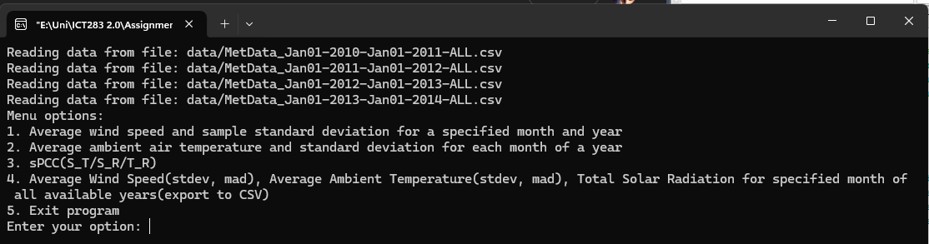
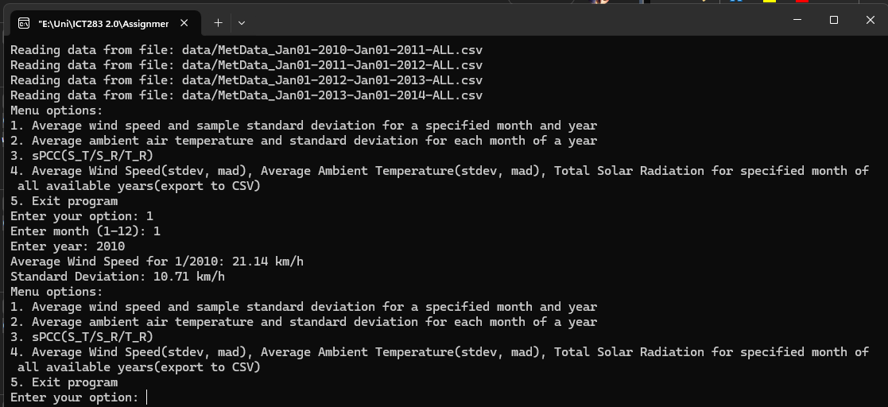
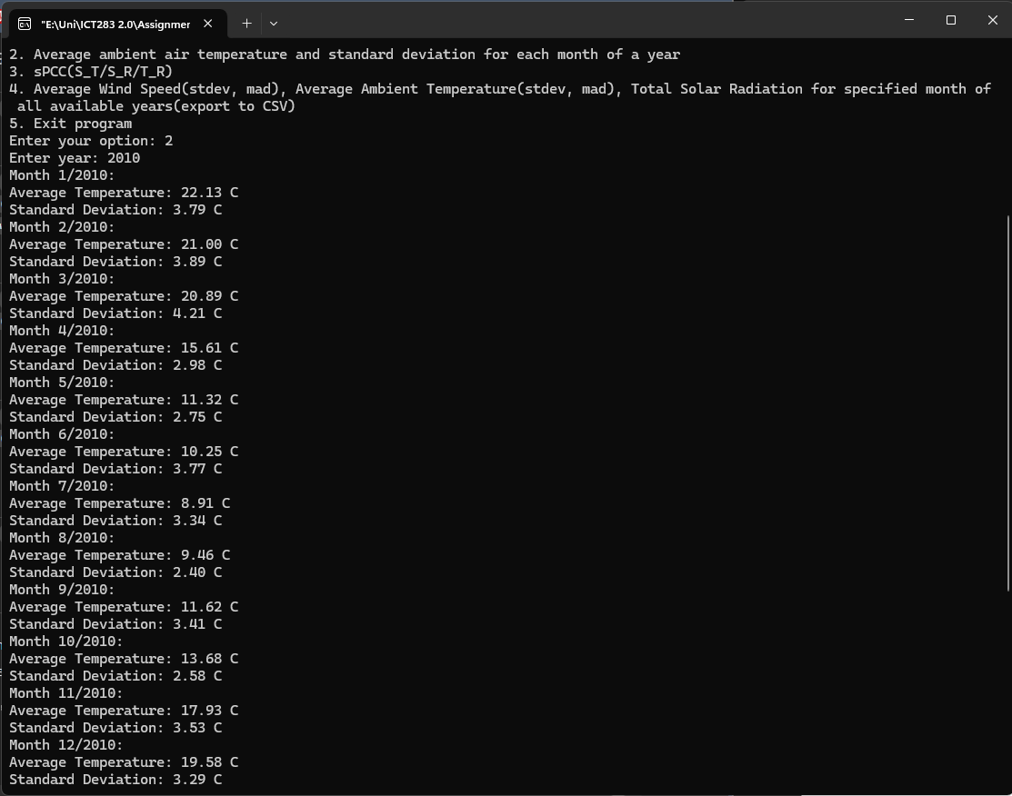
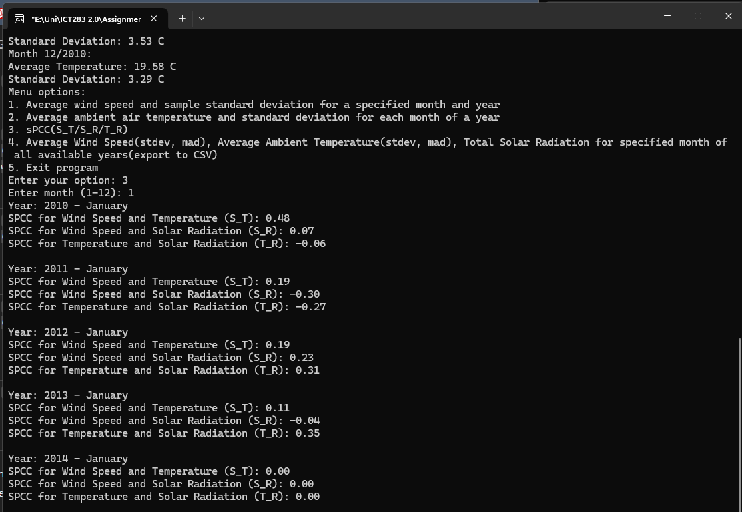
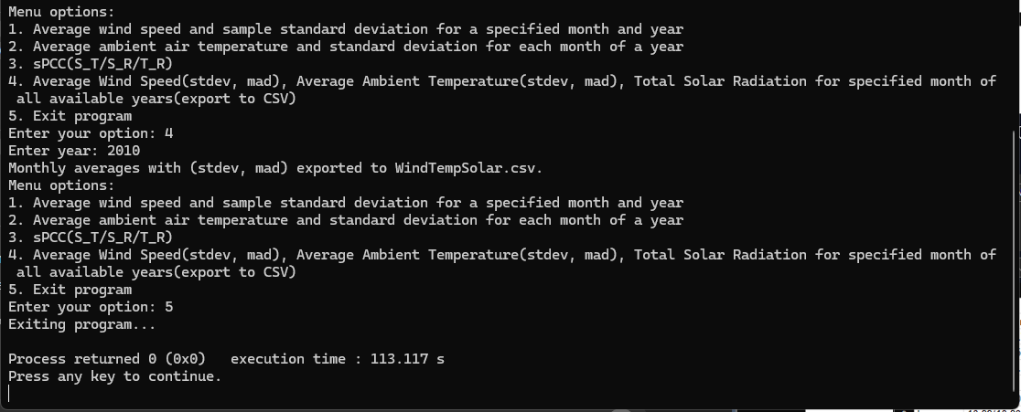
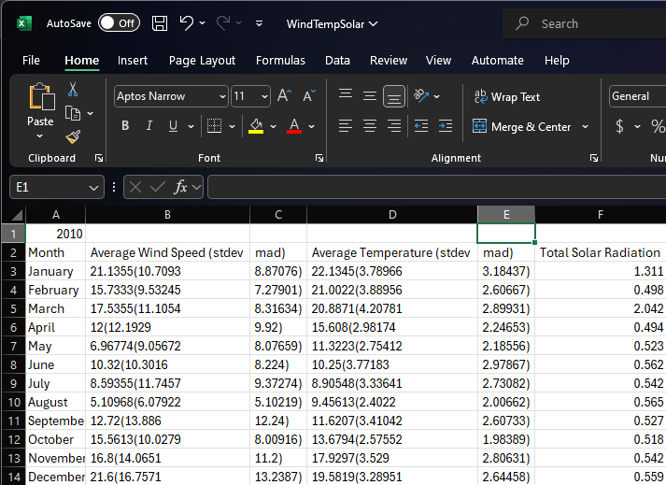
Method for versioning: Local Drive Computer.
