0430硬件备份综合说明：

管脚定义：

NexysA7版

|  |  |
| --- | --- |
| RESETn | PMOD: JD[ 7 ] |
| VGA_RST | BTNR |
| SYS_RSTn | CPU_RESETn |
| TDI | PMOD: JD[ 1 ] |
| TCK | PMOD: JD[ 2 ] |
| TMS | PMOD: JD[ 3 ] |
| TDO | PMOD: JD[ 4 ] |
| UART0: RXD / TXD | PMOD: JC[ 1 ] / JC[ 2 ] |
| UART1: RXD / TXD | PMOD: JC[ 3 ] / JC[ 4 ] |
| CAM: SCL / SDA / XCLK | PMOD: JA[ 1 ] / JA[ 2 ] / JC[ 3 ] |
| DCMI: PCLK / HREF / VSYNC | PMOD: JA[ 4 ] / JA[ 9 ] / JA[ 10 ] |
| DCMI: DATA[7:0] | PMOD: JB [10:7]-JB[4:1] |
| GPIO[1:0] | PMOD: JA[ 7 ] / JA[ 8 ] |
| GPIO[7:2] | SWITCH[5:0] |
| GPIO[15:8] | LED[7:0] |
| VGA_RST | BTNR |
| RESETn | PMOD: JD[ 7 ] |
| TDI | PMOD: JD[ 1 ] |
| TCK | PMOD: JD[ 2 ] |
| TMS | PMOD: JD[ 3 ] |
| TDO | PMOD: JD[ 4 ] |
| UART0: RXD / TXD | PMOD: JC[ 1 ] / JC[ 2 ] |
| UART1: RXD / TXD | PMOD: JC[ 3 ] / JC[ 4 ] |
| CAM: SCL / SDA / XCLK | PMOD: JA[ 1 ] / JA[ 2 ] / JC[ 3 ] |
| GPIO[1:0] | PMOD: JA[ 7 ] / JA[ 8 ] |
| GPIO[7:2] | SWITCH[5:0] |
| GPIO[15:8] | LED[7:0] |
| SD_nCS | PMOD: JC[7] |
| SD_MOSI | PMOD: JC[8] |
| SD_DCLK | PMOD: JC[9] |
| SD_MISO | PMOD: JC[10] |

总线矩阵：

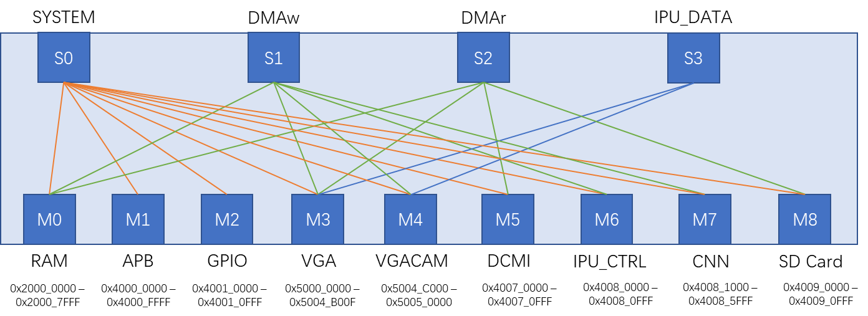

APB总线

|  |  |  |
| --- | --- | --- |
| MEM | 0x0000 – 0x0FFF | 4kB |
| TIMER1 | 0x1000 – 0x1FFF | 4kB |
| UART0 | 0x4000 – 0x4FFF | 4kB |
| UART1 | 0x5000 – 0x5FFF | 4kB |
| CAM | 0x8000 – 0x8FFF | 4kB |
| DMA | 0xD000 – 0xDFFF | 4kB |

中断信号：

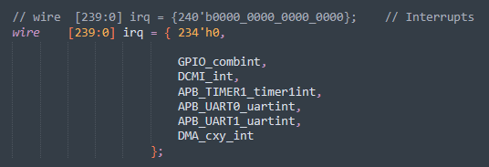

资源占用：

