The Brain That Remains:
A Framework for Neuroplasticity, Residual Capacity, and Open-Source Protocol Design in Complex Neurodegenerative Disease
Logan Henderson
Independent Researcher, Houston, Texas, United States
Correspondence: Logan Henderson
Version: v1.1.0 Figure-Enhanced Edition | Zenodo DOI: https://doi.org/10.5281/zenodo.20832833 | Changelog: embeds seven explanatory figures and captions; no clinical outcomes or efficacy claims added.

Abstract
Complex neurodegenerative and vascular phenotypes are rarely explained by a single failing pathway. Progressive supranuclear palsy, vascular cognitive impairment, Parkinsonian syndromes, traumatic brain injury burden, post-stroke decline, sleep disruption, inflammation, respiratory limitation, and social instability can interact as coupled biological systems. Existing evidence supports multidomain lifestyle intervention in cognitive-risk populations, emerging neuroplasticity mechanisms in psychedelic science, and early neurotrophic signals from selected functional mushrooms and related nutraceuticals. These evidence streams remain operationally fragmented. This paper proposes the Regenerative Loop + APPRE + RAY-VASC architecture as a testable open-source framework for studying residual adaptive capacity in complex neurodegenerative and vascular phenotypes. The framework integrates four daily biological loops - exertion, circadian timing, sleep/repair, and social safety - with a three-phase plasticity architecture: Pre-Load, Governed Plasticity Window, and Sustain/Integration. APPRE, the Algorithmic Personalization Predictive Response Engine, is defined here as a schema-and-rules framework for closed-loop measurement rather than a validated clinical decision system or AI product; it maps subject profile to inputs, outcomes, and updated response policy. RAY-VASC supplies the originating measurement spine but does not report clinical outcomes in this manuscript. The contribution is architectural: a reproducible, de-identified, open-source measurement system for staged testing from N-of-1 feasibility to case series, observational cohorts, pilot trials, and randomized trials. The framework is speculative and hypothesis-generating. It is designed to test coordinated measurement and adaptive personalization, not to claim treatment efficacy or disease reversal.
Keywords: neuroplasticity; residual capacity; vascular cognitive impairment; progressive supranuclear palsy; APPRE; RAY-VASC; functional mycology; psilocybin; N-of-1; open-source protocol design

1. Introduction
Complex neurodegenerative disease has not yielded to single-factor models. Dementia prevention, vascular cognitive impairment, Parkinsonian syndromes, post-stroke decline, traumatic brain injury, sleep disorders, depression, respiratory limitation, metabolic risk, and inflammatory burden rarely occur in isolation. They accumulate, interact, and constrain one another. The practical failure is not only a lack of disease-modifying therapy; it is also a lack of reproducible architecture for measuring how multiple modifiable biological loops interact over time.
The dominant clinical workflow often separates domains that the patient experiences as one system. A person with vascular injury, Parkinsonian features, impaired sleep, reduced mobility, mood disturbance, caregiver burden, and respiratory limitation does not live inside separate diagnostic compartments. Cognition changes with sleep. Gait changes with fatigue and breathing. Mood changes with isolation. Adherence changes with family structure. Biomarkers change with infection, medication changes, and metabolic instability. A framework that ignores these interactions risks misattributing signal, missing confounders, and overclaiming transient fluctuation.
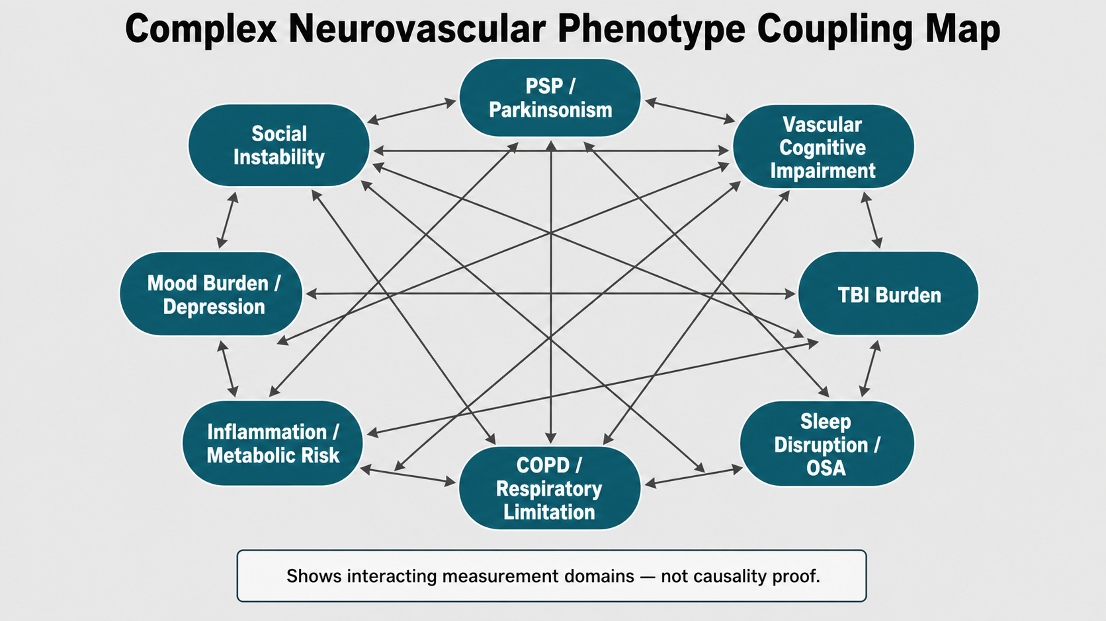
Figure 2. Complex neurovascular phenotype coupling map. Network/coupling map depicting interacting measurement domains in complex neurovascular and neurodegenerative phenotypes, including PSP/Parkinsonism, vascular cognitive impairment, TBI burden, sleep disruption/OSA, COPD/respiratory limitation, inflammation/metabolic risk, mood burden/depression, and social instability. The map shows measurement-domain coupling, not causality proof.
Multidomain intervention research already supports the premise that cognition is shaped by bundled lifestyle and vascular-risk modification rather than isolated inputs alone. The Finnish Geriatric Intervention Study to Prevent Cognitive Impairment and Disability (FINGER) demonstrated that a two-year multidomain intervention combining diet, exercise, cognitive training, and vascular-risk monitoring improved or maintained cognition in at-risk older adults (Ngandu et al., 2015). Eleven-year follow-up reporting indicates that long-term adherence to lifestyle changes and intervention engagement were associated with more favorable cognitive trajectories, although the 2025 source is conference-supplement reporting rather than the original trial publication (Ngandu et al., 2025). The U.S. POINTER randomized clinical trial extended the multidomain logic in a U.S. cohort by comparing structured and self-guided lifestyle interventions around physical activity, diet, cognitive engagement, social interaction, and cardiovascular risk monitoring (Baker et al., 2025).
These trials do not prove the framework proposed here. They establish the precedent that complex brain aging is best studied through coordinated, measurable, multidomain systems. The next problem is not whether lifestyle matters; the next problem is how to measure individualized response, confounder stability, adaptive timing, and durable change in complex phenotypes where single-arm narratives can easily become unreliable.
The missing layer is adaptive architecture. Rather than asking whether one intervention works for every subject, the RAY-VASC framework asks whether coordinated daily biological loops, a candidate neurotrophic Pre-Load phase, a lawful clinician-governed Plasticity Window, and structured longitudinal measurement can detect individual residual capacity. The core claim is deliberately narrow: The Regenerative Loop + APPRE + RAY-VASC architecture is designed to test whether coordinated daily biological loops and structured adaptive measurement can identify and amplify residual adaptive capacity in complex neurodegenerative and vascular phenotypes. It is not a treatment claim. It is a testable framework.
This paper is a Hypothesis and Theory framework manuscript. It reports no new clinical outcomes, claims no vascular-lesion repair or neurodegeneration reversal, and provides no controlled-substance sourcing, preparation, dosing, administration, or self-use instructions. Its purpose is to establish a disciplined measurement architecture that qualified teams can test under appropriate clinical, ethics, and regulatory governance.

2. The Residual Capacity Hypothesis
The residual capacity hypothesis proposes that some measurable functional capacity may remain inaccessible under ordinary physiological, network, behavioral, or environmental conditions, even when structural disease is substantial. Structural loss refers to tissue injury, atrophy, infarction, synaptic loss, tauopathy, vascular injury, or neurodegenerative pathology. Functional accessibility refers to whether remaining networks can coordinate, route information, sustain attention, execute motor plans, regulate mood, and support adaptive behavior.
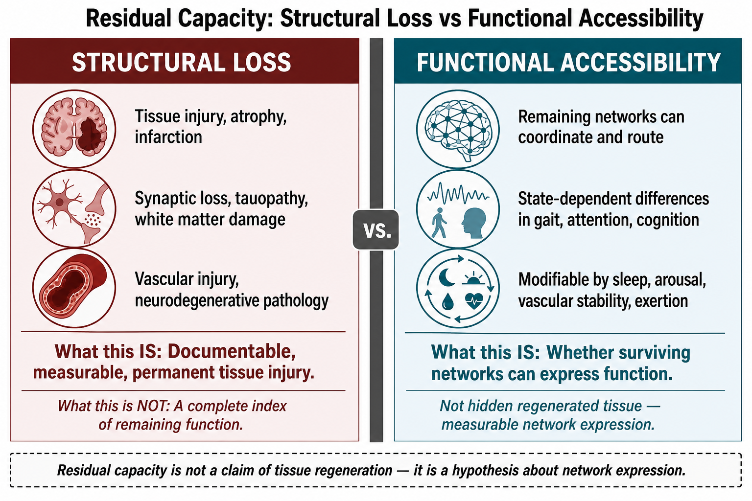
Figure 7. Residual capacity: structural loss versus functional accessibility. Two-column conceptual contrast separating documentable structural loss - tissue injury, synaptic loss, tauopathy, white matter damage, vascular injury, or neurodegenerative pathology - from functional accessibility, defined as whether surviving networks can coordinate, route, and express function under state-dependent conditions. Residual capacity is not a claim of tissue regeneration; it is a hypothesis about measurable network expression.
This distinction is not a claim that destroyed tissue remains hidden and recoverable. It is a claim about network expressions. A brain with substantial injury may still exhibit state-dependent differences in function: better gait on days with better sleep, better attention after controlled exertion, worse processing speed during infection, more falls during medication transitions, or altered EEG connectivity after changes in arousal and stress load. These are not proof of disease reversal. They are measurable expressions of residual system capacity.
The thalamus illustrates the concept. Thalamic pathology is increasingly recognized as relevant to cognition and dementia, and thalamocortical circuits support more than sensory relay; they participate in attention, cortical coordination, and cognitive control (Biesbroek et al., 2024; Halassa & Sherman, 2019). In vascular and mixed neurodegenerative phenotypes, thalamic, frontal, cerebellar, basal ganglia, and white matter systems may interact such that a strategic lesion can impair distributed routing beyond the local volume of tissue damage. Under this model, improving sleep, arousal, vascular stability, stress state, and motor engagement could affect the accessibility of remaining circuits without implying regeneration of lost tissue.
Psychedelic neuroimaging and network studies add a second line of plausibility: brain network states can be acutely altered. Psilocybin has been associated with changes in large-scale functional integration, default-mode network dynamics, signal diversity, and topological properties of functional networks (Carhart-Harris et al., 2012; Petri et al., 2014). These findings support the general proposition that network state is modifiable. They do not establish recovery in PSP, vascular dementia, stroke injury, or TBI.
RAY-VASC therefore separates three questions that are often collapsed in early-stage neuroplasticity claims. First, what tissue or network substrate remains? Second, under what physiological and behavioral conditions can that substrate express function? Third, can structured daily loops and adaptive measurement identify reproducible windows of improved function? Only the third question is addressed by this framework manuscript.

3. The Regenerative Loop
The Regenerative Loop is the daily enabling environment for residual-capacity testing. It contains four pillars: exertion, circadian timing, sleep/repair, and social safety. Each pillar has independent evidence and a plausible mechanism. The framework contribution is not that any pillar is new; it is that each pillar is treated as a measurable loop in a longitudinal adaptive system.
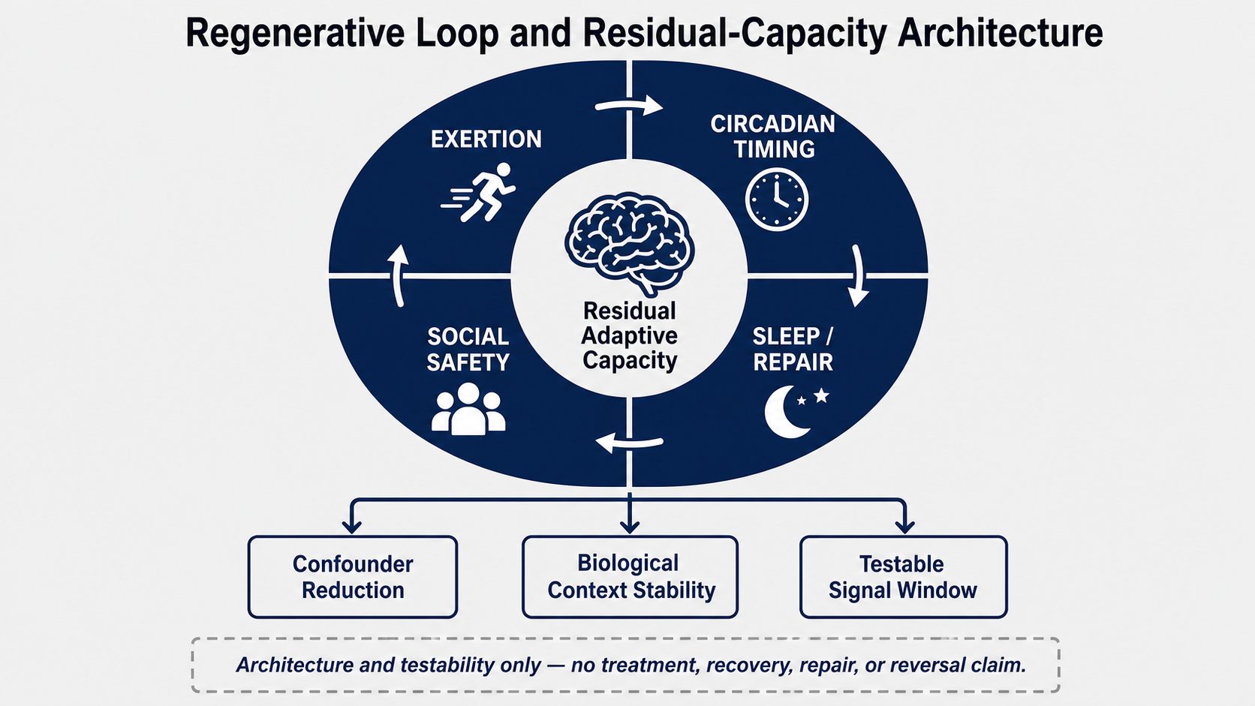
Figure 1. Regenerative Loop and residual-capacity architecture. Conceptual systems diagram showing four daily biological loops - exertion, circadian timing, sleep/repair, and social safety - feeding a residual adaptive capacity construct and outputting to confounder reduction, biological context stability, and a testable signal window. The figure represents architecture and testability only; it makes no treatment, recovery, repair, or reversal claim.
Exertion is the strongest pillar. Physical activity and structured training can support vascular health, metabolic control, mood, sleep regulation, and BDNF-related neuroplasticity. Exercise interventions have been associated with increased BDNF in neurodegenerative populations, though effect size and clinical translation depend on population, modality, dose, adherence, and baseline impairment (Zhou et al., 2022). In the Regenerative Loop, exertion is not a generic wellness recommendation. It is an input variable: duration, intensity, functional tolerance, breathlessness, post-exertional fatigue, steps, falls, gait speed, and recovery time.
The framework rejects one-size-fits-all exercise prescriptions in complex phenotypes. For one subject, the useful signal may be two minutes of safe assisted walking. For another, it may be resistance training, stationary cycling, balance therapy, or cognitive-motor dual-task practice. The hypothesis is not that exertion is universally safe or uniformly beneficial. The hypothesis is that carefully measured exertion supplies an adaptive demand signal that may reveal or improve functional accessibility when safely dosed and tracked.
Circadian timing is the temporal gate. Light exposure, sleep-wake regularity, meal timing, activity timing, and daily routine shape the biological context in which attention, repair, mood, and adherence occur. Circadian disruption can distort every downstream measure. A subject tested after fragmented sleep, irregular light exposure, late-night stimulation, or inconsistent waking time may appear cognitively worse for reasons that are not disease progression. Therefore, circadian inputs are treated as measurement prerequisites and confounder controls.
Sleep/repair is the maintenance phase. Sleep quality, sleep duration, sleep efficiency, obstructive sleep apnea treatment adherence when relevant, and periodic limb movement burden can directly affect cognition, mood, daytime movement, and biomarker interpretation. Human glymphatic research now supports a pathway by which amyloid beta and tau can clear from the brain to plasma, strengthening the biological rationale for sleep as a measurement and intervention priority (Winer et al., 2026). In RAY-VASC, sleep is not merely an outcome; it is also a confounder and gatekeeper for interpretation.
Social safety is the adherence and stress-buffering pillar. Social connection, emotional safety, caregiver support, meaningful interaction, low-threat routines, and stable daily assistance may reduce chronic stress load and protect adherence. Social isolation is treated as a modifiable dementia risk factor in major prevention frameworks, and systematic review evidence has linked social relationship factors with dementia risk (Kuiper et al., 2015; Livingston et al., 2024). In this framework, social safety is measured because unsupported protocols fail operationally even when the biological theory is plausible.
The loop model matters because each pillar can amplify or constrain the others. Poor sleep reduces exertion tolerance. Respiratory limitation reduces activity. Isolation reduces adherence. Circadian disruption worsens sleep and mood. The Regenerative Loop is therefore not a list of lifestyle tips. It is a control system for reducing noise, improving feasibility, and creating a stable biological context in which mechanistic hypotheses can be tested.

4. Multidomain Precedent and the Design Gap
The strongest foundation for this framework comes from the multidomain prevention literature. The FINGER study demonstrated that diet, exercise, cognitive training, and monitoring of vascular risks can be integrated into a structured program with specific cognitive outcomes (Ngandu et al., 2015). The U.S. POINTER study expanded on this concept in a larger trial in the United States, showing that a structured multidomain lifestyle intervention can be compared to a self-guided version, using global cognitive function as the main outcome measure (Baker et al., 2025). These studies signal a shift in the field away from single-factor prevention approaches.
However, multidomain intervention success creates a new design gap. Once multiple inputs are bundled, attribution becomes more difficult. Which components matter? Which subjects respond? Which confounders dominate? Which signals are transient, durable, or measurement artifacts? A conventional group-level trial can estimate average effect, but it can miss individualized trajectories, threshold effects, adherence patterns, and interaction effects across sleep, exertion, mood, vascular risk, and social structure.
RAY-VASC addresses this gap by treating multidomain intervention as a staged, measurable system rather than a fixed lifestyle package. It begins with feasibility and baseline stabilization. It records confounders before interpreting change. It separates lawful, clinician-governed Plasticity Window exposures from legal daily inputs. It uses modular measurement so that a home-based N-of-1 study, a case series, and a multi-site pilot can share the same data logic even when resources differ.
The design gap is also translational. Psychedelic science has produced mechanistic and psychiatric evidence, but most studies are not designed for complex mixed neurodegenerative and vascular phenotypes. Mycology and nutraceutical research contain candidate mechanisms but limited standardization and uneven human evidence. Lifestyle intervention research is stronger but often not individualized at high temporal resolution. APPRE is proposed as the adaptive layer that connects these streams without overclaiming any one of them.
The contribution of this paper is therefore an operational synthesis: a framework that can absorb strong evidence where it exists, flag weak evidence where it remains early, and convert both into testable protocol layers.

5. Framework Claim Boundary
This manuscript uses a strict claim boundary. The framework is designed to test residual adaptive capacity, not to prove that any intervention treats PSP, vascular dementia, Alzheimer's disease, stroke injury, traumatic brain injury, COPD, depression, or any other condition. It is not clinical guidelines. It is not a supplement protocol. It is not a psychedelic protocol. It is a measurement architecture.
Publishable claims are limited to architecture, plausibility, and testability. Examples include: the framework organizes staged measurement; the Pre-Load phase can be tested without entering Phase 2; APPRE can structure repeated measurement and response-policy updates; and candidate mycology inputs may be studied as a neurotrophic substrate under standardized, safety-gated conditions. These statements are testable and bounded.
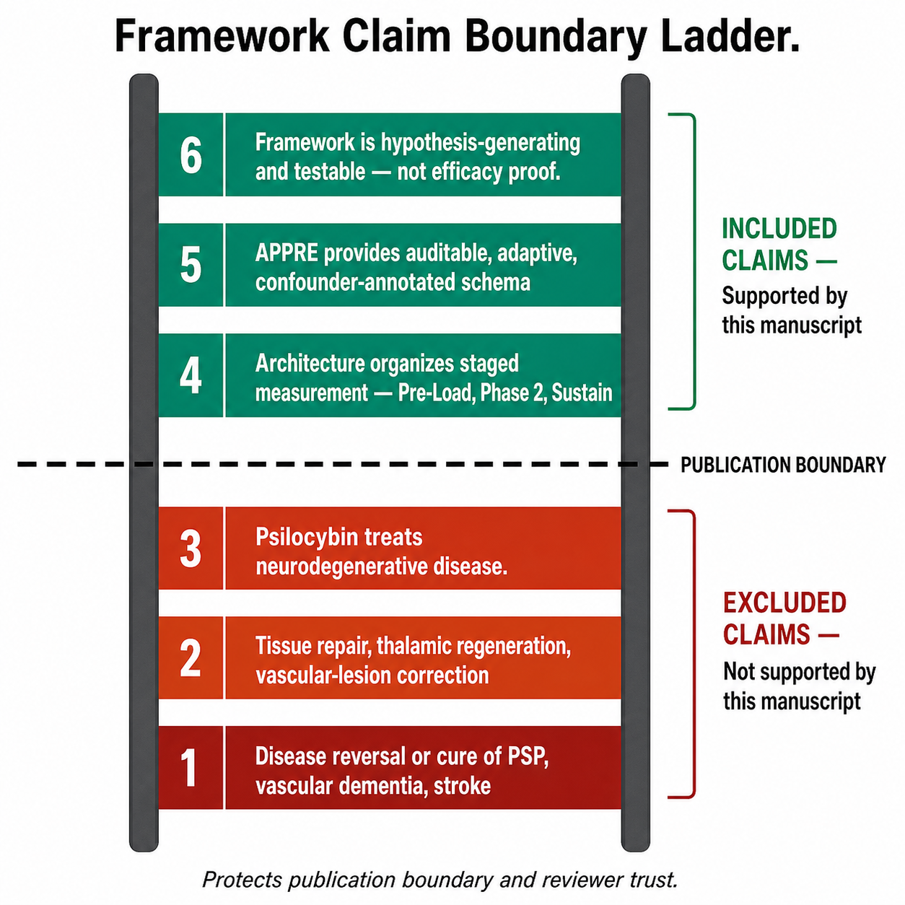
Figure 5. Framework claim boundary ladder. Stacked claim-boundary figure separating included framework claims from excluded clinical claims. Included claims are architecture for staged measurement, auditable APPRE schema logic, and hypothesis-generating testability. Excluded claims include disease reversal, cure, tissue repair, thalamic regeneration, vascular-lesion correction, or psilocybin treatment efficacy for neurodegenerative disease.

5.1 Publishable Claims Included in This Manuscript
- The framework organizes staged measurement around Pre-Load, Governed Plasticity Window, and Sustain/Integration phases.
- The Pre-Load phase can be tested independently without controlled substance exposure.
- APPRE provides an auditable structure for repeated measurement, confounder annotation, and response-policy updates.
- Candidate legal mycology and nutraceutical inputs may be studied as standardized, safety-gated neurotrophic-support variables.
- Published supervised psilocybin studies can be cited for scientific transparency when clearly separated from self-use guidance and restricted to clinician-governed research contexts.

5.2 Non-Publishable Claims Excluded from This Manuscript
Non-publishable claims are excluded. The manuscript does not claim to repair brain damage, reverse dementia, cure PSP, restore infarcted tissue, regenerate thalamic circuits, or guarantee cognitive recovery. It does not claim that psilocybin treats neurodegenerative disease. It does not claim that functional mushrooms are disease-modifying therapies. Any such claims would require controlled human trials and regulatory review.

5.3 Controlled-Substance Content Restriction
Controlled-substance use is limited to high-level research design, safety monitoring, and documentation of exposure under lawful clinician oversight. There are no instructions for sourcing, preparation, dosing, administration, or self-use. APPRE is explicitly prohibited from adjusting controlled-substance dosing outside formal governance.

6. The Three-Phase Plasticity Architecture
The three-phase plasticity architecture is the core operational contribution of this paper. It organizes the framework as a temporal sequence with distinct measurement objectives and safety gates at each stage: Phase 1 Pre-Load, Phase 2 Governed Plasticity Window, and Phase 3 Sustain/Integration.
This architecture allows staged hypothesis testing. Phase 1 feasibility can be tested without ever entering Phase 2. If Phase 2 is legally and clinically accessible, its effects can be measured against the Pre-Load baseline. Phase 3 tests whether observed changes persist beyond the intervention window. This staged approach prevents the framework from depending on any controlled-substance layer and preserves scientific value even when Phase 2 is unavailable.
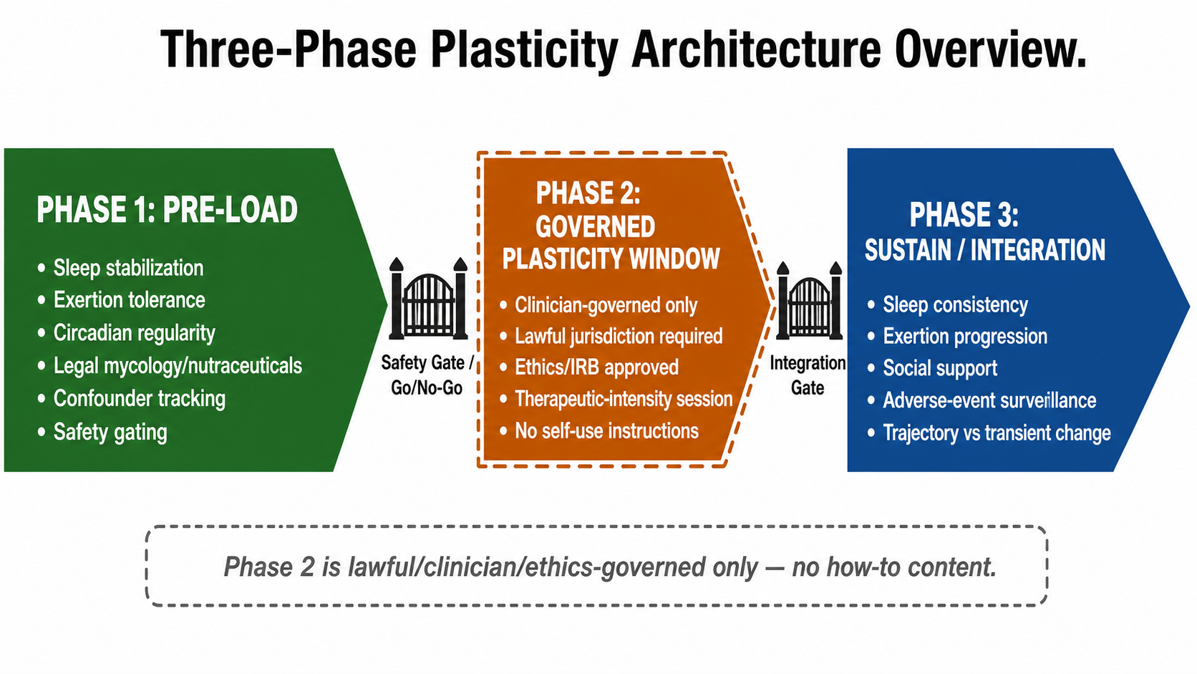
Figure 3. Three-phase plasticity architecture overview. Horizontal phase timeline showing Phase 1 Pre-Load, optional Phase 2 Governed Plasticity Window, and Phase 3 Sustain/Integration with safety and integration gates. Phase 2 is represented only as a lawful, clinician-governed, ethics/IRB-approved research window and provides no self-use or how-to content.

6.1 Phase 1: Pre-Load
Pre-Load is the preparation and stabilization phase. Its purpose is to establish whether the subject is stable enough to interpret the signal. It includes sleep stabilization, exertion tolerance assessment, circadian regularity, social safety, vascular monitoring, respiratory monitoring, medication stability, adverse-event tracking, and standardized legal candidate inputs such as functional mycology or neuroprotective nutraceuticals, where clinically appropriate. The Pre-Load phase does not attempt to prove treatment efficacy. It asks whether the measurement system works, whether inputs can be standardized, whether confounders can be identified, and whether any signal is visible beyond baseline variance.
Pre-Load also serves as a safety gate. Acute infection, recent falls, medication changes, unstable sleep, respiratory instability, severe stress events, or inconsistent adherence can invalidate interpretation. Rather than hiding these realities, the framework captures them. A failed Pre-Load phase is not a failed study; it is evidence that the subject or setting is not yet ready for mechanistic interpretation.

6.2 Phase 2: Governed Plasticity Window
The Governed Plasticity Window is optional. It may include psychedelic or controlled-substance variables only where legal, medically supervised, and governed by institutional, jurisdictional, and ethical requirements. In this framework, Phase 2 refers to clinician-administered therapeutic-intensity psilocybin exposure designed to test acute and subacute changes in network organization, mood, cognition, motor function, biomarkers, and safety. Phase 2 is not microdosing and is not self-administered or APPRE-tuned exposure.
The purpose of Phase 2 is not to prescribe exposure. It is to define what must be measured if exposure occurs under lawful governance: safety, tolerability, acute adverse events, subacute outcome change, biomarker timing, EEG timing, psychometric timing, and confounder stability. Published clinical protocols and safety reviews are cited only to establish that psilocybin has been evaluated under controlled therapeutic conditions; they are not included here as public dosing instructions (Davis et al., 2021; Garcia-Romeu et al., 2021; Goodwin et al., 2022; MacCallum et al., 2022).

6.3 Phase 3: Sustain/Integration
Sustain/Integration is the durability phase. It tests whether observed changes persist, decay, or depend on continued support. This phase emphasizes sleep consistency, exertion progression, social support, adverse-event surveillance, confounder review, and repeated measurement. Acute change is less important than trajectory. A framework that cannot distinguish transient state change from durable functional change is not clinically or scientifically useful.
Phase 3 is also where regression is measured rather than ignored. If cognition improves for two weeks and returns to baseline, that is a finding. If motor function improves only when sleep improves, that is a finding. If mood improves but biomarkers do not move, that is a finding. The architecture is designed so that negative, mixed, or partial results refine the model rather than collapse the project.

7. The Mycology + Psilocybin Synergy Hypothesis
The mycology convergence layer is the most novel and least proven human component of the framework. It must therefore be stated carefully. RAY-VASC proposes that selected legal functional mushrooms and neuroprotective compounds may serve as a candidate neurotrophic substrate for the Pre-Load and Sustain phases. This is not a treatment stack. It is not a clinical recommendation. It is a structured hypothesis space for future testing.
The convergence hypothesis is that multiple legal candidate inputs may support a measurable biological context for adaptive change by converging on neurotrophic, cholinergic, antioxidant, mitochondrial, membrane-support, and anti-inflammatory pathways. The mechanistic target is not one compound. It is the measured system state before, during, and after an intervention window.
Lion's Mane (Hericium erinaceus) is included as a candidate neurotrophic input because hericenones and erinacines have been studied for NGF-related activity, and Mori et al. reported cognitive-score improvement in a small MCI trial, with loss of benefit after discontinuation (Mori et al., 2009). Modern human evidence remains limited and mixed, including healthy-adult studies with narrower or domain-specific findings (Surendran et al., 2025). Therefore, Lion's Mane is framed as Evidence Grade C for human MCI outcomes and B for preclinical plausibility, not as a proven dementia treatment.
Bacopa monnieri is included as a candidate cognitive and cholinergic-support input because meta-analytic evidence suggests possible benefits for attention or memory domains, while disease-specific evidence in PSP, vascular dementia, and post-stroke cognitive impairment remains limited (Kongkeaw et al., 2014). NAC is included as an antioxidant and glutathione-support candidate because oxidative stress, inflammation, mitochondrial dysfunction, and tau-related pathways are relevant to neurodegeneration; however, clinical disease-modification evidence remains unproven (Hara et al., 2017; Lomeli Martinez et al., 2025).
Cordyceps and Reishi are retained only as lower-evidence mechanistic candidates. Cordyceps are framed around mitochondrial and energetic context. Reishi is framed around an immune-modulatory and inflammation-adjacent context. Neither should be described as proven to alter neurodegenerative disease trajectories. In any future implementation, batch documentation, standardized form, adverse-event tracking, medication interaction review, and adherence capture are required before outcome interpretation.
In this framework, psilocybin belongs only in Phase 2 and only under lawful clinician- or IRB-governed conditions. Preclinical studies indicate that psychedelics can promote structural plasticity, and experimental research has shown that psilocin and other psychedelics can directly bind to TrkB in controlled settings (Ly et al., 2018; Moliner et al., 2023; Shao et al., 2021). Review literature in Alzheimer's disease supports continued investigation into neuroplasticity, neuroinflammation, and network-level mechanisms, but clinical evidence in Alzheimer's disease remains preliminary (Zheng et al., 2024).
Human evidence is strongest in psychiatric indications such as treatment-resistant depression, with neurological evidence still early and primarily open-label, observational, narrative-review, or preclinical. Bradley et al. reported feasibility and tolerability in a small open-label Parkinson's disease pilot. Blest-Hopley et al. reported observational mental-health and EEG changes in veterans with TBI histories after retreat participation. Palmer et al. reviewed potential mechanisms in TBI, and Brengel et al. reported preclinical repetitive mild head-injury findings in a bioRxiv preprint (Blest-Hopley et al., 2025; Bradley et al., 2025; Brengel et al., 2025; Palmer et al., 2025). These findings are hypothesis-generating, not causal proof for complex neurodegenerative disease.
The synergy hypothesis is as follows: if Phase 1 can measurably improve a subject's neurotrophic, inflammatory, sleep, respiratory, and behavioral readiness state, then a lawful clinician-governed Phase 2 exposure may produce a more detectable and durable downstream signal than either layer alone. This has not been clinically validated. It is the central hypothesis to be tested. Phase 3 then asks whether any observed signal persists under continued Regenerative Loop support.
The most important discipline is claiming separation. Mycology can be APPRE-tunable only when legal, non-controlled, clinically appropriate, and safety-gated. Controlled substances are never APPRE-tuned outside formal governance; they are recorded as clinician-governed or as-administered exposure variables only.
Table 1. Candidate Mycology and Governed Plasticity Convergence Map
Candidate input | Proposed biological rationale | Convergence target | Evidence grade and claim boundary
Lion's Mane (Hericium erinaceus) | Hericenones/erinacines; NGF-like neurotrophic activity; limited human MCI signal; stronger preclinical rationale. | NGF/BDNF context, neurite outgrowth, synaptic support. | C human MCI; B preclinical. Candidate substrate only.
Bacopa monnieri | Cholinergic support, possible AChE inhibition, memory/attention meta-analytic signal. | Cholinergic tone + BDNF-adjacent cognition pathway. | B/C. Not proven for PSP, vascular dementia, or stroke recovery.
N-acetylcysteine (NAC) | Glutathione support; oxidative-stress and inflammatory-pathway rationale; AD-focused review literature. | Oxidative stress, neuroinflammation, mitochondrial context, tau-phosphorylation hypothesis. | B/C for adjacent AD review evidence. Safety and interaction review required.
Cordyceps spp. | Mitochondrial/energetic and adenosine-linked preclinical mechanisms. | Energetic substrate for repair and exertion tolerance. | C/D. Limited disease-specific human evidence.
Reishi (Ganoderma lucidum) | Triterpenes and polysaccharides; immune modulation and anti-inflammatory preclinical rationale. | Permissive inflammatory environment for adaptation. | C/D. Not proven neurodegenerative therapy.
Psilocybin (Phase 2 only) | 5-HT2A signaling plus direct TrkB binding in preclinical systems; human psychiatric evidence; early neurological pilots. | BDNF/TrkB, mTOR, PSD-95, dendritic spines, network dynamics. | B for TRD psychiatric evidence; C/D for neurological/TBI translation. Clinician-governed only.
Table 2. Expanded Modular Measurement Architecture
Measurement Tier | Domain | Instrument/Tool | Tier 1 (N-of-1 Feasibility) | Tier 2 (Cohort/Standardization) | Tier 3 (Pilot RCT Readiness)
Cognition | Global cognition | MoCA | Daily/weekly self-report + baseline/endpoint MoCA | Blinded rater MoCA | Full neuropsych battery
 | Executive function | Stroop, Trails B | Optional | Baseline + quarterly | Baseline + monthly + endpoint
 | Processing speed | Digit Symbol Substitution | Optional | Baseline + quarterly | Baseline + endpoint
Motor | Gait/balance | Timed Up-and-Go, steps/day | Daily steps + weekly TUG | Wearable actigraphy + monthly TUG | Wearable + video-recorded TUG
 | Parkinsonian signs | MDS-UPDRS Part III | Baseline + endpoint | Baseline + monthly | Baseline + biweekly + endpoint
Mood | Depression | PHQ-9 | Weekly | Weekly | Weekly + blinded clinician rating
 | Anxiety | GAD-7 | Weekly | Weekly | Weekly + blinded clinician rating
Sleep | Efficiency | Sleep diary | Daily | Daily + actigraphy | Daily + actigraphy + PSG if indicated
 | OSA/PLMD | CPAP adherence, PLMD severity | Self-report + device download | Device download monthly | Device download + repeat PSG if clinically indicated
Respiratory | Breathlessness | mMRC Dyspnea Scale | Weekly | Weekly + spirometry baseline | Weekly + spirometry quarterly
 | Exertion tolerance | 6-minute walk test | Optional baseline | Baseline + quarterly | Baseline + monthly + endpoint
Vascular/Metabolic | Blood pressure | Home BP monitoring | Daily | Daily + quarterly clinic BP | Daily + quarterly clinic BP
 | Glycemic control | A1c | Baseline + endpoint | Baseline + quarterly | Baseline + quarterly
Biomarkers | Neurotropic | BDNF serum | Optional | Baseline + endpoint | Baseline + post-Phase 2 + endpoint
 | Inflammatory | hs-CRP | Optional | Baseline + endpoint | Baseline + quarterly
 | Neurodegenerative | p-tau217, NfL | Optional | Baseline + endpoint | Baseline + post-Phase 2 + endpoint
EEG | Network dynamics | Resting-state EEG, alpha/beta coherence, P300 | Optional | Baseline + endpoint | Baseline + post-Phase 2 + endpoint
Adverse Events | Safety | AE log, falls, infections, med changes | Daily | Daily + centralized review | Daily + independent safety monitor
Adherence | Protocol fidelity | Input log, dose timing, confounder annotation | Daily | Daily + adherence algorithm | Daily + blinded adherence audit

The RAY-VASC protocol employs a modular intervention stack organized by evidence strength, governance requirements, and temporal phase. Phase 1 (Pre-Load) and Phase 3 (Sustain/Integration) inputs are legal, non-controlled, and APPRE-tunable within safety constraints. Phase 2 (Governed Plasticity Window) is defined by a clinician-administered therapeutic-intensity psilocybin session under lawful governance or ethics-approved research settings and is never algorithmically tuned. Optional low-level psilocybin exposure, where lawful and clinician-governed, may be recorded in Phase 1 or Phase 3 as an as-administered observational variable, but it does not constitute the Plasticity Window itself. Table 3 specifies candidate non-controlled input ranges derived from published clinical trials, safety reviews, and preclinical mechanistic studies, with explicit rationale for each candidate. Controlled-substance exposure fields are documented only as clinician- or program-administered, as-administered data. Actual implementation requires medication interaction review, adverse-event monitoring, adherence tracking, and confounder annotation as specified in Section 10 (Measurement Architecture).
Published supervised psilocybin studies are cited only to define Phase 2 as a therapeutic-intensity, clinician-governed research category. The public RAY-VASC framework does not provide subject-level dose selection, dried-mushroom conversion, sourcing, preparation, administration, or self-use guidance. Any controlled-substance exposure, if present, must be lawful, ethics-governed, clinician-administered, and recorded only as as-administered observational data.
Table 3. RAY-VASC Candidate Intervention Stack - Public Protocol Boundaries, Evidence Grades, and Governance
Category | Ingredient | Public Protocol Boundary / As-Administered Documentation | Evidence Grade | Rationale / Claim Boundary | Governance Layer
Core Mycology (Phase 1 & 3) | Lion's Mane | 500-1000 mg/day | C (human MCI); B (preclinical) | Candidate neurotrophic substrate supporting NGF/BDNF-related neurite growth, axon/dendrite remodeling, and myelination hypotheses. Dose range mapped from small human MCI trials and preclinical safety/plausibility literature. Not a proven dementia, PSP, stroke, or TBI treatment. | Legal, non-controlled input. APPRE-tunable only within safety gates; requires batch documentation, medication review, adherence capture, and adverse-event monitoring.
Core Mycology (Phase 1 & 3) | Cordyceps | 500-1000 mg/day | C-D | Candidate energetic and respiratory-support substrate for fatigue, COPD-adjacent exertion tolerance, and post-stroke deconditioning hypotheses. Human evidence remains limited and not disease-modifying. | Legal, non-controlled input. APPRE-tunable with renal/hepatic safety review and batch documentation.
Core Mycology (Phase 1 & 3) | Reishi | 500-1500 mg/day | C-D | Candidate immune-modulatory and anti-inflammatory substrate. Not proven neurodegenerative therapy. | Legal, non-controlled input. APPRE-tunable with medication interaction and adverse-event monitoring.
Neuroprotective Layer (Phase 1 & 3) | Bacopa monnieri | 300-600 mg/day | B-C | Candidate cholinergic support and memory/attention input. Meta-analytic evidence supports cognitive domains; disease-specific evidence (PSP, vascular dementia, stroke) remains limited. | Legal, non-controlled input. APPRE-tunable with GI tolerance and medication interaction review.
Neuroprotective Layer (Phase 1 & 3) | Citicoline | 500-1000 mg/day | B | Candidate membrane, phospholipid, acetylcholine, and mitochondrial-support input. Rationale is stroke-adjacent functional recovery and cognitive-support literature, not proof of PSP or vascular dementia reversal. | Legal, non-controlled input. APPRE-tunable with medication review and adverse-event monitoring.
Neuroprotective Layer (Phase 1 & 3) | NAC | 600 mg twice daily | B-C | Candidate glutathione-support, oxidative-stress, inflammatory, mitochondrial, and tau-adjacent input. Evidence supports mechanistic plausibility and limited clinical signals; disease modification remains unproven. | Legal, non-controlled input. APPRE-tunable with renal function, medication interaction, GI tolerance, and adverse-event monitoring.
Neuroprotective Layer (Phase 1 & 3) | Melatonin | 3-10 mg at bedtime | B-C | Candidate sleep/circadian gate and neuroprotective-support input. Dose range is titrated to individual sleep response and tolerability; not a disease-modifying claim. | Legal, non-controlled input. APPRE-tunable with next-day sedation, fall risk, dream disturbance, and sleep metric monitoring.
Neuroprotective Layer (Phase 1 & 3) | Alpha-Lipoic Acid | 600 mg/day | D (preclinical) | Candidate mitochondrial and antioxidant-support input. Stroke and neurorestoration rationale is primarily preclinical; human dose anchoring is extrapolated from adjacent neuropathy literature. | Legal, non-controlled input. APPRE-tunable only with glucose, renal, hepatic, and medication interaction review.
Neuroprotective Layer (Phase 1 & 3) | Curcumin | 90-180 mg/day (bioavailable formulation) | C-D | Candidate anti-inflammatory and oxidative-stress input. Bioavailable formulation is specified because absorption limits ordinary curcumin interpretation. Evidence remains adjunctive, not disease-modifying. | Legal, non-controlled input. APPRE-tunable with bleeding-risk, GI tolerance, and medication interaction monitoring.
Neuroprotective Layer (Phase 1 & 3) | Phosphatidylserine (DHA-PS preferred) | 300 mg/day | B | Candidate neuronal membrane integrity and cognitive-support input. Dose mapped from published cognitive trials; not proven for PSP or vascular dementia. | Legal, non-controlled input. APPRE-tunable with bleeding-risk review and batch documentation.
Neuroprotective Layer (Phase 1 & 3) | Omega-3 (EPA+DHA) | 1000-2000 mg/day | B | Candidate vascular, anti-inflammatory, and membrane-support input. Cardiovascular and cognitive-support evidence is stronger than disease-specific neurodegenerative evidence. | Legal, non-controlled input. APPRE-tunable with bleeding-risk and GI tolerance monitoring.
Neuroprotective Layer (Phase 1 & 3) | Vitamin D3 | 2000-4000 IU/day | B | Candidate immune, inflammatory, mood, and bone-health support. Dose titrated to 25-OH vitamin D serum level targets (30-50 ng/mL). | Legal, non-controlled input. APPRE-tunable with serum monitoring and hypercalcemia safety review.
Neuroprotective Layer (Phase 1 & 3) | B-Complex | Standard multivitamin B-complex | B | Candidate methylation, homocysteine, and neuroprotective-support input. B6, B9, B12 are emphasized. | Legal, non-controlled input. APPRE-tunable with baseline B12/homocysteine monitoring.
Phase 2 Governed Plasticity Window | Psilocybin | Public dose range omitted; documented only as as-administered exposure under lawful, clinician-governed, ethics-approved protocols. | A (psychiatric RCTs for TRD/MDD); C-D (neurological translation) | Candidate neuroplasticity, network-dynamics, and 5-HT2A + TrkB-binding input. Published supervised clinical paradigms are cited for governance framing only. Not a prescription, self-use instruction, dose-selection guide, conversion guide, or dosing recommendation. Neurological evidence (PSP, vascular dementia, TBI, stroke) remains early-stage, open-label, and hypothesis-generating. | Controlled-substance layer. Clinician-governed only; lawful jurisdiction and ethics approval required. Not APPRE-tunable. Recorded as clinician-administered, as-administered exposure data only. No sourcing, preparation, dosing, administration, conversion, or self-use instructions.
Optional Phase 3 Observational Field | Low-level psilocybin exposure (if lawful and clinician-governed) | As-administered documentation only; no public protocol range. | E-C | Optional observational field for lawful clinical programs. Not required for Phase 3. Evidence remains limited and hypothesis-generating. | Controlled-substance layer. Clinician-governed only. Not APPRE-tunable. No sourcing, preparation, dosing, administration, conversion, or self-use instructions.

7.1 Table 3 Governance Notes
1. Phase 1 and Phase 3 inputs are legal, non-controlled, and APPRE-tunable within safety constraints. Phase 2 is defined by clinician-administered therapeutic-intensity psilocybin exposure under lawful governance.
2. Psilocybin clinical-trial reference note: Published supervised psilocybin studies are cited only for scientific transparency and governance framing. They define Phase 2 as a therapeutic-intensity, clinician-governed research category; they are not instructions for sourcing, preparation, dose selection, administration, conversion, or self-use.
3. Dried-mushroom gram equivalents are intentionally excluded because alkaloid content, including psilocybin, psilocin, and related tryptamines, varies substantially across biological material, cultivation conditions, harvest timing, storage, and preparation methods.
4. Optional low-level Phase 3 psilocybin exposure is an as-administered observational field for lawful clinical programs only. Phase 3 does not require psilocybin. Core Phase 3 inputs are non-controlled mycology, neuroprotective candidates, and Regenerative Loop support.
5. APPRE tuning applies only to legal, non-controlled inputs and implementation variables such as timing, adherence support, safety gates, and confounder response. Controlled substances are never algorithmically tuned; they are recorded as fixed clinician-governed exposure variables.
Controlled-substance note: Phase 2 is a governed therapeutic-intensity exposure window, not microdosing. Published synthetic psilocybin clinical-trial values are cited for context, transparency, and safety framing only. Dried-mushroom gram equivalents are excluded. Any controlled-substance exposure must be clinician- or program-administered, lawful, ethics-governed, and recorded as as-administered data only. This manuscript provides no sourcing, preparation, administration, or self-use instructions.

8. APPRE - The Closed-Loop Engine
APPRE stands for Algorithmic Personalization Predictive Response Engine. In this paper, APPRE is a schema-and-rules framework for closed-loop measurement and adaptive protocol refinement, not a validated clinical decision system or AI product.
The APPRE loop is: Subject Profile -> Inputs -> Outcomes -> Updated Response Policy. A static protocol assigns the same intervention to everyone; APPRE assumes heterogeneity. It asks which legal input, at which time, in which subject profile, and under which confounder conditions produces a reproducible signal. The first goal is not machine-learning complexity. The first goal is clean data integrity: standardized inputs, clear timestamps, adverse-event capture, confounder flags, and reproducible analysis notebooks.
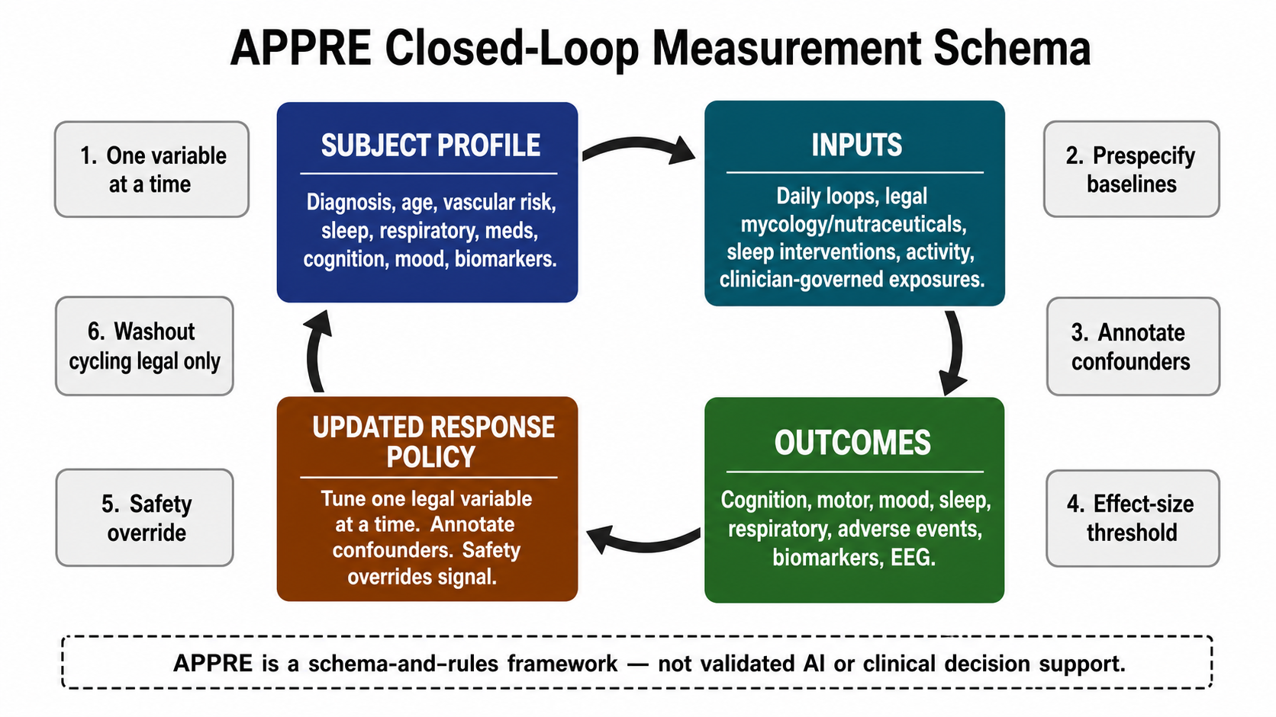
Figure 4. APPRE closed-loop measurement schema. Clockwise four-node schema linking Subject Profile, Inputs, Outcomes, and Updated Response Policy with rule badges for one-variable-at-a-time testing, prespecified baselines, confounder annotation, effect-size thresholding, safety override, and legal washout cycling. APPRE is a schema-and-rules framework, not validated artificial intelligence or clinical decision support.
The subject profile includes baseline diagnosis, age, sex, vascular risk, sleep status, respiratory status, medication list, functional level, cognitive baseline, mood burden, caregiver support, nutritional status, biomarker profile, where available, and relevant safety constraints. Inputs include daily loop variables, legal candidate mycology or nutraceutical inputs, therapy exposure, sleep interventions, activity load, social engagement, and clinician-governed exposures when present. Outcomes include cognition, motor function, mood, sleep, respiratory burden, adverse events, biomarkers, EEG, and daily function.
APPRE operates through six release-gated rules:
1. Tune one legal variable at a time where feasible.
2. Prespecify baseline windows before interpretation.
3. Annotate or exclude confounded intervals.
4. Define provisional effect-size thresholds, such as a framework-defined and unvalidated 0.3 SD signal threshold.
5. Apply washout or anti-tolerance cycling only to legal, non-controlled inputs where biologically and clinically appropriate.
6. Treat safety overrides as superior to signal detection.
APPRE can support N-of-1 crossover blocks, repeated-measures time series, case-series aggregation, and later cohort-level modeling. In the earliest stage, APPRE is a spreadsheet-and-schema discipline. At scale, it could become a software layer, but it should not be described as artificial intelligence until predictive performance is validated. Before prediction comes reproducibility.

8.1 APPRE Adaptive Logic Examples
1. If sleep efficiency improves and cognition improves while exertion remains low, the response policy can prompt safe exertion progression under the appropriate clinical or caregiver safety constraints.
2. If mood worsens during a respiratory exacerbation, APPRE flags the respiratory event as a confounder and prevents premature interpretation of mood change as intervention failure.
3. If adherence drops during a family crisis or caregiver transition, APPRE records the social-safety breakdown rather than attributing outcome regression to biological failure.
4. If a legal input produces repeated adverse effects or worsens fall risk, safety overrides signal detection, and the input is paused, discontinued, or referred back for clinician review.
APPRE is designed to be transparent and auditable. Every input, output, decision rule, and confounder annotation is logged. The goal is not to create a black-box algorithm. The goal is to create a reproducible measurement system that can scale from N-of-1 to cohort to RCT without losing the capacity to detect individual response.
The framework also rejects optimization without boundaries. Human systems do not have a single objective function. A subject's best week is not necessarily the week with the highest exertion, lowest PHQ-9, highest HRV, or fastest TUG. A clinically meaningful response policy must balance cognition, mobility, mood, sleep, respiratory burden, adverse events, caregiver load, and feasibility. APPRE is therefore a satisficing engine: it seeks safe, repeatable improvement across multiple goals rather than a single maximized metric.

9. RAY-VASC: From Originating Case to Open-Source Architecture
RAY-VASC (Residual Adaptive Vascular And Stroke Capacity) is the originating case framework that motivated this architecture. It began as a single-subject N-of-1 observational protocol for a 66-year-old male with progressive supranuclear palsy (PSP), vascular dementia with vascular injury, Parkinsonism, sleep disruption, respiratory risk, recurrent confounder burden, and functional decline. The case is not reported here because this is a framework manuscript, not a case report. However, the measurement spine, confounder discipline, three-phase logic, and APPRE structure were developed to address the operational challenge of studying a complex, multi-system phenotype in a real-world setting with limited resources and family-led documentation support.
As a public framework, RAY-VASC is a longitudinal observational protocol for tracking cognitive, motor, mood, sleep, respiratory, vascular, biomarker, EEG, adverse-event, nutritional-status, medication-change, and confounder data in post-stroke vascular dementia, vascular Parkinsonism, PSP-adjacent, and COPD-adjacent phenotypes. It is designed to be feasible, reproducible, and scalable from home-based N-of-1 studies to multi-site cohorts.
Authorization for public attribution to Raymond Hornsby is on file dated 2026-06-06. Christine A. Hood is acknowledged for family authorization and care coordination support. All identifying clinical data remains private and is not published in this manuscript. Only the de-identified measurement framework is shared.
RAY-VASC functions here as the originating protocol spine. Its value is architectural: it forced the integration of cognitive, motor, mood, sleep, respiratory, vascular, biomarker, EEG, adverse-event, adherence, nutritional-status, and confounder measurement into one practical system. The same spine can be used without naming or exposing any patient.

10. Measurement Architecture
As summarized in Table 2, the measurement architecture is modular, allowing implementation in layers based on setting, resources, and study maturity. Core measures establish feasibility. Biomarkers and EEG add mechanistic depth. Wearables provide continuous validation. The goal is not maximal data collection at the start; the goal is reliable data capture that can survive daily life.
Tier 1 is N-of-1 feasibility: cognition, motor, mood, sleep, respiratory/vascular basics, adherence, adverse events, and confounders. Tier 2 is case-series or observational-cohort expansion: add biomarkers, wearables, and more rigorous assessor standardization. Tier 3 is multi-site pilot or RCT readiness: add EEG, full biomarker panels, blinded assessment where feasible, data monitoring, and prespecified analysis notebooks.
The architecture prioritizes measures that can be repeated. A beautiful baseline assessment with no follow-up is less useful than a modest assessment repeated with discipline. Daily data should be short enough to complete. Weekly data should test the function. Monthly data should verify the trajectory. Biomarkers and EEG should be used when they answer a specific mechanistic question, not as decoration.
Every measurement layer must include confounder annotation: infection, falls, medication changes, sleep disruption, respiratory exacerbation, acute stress, missed inputs, clinic visits, travel, caregiver changes, and adverse events. Without confounder capture, longitudinal neuroplasticity interpretation becomes storytelling.

10.1 Core Measurement Principles
1. Measure confounders before interpreting outcomes. Infection, falls, medication changes, sleep disruption, respiratory exacerbation, acute stress, missed inputs, clinic visits, travel, caregiver changes, nutritional instability, and adverse events must be captured before signal interpretation.
2. Separate signal from noise. Transient fluctuations are not a durable change. A two-week cognitive improvement that disappears is a state change, not a trajectory shift.
3. Track adherence as rigorously as outcomes. Non-adherent protocols cannot test biological hypotheses.
4. Document adverse events in real time. Retrospective safety assessment is unreliable.
5. Use validated instruments wherever possible. MoCA, Trail Making, PHQ-9, GAD-7, MDS-UPDRS, mPSPRS, mMRC, sleep diaries, actigraphy, home BP, SpO2, EEG, and biomarker panels are modular layers rather than mandatory starting requirements.

10.2 Biomarkers and Mechanistic Probes
Biomarkers and EEG belong in Tier 2 or Tier 3 when they answer a specific mechanistic question. Candidate biomarkers include BDNF, p-tau217, NfL, hs-CRP, IL-6, TNF-alpha, HbA1c, eGFR, B12, folate, homocysteine, vitamin D, ferritin, iron studies, and nutritional-status markers when weight loss, dysphagia, or caloric adequacy is a concern. These measures do not prove neurorepair; they help test whether functional change maps to inflammatory, neurodegenerative, metabolic, or neurotrophic context.

10.3 EEG as a Mechanistic Window
EEG is relevant because psychedelic neuroimaging and neurophysiology literature have identified network-level changes during and after psilocybin exposure, while TBI-adjacent observational studies have reported EEG shifts in real-world psychedelic retreat contexts. If Phase 2 produces detectable EEG changes and Phase 3 tracks whether those changes persist or decay, EEG becomes a mechanistic probe for residual-capacity hypothesis testing, not proof of disease reversal.

11. Governance Boundary
The public repository (github.com/onlygreentrades/ray-vasc-regenerative-loop) contains de-identified protocols and measurement schemas under CC BY 4.0.
Raw clinical data remains private. No public file should include medical record numbers, full dates of birth, addresses, raw clinical notes, private imaging reports, or identifiable clinical documents without separate written consent and privacy review. OSF registration should precede external prospective data collection. GitHub should mirror protocol updates. Major releases should be archived through OSF or Zenodo.
Controlled-substance research is restricted to lawful, clinically governed, ethics-approved settings. The repository may discuss high-level study design, measurement architecture, safety monitoring, and as-administered exposure documentation. It must not provide sourcing, preparation, dosing, administration, or self-use instructions for controlled substances.

11.1 Safety Monitoring
All candidate inputs, including legal mycology and neuroprotective inputs, require adverse-event monitoring. Safety gates include medication interaction review, renal and hepatic function review where relevant, bleeding-risk review where relevant, fall-risk assessment, sleep disruption tracking, GI intolerance tracking, allergic reaction monitoring, infection flags, respiratory exacerbation flags, and caregiver-reported functional change. Safety overrides signal detection. A promising data trend is not actionable if it increases falls, confusion, respiratory burden, agitation, bleeding risk, or caregiver instability.

11.2 Phase 2 Safety and Contraindication Boundary
Psilocybin has been studied under controlled therapeutic conditions with careful screening, preparation, monitoring, and integration support (Davis et al., 2021; Garcia-Romeu et al., 2021; Goodwin et al., 2022; MacCallum et al., 2022). RAY-VASC does not loosen or replace those safeguards. Any Phase 2 exposure requires lawful jurisdiction, physician or qualified clinical governance, informed consent, safety monitoring during and after the session, adverse-event documentation, and explicit exclusion or caution review for psychiatric instability, psychosis-spectrum risk, medication interactions, cardiovascular risk, uncontrolled medical instability, and caregiver/safety readiness.

11.3 Ethics Governance
All research involving human subjects requires appropriate ethics review when it is intended to contribute to generalizable knowledge, be externally published, or share identifiable or prospectively collected data. Personal N-of-1 logging conducted for documentation may be outside formal IRB requirements in some settings, but any protocol intended for publication, data sharing, recruitment, external implementation, or controlled-substance exposure must comply with institutional, jurisdictional, consent, privacy, and regulatory requirements.

11.4 Informed Consent Minimum Content
1. Purpose and hypothesis-generating status of the protocol.
2. What data will be collected, who can access it, and how it will be de-identified.
3. Known and unknown risks, including adverse events, falls, psychiatric distress, sleep disruption, medication interactions, and privacy risk.
4. Voluntary participation, withdrawal rights, caregiver role, and limits of confidentiality.
5. Explicit separation between research documentation, medical advice, and clinical treatment decisions.
6. Separate consent and governance requirements for any controlled-substance exposure.

12. Implementation Path
The implementation path is deliberately staged: N-of-1 feasibility, case series, observational cohort, multi-site pilot, and randomized controlled trial. Each stage answers a different question and should not pretend to answer the next one.
N-of-1 feasibility asks whether daily and weekly measures are tolerable, whether inputs can be standardized, whether confounders can be tracked, and whether any signal is visible beyond baseline variance. It does not establish efficacy. It establishes whether the protocol can run.
Case-series testing asks whether similar signals appear across more than one subject or phenotype. It improves generalizability but remains vulnerable to selection bias, expectancy effects, regression to the mean, and uncontrolled confounding. Observational cohorts ask whether signals replicate across broader populations and whether APPRE can stratify responders from non-responders.
Multi-site pilot trials test recruitment, protocol fidelity, safety monitoring, assessor training, data pipelines, missingness, and endpoint sensitivity. Randomized controlled trials are required for causal attribution. If Phase 2 controlled-substance exposure is included, governance requirements increase substantially and must be addressed before recruitment.
The framework is explicitly designed so that negative findings remain valuable. If a candidate input fails to produce a signal, if adherence collapses, if sleep instability explains all apparent change, or if biomarker trajectories do not move, those findings refine the model. Publication value comes from disciplined measurement, not only positive outcomes.

13. Limitations
This paper is speculative and hypothesis-generating. No human-subject outcomes are reported. No RCT has tested the full Regenerative Loop + mycology convergence + governed plasticity window + APPRE architecture. APPRE is a design framework, not a clinically validated algorithm.
The evidence base is uneven. The strongest human evidence supports multidomain lifestyle approaches, exercise, dementia-risk modification, and social-risk frameworks. Sleep and glymphatic evidence are biologically important but still developing for direct clinical translation. Mycology evidence remains early, heterogeneous, and vulnerable to batch inconsistency, extraction differences, dose-form variability, and small-sample human studies.
Psilocybin-related evidence is stronger in depression than in neurodegeneration, TBI, or stroke recovery. Neurological applications remain early and include small open-label pilots, observational retreat studies, narrative reviews, and preclinical work. These sources are useful for hypothesis generation but cannot justify treatment claims.
Measurement burden is another limitation. Complex protocols can fail because caregivers and subjects cannot sustain data capture. The framework addresses this through modular tiers, but feasibility remains an empirical question. Overmeasurement can reduce adherence and increase missingness.
Finally, the framework may fail. It may identify no reproducible signal. It may prove useful only as a measurement architecture rather than an intervention architecture. That outcome would still be scientifically valuable if documented clearly.

14. Future Directions
1. Pilot feasibility studies: Tier 1 N-of-1 studies should test measurement reliability, adherence, missingness, adverse-event rates, and confounder capture before interpreting biological efficacy.
2. Case series: Aggregated Tier 1 or Tier 2 data across 5-10 subjects can assess signal consistency, implementation burden, and dominant confounder patterns.
3. Standardization studies: Mycology batch testing, certificate-of-analysis validation, extraction consistency, and active-constituent characterization are required before reproducible multi-site mycology research is credible.
4. Biomarker validation: Future work should test whether BDNF, p-tau217, NfL, inflammatory markers, metabolic measures, nutritional markers, and EEG measures correlate with cognitive, motor, mood, sleep, respiratory, and adherence outcomes.
5. Controlled trials: If feasibility and safety are established, progression can move toward randomized designs comparing Pre-Load alone, Pre-Load plus structured Regenerative Loop support, and, where lawful and ethics-approved, Pre-Load plus clinician-governed Phase 2 exposure.
6. Open-source data sharing: De-identified longitudinal datasets, APPRE schemas, synthetic example data, analysis notebooks, and measurement templates should be mirrored through GitHub and archived through OSF or Zenodo.
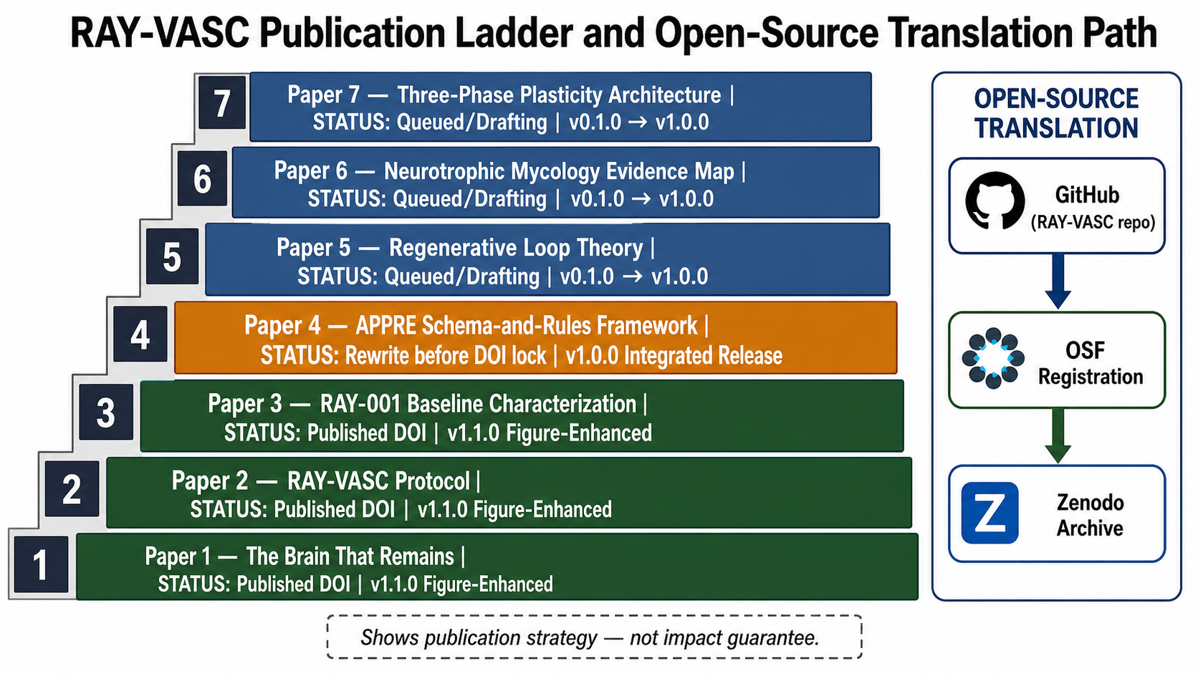
Figure 6. RAY-VASC publication ladder and open-source translation path. Roadmap showing the staged manuscript ladder from Papers 1-7 and the open-source translation path from GitHub repository to OSF registration to Zenodo archive. The figure describes publication strategy only and does not imply impact, efficacy, adoption, or clinical outcome guarantee.

15. Conclusion
Complex neurodegenerative and vascular phenotypes require complex, adaptive, and reproducible measurement systems. The Regenerative Loop + APPRE + RAY-VASC architecture is proposed as a testable framework for studying residual adaptive capacity in PSP, vascular cognitive impairment, Parkinsonian syndromes, post-stroke decline, TBI burden, respiratory limitation, sleep disruption, mood burden, and related phenotypes.
The framework is not a treatment claim. It is a measurement architecture designed to test whether coordinated daily biological loops, candidate neurotrophic Pre-Load, lawful clinician-governed Plasticity Window, and structured longitudinal tracking can detect individualized functional accessibility in complex brain injury and neurodegeneration.
The contribution is operational: staged testing, confounder discipline, safety gates, adaptive personalization, and open-source reproducibility. The framework can be tested without Phase 2, and Phase 2 can be tested only where legal and ethics-approved. Every layer is modular, auditable, and refinable.
This is hypothesis-generating work. Its value is not in proving efficacy. Its value is in defining what must be measured, how confounders must be tracked, and how adaptive systems can scale from N-of-1 feasibility to population-level evidence.

Data Availability Statement
No new clinical data are reported in this manuscript. Protocols, forms, schemas, evidence maps, synthetic examples, and analysis pipeline templates are intended for public release through github.com/onlygreentrades/ray-vasc-regenerative-loop. OSF registration should precede any external prospective data collection.

Ethics Statement
This manuscript is a framework paper and reports no human-subject outcomes. Any future implementation involving identifiable participants, prospective data collection, clinical interventions, or controlled-substance exposure requires appropriate consent, privacy review, clinician oversight, and IRB or ethics review as applicable. Not medical advice. Not legal advice.

Conflict of Interest Statement
The originating researcher reports no commercial product, supplement brand, retreat, clinic, or treatment service associated with this manuscript. Future commercialization, licensing, or platform development would require separate disclosure before submission or publication.

Acknowledgments
This framework was motivated by the care of Raymond Hornsby, who is acknowledged as the human origin point of this work. Authorization for attribution is on file. Christine A. Hood is acknowledged for family authorization and care coordination support. No raw medical records or individual-level clinical outcomes are reported in this manuscript.

Disclaimer
This manuscript is for research planning, documentation, and protocol/measurement design only. It is not medical advice, legal advice, clinical care, a treatment recommendation, a supplement protocol, or a controlled-substance protocol. All clinical decisions remain clinician-directed. All controlled-substance exposure, if any, requires lawful jurisdiction, ethics governance, qualified clinical oversight, informed consent, and adverse-event monitoring.

Funding
This research received no external funding.

Author Contributions
Logan Henderson conceived the framework, designed the measurement architecture, developed the APPRE logic, originated the RAY-VASC protocol, and wrote the manuscript.

References
Baker, L. D., Espeland, M. A., Whitmer, R. A., et al. (2025). Structured vs self-guided multidomain lifestyle interventions for global cognitive function: The U.S. POINTER randomized clinical trial. JAMA, 334(8), 681-691. https://doi.org/10.1001/jama.2025.12923
Biesbroek, J. M., Verhagen, M. G., van der Stigchel, S., & Biessels, G. J. (2024). When the central integrator disintegrates: A review of the role of the thalamus in cognition and dementia. Alzheimer's & Dementia, 20(3), 2209-2222. https://doi.org/10.1002/alz.13563
Blest-Hopley, G., Pasculli, G., Ruffell, S., Tsang, W. F., et al. (2025). Improved mental health outcomes and normalised spontaneous EEG activity in veterans reporting a history of traumatic brain injuries following participation in a psilocybin retreat. Frontiers in Psychiatry, 16, 1594307. https://doi.org/10.3389/fpsyt.2025.1594307
Bradley, E. R., Sakai, K., Fernandes-Osterhold, G., et al. (2025). Psilocybin therapy for mood dysfunction in Parkinson's disease: An open-label pilot trial. Neuropsychopharmacology, 50(8), 1200-1209. https://doi.org/10.1038/s41386-025-02097-0
Brengel, E. K., Axe, B., Maheswari, A., Abeer, M. I., et al. (2025). Psilocybin as a treatment for repetitive mild head injury: Evidence from neuroradiology and molecular biology. bioRxiv. https://doi.org/10.1101/2025.02.03.636248
Carhart-Harris, R. L., Erritzoe, D., Williams, T., et al. (2012). Neural correlates of the psychedelic state as determined by fMRI studies with psilocybin. Proceedings of the National Academy of Sciences, 109(6), 2138-2143. https://doi.org/10.1073/pnas.1119598109
Compass Pathways. (2025, June 23). Compass Pathways successfully achieves primary endpoint in first Phase 3 trial evaluating COMP360 psilocybin for treatment-resistant depression. https://ir.compasspathways.com/
Compass Pathways. (2026, February 17). Compass Pathways successfully achieves primary endpoint in second Phase 3 trial evaluating COMP360 psilocybin for treatment-resistant depression. https://ir.compasspathways.com/
Davis, A. K., Barrett, F. S., May, D. G., Cosimano, M. P., Sepeda, N. D., Johnson, M. W., Finan, P. H., & Griffiths, R. R. (2021). Effects of psilocybin-assisted therapy on major depressive disorder: A randomized clinical trial. JAMA Psychiatry, 78(5), 481-489. https://doi.org/10.1001/jamapsychiatry.2020.3285
Garcia-Romeu, A., Barrett, F. S., Carbonaro, T. M., Johnson, M. W., & Griffiths, R. R. (2021). Optimal dosing for psilocybin pharmacotherapy: Considering weight-adjusted and fixed dosing approaches. Journal of Psychopharmacology, 35(4), 353-361. https://doi.org/10.1177/0269881121991822
Goodwin, G. M., Aaronson, S. T., Alvarez, O., et al. (2022). Single-dose psilocybin for a treatment-resistant episode of major depression. The New England Journal of Medicine, 387, 1637-1648. https://doi.org/10.1056/NEJMoa2206443
Halassa, M. M., & Sherman, S. M. (2019). Thalamocortical circuit motifs: A general framework. Neuron, 103(5), 762-770. https://doi.org/10.1016/j.neuron.2019.06.005
Hara, Y., McKeehan, N., Dacks, P. A., & Fillit, H. M. (2017). Evaluation of the neuroprotective potential of N-acetylcysteine for prevention and treatment of cognitive aging and dementia. The Journal of Prevention of Alzheimer's Disease, 4(3), 201-206.
Hinkle, J. T., Graziosi, M., Nayak, S. M., & Yaden, D. B. (2024). Adverse events in studies of classic psychedelics: A systematic review and meta-analysis. JAMA Psychiatry, 81(12), 1225-1235. https://doi.org/10.1001/jamapsychiatry.2024.2546
Kongkeaw, C., Dilokthornsakul, P., Thanarangsarit, P., Limpeanchob, N., & Norman Scholfield, C. (2014). Meta-analysis of randomized controlled trials on cognitive effects of Bacopa monnieri extract. Journal of Ethnopharmacology, 151(1), 528-535. https://doi.org/10.1016/j.jep.2013.11.008
Kuiper, J. S., Zuidersma, M., Oude Voshaar, R. C., et al. (2015). Social relationships and risk of dementia: A systematic review and meta-analysis of longitudinal cohort studies. Ageing Research Reviews, 22, 39-57. https://doi.org/10.1016/j.arr.2015.04.006
Livingston, G., Huntley, J., Liu, K. Y., et al. (2024). Dementia prevention, intervention, and care: 2024 report of the Lancet standing Commission. The Lancet, 404(10452), 572-628. https://doi.org/10.1016/S0140-6736(24)01296-0
Lomeli Martinez, S. M., Pacheco Moises, F. P., Bitzer-Quintero, O. K., Ramirez-Jirano, J., Delgado-Lara, D. L. C., Cortes Trujillo, I., Torres Jasso, J. H., Salazar-Flores, J., & Torres-Sanchez, E. D. (2025). Effect of N-acetyl cysteine as an adjuvant treatment in Alzheimer's disease. Brain Sciences, 15(2), 164. https://doi.org/10.3390/brainsci15020164
Ly, C., Greb, A. C., Cameron, L. P., et al. (2018). Psychedelics promote structural and functional neural plasticity. Cell Reports, 23(11), 3170-3182. https://doi.org/10.1016/j.celrep.2018.05.022
MacCallum, C. A., Lo, L. A., Pistawka, C. A., & Deol, J. K. (2022). Therapeutic use of psilocybin: Practical considerations for dosing and administration. Frontiers in Psychiatry, 13, 1040217. https://doi.org/10.3389/fpsyt.2022.1040217
Mason, N. L., Kuypers, K. P. C., Muller, F., et al. (2023). Psilocybin induces acute and persisting alterations in immune status in healthy volunteers: An experimental placebo-controlled study. Brain, Behavior, and Immunity, 114, 299-310. https://doi.org/10.1016/j.bbi.2023.08.037
Moliner, R., Girych, M., Brunello, C. A., et al. (2023). Psychedelics promote plasticity by directly binding to BDNF receptor TrkB. Nature Neuroscience, 26, 1032-1041. https://doi.org/10.1038/s41593-023-01316-5
Mori, K., Inatomi, S., Ouchi, K., Azumi, Y., & Tuchida, T. (2009). Improving effects of the mushroom Yamabushitake (Hericium erinaceus) on mild cognitive impairment: A double-blind placebo-controlled clinical trial. Phytotherapy Research, 23(3), 367-372. https://doi.org/10.1002/ptr.2634
Ngandu, T., et al. (2025). Long-term adherence to lifestyle changes and association with cognitive change: 11-year results from the FINGER randomized, controlled trial. Alzheimer's & Dementia, 21(Suppl. 6), e106542. https://doi.org/10.1002/alz70860_106542
Ngandu, T., Lehtisalo, J., Solomon, A., et al. (2015). A 2-year multidomain intervention of diet, exercise, cognitive training, and vascular risk monitoring versus control to prevent cognitive decline in at-risk elderly people (FINGER): A randomized controlled trial. The Lancet, 385(9984), 2255-2263. https://doi.org/10.1016/S0140-6736(15)60461-5
Palmer, C., Ferber, A. T., & Greenwald, B. D. (2025). The potential role of psilocybin in traumatic brain injury recovery: A narrative review. Brain Sciences, 15(6), 572. https://doi.org/10.3390/brainsci15060572
Petri, G., Expert, P., Turkheimer, F., Carhart-Harris, R., Nutt, D., Hellyer, P. J., & Vaccarino, F. (2014). Homological scaffolds of brain functional networks. Journal of The Royal Society Interface, 11(101), 20140873. https://doi.org/10.1098/rsif.2014.0873
Shao, L. X., Liao, C., Gregg, I., Davoudian, P. A., Savalia, N. K., Delagarza, K., & Kwan, A. C. (2021). Psilocybin induces rapid and persistent growth of dendritic spines in frontal cortex in vivo. Neuron, 109(16), 2535-2544.e4. https://doi.org/10.1016/j.neuron.2021.06.008
Surendran, R., et al. (2025). Acute cognitive and mood effects of a standardized fruiting body Hericium erinaceus intervention in healthy young adults. Frontiers in Nutrition, 11, 1419567. https://doi.org/10.3389/fnut.2024.1419567
Winer, J. R., et al. (2026). The glymphatic system clears amyloid beta and tau from brain to plasma in humans. Nature Communications, 17, 715. https://doi.org/10.1038/s41467-026-68374-8
Zheng, S., Ma, R., & Yang, Y. (2024). Psilocybin for the treatment of Alzheimer's disease. Frontiers in Neuroscience, 18, 1420601. https://doi.org/10.3389/fnins.2024.1420601
Zhou, Y., et al. (2022). Effects of physical exercise on plasma brain-derived neurotrophic factor in neurodegenerative disorders: A systematic review and meta-analysis. Frontiers in Aging Neuroscience, 14, 981002. https://doi.org/10.3389/fnagi.2022.981002

