RAY-001 Baseline Characterization in a Complex Neurovascular Parkinsonian Phenotype: Documenting Pre-Intervention Architecture and Measurement Feasibility for Future Neuroplasticity Research
Logan Henderson
Independent Researcher, Houston, Texas, United States
Correspondence: Logan Henderson

Abstract
Background: Complex neurovascular and mixed neurodegenerative-vascular phenotypes rarely behave as single-diagnosis conditions. Progressive supranuclear palsy-spectrum features, vascular cognitive impairment, Parkinsonian motor burden, sleep-disordered breathing, respiratory disease, dysphagia, falls, medication complexity, vascular-metabolic risk, functional dependence, and caregiver burden can interact as one coupled clinical and operational system. Standard episodic follow-up may be too coarse to support high-frequency N-of-1 measurement planning in these settings.
Case presentation: RAY-001 is the originating human context that informed the RAY-VASC measurement architecture. The case is presented as a privacy-preserving baseline characterization and measurement-feasibility report, not as an intervention-outcome manuscript. Available records support a complex neurovascular Parkinsonian phenotype involving PSP-spectrum features, vascular cognitive impairment or vascular dementia, Parkinsonism with abnormal dopamine-transporter imaging, sleep-disordered breathing with severe periodic limb movement burden, chronic respiratory burden, dysphagia, recurrent falls, vascular-metabolic risk, medication complexity, and high caregiver dependence in a homebound context.
Objective: The objective is to characterize the pre-intervention baseline phenotype and map which RAY-VASC Tier 1 and Tier 2 measurement layers were available, partially reconstructable, planned, or not executed before the clinical window for clean prospective N-of-1 measurement closed.
Methods: Available baseline clinical records, neurology consultation data, imaging summaries, sleep-study findings, laboratory markers, medication context, functional descriptions, caregiver-context information, and protocol materials were retrospectively synthesized and mapped against the RAY-VASC Tier 1, Tier 2, and APPRE schema architecture. Public reporting uses banded or ordinal descriptors by default, with selective single-timepoint numeric anchors only where they materially strengthen baseline interpretation and are supported by source records.
Results: Baseline characterization was feasible from routine records and protocol-planning materials, but daily Tier 1 logging, weekly functional packets, baseline EEG, serial EEG, synchronized biomarkers, wearable capture, APPRE response-policy cycles, and intervention-phase follow-up were not completed before transition to 24/7 care. Single-timepoint baseline anchors included MoCA 11/30, Hoehn and Yahr stage 3, UPDRS motor score 52, A1C 5.8%, severe periodic limb movement burden greater than 130/hour, sleep efficiency near 40%, and CPAP responsiveness during brief titration. These values are used only as baseline descriptors and are not interpreted as longitudinal outcomes or intervention effects.
Conclusion: RAY-001 demonstrates that missingness can be an operational signal. In rapidly evolving complex neurovascular Parkinsonian disease, low-burden caregiver-supported Tier 1 baseline capture should begin before Tier 2 EEG and biomarker readiness delays the remaining clinical window. No treatment efficacy, recovery, reversal, repair, cure, or disease-modification claim is made.
Keywords: RAY-001; RAY-VASC; case report; baseline characterization; progressive supranuclear palsy; vascular cognitive impairment; vascular Parkinsonism; N-of-1; measurement feasibility; EEG; biomarkers; caregiver burden; dysphagia; sleep-disordered breathing; APPRE; open science

1. Introduction
Complex neurovascular and mixed neurodegenerative-vascular phenotypes do not present as isolated diagnostic compartments. A person may simultaneously carry vascular cognitive impairment, PSP-spectrum signs, Parkinsonian motor burden, post-stroke or strategic infarct burden, sleep fragmentation, respiratory disease, dysphagia, recurrent falls, medication complexity, functional dependence, and caregiver strain. In practice, these domains interact. Cognition may fluctuate with sleep quality, respiratory burden, infection, medication changes, caregiver stability, or fatigue. Gait and fall risk may fluctuate with sleep disruption, bradykinesia, balance impairment, oxygenation, environmental hazards, and confidence. Swallowing safety may constrain medication adherence, nutrition, hydration, aspiration risk, and hospitalization risk. A baseline protocol that treats these domains as independent risks, missing the operational causes of missingness and misattributing signal.
Progressive supranuclear palsy is a progressive atypical Parkinsonian disorder involving gait, balance, eye movements, cognition, speech, swallowing, and falls. The Movement Disorder Society diagnostic framework emphasizes ocular motor dysfunction, postural instability, akinesia, and cognitive dysfunction as core domains for PSP diagnosis and classification (Höglinger et al., 2017). Practical management reviews also emphasize the importance of family context, falls, swallowing risk, and multidisciplinary care in PSP (Rowe et al., 2021). Vascular cognitive impairment and cerebral small vessel disease can affect executive function, processing speed, gait, and multiple cognitive domains, particularly when strategic subcortical structures and white matter systems are involved (Hamilton et al., 2021; Zotin et al., 2021). Dysphagia is clinically relevant in PSP and can appear earlier than in Parkinson's disease, affecting safety, nutrition, and care burden (Clark et al., 2020). Sleep-disordered breathing can further complicate neurodegenerative presentations and may affect cognition, daytime function, and clinical interpretation (Lajoie et al., 2020).
Paper 1, The Brain That Remains, established the residual-capacity and open-source protocol design framework for studying complex neurodegenerative and vascular phenotypes without claiming treatment efficacy or disease reversal (Henderson, 2026a). Paper 2, RAY-VASC: A Multidomain N-of-1 and Small-Series Protocol for Complex Neurovascular Disease, translated that framework into a prospective, burden-limited N-of-1 and small-series measurement spine (Henderson, 2026b). The RAY-VASC protocol specifies Tier 1 caregiver-supported feasibility capture across cognition, mobility, and falls, mood, sleep, respiratory burden, dysphagia, functional dependence, caregiver context, adverse events, and confounders. It also specifies Tier 2 neurophysiology and biomarker layers, including serial EEG, event-related potentials, synchronized biomarkers, wearable streams, and APPRE schema mapping when that implementation level is actually activated.
RAY-001 is the originating human case that motivated the measurement architecture. The present manuscript is not a protocol paper and not a longitudinal outcome report. It is the baseline case paper in the sequence: the bridge between framework, protocol, and future implementation discipline. The central question is what can be learned from a richly characterized pre-intervention baseline when prospective multidomain capture begins too late to generate a complete Phase 1 dataset.
This manuscript does not ask whether an intervention worked. It does not report clinical improvement, treatment efficacy, disease modification, recovery, repair, or reversal. The absence of intervention-phase data is not hidden. It is the central operational lesson.

2. Methods

2.1 Design
This is a CARE-aligned baseline characterization and methods case report based on retrospective synthesis of available records and protocol materials. It is not a prospective intervention study, not a clinical trial, and not an outcome analysis. The manuscript uses a structured case-methods format to describe baseline phenotype, data availability, missingness, protocol-readiness mismatch, and implementation lessons.
The CARE guidelines identify core case-report elements, including title, keywords, abstract, introduction, de-identified patient information, clinical findings, timeline, diagnostic assessment, intervention, and follow-up when present, discussion, patient perspective, and informed consent (Gagnier et al., 2013; Riley et al., 2017). This manuscript follows the applicable CARE structure while explicitly omitting intervention and outcome interpretation because the RAY-VASC protocol was not prospectively executed for RAY-001.

2.2 Source Materials
Source materials reviewed for this manuscript included neurology consultation data, imaging summaries, dopamine-transporter imaging summaries, sleep-study findings, laboratory markers, medication context, functional status descriptions, dysphagia and speech-therapy referral context, homebound and caregiver-context documentation, and RAY-VASC protocol materials. Protocol materials included Tier 1 and Tier 2 measurement plans, daily and weekly forms, EEG scheduling logic, biomarker synchronization logic, APPRE schema structure, adverse-event structure, confounder-logging rules, privacy boundaries, and open-source governance materials.

2.3 Reporting Rule: Hybrid Banded and Numeric Reporting
To balance scientific utility and privacy, this manuscript uses banded or ordinal descriptors by default. Single-timepoint numeric anchors are included only where they materially strengthen baseline characterization or protocol-design interpretation and are supported by available source records.
Retained numeric anchors include MoCA 11/30 as a single cognitive anchor, Hoehn and Yahr stage 3, and UPDRS motor score 52 as a single motor anchor set, A1C 5.8% as a vascular-metabolic context anchor, and rounded sleep-study magnitude anchors: moderate obstructive sleep apnea, periodic limb movement burden greater than 130/hour, sleep efficiency near 40%, and CPAP titration at 11 cm H₂O.
Banded reporting is used for functional dependence, caregiver burden, respiratory burden, dysphagia and nutrition burden, renal-function risk, longitudinal timing, care-transition sequence, and potentially re-identifiable clinical-data combinations. No exact calendar timeline, full date of birth, medical record number, address, raw report, portal screenshot, or facility identifier is published.

2.4 Measurement Architecture Mapping
Available and missing data were mapped against the RAY-VASC architecture:
Tier 1: caregiver-supported daily and weekly capture of cognition, motor function and falls, mood, sleep, respiratory burden, dysphagia, medication changes, adverse events, functional dependence, caregiver burden, and confounders.
Tier 2: serial EEG, event-related potentials, synchronized biomarkers, wearable streams, and structured quarterly measurement windows.
APPRE: subject profile, inputs, outcomes, confounders, adverse events, and response-policy versioning.
The mapping distinguishes data available from routine records, data partially reconstructable from clinical summaries, data specified in the protocol but not executed, and data absent.

2.5 Claim Boundary
This manuscript is a baseline characterization and measurement-feasibility case report. It does not report clinical improvement, treatment efficacy, disease modification, recovery, reversal, or repair. The RAY-VASC protocol and APPRE are presented as a measurement architecture and schema-and-rules framework only, not as a treatment package, validated artificial intelligence, clinical decision support, or a medical device.

2.6 Ethics, Consent, and Privacy
Written authorization for publication of a privacy-preserving case characterization and measurement-feasibility analysis was obtained through the project’s governance pathway and is maintained in the internal governance record. Public reporting in this manuscript is restricted to de-identified or authorization-consistent summaries. No full date of birth, medical record numbers, addresses, facility identifiers, raw clinical report images, or portal screenshots are published. Relative timepoints are used instead of exact calendar dates unless a journal-specific requirement and privacy review justify more specific timing.
Informed consent or authorized representative permission for publication of this de-identified case report was obtained in accordance with applicable ethical and privacy requirements.

3. Case Presentation

3.1 Diagnostic Categories
Available records support classification of RAY-001 as having a complex neurovascular Parkinsonian phenotype involving PSP-spectrum progressive supranuclear palsy features, vascular cognitive impairment or vascular dementia, Parkinsonism with abnormal dopamine-transporter imaging, sleep-disordered breathing, periodic limb movement burden, chronic respiratory disease, dysphagia, recurrent falls, medication complexity, and caregiver dependence. Diagnostic wording is intentionally conservative. The manuscript uses “documented,” “clinically characterized as,” or “supported by available records” rather than treating every label as a final adjudicated diagnosis.

3.2 Baseline Neurological and Functional Burden
At the index neurology assessment, RAY-001 demonstrated severe cognitive impairment and moderate-to-severe Parkinsonian motor burden in a complex neurovascular context. Global cognition was markedly impaired, with a Montreal Cognitive Assessment score of 11/30 documented as a single baseline cognitive anchor. Parkinsonian motor burden was in the moderate-to-severe range, with Hoehn and Yahr stage 3 and a Unified Parkinson’s Disease Rating Scale motor score of 52 documented at the same baseline clinical window. These values are used only as one-time baseline descriptors and are not interpreted as trajectory markers, progression estimates, treatment markers, or intervention outcomes.
The motor phenotype included axial and gait impairment, recurrent falls, postural instability, shuffling or shortened stride, impaired turning, bradykinesia, rigidity, hypomimia, hypophonia, and the need for safety support during mobility. These features are relevant to protocol feasibility because home-based Timed Up and Go, 10-meter walk testing, weekly gait assessments, fall logging, and in-person EEG visits would require caregiver supervision, fall-risk controls, environmental safety review, and low-burden administration.
The motor anchor, therefore, supports protocol-design interpretation rather than outcome interpretation. No longitudinal UPDRS tracking was completed for RAY-001 under the RAY-VASC protocol.

3.3 Sleep, Circadian, and Respiratory Confounding
Baseline sleep architecture was a major feasibility and interpretation constraint. Overnight polysomnography documented moderate obstructive sleep apnea, severe periodic limb movement burden with a limb-movement index greater than 130 events per hour, markedly fragmented sleep, and sleep efficiency near 40%. During a brief CPAP titration at 11 cm H₂O, the apnea-hypopnea index normalized, and oxygen saturation remained above 90%, indicating physiologic responsiveness under supervised titration conditions. Stable real-world CPAP use was not established, leaving sleep-disordered breathing and sleep fragmentation as persistent confounders for cognition, gait, mood, daytime alertness, caregiver burden, and EEG readiness.
Chronic respiratory burden from COPD or COPD-like respiratory disease further compounds the feasibility. Available records describe chronic respiratory disease, inhaler use, and respiratory reserve concerns. Even where resting oxygen saturation was preserved during clinical assessment, the combination of respiratory disease, sleep-disordered breathing, reduced sleep efficiency, and severe limb movements during sleep would require systematic confounder annotation around any high-frequency cognitive, motor, mood, or EEG assessment.
For public reporting, sleep-study details are treated as magnitude anchors rather than a full polysomnography fingerprint: moderate OSA, severe periodic limb movement burden greater than 130/hour, sleep efficiency near 40%, and CPAP responsiveness during supervised titration without established sustained use. These details are scientifically useful because RAY-VASC treats prior-night sleep and respiratory status as confounder gates for cognitive, motor, mood, and neurophysiological interpretation. They do not imply that any sleep-treatment program was executed as part of a trial or that sleep-related interventions produced protocol outcomes in RAY-001.

3.4 Dysphagia, Nutrition, and Oral-Adherence Constraints
Oropharyngeal dysphagia was documented at baseline, with transition to pureed or softened food and referral for home-health speech therapy for swallowing safety. Substantial pre-intervention weight loss was recorded in the available clinical history, consistent with increased swallowing and nutrition burden. These findings are reported as a moderate-to-high swallowing and nutrition burden rather than as a detailed nutrition chronology, preserving privacy while capturing protocol-relevant constraints.
Dysphagia is included as a feasibility and confounder variable rather than as an intervention target or outcome domain for this case. Swallowing impairment can alter oral intake, medication adherence, consistency of any study inputs, aspiration risk, hospitalization risk, caregiver workload, and the feasibility of daily logging or structured protocol execution. For future RAY-VASC implementations, this baseline supports early swallowing-risk screening where clinically appropriate, speech-language pathology review when indicated, and explicit logging of any medication, nutrition, or supplement administration-route changes as adherence-affecting protocol adaptations.

3.5 Caregiver Setting, Homebound Status, and Measurement Burden
RAY-001 lived with a primary caregiver in a physically constrained setting requiring navigation of steps and presenting fall hazards in the context of progressive functional dependence. Available records describe recurrent falls, use or recommendation of assistive devices, formal home-health orders, and certification as homebound based on poor endurance, need for an assistive device, need for another person’s attendance to leave home, and high fall risk. These factors are reported as caregiver-setting and feasibility constraints, not as a family narrative. Specific addresses, agency names, facility names, and other identifiers are omitted.
This context is central because it explains why a high-burden prospective protocol became impractical as the care window narrowed, even though the RAY-VASC measurement architecture and forms were protocol-ready. In RAY-VASC terms, caregiver sustainability, homebound status, constrained environment, and fall risk were direct feasibility and safety variables rather than peripheral social details. The appropriate interpretation is that Tier 1 baseline capture should have been activated earlier in a caregiver-proxy format, before escalating fall risk, care transitions, and 24/7 support needs reduced the practical capacity for clean baseline logging, serial EEG, synchronized biomarkers, or full Phase 1 execution.

3.6 Integrated Baseline Phenotype
Taken together, the baseline case does not reflect a single-diagnosis presentation. RAY-001 entered the protocol-design window with severe cognitive impairment, moderate-to-severe Parkinsonian motor burden, recurrent falls, major sleep disruption, respiratory burden, dysphagia and nutrition risk, medication complexity, vascular and metabolic risk factors, renal-function considerations, and escalating caregiver dependence in a homebound context. These interacting constraints made the case scientifically valuable as a baseline characterization and feasibility lesson, but prevented completion of a clean prospective Phase 1 dataset, serial EEG series, synchronized biomarker panel, or longitudinal RAY-VASC Tier 1 implementation before transition to 24/7 care.
Within the overall RAY-VASC series, Paper 3 therefore treats the missing prospective dataset as a central operational finding rather than a limitation to hide. In rapidly evolving complex neurovascular Parkinsonian disease, low-burden Tier 1 baseline capture must begin as soon as caregiver support and consent or legally authorized representative pathways are available, rather than waiting for Tier 2 EEG and biomarker readiness that may never align with the remaining clinical window.

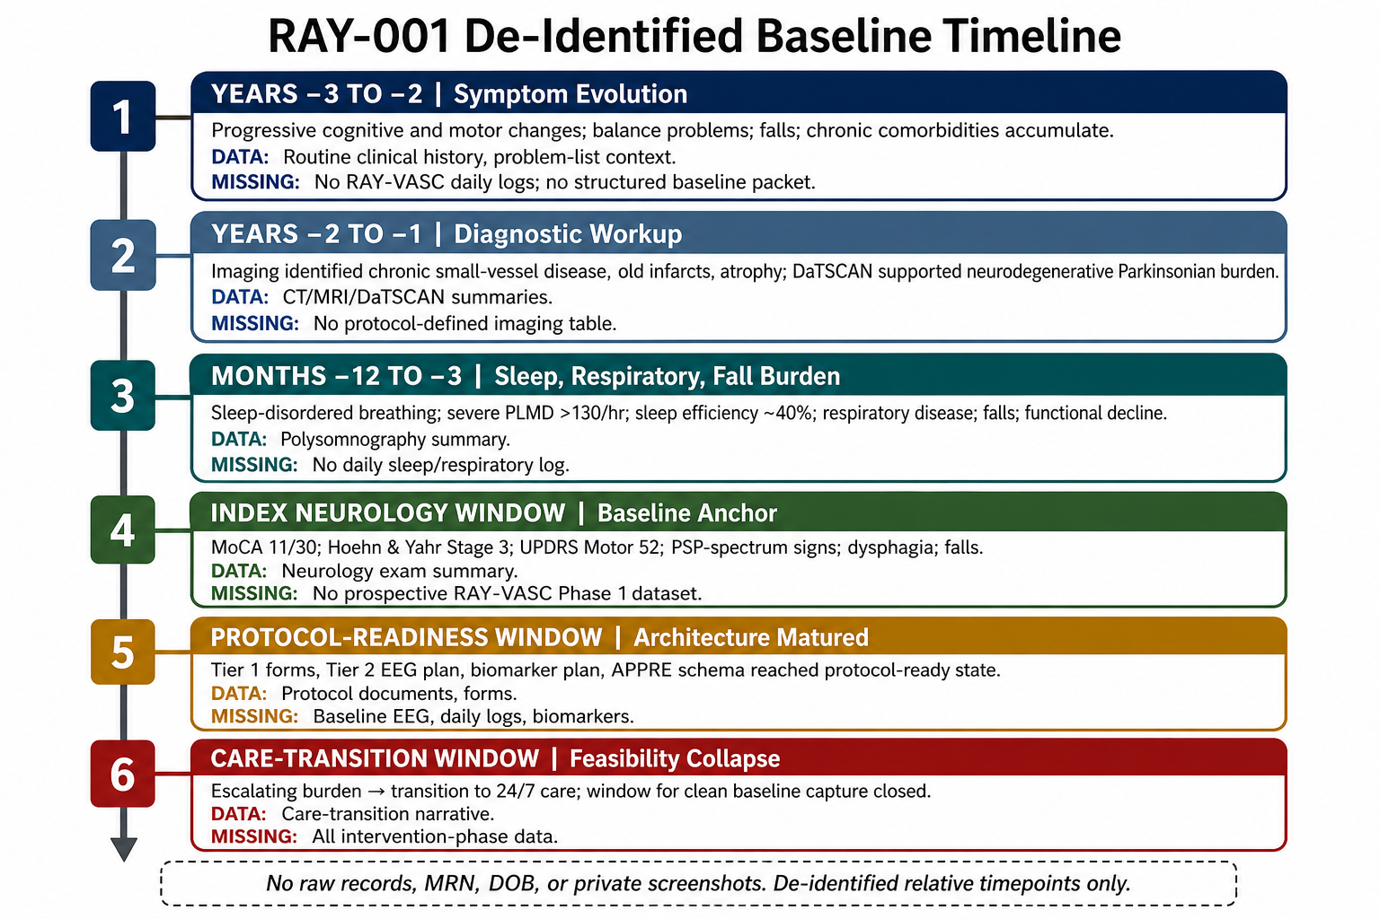
Figure 1. RAY-001 de-identified baseline timeline. Relative timepoints are used to preserve privacy and to separate available baseline records from missing prospective RAY-VASC layers.

4. Relative Timeline
Relative timing is used rather than exact calendar dates to preserve privacy.
Relative timepoint | Clinical or operational category | Public-facing description | Data available | Data not available
Years −3 to −2 | Symptom evolution | Progressive cognitive and motor changes, balance problems, falls, and chronic comorbidities accumulated. | Routine clinical history; problem-list context | No RAY-VASC daily logs; no structured baseline packet
Years −2 to −1 | Diagnostic workup | Imaging summaries identified chronic small-vessel disease, old infarcts involving strategic regions, and generalized atrophy; dopamine-transporter imaging supported neurodegenerative Parkinsonian burden. | CT, MRI, and DaTSCAN summaries | No protocol-defined imaging adjudication table
Months −12 to −3 | Sleep, respiratory, and fall burden | Sleep-disordered breathing, severe limb-movement burden during sleep, respiratory disease, falls, and functional decline became operationally central. | Polysomnography summary; respiratory context; fall history | No daily sleep or respiratory log; no wearable stream
Index neurology window | Baseline anchor | Neurology assessment documented severe cognitive impairment, moderate-to-severe motor burden, PSP-spectrum signs, dysphagia, recurrent falls, and assistive-support needs. | MoCA 11/30; Hoehn and Yahr stage 3; UPDRS motor 52; exam summary | No prospective RAY-VASC Phase 1 dataset
Protocol-readiness window | Measurement architecture | RAY-VASC Tier 1 forms, Tier 2 EEG plan, biomarker plan, APPRE schema, safety governance, and missingness logic reached protocol-ready state. | Protocol documents; forms; schedules; schema logic | Baseline EEG; daily logs; synchronized biomarkers; wearable stream
Care-transition window | Feasibility collapse | Escalating clinical and caregiver burden led to transition into 24/7 care, closing the window for clean baseline capture. | Care-transition narrative; functional context | Intervention-phase data; follow-up trajectory; serial EEG; APPRE response-policy cycles

5. Clinical Phenotype Mapping
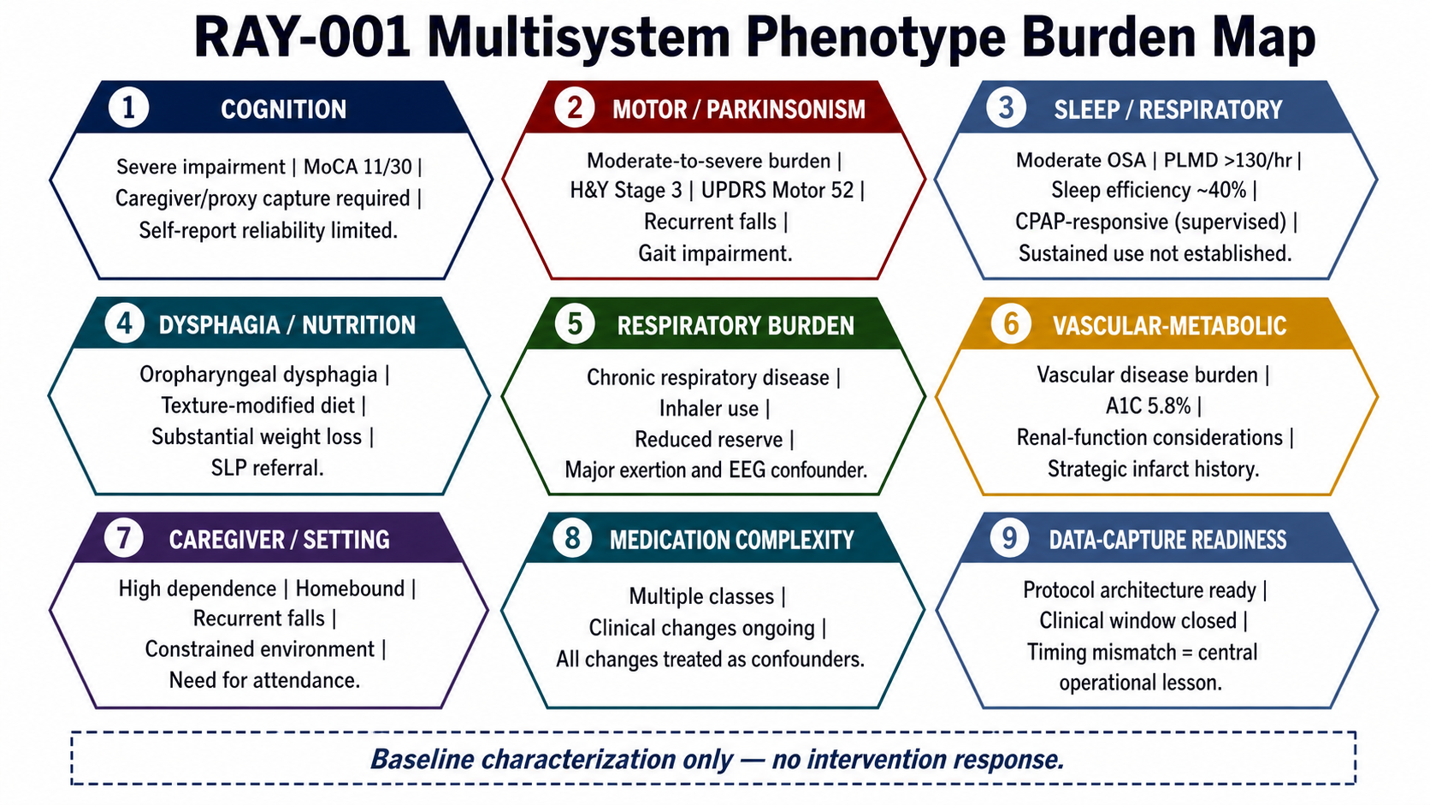
Figure 2. RAY-001 multisystem phenotype burden map. Domains are presented as baseline characterization only and do not imply intervention response.
Domain | Baseline characterization | Public reporting format | Interpretation for RAY-VASC feasibility
Cognition | Severe cognitive impairment with MoCA 11/30 at the index neurology window | Single-timepoint numeric anchor plus severity band | Self-report reliability is limited; caregiver/proxy capture is required
Motor / Parkinsonism | Moderate-to-severe motor burden; Hoehn and Yahr stage 3; UPDRS motor score 52; recurrent falls and gait impairment | Single-timepoint numeric anchor plus severity band | Home testing requires caregiver support, fall-risk precautions, environmental safety controls, and confounder annotation
Sleep / respiratory | Moderate OSA; severe periodic limb movement burden greater than 130/hour; sleep efficiency near 40%; CPAP-responsive during brief titration, but sustained real-world use not established | Rounded magnitude anchors plus feasibility context | Major confounder for cognition, gait, mood, fatigue, EEG interpretation, and protocol adherence
Dysphagia / nutrition | Oropharyngeal dysphagia; texture-modified diet; substantial pre-intervention weight loss; speech-therapy referral | Banded severity; no detailed chronology | Oral intake, medication administration, aspiration risk, nutrition stability, and adherence tracking must be treated as feasibility variables
Respiratory burden | Chronic respiratory disease with inhaler use and reduced reserve concerns | Banded burden | Respiratory status should be logged around exertion, sleep, cognition, EEG, and adverse-event interpretation
Vascular-metabolic context | Vascular disease burden with A1C 5.8% and renal-function considerations | Selective numeric anchor for A1C; renal function banded | Vascular-metabolic and renal status affect safety gating, confounder interpretation, and future biomarker panels
Caregiver / setting | High caregiver dependence; homebound status; recurrent falls; constrained physical environment; need for assistance to leave home | Banded feasibility context | Tier 1 capture must be caregiver-proxy capable; daily burden ceiling is low; in-person research visits carry high friction
Medication / clinical complexity | Multiple medication classes and clinical changes are present in the background record | High-level class/context summary only | Medication changes must be treated as confounders; no medication-outcome inference is made
Data-capture readiness | Protocol architecture ready, but patient window closed | Protocol-level statement, not execution statement | Timing mismatch is the central operational lesson

6. Available Baseline Data
A structured data inventory was created to distinguish what was available from what was missing.
Data category | Available source type | Baseline information recoverable | Public reporting recommendation | Manuscript use
Neurology | Consultation/exam summary | MoCA, UPDRS motor, Hoehn and Yahr stage, PSP-spectrum signs, falls, gait impairment, dysphagia, homebound context | Report only de-identified summary and selective one-time numerics | Primary baseline severity anchor
Imaging | CT, MRI, and DaTSCAN summaries | Chronic small-vessel ischemic change, old infarcts in strategic regions, atrophy, severely reduced striatal uptake | Report summary only; no raw images or full reports | Diagnostic context and vascular-neurodegenerative burden
Sleep | Polysomnography summary | Moderate OSA, severe periodic limb movement burden, low sleep efficiency, CPAP titration response | Use rounded magnitude anchors | Confounder and feasibility interpretation
Respiratory | Clinical diagnosis and medication context | COPD/chronic respiratory burden, inhaler use, respiratory reserve concerns | Banded context only | Safety and burden interpretation
Labs | Available routine markers | A1C 5.8%, renal-function variability, general metabolic context | Use A1C numeric; renal function banded unless safety-relevant | Vascular-metabolic context
Functional status | Clinical notes and home-health context | Falls, mobility limitation, homebound status, assistive support, need for caregiver attendance | Banded dependence level | Tier 1 feasibility and burden mapping
Dysphagia/nutrition | Clinical notes and referral context | Texture-modified diet, speech-therapy referral, weight-loss burden | Banded severity; no detailed chronology | Oral-adherence and aspiration-risk context
Caregiver context | Visit accompaniment, homebound certification, care-transition context | High caregiver involvement, homebound certification, need for assistance leaving home | Banded caregiver/setting context | Explains missingness and protocol timing failure
Protocol materials | RAY-VASC forms, schedules, schemas | Tier 1/Tier 2 architecture, APPRE schema, missingness logic | Cite protocol-level availability; do not imply execution | Measurement architecture mapping

Routine clinical records support a baseline architecture map consistent with the domains specified in the RAY-VASC protocol. They do not constitute a formal prospective RAY-VASC Tier 1 dataset.

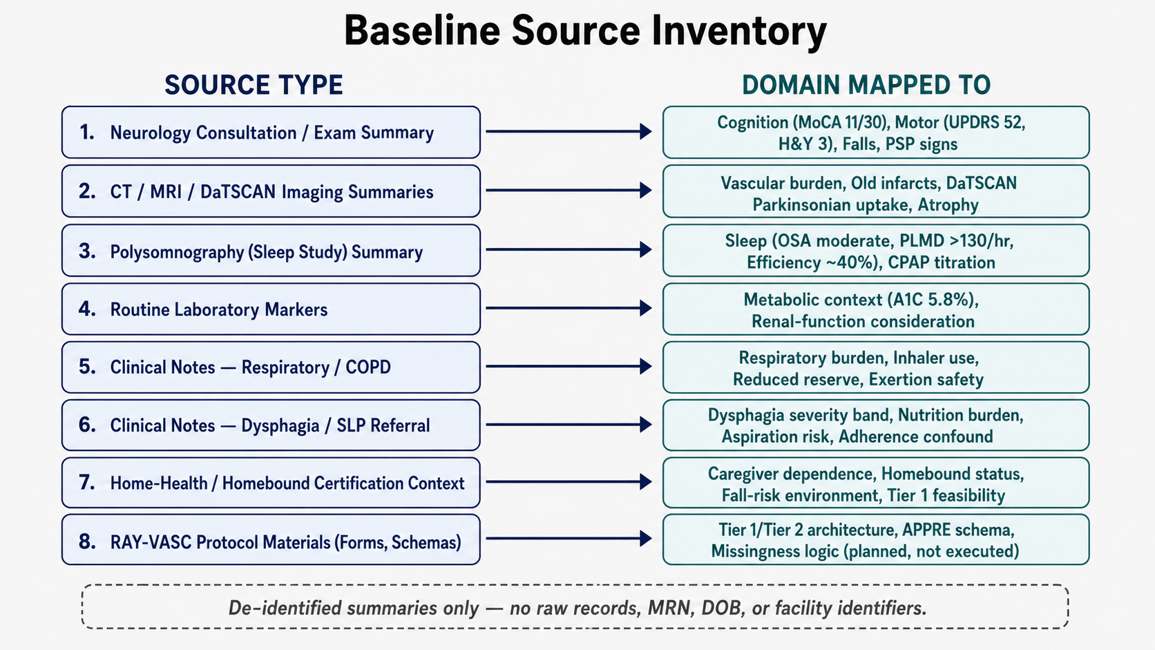
Figure 5. Baseline source inventory. De-identified source categories are mapped to RAY-VASC domains; raw records and identifiers are not included.

7. Missing Data Inventory
Missingness is treated as a central result.
Planned RAY-VASC measure | Intended timing | RAY-001 status | Root cause | Interpretation
Daily Tier 1 log | Baseline and Phase 1 | Not prospectively implemented | Clinical decline, caregiver burden, care transition, late protocol activation | Tier 1 feasibility and interpretable-cycle calculation cannot be performed
Weekly packet | Baseline and Phase 1 | Not prospectively implemented | Clinical burden and care transition | No standardized weekly functional trend exists
Modified ADL/IADL packet | Weekly/monthly | Not prospectively implemented | Care burden and transition | Functional dependence can be banded from records but not scored as a prospective outcome
Baseline EEG / EEG-01 | Baseline window | Not recorded | No clean implementation window before 24/7 care | Tier 2 EEG was planned but unexecuted
Serial EEG series | Twelve-session protocol schedule | Not executed | Protocol readiness did not align with clinical window | No EEG trajectory exists
P300/ERP | Tier 2 EEG sessions | Not executed | No EEG session completed | No event-related potential data are available
Synchronized biomarkers | Baseline/quarterly; aligned to EEG where applicable | Not executed as a RAY-VASC panel | Care-transition and operational timing | Routine labs exist but do not substitute for protocol-defined biomarkers
Wearables | Continuous/passive capture | Not implemented as protocol-defined dataset | Device/workflow/care transition constraints | No passive valid-day stream exists
APPRE response-policy log | Prospective input-outcome cycles | Not executed | No stable daily/weekly data stream | APPRE remains schema-level for RAY-001
Adverse-event log | Daily or event-driven | Not implemented as RAY-VASC log | Late activation | Events exist in records but not as protocol-standard AE entries
Intervention-phase data | Phase 2 if lawfully and clinically governed | Not applicable / not reported | Protocol not launched before care transition | No treatment efficacy inference possible
Follow-up trajectory | Phase 3 / 52-week observation | Not available | Protocol not executed | No longitudinal outcome manuscript is justified

The missing data pattern is not merely a technical gap. It documents a timing failure: the measurement architecture matured after the originating case had already entered a rapidly narrowing clinical window. By the time Tier 2 EEG and biomarker readiness existed at the protocol level, clinical deterioration and transition to 24/7 care had closed the practical window for clean baseline capture.

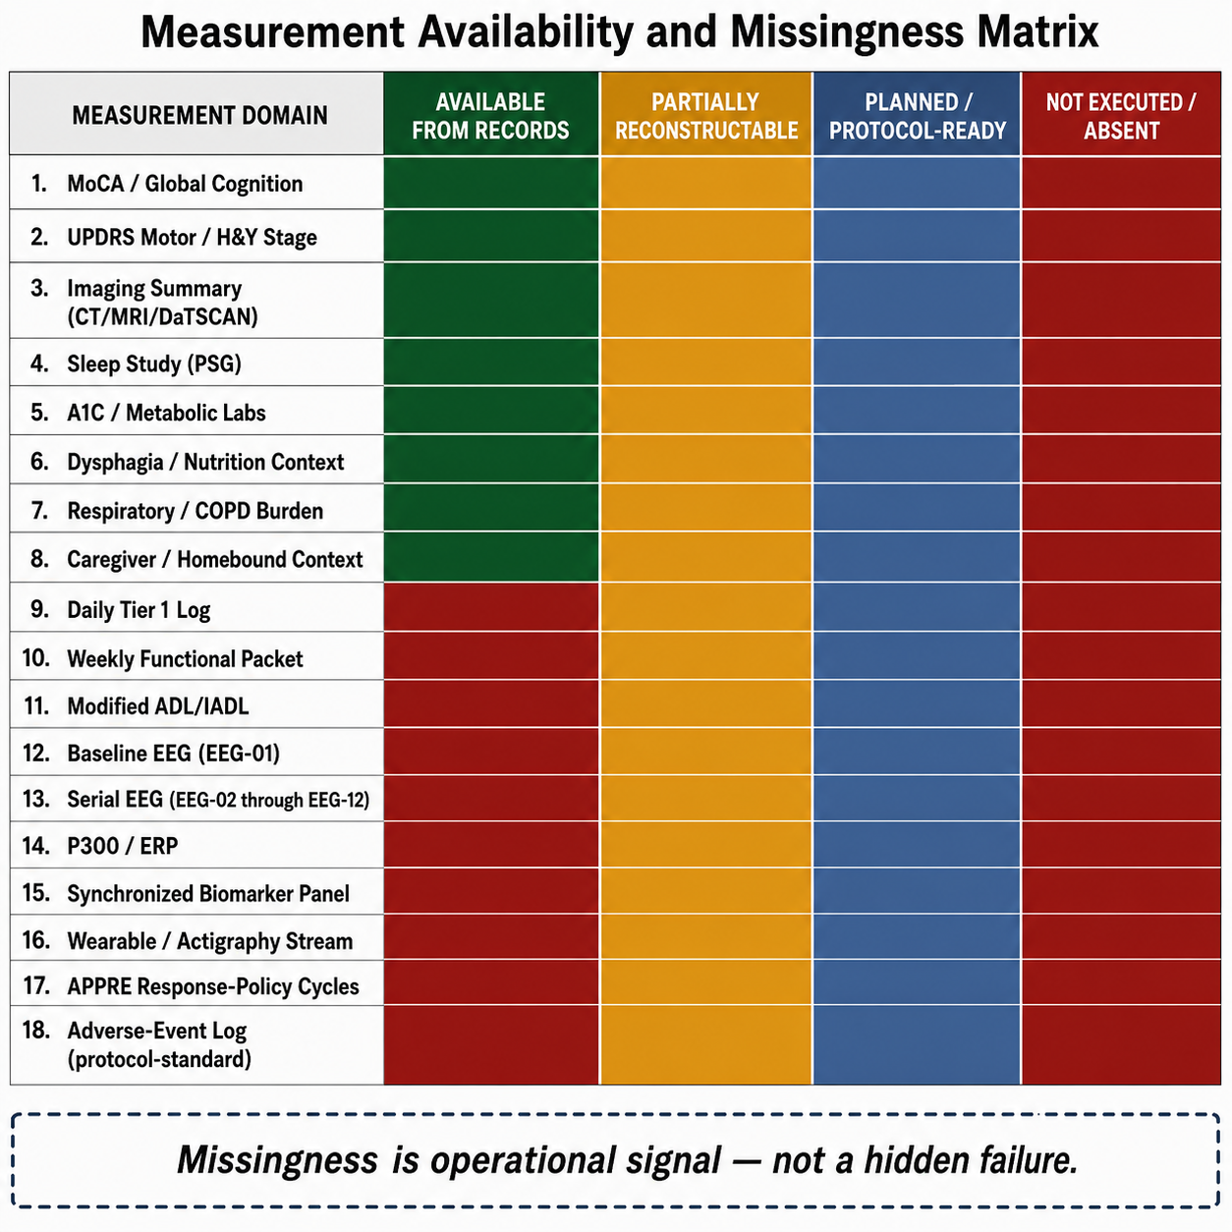
Figure 3. Measurement availability and missingness matrix. Missingness is treated as an operational signal rather than a hidden failure.

8. Measurement Architecture Mapping

8.1 Tier 1 Mapping
RAY-VASC Tier 1 is designed as a low-burden, caregiver-supported daily and weekly measurement layer. It captures cognition, motor function, falls, mood, sleep, respiratory burden, dysphagia, medication changes, adverse events, caregiver burden, functional status, and confounders.
For RAY-001, routine records allow partial retrospective mapping across several Tier 1 domains:
Cognition: severe impairment documented by MoCA 11/30; self-report reliability likely limited.
Mobility and falls: recurrent falls, gait impairment, Hoehn and Yahr stage 3, and UPDRS motor 52 were documented at baseline.
Sleep: moderate OSA, severe periodic limb movement burden, low sleep efficiency, and CPAP titration context documented.
Respiratory burden: chronic respiratory disease and inhaler use documented.
Dysphagia/nutrition: texture-modified diet, weight-loss burden, and speech-therapy referral documented.
Caregiver dependence: homebound status and need for another person’s attendance documented.
Medication and confounder context: medication complexity and clinical transitions documented.
However, retrospective mapping cannot substitute for daily or weekly prospective capture. No Tier 1 adherence rate, missingness rate, interpretable-cycle proportion, caregiver completion rate, or within-person fluctuation estimate can be calculated for RAY-001.

8.2 Tier 2 Mapping
The RAY-VASC Tier 2 layer, including serial EEG, event-related potentials, synchronized biomarker panels, and wearable streams, was fully specified at the protocol level but was not implemented for RAY-001. All Tier 2 references in this manuscript refer to protocol design and feasibility context, not to measures collected in this case.
Unexecuted Tier 2 elements included:
Baseline resting-state EEG.
P300 or other event-related potential testing.
Serial EEG schedule.
Biomarker collection synchronized to EEG.
Wearable data capture under valid-day rules.
Protocol-defined mechanistic biomarker panels.
Structured EEG-biomarker interpretation windows.
This distinction is critical. Tier 2 readiness existed on paper, not in the participant dataset. The manuscript therefore describes Tier 2 as planned architecture, not executed measurement.

8.3 APPRE Mapping
APPRE, the Algorithmic Personalization Predictive Response Engine, is described in this manuscript solely as a transparent schema-and-rules framework for data integrity, confounder annotation, and versioned response-policy documentation. It is not validated artificial intelligence, not clinical decision support, and not a medical device. For RAY-001, APPRE remained at the schema level; no prospective input-outcome cycles, optimization routines, or automated recommendations were executed.
APPRE component | RAY-001 baseline mapping | Execution status
Subject profile | Diagnostic categories, cognitive/motor severity, sleep/respiratory burden, dysphagia, caregiver dependence | Partially retrospectively mappable
Inputs | Sleep, exertion, social support, medication context, nutrition, lawful candidate inputs if present | Not prospectively logged
Outcomes | Cognition, motor/falls, mood, sleep, respiratory burden, ADL/IADL | Partially inferable from records; no prospective sequence
Confounders | Falls, infection risk, medication changes, sleep disruption, care transition | Partially inferable from routine records
Adverse events | Events may appear in records | Not logged in protocol-standard AE form
Response-policy documentation | Would require repeated input-outcome cycles | Not executed
Version log | Would require APPRE implementation | Not executed

APPRE is not described here as validated artificial intelligence, clinical decision support, a medical device, a recommender system, or a controlled-substance optimization system.

9. Care Transition and Timing Constraint
The central operational finding is the mismatch between protocol readiness and clinical reality.
The RAY-VASC architecture matured enough to define Tier 1 forms, Tier 2 EEG, biomarker schedules, APPRE schema logic, safety boundaries, and privacy governance. Conceptually, Phase 1 baseline capture could have begun at the Tier 1 level before EEG readiness. Practically, however, RAY-001 had already entered a narrowing window characterized by severe cognitive impairment, recurrent falls, dysphagia, respiratory burden, caregiver strain, and escalating care needs.
By the time the EEG and biomarker layers were operationally specified, RAY-001 had transitioned beyond the practical capacity to obtain a clean baseline EEG or initiate a complete prospective Phase 1 dataset. Initiating a high-burden protocol at that point would have risked adding burden without producing interpretable data. The decision not to force late protocol execution is framed as aligned with the RAY-VASC rule: safety before signal, governance before implementation, and measurement before interpretation.
This timing failure generates a future implementation rule: in complex PSP-spectrum or vascular Parkinsonian phenotypes, minimum viable Tier 1 baseline capture should begin as soon as caregiver support and consent or legally authorized representative pathways are available, even if Tier 2 EEG and biomarker infrastructure are still pending.

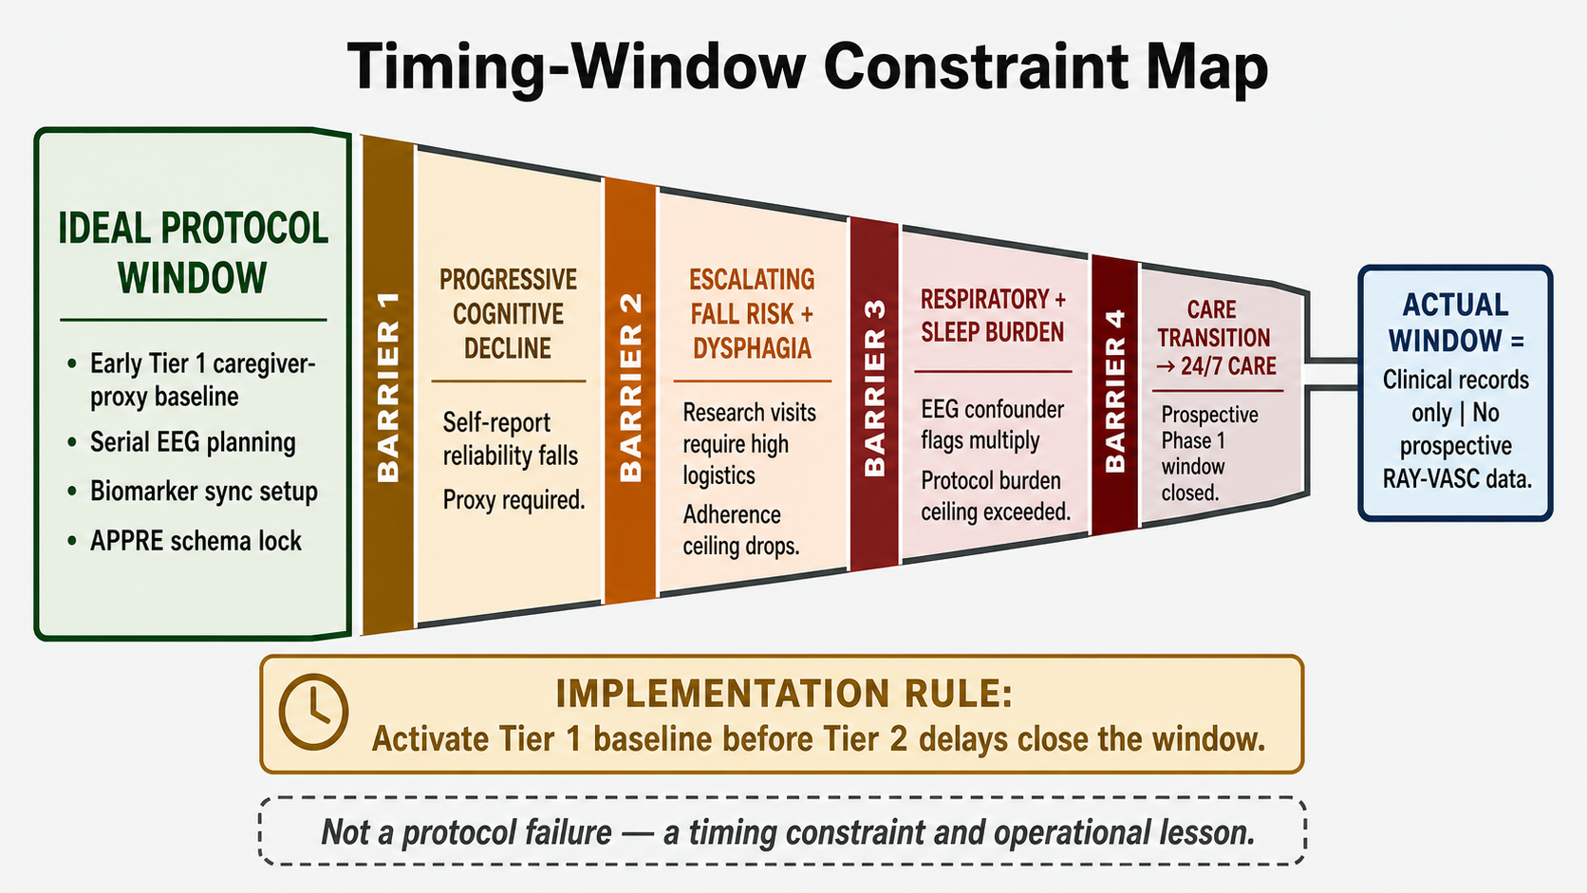
Figure 4. Timing-window constraint map. The figure illustrates a protocol timing constraint, not a treatment failure or outcome claim.

10. Discussion

10.1 What This Case Demonstrates
RAY-001 demonstrates that a richly characterized baseline can be scientifically useful even when a prospective protocol is not completed. The case shows how routine clinical records can support a structured baseline architecture map across cognition, motor burden, sleep, respiratory disease, dysphagia, vascular-metabolic risk, functional dependence, caregiver burden, and care setting.
The case also demonstrates that high-frequency N-of-1 measurement cannot wait indefinitely for advanced instrumentation. In a rapidly evolving phenotype, EEG and biomarkers add value only if captured before the timing window closes. If Tier 2 readiness delays Tier 1 activation, the protocol may lose the baseline entirely.
Finally, the case demonstrates that missingness is not always random. In RAY-001, missingness was produced by clinical deterioration, caregiver burden, homebound status, fall risk, dysphagia, respiratory complexity, and care transition. These are not administrative inconveniences. They are measurable feasibility variables.

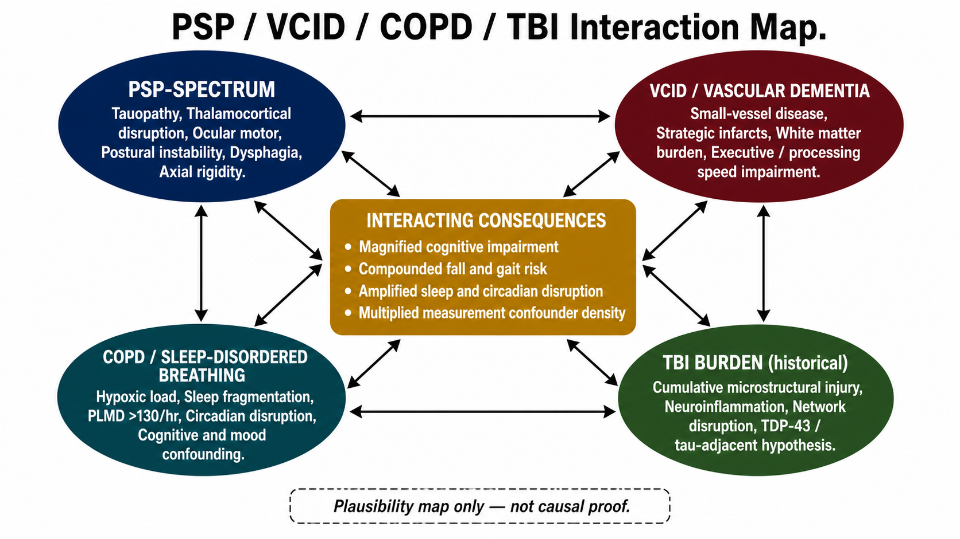
Figure 6. PSP / VCID / COPD / TBI interaction map. This is a mechanistic-context plausibility map only and is not causal proof.

10.2 What This Case Cannot Support
RAY-001 cannot support intervention-phase inference, treatment efficacy claims, longitudinal outcome tracking, causal conclusions, disease-modifying claims, reversal language, repair language, or cure claims.
There is no completed RAY-VASC Phase 1 dataset. There is no serial EEG trajectory. There is no synchronized biomarker panel. There is no wearable stream. There is no APPRE response-policy cycle. There is no protocol-defined Phase 2 or Phase 3 dataset. No observed clinical change can be attributed to the RAY-VASC protocol because the protocol was not prospectively executed for RAY-001.
Any historical clinical changes described in source records are therefore treated as baseline and contextual information, not as protocol outcomes.

10.3 Future Implementation Rules
Future RAY-VASC implementations should begin with a minimum viable Tier 1 baseline, then layer in Tier 2 when practical.
The minimum viable Tier 1 package should include:
Caregiver/proxy daily log.
Falls and near-falls log.
Sleep and respiratory burden log.
Medication-change log.
Acute-illness and infection confounder log.
Dysphagia, nutrition, and adherence annotation.
Weekly functional packet.
Adverse-event log.
One cognitive anchor.
One motor or functional anchor.
Caregiver-burden and setting-feasibility annotation.
Tier 2 should include EEG, event-related potentials, synchronized biomarkers, and wearables only when the subject, caregiver, and site can support them without delaying Tier 1 baseline activation.

10.4 Implications for the RAY-VASC Series
Paper 3 completes a necessary bridge in the RAY-VASC sequence. Paper 1 defines the framework. Paper 2 defines the protocol. Paper 3 documents why timing and baseline capture matter before outcome claims are possible. The next manuscripts can build from this discipline: APPRE as an open data architecture, the Regenerative Loop as a standalone theory, neurotrophic mycology as a graded evidence map, and the Three-Phase Plasticity Architecture as a staged protocol framework.

11. Patient and Family Perspective
The initial manuscript does not include a narrative patient or family reflection section. This is intentional. The present paper focuses on clinical baseline characterization, measurement architecture, data availability, missingness, and feasibility. A patient or family narrative can be prepared as a short de-identified revision addendum if required by a target journal and if consistent with the signed authorization and privacy-review pathway.

12. Consent and Privacy
Written authorization for publication of a privacy-preserving case characterization and measurement-feasibility analysis was obtained through the project’s governance pathway and is maintained in the internal governance record. Public reporting in this manuscript is restricted to de-identified or authorization-consistent summaries. No full date of birth, medical record numbers, addresses, facility identifiers, raw clinical report images, or portal screenshots are published. Relative timepoints are used instead of exact calendar dates unless a journal-specific requirement and privacy review justify more specific timing.
Informed consent or authorized representative permission for publication of this de-identified case report was obtained in accordance with applicable ethical and privacy requirements.

13. Open-Source Availability
De-identified protocol materials, forms, schemas, adverse-event templates, confounder logs, implementation documents, and analysis scaffolds are made available through the RAY-VASC open-science repository and related open-science infrastructure. Individual-level clinical records from RAY-001 are not publicly released without separate consent, privacy review, and governance approval. External teams implementing RAY-VASC must obtain local ethics review, consent pathways, privacy protections, adverse-event procedures, and safety monitoring appropriate to their setting.
Public RAY-VASC repository: https://github.com/onlygreentrades/ray-vasc-regenerative-loop

14. Limitations
This case has several limitations.
First, it is a single-case report based on retrospective synthesis of available records and protocol materials. Second, no complete prospective RAY-VASC Phase 1 dataset was captured. Third, no baseline EEG, serial EEG, P300/ERP, synchronized biomarker panel, wearable stream, APPRE response-policy cycle, or protocol-defined follow-up trajectory exists for RAY-001. Fourth, routine clinical records were not collected for the same purpose as RAY-VASC and cannot substitute for structured daily or weekly prospective measurement. Fifth, privacy-preserving banding reduces granularity. Sixth, the manuscript is CARE-aligned but is not a conventional intervention case report because it intentionally does not report intervention exposure or intervention outcome.
These limitations are also the manuscript’s operational contribution. The absence of prospective data is not used to imply an outcome signal. It is used to define a practical rule for future implementation: activate low-burden Tier 1 baseline capture early, then add Tier 2 layers when feasible.

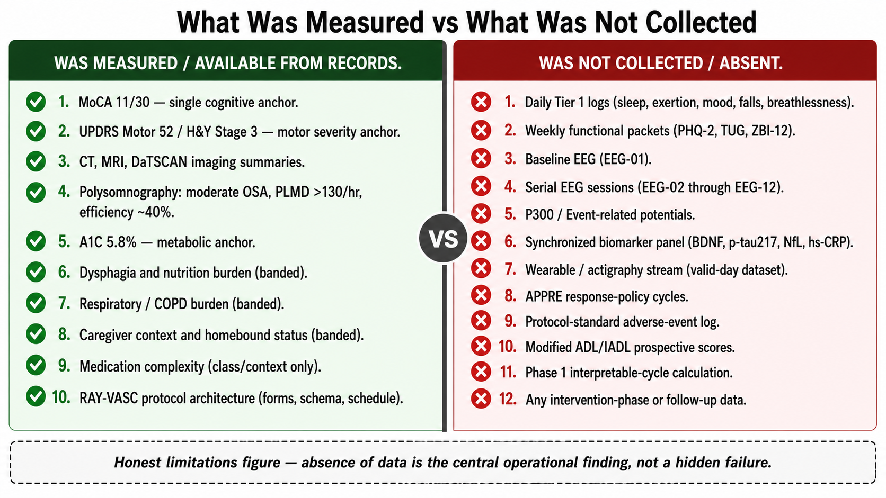
Figure 7. What was measured vs what was not collected. The figure summarizes the core limitation and operational finding of the case.

15. Future Directions
Future RAY-VASC cases should test whether early caregiver-supported Tier 1 capture can preserve baseline interpretability in complex neurovascular Parkinsonian phenotypes. A minimum future implementation should begin with daily caregiver/proxy logs, weekly functional packets, falls and near-falls tracking, sleep and respiratory burden annotation, medication-change logging, adverse-event capture, dysphagia and nutrition annotation, and at least one cognitive and one motor or functional anchor. Tier 2 EEG and synchronized biomarkers should be added when feasible, but not allowed to delay Tier 1 activation.
Future case series or small-series implementations should predefine missingness categories, caregiver-burden thresholds, escalation rules, and protocol-deviation language before data collection. This would allow RAY-VASC to distinguish measurement failure caused by design burden from missingness caused by clinical deterioration, care transition, adverse events, or caregiver-capacity limits.

16. Conclusion
RAY-001 is a baseline characterization and measurement-feasibility case, not an intervention-outcome report. The case documents a complex neurovascular Parkinsonian phenotype involving severe cognitive impairment, moderate-to-severe motor burden, recurrent falls, sleep-disordered breathing with severe periodic limb movement burden, respiratory disease, dysphagia, nutrition risk, vascular-metabolic context, medication complexity, caregiver dependence, and homebound status.
The central finding is operational: RAY-VASC measurement architecture reached protocol readiness after the originating case had already entered a narrowing clinical window. Because a clean prospective Phase 1 dataset, serial EEG, synchronized biomarkers, wearables, and APPRE response-policy cycles were not captured, no treatment efficacy inference is possible. The scientific value lies in disciplined baseline characterization, transparent missingness, and a protocol-timing rule for future work.
Future RAY-VASC implementations should begin caregiver-supported Tier 1 baseline capture as soon as consent or legally authorized representative pathways and caregiver structures are in place. EEG, biomarkers, and wearables should strengthen the design when feasible, but they should not delay baseline capture in rapidly evolving complex neurovascular disease.

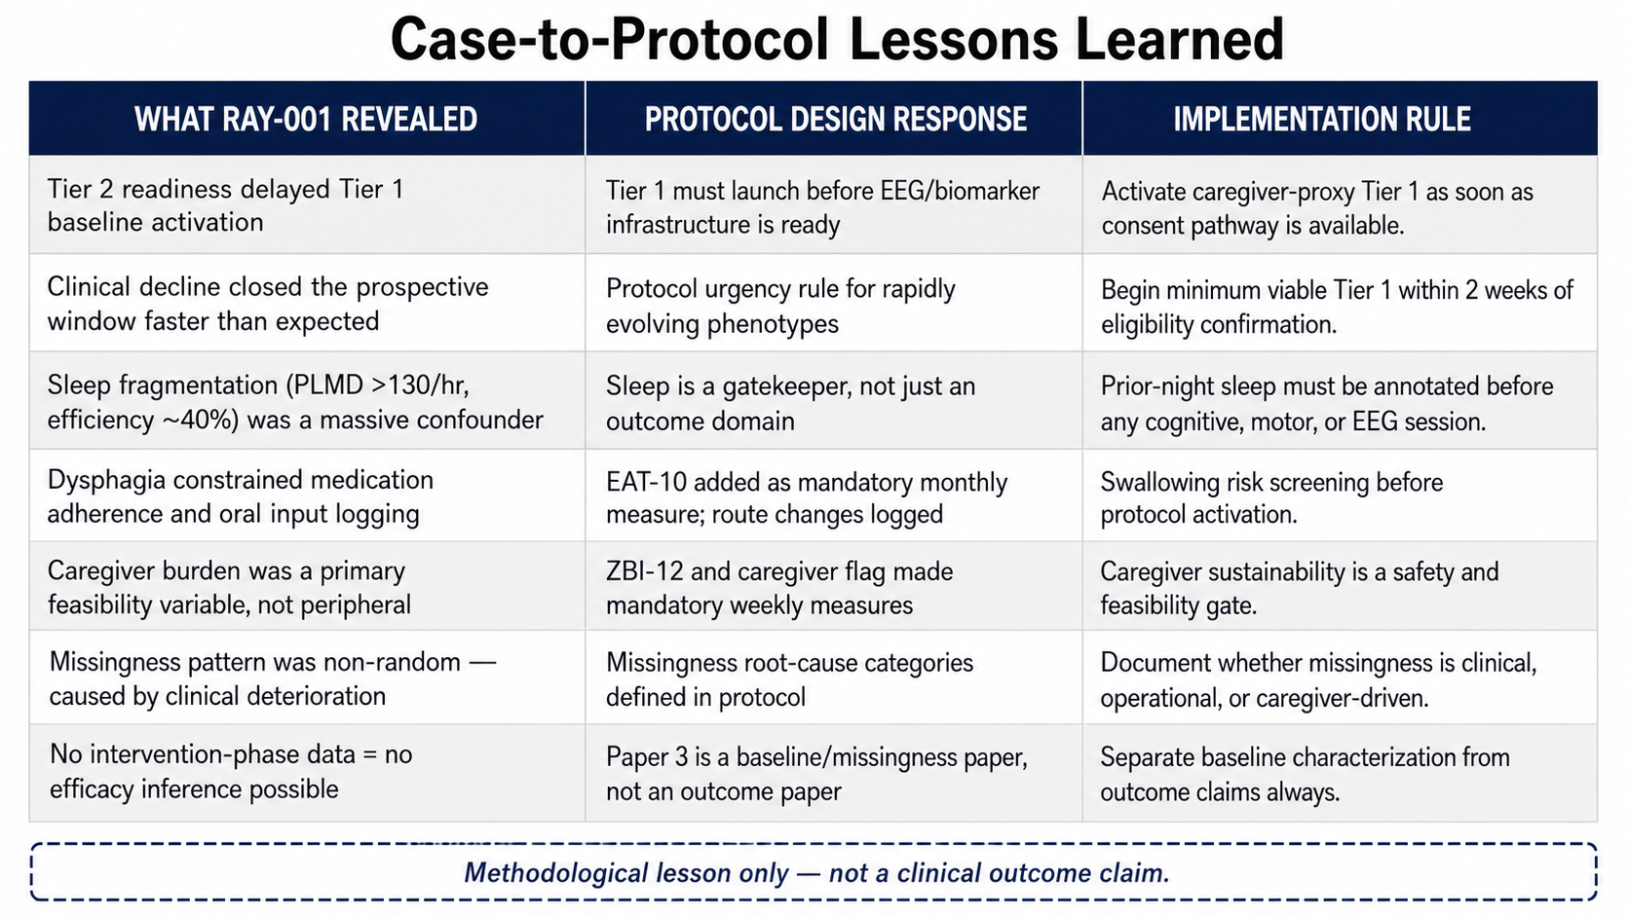
Figure 8. Case-to-protocol lessons learned. Lessons are methodological implementation rules only and do not represent clinical outcome claims.

Data Availability Statement
De-identified RAY-VASC protocol documents, study forms, data dictionaries, schemas, adverse-event templates, confounder logs, and implementation materials are available through the RAY-VASC open-science repository and related public research infrastructure. Individual-level clinical records for RAY-001 are not publicly available because they contain private health information and are outside the public data-sharing boundary.

Ethics Statement
This manuscript is a baseline characterization and measurement-feasibility case report. It does not report a prospective clinical intervention, a controlled-substance exposure, or clinical trial outcome data. Written authorization for a privacy-preserving case characterization is maintained in the internal project governance record. Any future prospective implementation involving external participants should occur only after local ethics review, IRB review or determination as applicable, informed consent or legally authorized representative consent, privacy review, adverse-event procedures, and appropriate clinical oversight.

Conflict of Interest Statement
The author is the originating researcher and operator of the RAY-VASC Regenerative Loop Research Program. The present manuscript makes no product, treatment, supplement, retreat, clinic, controlled-substance, or service claim. Any future institutional, advisory, employment, equity, product, or clinical relationships related to this work should be disclosed before submission according to target-journal requirements.

Acknowledgments
The RAY-VASC research program originated from the lived clinical and family context of RAY-001. Raymond A. Hornsby is the documented human origin of the work and is credited according to the project authorization and privacy-governance pathway. Family and caregiver contributions are acknowledged only within the limits of authorization, privacy protection, and journal requirements.

Disclaimer
This case report and the broader RAY-VASC framework are presented for research, measurement, and protocol-design purposes only. They do not constitute medical advice, legal advice, or a clinical treatment protocol. No claims of treatment efficacy, cure, reversal, recovery, repair, or disease modification are made. Any future implementation of RAY-VASC or related architectures requires independent clinical oversight, ethics review, and regulatory governance within the implementing institution’s jurisdiction. No sourcing, preparation, dosing, administration, procurement, conversion, or self-use instructions are provided for controlled substances.

Funding
This manuscript was prepared as part of a self-funded independent open-source research documentation program unless otherwise updated before submission. No commercial treatment service, clinic, retreat, supplement product, or controlled-substance service is part of this manuscript.

Author Contributions
Logan Henderson originated the RAY-VASC Regenerative Loop Research Program, designed the manuscript sequence, created the baseline characterization framework, synthesized the available case materials, drafted the manuscript, and prepared the open-source research architecture. Future co-author contributions, if added, should be specified according to journal requirements and actual role.

References
Clark, H. M., Stierwalt, J. A. G., Tosakulwong, N., Botha, H., Ali, F., Whitwell, J. L., & Josephs, K. A. (2020). Dysphagia in progressive supranuclear palsy. Dysphagia, 35(4), 667–676. https://doi.org/10.1007/s00455-019-10073-2
Gagnier, J. J., Kienle, G., Altman, D. G., Moher, D., Sox, H., Riley, D., & the CARE Group. (2013). The CARE guidelines: Consensus-based clinical case reporting guideline development. Journal of Medical Case Reports, 7, 223. https://doi.org/10.1186/1752-1947-7-223
Hamilton, O. K. L., Backhouse, E. V., Janssen, E., Jochems, A. C. C., Maher, C., Ritakari, T. E., Stevenson, A. J., Xia, L., Deary, I. J., Wardlaw, J. M., & Doubal, F. N. (2021). Cognitive impairment in sporadic cerebral small vessel disease: A systematic review and meta-analysis. Alzheimer’s & Dementia, 17(4), 665–685. https://doi.org/10.1002/alz.12221
Henderson, L. (2026a). The Brain That Remains: A Framework for Neuroplasticity, Residual Capacity, and Open-Source Protocol Design in Complex Neurodegenerative Disease. Manuscript submitted for publication.
Henderson, L. (2026b). RAY-VASC: A Multidomain N-of-1 and Small-Series Protocol for Complex Neurovascular Disease. OSF. https://doi.org/10.17605/OSF.IO/WESZY
Höglinger, G. U., Respondek, G., Stamelou, M., Kurz, C., Josephs, K. A., Lang, A. E., Mollenhauer, B., Müller, U., Nilsson, C., Whitwell, J. L., Arzberger, T., Englund, E., Gelpi, E., Giese, A., Irwin, D. J., Meissner, W. G., Pantelyat, A., Rajput, A., van Swieten, J. C., Troakes, C., Antonini, A., Bhatia, K. P., Bordelon, Y., Compta, Y., Corvol, J.-C., Colosimo, C., Dickson, D. W., Dodel, R., Ferguson, L., Grossman, M., Kassubek, J., Krismer, F., Levin, J., Lorenzl, S., Morris, H. R., Nestor, P., Oertel, W. H., Poewe, W., Rabinovici, G., Rowe, J. B., Schellenberg, G. D., Seppi, K., van Eimeren, T., Wenning, G. K., Boxer, A. L., Golbe, L. I., & Litvan, I. (2017). Clinical diagnosis of progressive supranuclear palsy: The Movement Disorder Society criteria. Movement Disorders, 32(6), 853–864. https://doi.org/10.1002/mds.26987
Kivipelto, M., Mangialasche, F., Snyder, H. M., Allegri, R., Andrieu, S., Arai, H., Baker, L., Belleville, S., Brodaty, H., Brucki, S. M., Calandri, I., Caramelli, P., Chen, C., Chertkow, H., Chew, E., Choi, S.-H., Chowdhary, N., Crivelli, L., D’Antonio, F., de Jager, C. A., Eriksdotter, M., Espeland, M. A., Feldman, H. H., Hartmanis, M., Hartmann, T., Heffernan, M., Henry, C. J., Hong, C. H., Hakansson, K., Iwatsubo, T., Jeong, J. H., Jimenez-Maggiora, G., Kivipelto, M., Mangialasche, F., Ngandu, T., Qiu, C., Raman, R., Rao, N., Ravindranath, V., Rosenberg, A., Sakurai, T., Scheltens, P., Schneider, L. S., Shahar, S., Stephen, R., Soininen, H., Solomon, A., Ter Riet, G., Yaffe, K., & Carrillo, M. C. (2020). World-Wide FINGERS Network: A global approach to risk reduction and prevention of dementia. Alzheimer’s & Dementia, 16(7), 1078–1094. https://doi.org/10.1002/alz.12123
Lajoie, A. C., Lafontaine, A. L., & Kaminska, M. (2020). Obstructive sleep apnea in neurodegenerative disorders: Current evidence in support of benefit from sleep apnea treatment. Journal of Clinical Medicine, 9(2), 297. https://doi.org/10.3390/jcm9020297
Ngandu, T., Lehtisalo, J., Solomon, A., Levälahti, E., Ahtiluoto, S., Antikainen, R., Bäckman, L., Hänninen, T., Jula, A., Laatikainen, T., Lindström, J., Mangialasche, F., Paajanen, T., Pajala, S., Peltonen, M., Rauramaa, R., Stigsdotter-Neely, A., Strandberg, T., Tuomilehto, J., Soininen, H., & Kivipelto, M. (2015). A 2-year multidomain intervention of diet, exercise, cognitive training, and vascular risk monitoring versus control to prevent cognitive decline in at-risk elderly people: A randomised controlled trial. The Lancet, 385(9984), 2255–2263. https://doi.org/10.1016/S0140-6736(15)60461-5
Riley, D. S., Barber, M. S., Kienle, G. S., Aronson, J. K., von Schoen-Angerer, T., Tugwell, P., Kiene, H., Helfand, M., Altman, D. G., Sox, H., Werthmann, P. G., Moher, D., Rison, R. A., Shamseer, L., Koch, C. A., Sun, G. H., Hanaway, P., Sudak, N. L., Kaszkin-Bettag, M., Carpenter, J. E., Gagnier, J. J., & CARE Group. (2017). CARE guidelines for case reports: Explanation and elaboration document. Journal of Clinical Epidemiology, 89, 218–235. https://doi.org/10.1016/j.jclinepi.2017.04.026
Rosenberg, A., Mangialasche, F., Ngandu, T., Solomon, A., & Kivipelto, M. (2020). Multidomain interventions to prevent cognitive impairment, Alzheimer’s disease, and dementia: From FINGER to World-Wide FINGERS. The Journal of Prevention of Alzheimer’s Disease, 7, 29–36. https://doi.org/10.14283/jpad.2019.41
Rowe, J. B., Holland, N., Rittman, T., & Ghosh, B. C. P. (2021). Progressive supranuclear palsy: Diagnosis and management. Practical Neurology, 21(5), 376–383. https://doi.org/10.1136/practneurol-2020-002794
Zotin, M. C. Z., Sveikata, L., Viswanathan, A., & Yilmaz, P. (2021). Cerebral small vessel disease and vascular cognitive impairment: From diagnosis to management. Current Opinion in Neurology, 34(2), 246–257. https://doi.org/10.1097/WCO.0000000000000913

