APPRE:
A Schema-and-Rules Framework for Adaptive Measurement, Confounder Annotation, and Response-Policy Documentation in Complex Neurovascular Disease
Logan Henderson
Independent Researcher, Houston, Texas, United States
Correspondence: Logan Henderson
Abstract
A single failing pathway rarely explains complex neurovascular and mixed neurodegenerative-vascular phenotypes. Cognition, mobility, sleep, respiratory burden, mood, caregiver support, medication context, adverse events, missingness, and acute illness can interact as one coupled clinical and operational system. This paper introduces APPRE as a schema-and-rules framework for adaptive measurement, confounder annotation, adverse-event capture, missingness handling, provenance, synthetic-data release, and response-policy documentation in RAY-VASC-style N-of-1 and small-series research. APPRE maps subject profile, candidate inputs, repeated outcomes, confounders, adverse events, missingness, response-policy records, and version logs into a traceable documentation architecture. The framework is standards-aware, with conceptual alignment to FAIR data principles, W3C PROV-style provenance logic, selected HL7 FHIR resource analogues, and REDCap or other structured capture substrates. No clinical outcomes are reported. APPRE is not validated artificial intelligence, not clinical decision support, not Software as a Medical Device, not a treatment optimizer, and not a longevity product. Controlled-substance exposure, if present in future lawful research implementations, is documented only as as-administered observational data under separate lawful, clinician-governed, ethics-approved oversight. The contribution is architectural: a reproducible, de-identified, open documentation system for interpreting repeated measures without compromising safety, confounder control, missingness, or provenance context.
Keywords: APPRE; RAY-VASC; N-of-1; small-series protocol; complex neurovascular disease; schema-and-rules framework; confounders; adverse events; missingness; provenance; response-policy documentation; FAIR; W3C PROV; HL7 FHIR; REDCap; open science
1. Introduction
Complex neurovascular disease is not operationally simple. A participant with vascular cognitive impairment, PSP-spectrum features, Parkinsonian motor burden, sleep fragmentation, respiratory disease, dysphagia, mood symptoms, polypharmacy, fall risk, caregiver dependence, and recurrent acute illness does not live inside separate diagnostic compartments. Cognition changes with sleep, respiratory burden, medication timing, infection, fatigue, caregiver stability, and care setting. Gait changes with oxygenation, bradykinesia, recent falls, injury, exertion tolerance, environmental hazards, and sleep debt. A protocol that treats these domains as independent risks confusing signal with noise.
The practical problem is not only that complex phenotypes generate many measurements. The practical problem is that context is often unstructured. A daily log, wearable export, EEG session, biomarker draw, cognitive screen, fall report, or caregiver note becomes interpretable only when timing, reporter role, missingness, safety context, medication context, and confounder status are preserved.
APPRE is introduced to address that gap. APPRE is a schema-and-rules framework for organizing repeated measurements, confounders, adverse events, missingness, provenance, synthetic examples, and response-policy documentation in complex neurovascular research. It is a documentation architecture, not an autonomous inference system. It records what was measured, when it was measured, who reported it, what was missing, what may have confounded it, what safety events occurred, what rule version was active, and why a response-policy update was documented.
This manuscript is Paper 4 in the RAY-VASC Regenerative Loop series. Paper 1 established the residual-capacity and open-source protocol framework. Paper 2 translated that framework into a prospective N-of-1 and small-series protocol. Paper 3 documented the baseline characterization and timing-window problem that occurs when a complex neurovascular phenotype is richly characterized, but prospective baseline capture begins too late. Paper 4 publishes the data architecture needed to prevent that operational failure from repeating.
2. Position in the RAY-VASC Publication Series
APPRE sits inside the RAY-VASC publication sequence as the methods and data-architecture paper. The sequence moves from framework to protocol, then to baseline feasibility, and finally to reusable measurement architecture.
Paper | Public role | APPRE relationship
Paper 1: The Brain That Remains | Framework and hypothesis paper | Defines the need for adaptive longitudinal measurement without efficacy claims.
Paper 2: RAY-VASC protocol | N-of-1 and small-series protocol | Introduces APPRE as schema-and-rules support for measurement, safety, and response-policy documentation.
Paper 3: RAY-001 baseline characterization | Baseline and feasibility paper | Shows why early capture, missingness, and confounder architecture matter before prospective implementation.
Paper 4: APPRE methods paper | Present manuscript | Publishes the schema families, validation rules, figures, synthetic data logic, and release package.
3. Design Objectives and Claim Boundary
APPRE has five design objectives. First, it organizes repeated measures across domains that interact in complex neurovascular phenotypes: cognition, mobility, falls, mood, sleep, respiratory burden, dysphagia, caregiver support, medication context, adverse events, EEG, biomarkers, and wearable signals. Second, it preserves context by making missingness, confounders, adverse events, protocol deviations, proxy reporting, and device failure structured data rather than narrative afterthoughts.
Third, APPRE supports versioned response-policy documentation. A response policy is not an automated treatment recommendation. It is a documented protocol posture: continue, pause, simplify, repeat, exclude, review, escalate, amend, or update. Fourth, APPRE is implementation-agnostic and can be represented in paper forms, spreadsheets, REDCap-style systems, ePRO systems, databases, or future software. Fifth, APPRE is built for open-science release through de-identified manuscripts, figures, schemas, synthetic datasets, validation rules, and governance files.
APPRE is not validated artificial intelligence, not clinical decision support, not a medical device, not Software as a Medical Device, and not a treatment optimizer. APPRE does not diagnose, prescribe, recommend, decide, optimize, or replace clinician judgment. Controlled-substance exposure, if present in future lawful research implementations, is documented only as as-administered observational data under separate lawful, clinician-governed, ethics-approved oversight. APPRE does not recommend, adjust, tune, or optimize controlled-substance exposure.
4. APPRE Conceptual Model
The APPRE core loop is deliberately simple: Subject Profile -> Candidate Inputs -> Outcomes -> Confounders / Adverse Events / Missingness -> Updated Response Policy -> Version Log. The loop does not imply autonomy. APPRE records what the protocol team documents and why; it does not decide what should happen.
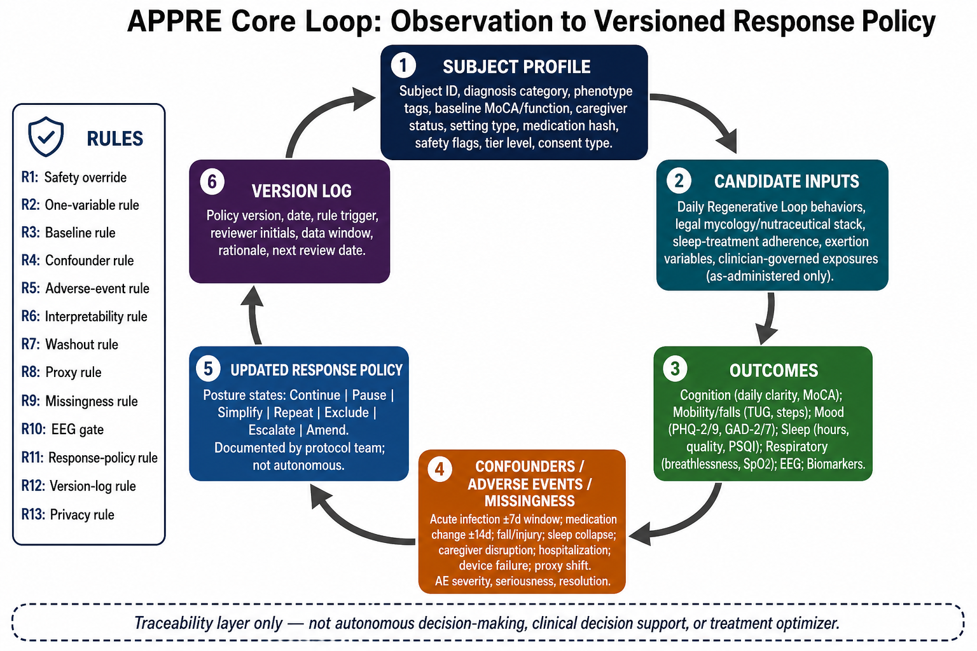
Figure 1. APPRE core loop. APPRE maps repeated observations into a traceable documentation loop: Subject Profile -> Candidate Inputs -> Outcomes -> Confounders / Adverse Events / Missingness -> Updated Response Policy -> Version Log. The loop is not an autonomous control system, clinical decision-support tool, or treatment optimizer. It is a schema-and-rules structure for preserving context, interpretation status, and response-policy provenance.
5. APPRE Object Model and Schema Architecture
APPRE is organized as a family of linked schema objects. Measurement streams are separated from interpretation controls so that repeated observations are not interpreted without safety, missingness, confounders, and provenance context.
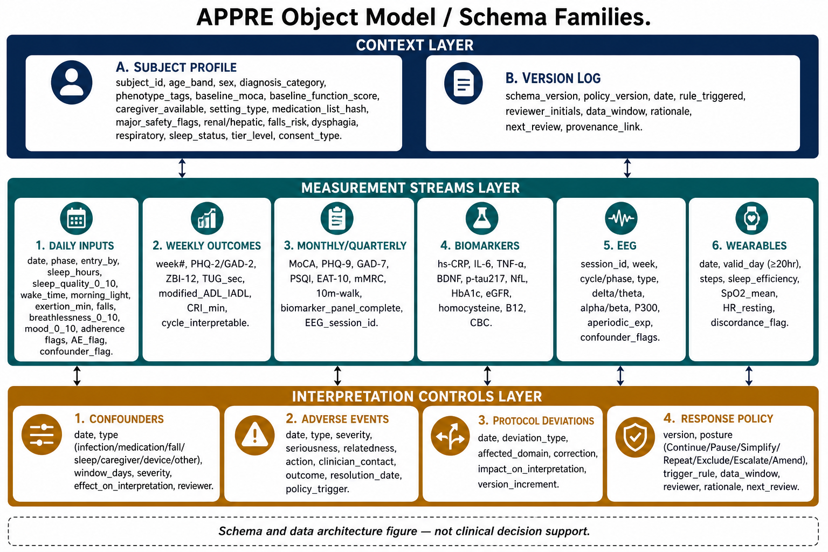
Figure 2. APPRE schema-family architecture. APPRE organizes implementation data into schema families distributed across context, measurement streams, and interpretation controls. The structure separates repeated observations from confounders, adverse events, protocol deviations, response-policy records, and version logs.
Layer | Schema families | Purpose
Context | Subject Profile; Version Log | Defines participant context, study identifiers, baseline posture, and provenance links.
Measurement streams | Daily Inputs; Weekly Outcomes; Monthly/Quarterly Measures; Biomarkers; EEG; Wearables | Captures low-burden repeated measures and higher-burden scheduled assessments.
Interpretation controls | Confounders; Adverse Events; Protocol Deviations; Response Policy | Determines whether a window is clean, partial, confounded, safety-review-only, or ready for descriptive candidate-signal review.
6. Behaviorome-Inspired Longitudinal Signal Architecture
High-frequency longitudinal measurement is changing how biological trajectories can be studied. Recent behaviorome work in vertebrate model systems shows how continuous behavioral recording can reveal structured individual trajectories and state transitions. Those findings do not automatically transfer to human neurovascular disease. The methodological lesson does: repeated state signals become more interpretable when captured consistently and linked to context.
APPRE adapts that logic as a human neurovascular research data architecture. The human analogue proposed here is a responseome: a structured, longitudinal representation of how a person's measurable state changes across biological, behavioral, safety, and operational domains. The responseome is not a biological age clock, not a lifespan predictor, not a diagnostic model, and not a clinical response predictor. It is a documentation architecture for organizing within-person state signals.
Human sensing is noisier than controlled animal video tracking. APPRE therefore leans harder on confounder annotation, missingness classification, adverse-event separation, caregiver/proxy reporting, and response-policy versioning than a controlled laboratory platform would need to do.
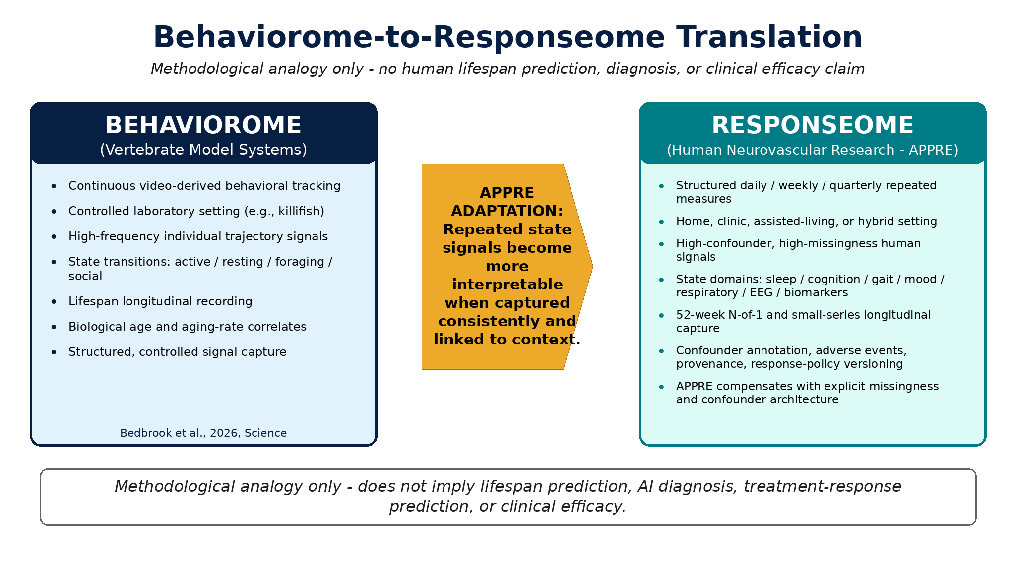
Figure 3. Behaviorome-to-responseome translation. APPRE adapts behaviorome logic into a human neurovascular research-data architecture. In place of continuous video-derived animal behavior, APPRE uses repeated human measures - sleep, activity, gait, falls, cognition, mood, respiratory burden, EEG, biomarkers, adverse events, wearables, and caregiver-supported reports - as a multidomain responseome. The figure illustrates the methodological analogy only; it does not imply human lifespan prediction, diagnosis, treatment-response prediction, or clinical efficacy.
7. Data Capture and Quality-Control Workflow
The APPRE notebook skeleton is structured as a longitudinal measurement engine rather than a binary classifier. Eight schema layers are ingested as separate dataframes: daily logs, weekly outcomes, monthly/quarterly measures, biomarkers, EEG, wearables, confounders, adverse events, and the response-policy log. Missingness is a first-class data element through fields such as missing_flag and completed_by_role. This is essential when cognition or motor function limits self-report and caregiver or mixed reporting becomes necessary.
The quality-control summary should report daily completion rate, confounded days, adverse-event days, reporter role distribution, and response-policy versions as structured outputs. These outputs are designed for audit and feasibility review, not for efficacy claims.
8. Validation Rules and Interpretable Windows
APPRE validation is documentation quality control. A record may be valid as entered but still belong to a window that should not be interpreted as a candidate signal because of acute illness, adverse events, medication changes, device failure, or major missingness. A window may still be valuable for feasibility and burden reporting even when it is not appropriate for candidate-signal interpretation.
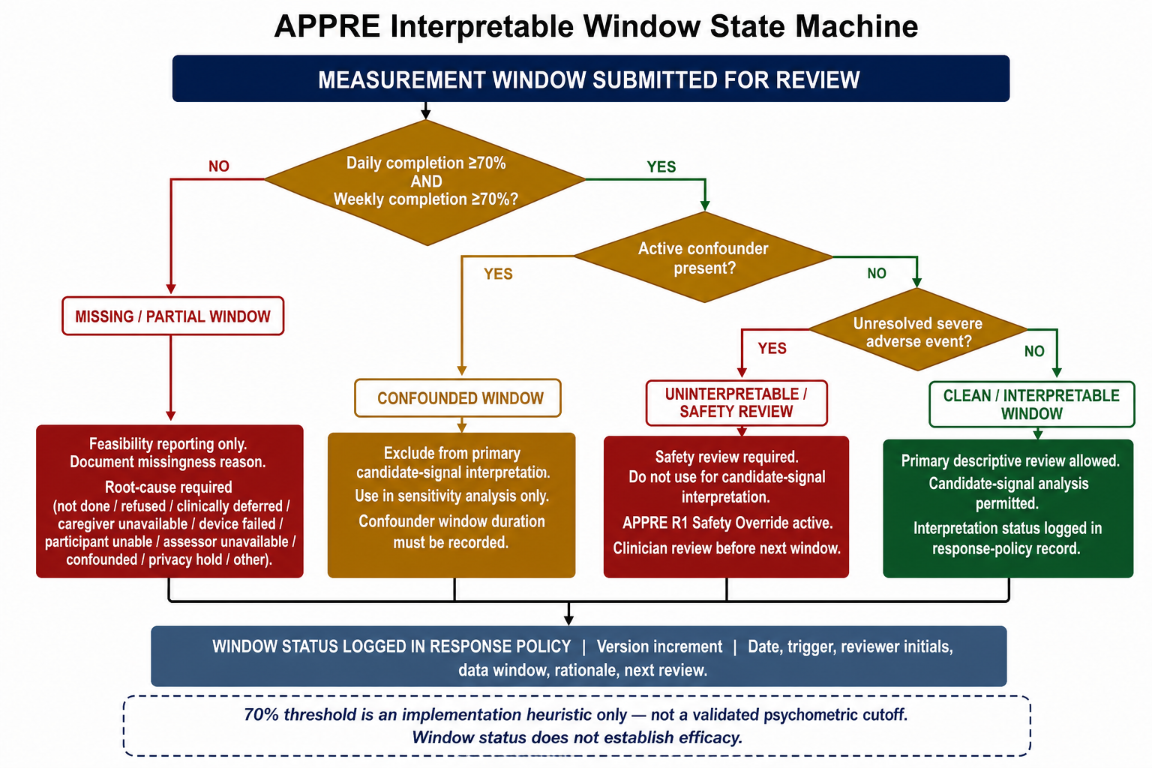
Figure 4. APPRE interpretable-window state model. APPRE classifies measurement windows as clean, partial, confounded, missing, or uninterpretable. The default 70% daily/weekly completion threshold is an implementation heuristic, not a validated psychometric cutoff. Window status does not establish efficacy, disease modification, recovery, or clinical significance.
Window status | Operational rule | Use
Clean / interpretable | Minimum completion reached, no active confounder, no unresolved severe adverse event. | Primary descriptive review; candidate-signal analysis allowed.
Missing / partial | Minimum completion not reached or missingness reason unresolved. | Feasibility reporting only; document missingness reason.
Confounded | Active infection, medication change, care transition, device failure, or other confounder. | Exclude from primary interpretation or use sensitivity-only.
Uninterpretable / safety review | Severe adverse event active or unresolved. | Safety review required; do not use for candidate-signal interpretation.
9. Missingness Model
Missingness is not a nuisance variable in APPRE. In complex neurovascular research, missingness may indicate fatigue, caregiver overload, hospitalization, cognitive fluctuation, device failure, dysphagia burden, acute illness, mood collapse, respiratory exacerbation, transition to higher care, or protocol burden. Treating all missingness as generic absence destroys interpretability.
APPRE missingness categories include not done, not available, refused, clinically deferred, caregiver unavailable, participant unable, technically failed, device not worn, assessor unavailable, confounded window, privacy hold, and other documented reasons. Missingness should be summarized at the field, row, window, and phase levels.
10. Confounder Annotation
A confounder is a contextual event or state that may change the interpretation of a measurement window. Common confounders include acute infection, medication change, hospitalization, fall, injury, sleep collapse, respiratory exacerbation, device failure, caregiver disruption, travel, care-setting change, major stressor, dysphagia disruption, and assessment-mode change. Confounders do not automatically invalidate a window; they trigger review and determine whether the window remains interpretable, becomes sensitivity-only, or should be excluded from primary interpretation.
11. Adverse-Event Structure
Adverse events are documented separately from routine outcomes. A fall is not merely a weekly mobility score. A hospitalization is not merely missingness. A severe respiratory event is not merely a high breathlessness score. APPRE adverse-event records preserve event type, severity, seriousness, relatedness assessment where applicable, action taken, clinician contact, urgent-care or emergency evaluation, outcome status, resolution date, response-policy trigger, reviewer role, and version-log link.
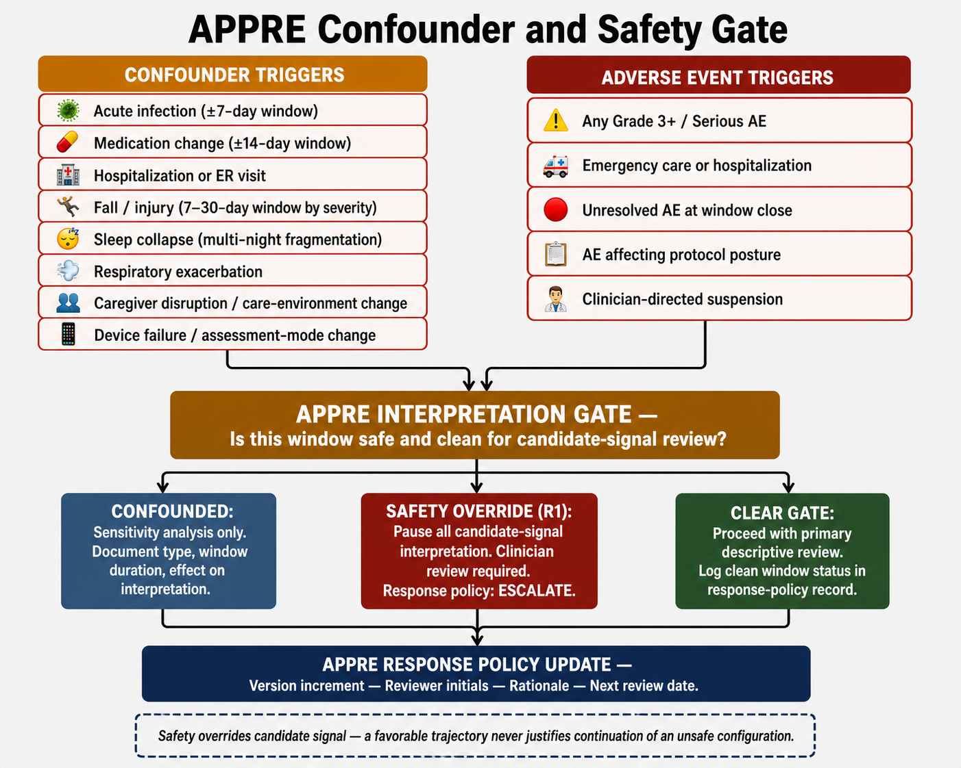
Figure 5. Confounder and adverse-event interpretation gate. APPRE treats confounders and adverse events as first-class data objects. Infection, medication changes, falls, sleep collapse, respiratory exacerbation, device failure, caregiver disruption, and testing irregularities can change the interpretation status of a measurement window. Safety overrides candidate signal: a favorable trajectory never justifies continuation of a configuration that creates unacceptable safety risk.
12. Response-Policy Versioning
A response policy is the documented protocol posture after review of data, safety, missingness, and confounders. It does not prescribe treatment. It does not replace clinician judgment. It does not produce autonomous recommendations. Response-policy states may include continue current capture, simplify daily fields, pause nonessential measurement burden, repeat baseline window, repeat confounded window, escalate safety review, defer phase transition, annotate a window as sensitivity-only, document protocol deviation, amend forms, update release metadata, or close a cycle summary.
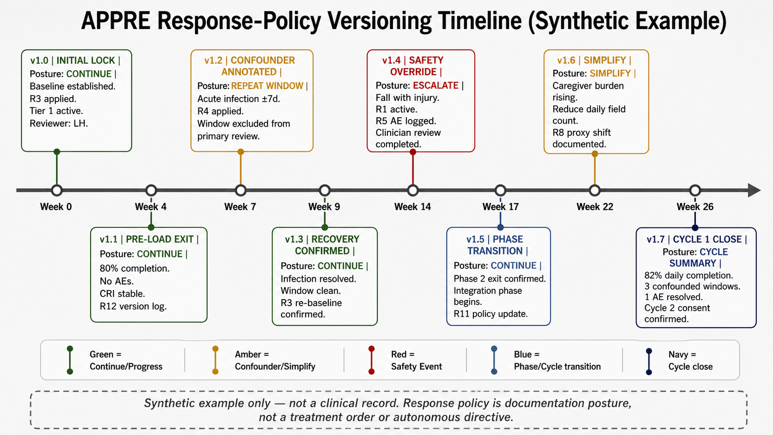
Figure 6. Response-policy versioning timeline. APPRE records protocol posture as a versioned documentation artifact. A response-policy update may document continuation, pause, simplification, repeated measurement, exclusion of a confounded window, clinician review, missingness-rule update, or schema change. It is not a treatment order, an autonomous decision, or a clinical directive.
Response-policy state | Meaning | Boundary
Continue | Maintain current measurement posture. | Documentation of protocol status only.
Pause | Temporarily suspend a candidate input or measurement burden under review. | Not an autonomous instruction.
Simplify | Reduce form burden or field count for feasibility/safety. | Operational documentation.
Repeat window | Repeat a confounded or incomplete window after recovery or stabilization. | No efficacy inference.
Escalate review | Trigger clinician/protocol-team review because of safety or interpretability concern. | Safety overrides candidate signal.
Amend version | Update schema, missingness rule, or response-policy version with rationale. | Versioned provenance, not treatment optimization.
13. RAY-VASC Implementation Cadence
At enrollment, APPRE initializes Subject Profile, Baseline Phenotype, Medication Context, Safety Flags, Consent/Proxy status, Tier Level, Reporter Role, and initial Response Policy records. During Weeks 0-4, staff or caregivers complete daily logs, weekly outcomes, adverse-event checks, medication-change logs, and confounder entries. At phase transition, APPRE generates a summary of completion, missingness, confounders, adverse events, caregiver burden, and readiness for the next window.
During governed exposure windows, if any are separately activated under lawful clinician-governed ethics-approved oversight, APPRE records exposure context only as administered observational documentation. It does not adjust controlled-substance exposure, provide dosing logic, or recommend activation of a governed window.
14. Synthetic Notebook Metrics and Candidate-Signal Review
The APPRE notebook may include synthetic composite metrics to show how schema outputs can support decomposable measurement review. One example is a Primary Response Score (PRS) that combines proportional-delta changes in cognition, mood, sleep, motor burden, respiratory burden, and safety penalty. This PRS is a synthetic notebook demonstration only. It is not part of APPRE’s core standard, not a validated endpoint, not a responder definition, and not an inference rule.
In the notebook, deterministic rules such as ADVANCE, HOLD, REDUCE, STOP, RETEST, and ESCALATE_MONITORING are used only to demonstrate how response-policy records can be generated from synthetic data. Confounded windows return RETEST automatically. The 0.3 SD or proportional-delta equivalent threshold is explicitly labeled as an exploratory heuristic only, not a validated responder criterion.
Future Bayesian, mixed-effects, LightGBM, SHAP, or other analytic layers remain out of scope unless multi-subject or multi-block data density, governance review, intended-use definition, validation, and regulatory assessment are completed separately.
15. Small-Series Aggregation
APPRE is built for N-of-1 research but supports small-series expansion. Each participant maintains a complete APPRE object: subject profile, repeated measures, missingness, confounders, adverse events, protocol deviations, response-policy versions, and version logs. Aggregation occurs above the participant level. The series-level layer summarizes feasibility, missingness, confounder density, adverse-event completeness, response-policy stability, and measurement burden without collapsing individual trajectories into one pooled narrative.
16. Standards Alignment
APPRE is standards-aware but not standards-certified. It is aligned conceptually with FAIR data principles by emphasizing stable identifiers, versioned schemas, data dictionaries, machine-readable metadata, synthetic examples, and repository-based release packages. It uses W3C PROV-style provenance logic by treating records as entities, collection and review as activities, and participants, caregivers, reviewers, or site teams as agents. It maps to selected HL7 FHIR resource analogues for implementation planning only, and it can be implemented in REDCap or other structured capture substrates.
For example, a weekly APPRE outcome row could map conceptually to a FHIR Observation for a timed mobility measure, while a corresponding Provenance-like record documents the assessor role, collection date, and review activity. This example is conceptual and partial; APPRE is not a FHIR-native implementation and not a formal FHIR implementation guide.
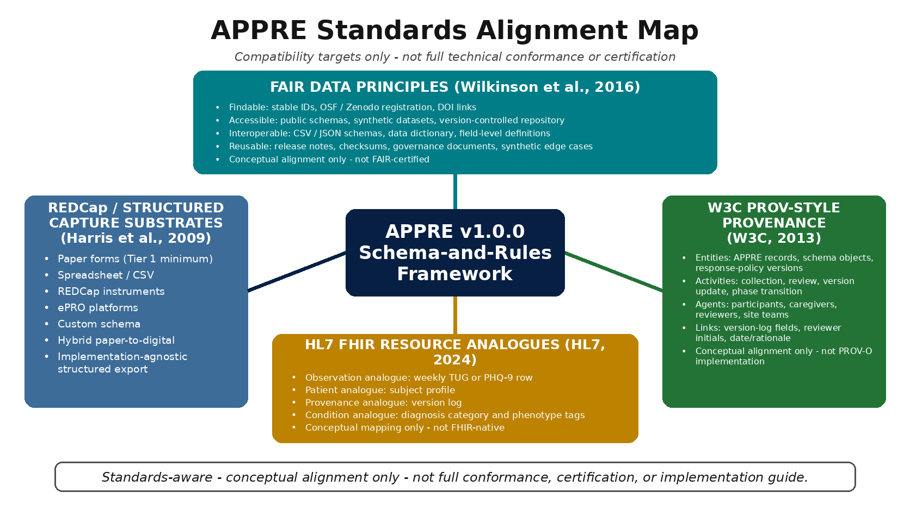
Figure 7. APPRE standards-alignment map. APPRE is designed for conceptual alignment with FAIR data principles, W3C PROV-style provenance logic, selected HL7 FHIR resource analogues, and REDCap or other structured capture systems. The figure shows compatibility targets only; APPRE is not a formal FHIR implementation guide and does not claim full technical conformance.
17. Synthetic Dataset and Open-Source Release Package
A public APPRE release should include synthetic data. Synthetic data allows external teams to test schema structure, validation rules, joins, missingness handling, confounder logic, adverse-event capture, and response-policy versioning without exposing identifiable clinical records. Synthetic data should preserve edge cases such as clean baseline windows, sleep-collapse weeks, falls without injury, medication-change confounders, acute illness confounders, missed daily logs, device non-wear, caregiver proxy shifts, response-policy version increments, protocol deviations, phase-transition summaries, and version-log entries.

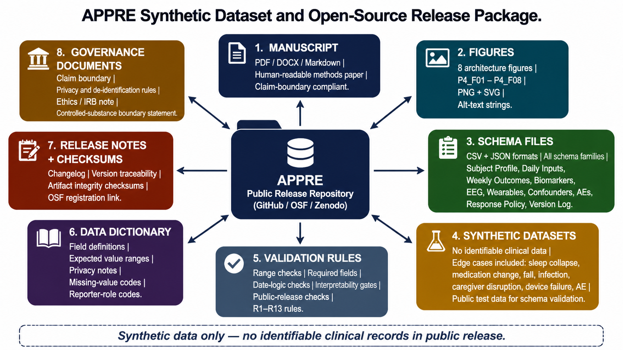
Figure 8. APPRE synthetic dataset and reproducibility package. APPRE should be released with public schemas, synthetic datasets, validation rules, analysis templates, governance documents, release notes, and a manifest. Synthetic data allow external reviewers to inspect schema behavior, validation rules, missingness handling, confounder logic, and response-policy versioning without exposing identifiable clinical data.
Release artifact | Purpose
Manuscript PDF/DOCX/Markdown | Human-readable methods paper and source copy.
Figures | Architecture maps for conceptual model, schema family, validation, safety, versioning, standards, and release package.
Schema CSV/JSON files | Machine-readable APPRE structure for implementation.
Synthetic datasets | Public test data with no identifiable clinical records.
Validation rules | Range checks, required fields, date logic, interpretability gates, and public-release checks.
Data dictionary | Field definitions, expected values, and privacy notes.
Release notes and checksums | Version traceability and artifact integrity.
18. Security, Privacy, and Release Governance
APPRE is de-identification-friendly by design. Public tables should use pseudonymous identifiers and should not include names, addresses, full dates of birth, medical record numbers, portal screenshots, raw clinical reports, identifiable free text, or unreviewed exports. Minimum safeguards include secure storage, encryption at rest where available, encryption in transit for web-based tools, role-based access, least-privilege permissions, audit logging, release review before public upload, and separation of raw source records from public schemas.
Public sharing should be limited to manuscripts, protocols, forms, schemas, synthetic datasets, validation rules, reproducibility checklists, and governance documents unless separate consent and ethics review authorize additional sharing. Raw identifiable clinical documents should not be released publicly.
19. Future Software and AI Pathway
APPRE is published here as a research data architecture. Future software, dashboards, validation tools, rules engines, workflow systems, or AI-assisted research data tools may build on this architecture. Those downstream implementations are not validated by this manuscript. Future implementation requires intended-use definition, user-role definition, locked input/output specification, technical validation, usability and human-factors review, privacy and cybersecurity review, risk classification, regulatory assessment, prospective evaluation, governance for updates, and monitoring for misuse.
No future APPRE implementation should be described as clinical decision support, Software as a Medical Device, validated AI, predictive medical software, or treatment optimizer unless it undergoes separate validation and regulatory review appropriate to that claim.
20. Limitations
First, APPRE is a proposed data architecture, not a validated software system. Its utility must be tested through implementation, external review, and prospective use.
Second, APPRE does not solve the statistical limitations of N-of-1 research. It improves documentation quality but does not create causal certainty.
Third, the responseome framing is methodological only. It does not validate lifespan prediction, diagnosis, treatment-response prediction, or clinical efficacy.
Fourth, FHIR mapping is conceptual and partial. It is not a formal implementation guide.
Fifth, APPRE does not validate any intervention, candidate input, mycology stack, controlled-substance exposure, lifestyle pattern, or clinical protocol.
21. Discussion
Paper 4 completes the first operational bridge in the RAY-VASC sequence. Paper 1 established the framework. Paper 2 built the protocol. Paper 3 showed why baseline timing and missingness matter. Paper 4 publishes the data architecture required to make the protocol auditable.
The core argument is straightforward: complex adaptive protocols cannot be credible if context is not structured. A daily score without a sleep context is weak. A gait measure without a fall context is incomplete. A biomarker without an illness context is fragile. A missed entry without a missingness reason is ambiguous. A phase transition without response-policy versioning is not reproducible. APPRE turns those operational realities into schema objects.
APPRE’s strongest contribution is not algorithmic sophistication. Its strongest contribution is discipline. It forces the protocol team to record what changed, what was missing, what happened, what may have confounded interpretation, what safety events occurred, what policy version was active, and why the next documented protocol posture changed.
22. Data and Code Availability
Public release materials are intended to include the manuscript, figures, schemas, validation rules, synthetic datasets, analysis templates, changelog, citation metadata, and governance documents through GitHub, OSF, Zenodo, or equivalent archival repositories. Raw identifiable clinical data will not be publicly released. Any additional sharing requires separate consent, privacy review, ethics governance, and applicable institutional or legal review.
23. Ethics and Governance
This manuscript reports methods and data architecture. It does not present prospective interventional human outcomes. Any external prospective implementation intended to contribute to generalizable knowledge requires local ethics review, IRB review, or formal determination before enrollment. Public sharing is limited to de-identified materials, synthetic data, public manuscripts, schemas, and governance documents unless separate consent and review authorize more.
24. Conflicts of Interest
Logan Henderson is the originating researcher and architect of the RAY-VASC Regenerative Loop and APPRE framework. Future software, educational, or platform development may build on APPRE under separate governance, validation, regulatory, and legal review. No clinical product is validated in this manuscript.
25. Funding
No external funding is reported for this manuscript.
26. Author Contributions
Logan Henderson conceptualized the APPRE framework, drafted the manuscript, designed the schema-and-rules architecture, prepared the open-science release logic, and accepted responsibility for the public claim boundary.
27. Acknowledgments
The RAY-VASC research program originated from the care context of Raymond A. Hornsby, whose case motivated the need for earlier baseline capture, caregiver-supported feasibility tracking, and structured neurovascular protocol documentation. Public attribution is limited to authorized forms and privacy-preserving materials.
28. Disclaimer
This manuscript is for research documentation, protocol design, and open-science review only. It is not medical advice. It is not legal advice. It is not clinical guidance. It does not provide treatment recommendations, dosing instructions, controlled-substance instructions, supplement marketing, or claims of cure, recovery, repair, reversal, or disease modification.
References
Bedbrook, C. N., et al. (2026). Lifelong behavioral screen reveals an architecture of aging in a vertebrate. Science. https://doi.org/10.1126/science.aea9795
Calvert, M., Kyte, D., Mercieca-Bebber, R., Slade, A., Chan, A.-W., King, M. T., & the SPIRIT-PRO Group. (2018). Guidelines for inclusion of patient-reported outcomes in clinical trial protocols: The SPIRIT-PRO extension. JAMA, 319(5), 483-494. https://doi.org/10.1001/jama.2017.21903
Harris, P. A., Taylor, R., Thielke, R., Payne, J., Gonzalez, N., & Conde, J. G. (2009). Research electronic data capture (REDCap)-A metadata-driven methodology and workflow process for providing translational research informatics support. Journal of Biomedical Informatics, 42(2), 377-381. https://doi.org/10.1016/j.jbi.2008.08.010
Henderson, L. (2026a). The Brain That Remains: A Framework for Neuroplasticity, Residual Capacity, and Open-Source Protocol Design in Complex Neurodegenerative Disease (v1.0.0). Zenodo. https://doi.org/10.5281/zenodo.20832833
Henderson, L. (2026b). RAY-VASC: A Multidomain N-of-1 and Small-Series Protocol for Complex Neurovascular Disease. OSF Registries. https://doi.org/10.17605/OSF.IO/WESZY
Henderson, L. (2026c). RAY-001 Baseline Characterization in a Complex Neurovascular Parkinsonian Phenotype: Documenting Pre-Intervention Architecture and Measurement Feasibility for Future Neuroplasticity Research (v1.0.0). Zenodo. https://doi.org/10.5281/zenodo.20834331
HL7 International. (2024). FHIR Release 5.0.0. https://hl7.org/fhir/
Porcino, A. J., Shamseer, L., Chan, A.-W., Kravitz, R. L., Orkin, A., Punja, S., Ravaud, P., Schmid, C. H., & Vohra, S. (2020). SPIRIT extension and elaboration for n-of-1 trials: SPENT 2019 checklist. BMJ, 368, m122. https://doi.org/10.1136/bmj.m122
Vohra, S., Shamseer, L., Sampson, M., Bukutu, C., Schmid, C. H., Tate, R., Nikles, J., Zucker, D. R., Kravitz, R., Guyatt, G., Altman, D. G., Moher, D., & CENT Group. (2015). CONSORT extension for reporting N-of-1 trials (CENT) 2015 statement. BMJ, 350, h1738. https://doi.org/10.1136/bmj.h1738
W3C. (2013a). PROV-DM: The PROV Data Model. https://www.w3.org/TR/prov-dm/
W3C. (2013b). PROV-O: The PROV Ontology. https://www.w3.org/TR/prov-o/
Wilkinson, M. D., Dumontier, M., Aalbersberg, I. J., Appleton, G., Axton, M., Baak, A., Blomberg, N., et al. (2016). The FAIR Guiding Principles for scientific data management and stewardship. Scientific Data, 3, 160018. https://doi.org/10.1038/sdata.2016.18

