**Annual-base Analaysis**

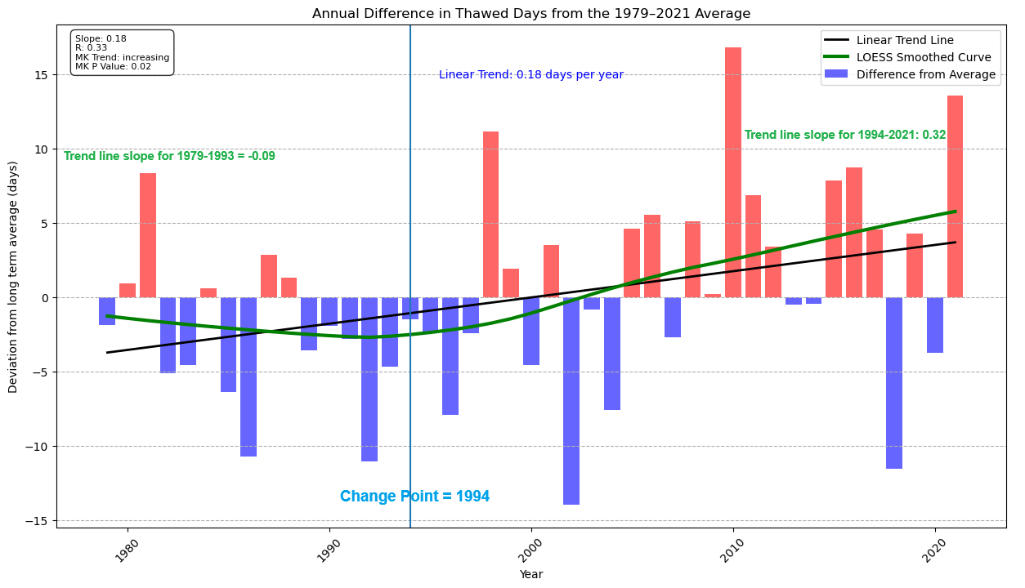

Caption: This figure illustrates the fluctuation in the number of unfrozen days in Canada from 1979 to 2021. Each bar represents the deviation from the average number of days for a given year, with positive values indicating years with more unfrozen days than the average. The trend line depicts the ordinary least-squares linear regression, providing insight into the overall trend. Additionally, the green line represents a smoothed LOESS curve, offering a more nuanced view of the data's trajectory. A vertical line at the year 1994 denotes a significant change in the LOESS curve, highlighting a notable shift in the trend during that period.

Highlights:

* The linear trend analysis conducted on the number of unfrozen days across Canada for the entire study period revealed a significant increasing trend (p-value 0.02) with a slope of +0.18 days per year (r = 0.33).
* Utilizing LOESS smoothing in conjunction with a changing point analysis, it was observed that since 1994, the increasing trend exhibited a steeper slope (p-value <=0.05) compared to the linear regression over the entire study period. During this period, there was a noteworthy acceleration in the rate of increase, with a slope of +0.32 days per year (r = 0.996) in the number of unfrozen days across Canada.

Caption: This figure displays the interannual variations in the number of Unfrozen (red), Frozen (blue), and Transitional (yellow) Days across Canada from 1979 to 2021.

Highlights:

* An increasing trend in the number of unfrozen days in Canada was observed (p-value = 0.024), alongside a decreasing trend in the number of frozen days (p-value = 0.028), while no significant trend in the number of transitional days was detected.
* Since 1979, there has been a notable 9.1% increase in the number of unfrozen days.
* The number of unfrozen days exhibited a steady increase of 1.1% per decade during the study period.
* The mean number of frozen, unfrozen, and transitional days for the study period were 148.15, 166.54, and 50.56, respectively.

**Montly-base Analaysis**

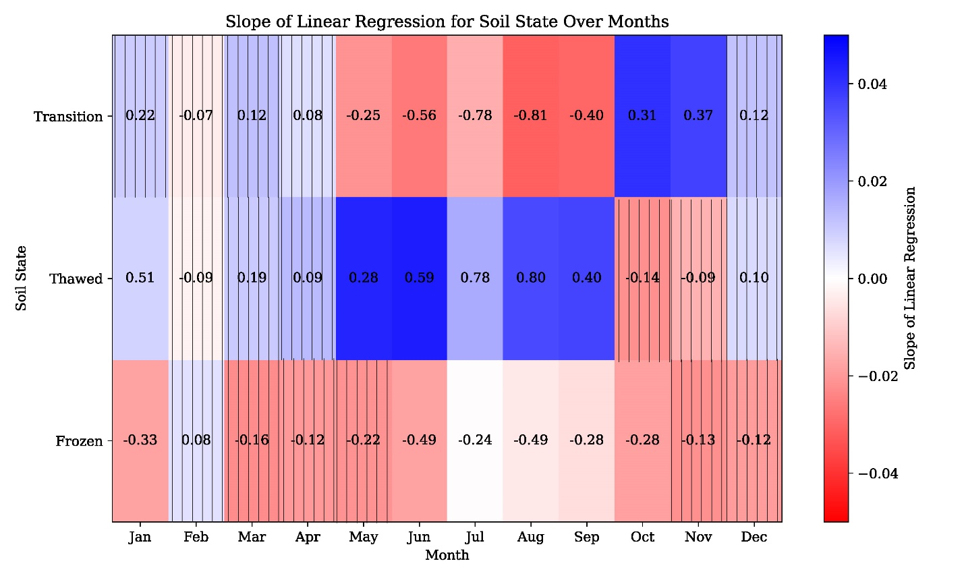

Caption: This figure presents a heatmap illustrating the slopes of the fitted linear regressions on the number of frozen, thawed, and transitional days for each month of the year from 1979 to 2021. The color gradient indicates trends, with red indicating a decreasing trend (negative slope) and blue indicating an increasing trend. Cells with gridded lines denote p-values greater than or equal to 0.1 in the Mann-Kendall test, suggesting no significant trend. The numbers within each cell represent the correlation coefficient (r value) of the fitted linear regression.

Highlights:

* Overall, with the exception of October and November, the number of unfrozen days has increased across all months during the study period. Specifically, January, May, June, July, August, and September exhibit a significant increasing trend (p-value <= 0.1). Notably, the correlation coefficient (r value) for January, June, July, and August is significant (r >= 0.5).
* Across all months except February, there is a general decreasing trend in the number of frozen days.
* From October to April, there is an increasing trend in the number of transitional days (except for February, which shows no significant trend). Conversely, from May to September, the number of transitional days displays a decreasing trend over the study period.

Caption: This figure illustrates the probability of occurrence for frozen, thawed, and transitional soil states during the initial five years of the study period (1979-1984) compared to the latest five years of the study period (2016-2021).

Highlights:

* The probability of thawed days occurring decreased significantly in November (by approximately 10%) and October (by approximately 5%), while the probability of frozen days increased by 4% during November. Additionally, the probability of transitional days increased by 6% during these months, indicating a trend of more thawed days transitioning into transitional soil and becoming frozen during the fall shoulder season.
* Overall, from October to April, there was an increase in the probability of transitional days occurring.
* During all summer months, the probability of unfrozen days increased by 4%, 2%, and 4% for June, July, and August respectively. Generally, from January to September (except for February, which showed a slight decrease), the probability of unfrozen days increased. Moreover, in October, November, and December, this probability increased significantly.
* With the exception of November and February, the probability of frozen days occurring decreased in all months.

**Vegetaion Cover base Analysis:**

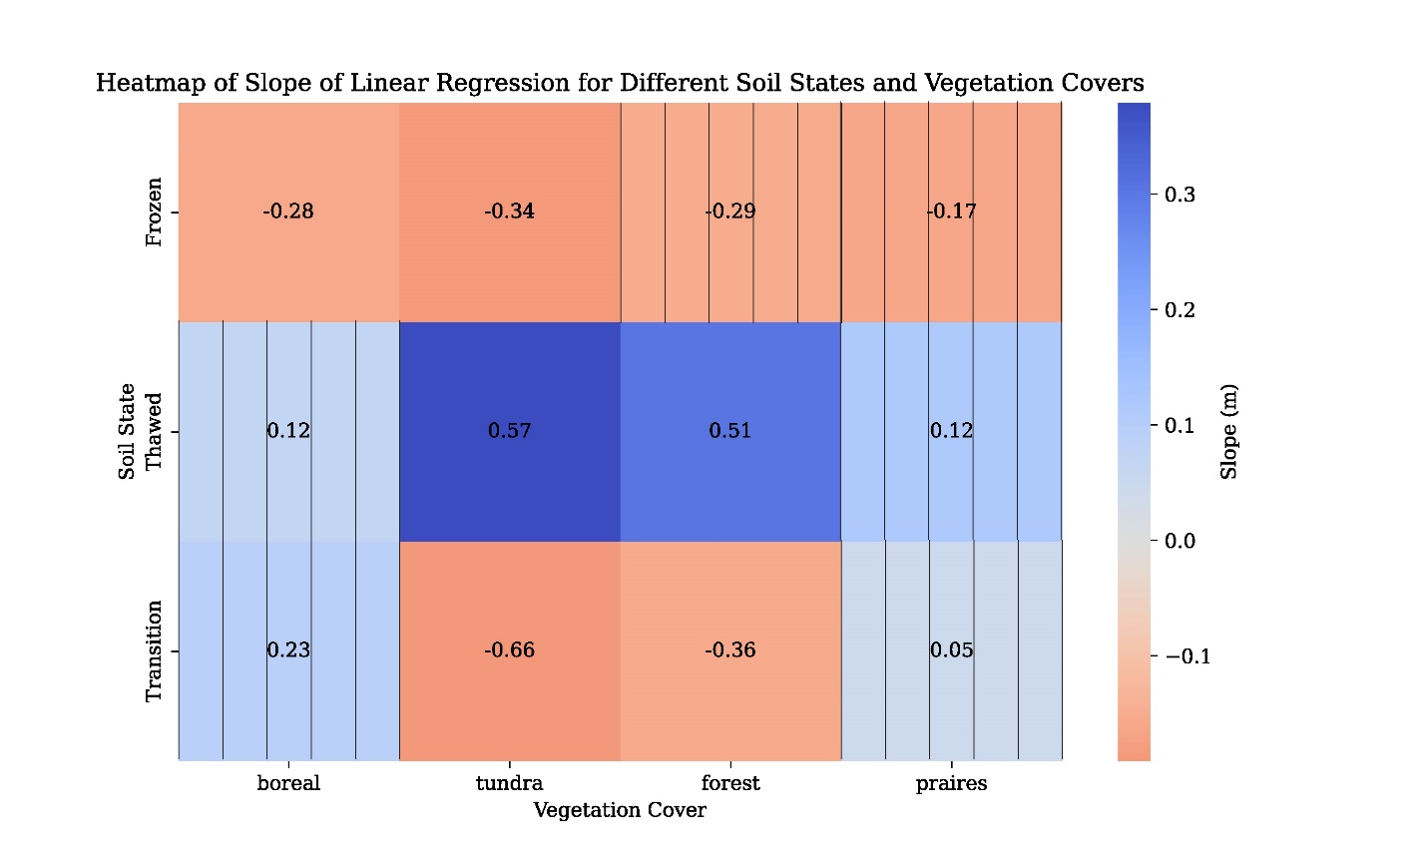

Caption: This figure presents a heatmap depicting the slopes of the fitted linear regression lines over the number of frozen, thawed, and transitional days across various vegetation covers in Canada from 1979 to 2021. The numbers displayed on each tile represent the correlation coefficient (r value) associated with the fitted regression line. Vertical lines indicate cases where the p-value of the trend line is not statistically significant (p-value > 0.1).

Highlights:

* In the Tundra region, the number of unfrozen days has increased by 28% since 1979, while the number of transitional days has decreased by 25%. These changes suggest an extension of the unfrozen season into the shoulder season in the Tundra. Additionally, the number of frozen days has decreased by around 6%, indicating a shortening of the frozen period in the Tundra.
* For all other vegetation covers, including Boreal forest, temperate forest, and prairies, the number of unfrozen days has increased at a more moderate rate, approximately 6% since 1979. However, the increasing trend is statistically significant for the temperate forest cover only.

Caption: This figure illustrates the interannual variations in the number of unfrozen days across the Tundra region in Canada from 1979 to 2021.

Highlights:

* The number of unfrozen days in the Tundra region increased by 27 days (almost one month) in 2021 compared to 1979. This suggests that the unfrozen season in the Tundra is now approximately one month longer than it was in 1979.
* The rate of increase in the number of unfrozen days in the Tundra is approximately 4% every decade.