iFox
School Management System

FEATURES

- Admissions
- Fee Register
- Fee Dues
- Class & Section wise fee structure
- Vehicle & Route Maintenance (Transport facility)
- Class/Section/Vehicle wise dues list
- Fee Register – Class/Section/Vehicle/Date Range
- Total outstanding dues list
- Easy entry of Marks – Class & Section wise
- Progress Reports
- Various types of Marks Statements
- Attendance Report
- Marks Analysis/Teacher performance analysis
- Option to print Rank/Grade on progress report and different ranking methods
- Export Marks to Excel (support for Govt. reports)
- Student Identity Cards Printing
- Account Heads/Ledgers & Voucher Printing
- Expenditure Report
- Multiple schools management from central location
- Multi user support
- User level permissions

Screen Previews
Admissions & Reports
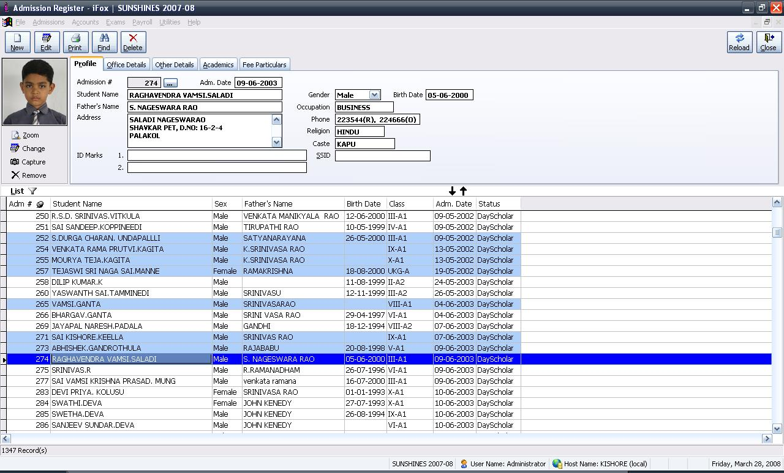

Fee Register
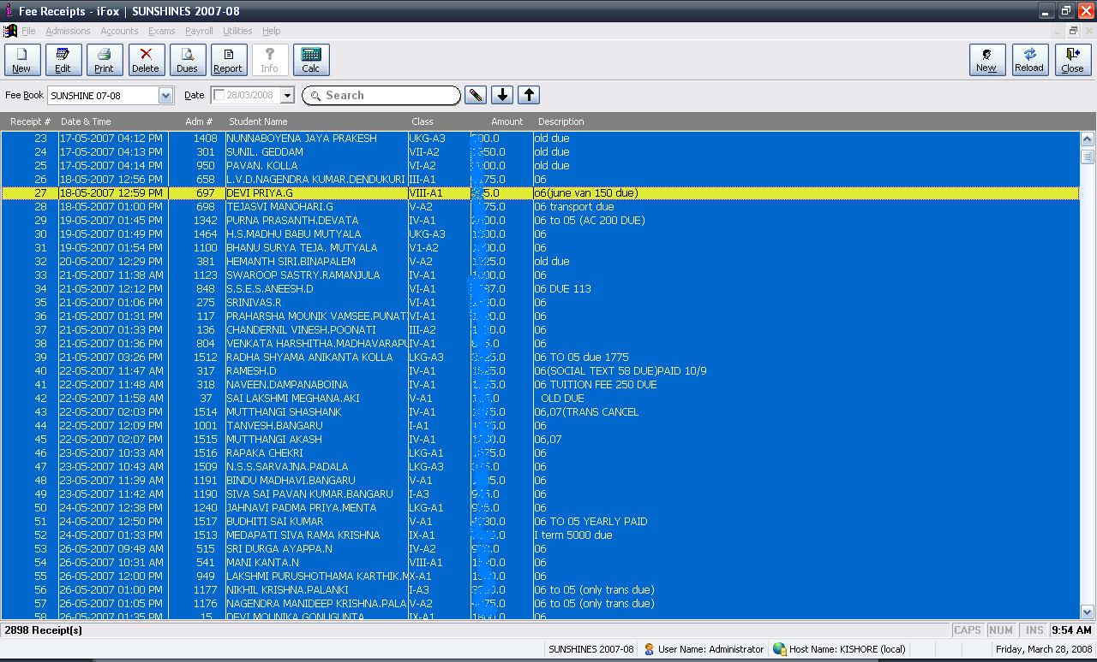

Marks Entry
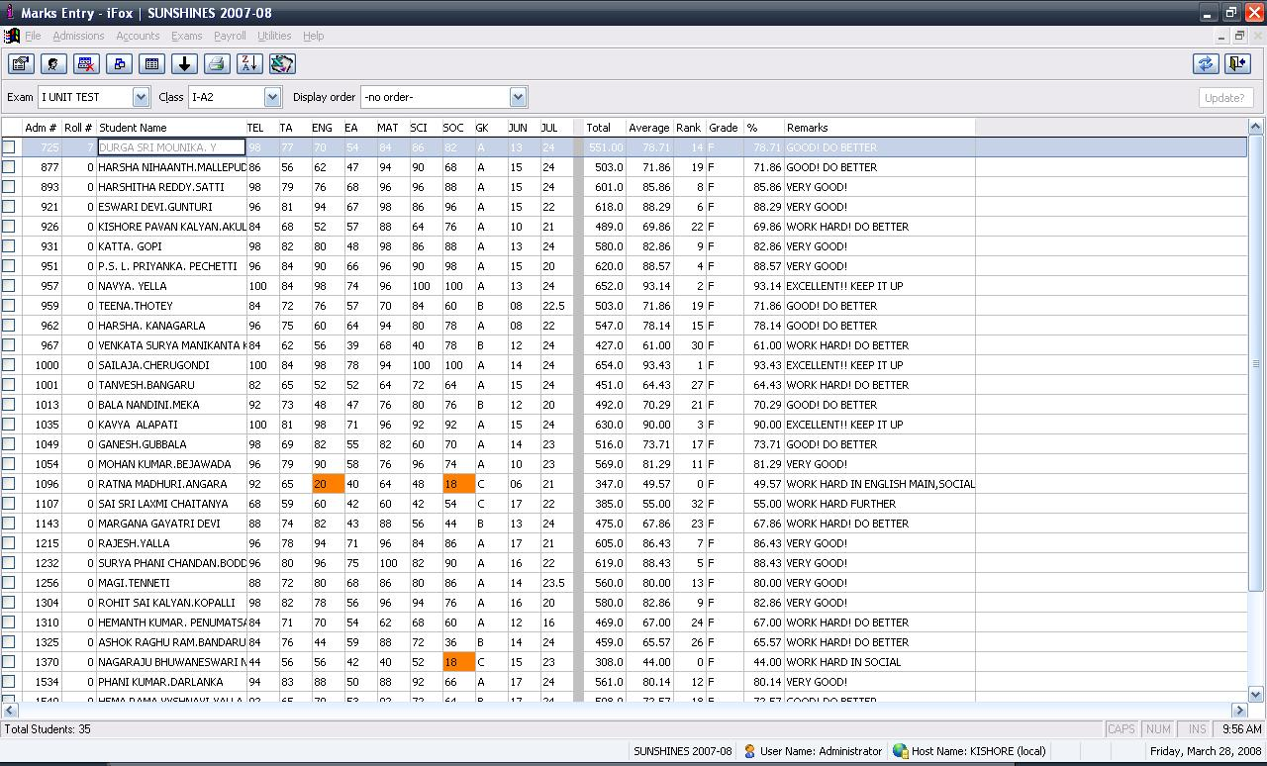
ID Cards
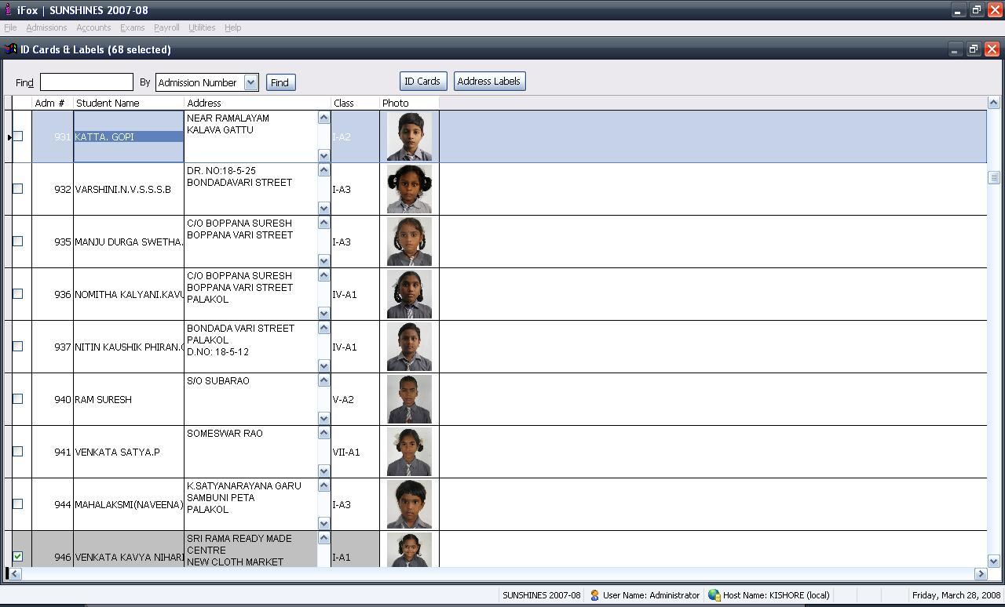
ID Cards Printing
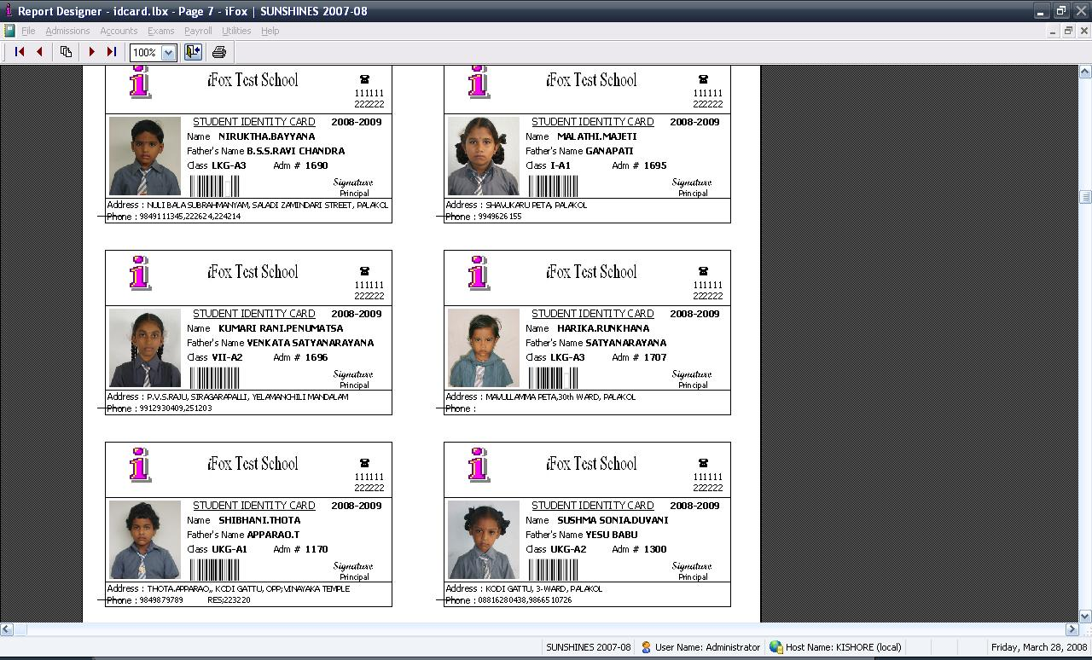
Vouchers
