Run your Eclipse under Java 6
IF YOU SKIP THIS, SECTION 3 OF THIS DOCUMENT WILL NOT WORK.

Install Java 6
JRE is fine

Force Eclipse to run under Java 6
Under Windows, edit your shortcut to Eclipse, and make the Target look like this (must all be on one line, of course)
E:\dev\eclipse-jee-helios-win32\eclipse\eclipse.exe -vm "C:\Program Files\Java\jdk1.6.0_17\bin" -vmargs -Xms512m -Xmx512m

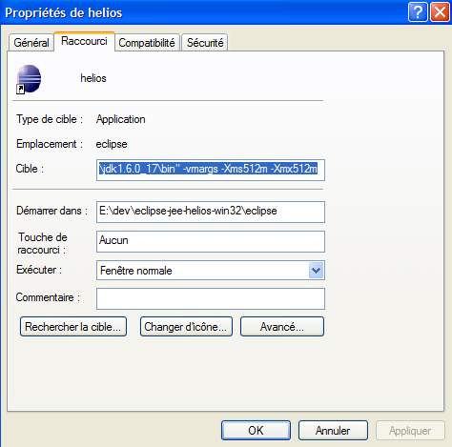

Configure the project as a Maven project

Install the M2Eclipse plugin

Create the project as a Maven project
Check the pom.xml for the required dependencies. They should all be pulled in automatically.
Note that Hibernate is used for testing. javax.persistence is pulled from there if Hibernate is early in the dependency list.
Note usage of the latest Jetty plugin as well.

Configure annotation processing
To create Typesafe definitions, JPA needs a metamodel which is generated automatically from the Java classes. This prevents “select * where foo = 2” when there is no longer any foo.
See http://docs.jboss.org/hibernate/jpamodelgen/1.0/reference/en-US/html_single/ for details

Enable annotation processing
Note: normally the generated files don’t go in src/main/java; in Helios version used for testing, putting the files elsewhere led to strange situations where the Java editor would see the files (and allow auto compile), but not the compiler.
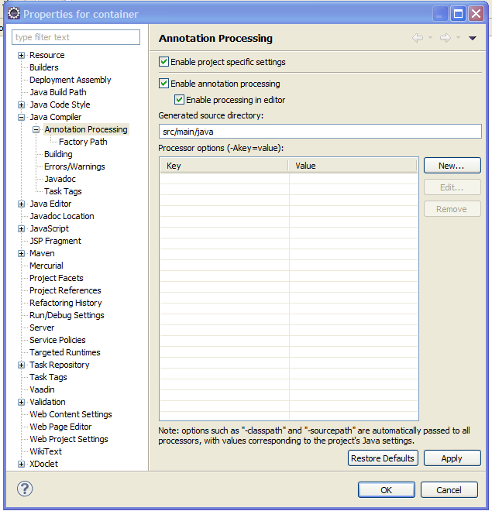

Configure the jars required for processing.
Then add the two jars indicated below to the Factory Path.
Click on Factory Path, just under the “Annotation Processing” line.

Use the “Add Variable” button on the right.
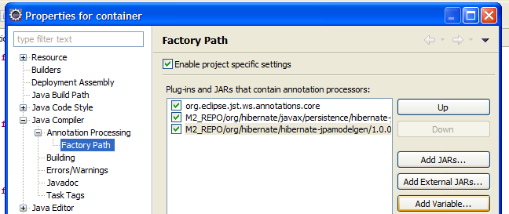

Then select the two jars below

M2_REPO/org/hibernate/javax/persistence/hibernate-jpa-2.0-api/1.0.0.Final/hibernate-jpa-2.0-api-1.0.0.Final.jar
M2_REPO/org/hibernate/hibernate-jpamodelgen/1.0.0.Final/hibernate-jpamodelgen-1.0.0.Final.jar

This is done by “Add Variable…”, then selecting M2_Repo and then clicking the “Extend…” button. You can then navigate down the tree and select the two jars listed above.

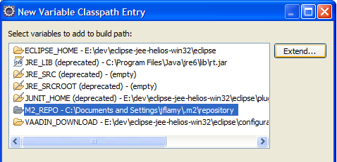

After doing this, Eclipse will generate a file called Foo_ if you have a JPA @Entity called Foo. For every attribute in your entity Foo, there will be a metamodel definition of the attribute in Foo_. This is documented in the JPA specification.

