Art, Power, and Materiality: A Study of an Early-Eighteenth Century Boulle Coffer
In my first paper, I attempted to envision the life of an coffer (Figure1) through a literary perspective. Adopting the persona of Anne Shirley, I described an 18th-century coffer as an exquisite yet commonplace container: “Its surface is adorned with intricate tortoiseshell patterns… delicate gilt-bronze mounts beautifully sculpted into lilies-of-the-valley. This coffer truly embodies all the treasures of Four Winds Harbor.” However, upon directly confronting the Coffer by André-Charles Boulle at the Art Institute of Chicago, I was struck by the profound technical mastery and historical depth conveyed through its opulent design and meticulous details. This paper aims to uncover the true historical narrative and value of this coffer through an analysis of its materials, masterful craftsmanship, symbolism, and historical context. As a refined artifact from the France of the “Sun King”, it embodies power, luxury, and a meticulously constructed worldview.
1.Materials and Making
The coffer’s creator, André-Charles Boulle (1642–1732), was one of the most influential cabinetmakers of the French Baroque period, celebrated as the “king of cabinetmakers” (Pavez, 2018). His innovative “Boulle marquetry” technique, characterized by the lavish use of tortoiseshell, brass, pewter, and ebony, did not merely represent the pinnacle of courtly decoration under the Sun King but established a stylistic legacy that influenced European decorative arts for over three centuries (Duin & Dorscheid, 2020).
Boulle applied the exquisite marquetry technique of tortoiseshell, pewter, and gilt-copper onto oak furniture surfaces, further enriching them with sculptural gilt-bronze mounts. Each material choice and processing method reflects the complex network of luxury production in the 17th and 18th century French court—a system reliant on colonial trade, precision craftsmanship, and a highly organized workshop system.
Firstly, the tortoiseshell used as a ground material was not locally available in France but a rare resource from distant tropical waters. The raw material primarily came from the hawksbill turtle in the Caribbean, prized in Europe for its translucent, amber-like carapace for high-end furniture and decorative arts (L., 1899). This choice, however, was underpinned by brutal ecological exploitation and colonial economic chains. Transported from the West Indies to French ports like La Rochelle or Marseille via slave and merchant ships, the tortoiseshell was transformed by royally privileged artisans into objects symbolizing power. It is worth noting that modern conservation ethics highlight the unsustainability of such material use (Leroux & Bertholon, 2020), yet in the era of Louis XIV, this was a classic example of the “Global South” supplying curiosities to the “Northern courts”.
Secondly, the core of Boulle marquetry lies in the laminated cutting technique of metal foils, known as the dual-pattern generation of “première partie” and “contrapartie” (Pavez, 2018). This technique involves firmly bonding multiple layers—typically brass, pewter foil, and tortoiseshell—before engraving as a whole. This process allows a single cut to yield two complementary sets of patterns, which greatly enhances material efficiency and productivity. On this coffer, scrollwork motifs (see the red circle in Figure1) in engraved brass are set against a tortoiseshell ground, creating a striking contrast; the reverse likely used the negative cut from the original to create another piece with a different color scheme. This technique demonstrates not only superior design intelligence but also the workshop's acute awareness of cost control.
The material complexity is further heightened by the gilt-bronze mounts. These underwent a labor-intensive process of lost-wax casting, meticulous hand-chasing, and hazardous mercury fire-gilding to achieve their luminous finish (Thiriet & Voisot, 2020). These mounts are not merely decorative; they are crucial for enhancing structural integrity and durability, protecting vulnerable corners while transforming the coffer into a sculptural object (Pavez, 2018).
2.Design as Ideology
The design of this coffer’s patterns and motifs is rich in symbolic meaning. Considering the historical and cultural context of France at the time, we can infer that it contains a political allegory concerning power, reason, and cosmic order.
The Apollo head on the front escutcheon (see the blue circle in Figure1) is undoubtedly the central symbolic element of the entire design. The image of the sun god, with his braided long hair and idealized countenance, is not a randomly chosen classical motif but a direct reference to the carefully crafted self-image of Louis XIV as the “Sun King”. The Sun, music, and the god of rational order, Apollo, were the personal symbols chosen by Louis XIV. Since assuming personal rule in 1661, Louis XIV’s propaganda machine has persistently linked his rule with the radiance and orderliness of Apollo (Goldstein, 1967). The Hall of Mirrors at Versailles faces east, the king’s bedchamber is named the “Sun Room”, and he personally played the role of Apollo in court ballets—all indicating that Apollo had become the embodiment of the ideology of divine-right monarchy (Bonney, 2011).
In stark contrast is the satyr figure on the lid. This grinning, heavily bearded male face with a radiant crown derives from the mythological archetype of Dionysus’s follower, symbolizing instinct, revelry, natural force, and untamed wildness (Ling, 2011). The satyr’s visage belongs to the enduring artistic tradition of the grotesque mask. These fantastical, half-human, half-animal faces are descendants of ancient Roman decorative arts, where they adorned fountains, theaters, and triumphal arches, believed to ward off evil spirits with their exaggerated, simultaneously amusing and intimidating expressions (Wawrzak, 2016). The tradition was vividly revived during the Renaissance, where grotesque masks served as playful yet profound decorations (Tarakanova, 2020), embodying the era’s fascination with classical antiquity and its acknowledgement of the irrational forces within nature and the human psyche. Similar thematic combinations are also found in Boulle’s other furniture (Figure4), further confirming that such designs were part of the common visual language of courtly art at the time. This may well illustrate a major characteristic of Baroque aesthetics—demonstrating the absolute dominion of central authority through strong binary oppositions. Apollo represents the divine right of kings and the rational order of monarchy, while the satyr embodies the vital, creative energies of the kingdom, both perfectly contained and glorified within the boundaries of ebony and gilt bronze.
Furthermore, the scrolls encircling the main figures also carry rich symbolic meaning. These intricately intertwined vegetal motifs are not mere decorative filler but originate from the typical decorative system of the French Baroque and early Rococo. Their infinitely extending, interwoven dynamic forms symbolize vitality, prosperity, and eternity (Liu & Fei, 2025). Simultaneously, their strictly symmetrical layout and geometric treatment may metaphorize the discipline of natural forms by human reason. On numerous bronze decorations and furniture ornaments made for the Palace of Versailles, similar, dynamic and life-like scroll patterns can be seen (Figure2 & Figure3). Together, they form a kind of decorative grammar of the era.
Notably, the three-dimensional bird motifs flanking the Apollo head are likely variants of the phoenix or eagle. The phoenix, as a mythical bird reborn from fire, is a universal symbol of eternity, resurrection, and imperial immortality (Kałużny, 2020). In antiquity, the eagle appears as a royal bird and mythological personification of the gods. The Christian world saw in the eagle a symbol of rebirth, as well as Christ himself (Filipek, 2023). It can thus be inferred that these sculpted birds aimed to reinforce the divine kingship represented by Apollo.
3.Belonging and Usage
To understand for whom and why this object was created, it must be situated within the tense social theatre of the late-17th century French court. Louis XIV’s absolutist project was as much aesthetic as it was political. After assuming personal rule, he cultivated an unprecedented culture of luxury at Versailles, deliberately distinguishing his court through splendor (Pavez, 2018). Furniture like this played a key role in this performance. Described as a container for medals or jewels, it links to the worlds of elite male collectors (numismatic cabinets) or aristocratic women (jewelry). As a component of a “cabinet de curiosités”, it signaled the owner’s wealth, global connections, and refined taste (Gołąbek & Paprocka-Gajek, 2023). Boulle occupied a unique position to serve this market. He served as the “King's Joiner” for sixty years, and his clients were all from the highest echelons of society, including monarchs like King Felipe V of Spain and Maximilian Emanuel of Bavaria (Pavez, 2018). Therefore, although the specific patron of this coffer remains unknown, it was undoubtedly created for someone at the apex of a power structure where material magnificence equated to social and political standing. Its purpose was dual: practical storage and magnificent display, which is a tangible fragment of the Sun King’s radiant world.
4.Influences & Conclusion
However, over the subsequent centuries up to the present, the allure of Boulle-style marquetry furniture and objects has never waned within the sphere of French cultural influence (Pavez, 2018).
The afterlife of Boulle’s work attests to its enduring power as the ultimate symbol of luxury. “Boulle marquetry” itself became a genre, continuously imitated for over three centuries. The 19th century, particularly during the Second Empire, saw a major revival where industrial techniques were used to produce more accessible, even if mechanically stamped, imitations (Edwards, 2012). This very act of reproduction added a new layer to the object's biography, reflecting 19th-century nostalgia for the perceived grandeur of the Ancien Régime.
Thus, to rediscover this coffer’s provenance and unravel its enigma requires synthesizing its material, symbolic, social, and historical dimensions. My initial literary hypothesis, while not mistaken in sensing the object’s emotional weight, identified the wrong source. In essence, this coffer guards treasures, but they are the treasures of statecraft: authority, lineage, and dominion. It is a vessel of stories, but those stories narrate the realities of global empire, absolute monarchy, and sublime artistry.
Therefore, the question “What did it take for it to come into existence?” can only be answered by outlining a vast collaborative endeavor. This encompassed the centralized power and vanity of the Sun King’s court, the genius and defiance of a master artisan like Boulle, a global trade network supplying exotic materials, and the perilous labor of specialized craftsmen. Fundamentally, it required an ideology that legitimized such concentrated splendor as an expression of power. Far from being merely the refined container I once imagined, it is a nexus where ecology, empire, artistry, and myth converge, offering us a singular reflection of the world that created it.

Reference
Bonney, R. (2011). Louis XIV of France (1638–1715). In The Encyclopedia of War. Wiley. https://doi.org/10.1002/9781444338232.wbeow372
Duin, P. van, & Dorscheid, J. (2020). Floral wood marquetry cabinets attributed to André-Charles Boulle – A technical comparison. Technè, 49, 34–43. https://doi.org/10.4000/techne.5356
Edwards, C. (2012). “Improving” the Decoration of Furniture: Imitation and Mechanization in the Marquetry Process in Britain and America, 1850–1900. Technology and Culture, 53(2), 401–434. https://doi.org/10.1353/tech.2012.0073
Filipek, S. (2023). The King of Birds and the Bird of Kings: About the Symbolism of the Eagle in Culture, Beliefs and Art. Asian Journal of Social Science Studies, 8(2), 17. https://doi.org/10.20849/ajsss.v8i2.1359
Gołąbek, M., & Paprocka-Gajek, J. (2023). WHAT DO THE POTOCKIS NEED AN ART COLLECTIONFOR, NAMELY ON THE ART COLLECTING IN THEPOTOCKI FAMILY EXHIBITION AT THE MUSEUM OFKING JOHN III’S PALACE AT WILANÓW. Muzealnictwo, 64, 170–179. https://doi.org/10.5604/01.3001.0053.9556
Goldstein, C. (1967). Louis XIV and Jason. The Art Bulletin, 49(4), 327–329. https://doi.org/10.1080/00043079.1967.10788671
Kałużny, J. C. (2020). Phoenix and Delphinus Salvator: The History of the Forgotten Images of Early Christian Iconography. Perspektywy Kultury, 30(3), 9–26. https://doi.org/10.35765/pk.2020.3003.03
L., R. (1899). The Trade in Tortoiseshell. Nature, 59(1531), 425–426. https://doi.org/10.1038/059425a0
Leroux, M., & Bertholon, R. (2020). Le mobilier Boulle : étude de l’altération du laiton et de l’étain des marqueteries. Technè, 49, 60–67. https://doi.org/10.4000/techne.5697
Ling, X. (2011). Satyr Chorus and Ancient Greek Tragedy-Reading of Sections 7 and 8 of "The Birth of Tragedy". Zhejiang Academic Journal, (02), 34-40. https://doi.org/10.16235/j.cnki.33-1005/c.2011.02.004.
Liu, X. & Fei, Y. (2025). Dialogue in Patterns: A Study on the East-West Cultural Fusion of Harbin Chinese Baroque Architectural Patterns. Journalism and Communication, (16), 54-56.
Paulin, M.-A., & Leblanc, F. (2013). Note sur la restauration du mobilier Boulle du musée du Louvre : 03. le nettoyage des marqueteries métalliques. Technè, 38, 101–1https://doi.org/10.4000/techne.14664
Pavez, M. I. (2018). Evocando a André-Charles Boulle (1642-1732): un ‘obrero libre’, y un nuevo estilo para Europa. RChD: Creación y Pensamiento. https://doi.org/10.5354/0719-837x.2018.50235
Tarakanova, E. I. (2020). Antique motifs in Pinturicchio decoration of Roman chapels. Academia, 4. https://doi.org/10.37953/2079-0341-2020-4-1-464-478
Thiriet, É., & Voisot, M. (2020). L’examen visuel de la fonte, de la ciselure et de la dorure des bronzes d’ornementation du mobilier Boulle du musée du Louvre : rapport d’étape. Technè, 49, 80–85. https://doi.org/10.4000/techne.5853
Wawrzak, M. (2016). Piękne i szkaradne. Motyw maski na drodze rozwoju i transmisji nowożytnej groteski. Acta Universitatis Nicolai Copernici Zabytkoznawstwo i Konserwatorstwo, 46, 155. https://doi.org/10.12775/aunc_zik.2015.006

Figures
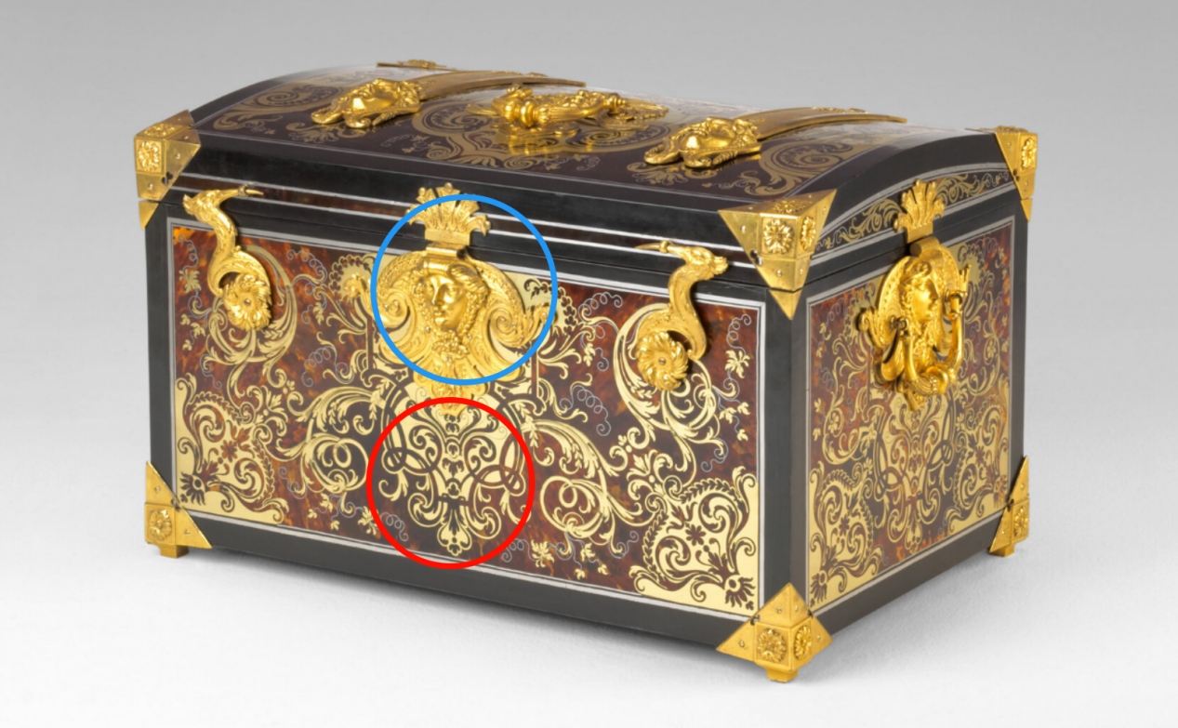
Figure1：Boulle, A.-C. (1700-1720). Coffer[Oak, tortoiseshell, brass, pewter, ebony, and gilt-bronze mounts]. Art Institute of Chicago.
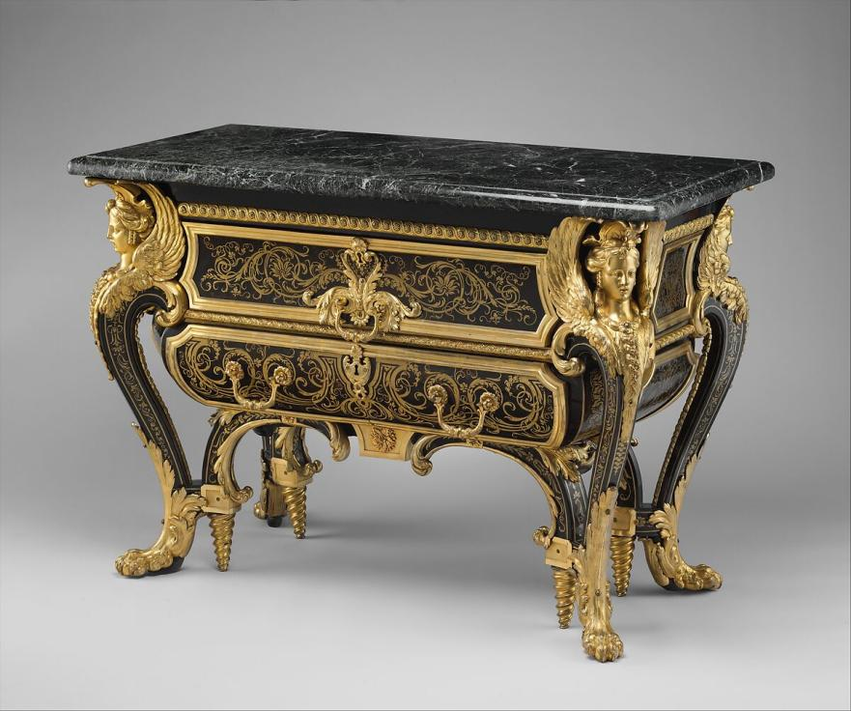
Figure2: Boulle, A.-C. (1710-1720). Commode [Gilt bronze, tortoiseshell, brass, pewter, and ebony on oak]. The Wallace Collection, London, England.
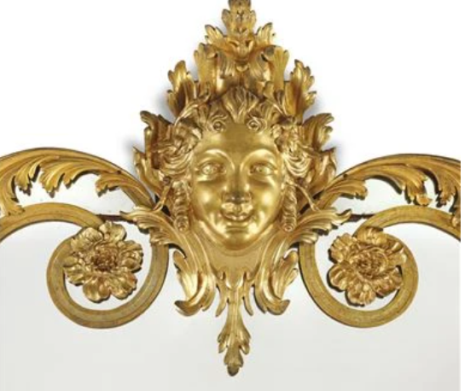
Figure3: Bronze decoration. (1720). MIROIR A PARCLOSES D'EPOQUE REGENCE[Gilt bronze].
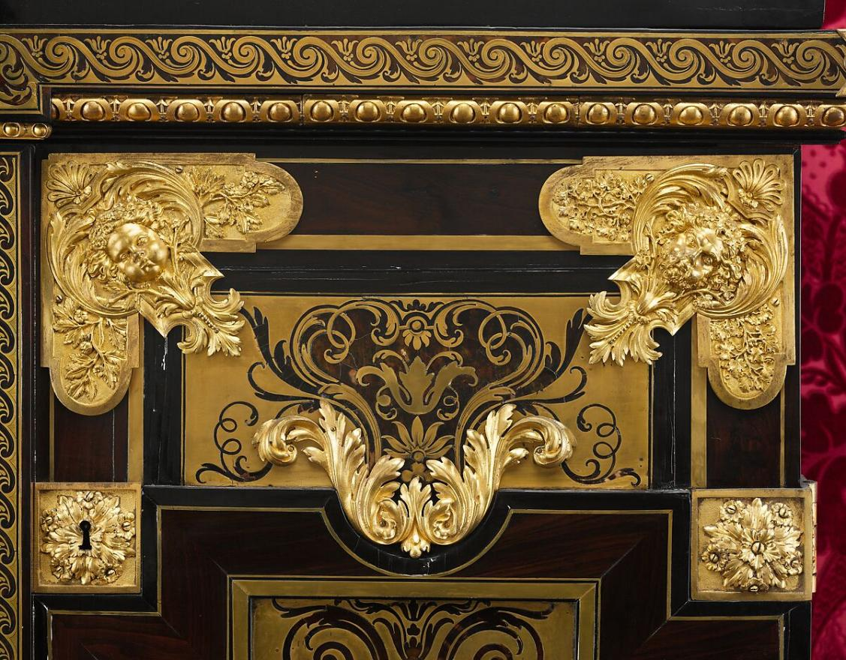
Figure4: Boulle, A.-C. (1700). Cabinet [Gilt bronze, tortoiseshell, brass, pewter, and ebony on oak; H: 150 cm; with 2 contrast images].

