Jeans Advertising and the Commodification of Feminism
The evolution of jeans from their origins as workwear to a fashion symbol reflects broader sociocultural shifts throughout the 20th century. In their relationship with feminism, jeans advertisements have played a complex and contradictory role: while appearing to respond to feminist demands, they have skillfully absorbed and channeled these demands into consumer strategies and commercial labels, gradually completing the process of commodifying the spirit of feminism in the decades leading up to the 21st century.
The origin of jeans can be traced back to the mid-19th century, when the durable workwear introduced by Levi Strauss gained popularity among miners and farmers (Howard, 2014). Advertisements in this period directly framed jeans as durable workwear. A 1910s Blue Buckle ad (Fig. 1) declares them “Designed for workers,” visually linking the garment to manual labor. Similarly, a 1930s Lee ad (Fig. 2) asserts "Save money for men; save mending and patching for women," pitching the product's value through promises of economic savings and long-lasting resilience.
The image of James Dean wearing jeans in the famous film Rebel Without a Cause (Fig. 3) further popularized jeans. In this context, advertising also shifted towards expressing individuality and rebellious spirit, no longer focusing solely on functionality (Schober-de Graaf, 2001). Jeans became a vehicle for young people to express themselves and challenge traditions, reflecting a resistance to social norms and a pursuit of personal style.
However, as seen in Levi’s advertisement with the tagline “Rugged as the men who wear them” (Fig. 4), which associated jeans’ toughness with masculinity, the vast majority of jeans advertisements at the time still targeted men primarily, with female images largely marginalized or serving as accessories to men (Hikmah & Munandar, 2022; Yang, 2011). It was not until the surge of second-wave feminism in the 1960s and 70s that jeans gradually became a practical tool and distinct symbol for female activists in real society to break away from the constraints of dresses and strive for equal rights. They wore jeans to participate in protests and rallies (Fig. 5), declaring a break with traditional female roles (Ford, 2013). During this period, advertisements targeting female consumers also emerged to cater to social trends and expand the market. Levi’s, for instance, directly addressed the new demographic with slogans like “Now cut for women” (Fig. 6), explicitly acknowledging women as distinct consumers. These advertisements primarily highlighted the product’s curved tailoring, using prominent visual showcases of the jeans’ fit (Fig. 7) to demonstrate how they accentuated the female figure. This alignment with contemporary female aesthetics contributed to the style’s growing popularity.
In the 1980s, a key transformation occurred in the portrayal of the female body in jeans advertisements, represented by brands like Calvin Klein. The core strategy was to substitute the feminist discourse of “bodily autonomy” with a narrative of “sexual display”, thereby reinforcing a more subtle form of the “male gaze”. Given that erotic content reliably captured attention in a crowded advertising landscape (Vezina & Paul, 1997), brands employed bold and sensual imagery. This allowed them to court female consumers with a veneer of liberation while simultaneously resonating with a wider audience attuned to overt sexuality.
Firstly, more advertisements focused on specific body parts—the tightly clad hips, exposed abdomen, or thighs (Fig. 8, 9). Some ads appeared to embrace women’s liberation merely as a trendy element; for instance, in one advertisement, the model removed her bra, but the focus on parts of her body still carried a heavy sense of objectification (Fig. 10). This “fragmentation”, as Berger (1972) argued, strips the female body of its personhood, transforming it into an abstract object for scrutiny and desire.
In these advertisements, women’s power no longer stemmed from their intellect, professional achievements, or political actions, but from the desirability their bodies could generate under the male gaze. Women were encouraged to see themselves as objects to be looked at, internalizing this gaze, constantly managing and curating their appearance and sexiness, misinterpreting this as a form of “self-empowerment”, and even learning to see themselves through a male perspective (Berger, 1972). For example, Brooke Shields provocatively declared in a Calvin Klein advertisement (Fig. 11), “You know what comes between me and my Calvins? Nothing.” This line superficially claims bodily autonomy but cleverly reframes it within a context that invites viewing and sexual interpretation. As McRobbie (2004) states, “we are witness to a hyper-culture of commercial sexuality, one aspect of which is the repudiation of a feminism invoked only to be summarily dismissed.”
Advertisers shrewdly appropriated the feminist call for sexual liberation while stripping it of its political content. The sexual freedom feminism fought for concerned women's own desires and agency, aiming to break down male-defined sexual morals. However, in advertising, this “freedom” was simplified into a stylized performance of sexuality tailored to male-desired patterns. This is evidenced by ads featuring models in overtly suggestive poses (Fig. 12), and culminated in imagery of complete female nudity (Fig. 13), which together equated empowerment with a sexually charged display of the body. As sociologist Robert Goldman (2005) pointed out in analyzing gender and advertising, this strategy presents the commodity as a “tool for personal expression and resistance to conformism”, while in reality, it merely replaces old norms of consumption with new ones.
Therefore, the jeans advertisements of the 1980s and 90s did not truly liberate women but created a new, more seductive cage: they told women that through consumption and bodily display, they could become powerful and rebellious, while in truth, they were only sinking deeper into the trap of the male gaze, generating substantial profits for brands in the process.
Over these decades, advertising did not simply reflect the progress of feminism; instead, it transformed its core elements—rebellion, autonomy, and empowerment—into commercial labels. This reminds us that in the age of consumerism, when “being yourself” becomes the loudest advertising slogan, we must be even more vigilant: true liberation likely cannot be achieved through shopping.

References
Berger, J. (1972). Ways of Seeing. Harmondsworth: Penguin.
Ford, T. C. (2013). SNCC Women, Denim, and the Politics of Dress. The Journal of southern history, 79(3), 625-658.
Goldman, R. (2005). Reading ads socially. Routledge.
Hikmah, N., & Munandar, A. (2022). Print Ads and Sexist Appeal: The Portrayal of Women in American Men’s Apparel Ads From The 1950s-1970s. Celt: A Journal of Culture, English Language Teaching & Literature, 22(2), 387-413.
Howard, M. C. (2014). Transnationalism and society: An introduction. McFarland.
McRobbie, A. (2004). Post‐feminism and popular culture. Feminist media studies, 4(3), 255-264.
Schober-de Graaf, A. (2001). Blue Jeans. Vom Leben in Stoffen und Bildern. Campus.
Vezina, R., & Paul, O. (1997). Provocation in advertising: A conceptualization and an empirical assessment. International Journal of research in Marketing, 14(2), 177-192.
Yang, L. (2011). Research on Advertising Symbols of Jeans (Master's Thesis, Ocean University of China). Master's Degree https://kns.cnki.net/kcms2/article/abstract?v=BVV9sVd_tjGgQPjItAJMEDBBGKD-NGixmOAg6rHE-rRsw2VUHEZNZSMgTEqt6fjOpT5pGj7BUxIqQv8ufusypOlicwhipafr0vtqhDbF4YjuKb07HbJgagvQVeNReslbrqRLZO5o4o0z2X2JuZ-6lhqbm4f9MFa7K5OB2hbFJhqDXBYMO1ZEtA==&uniplatform=NZKPT&language=CHS

Figures
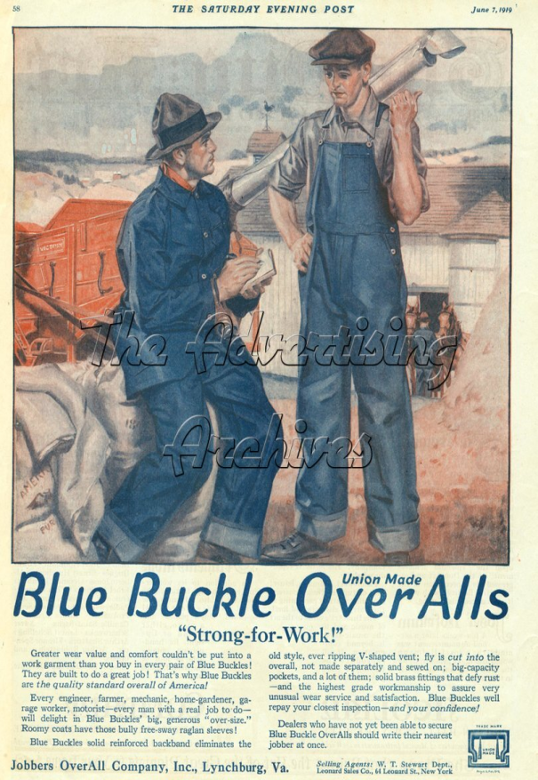 | 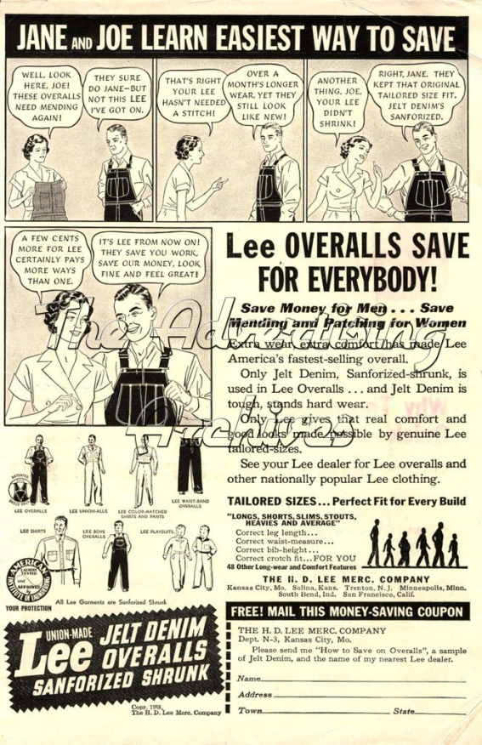
Figure1: 1910s; Blue Buckle Jeans; Designed for workers. | Figure2: 1930s; Lee; “Save money for men; save mending and patching for women”
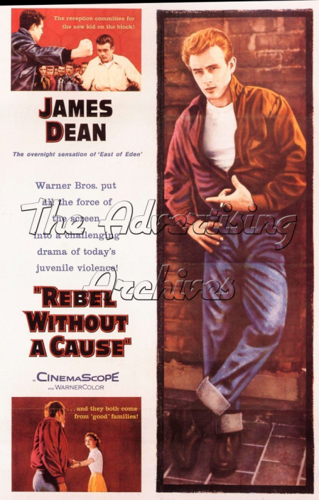 | 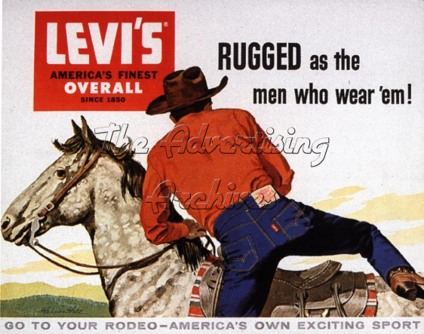
Figure3: 1955; Rebel Without A Cause; James Dean | Figure4: 1950s; Levi’s; “Rugged as the men who wear them!”
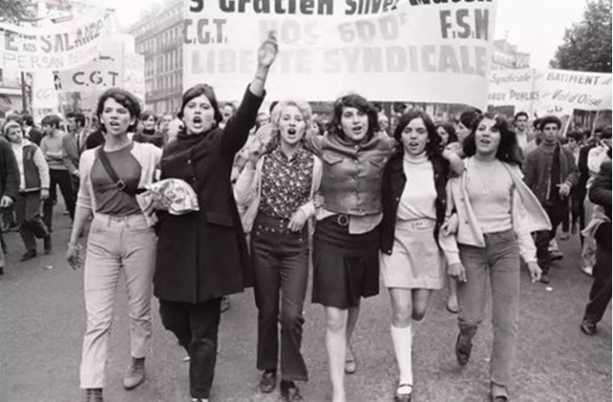 | 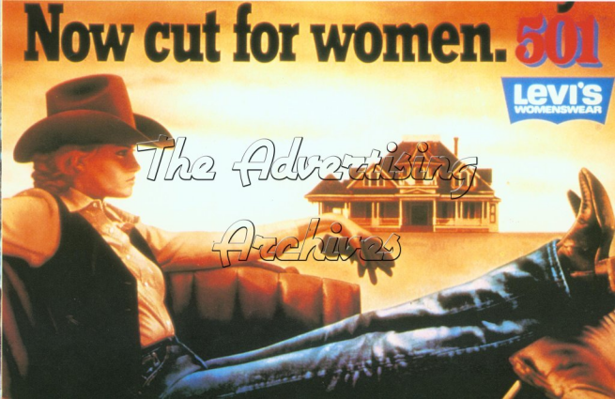
Figure5: 1968; France; Women wearing jeans participated in the protest. | Figure6: 1970s; Levi's; A woman wearing jeans with slogan “Now cut for women”.
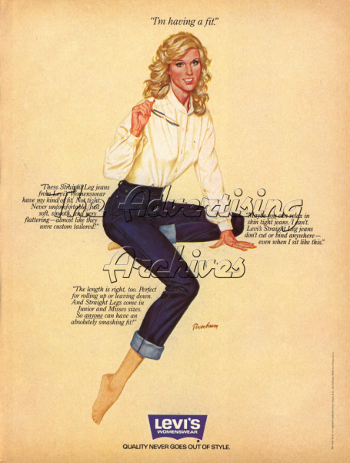 | 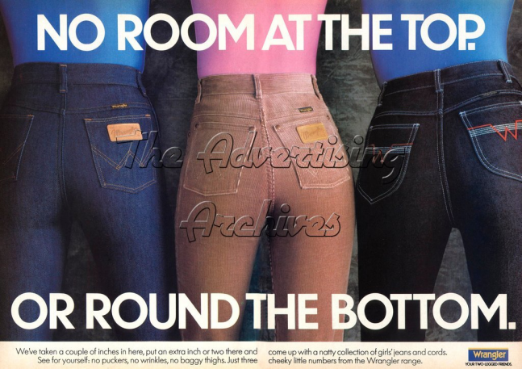
Figure7: 1970s; Levi’s; Prominent curve-cutting and fitting advertisements for women's figures | Figure8: 1990s; Wrangler; Focus on the buttocks
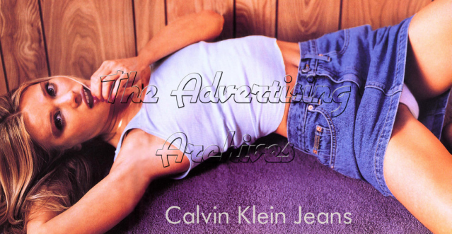 | 
Figure9: 1990s; Calvin Klein; The model partially exposed her body. | Figure10: 1990s; Guess; A model without a bra on.
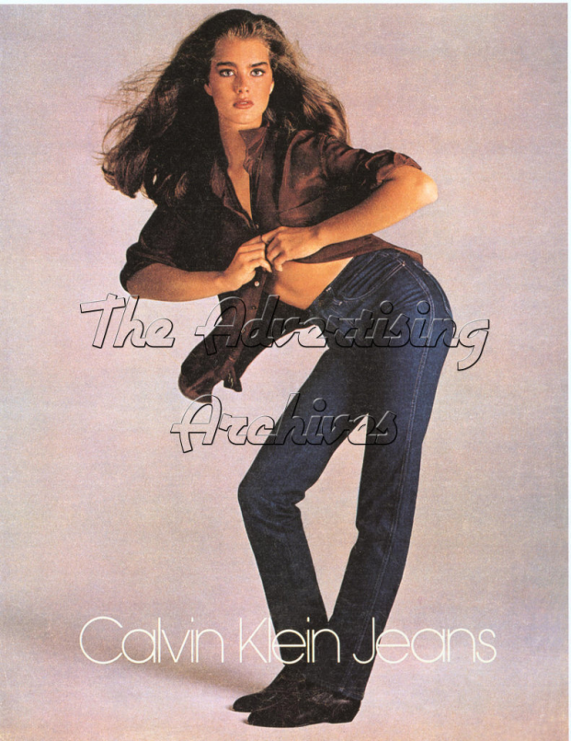 | 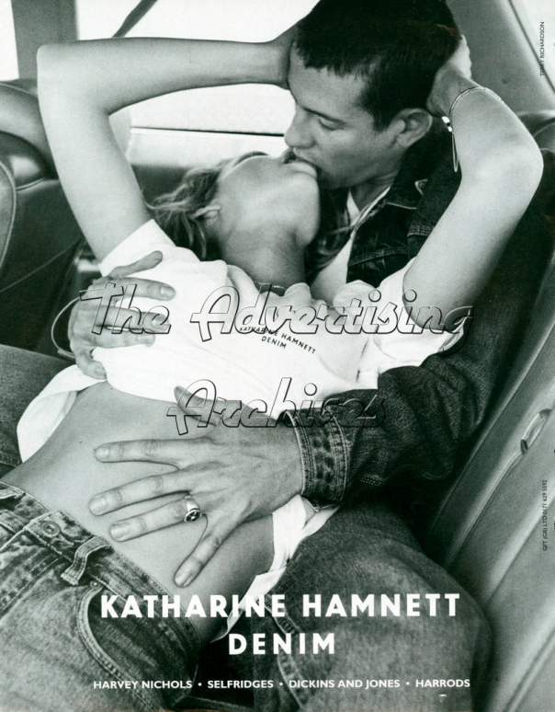
Figure11: 1980s; Calvin Klein; Brooke Shields, “You know what comes between me and my Calvins? Nothing.” | Figure12: 1990s; Katharine Hamnett; An advertisement with erotic elements
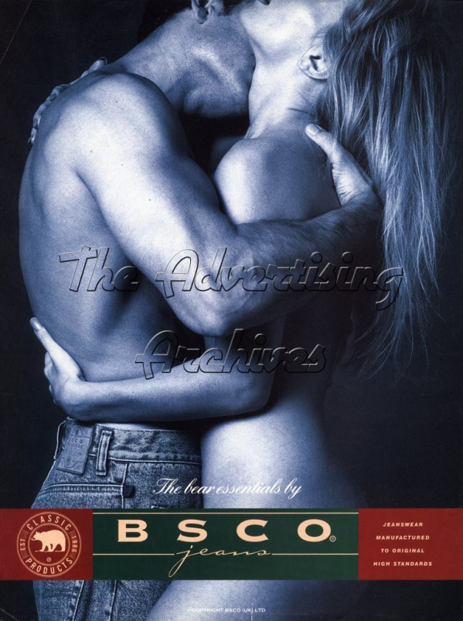
Figure13: 1990s; BSCO; An advertisement with female nudity

