Framework
https://www.w3schools.com/bootstrap4

Table for saves & throws
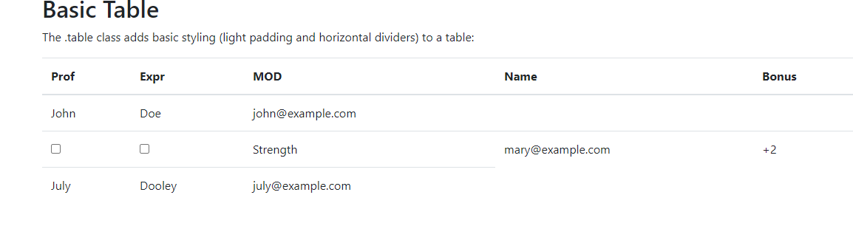
<table class="table">
<thead>
<tr>
<th>Prof</th>
<th>Expr</th>
<th>MOD</th>
<th>Name</th>
<th>Bonus</th>

</tr>
</thead>
<tr>
<td><input type="checkbox" name="prof" /></td>
<td><input type="checkbox" name="prof" /></td>
<td>Strength</td>
<td>mary@example.com</td>
<td><span id="save-strength">+2</span></td>

</tr>

base color theme
#343a40 https://www.colorhexa.com/343a40

Layout Reference
https://external-content.duckduckgo.com/iu/?u=https%3A%2F%2Fmedia-waterdeep.cursecdn.com%2Fattachments%2F3%2F983%2Fcharacterdesktop.PNG&f=1&nofb=1

Layout reference 2
Go back to layout with jumbotron on top, but make the nav bar collapse on scroll or sticky to top
