ProblemSet 1
Onno
2025-10-02
#Part 1: Preparations
## Clear working environment
rm(list=ls())
## Set working directory
setwd("C:/Users/onnos/Documents/GitHub/StatsI_2025/problemSets/PS01")
#Task 1; part 1
## Load data; I used iq instead of y; it'S easier to operate with
iq <- c (105 , 69 , 86 , 100 , 82 , 111 , 104 , 110 , 87 , 108 , 87 , 90 , 94 , 113 , 112 , 98 ,
80 , 97 , 95 , 111 , 114 , 89 , 95 , 126 , 98)
## Construct length indicator
n <- length(iq)
# Sample mean; (there are no NAs, so no na.rm = T necessary for all analyses)
sample_mean <- mean(iq)
## Sample standard deviation
sample_sd <- sd(iq)
## t critical value for 90% confidence interval; use t because n<=30
t90 <- qt((1 + 0.90)/2, df = n - 1)
## Lower and upper bounds
lower_90 <- sample_mean - (t90 * (sample_sd / sqrt(n)))
upper_90 <- sample_mean + (t90 * (sample_sd / sqrt(n)))
## Combine into a confidence interval
confint90 <- c(lower_90, upper_90)
# result
confint90
## [1] 93.95993 102.92007
## the 90% CI is 93.96 and 102.92

TASK 1; part 2
## two important infos:
#the average student IQ in her school is "higher" than the average IQ score (100) - use one-sided t-test
# alpha = 0.05
# construct value for real IQ mean
mu0 <- 100
## find our sample standard deviation
sd <- sd(iq)
## and now calculate the standard error
se <- sd/sqrt(n)
## adjust the degrees of freedom
df <- n-1
## set t-statistic
t <- (sample_mean-mu0)/se
## One-sided p-value (test if mean > mu0) -> remember we want to know if HIGHER than 100
p_value <- 1-pt(t, df)
## Integrate results
dat <- c(Mean = sample_mean, StdError = se, t = t, df = df, p_value = p_value)
## See our results!!
dat
## Mean StdError t df p_value
## 98.4400000 2.6185747 -0.5957439 24.0000000 0.7215383
## Time for interpretation:
# The mean in the sample is lower than 100; we do not find enough evidence to reject the 0 hypothesis. Because: p = 0.72 > 0.05

TASK 2; part 1
## Import our data set; could be done with setwd as well, but only one line like this
expenditures <- read.table("C:/Users/onnos/Documents/GitHub/StatsI_2025/datasets/expenditure.txt", header = TRUE, sep = "\t")
## create a subset!!
vars <- expenditures[, c("Y", "X1", "X2", "X3")]
## and a correlation matrix
cor_matrix <- cor(vars)
## Let's see the correlation matrix
round(cor_matrix, 2)
## Y X1 X2 X3
## Y 1.00 0.53 0.45 0.46
## X1 0.53 1.00 0.21 0.60
## X2 0.45 0.21 1.00 0.22
## X3 0.46 0.60 0.22 1.00
### INTERPRETATION
# X1 and Y: Moderate positive correlation (0.53): states with higher per capita income tend to spend more on homelessness
# X2 and Y: Moderate positive correlation (0.45): states with more financially insecure residents tend to spend more
# X3 and Y: Moderate positive correlation (0.46): states with more urban residents spend more
# Furthemrore, there seems to be a connection between X1 and x3!!; attention - danger of collinearity
# There is a moderate positive correlation (0.60) between X1 and X3: richer states tend to be more urban!
#Other predictors not too strongly correlating

TASK 2; part 2
## compare regions regarding their expenditure
## first of all, make labels clear! way easier to interpret
expenditures$Region <- factor(expenditures$Region,
levels = c(1,2,3,4),
labels = c("Northeast", "North Central", "South", "West"))
# now lets create a boxplot of Y by region
boxplot(Y ~ Region, data = expenditures,
main = "Per Capita Expenditure on Housing Assistance by Region",
xlab = "Region",
ylab = "Per Capita Expenditure",
col = c("lightblue","lightgreen","lightpink","lightyellow"))
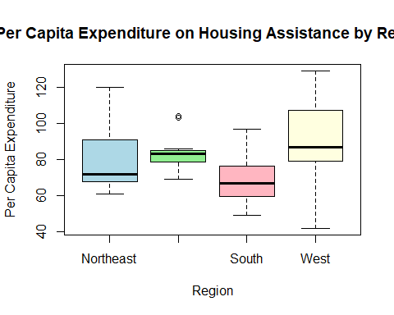
## lookin pretty
## INTERPRETATION: on average, states in the West spend the most on housing assistance

TASK 2; part 3
## first: plot!
plot(expenditures$X1, expenditures$Y)
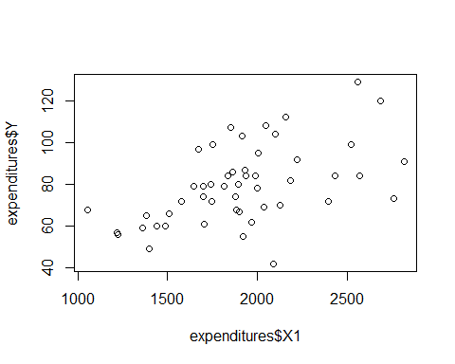
#okay, nice already, but lets make it fancy
plot(expenditures$X1, expenditures$Y,
main = "Per Capita Expenditure vs Per Capita Income",
xlab = "Per Capita Income (X1)",
ylab = "Per Capita Expenditure (Y)",
pch = 19, col = "blue")
# and adding a regression line
abline(lm(Y ~ X1, data = expenditures), col = "red", lwd = 2)
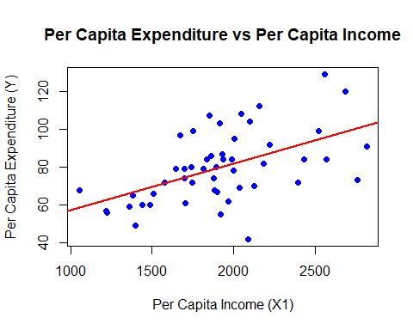
#beautiful
### Now the different colours and symbols!
# assigning colors and symbols by Region
region_colors <- c("Northeast" = "red",
"North Central" = "blue",
"South" = "green",
"West" = "purple")
region_symbols <- c("Northeast" = 17, # triangle
"North Central" = 19, # circle
"South" = 15, # square
"West" = 18) # diamond
# plotting with colors and symbols
plot(expenditures$X1, expenditures$Y,
main = "Per Capita Expenditure vs Per Capita Income by Region",
xlab = "Per Capita Income (X1)",
ylab = "Per Capita Expenditure (Y)",
col = region_colors[expenditures$Region],
pch = region_symbols[expenditures$Region])
# And we can even add legend to be able to interpret easier:
legend("topleft", legend = levels(expenditures$Region),
col = region_colors, pch = region_symbols, title = "Region")
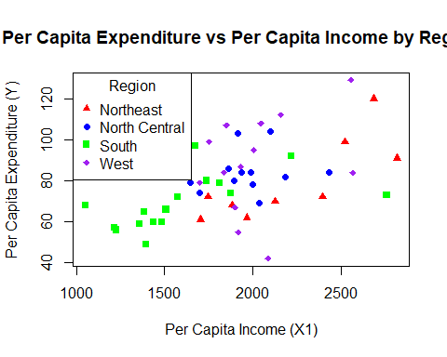
#nice

