NORTH STUDIO / CLIENT BRIEF
Brand launch brief
Fieldwork Coffee · Launch 18 November 2026
A familiar place. A fresh identity.  Create a welcoming identity for a neighborhood coffee company, from the morning cup to the shopfront. | 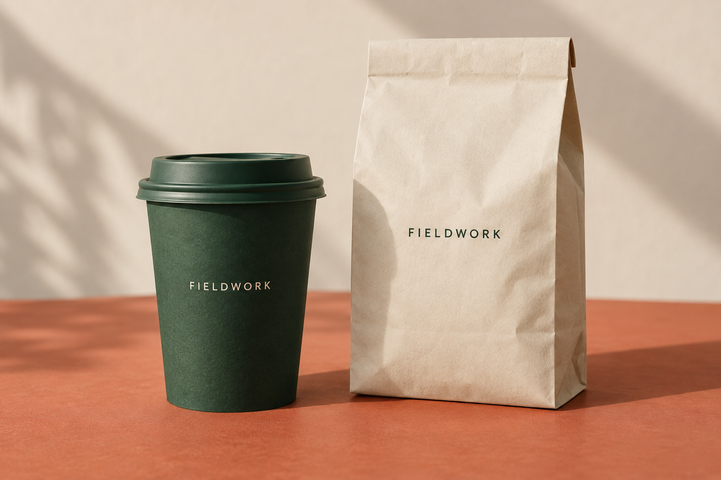
DELIVERABLES & DATES
Deliverable | Owner | Due
Identity & packaging | Maya | Nov 04
Shopfront & menu | Eli | Nov 11
Launch-ready files | Noor | Nov 18
Client approval:
Date: __________

