Fieldwork Coffee
Brand launch report · North Studio · 9 October 2026

Ready for the next chapter
The new identity is ready for production. Customers recognized the forest-green packaging in our first shop trial, and staff found the revised menu easier to explain during the morning rush. The team is preparing the remaining shopfront and launch materials for 18 November.
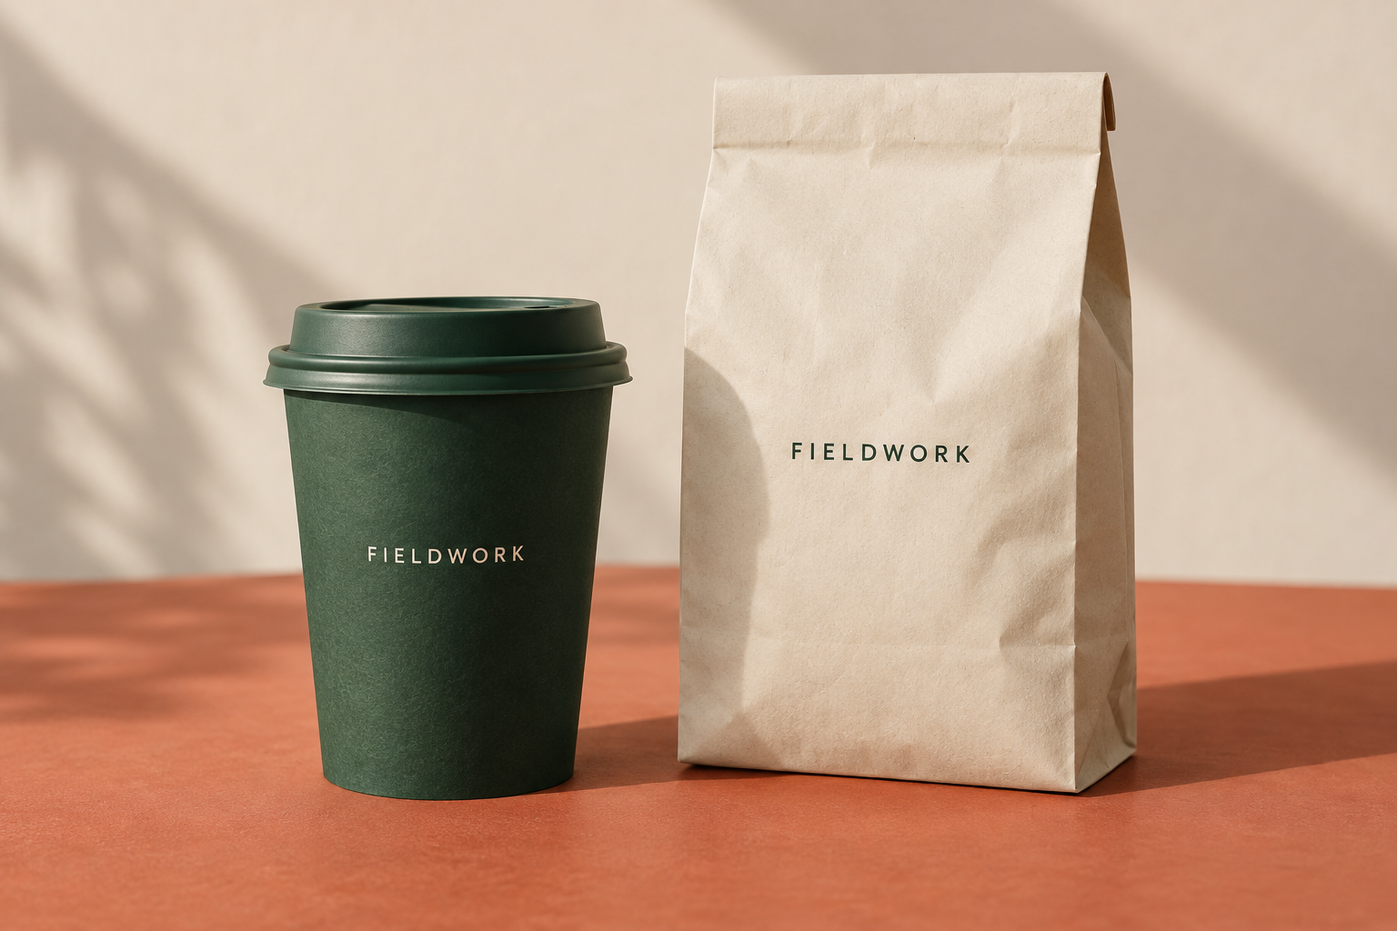
Packaging concept approved for the first production run.

This month’s progress
- Approved the cup, coffee bag and takeaway labels.
- Tested menu readability with the café team.
- Confirmed print specifications and supplier lead times.

Delivery plan
Each owner will confirm final artwork before the supplier deadline. The launch date includes one week for print checks and installation.
Deliverable | Owner | Due | Status
Identity & packaging | Maya Chen | 4 November | Approved
Shopfront & menu | Eli Morgan | 11 November | In progress
Launch-ready files | Noor Patel | 18 November | Scheduled

Budget
Workstream | Agreed fee
Identity and packaging | $4,800
Shopfront and menu | $2,600
Production handoff | $1,200
Total project fee | $8,600

Decisions for the client
- Confirm the final seasonal drink names by 16 October.
- Approve the shopfront installation window for 12 November.
- Nominate a staff contact for the production handoff.

Next review
We will review print proofs with the Fieldwork team on 23 October. Maya will circulate the proof pack two working days before the meeting. Any changes to quantities will be confirmed with the supplier before production starts.

