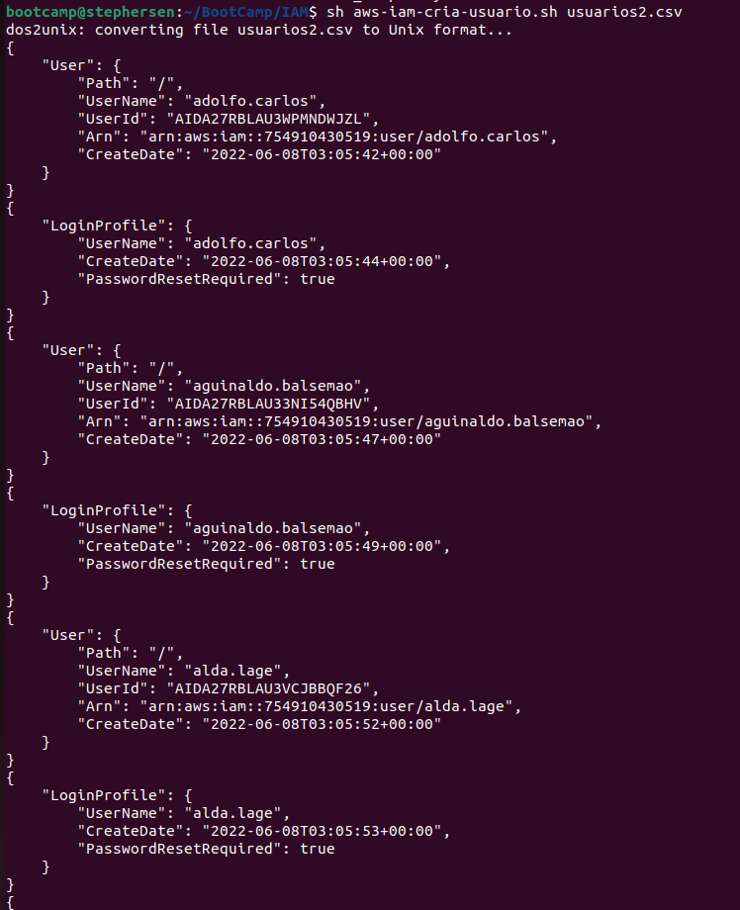
BootCamp AWS Pratical tasks

Creating user by a bash script.
Users created on Project

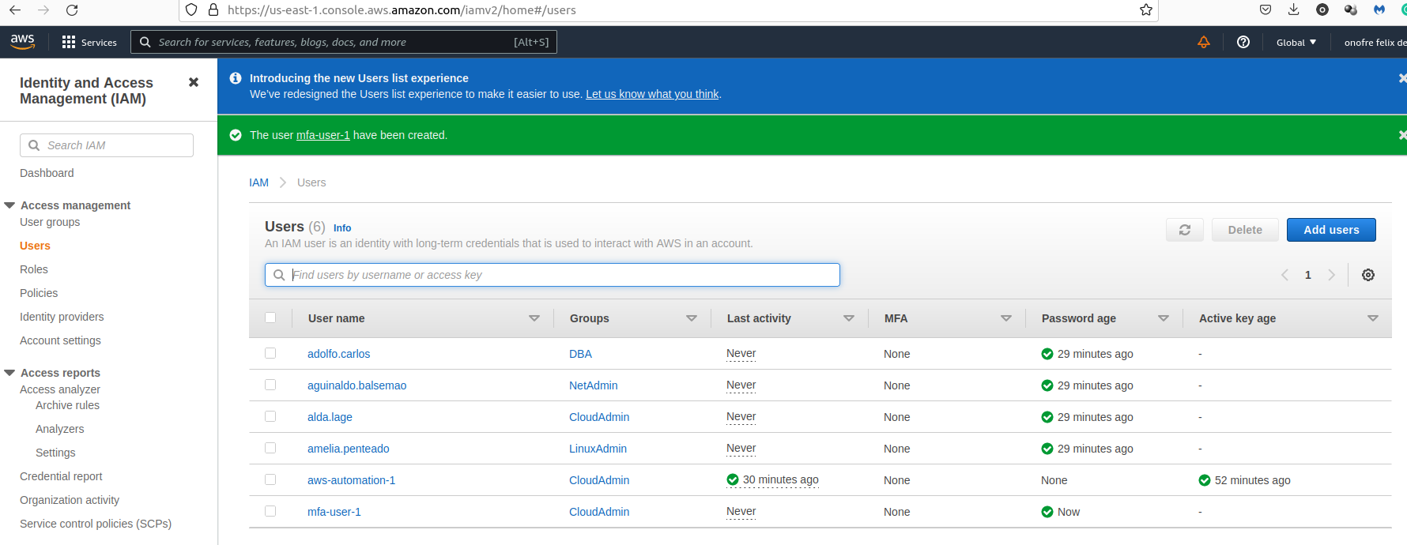

Mfa-policy applyed on a group
