From Churn Risk to Retention Pilots: A BI-Enabled CRM Strategy for a Telecom Provider
Nov 5, 2026 · @ALLEN
COMP3134 Business Intelligence and Customer Relationship Management · Group Project · Project Group 5 · Dataset: IBM Telco Customer Churn

Abstract
Telecom providers lose revenue when customers on flexible contracts leave early in the relationship. Using the public IBM Telco Customer Churn dataset (7,043 customers, 26.5% churned), we asked which customers a provider should prioritise for retention and what it should test with them.
We audited and cleaned the data without deleting any records, explored churn patterns descriptively, and trained an interpretable classification tree (maximum depth 4, at least 100 training customers per leaf) on a stratified 60/20/20 split. On the test set the model reached ROC-AUC 0.826, average precision 0.600 and churn recall 69.3% at a validation-selected threshold.
Three tree leaves define priority groups: new fiber customers on month-to-month contracts (S1, 40 of 44 test customers churned), fiber customers in months 2–15 (S2, 102 of 166) and new DSL customers without the technical-support add-on (S3, 37 of 60). Together they contain 19.2% of test customers but 47.9% of observed test churners.
We propose segment-specific retention packages: early-experience support for S1, a needs-based plan review for S2 and onboarding guidance for S3. Each would be evaluated in a randomised pilot against usual service, with 60-day retention as the primary KPI and cost and complaint limits as rollout conditions. The findings are associations from a cross-sectional teaching dataset; the pilots, not the model, would establish which actions work.

1. Business problem and research questions (Part A)
About one in four customers in this sample churned, and churn is concentrated among customers who can leave easily: those on month-to-month contracts and early in their tenure. The business problem is therefore not only predicting churn, but deciding whom to prioritise and which retention actions to test with limited follow-up capacity.

1.1 Business context
Subscription telecom services earn revenue over the length of the customer relationship. A customer on a month-to-month contract faces a low switching cost, like the "always a share" customer who can move to a competitor at any time; longer contracts create switching barriers (Lecture CRM3 [10]). Retention is one of the outcomes that CRM performance assessment tracks, alongside acquisition, win-back, satisfaction and loyalty (Lecture CRM1, p. 6 [8]).
This project addresses the retention stage of the acquisition–retention–win-back cycle (Lecture CRM2 [9]). It targets current customers before they leave, not former customers.
In the dataset, 1,869 of 7,043 customers (26.5%) churned. Churn was 42.7% among month-to-month customers but 2.8% among two-year customers, and churners had a median tenure of 10 months compared with 38 months for non-churners (Section 3). These gaps motivate the analysis but do not show why customers left.

1.2 Problem statement
The provider cannot contact every customer. A single blanket offer, such as a discount for everyone, spends resources on customers who would have stayed and may not address why different customers leave. The provider therefore needs:
- an evidence-based, explainable way to identify customer groups in which churn is concentrated; and
- differentiated retention actions for those groups that can be tested and measured before rollout.

1.3 Research questions
RQ | Question | Analytics type | BI technique | Section (part)
RQ1 | Which customer, service and account characteristics are associated with higher churn? | Descriptive | Data audit, cleaning, exploratory analysis | 2–3 (B)
RQ2 | Can an interpretable model identify higher-risk customers, and which feature combinations define high-churn groups? | Predictive | Classification decision tree, validation-based tuning | 4 (C)
RQ3 | How do the priority groups differ, and how much observed churn do they concentrate? | Descriptive, diagnostic | Profiling of tree-leaf segments | 5 (D)
RQ4 | Which retention actions should be tested for each group, and how should their effect be measured? | Prescriptive, evaluated by A/B testing | Evidence-to-action matrix, randomised pilot, KPIs | 6–7 (E)
Table A1. Research questions, analytics types and report sections. Tables and figures are numbered by part (A–E).

1.4 Why these BI techniques support the CRM strategy
The project follows Simon's decision process (Lecture BI1 [5]). Intelligence identifies and defines the problem (Sections 1–3); design builds and validates a model (Section 4); choice selects priority groups and actions (Sections 5–6); implementation is a pilot whose results can loop back to earlier phases (Section 6).
It also moves through the types of analytics in Lecture BI1 (p. 41 [5]). Descriptive statistics summarise what happened. A decision tree, a predictive technique, estimates which customers are more likely to churn. A/B testing supplies the evidence needed before an action is recommended for rollout.
We chose a supervised classification tree for three reasons:
- Churn is a labelled Yes/No outcome, so a classifier can learn from it directly.
- Every leaf is a readable rule, such as "month-to-month, fiber, tenure ≤ 1 month", that service staff can apply and a CRM system can target.
- Leaves act as segments, linking the model to segmentation and targeting in the STP process (Lecture CRM3, pp. 13–14 [10]).
Unsupervised clustering (K-means) was considered when the group planned the project. It does not use the churn label, and its clusters would still need interpretation before targeting.
The work is analytical CRM feeding operational CRM (Lecture CRM1 [8]). The analysis decides whom to contact and what to test; the contact itself would run through the provider's existing service channels.

1.5 Dataset and scope
We use the IBM Telco Customer Churn dataset published on Kaggle by BlastChar (version 1, last updated 23 February 2018) [1], one of the example datasets in the project brief [11]. It holds 7,043 customer records and 21 fields: demographics, subscribed services, account information (contract, billing, payment method, tenure, charges) and the Churn label.
It is a fictional telecom teaching sample. It has no observation or churn dates, its currency is not stated, and monthly charges are billing amounts, not profit or customer lifetime value. Findings are therefore associations within one cross-sectional sample, and the proposed actions are hypotheses to test, not proven effects.

2. Data source and preparation (Part B)
Integration note, delete before submission: Part A compiled this section from B's repository documents (data_source.md, decision_log.md, cleaning.md) [2]. B to confirm or replace with B's own wording.
The cleaned dataset keeps all 7,043 customers and every original value. The only change is that 11 blank TotalCharges entries are recorded as missing instead of zero.

2.1 Source and version control
The CSV was downloaded directly from the Kaggle endpoint and preserved byte-for-byte: 977,501 bytes, 7,043 rows and 21 fields [1, 2]. A SHA-256 checksum was recorded so that later steps can verify their input. Every later section uses the cleaned file fixed at repository commit f392d45.

2.2 Audit findings and cleaning decisions
Check | Finding | Decision
Missing values | 11 TotalCharges cells contain a single space; all 11 customers have tenure 0 and Churn = No | Kept all 11 customers; blanks set to missing, not zero; TotalChargesMissing flag added (11 ones, 7,032 zeros)
Duplicates | 0 duplicate rows, 0 duplicate customer IDs | No deletion
Numeric values | No negative or non-numeric values; no 1.5 × IQR outliers in tenure, MonthlyCharges or TotalCharges | No capping; valid high charges and long tenures kept
Service consistency | "No phone service" and "No internet service" agree with the base service in every row | Kept as distinct categories, not merged with "No" or treated as missing
Dates | No observation, joining or churn dates | Tenure treated as a duration in months; no calendar cohorts
Table B1. Data audit and cleaning decisions [2]. Course basis: consistency and missing values (Lecture BI2, p. 10), nominal categories (pp. 43–53), dispersion and extreme values (pp. 65, 74–79, 94–99) [6].
The result is 7,043 rows × 22 columns: the 21 original fields plus TotalChargesMissing. customerID is kept only for tracing records and Churn only as the target; neither is a model input (Section 4).

3. Exploratory analysis (Part B)
Integration note, delete before submission: compiled by Part A from B's eda.md and EDA tables [2]. B to confirm or replace.
Churn is highest among month-to-month, fiber-optic and no-technical-support customers, and among customers with short tenure. These are full-sample descriptive comparisons, not model evaluation.
Field | Category | Churned / customers | Churn rate
All customers | — | 1,869 / 7,043 | 26.5%
Contract | Month-to-month | 1,655 / 3,875 | 42.7%
Contract | One year | 166 / 1,473 | 11.3%
Contract | Two year | 48 / 1,695 | 2.8%
InternetService | Fiber optic | 1,297 / 3,096 | 41.9%
InternetService | DSL | 459 / 2,421 | 19.0%
InternetService | No internet | 113 / 1,526 | 7.4%
TechSupport | No | 1,446 / 3,473 | 41.6%
TechSupport | Yes | 310 / 2,044 | 15.2%
Table B2. Within-category churn rates: churned customers ÷ all customers in that category [2].
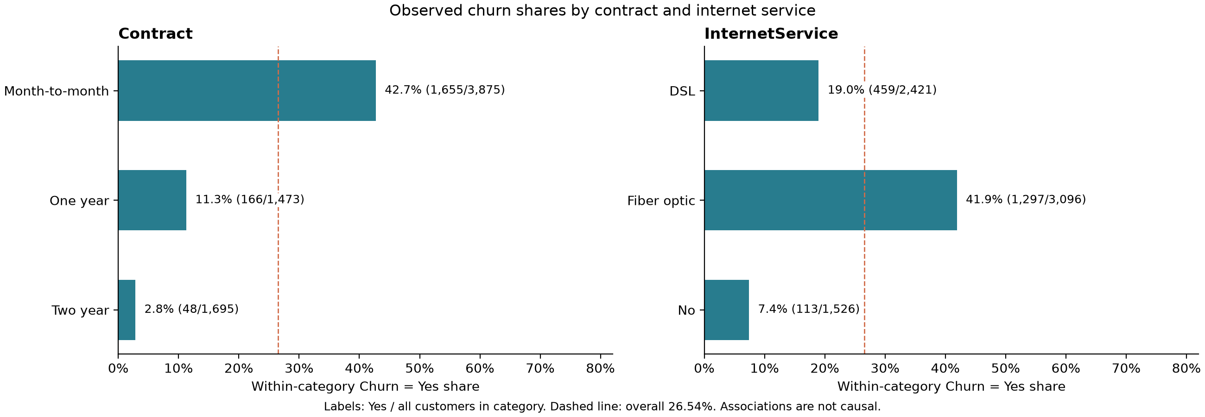
Figure B1. Observed churn shares by contract and internet service, full sample of 7,043 customers; dashed line = overall 26.5% [2].
Tenure separates the two groups clearly. Churners had a median tenure of 10 months, against 38 months for customers who stayed. Their median monthly charge was also higher: 79.65 against 64.43 (source units) [2].
Tenure and TotalCharges are strongly correlated (Pearson r = 0.826 over 7,032 customers with known charges), because accumulated charges grow with tenure. This overlap informed the decision to leave TotalCharges out of the model (Section 4).
Each row of Table B2 views one variable at a time. The rate for customers who are both month-to-month and fiber is not shown here; finding such combinations is the purpose of the decision tree in Section 4. Contract and service differences may also reflect tenure or customer mix, so they do not show that changing a contract or adding a service would prevent churn. Course basis: descriptive statistics, frequencies and distributions (Lecture BI2, pp. 64–99 [6]).

4. Decision-tree modelling and evaluation (Part C)
Integration note, delete before submission: compiled by Part A from the English text of C's Telecom_DT_Model_Report.pdf and the result files in code/results [3]. C to confirm or replace.
A depth-4 classification tree ranks churn risk well above chance (test ROC-AUC 0.826), and its rules yield three interpretable priority groups. Contract type, tenure and internet type drive the splits.

4.1 Model design
Choice | Setting | Rationale
Model | Classification tree [4] | Churn Yes/No is the target; leaf churn proportions estimate risk; rules are readable (Lecture BI4, pp. 69–73 [7])
Inputs | 18 original attributes: demographics, services, contract, billing, payment, tenure, MonthlyCharges | Excludes customerID (identifier), Churn (target), TotalCharges (overlaps with tenure and monthly charges; a simplifying choice) and TotalChargesMissing (audit flag)
Data split | Stratified 60/20/20: 4,225 training, 1,409 validation, 1,409 test; seed 42 | Test data are not used for tuning
Preprocessing | One-hot encoding; median imputation fitted on training data only | Numeric values keep source units, so cut-offs stay readable
Complexity | Depth 2/3/4 × minimum leaf 50/100/200, chosen by five-fold training cross-validation on average precision (AP) | Selected depth 4, minimum leaf 100 (CV AP 0.589); 15 leaves
Threshold | 0.335, chosen by validation F1 | Raises recall above the 0.5 default; not a cost-optimised marketing threshold
Priority groups | Top three leaves by training churn proportion | Test labels are not used to choose groups
Table C1. Model design choices and rationale [3].

4.2 Test performance
Threshold | Accuracy | Precision | Recall | F1 | False alerts | Missed churners
0.335 (selected) | 76.1% | 53.8% | 69.3% | 0.606 | 222 | 115
0.500 | 79.7% | 66.3% | 47.9% | 0.556 | 91 | 195
Table C2. Test-set results for 1,409 customers, 374 of whom churned [3].
On the test set the tree achieved ROC-AUC 0.826, AP 0.600 against a churn prevalence of 26.5%, and a Brier score of 0.141. Accuracy alone is misleading here: predicting "no churn" for everyone would already score 73.5%.
At the selected threshold the model finds 259 of 374 churners. If the provider contacted only the 20% of test customers with the highest risk, that list would contain an expected 49.1% of observed churners.

4.3 What drives the tree
The root split is contract type. In the month-to-month branch, the tree next separates fiber from other internet types and then splits on tenure (Figure C1).
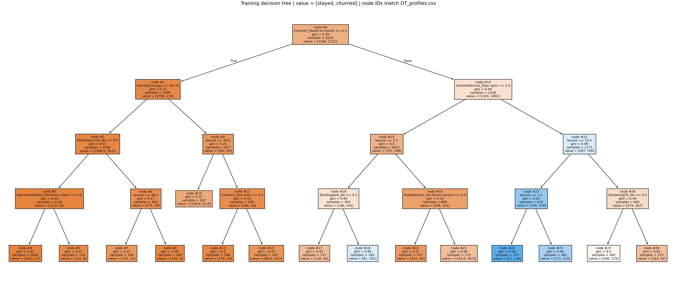
Figure C1. Reference decision tree fitted on 4,225 training customers; value = [stayed, churned]; node IDs match the rule tables. Leaves 24, 25 and 18 are S1, S2 and S3 [3].
Shuffling one attribute at a time and measuring the drop in test AP gives the same order: Contract 0.145, tenure 0.120, InternetService 0.104, TechSupport 0.011 and MonthlyCharges 0.005. This permutation importance shows what the model relies on, not the direction of an effect or its cause.

4.4 Priority groups
Group | Leaf | Rule | Training customers | Training churn rate
S1 | 24 | Month-to-month, fiber optic, tenure ≤ 1 month | 152 | 84.9%
S2 | 25 | Month-to-month, fiber optic, tenure 2–15 months | 481 | 64.4%
S3 | 18 | Month-to-month, DSL, tenure ≤ 3 months, no technical-support add-on | 182 | 55.5%
Table C3. The three training-selected priority leaves [3]. Their test evidence is profiled in Section 5.

4.5 Stability check
The fixed specification was refitted 20 times on stratified 80% subsamples of the training data (seeds 100–119). Contract was the root in all 20 refits, and tenure, internet type and monthly charges appeared in every refit; technical support appeared in 11. Validation AP averaged 0.588 (SD 0.019, range 0.545–0.611).
Exact group boundaries were less stable. Mean membership overlap (Jaccard) with the reference groups was 0.64–0.70, with minima of 0.14–0.36. Broad signals recur, but cut-offs such as "1 month" or "15 months" should be treated as pilot definitions, not universal rules [3].

5. Customer profiles and business insights (Part D)

5.1 Analytical scope and connection to the preceding analysis
The preceding exploratory analysis found elevated observed churn among customers with month-to-month contracts (42.7%) and fiber-optic service (41.9%), compared with 26.5% across all 7,043 customers. These are separate category comparisons, not the churn rate of customers satisfying both conditions. They establish the background for examining combinations of contract, service and tenure characteristics. [2]
Building on the decision tree developed in Section 4, we examine three priority groups selected by their training-leaf churn proportions. The profiles below use the same 1,409 test customers as Section 4, including 374 observed churners. S1, S2 and S3 are three of the tree's 15 leaves; the remaining customers stay in other leaves. Our purpose is to identify whom the telecom provider should investigate and prioritise for retention trials, using observed customer characteristics rather than assuming why they left. [3]

5.2 Profiles of the three priority groups
Table D1. Customer profiles: selected fields from the Section 4 model outputs
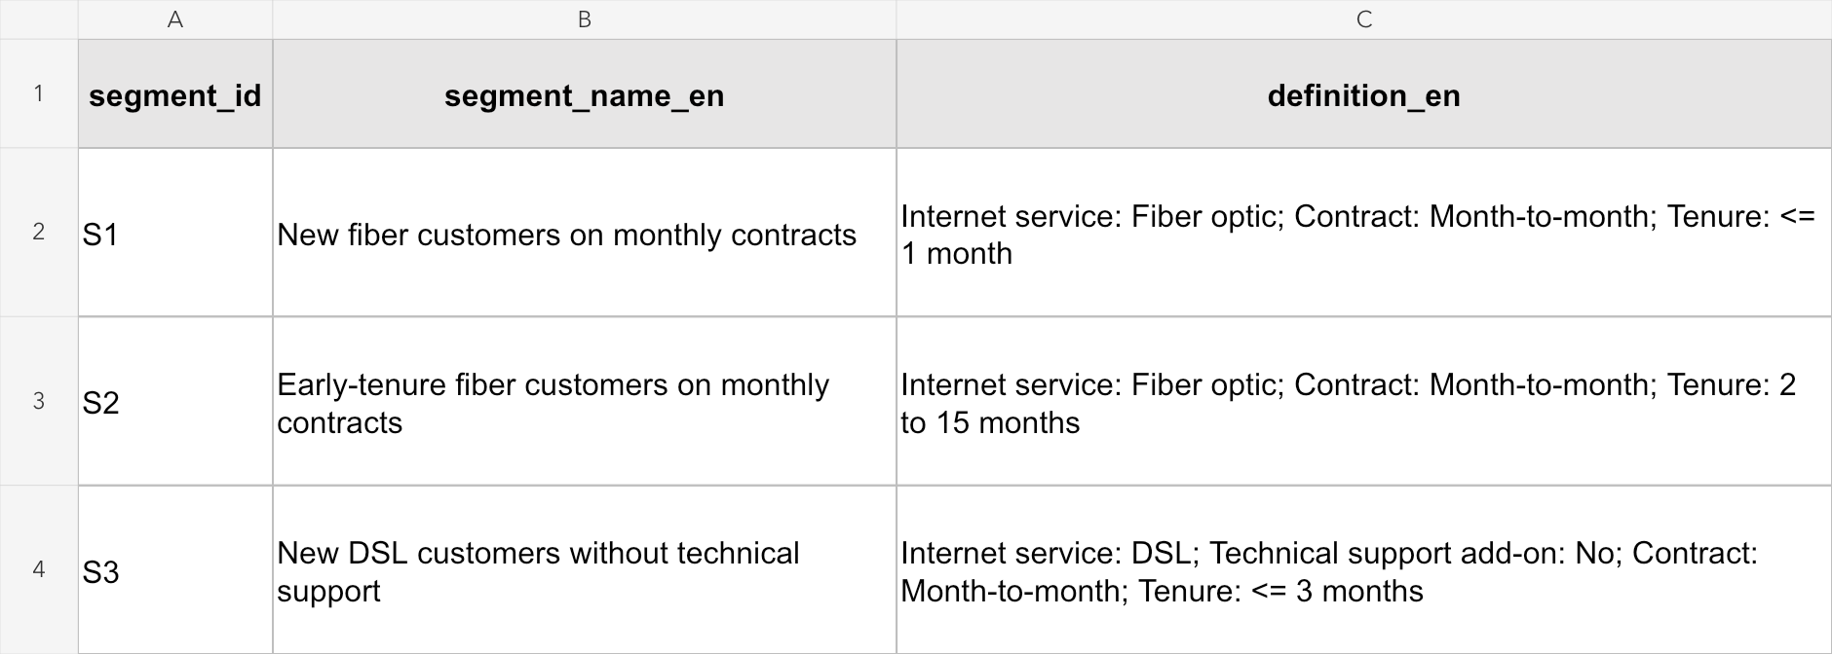
Source: code/results/priority_segments_bilingual.csv. Spreadsheet view of segment_id, segment_name_en and definition_en, retaining the original field names and text. Tenure is recorded in whole months. S1 and S2 do not restrict the technical-support add-on.
The groups differ in the stage of their customer relationship and their service configuration. S1 and S3 contain very new customers, with median tenure of one month, while S2 has median tenure of six months. These distinctions make the profiles more useful for CRM planning than a single label such as “high-risk customers”.

5.3 Differences in observed churn and service needs
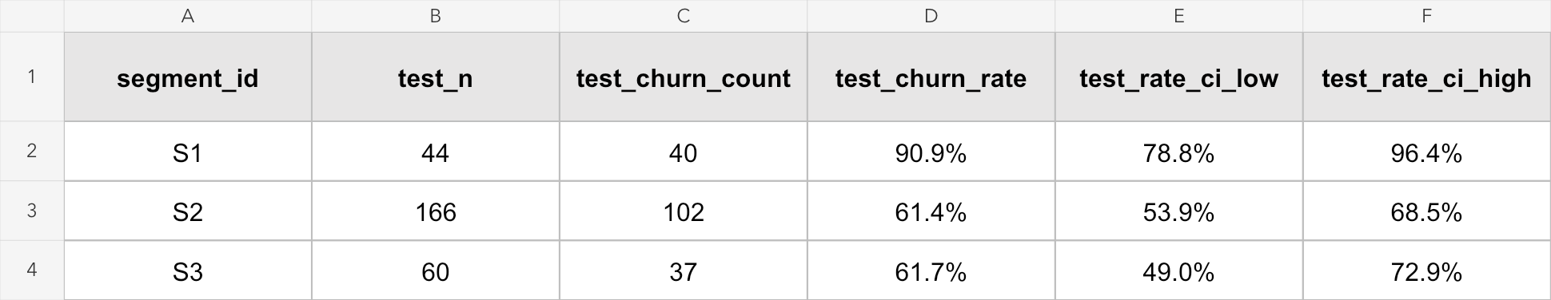
Figure D1. Observed churn evidence from code/results/priority_segments.csv. The selected original fields show test sample size, churn count, churn rate and the lower and upper 95% Wilson limits. Rates are displayed as percentages; the underlying CSV values are unchanged. [3]

Highest observed risk and largest affected group
S1 has the highest observed churn rate: 40 of 44 customers churned (90.9%). Its combination of a monthly contract, fiber service and at most one month of tenure points to the beginning of the customer relationship as an important area for investigation. However, the group is small, and its 95% Wilson interval is 78.8%–96.4%. The result supports examining early experiences, including service setup and first-bill understanding, but does not establish that either caused churn.
S2 presents a different priority because it is larger. It contains 166 test customers and 102 observed churners, equivalent to 27.3% of all 374 test churners. Its churn rate of 61.4% is below S1's, yet it accounts for more than twice as many observed churners. A provider allocating limited follow-up capacity should therefore consider both the proportion at risk and the number of customers affected. S1 warrants focused investigation, while S2 offers a larger population for evaluating a retention trial. [3]

Different service configurations require different explanations
S1 and S2 use fiber service and have median monthly charges of 76.03 and 80.00. S3 uses DSL, has no technical-support add-on and has a lower median monthly charge of 45.83, yet 37 of its 60 customers churned (61.7%). High monthly charges alone therefore do not describe all three priority groups. S3 suggests a separate line of inquiry into onboarding and support needs, whereas the fiber groups may require investigation of service experience and plan suitability.
These are questions for follow-up, not established reasons for leaving. TechSupport=No means that the customer did not subscribe to the add-on; it does not show that general customer service was unavailable. Likewise, a higher monthly charge does not prove price sensitivity or a need for discounts. S2 and S3 also have very similar observed rates and overlapping intervals, so the small numerical difference does not justify ranking one as clearly riskier. [3]

5.4 Concentration of churn and implications for CRM
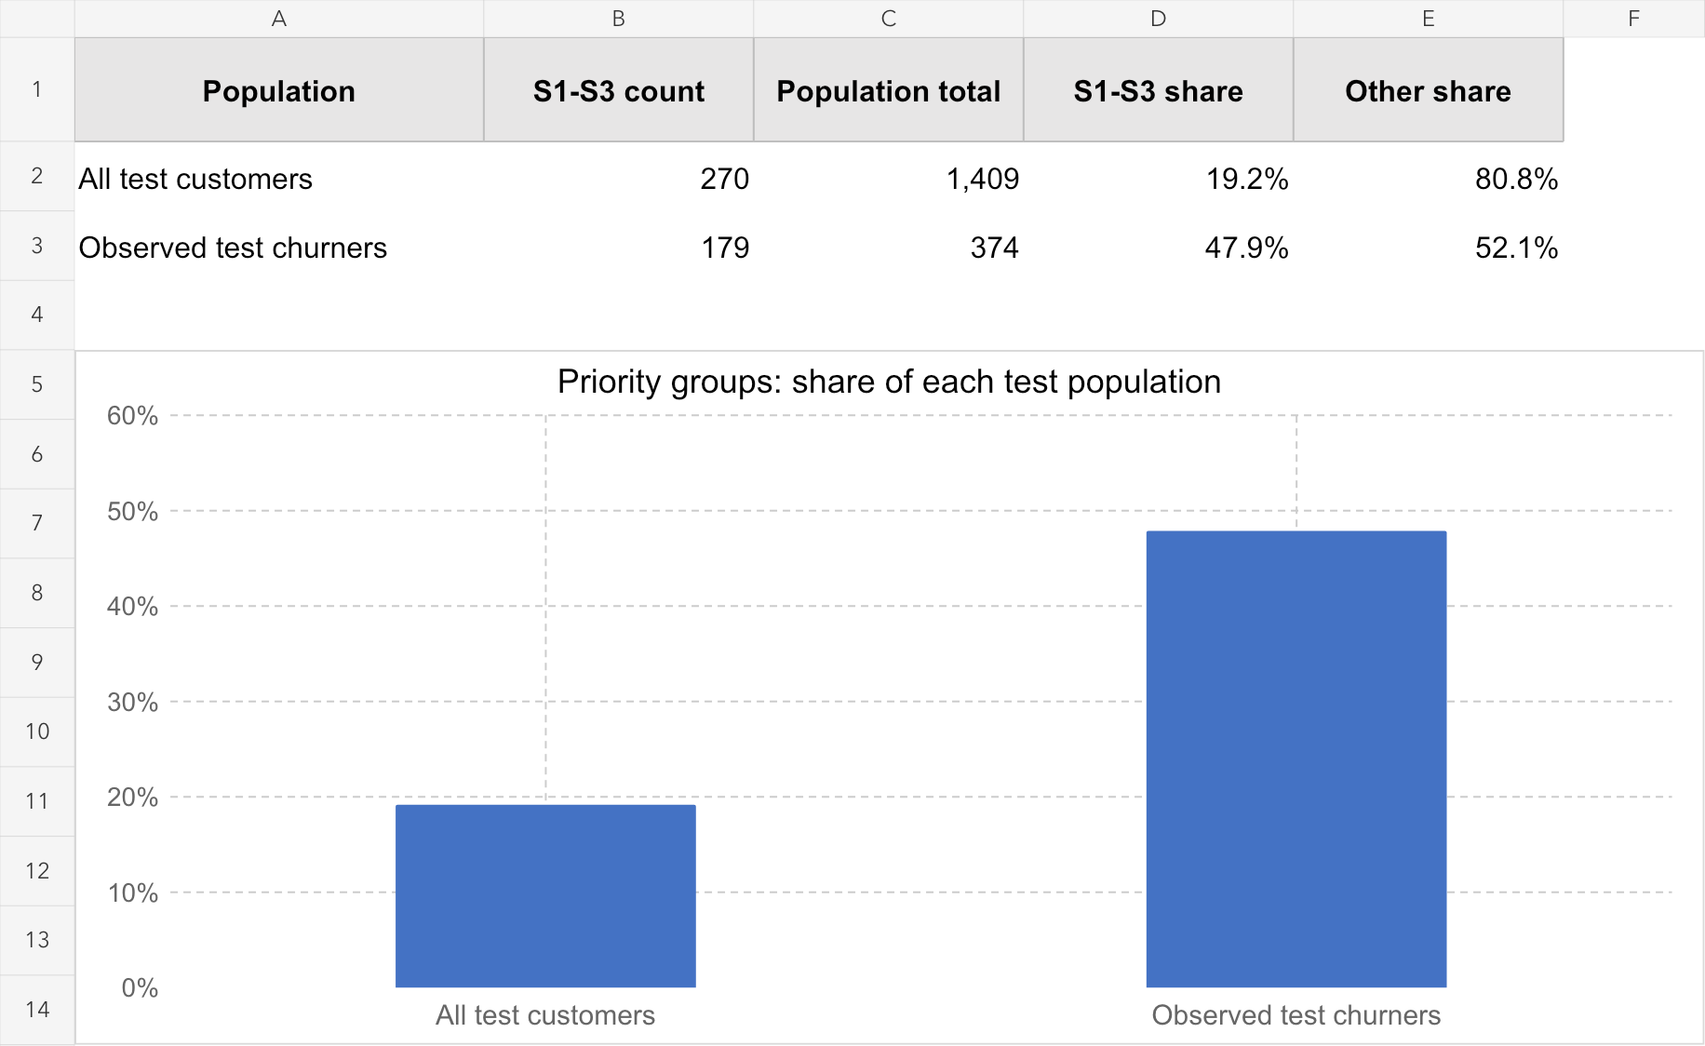
Figure D2. S1–S3 as a share of each test population. A simple Excel chart and calculation table based on code/results/test_predictions.csv: segment_id identifies S1–S3, and actual_churn identifies observed churners. The two denominators are different. [3]
S1–S3 contain 270 of 1,409 test customers (19.2%) and 179 of 374 observed churners (47.9%). Their combined churn rate is 66.3%, compared with 26.5% overall and 17.1% among the remaining 1,139 customers (195 churners). This concentration provides a starting point for trials among current customers with similar characteristics.
The 47.9% represents observed churn coverage, not the proportion an intervention would prevent. The remaining customers still account for 195 churners (52.1%). They belong to multiple leaves and should not be treated as one uniform low-risk group.

5.5 Interpretation limits and transition to retention strategy
Across the 20 training-subsample checks in Section 4.5, mean membership overlap (Jaccard) was 0.64–0.70, with minima of 0.14–0.36. Exact boundaries can vary even when broad predictors recur. The test split was previously inspected during exploration. These results are therefore exploratory associations, not proof of churn causes, future predictive performance or intervention effects. [3]
Section 6 builds on S1's early relationship stage, S2's larger affected population and S3's support configuration to design trials measuring subsequent retention, costs and complaints. Monthly charges retain the source units and describe billing levels, not profit or customer lifetime value. Priorities ultimately require evidence about both customer outcomes and intervention costs.

6. CRM strategy and pilot evaluation (Part E)

6.1 Evidence and retention priorities
Building on Section 5, we recommend three differentiated retention trials for current customers with characteristics matching S1–S3. These groups contain 270 of 1,409 test customers (19.2%) and 179 of 374 observed churners (47.9%). This concentration supports focused investigation; it does not mean that a campaign would retain 47.9% of churners. The remaining leaves still contain 195 churners and require normal service and continued monitoring. (Section 5; [3])
We propose S2 as the main pilot cohort, subject to sufficient current eligible customers, because it contains the largest number of observed churners: 102, compared with 40 in S1 and 37 in S3. S1 warrants focused early-experience investigation because its observed rate is highest, but its test sample is only 44. Actual trial size must be based on a new power calculation, not these historical counts. (Section 5; [3])
Priority group and test evidence | Proposed retention package | What the trial should establish
S1 Monthly fiber, tenure 0–1 months; 40/44 churned (90.9%) | Installation follow-up, connection and device checks, first-use help, and first-bill explanation. | Whether structured early support improves subsequent retention without excessive contact or service cost.
S2 Monthly fiber, tenure 2–15 months; 102/166 churned (61.4%) | Needs-based plan review and service follow-up; resolve reported issues before considering a capped offer. | Whether better plan fit and issue resolution improve retention. No blanket discount is assumed.
S3 Monthly DSL, tenure 0–3 months, TechSupport=No; 37/60 churned (61.7%) | Onboarding guidance, self-help troubleshooting and a clear route to existing human support. | Whether guidance and support access improve retention; assess demand before proposing an add-on.
Table E1. Evidence to action matrix for the three priority groups. Source: Section 5 and code/results/priority_segments.csv, priority_segments_bilingual.csv and DT_rules.csv. Evidence is descriptive. S1 and S2 do not restrict TechSupport. TechSupport=No means no technical-support add-on, not no general customer service. [3]

6.2 How the packages would operate
For S1, a service adviser would check activation, explain setup and confirm that the customer understands the first bill. A proposed contact within seven days of enrolment, followed by first-bill follow-up, would test the early-journey hypothesis. These timings are design choices, not findings. [8, 9]
For S2, advisers would ask about usage needs, service experience and unresolved issues, then explain suitable plan choices. Its median monthly charge of 80.00 is a billing measure, not evidence of price sensitivity or profitability. Any later discount test would require a separate cost case. [3, 9]
For S3, the package would provide setup guidance and an accessible help route without requiring purchase of an extra service. A missing add-on does not establish that support was unavailable or caused churn. These three packages apply customer-experience management and personalisation to different relationship stages. [8–10]

6.3 Randomised pilot design
The evaluation would recruit a new cohort of active customers matching the current rules. The historical test customers are evidence for defining the pilot, not the pilot participants. Before recruitment, confirm that contract, service and tenure are available at the decision date, and that a permitted contact channel exists. The dataset does not establish channel preference, so email, app or telephone contact would follow the provider’s actual contact permissions. (Section 5; [3])

Assignment and delivery
Within each eligible segment, randomly assign customers 1:1 to the segment-specific package or usual service. S2 would be the main confirmatory comparison if recruitment permits; S1 and S3 would begin as smaller feasibility studies or use a longer recruitment period if underpowered. S1 must not be compared directly with S2 as a control because their starting characteristics differ. Freeze segment membership at enrolment and allow each customer to enter once, even as tenure increases. [5]
Use a proposed 60-day follow-up from assignment, with the same window in both arms. Usual support remains available to everyone. Log assigned group, attempted and completed contacts, delivery dates, service issues, actions, costs and account status. Analyse customers in their original assigned arm, including those who decline or cannot be reached. Document missing outcomes and assess their effect rather than silently excluding them. [5, 8, 10]

Outcomes and cost controls
Metric | Definition and interpretation
Primary 60-day retention | Customers with no qualifying service cancellation during 60 days ÷ all customers assigned to that arm. Prespecify qualifying cancellation and account for missing outcomes.
Incremental retention | Treatment retention rate − control retention rate, in percentage points. Equivalently, control churn rate − treatment churn rate.
Cost per assigned customer | All recorded contact, staff, service and offer costs ÷ assigned customers; report each arm and their difference.
Customer experience | Complaint and contact-opt-out rates per assigned customer; also track unresolved issues. Report satisfaction among respondents together with survey response rate.
Cost per additional retained customer | Incremental cost per assigned customer ÷ positive estimated retention-rate difference, expressed as a fraction. Use only when the effect is sufficiently reliable; include uncertainty.
Table E2. Prespecified pilot metrics.
Before launch, estimate a contemporary control retention rate, define the smallest worthwhile improvement and calculate sample size using the chosen power and significance level. Do not substitute S1’s 90.9% historical churn proportion for a prospective 60-day baseline. If all three groups are tested confirmatorily, prespecify how multiple comparisons will be handled. [5]

Rollout decision
Prespecify practical cost and complaint limits from the provider’s budget and current service standards. Expand only when the randomised comparison shows a useful retention improvement with acceptable uncertainty and these limits are met. A risk score identifies whom to investigate; treatment benefit must be measured separately. No numerical lift, savings or ROI is claimed before the trial. [3, 5, 8–10]

6.4 Course concepts supporting the strategy
Proposed use | Verified lecture support | Boundary
Onboarding and first-bill journey | CRM1 PDF pp. 46–47: Customer Experience Management and Journey Maps | Supports managing customer touchpoints; seven-day contact is a proposed timing.
Plan review and differentiated service | CRM2 PDF pp. 15–16: Retention Strategies | Supports improved service, personalisation and customisation; does not prove these interventions work here.
Choosing target groups | CRM3 PDF pp. 13–14: BI for Market Segmentation and STP | Supports evidence-informed targeting; groups do not establish customer motives.
Retention and experience KPIs | CRM1 PDF p. 6; CRM3 PDF p. 21: Performance assessment; Building Customer Satisfaction | Supports retention, surveys, complaints and follow-up calls. Specific pilot metrics are project definitions.
A/B evaluation | BI1 PDF pp. 38, 41: Diagnostic analytics and analytics comparison | Names A/B testing. Randomisation, 60 days, sample size and rollout rules are our proposed design.
Table E3. Lecture references using PDF reader page numbers, with the cover counted as page 1 [5, 8–10].

7. Limitations and conclusion

7.1 Limitations (Part E)
The source is a fictional telecom teaching sample with insufficiently established observation dates and currency. The existing test split had already been examined during exploration. The tree and profiles therefore provide exploratory associations, not validated future intervention outcomes. In 20 training-subsample checks, mean segment-membership Jaccard was 0.64–0.70, with some much lower matches. Keep the present cutoffs auditable, but reassess them on new data rather than treating one or fifteen months as universal boundaries. (Section 5; [1, 3])
S1’s 95% Wilson interval is 78.8%–96.4%, reflecting its small test sample. S2 and S3 have similar rates and overlapping intervals, so the slight difference between 61.4% and 61.7% is not a sound basis for ordering them. Risk, contactability, intervention cost and likely treatment benefit all matter. The source has no realised profit, service-quality measure or retention experiment; monthly charges cannot replace profit or customer lifetime value. (Section 5; [3])

7.2 Conclusion (Part E)
We recommend a needs-based review and service-follow-up pilot for S2, alongside focused onboarding studies for S1 and S3 when recruitment allows. The evidence determines whom to investigate; the randomised pilots determine which actions to expand. The objective is improved subsequent retention within agreed cost and customer-experience limits.

7.3 Answers to the research questions (Part A)
RQ | Answer in one line | Evidence
RQ1 | Month-to-month contracts, fiber-optic service, no technical-support add-on and short tenure are associated with higher churn. | Section 3, Table B2
RQ2 | Yes: a depth-4 tree reaches test ROC-AUC 0.826 and recall 69.3%; contract, tenure and internet type define three high-churn leaves. | Section 4, Tables C2–C3
RQ3 | S1 has the highest rate (90.9%), S2 the most churners (102), S3 a different, DSL and support-related profile; together 47.9% of test churners. | Section 5, Figures D1–D2
RQ4 | Test early-experience support (S1), plan review (S2) and onboarding guidance (S3) in randomised pilots, judged on 60-day retention within cost and complaint limits. | Section 6, Tables E1–E2
Table A2. How the analysis answers each research question.

References
- BlastChar (2018). Telco Customer Churn (Version 1) [Data set]. Kaggle. kaggle.com/datasets/blastchar/telco-customer-churn
- Project Group 5, Part B (2026). IBMTelecom-Customer-Retention: data audit, cleaning and exploratory analysis, commit f392d45 [Code repository]. GitHub. github.com/onoizu/IBMTelecom-Customer-Retention. Files used: docs/data_source.md, docs/decision_log.md, reports/cleaning/, reports/eda/.
- Project Group 5, Part C (2026). Decision-tree model outputs in code/results/ (metrics.csv, DT_cv.csv, DT_rules.csv, DT_importance.csv, priority_segments.csv, priority_segments_bilingual.csv, test_predictions.csv, feature_stability.csv, segment_stability.csv, stability_report.md, run_info.json) and Telecom_DT_Model_Report.pdf, 29 October 2026.
- scikit-learn developers. Decision Trees, scikit-learn 1.7 User Guide. scikit-learn.org/1.7/modules/tree.html
- COMP3134 Business Intelligence and CRM, Lecture BI1: Business Intelligence. The Hong Kong Polytechnic University.
- COMP3134, Lecture BI2. The Hong Kong Polytechnic University.
- COMP3134, Lecture BI4. The Hong Kong Polytechnic University.
- COMP3134, Lecture CRM1: CRM Fundamentals. The Hong Kong Polytechnic University.
- COMP3134, Lecture CRM2: Relationship Marketing and Retention. The Hong Kong Polytechnic University.
- COMP3134, Lecture CRM3: Profitability, Segmentation and Customer Perceived Value. The Hong Kong Polytechnic University.
- COMP3134 (2026). Group Project: BI-Enabled CRM Strategy, revised project description, Semester 1, AY2026–27. The Hong Kong Polytechnic University.

Appendix: Contribution statement
Part | Member | Responsibility | Sections
A | [name] | Business problem and research questions, abstract, integration of report and slides, references, submission checklist, rehearsal | Abstract, 1, 7.3, References
B | [name] | Data download, audit, cleaning and exploratory analysis | 2, 3
C | [name] | Decision-tree modelling, evaluation, priority-group selection, stability check | 4
D | [name] | Customer profiles and business insights | 5
E | [name] | CRM strategy, pilot design, KPIs, limitations and conclusion | 6, 7.1–7.2
Table A3. Contribution by part.

