  - Part D

Customer Profiles and Business Insights

Analytical scope and connection to the preceding analysis
The preceding exploratory analysis found elevated observed churn among customers with month-to-month contracts (42.7%) and fiber-optic service (41.9%), compared with 26.5% across all 7,043 customers. These are separate category comparisons, not the churn rate of customers satisfying both conditions. They establish the background for examining combinations of contract, service and tenure characteristics. [1]
Building on the decision tree developed in Part C, we examine three priority groups selected by their training-leaf churn proportions. The profiles below use the same 1,409 test customers as Part C, including 374 observed churners. S1, S2 and S3 are three of the tree's 15 leaves; the remaining customers stay in other leaves. Our purpose is to identify whom the telecom provider should investigate and prioritise for retention trials, using observed customer characteristics rather than assuming why they left. [2]

Profiles of the three priority groups
Table D1. Customer profiles: selected fields from Part C's CSV
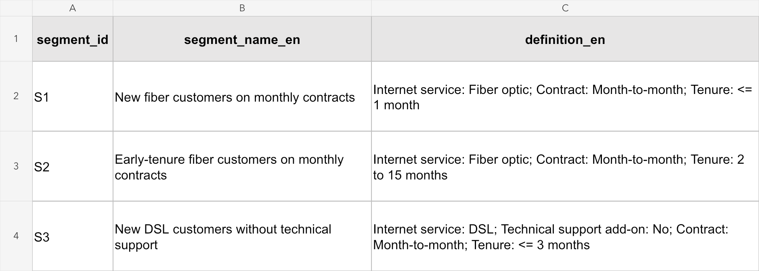
Source: code/results/priority_segments_bilingual.csv. Spreadsheet view of segment_id, segment_name_en and definition_en, retaining the original field names and text. Tenure is recorded in whole months. S1 and S2 do not restrict the technical-support add-on.

The groups differ in the stage of their customer relationship and their service configuration. S1 and S3 contain very new customers, with median tenure of one month, while S2 has median tenure of six months. These distinctions make the profiles more useful for CRM planning than a single label such as “high-risk customers”.

Differences in observed churn and service needs
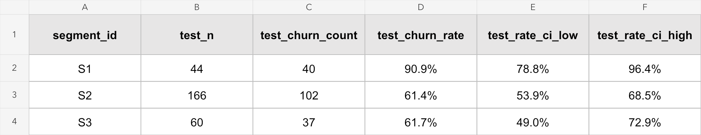
Figure D1. Observed churn evidence from code/results/priority_segments.csv. The selected original fields show test sample size, churn count, churn rate and the lower and upper 95% Wilson limits. Rates are displayed as percentages; the underlying CSV values are unchanged. [2]

Highest observed risk and largest affected group
S1 has the highest observed churn rate: 40 of 44 customers churned (90.9%). Its combination of a monthly contract, fiber service and at most one month of tenure points to the beginning of the customer relationship as an important area for investigation. However, the group is small, and its 95% Wilson interval is 78.8%–96.4%. The result supports examining early experiences, including service setup and first-bill understanding, but does not establish that either caused churn.
S2 presents a different priority because it is larger. It contains 166 test customers and 102 observed churners, equivalent to 27.3% of all 374 test churners. Its churn rate of 61.4% is below S1's, yet it accounts for more than twice as many observed churners. A provider allocating limited follow-up capacity should therefore consider both the proportion at risk and the number of customers affected. S1 warrants focused investigation, while S2 offers a larger population for evaluating a retention trial. [2]

Different service configurations require different explanations
S1 and S2 use fiber service and have median monthly charges of 76.03 and 80.00. S3 uses DSL, has no technical-support add-on and has a lower median monthly charge of 45.83, yet 37 of its 60 customers churned (61.7%). High monthly charges alone therefore do not describe all three priority groups. S3 suggests a separate line of inquiry into onboarding and support needs, whereas the fiber groups may require investigation of service experience and plan suitability.
These are questions for follow-up, not established reasons for leaving. TechSupport=No means that the customer did not subscribe to the add-on; it does not show that general customer service was unavailable. Likewise, a higher monthly charge does not prove price sensitivity or a need for discounts. S2 and S3 also have very similar observed rates and overlapping intervals, so the small numerical difference does not justify ranking one as clearly riskier. [2]

Concentration of churn and implications for CRM
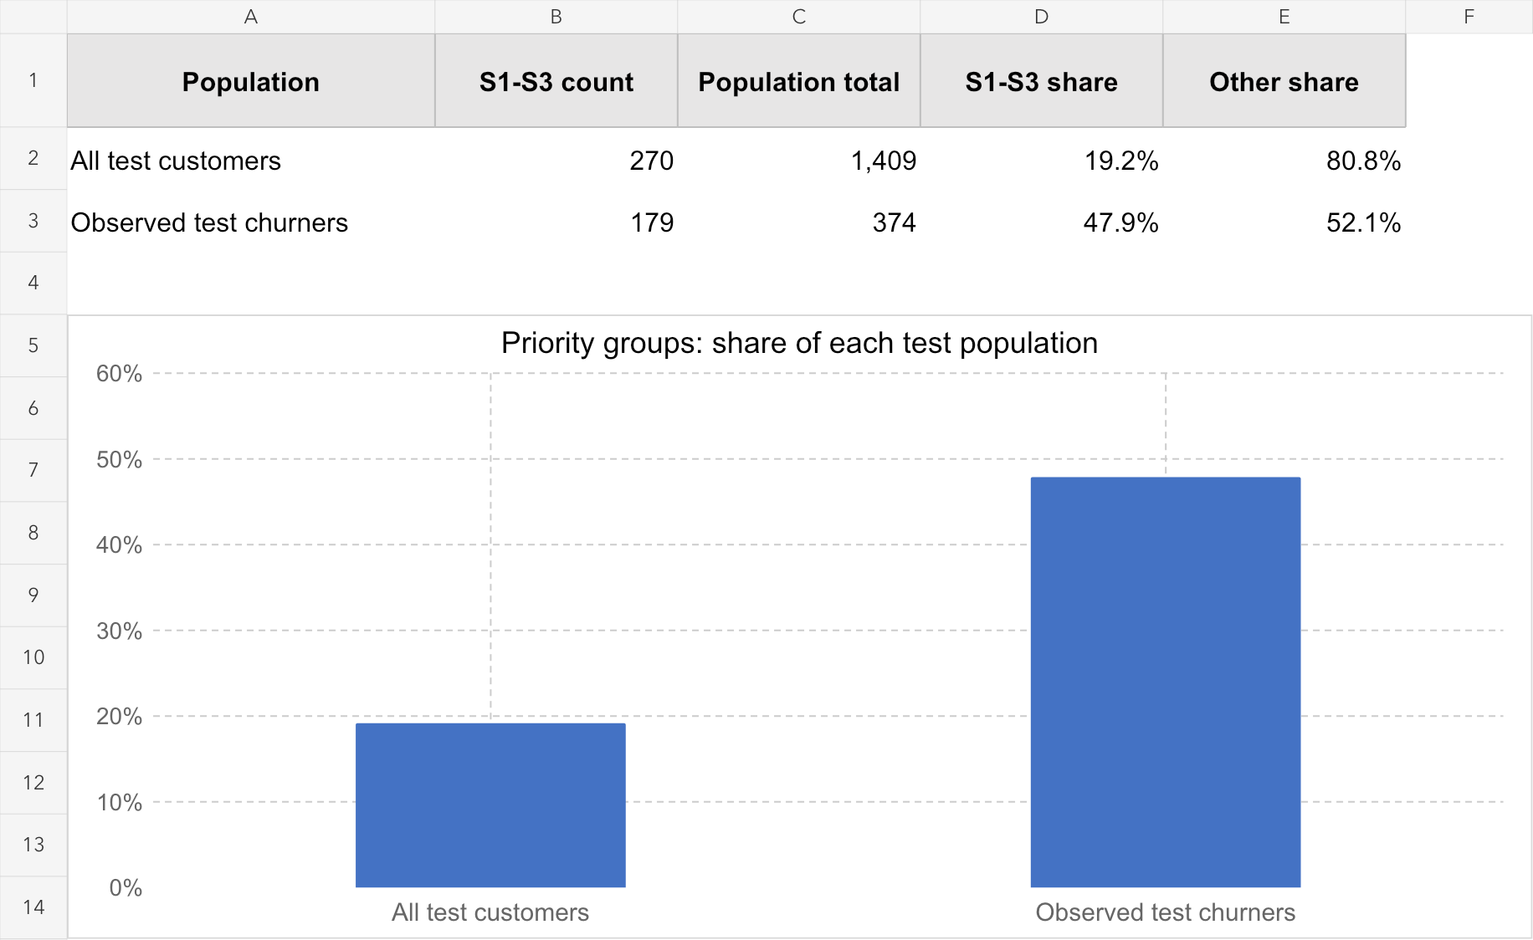
Figure D2. S1–S3 as a share of each test population. A simple Excel chart and calculation table based on code/results/test_predictions.csv: segment_id identifies S1–S3, and actual_churn identifies observed churners. The two denominators are different. [2]
S1–S3 contain 270 of 1,409 test customers (19.2%) and 179 of 374 observed churners (47.9%). Their combined churn rate is 66.3%, compared with 26.5% overall and 17.1% among the remaining 1,139 customers (195 churners). This concentration provides a starting point for trials among current customers with similar characteristics.
The 47.9% represents observed churn coverage, not the proportion an intervention would prevent. The remaining customers still account for 195 churners (52.1%). They belong to multiple leaves and should not be treated as one uniform low-risk group.

Interpretation limits and transition to retention strategy
Across Part C's 20 training-subsample checks, mean membership overlap (Jaccard) was 0.64–0.70, with minima of 0.14–0.36. Exact boundaries can vary even when broad predictors recur. The test split was previously inspected during exploration. These results are therefore exploratory associations, not proof of churn causes, future predictive performance or intervention effects. [3]
Part E can build on S1's early relationship stage, S2's larger affected population and S3's support configuration to design trials measuring subsequent retention, costs and complaints. Monthly charges retain the source units and describe billing levels, not profit or customer lifetime value. Priorities ultimately require evidence about both customer outcomes and intervention costs.

Data sources
[1] Part B exploratory analysis, category_churn.csv: full sample of 7,043 customers; Contract and InternetService category summaries. Project repository: github.com/onoizu/IBMTelecom-Customer-Retention.
[2] Part C model outputs in code/results/: priority_segments_bilingual.csv, priority_segments.csv, DT_rules.csv and test_predictions.csv. Table D1 and Figure D1 show selected CSV fields; Figure D2 aggregates the same test predictions. All required CSV evidence views are included.
[3] Part C stability_report.md, segment_stability.csv and README.md: rule sensitivity and the stated limitations of the existing test split.

