Registration for DMA2027
International Workshop on Discrete Mathematics and Algorithms 2027
Please complete this form and email it to hojinchu@kias.re.kr
Venue: Jeju Shinhwa World (Landing Resort), Jeju Island, Korea | Hotel website
Dates: March 16–20, 2027
The workshop will open on the evening of March 16 and close on the morning of March 20. Talks will take place on March 17–19 in two parallel tracks: Graph Theory and Combinatorics and Discrete Algorithms.

Registration
Registration | Deadline | Standard fee | Student fee
Early | December 12, 2026 | JPY 12,000 | JPY 8,000
Late | January 30, 2027 | JPY 15,000 | JPY 12,000
The registration fee includes the workshop banquet and lunch boxes on March 17 and March 19.
Registration fees must be paid in Japanese yen through the designated online payment system: Payment – Registration Fee
Your registration will be complete only after you have submitted this form and paid the registration fee through the workshop website.
Advance registration is required. On-site registration will not be available.
Due to the limited capacity of the lecture hall, registration may close early if the maximum number of participants is reached.
Please see the workshop website for details.

Accommodation
We can arrange accommodation at a discounted rate of KRW 120,000 per room per night, excluding breakfast. Standard single and twin rooms are available at the same rate.
A limited number of rooms have been reserved for workshop participants and will be allocated on a first-come, first-served basis, in the order in which registration forms are received.
Once all reserved rooms have been allocated, participants who have not secured a room through the organizers will need to arrange their own accommodation, even if workshop registration is still open.
Please see the Accommodation section below for details, including payment deadlines and requirements for students.
* Required field. For single-choice questions, select one option; for meals, select all that apply.

Schedule (tentative)
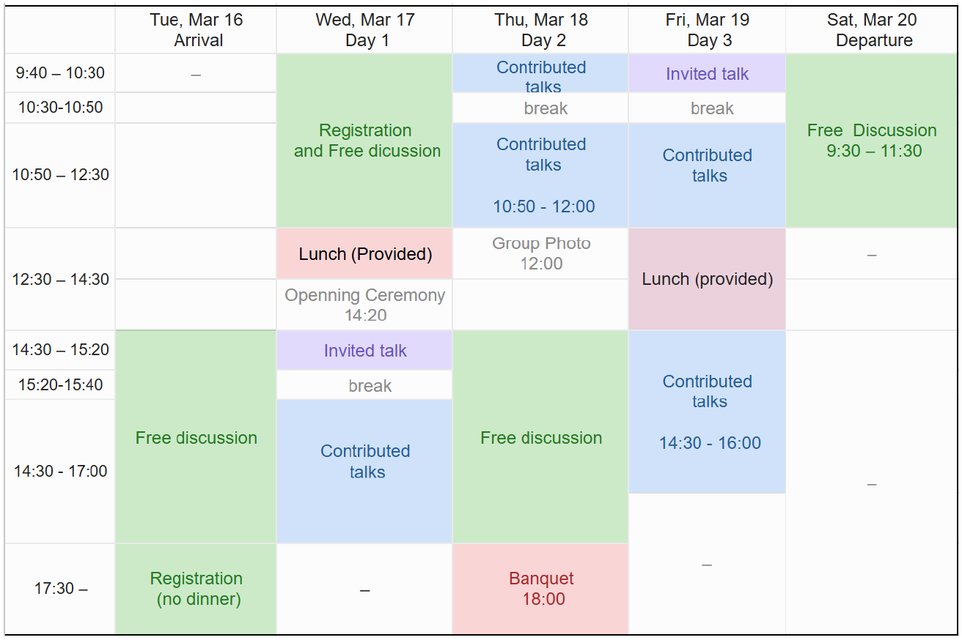

Personal information
1. Email address *
Please double-check your email address.
2. Given name *
3. Family name *
4. Affiliation *
5. Nationality (for hotel booking purposes) *
6. Position *
Select one option.
○ Faculty ○ Postdoctoral researcher ○ Graduate student
○ Undergraduate student ○ Other: __________________________

Student registration
7. Recommendation letter acknowledgment *
Students registering at the student rate must arrange for their academic supervisor to email a letter of recommendation to hojinchu@kias.re.kr.
The recommendation letter must be received by December 12, 2026 (21:00 JST).
If the student also wishes to book accommodation through the organizers, the supervisor must explicitly state this request in the email.
☐ I understand. (This requirement does not apply to participants registering at the standard rate.)
8. Recommender’s name, affiliation, and position/title
Complete this field if you are registering at the student rate; otherwise, leave it blank.

Workshop participation — Accommodation
A limited number of standard single and twin rooms have been reserved at Jeju Shinhwa World. Rooms will be allocated on a first-come, first-served basis, in the order in which registration forms are received, subject to availability.
The discounted rate is KRW 120,000 per room per night for either room type, excluding breakfast. Breakfast can be added at check-in for approximately KRW 35,000, payable directly to the hotel.
We can assist with bookings for standard single and twin rooms only. Participants who would like a larger room should make their own reservations directly with the hotel.
Participants who wish to share a twin room must agree with another participant in advance and list each other as their preferred roommate. Shared bookings are subject to availability. The room charge will be split equally, at KRW 60,000 per person per night.
Students requesting accommodation must have this request explicitly stated in the recommendation email sent by their academic supervisor.
Your accommodation reservation will be automatically canceled if your registration fee is not paid by the applicable registration deadline.
Once all reserved rooms have been allocated, bookings through the organizers will close, even if workshop registration remains open. Participants who have not secured a room will need to arrange their own accommodation. We will announce this on the workshop website or notify participants by email.
9. Accommodation type requested *
Select one option. Room assignment is subject to availability of the requested room type.
○ No preference between a single room and a twin room — KRW 120,000 per room per night
○ Twin room required — KRW 120,000 per room per night
○ I will arrange my own accommodation.
10. Preferred roommate’s name (optional)
If you would like to share a twin room, please agree with your roommate in advance and enter their name below. A shared twin room can be arranged only if both participants list each other. The room charge is split equally: KRW 60,000 per person per night. Leave this field blank if you do not wish to share a room.

Accommodation — Stay dates
All dates below are in March 2027. Select one option for each question.
11. Check-in date *  ○ March 16  ○ March 17  ○ March 18  ○ March 19  ○ I do not need a reservation. | 12. Check-out date *  ○ March 20  ○ March 19  ○ March 18  ○ March 17  ○ I do not need a reservation.

Meals
Lunch boxes will be provided on March 17 and March 19. The workshop banquet will be held on March 18.
Breakfast is not included. Lunch will not be provided on March 16 or March 18, and no other dinners will be provided.
Please indicate which meals you plan to attend so that we can make the necessary arrangements.
13. Meals you will attend *
Select all that apply.
☐ Wednesday, March 17 — Lunch box
☐ Thursday, March 18 — Banquet
☐ Friday, March 19 — Lunch box
☐ I will not attend any of the meals.
14. Will you be accompanied by family members? *
Banquet meals for family members are available only if requested in advance at registration.
○ Yes ○ No
15. How many accompanying family members would like to attend the banquet? *
Do not include yourself. Select one option.
○ None / Not applicable
○ One family member (additional charge)
○ Two family members (additional charge)
○ More than two family members (additional charge)
16. If three or more family members will attend the banquet, enter the number.

Meals and special requirements
17. Dietary restrictions or food allergies
Examples: vegetarian, vegan, halal, or food allergies. Leave blank if none.
18. Accessibility or other special requirements
Please tell us about any accessibility needs or other arrangements we should be aware of.

Talks
Each contributed talk will be allotted 25 minutes, including questions and answers.
19. Will you give a talk? *
Select one option.
○ Yes, I would like to give a talk. ○ No
20. Talk title in LaTeX format
Complete this field if you will give a talk.
21. Talk abstract in LaTeX format
Complete this field if you will give a talk.

Registration acknowledgment
22. Registration acknowledgment *
Submitting this form alone does not complete your registration or accommodation reservation. You must also pay the registration fee by the applicable deadline through the workshop website to complete your registration.
Payment – Registration Fee
☐ I understand.

