

Timothy Luciani

Victor Powell

Tom Lee

Nina Musser

Through the course of this semester, we as a team have had many ups and downs. Time conflicts, looming deadlines for other class, and sometimes even disagreements hindered the create projects. Though all of this though, our team has pulled through to create a very respectable final project.

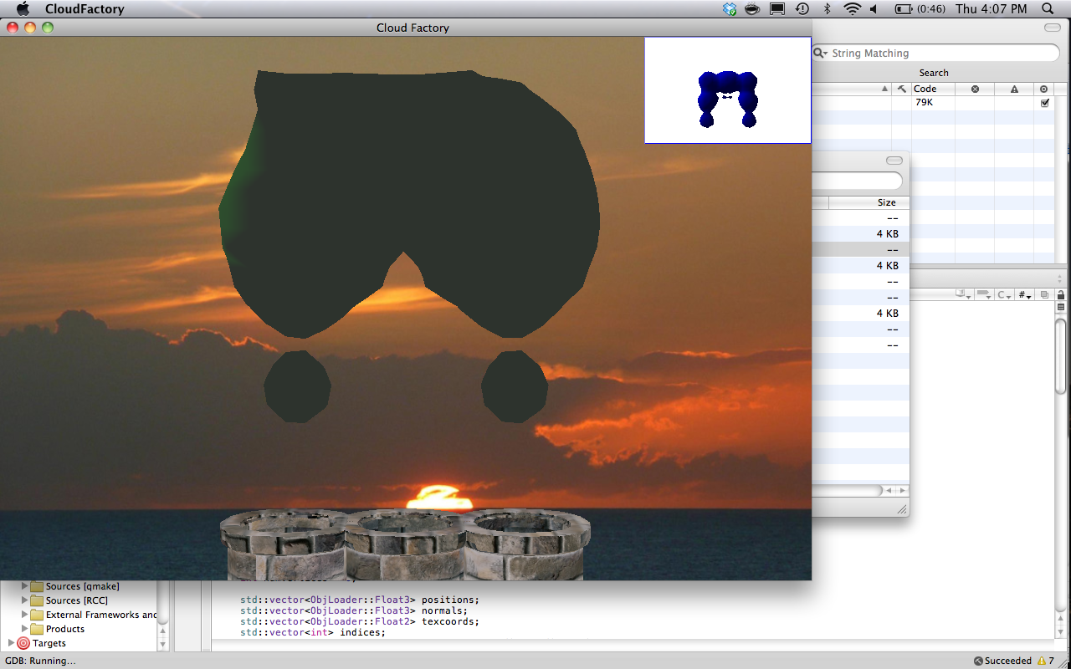 In our final result, I would say the accomplishment we are most proud of is the effects we were able to create with the clouds. Instead of using normal sphere, we were able to implement metaballs that conform to their surroundings depending on whether or not other clouds exist around them. Using a non-trivial algorithm, marching cubes, we were able to achieve a level elegance, which our game would have lacked otherwise.

From a design standpoint, the biggest issue we had has making the marching cubes algorithm run in real time inside our game. It seemed that no matter how hard we tried, the CPU would just not render the advancing images in real-time. We actually came up with two methods to fix this, both of which seemed to have solved the issue. First, we decided to only limit the metaball canvas to only one part of the screen. So, instead of computing the proximity of the metaballs to a grid of voxels that covered the whole screen, only those within the width of the end cannons where computed. The second method we came up 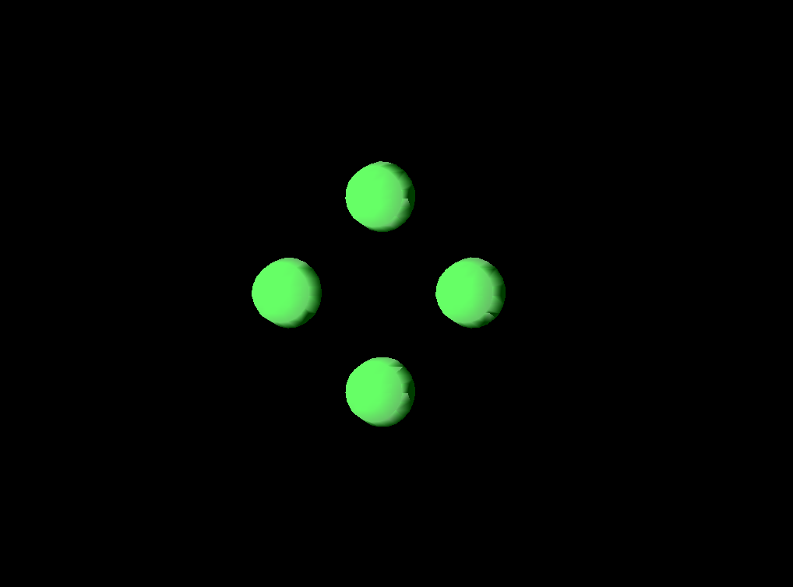with was to write the computation of the metaballs strictly on the GPU using Cuda. To the right show a prototype of our metaballs using NVidia’s Cuda. While this proved better than limiting the metaball canvas between two points, porting it into a WildMagic project was not as simple as it would seem. Because of this, we were left to use the first method mentioned.

Originally, our design had the clouds advancing as a monotone color, with no indication on how close the player was coming to achieving the goal. Through our playtesting, though, we discovered that players were having a hard time adjusting their clouds to form the shapes, and that they had not idea how close they were actually coming. To alleviate this, one of the play testers mentioned to us that we should add a gradient of color to the clouds so that the player understands exactly how close they are actually coming. To do this, we took the center of mass of the largest “blob” on the screen, compared it to the blueprint, and then colored the metaballs towards purple by the percentage of proximity to correct.

Overall, we are very pleased with the outcome of the game, but at the same time would have added more if given the time. First, we would have liked to port the game into Objective-C so as to create an Iphone or Ipad game out of it. Since our game is very simplistic when it comes to mechanics, it would have leant itself nicely to the mobile platform. Anther improvement we would have made is getting the metaball implementation in Cuda to work fully with WildMagic and QT. While not a major concern, the Cuda implementation would have added more in what we could have done with the style of the metaballs. Finally, we would have liked to add more dramatic elemets to our game. Even though we worked with an artist and writer, we have our issues with both. With some pushing we got a nice narrative, but the art was lacking since she did not want to commit time.