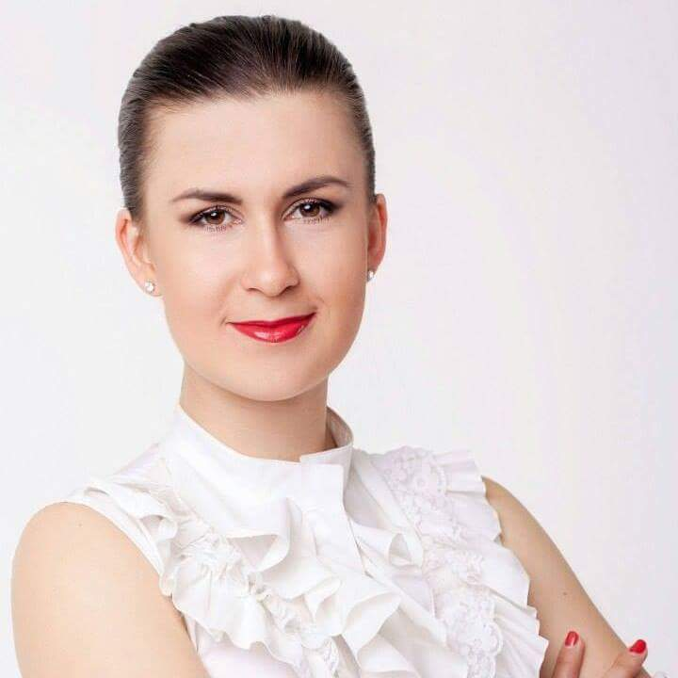

**Olga Novosilska**

**Cell (WhatsApp):** +38 093 025 13 77

**e-mail:** [onovasila@gmail.com](mailto:onovasila@gmail.com)

**DESIRED POSITION**

Junior QA Manual Testing Specialist

**GOAL**

Obtain an interesting job using real knowledge, abilities and skills, acquiring new one. Become a professional in the field of software testing, become a part of friendly team.

**SKILLS**

* Cross-browser testing (IE, Mozilla Firefox, Google Chrome, Safari);
* Experience in manual testing of web applications;
* Brief experience in manual iOS/Android application testing;
* Understanding of client-server architecture principles;
* Knowledge and understanding of the TCP/IP protocol working principle;
* Work with a plugin Firebug for error checking of web pages;
* Work with proxy Fiddler (interception and modification of requests / responses, emulation of low connections, connection of mobile devices);
* Work with ADB (removal of logs, installation and removal of applications, video recording, taking screenshots);
* XML/JSON
* Functional / non-functional / regression testing of web applications;
* JIRA bug-tracker;
* HTML/CSS;
* Java Script;
* SQL (basic);
* Understanding of UX design principles;
* Ability to analyze product requirements;
* Experience in creating test cases and checklists;
* Knowledge and understanding of the main methods and types of testing;
* Knowledge of test design basics.

Theoretical knowledge in QA:

* Understanding the basics of testing;
* Understanding of the development process;
* Knowledge of the defect life cycle;
* Understanding the roles in the team.

Languages:

* English – Intermediate+;
* Ukrainian - Native;
* Russian - Full.

**PERSONAL DATA**

Ambitious, keen about new technologies and QA practices, searching for interesting projects where I could best apply my skills and knowledge as Intern Test Engineer. Have good analytical and communication skills. Fast learner and team player. Easily perform monotonous work and very attentive to details.

**Freelance Graphic WEB-designer**

“MAX-TD” online marketing agency (04.2018-6.2018)

MAX-TD is specialist in online marketing for small business in topics of tourism service. MAX-TD owns the network of sites for booking accommodations around the world. My work was to develop new UI for websites, new logo and banners for advertising companies.

**Seller**

“Citrus” gadgets and accessories store (08.2014-03.2016)

I worked in the widely known chain of stores in Ukraine. I was helping customers not to drown in a variety of gadgets, understand the expectations, clarify requirements and finally make the very best choice. From the other side I was required to fulfil personal sales plan. It was a great experience to directly communicate with the end clients, understand their needs, analyze the market which gave me a big push to my future profession choice!

Achievement: The best seller 4 months in a row.

**EDUCATION**

Master of Physics

University of Oles Honchar (2008-2013), Dnipro, Ukraine

Course of Software Testing

IT Specialist training center LevelUp, Dnipro, Ukraine

January-May 2019

Course of HTML/CSS, SQL

IT Specialist training center Skill UP, Dnipro, Ukraine

June 2019

Practice lessons with Senior Manual QA

July 2019

Course Front-End Developer (learn now)

IT Specialist training center LevelUp, Dnipro, Ukraine