


Prepared For
National Primary Health Care Development Agency (NPHCDA)
Prepared By
Consortium of Center for Infectious Diseases Research and Evaluation (CIDRE) & Quantium Insights LLC
Consolidated Final Technical Report on Zero-Dose Forecasting, Immunization Risk Modelling, and Baseline–Endline Institutional Readiness
Integrating Predictive Modelling into Existing Immunization Programmes to Enhance Decision-Making and Reduce the Zero-Dose Burden in Nigeria
June 2026
Table of Contents
List of Abbreviations 4
Executive Summary 5
1. Introduction and Background 9
1.1 The Zero-Dose Child 10
1.2 Where Nigeria Stands, NDHS 2024 10
1.3 Why Zero-Dose Matters: The Link to Vaccine-Preventable Child Deaths 10
2. Literature Review 12
2.1 Global and Nigerian Immunization Challenges 12
2.2 Data Quality, Access, and Logistics in Nigeria 13
2.3 Predictive Modelling in Sub-Saharan Africa 13
2.4 Outcomes and Challenges of Modelling Application 14
3. Modelling Domains and Research Questions 15
4. Methodology Including Data Sources 16
4.1 Principal Datasets 16
4.2 Analytical Methods 17
5. Findings by Modelling Domain 18
5.1 Domain 1 — Antigen Coverage Forecasting 18
5.2 Domain 2 — Dropout and Incomplete Vaccination 21
5.3 Domain 3 — Equity and Zero-Dose Risk Stratification 23
5.4 Domain 4 — Vaccine Hesitancy 25
5.5 Domain 5 — Where Zero-Dose Children Concentrate, and the Archetypes Behind Them 27
5.6 Domain 6 — Polio Risk and the Interruption Pathway 34
5.7 Domain 7 — Outbreak Risk and the Coverage-to-Mortality Link 36
5.8 The Predictive Modelling Platform 38
6. Readiness Assessment: Baseline and Endline 40
6.1 Baseline Findings 40
6.1.1 Quantitative readiness (baseline) 41
6.1.2 Qualitative findings (baseline) 42
6.2 Endline Findings 43
6.2.1 Quantitative Readiness (Endline) 43
6.2.2 Qualitative Findings (Endline) 46
7. Stakeholder Engagement, Digital Gap Remediation and Close-out Activities 50
7.1 Stakeholders Engaged 50
7.2 Preparatory Engagement, State Entry and Participant Selection 50
7.3 Remedy Plan to Address Digital and DIH Gaps 52
7.3.1 DIH Governance, Ownership and Workflow Activation 52
7.3.2 Hardware, Power and Connectivity Remediation 52
7.3.3 Data Integration, Hosting and Digital Workflow 52
7.3.4 Data Quality, Denominator Validation and Reporting Completeness 52
7.3.5 Capacity Development and Routine Use 53
7.3.6 Platform Expansion Based on Stakeholder Feedback 53
7.4 Close-out Meetings and Dissemination Activities 53
7.4.1 GAVI Engagements 53
7.4.2 NPHCDA Leadership and Technical Staff Meeting 53
7.4.3 Meeting with the Executive Director 53
7.4.4 DIH Handover and Operationalization Meeting 54
7.4.5 Routine Immunization Technical Working Group Meeting 54
8. Discussion 55
9. Conclusions and Recommendations 57
9.1 Conclusions 57
9.2 Recommendations 57
9.3 Limitations and Next Steps 58
References 60

List of Tables
Table 1: Modeling Domains and Research Questions 15
Table 2. Principal Datasets Mapped to the Domains They Feed 16
Table 3. Analytical method by Domain 17
Table 3b. The 44 LGAs excluded from DHIS2-based modelling, by state. 18
Table 4. Model comparison for equity stratification. 23
Table 5. The nine highest-burden states by estimated zero-dose children in 2026 (extract of the full 37-state Bayesian forecast). 27
Table 6. The five LGA-level community archetypes, their signatures and matched intervention packages. 31
Table 6b. The ten highest-burden LGAs by modelled zero-dose children, 2026. 32
Table 6c. The RMNCH–EPI operational list: maternal-care indicators and the matched package, by archetype. 33
Table 7. The six highest outbreak-risk states on the composite VPD risk surface. 36
Table 8. Baseline Part A readiness scores by administrative unit and section 41
Table 9. Part A readiness scores by administrative unit and section 43
Table 10. Part B Capacity, Systems, and Infrastructure Assessment Scores by Administrative Unit 44
Table 11. Overall Capacity, Systems Readiness, And Estimated Time to Modelling Readiness by Unit. 45
Table 12. State-By-State Summary of Qualitative Findings Against the Recurring Themes 49

List of Figures
Figure 1a. National antigen coverage trajectories with prediction intervals (Prophet). 19
Figure 1b. 2026 Estimated coverage of the eligible cohort against the 80% target (NDHS 2024 triangulation). 19
Figure 1c. Forecast trajectories for the nine additional antigens against the 80% at-risk-of-decline mark (Prophet, DHIS2 2021–2025, projected to 2027). 20
Figure 1d. Worked example: the dotted line is 80% of OPV3’s own 2024 doses. The forecast remains above it, so OPV3 is not flagged. 21
Figure 2. National dropout-rate forecasts for the three antigen transitions (Prophet). 22
Figure 3. Observed and forecast dropout by state (Penta1–Penta3 and Measles1–Measles2). 22
Figure 4. LASSO feature importance for the three dropout transitions. 22
Figures 5–6. Observed zero-dose by state (NDHS 2024) and the composite equity-deprivation tiers. 24
Figure 6b. LGA-level composite equity-deprivation tiers, 774 LGAs (GRID3 boundaries). 25
Figure 6c. MGWR local coefficient surfaces: which barrier is strongest where. Red indicates association with higher zero-dose, blue the reverse; unmodelled LGAs are blank. 26
Figures 7–8. Coded caregiver concerns and the Composite Hesitancy Index versus zero-dose burden (decoupling). 27
Figure 9. State-level zero-dose trajectories and forecasts, 2008–2028 (Bayesian hierarchical Beta regression; shaded bands are 95% credible intervals 28
Figure 10. Predicted state zero-dose rate (2026) with 95% credible intervals, by priority tier. 29
Figures 11–12. Zero-dose hotspots (Getis-Ord Gi*) and LGA-level calibrated surface, 774 LGAs. 29
Figure 13. Zero-dose by geopolitical zone: mean rate (with forecast) and predicted 2026 burden in children. 30
Figure 14. Pareto concentration of zero-dose burden across 730 reporting LGAs (total ≈ 2.09 million children). 30
Figure 15. LGA archetypes against modelled zero-dose burden; colour denotes archetype, bubble size the number of children missed. 32
Figure 16. Antenatal care (four or more visits) against the modelled zero-dose rate across 774 LGAs, and maternal-care indicators by archetype. 33
Figure 17. AFP case clustering, 2015–2025 (Bernoulli case-control spatial scan); one significant cluster on the north-eastern border. 35
Figure 18. Historical confirmed-polio cases and forecast to 2030; interruption threshold below one case per year. 35
Figure 19. Recurrence-free survival of confirmed polio cases against the WHO 36-month certification threshold. 36
Figure 20. Surveillance-timeliness completion curves against WHO performance targets. 36
Figures 21–22. Coverage-to-mortality hypothesis grid and the composite VPD outbreak-risk surface. 37
Figure 23. Triangulation: the vaccine-targeted mortality share tracks the zero-dose forecast (r = 0.87); the North-West forms the convergent-risk cluster. 37
Figure 24. The predictive modelling platform: secure sign-in to the live Hugging Face deployment operated by the Digital Innovation Hub. 39
Figure 25. Prospective validation: the 2026 state forecasts against the NmDHS 2025-26 survey, 37 states (ρ = 0.88). 39
Figure 26. Convergent validity: the 2026 LGA estimates against the IHME Local Burden of Disease DTP1 coverage surface (ρ = 0.60). 40
Figure 27: Study States 41

List of Abbreviations
Abbreviation | Meaning | Abbreviation | Meaning
ACSM | Advocacy, Communication and Social Mobilisation | AFP | Acute Flaccid Paralysis
AI | Artificial Intelligence | AICc | Corrected Akaike Information Criterion
AMAC | Abuja Municipal Area Council | ANC | Antenatal Care
BCG | Bacille Calmette-Guérin vaccine | BI | Business Intelligence
CHI | Composite Hesitancy Index | CHIPS | Community Health Influencers, Promoters and Services
CI | Confidence Interval or Credible Interval, as applicable | COVID-19 | Coronavirus Disease 2019
DHIS2 | District Health Information Software 2 | DIH | Digital Innovation Hub
DTP | Diphtheria-Tetanus-Pertussis | DTP1 | First dose of a DTP-containing vaccine
DTP3 | Third dose of a DTP-containing vaccine | ECHIS/eCHIS | Electronic Community Health Information System
EMR | Electronic Medical Record | EPI | Expanded Programme on Immunization
EVM | Effective Vaccine Management | FCT | Federal Capital Territory
FDR | False Discovery Rate | Gavi | Gavi, the Vaccine Alliance
GBD | Global Burden of Disease | Gi* | Getis-Ord Gi* hotspot statistic
GLM | Generalized Linear Model | GRID3 | Geo-Referenced Infrastructure and Demographic Data for Development
GWR | Geographically Weighted Regression | HMIS | Health Management Information System
HTR | Hard-to-Reach | ICT | Information and Communication Technology
IDSR | Integrated Disease Surveillance and Response | IEV | Identify-Enumerate-Vaccinate
IHME | Institute for Health Metrics and Evaluation | LASSO | Least Absolute Shrinkage and Selection Operator
LGA | Local Government Area | LMIC | Low- and Middle-Income Country
LQAS | Lot Quality Assurance Sampling | M&E | Monitoring and Evaluation
MCV1 | First dose of Measles-Containing Vaccine | MCV2 | Second dose of Measles-Containing Vaccine
MGWR | Multiscale Geographically Weighted Regression | NCDC | Nigeria Centre for Disease Control and Prevention
NDHS | Nigeria Demographic and Health Survey | NITDA | National Information Technology Development Agency
NPC | National Population Commission | NPHCDA | National Primary Health Care Development Agency
ODK | Open Data Kit | OLS | Ordinary Least Squares
Penta1 | First dose of Pentavalent vaccine | Penta3 | Third dose of Pentavalent vaccine
PHC | Primary Health Care | PRS | Planning, Research and Statistics
QGIS | Open-source Geographic Information System software | R-hat | Potential Scale Reduction or model-convergence statistic
RI | Routine Immunization | RTS,S | Malaria vaccine targeting Plasmodium falciparum
SIA | Supplementary Immunization Activity | SMS | Short Message Service
SPHCDA | State Primary Health Care Development Agency | SPSS | Statistical Package for the Social Sciences
TBA | Traditional Birth Attendant | UNICEF | United Nations Children’s Fund
VPD | Vaccine-Preventable Disease | WHO | World Health Organization
WUENIC | WHO/UNICEF Estimates of National Immunization Coverage | ZARA | Zero-dose Analytics and Risk Assistant
ZD | Zero-Dose
ACLED | Armed Conflict Location and Event Data
BHCPF | Basic Health Care Provision Fund
LBD | Local Burden of Disease (IHME)
NmDHS | Nigeria mini Demographic and Health Survey
PCV | Pneumococcal conjugate vaccine
REC | Reaching Every Community
Rota | Rotavirus vaccine
WorldPop | Gridded population estimate programme

Executive Summary
Introduction and Background
Nigeria continues to carry a substantial and highly unequal burden of zero-dose and under-immunized children. Although national immunization indicators suggest gradual recovery and broadly stable routine delivery, national averages conceal severe subnational disparities, particularly across the North-West and parts of the North-East. Persistent challenges include unreliable population denominators, incomplete private-sector reporting, fragmented data systems, limited advanced analytics capacity, insecurity, geographical barriers, and uneven use of available data for proactive decision-making. The NPHCDA, with GAVI and UNICEF support, therefore implemented this programme to integrate predictive modelling into immunization planning to strengthen national and subnational capacity for data-driven prevention, preparedness, and response to vaccine-preventable diseases.
Objectives
The programme sought to build the capacity of the NPHCDA and State Primary Health Care Development Agencies to use surveillance and routine immunization data for trend analysis, predictive modelling, and decision support. Specific objectives included integrating modelling into routine planning and resource allocation, developing sustainable government capacity, strengthening staff proficiency in data analysis and predictive methods, and promoting the use of modelling for programme adaptation, vaccine introduction, and implementation strategy review.
Preparatory Engagement and Participant Selection
The implementation process included formal preparatory engagement with participating states and relevant institutional stakeholders. Letters were sent to states to introduce the assessment, clarify the purpose of the work, request cooperation, and support access to state, LGA and facility-level respondents. This was followed by state entry and community entry processes conducted in collaboration with state and local immunization structures. These activities supported respondent identification, scheduling of interviews, field team introduction, and smooth administration of the readiness checklist and key informant interviews.
Participant selection for the modelling fellowship was structured to support national and subnational ownership. A total of 20 national-level participants were selected, comprising 18 NPHCDA participants and 2 NCDC participants. In addition, 37 subnational participants were selected to represent state-level routine immunization and data-use structures. This ensured that capacity-building activities were not limited to the national level but extended to officers expected to interpret and apply modelling outputs in routine planning, supervision and corrective action.

Modelling Domains and Questions
Seven priority domains were completed: antigen-coverage forecasting; vaccination dropout and completion; equity and zero-dose risk stratification; vaccine hesitancy; zero-dose forecasting, hotspots and community archetypes; polio risk and interruption; and vaccine-preventable-disease outbreak risk. A planned eighth domain covering campaign optimization, counterfactual scenarios, and cost-effectiveness remains dependent on programme expenditure data.
Data Sources and Analytical Methods
The analyses triangulated routine DHIS2 immunization data, NDHS survey estimates, a 37-state zero-dose master dataset, ACSM activity records, equity indicators, GRID3 spatial boundaries, the national AFP line list, population estimates, and Institute for Health Metrics and Evaluation (IHME) Global Burden of Disease (GBD) 2023 mortality estimates. Methods included Prophet forecasting, LASSO feature selection, geographically weighted regression, composite indices, Bayesian hierarchical beta regression, Getis-Ord hotspot analysis, hierarchical clustering, spatial scan statistics, negative-binomial modelling, and false-discovery-rate-corrected correlation tests. The results were operationalized through a live no-code predictive-modelling application and the ZARA analytical assistant.
Findings by Modelling Domain
National forecasts for BCG, Penta1, Penta3, and Measles1 remained above 80%, but 1,645 LGA-antigen forecasts fell below the target, demonstrating that risk is local rather than national. A wider panel of nine additional antigens (OPV3, IPV1, PCV3, Yellow Fever and Meningitis A) showed stable or improving trajectories with no decline warnings, while IPV2 and the rotavirus series continue to rise. Measles1-to-Measles2 remained the most important completion gap, while dropout drivers differed by antigen transition and therefore require differentiated interventions. Equity analysis showed that locally varying models substantially outperformed a single national model and identified severe structural deprivation in the North-West. Hesitancy was not significantly associated with zero-dose burden, indicating that access and supply constraints must be addressed separately from demand-generation concerns. Bayesian forecasts identified Sokoto, Kebbi, and Zamfara as critical-rate states, while Kano, Katsina, Kaduna, and other populous states carried large absolute numbers of zero-dose children. The North-West accounted for approximately 1.08 million forecast zero-dose children in 2026. The top 20% of reporting LGAs contained about 62% of the estimated burden, while reaching 80% would require action across approximately 270 LGAs. Five community archetypes, defined at local government level across all 774 LGAs, demonstrated that intervention packages must be adapted to combinations of distance, fertility, poverty, education, facility delivery, and demand barriers. Polio risk was spatially concentrated, with residual vaccine-derived risk requiring sustained surveillance and campaign quality. Seven of eight coverage-to-mortality hypotheses were supported, and the zero-dose forecast correlated strongly with vaccine-targeted mortality, confirming convergence of immunization, equity and child-survival risks. The forecasts were validated out-of-sample against the NmDHS 2025-26, released after this work concluded, which ranked the 37 states in almost the same order (ρ = 0.88) and matched the North-West level to within one percentage point, and against an independently constructed IHME LGA coverage surface (ρ = 0.60).
Readiness Assessment
Baseline readiness ranged from 59.5% to 97.6%, while endline scores ranged from 78.6% to 97.6%. Bayelsa recorded the largest improvement, increasing from 59.5% to 90.5%. Routine data availability and use were generally strong. Qualitative findings showed progress from general awareness to confirmed operational use of modelling in identifying and reviewing priority zero-dose LGAs, although national capacity remained concentrated in a small number of staff and continued to depend on external partners.

Stakeholder Engagement, Digital Remediation and Close-out Activities
The programme included structured stakeholder engagement and close-out activities to support interpretation, ownership and uptake of the modelling outputs. Stakeholders engaged included NPHCDA leadership, the Executive Director NPHCDA, directors and key NPHCDA programme leads, the Digital Innovation Hub team, the Routine Immunization team, the Routine Immunization Technical Working Group, Gavi in-country and technical stakeholders, UNICEF, NCDC, national participants, subnational participants and the CIDRE–Quantium Insights Consortium.

Following the meeting with the GAVI in-country team, the consortium held a further presentation with the Deputy Director NPHCDA, other directors and key NPHCDA staff, including the Head of DIH and Head of RI. The team presented to the Executive Director, who recommended inclusion of additional antigens such as OPV and IPV, ranking of LGAs from worst to best for prioritization, and development of LGA-specific problem statements with corresponding proposed interventions and solutions. These inputs were intended to strengthen outbreak preparedness, intervention planning and operational use of the priority list. The team also presented to the Routine Immunization Technical Working Group.

A remedy plan was developed to address the digital and DIH gaps identified during implementation. The plan prioritizes DIH operationalization, routine DHIS2 data refresh, model-output visualization, state-level analytics participation, data-quality automation, systems integration, power and connectivity improvements, role-based access, approval workflows, documentation, and continued capacity-building. The gap analysis showed that DHIS2/HMIS and routine review structures provide a foundation, but predictive modelling requires a stronger digital ecosystem capable of linking data sources, assuring quality, running reproducible models, refreshing dashboards, protecting data, and embedding interpretation into routine decision forums.

Conclusions and Recommendations
Nigeria’s zero-dose burden is concentrated, persistent, and actionable. Immediate investment should prioritize Sokoto, Kebbi, and Zamfara, followed by other convergent high-risk states and the ranked high-burden LGAs. Programmes should protect Penta1-3 coverage, close the Measles2 completion gap, differentiate interventions by community archetype, strengthen polio surveillance, institutionalize the modelling platform within the Digital Innovation Hub, establish a small, dedicated analytics core, provide sustained mentorship, and assign explicit modelling responsibilities with leadership oversight. Systems and infrastructure support should be concentrated in weaker units, alongside decisive action to address denominator instability and private- and tertiary-facility reporting gaps.

Limitations and Next Steps
Outbreak-risk estimates currently use GBD mortality as a proxy pending IDSR/NCDC line-list data. Routine administrative data remain affected by reporting and denominator errors; hesitancy findings reflect recorded ACSM concerns rather than population prevalence; and readiness findings cover thirteen administrative units rather than every state. The next phase should update the models with surveillance and expenditure data, complete campaign optimization and cost-effectiveness modelling, validate LGA prioritization, include additional antigens such as OPV and IPV, develop LGA-specific problem-and-intervention profiles, and embed routine model refresh, review and decision-use processes within the DIH.

1. Introduction and Background
Immunization is one of the world's most cost-effective health interventions and is responsible for saving millions of lives every year from vaccine-preventable diseases. Although there has been great progress around the world, there are still significant inequalities in vaccine coverage, especially in LMICs. There are still far too many zero-dose and under-immunized children in Sub-Saharan Africa, undermining progress toward universal health coverage and the global immunization goals. Nigeria is the most populous country in Africa, with a significant contribution to the burden of unvaccinated children globally. In 2018, 8.9 million Nigerian children were unvaccinated for the diphtheria-tetanus-pertussis vaccine (DTP1), particularly in northern regions. These differences are attributed to poor health systems, insecurity, population mobility, socioeconomic inequalities, and data quality and use in routine immunization programmes.
Nigeria has adopted several measures, such as supplemental immunization activities (SIAs) and health system strengthening at the primary health care (PHC) level, but gaps in health coverage suggest a need for rethinking planning and monitoring to address these inequities. Lack of integration of data systems, lack of integration of surveillance and program data, and lack of analytical capacity at the national and subnational levels are challenges to evidence-based decision-making. Recent developments in predictive modelling and geospatial analytics can be used to boost routine immunization systems. Data can be used to identify zero-dose children, predict outbreak risks, and prioritize resources. Institutionalization will require structured capacity building, data governance, and long-term partnerships, however, within government systems.
In this context, the National Primary Health Care Development Agency (NPHCDA), supported by GAVI and UNICEF, aims to mainstream predictive analytics into Nigeria's existing immunization system to improve decision-making, ensure equity, and drive progress towards reaching global immunization goals. Routine immunization is a public health intervention that is one of the most resource-efficient and saves an estimated 2-3 million lives every year around the world. High and sustained vaccination coverage in many low- and middle-income countries (LMICs) still represents a major challenge, especially in sub-Saharan Africa. Nigeria, Africa's most populous country, has significant systemic challenges in immunization, due to which the burden of vaccine-preventable diseases is disproportionately high in the country.
With the assistance of GAVI, UNICEF, and other partners, the National Primary Health Care Development Agency (NPHCDA) has carried out several activities to enhance routine immunization services. But coverage gaps, geographic disparities, and data quality problems persist and hamper program effectiveness. The traditional way of planning and monitoring immunization has been reactive rather than proactive, responding to immunization coverage gaps and outbreaks after they have occurred.
Objectives
To build the capacity of the NPHCDA and SPHCDAs to use surveillance and immunization data to identify ways to improve immunization programme effectiveness in preventing disease through improved data-driven decision support for prevention, detection, preparedness, and response to vaccine-preventable diseases through trend analytics and mathematical modelling.

Specific Objectives
- To integrate predictive modelling into existing routine immunization programs based on the surveillance and routine immunization data to enhance decision-making and improve outcomes.
- To integrate modelling into immunization programs and routine decision-making processes from surveillance and routine immunization data to enhance planning, resource allocation, and overall program effectiveness.
- To build and institutionalize government capacity to adopt, sustain, and scale modelling practices for long-term impact and resilience in primary health care (PHC) initiatives.
- To enhance staff capacity in data modelling and predictive analysis by leveraging surveillance and immunization data from multiple platforms to inform evidence- based decision-making.
- To promote staff adoption of predictive modelling techniques for strategic program planning, including vaccine introductions and shifts in implementation strategies

1.1 The Zero-Dose Child
Zero-dose children are those who have received no routine vaccinations, operationally identified as children who have not received the first dose of a DTP-containing vaccine (DTP1, also Penta1). DTP1 is used worldwide as a proxy for access to the immunization system, because a child who never receives it has typically never been reached by routine services. In 2024, an estimated 14.3 million children globally were zero-dose, and just nine countries account for more than half of them, with Nigeria among the largest contributors. Geographic remoteness, poverty, low maternal education, insecurity, and weak health-system reach are the recurring drivers of this exclusion.

1.2 Where Nigeria Stands, NDHS 2024
The 2023 to 2024 Nigeria Demographic and Health Survey (NDHS 2024) is the most recent nationally representative measurement of routine coverage. Anchoring this study's state estimates to the NDHS series (2008 to 2024) and weighting by the 12-to-23-month cohort, the national zero-dose rate has been essentially flat for a decade: 48.7% in 2008, 33.1% in 2018, and 33.5% in 2024. National averages, however, conceal a profound subnational divide: independent ecological analysis of NDHS data finds North-West DTP1 coverage declining from 37.3% (2018) to 33.4% (2024) even as the South-East holds above 90%. This inequity, not the national mean, is the problem this modelling programme is built to localize and act on.

1.3 Why Zero-Dose Matters: The Link to Vaccine-Preventable Child Deaths
Nigeria carries one of the world's largest absolute burdens of under-five mortality, and the leading causes are dominated by conditions that vaccination prevents or mitigates. Global and Nigeria-specific estimates consistently rank malaria, diarrhoeal disease, and pneumonia (lower-respiratory infection) as the foremost causes of death among children aged 1 to 59 months, alongside neonatal causes (prematurity, birth asphyxia, sepsis). Measles, pertussis, diphtheria, tetanus, tuberculosis, and yellow fever, all directly preventable by EPI antigens, add a further avoidable layer of mortality. Because DTP1 non-receipt marks the children the system never reached, zero-dose concentration is, in effect, an early-warning map of where vaccine-preventable deaths are most likely to occur. Domain 7 tests that link formally and find it strongly supported.

1.4 How the Programme Was Delivered
The programme ran as one integrated six-month cycle from January to June 2026, moving from assessment through capacity-building and applied modelling to institutional handover.
- Month 1: Inception and governance. Kickoff, workplan, data inventory and stakeholder alignment, alongside a baseline assessment documenting existing status, infrastructure, staff capacity and governance.
- Months 1 to 2: Baseline and modelling questions. Readiness review and definition of decision-use questions, refined into the eight domains aligned to NPHCDA decision needs set out in Section 3.
- Month 3: Capacity building. Structured self-learning, a virtual class, an in-person fellowship and competency testing for the selected national and subnational participants.
- Months 4 to 5: Applied modelling. Group mentorship, abstract development, model validation and production of the domain outputs, with abstract presentations converting model outputs into policy-facing products.
- Month 6: Endline, integration and handover. Delivery of the no-code application and ZARA, standard operating procedures and user guides, the endline assessment, and close-out.
The intended shift is from one-off training to a modelling workflow the agency runs in-house. Whether that shift holds is the question the readiness assessment in Section 6 is designed to answer.

2. Literature Review
This review draws on evidence published up to mid-2026, focusing on the issues most directly relevant to the programme: the state of immunization systems globally and in Nigeria, developments in predictive modelling methods, and the factors that determine whether analytics capacity becomes sustainable institutional practice rather than a short-term project output.

2.1 Global and Nigerian Immunization Challenges
Since the COVID-19 pandemic, global immunization has seen both recovery and continued difficulty. DTP3 coverage has returned to near pre-pandemic levels in many low- and middle-income countries, but gains are uneven, with fragile and conflict-affected settings lagging. Nigeria reflects these trends: national DTP3 has improved modestly, yet several northern states still record coverage below 40%. Measles, pertussis, and rotavirus gastroenteritis remain significant contributors to under-five mortality where services are weakest.
Zero-dose children have become a central indicator of health-system reach and equity. Geographic analysis alone is insufficient; gender, ethnicity, socioeconomic status, and intersecting deprivation must also be considered. In Nigeria, although coverage has improved since 2018, inequities have widened, with unvaccinated children clustering in specific communities, wards, and disadvantaged groups increasingly in peri-urban and informal settlements as well as remote rural areas. In 2024, Nigeria was among the ten countries with the largest numbers of zero-dose children, recording an estimated 2.1 million DTP-unvaccinated and 3.1 million MCV-unvaccinated children.
The Immunization Agenda 2030 set targets of at least 90% national and 80% district-level coverage and a sharp reduction in zero-dose children. Nigeria, like many countries, remains off track. Closing the gap requires strategies capable of identifying and prioritising consistently missed children, which is precisely where predictive modelling has become relevant. Research in Nigeria and comparable settings shows machine-learning methods (random forests, gradient boosting, ridge classifiers) reliably identify high-risk facilities and communities from routine DHIS2 data, outperforming standard coverage-threshold approaches without requiring costly additional surveys.

2.2 Data Quality, Access, and Logistics in Nigeria
The scale-up of DHIS2 has materially improved the timeliness and completeness of routine immunization data, with reporting completeness above 80% in many states by 2019, though variation persists at the LGA and ward levels. Denominator accuracy remains a core challenge: discrepancies between 2006-census projections and field headcounts produce over- or under-estimates of coverage. Electronic registries, supervisory verification, community-based surveillance, and data-triangulation methods (including LQAS) have been introduced in priority states to validate figures.
On the supply side, expanded fixed sites, outreach and mobile teams, and emergency posts in conflict-affected areas have improved physical access. Demand-side barriers persist, including mistrust and misinformation in parts of the north; social mobilization, engagement with religious and traditional leaders, and community health influencers have shifted perceptions, while caregiver autonomy and the availability of female health workers shape uptake in conservative communities. Cold-chain investments, such as solar refrigerators, electronic temperature monitoring, and EVM assessments, have reduced failures, though maintenance gaps and last-mile transport remain constraints, especially in Borno, Zamfara, and Kebbi.

2.3 Predictive Modelling in Sub-Saharan Africa
Across the region, forecasting models for demand, outbreak-risk stratification, and coverage estimation increasingly shape strategic planning and resource allocation. Countries that have invested systematically tend to show superior, more consistent coverage. Rwanda is the most comprehensive regional example: forecasting integrated into its supply chain and district information system has helped sustain DTP3 and measles coverage above 90% and reduce zero-dose in hard-to-reach areas. Kenya and Senegal are developing outbreak-response risk-stratification models linked to surveillance. By contrast, settings with less consolidated data systems show volatile coverage and high urban-rural disparity.
Key transferable lessons recur: data-quality improvement is a prerequisite for reliable modelling; supply-chain managers and health workers must be engaged in model design so outputs are actionable; phased rather than system-wide rollout works better; and clear data-governance frameworks are essential. Nigeria's adoption of the GRID3 platform underscores the value of subnational calibration in heterogeneous contexts and of public-private data partnerships. The clear implication is that predictive capability must be built into institutional structures, namely routine planning processes, dedicated analytics units, and information-system procurement, rather than added as an afterthought.

2.4 Outcomes and Challenges of Modelling Application
In Nigeria, UNICEF and partners have piloted data-driven models for zero-dose identification, vaccine distribution, and outbreak risk, drawing on administrative data, surveys, satellite-derived environmental measures, and mobile-network data. Uptake has been uneven, concentrated where data infrastructure and technical capacity are strongest. Geospatial risk maps have helped target outreach to the highest-risk wards. Implementation studies show modelling identifies zero-dose children more accurately and earlier than administrative data alone, and supports outbreak preparedness for measles and meningitis by guiding the timing and extent of campaigns. Cost-effectiveness work in LMICs suggests data-driven allocation can achieve materially more coverage per unit of resource.
The barriers are equally well documented. Data quality and availability are the most fundamental: model accuracy depends directly on completeness, consistency, and granularity, and gaps in reporting, inconsistent denominators, and limited survey data reduce reliability and erode manager confidence. Technical-capacity constraints limit the interpretation of complex outputs at subnational levels. Institutional barriers, including limited buy-in, weak integration into formal planning, and competing priorities, constrain the translation of insight into action. Addressing these requires sustained capacity-building, data-system strengthening, and institutional change management alongside the technical work itself. This is the precise gap the readiness assessment in Section 6 is designed to measure.

3. Modelling Domains and Research Questions
Seven of the eight framework domains are reported here. Domain 8 (RI campaign design, counterfactual scenario modelling, and budget-constrained optimization) is the planned next phase and awaits the programme and expenditure data required for cost-effectiveness analysis.
Table 1: Modeling Domains and Research Questions
# | Domain | Research question (status)
1 | Antigen coverage forecasting | Which antigens are projected to fall below targets in the next 6–12 months at LGA/ward level? (Completed)
2 | Coverage continuity / dropout | What are predicted dropout rates between key antigen pairs, and what drives incomplete vaccination? (Completed)
3 | Equity & zero-dose stratification | How does coverage and zero-dose risk vary by location, poverty, maternal education and HTR status? (Completed)
4 | Hesitancy & behaviour | To what extent is hesitancy contributing to shortfalls, and how do patterns shift? (Completed)
5 | Zero-dose modelling & hotspots | Where do zero-dose children concentrate, and what archetypes explain it? (Completed)
6 | Polio mapping & interruption | Which areas are highest-risk for polio, and what is the interruption pathway? (Completed)
7 | Surveillance & outbreak risk | Which areas are highest-risk for VPD outbreaks given coverage gaps? (Completed, GBD 2023 proxy)
8 | Campaign design & effectiveness | Which states/LGAs to prioritize; access, demand or supply? (Planned next phase)

4. Methodology including Data Sources
The methodology including data analysis integrates NPHCDA-provided datasets with additional sources that the consortium curated. All models are reproducible from the consortium's analytical notebooks, and the analyses are operationalized in a live, no-code web application that the NPHCDA Digital Innovation Hub can run on uploaded data.

4.1 Principal Datasets
Table 2. Principal Datasets Mapped to the Domains They Feed
Dataset | Description | Domains
DHIS2 routine RI | Monthly administrative dose counts, all states, 2021–2025 | 1, 2, 5
NDHS 2008–2024 | Survey DTP1 coverage and zero-dose, 12–23-month cohort | 1, 3, 4, 5
Zero-dose master dataset | 37-state file: NDHS coverage plus 30+ predictors | 2, 3, 4, 5
NPHCDA ACSM register | 2,593 social-mobilization activities, 36 states | 4
Equity indicators | Wealth, education, HTR-distance, urbanicity by state | 3, 5
GRID3 boundaries | admin1/admin2 spatial layers | 3, 5, 6
AFP national line list | ~103,000 surveillance records, 2015–2025 | 6
IHME GBD 2023 | State under-5 cause-of-death fractions (proxy) | 7
LGA population (NPC 2022) | Distributes state cohort across 774 LGAs | 5
NmDHS 2025-26 | National mini survey released after this work concluded; out-of-sample check | Validation
IHME Local Burden of Disease | DTP1 admin-2 coverage surface, 2000–2018; independent LGA comparator | Validation
WorldPop | LGA population surfaces used with NPC 2022 for absolute-burden conversion | 1, 4, 5, 7
Meta Relative Wealth Index | LGA-level wealth covariate for deprivation index and archetypes | 3, 5
Weiss travel-time surface | Motorised travel time to nearest facility; remoteness covariate | 3, 5
ACLED | Political-violence event and fatality counts; conflict covariate | 3, 5

Pending from NPHCDA: IDSR/NCDC surveillance line-lists (Domain 7) and programme/expenditure data (Domain 8).

4.2 Analytical Methods
Table 3. Analytical method by Domain
Domain | Method | Output
1 | Prophet time-series forecasting, 80%/95% intervals, per antigen and per-LGA | Coverage trajectories to 2027; threshold-breach flags
2 | Prophet dropout forecasting + LASSO feature selection | Dropout heatmaps; ranked driver importance
3 | Multiscale geographically weighted regression (MGWR); composite equity index | Spatially varying coefficients; four-tier map
4 | Field-coded concern taxonomy → Composite Hesitancy Index; Gi*; correlation test | Concern inventory; zonal CHI; decoupling test
5 | Bayesian hierarchical Beta regression; Getis-Ord Gi*; Ward clustering (k=5) | Forecasts with credible intervals; hotspots; archetypes
6 | Bernoulli case-control spatial scan; negative-binomial GLM + Prophet | Significant AFP cluster; interruption-year projection
7 | Eight FDR-corrected coverage-to-mortality tests; composite risk surface | Hypothesis grid; ranked risk surface; triangulation

Bayesian convergence for Domain 5 is satisfactory (maximum R-hat = 1.00). Full step-by-step methods are held in the consortium's technical appendix.

4.3 Analytical Coverage and Excluded LGAs
Of Nigeria’s 774 LGAs, 730 met the Penta1 reporting standard required for the DHIS2-based domains and were modelled. Forty-four were excluded because Penta1 was not reported, and are flagged for data-quality investigation rather than treated as areas of zero burden. The exclusion is heavily concentrated in the two zones carrying the largest zero-dose burden: 23 in the North-West, 16 in the North-East, 3 in the North-Central and 2 in the South-South.
The distribution of these exclusions is material. The excluded LGAs sit disproportionately in high-burden territory and include several major metropolitan areas, so the national zero-dose estimate reported in Section 5.5 is likely to be conservative.
Table 3b. The 44 LGAs excluded from DHIS2-based modelling, by state.
State | Excluded LGAs | n
Adamawa | Fufore; Hong; Yola North | 3
Bauchi | Alkaleri; Bauchi*; Ganjuwa; Ningi; Toro | 5
Borno | Biu; Guzamala**; Maiduguri | 3
FCT | Abuja Municipal*; Bwari | 2
Gombe | Akko; Gombe; Yamaltu/Deba | 3
Jigawa | Birnin Kudu; Gwaram | 2
Kaduna | Birnin Gwari; Chikun; Giwa; Igabi; Ikara; Kaduna South; Kauru; Lere; Sabon Gari; Soba; Zaria | 11
Kano | Dala; Gezawa; Gwale; Kano Municipal; Kiru; Kumbotso; Nasarawa*; Sumaila; Tudun Wada; Ungogo | 10
Nasarawa | Lafia | 1
Rivers | Obio/Akpor*; Port-Harcourt | 2
Taraba | Sardauna | 1
Yobe | Potiskum | 1
Total |  | 44

* Penta1 blank and overall reporting sparse (4 LGAs). ** No data of any kind (1 LGA). Source: DHIS2 routine antigen export by LGA and month, 2021–2025.
The required remediation is narrow in scope. In most of these LGAs other antigens report normally, which indicates that the Penta1 data element itself has been dropped or misconfigured rather than the facility having stopped reporting altogether. Restoring that single element would return most of the 44 LGAs to the model. The Digital Innovation Hub should begin with the three metropolitan LGAs where the undercount is largest and most visible: Maiduguri, Kano Municipal and Port-Harcourt. It should then work through the Kaduna and Kano clusters, which together account for 21 of the 44.

5. Findings by Modelling Domain

5.1 Domain 1 — Antigen Coverage Forecasting
Domain 1 is read two ways. An early-warning view compares each antigen with its own 2024 baseline, treating the 80% line as a decline tripwire; on this view, all four tracer antigens hold at or above their 2024 level, so routine delivery looks broadly stable. At the national level the four tracers (BCG, Penta1, Penta3, Measles1) are forecast to remain above the 80% target over the next 6–12 months, the lowest national point being Penta3 at 87.5% in July 2026. The national aggregate conceals the operational risk. Each of the 730 reporting LGAs carries its own forecast for each of the four tracer antigens, giving 2,657 LGA-and-antigen forecasts in total. Of these, 1,645 dip below the 80% mark within the next 6 to 12 months, and they fall across 591 of the 730 reporting LGAs. The risk is real but local, and must be managed LGA by LGA rather than read off the national average.
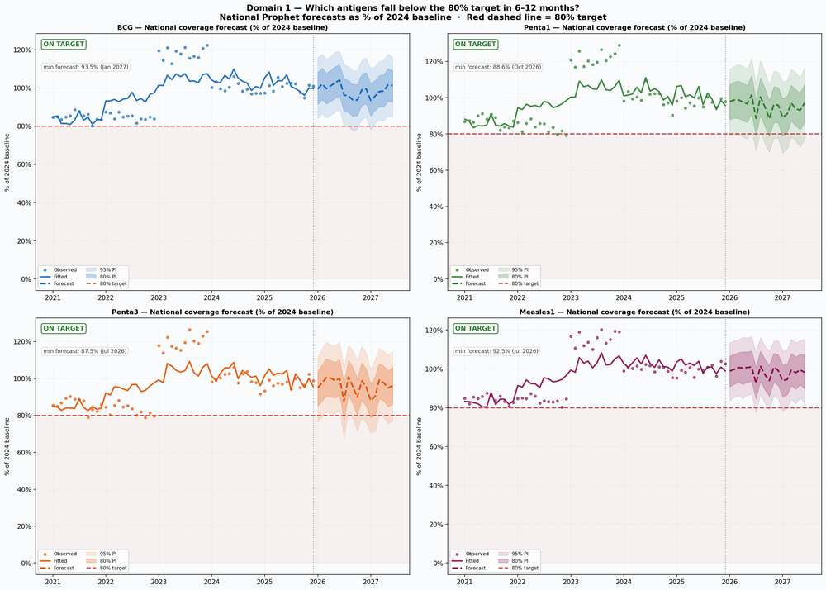
Figure 1a. National antigen coverage trajectories with prediction intervals (Prophet).
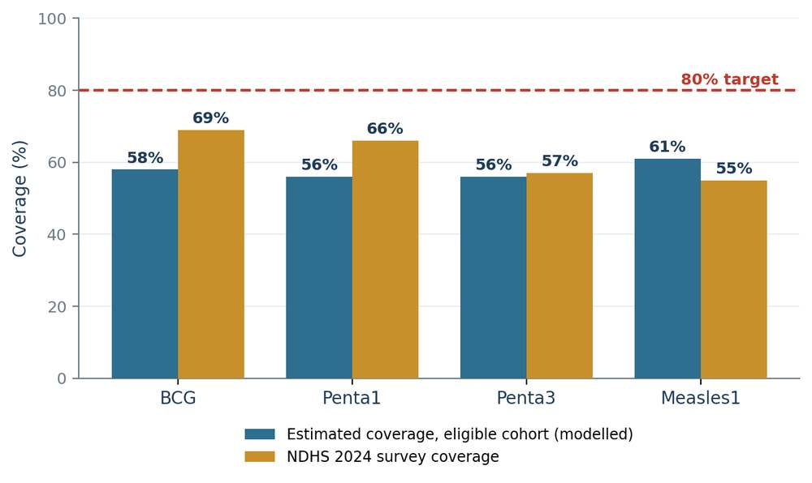
Figure 1b. 2026 Estimated coverage of the eligible cohort against the 80% target (NDHS 2024 triangulation).

5.1.1 The Wider Antigen Panel
The antigen panel was extended beyond the four tracers to cover nine further antigens, using the same Prophet specification. This applies decline screening across the routine schedule rather than to the tracer set alone, and covers the antigens that account for the majority of delivery volume.
Five established antigens (OPV3, IPV1, PCV3, Yellow Fever and Meningitis A) are projected to hold at or above 80% of their own 2024 delivery level through the forecast window, and none raises a decline warning. Four recently introduced series, IPV2 and Rotavirus doses 1 to 3, are still climbing as the introductions bed in; these are monitored for uptake rather than screened for decline, since a rising series cannot meaningfully be tested against a decline tripwire.
The programme consequence is that the decline signal identified in Section 5.1 is specific to the tracer antigens and to particular LGAs, and is not a general deterioration across the antigen schedule. Supervision can therefore be routed narrowly. The polio antigens in particular, OPV3, IPV1 and IPV2, show no national decline signal, which is consistent with the interruption pathway described in Section 5.6.
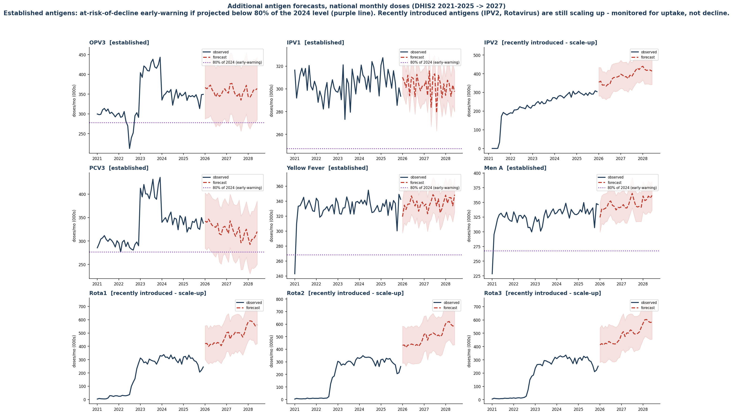
Figure 1c. Forecast trajectories for the nine additional antigens against the 80% at-risk-of-decline mark (Prophet, DHIS2 2021–2025, projected to 2027).

5.1.2 Reading the At-Risk-of-Decline Flag Correctly
The 80% figure used throughout Domain 1 is an early-warning threshold rather than a coverage statistic. The distinction is material to how the results are applied, and is set out in four points below.
- Definition. Projected monthly doses for an antigen in an LGA, expressed as a percentage of that same antigen’s 2024 delivery level in that same LGA.
- Interpretation. A reading below 80% means doses are slipping against a settled benchmark. It does not mean that only 80% of children were reached.
- Denominator independence. No child population enters the calculation, so the flag is unaffected by the denominator instability documented in Section 9.3. That is precisely why it is useful in a setting where denominators are contested.
- Programme use. Catch the decline early and route supervision to the exact antigen, month and LGA.
The benchmark is 2024 rather than 2025 because 2024 is the last complete, fully reported year and therefore holds still. The 2025 series is partial and continues to shift as late reports arrive; benchmarking against it would generate alerts that are in truth reporting lag.
True coverage answers a different question. It divides doses by the eligible 12-to-23-month cohort and is reported separately, both in Figure 1b and in the platform under “Estimated coverage (eligible cohort)”. The early-warning flag tells the programme when delivery is falling; coverage tells it how many children were reached. Different questions, different denominators, and the two should not be quoted interchangeably.
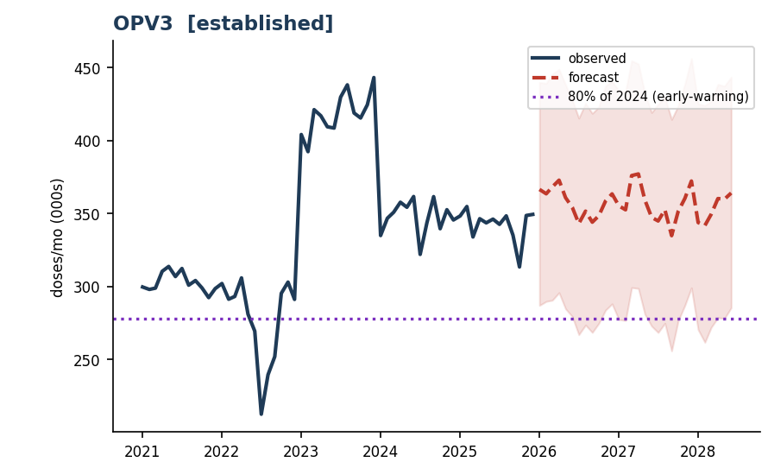
Figure 1d. Worked example: the dotted line is 80% of OPV3’s own 2024 doses. The forecast remains above it, so OPV3 is not flagged.

5.2 Domain 2 — Dropout and Incomplete Vaccination
The three antigen transitions tell different stories. Penta1-to-Penta3 dropout is low and broadly flat (near zero, forecast around -2% through 2027), so children who start the Penta series generally complete it. Penta1-to-Measles1 runs persistently negative (about -5% to -9%), consistent with measles-campaign top-ups and a reporting effect rather than a true gain. The decisive transition is Measles1-to-Measles2, where dropout has fallen steeply from roughly 55% in 2021 to about 10–12% by 2025, much improved but still the largest of the three leaks, so the second measles dose is where completion effort should concentrate.
LASSO driver selection finds different mechanisms for each transition, so a single retention strategy will not fix all three: stunting, media exposure, and low wealth dominate Penta1-to-Penta3; women's employment and facility delivery drive Penta1-to-Measles1; and Muslim-population share and distance-to-facility lead Measles1-to-Measles2. Retention efforts therefore, need to be tailored by transition: defaulter tracing and second-year reminders for the Penta series, facility-linked scheduling for Penta1-to-Measles1, and outreach plus trusted-messenger engagement for the measles second dose, concentrated on persistent high-dropout states in the South-East and South-West.
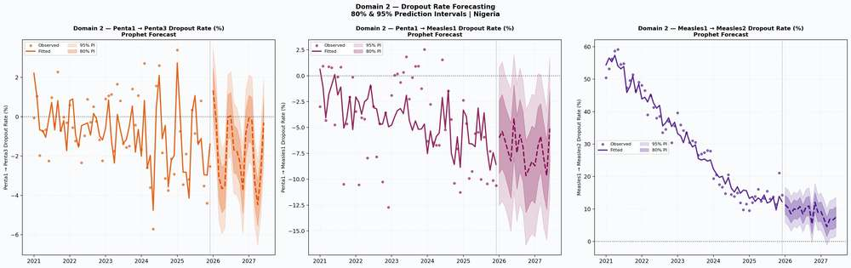
Figure 2. National dropout-rate forecasts for the three antigen transitions (Prophet).
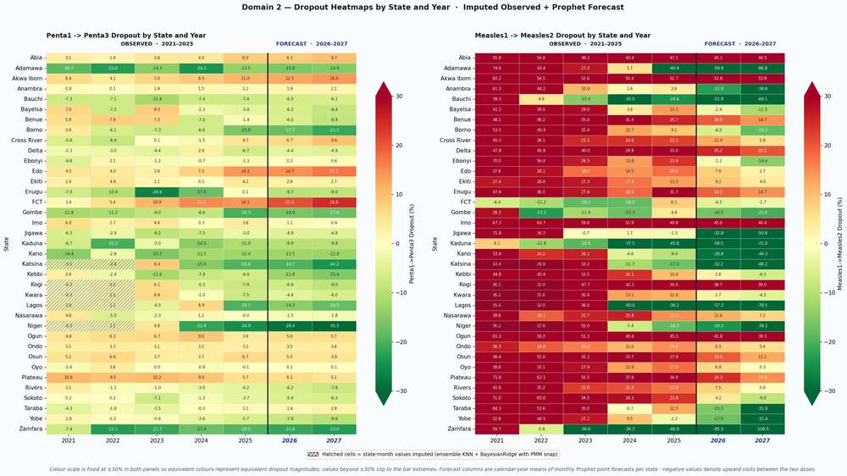
Figure 3. Observed and forecast dropout by state (Penta1–Penta3 and Measles1–Measles2).
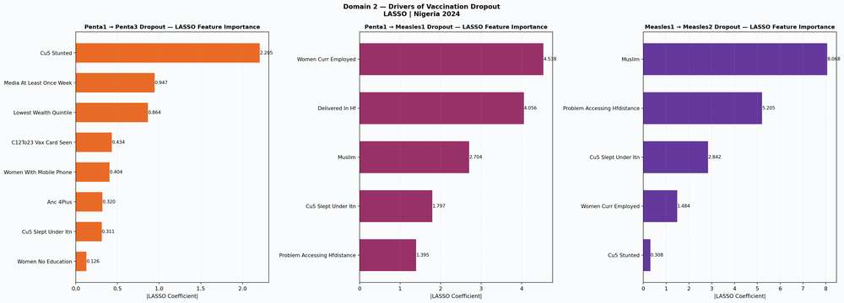
Figure 4. LASSO feature importance for the three dropout transitions.

5.3 Domain 3 — Equity and Zero-Dose Risk Stratification
Zero-dose risk does not respond to the same drivers everywhere. A multiscale geographically weighted regression fits substantially better than a single national model (the fit statistic rises from 0.743 to 0.868), and that 13-point gain is the share of the pattern that is purely local. It is the statistical justification for targeting states individually rather than applying one national playbook.
Table 4. Model comparison for equity stratification.
Model | R² | Adjusted R² | AICc
Global OLS | 0.743 | n/a | n/a
GWR (bandwidth 35) | 0.821 | 0.755 | 303.21
MGWR (per-predictor) | 0.868 | 0.803 | 301.65

Higher R² and lower AICc indicate the better fit.
A composite equity-deprivation index combines rural residence, distance to a facility, mothers with no formal education, and lowest-wealth-quintile status into a single 0–100 score, sorting states into four tiers. The most-deprived tier is dominated by the North-West, with Jigawa recording the highest deprivation score. The ranking reflects structural disadvantage, which is distinct from the current observed zero-dose rate: Jigawa ranks most disadvantaged on structure even though its observed rate is mid-range, while Sokoto and Kebbi combine very high deprivation with very high observed zero-dose. Tier 1 and Tier 2 states are where equity-focused investment should be concentrated.
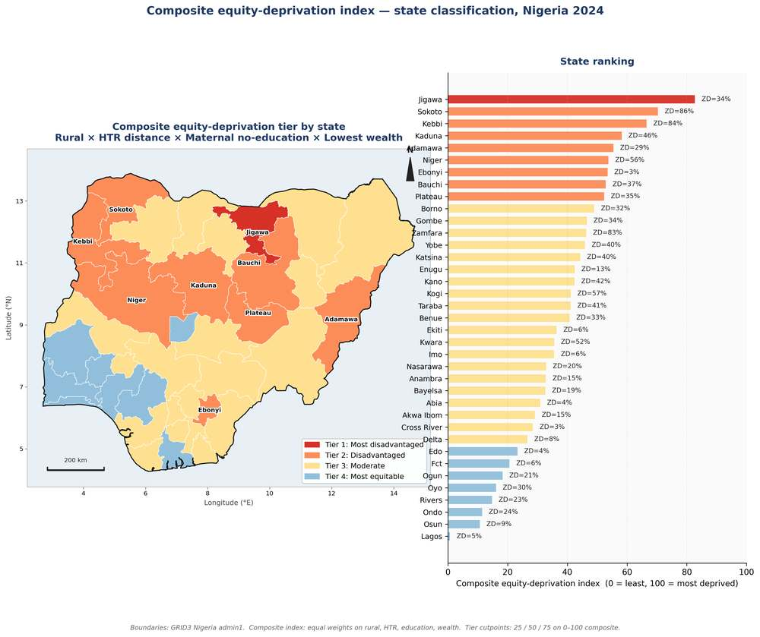
Figures 5–6. Observed zero-dose by state (NDHS 2024) and the composite equity-deprivation tiers.

5.3.1 Equity Analysis at LGA Level
The state-level analysis in Table 4 was repeated across all 774 LGAs to give the resolution that microplanning actually requires. The result is consistent in direction and larger in magnitude: allowing each driver to act differently in different places raises the share of variation explained from 39% to 55%. More than a third of the variation a single national model cannot account for is recovered by letting the drivers vary geographically.
The composite equity-deprivation index, built from travel time, maternal education, poverty and the Meta Relative Wealth Index, scored 0 to 100 and grouped into four equal bands, was likewise recalculated at LGA level on GRID3 boundaries. Tier 1, the most deprived band, is concentrated in the North-East and North-West, consistent with the state-level tiering but far more actionable, since it identifies specific LGAs within otherwise mixed states.
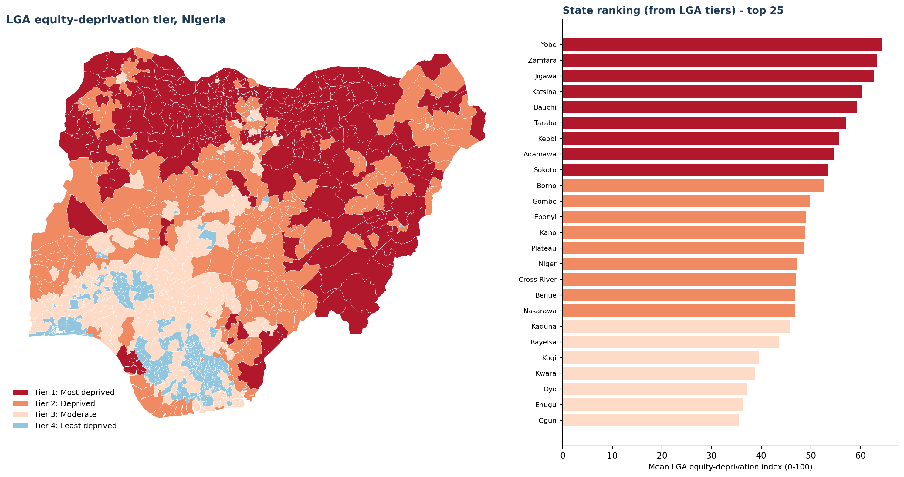
Figure 6b. LGA-level composite equity-deprivation tiers, 774 LGAs (GRID3 boundaries).
The two outputs answer different questions and should be used together. The burden ranking in Section 5.5.2 shows where the most children are; the deprivation tier shows where the barriers are deepest. LGAs that are high on both should take precedence over LGAs that are high on either alone.
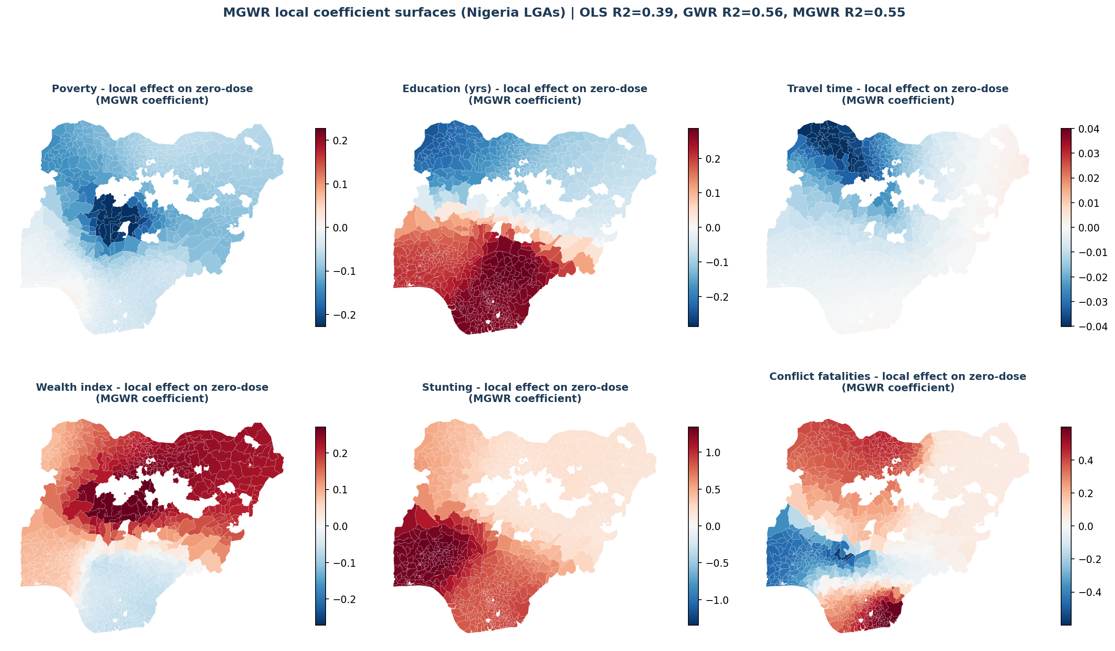
Figure 6c. MGWR local coefficient surfaces: which barrier is strongest where. Red indicates association with higher zero-dose, blue the reverse; unmodelled LGAs are blank.
Two cautions govern interpretation. The LGA coefficients are local, standardised, partial associations and are not causal effects. LGAs without DTP1 reporting, the 44 listed in Table 3b, carry no estimate at all rather than a zero and appear blank on the maps; they should not be read as low-risk.

5.4 Domain 4 — Vaccine Hesitancy
Across 2,593 ACSM field activities in 36 states, vaccine-safety fear is the dominant caregiver concern (710 safety questions and 108 rumours), far ahead of infertility, conspiracy and political concerns. To compare states fairly, a Composite Hesitancy Index normalizes coded concerns by each state's activity volume. Plotting it against the forecast zero-dose rate shows the two are largely decoupled (Spearman rho = -0.33, p = 0.06): the most hesitant states are not the worst zero-dose states. Sokoto, Kebbi, and Zamfara sit high on burden but only mid-range on hesitancy. The practical consequence is that supply-and-access interventions and demand-generation messaging address different maps; treating zero-dose purely as a demand problem would misdirect resources.
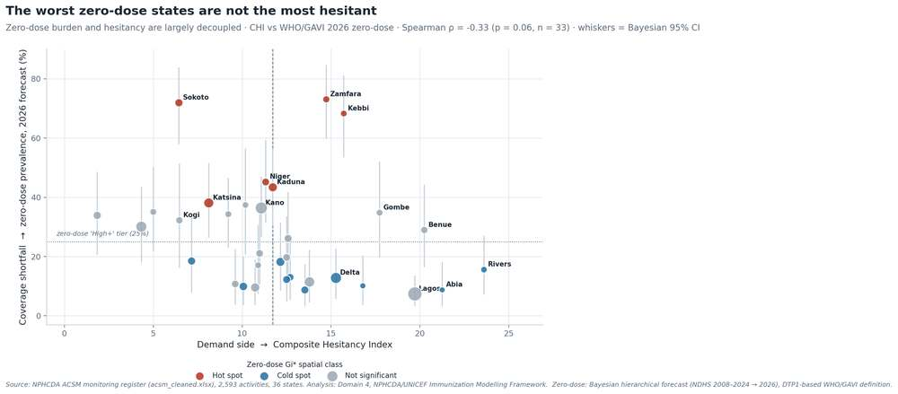
Figures 7–8. Coded caregiver concerns and the Composite Hesitancy Index versus zero-dose burden (decoupling).

5.5 Domain 5 — Where Zero-Dose Children Concentrate, and the Archetypes Behind Them
A Bayesian hierarchical Beta regression on the NDHS 2008–2024 series (well converged, maximum R-hat = 1.00) produces state-level posterior forecasts with full credible intervals for 2026–2028. The three Tier-1 (Critical) states, Sokoto, Kebbi, and Zamfara, carry the highest predicted rates, each with a 2026 posterior mean near or above 68%. The North-West sits in a band of its own throughout; most other states drift slowly downward, and credible intervals widen after 2024, where recent survey coverage is thinnest, reflecting honest forecast uncertainty rather than noise.
Table 5. The nine highest-burden states by estimated zero-dose children in 2026 (extract of the full 37-state Bayesian forecast).
State | Obs 2024 (%) | 2026 mean (95% CI) | ZD children 2026
Kano | 42.4 | 36.4 (27–47) | 194,932
Sokoto | 86.5 | 71.9 (58–84) | 168,837
Katsina | 39.8 | 38.1 (26–51) | 165,813
Zamfara | 82.6 | 73.1 (60–85) | 156,169
Kebbi | 84.0 | 68.3 (53–81) | 154,105
Kaduna | 45.6 | 43.4 (30–57) | 138,383
Bauchi | 36.9 | 34.3 (23–46) | 112,564
Niger | 56.0 | 45.2 (31–59) | 104,498
Jigawa | 34.3 | 33.9 (21–49) | 103,403
Burden is the posterior-mean rate applied to each state's 12-to-23-month birth cohort.
Aggregated to zones, the North-West alone holds about 1.08 million zero-dose children in 2026, more than the other five zones combined, with the North-East and North-Central following at roughly 330,000 each. The Getis-Ord Gi* hotspot analysis confirms a single contiguous high-risk block across the North-West and into the North-East that persists across 2026–2028, while the South remains a coherent cold-spot. The burden is not only high in the North-West, it is entrenched and spatially stable.
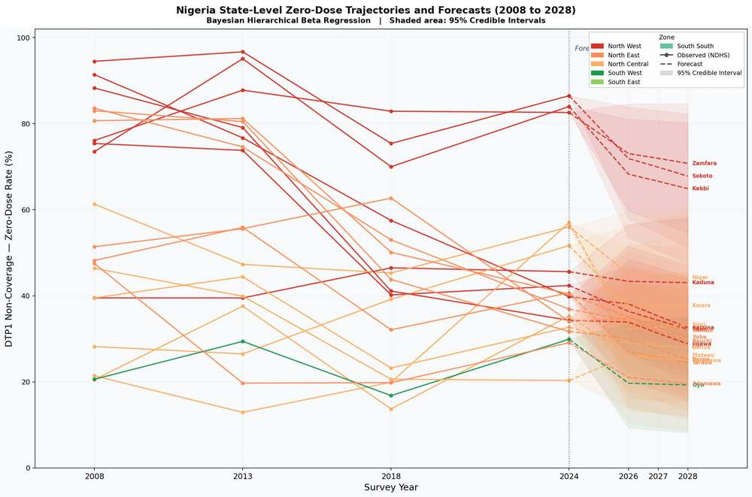
Figure 9. State-level zero-dose trajectories and forecasts, 2008–2028 (Bayesian hierarchical Beta regression; shaded bands are 95% credible intervals
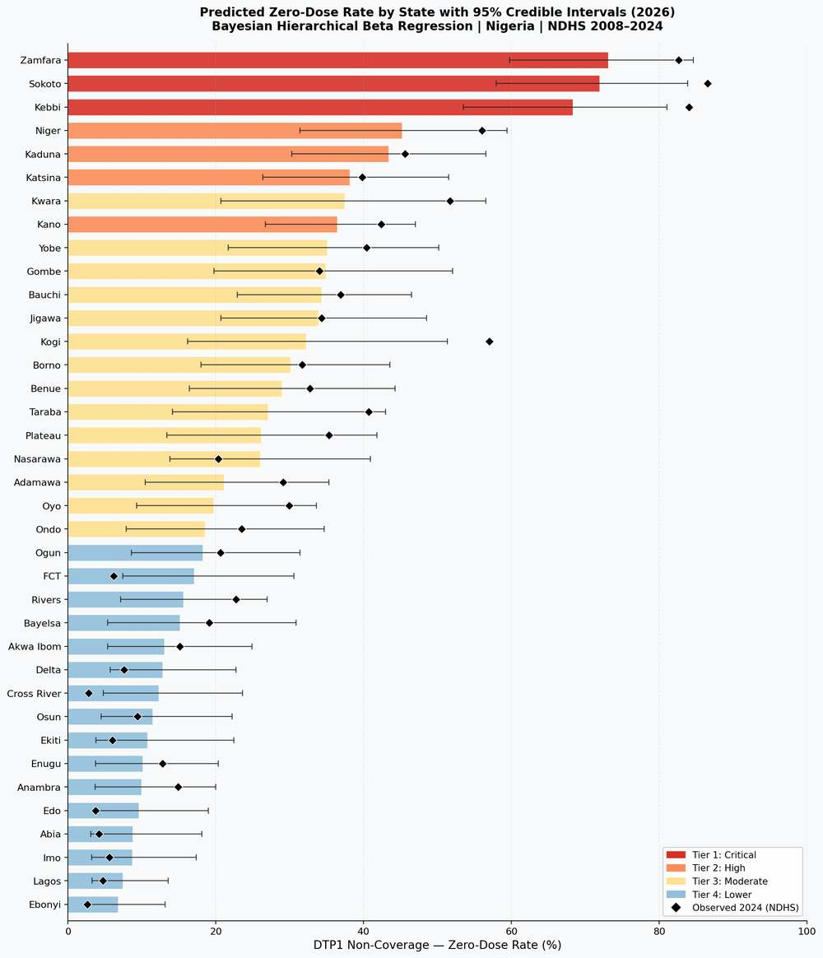
Figure 10. Predicted state zero-dose rate (2026) with 95% credible intervals, by priority tier.
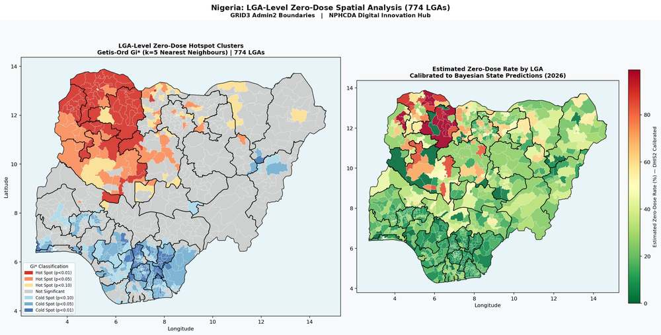
Figures 11–12. Zero-dose hotspots (Getis-Ord Gi*) and LGA-level calibrated surface, 774 LGAs.
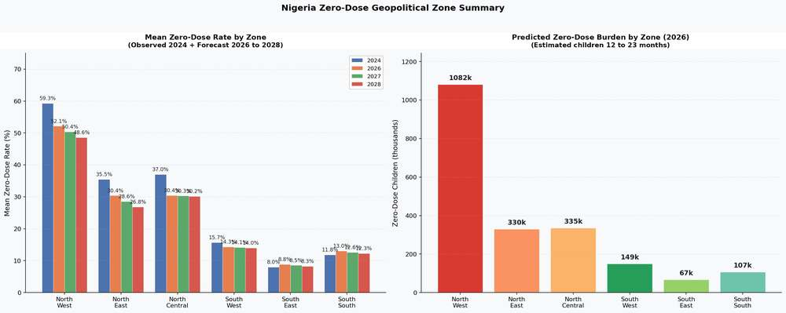
Figure 13. Zero-dose by geopolitical zone: mean rate (with forecast) and predicted 2026 burden in children.
A ranked list of all 730 reporting LGAs orders the burden for microplanning. The burden is concentrated, but less sharply than an 80/20 distribution would imply. The highest-burden 146 LGAs, the worst-performing 20% of those modelled, contain 62% of estimated zero-dose children. Reaching 80% of the national burden requires the highest-burden 270 LGAs, about 37% of those modelled.
The practical consequence is a two-wave effort. A first wave targeting the top 146 LGAs would reach close to two-thirds of unreached children and is fundable as a single package. Coverage of 80% cannot be achieved from that first wave alone, so the second should be planned alongside it rather than treated as contingent.
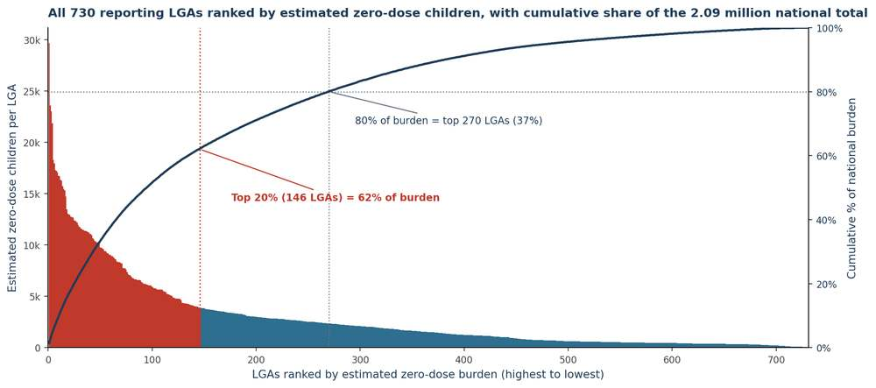
Figure 14. Pareto concentration of zero-dose burden across 730 reporting LGAs (total ≈ 2.09 million children).

5.5.1 Community Archetypes at LGA Level
Community archetypes are the structural profiles behind zero-dose burden: groups of areas that share a barrier mix and therefore need the same response. An earlier version of this clustering was built at state level as a proof of concept, before LGA-level predictors were available. It is not carried forward here. Stakeholder review confirmed that a state-level archetype is too coarse for operational use, since microplanning, supervision and outreach are organised at local government level and a single state commonly contains areas with materially different barriers. Once LGA-level predictors were identified, the clustering was rebuilt at that resolution, and all archetype results reported here are LGA-level.
The clustering uses agglomerative (Ward) linkage on fifteen covariates drawn from IHME, DHS, the Meta Relative Wealth Index, Weiss travel-time surfaces and ACLED conflict data, across all 774 LGAs. Five archetypes emerge, each with a distinct barrier signature and a correspondingly distinct response.
The clustering also provides an internal validation of the zero-dose surface. The archetypes were built from social and structural data alone: education, nutrition, poverty, wealth, travel time, antenatal care and conflict. No vaccination data of any kind entered the clustering. The archetypes nevertheless reproduce the observed geography of missed children: Archetypes 1 and 2 together hold approximately 1.44 million of the 2.09 million modelled zero-dose children, about 69% of the national burden, across 328 of the 774 LGAs. Structural disadvantage therefore predicts where children are missed without reference to immunization data, which supports a structural, multi-sectoral response rather than immunization-only outreach.
Table 6. The five LGA-level community archetypes, their signatures and matched intervention packages.
# | Archetype (example states) | LGAs | Zero-dose children | Mean rate | Defining signature | Priority intervention
1 | Remote Rural /  Hard-to-Reach  (Kano, Jigawa, Katsina) | 136 | 658,900  (32%) | 41.2% | Highest child undernutrition; lowest maternal education (~2.5 yrs) and facility delivery (~10%) | Reaching-Every-Community microplanning, BHCPF outreach and community health workers; co-deliver with nutrition and antenatal care
2 | Conflict-Affected /  Nomadic  (Borno, Niger, Adamawa) | 192 | 779,131  (37%) | 42.0% | Highest political-violence fatalities; high antigen dropout; weak antenatal care and delivery | Security-integrated microplanning, negotiated access, and mobile and transit-point teams
3 | Riverine /  Geographically Isolated  (Cross River, Bayelsa, Delta) | 20 | 22,425  (1%) | 16.6% | Extreme travel time to care (~108 minutes); low improved-water access | Boat-based outreach, community health worker networks, and multi-antigen bundling per visit
4 | Peri-urban /  Migrant Dense  (Osun, Akwa Ibom, Oyo) | 280 | 380,154  (18%) | 19.5% | Moderate on all fronts; fair care-seeking (ANC 72%, delivery 61%) | Ward enumeration, migrant-sensitive scheduling, and Periodic Intensification of Routine Immunization
5 | Urban Slums  (better-off core)  (Imo, Anambra, Lagos) | 146 | 150,166  (7%) | 11.0% | Highest wealth and education (~9.6 yrs) and facility delivery (78%); residual informal-settlement gaps | Targeted social mobilisation, a fixed-plus-outreach hybrid, and private-sector last-mile reach

Model estimate. Agglomerative (Ward) clustering of 15 covariates across all 774 LGAs. Example states are illustrative rather than exhaustive, since archetypes are assigned per LGA, so a single state may contain several. Percentages are of the 2.09 million national total. BHCPF = Basic Health Care Provision Fund.
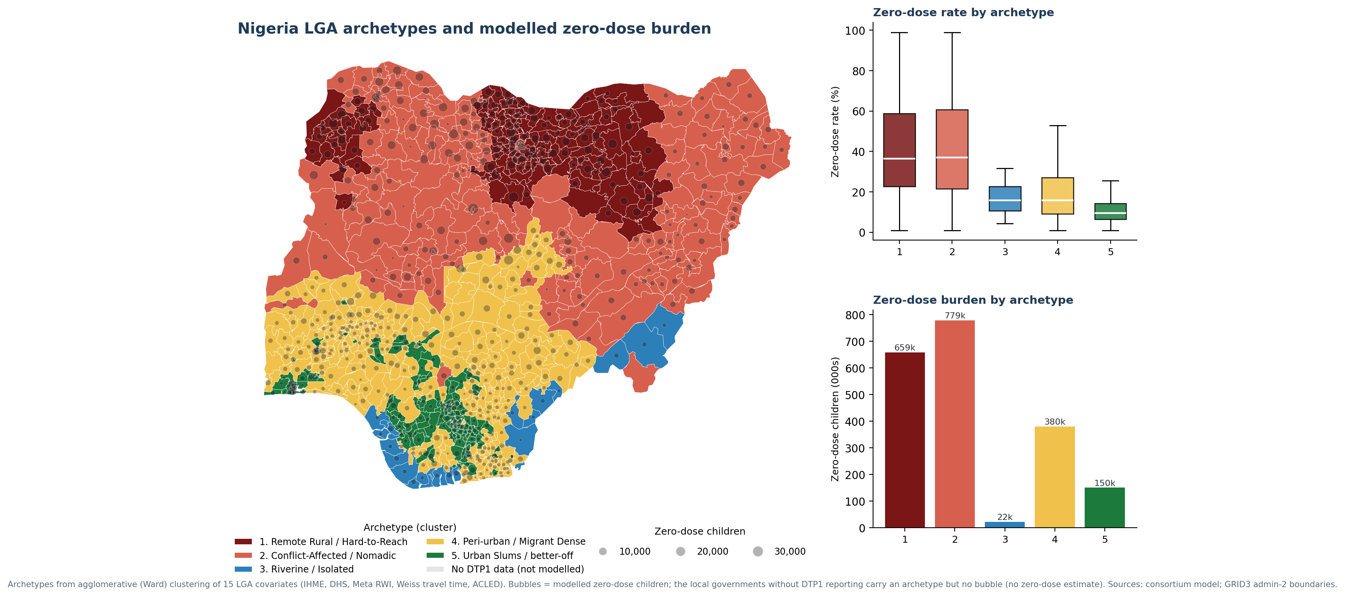
Figure 15. LGA archetypes against modelled zero-dose burden; colour denotes archetype, bubble size the number of children missed.
Archetype boundaries do not coincide with state boundaries. A single state may contain both Archetype 1 and Archetype 5 LGAs, which is why intervention packages should be assigned at local government level rather than delivered through whole-state campaigns.

5.5.2 The Ranked LGA Priority List
Every modelled LGA is ranked worst-to-best by estimated zero-dose burden, providing the prioritisation ordering required for microplanning. As Figure 14 shows, the top 146 LGAs, the worst-performing 20%, together reach about 62% of all zero-dose children, and extending to the top 270 reaches roughly 80%. The ten highest-burden LGAs are shown below; the full ranked list, filterable by state and priority tier, is held in the platform and in the operational workbook.
Table 6b. The ten highest-burden LGAs by modelled zero-dose children, 2026.
Rank | State | LGA | Zone | Zero-dose children | Rate (%)
1 | Kaduna | Kaduna North | North West | 29,585 | 78.9
2 | Kaduna | Kubau | North West | 23,524 | 81.4
3 | Kaduna | Zangon Kataf | North West | 22,943 | 69.9
4 | Zamfara | Gusau | North West | 21,871 | 99.0
5 | Kaduna | Jema’a | North West | 18,222 | 63.6
6 | Bauchi | Gamawa | North East | 17,943 | 57.2
7 | Kebbi | Birnin Kebbi | North West | 17,286 | 99.0
8 | Bauchi | Misau | North East | 17,217 | 59.8
9 | Kebbi | Danko/Wasagu | North West | 17,071 | 99.0
10 | Zamfara | Zurmi | North West | 16,755 | 99.0

Model estimate. Source: Domain 5 zero-dose model, 2026; GRID3 boundaries. Hotspot classification: Getis-Ord Gi*, k = 5 nearest neighbours (Figures 11–12).
Two features of this ranking have direct programme implications. First, the highest-burden LGAs are not confined to the highest-rate states: Kaduna holds four of the top five places on absolute burden while sitting well below Sokoto, Kebbi and Zamfara on rate, because its birth cohort is large. Rate-based and burden-based prioritisation therefore produce materially different lists, and microplanning needs both. Second, several LGAs sit at or near a 99% modelled rate, which should trigger verification of the local denominator before campaign resources are committed.
This ranking is the operational bridge between the modelling and the annual RI workplan. It should be paired with the archetype assignment in Table 6 so that each priority LGA carries both a position in the queue and a matched response package.

5.5.3 Maternal Care and Immunization Gaps Occupy the Same Geography
The LGAs with the weakest antenatal and delivery care are the same LGAs missing the most zero-dose children. Across all 774 LGAs, antenatal care with four or more visits correlates with the modelled zero-dose rate at r = −0.55, and facility delivery at r = −0.52. Both associations are strong and consistent, and they indicate an operational entry point that immunization delivery does not currently use.
The two archetypes with the weakest maternal care, Remote Rural / Hard-to-Reach and Conflict-Affected / Nomadic, hold approximately 1.44 million of the roughly 2.09 million modelled zero-dose children, on antenatal coverage of 36 to 40% and facility delivery of 10 to 19%. Where a maternal contact does occur in these places, it is an existing, funded, already-scheduled point of contact with precisely the households the immunization programme is failing to reach.
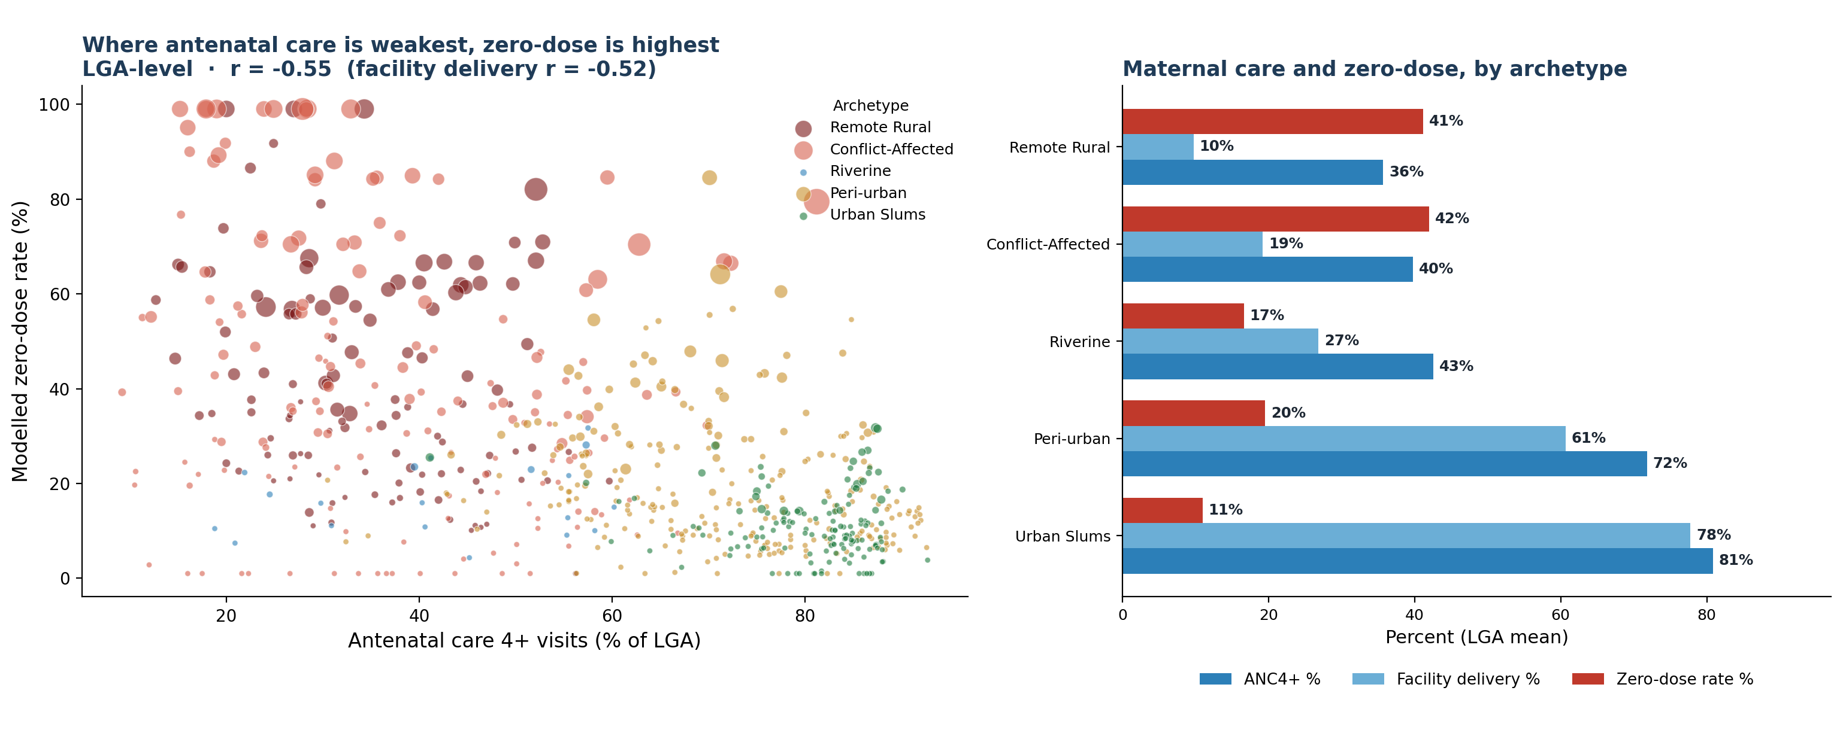
Figure 16. Antenatal care (four or more visits) against the modelled zero-dose rate across 774 LGAs, and maternal-care indicators by archetype.
The implication is that in the highest-burden archetypes, immunization should be co-delivered with antenatal and delivery contacts, so that one visit provides several services, rather than mounted as standalone immunization outreach. This lowers the cost per child reached and uses a contact the household has already accepted.
Table 6c. The RMNCH–EPI operational list: maternal-care indicators and the matched package, by archetype.
Archetype | LGAs | ANC4+ (%) | Facility delivery (%) | Zero-dose rate (%) | Zero-dose children | RMNCH–EPI intervention
Remote Rural / Hard-to-Reach | 136 | 35.7 | 9.8 | 41.2 | 658,900 | Reaching-Every-Community microplanning, BHCPF outreach and community health workers; co-deliver immunization with antenatal and nutrition contacts
Conflict-Affected / Nomadic | 192 | 39.8 | 19.2 | 42.0 | 779,131 | Security-integrated microplanning, negotiated access, and mobile and transit-point teams delivering immunization and antenatal care together
Riverine / Geographically Isolated | 20 | 42.6 | 26.8 | 16.6 | 22,425 | Boat-based outreach, community health worker networks, and multi-antigen and antenatal bundling per visit
Peri-urban / Migrant Dense | 280 | 71.8 | 60.7 | 19.5 | 380,154 | Ward enumeration, migrant-sensitive scheduling, and Periodic Intensification of Routine Immunization linked to antenatal clinics
Urban Slums (better-off core) | 146 | 80.9 | 77.8 | 11.0 | 150,166 | Targeted social mobilization, a fixed-plus-outreach hybrid, and private-sector last-mile reach for immunization and antenatal care

Model estimate. Source: LGA archetype master and the RMNCH–EPI operational workbook (IHME and DHS antenatal-care and facility-delivery covariates; modelled zero-dose). All 774 LGAs are ranked worst-to-best in the workbook, each carrying its archetype, antenatal and facility-delivery figures and matched package, ready for microplanning. Facility-level primary health care lists and facility density are not included; those require a GRID3 or National Health Facility Registry dataset.

5.6 Domain 6 — Polio Risk and the Interruption Pathway
A Bernoulli case-control spatial scan (71 confirmed polio cases against 78,862 non-polio AFP controls) detects one statistically significant residual cluster in the far north-east near the international border (relative risk about 10.5). Wild poliovirus has been absent since 2017; the remaining signal is vaccine-derived. Because the scan uses non-polio AFP from the same surveillance system as controls, it adjusts for surveillance intensity, so the cluster is a true excess rather than an artefact. Everywhere else, confirmed cases are statistically indistinguishable from background; there is no active reservoir elsewhere.
Modelling the interruption pathway with a negative-binomial GLM (Prophet cross-check), the projected annual case count declines and the upper 95% bound falls below one case per year before 2030, a credible, if conditional, interruption pathway. A recurrence-free survival analysis gives a 21.3% probability of remaining case-free for a full 36 months nationally; eighteen states are already past the WHO 36-month certification threshold, while six (Taraba, Kogi, Adamawa, Borno, Gombe, Kano) remain inside the window and gate national certification, with Borno and Kano the live reservoir. Surveillance timeliness comfortably meets WHO standards for stool collection and laboratory turnaround, so a no-new-case signal reflects genuine absence rather than missed detection; investigation timeliness (73.5% within 7 days) is one step below the target.
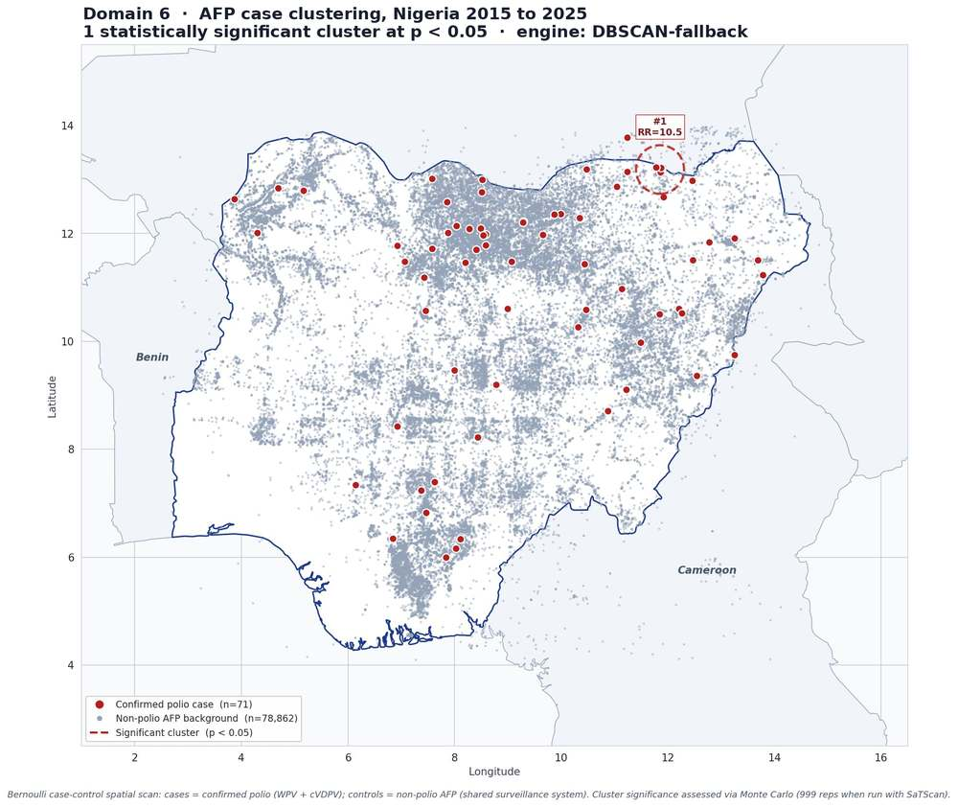
Figure 17. AFP case clustering, 2015–2025 (Bernoulli case-control spatial scan); one significant cluster on the north-eastern border.
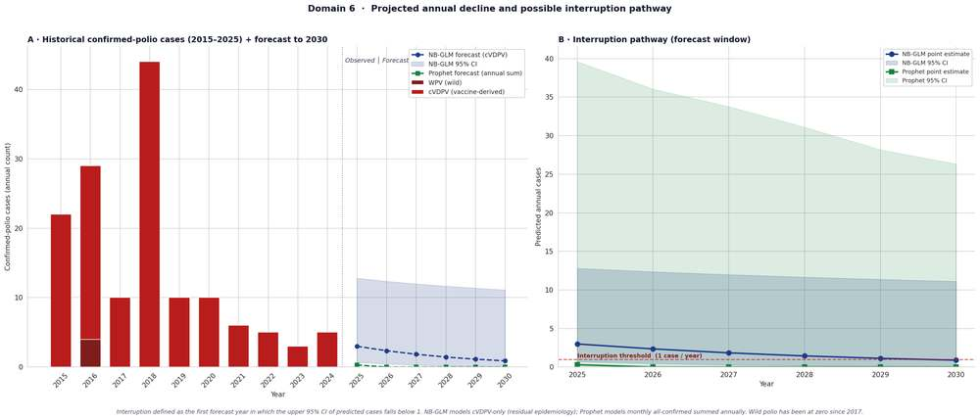
Figure 18. Historical confirmed-polio cases and forecast to 2030; interruption threshold below one case per year.
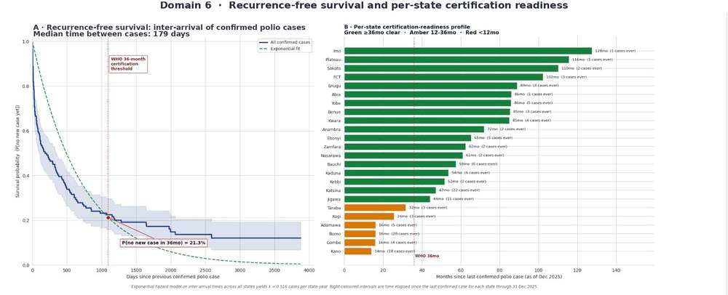
Figure 19. Recurrence-free survival of confirmed polio cases against the WHO 36-month certification threshold.
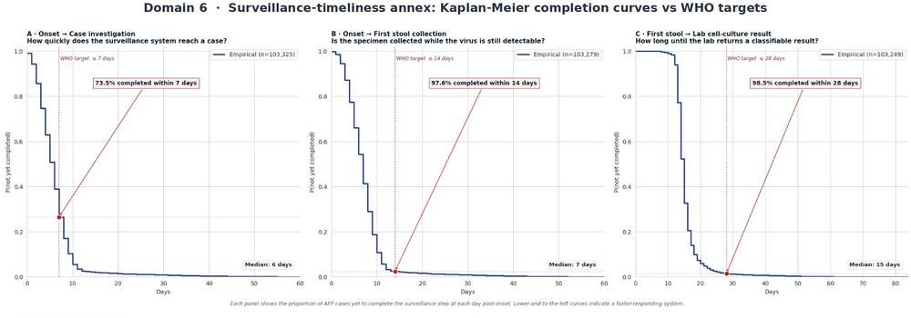
Figure 20. Surveillance-timeliness completion curves against WHO performance targets.

5.7 Domain 7 — Outbreak Risk and the Coverage-to-Mortality Link
Domain 7 tests the study's central hypothesis. Eight pre-specified directional tests with higher antigen coverage leading to a lower disease-specific share of under-five mortality were run against IHME GBD 2023 cause fractions and FDR-corrected. Seven of the eight are confirmed; the strongest are Measles1 to measles deaths (r = -0.86) and Measles1 to yellow-fever (r = -0.84). Because measles coverage tracks measles and yellow-fever mortality most tightly, raising the measles first dose and conducting timely follow-up campaigns in the Tier-1 North-West is the single highest-yield action for averting vaccine-preventable child deaths in the near term, and it supplies the cost-per-death-averted rationale GAVI investment requires.
The composite outbreak-risk surface ranks Zamfara, Sokoto, and Kebbi highest. A triangulation against the independent zero-dose forecast is decisive: the vaccine-targeted share of mortality and the zero-dose forecast correlate at r = 0.87, and six states fall in the convergent high-risk quadrant: Zamfara, Sokoto, Kebbi, Katsina, Niger, and Kaduna. Two independently built data products point to the same places.
Table 7. The six highest outbreak-risk states on the composite VPD risk surface.
Rank | State | Overall risk | Gi* class 2026 | Priority tier
1 | Zamfara | 99.2 | Hot spot (p<0.01) | Tier 1: Critical
2 | Sokoto | 96.1 | Hot spot (p<0.01) | Tier 1: Critical
3 | Kebbi | 95.0 | Hot spot (p<0.01) | Tier 1: Critical
4 | Katsina | 61.4 | Hot spot (p<0.05) | Tier 2: High
5 | Niger | 57.8 | Hot spot (p<0.01) | Tier 2: High
6 | Kaduna | 55.7 | Hot spot (p<0.05) | Tier 2: High
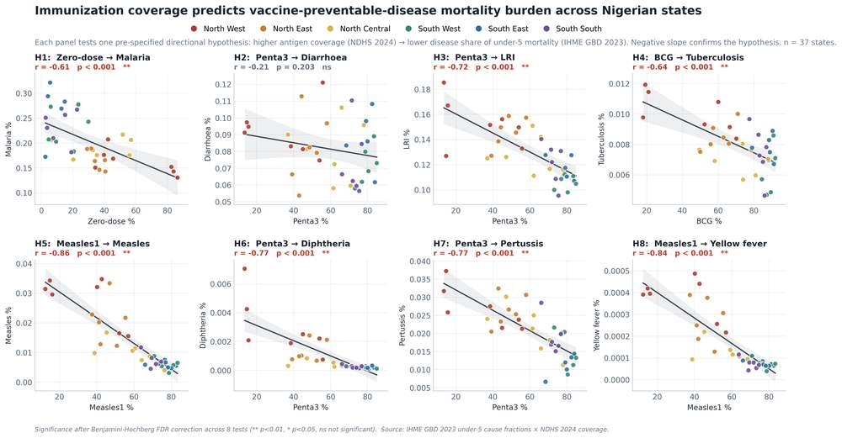
Figures 21–22. Coverage-to-mortality hypothesis grid and the composite VPD outbreak-risk surface.
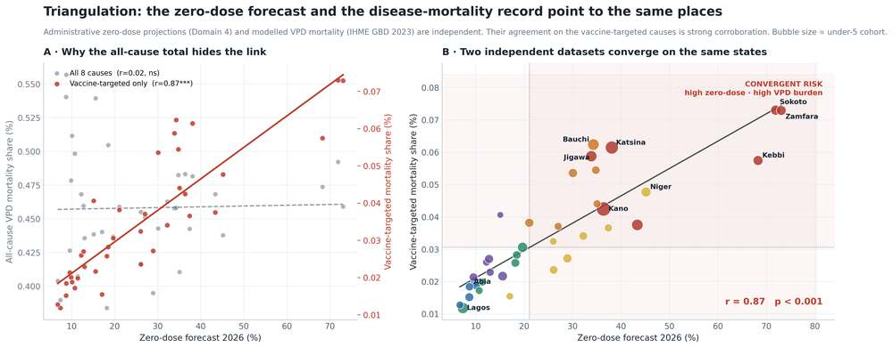
Figure 23. Triangulation: the vaccine-targeted mortality share tracks the zero-dose forecast (r = 0.87); the North-West forms the convergent-risk cluster.

5.8 The Predictive Modelling Platform
The analysis is delivered not as a static set of results but as a live, no-code web application that the NPHCDA Digital Innovation Hub can operate directly. The platform is deployed on Hugging Face under Docker, with secure login and usage tracking, and uploaded data remains in-session.
- Live re-runs on new data. Refreshed DHIS2 or survey files are uploaded through the browser; the application validates their structure and recomputes only what has changed. No code is written and no analyst is required.
- Reproduces this report. The platform regenerates the national total to within 0.01% of the figures reported here, and has been back-tested and wave-validated, so the report and the live tool cannot silently diverge.
- The LGA Priority and Archetypes screen. Filter by state or LGA to see antigen risks, estimated missed children, rank and recommended response package. Results export to Excel for microplanning.
- Two coverage lenses, held apart. Estimated coverage of the eligible cohort and the 2024 delivery index are displayed separately and triangulated against NDHS, so the distinction set out in Section 5.1.2 is preserved in the interface itself.
- ZARA, a grounded analyst. The Zero-dose Analytics and Risk Assistant answers plain-language questions in English, French, Hausa, Yoruba, Igbo, Pidgin, Swahili and other languages. It reads only the live outputs and uploaded documents, cites the page it drew from, and is instructed never to generate a figure that is not in the results.
- Provenance on every view. Each result carries its data date, reporting completeness and an indicator of whether the value is a model estimate, so that figures are interpreted with their limitations attached.
- One-click documents. A GAVI-style factsheet and a Word policy brief regenerate from the same live outputs, so report, factsheet, brief and slide deck remain a single source of truth.
- Governance built in. Role-based secure login, usage tracking, and a load–validate–run–review–approve–release sign-off cycle designed for DIH operation.
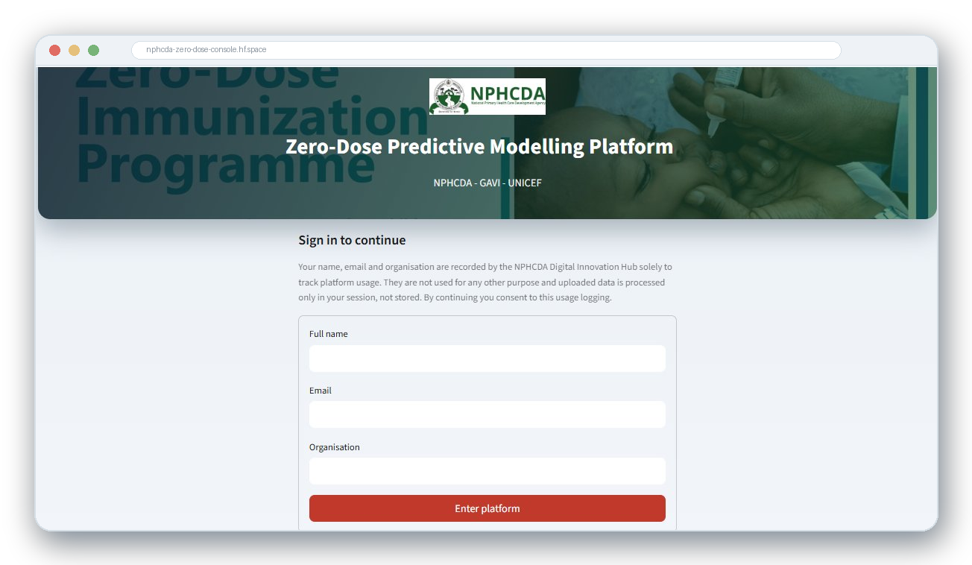
Figure 24. The predictive modelling platform: secure sign-in to the live Hugging Face deployment operated by the Digital Innovation Hub.
The platform converts the analysis from a set of consortium notebooks into a decision-support function the agency operates directly, and it is the mechanism through which the recommendations in Section 9.2 are to be sustained.

5.9 External Validation Against Independent Data
The forecasts were tested against two datasets that played no part in building them.
State level, against a survey that did not exist. The Nigeria mini Demographic and Health Survey (NmDHS) 2025-26 was released after this modelling concluded, which makes it a genuine out-of-sample test rather than a retrospective fit. The model and the new survey rank the 37 states in almost the same order (Spearman ρ = 0.88). On levels, the North-West forecast of 48% sits within one point of the survey’s 49%. Ordering and magnitude both hold against data the model never saw.
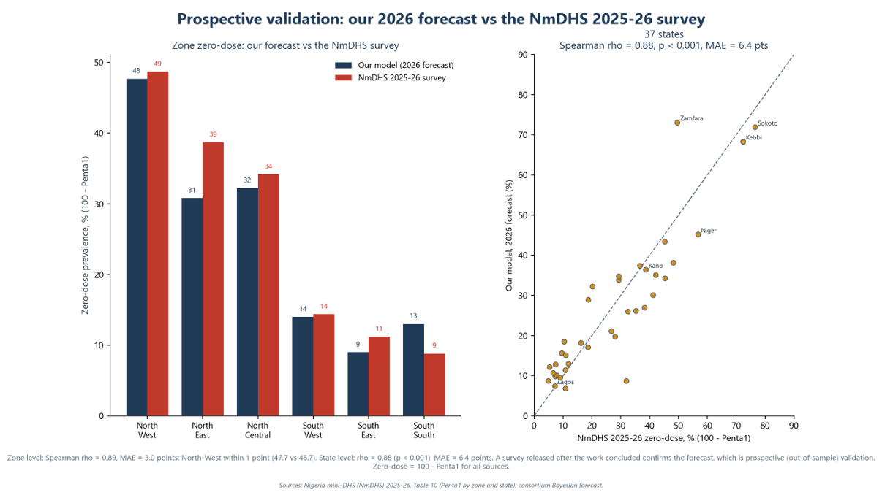
Figure 25. Prospective validation: the 2026 state forecasts against the NmDHS 2025-26 survey, 37 states (ρ = 0.88).
LGA level, against an independently constructed surface. The LGA ranking was compared with the IHME Local Burden of Disease DTP1 admin-2 surface, built by a different team using different methods and inputs. Across the matched LGAs the rank correlation is ρ = 0.60, and most LGAs fall in the same or an adjacent priority group; only 44 are placed far apart and are flagged for review. Absolute levels differ, as expected: the IHME surface ends in 2018 and these estimates are for 2026, and eight years shift the levels even where the geography agrees.
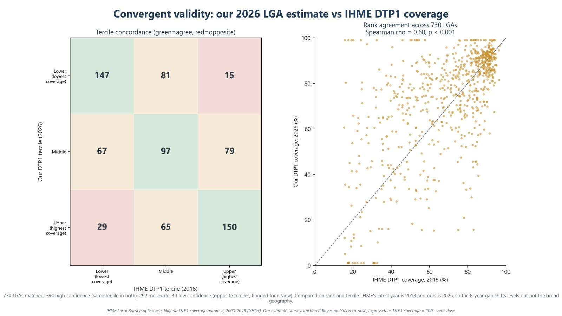
Figure 26. Convergent validity: the 2026 LGA estimates against the IHME Local Burden of Disease DTP1 coverage surface (ρ = 0.60).
A third, independent line of evidence points the same way. The pattern also matches the IHME Global Burden of Disease 2023 mortality data, which is the triangulation reported in Section 5.7 at r = 0.87.
Taken together, a survey published after the work concluded, a coverage surface constructed independently by another team, and an independent mortality series place the same states and the same LGAs in the same order. This convergence across independently produced data sources supports the use of these outputs for Gavi 6.0 targeting.

6. Readiness Assessment: Baseline and Endline
The modelling above is only as useful as the system's capacity to own and operate it. The baseline and endline assessments evaluated that capacity across twelve administrative units using a common instrument, covering data availability, analytics capacity, data-quality governance, systems integration, infrastructure adequacy, and the embedding of predictive modelling into routine governance. Following the agreed structure, baseline and endline results are presented separately below; they are then interpreted together in the Discussion (Section 7).

6.1 Baseline Findings
The baseline assessment combined a two-part quantitative readiness checklist (Part A on the presence of key data and decision-use functions; Part B on capacity, systems, and infrastructure) with key-informant interviews to contextualize the scores. Quantitative results are summarized first, then the qualitative themes.
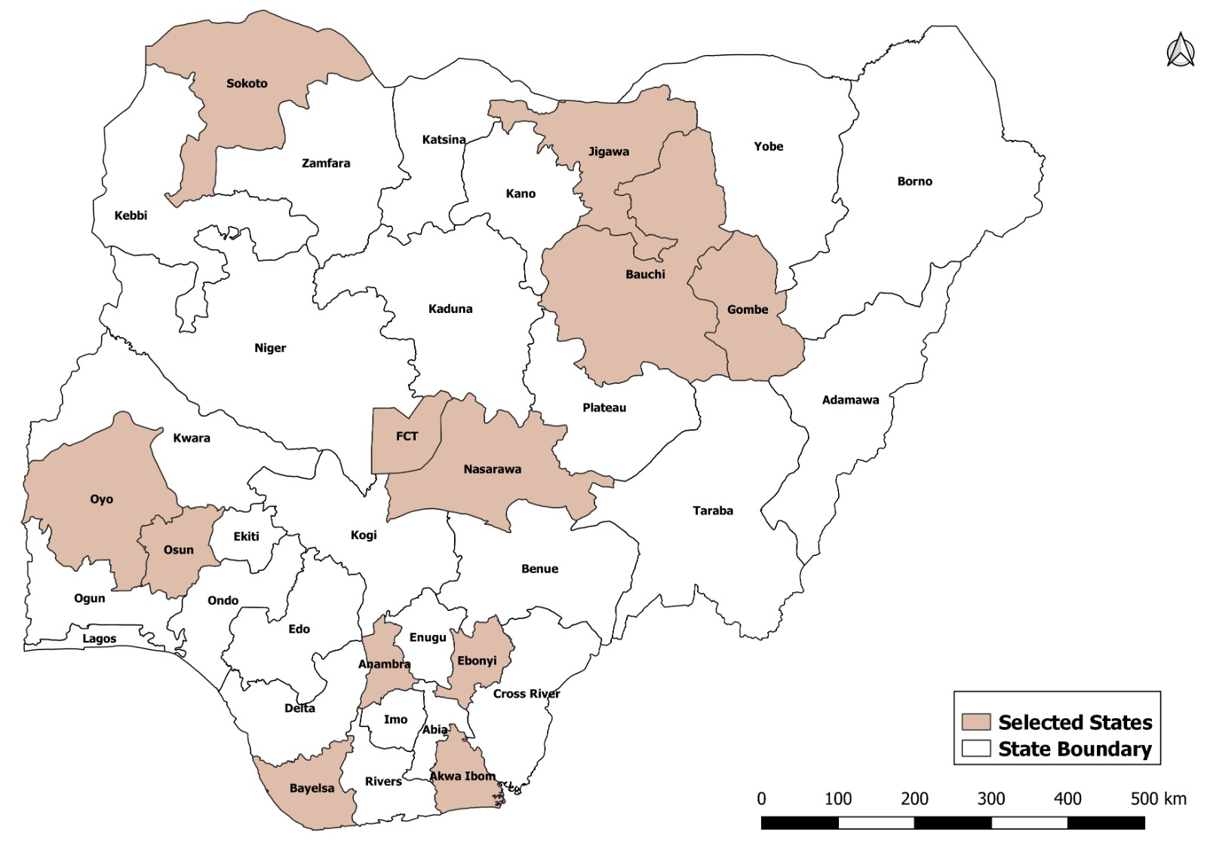
Figure 27: Study States

6.1.1 Quantitative readiness (baseline)
At baseline, overall Part A checklist scores ranged from 59.5% to 97.6%, with Nasarawa highest (97.6%) and Bayelsa lowest (59.5%). Performance was strongest in data availability, data use for planning and data analysis (most units at or near 100%), while the readiness-for-predictive-modelling sub-domain and governance-related domains showed the widest variation. Bayelsa was the clear outlier, recording low scores in data management and quality (20%), performance monitoring (33.3%), and data use for planning (20%) despite full data-availability compliance.
On Part B, capacity scores clustered at the upper end of the 1–5 scale: ten units recorded an overall capacity of 4, and three (Anambra, Bauchi, Ebonyi) recorded 3, with none below 3. Data-quality process maturity was uniformly high (4 for all units except Oyo at 5). On the overall modelling-readiness assessment, most units were classified as High readiness, and Anambra, Bauchi, and Ebonyi Moderate; systems readiness was Strong for Bayelsa, Nasarawa, and Osun, and Weak for Akwa Ibom, Anambra, and Oyo (reflecting weaker infrastructure). Estimated time-to-readiness ranged from 3–6 months for several units to 12+ months for Bauchi and Ebonyi. The baseline Part A scores by unit are shown below; Part B and the overall classification follow the same structure as the endline tables.
Table 8. Baseline Part A readiness scores by administrative unit and section
Unit | Overall % | S1 | S2 | S3 | S4 | S5 | S6 | S7
Akwa Ibom | 81.0 | 80.0 | 80.0 | 100 | 44.4 | 85.7 | 100 | 100
Anambra | 78.6 | 100 | 80.0 | 83.3 | 22.2 | 100 | 100 | 100
Bauchi | 92.9 | 100 | 100 | 100 | 88.9 | 71.4 | 100 | 100
Bayelsa | 59.5 | 100 | 20.0 | 33.3 | 77.8 | 71.4 | 20.0 | 80.0
Ebonyi | 78.6 | 100 | 100 | 100 | 44.4 | 42.9 | 100 | 100
FCT Abuja | 89.7 | 93.3 | 100 | 94.4 | 59.3 | 100 | 100 | 100
Gombe | 92.9 | 100 | 100 | 100 | 88.9 | 71.4 | 100 | 100
Jigawa | 95.2 | 100 | 100 | 100 | 100 | 71.4 | 100 | 100
Nasarawa | 97.6 | 100 | 100 | 100 | 88.9 | 100 | 100 | 100
National | 95.2 | 100 | 100 | 100 | 88.9 | 85.7 | 100 | 100
Osun | 92.9 | 100 | 100 | 100 | 88.9 | 71.4 | 100 | 100
Oyo | 92.9 | 100 | 100 | 100 | 88.9 | 71.4 | 100 | 100
Sokoto | 88.1 | 100 | 100 | 83.3 | 55.6 | 100 | 100 | 100

6.1.2 Qualitative findings (baseline)
The baseline key-informant interviews, organized under the same themes as the endline, established the starting picture. On data systems and governance, DHIS2 and HMIS were the central platforms, with supplemental campaign and surveillance data; encryption and audit trails were cited as safeguards, but respondents noted that data security and governance policies were not uniformly enforced. On staff capacity, a significant skills gap existed at national and subnational levels, with foundational skills (data management, statistics, visualisation) present and working knowledge of MySQL and R among some staff, but Python was concentrated in a single individual, a clear single point of failure. Data-quality challenges were persistent and multi-level, rooted in irregular supportive supervision, insufficient logistics (laptops, power, connectivity), human error, and weak policy enforcement.
On data use, indicators such as antigen coverage and Penta dropout were reviewed descriptively through dashboards and Excel, not through predictive models. On predictive-modelling awareness, respondents understood the concept and were enthusiastic, citing the RTS, malaria vaccine state selection as prior modelling experience, and identifying clear perceived benefits (outbreak prediction, vaccine allocation, target population estimation, budgeting). The barriers identified were structural and consistent: continuous loss of trained staff to better-resourced partners, weak governance enforcement, a subnational infrastructure deficit, narrow programming capacity, and a reactive analytical culture focused on describing the past rather than forecasting. At the state level, capability was real but typically concentrated in one individual (for example, the Akwa Ibom State M&E Officer), with the absence of R and Python skills and a non-functional DIH limiting broader readiness, a pattern that recurs across the assessed states.
Several states illustrated the baseline picture concretely. Nasarawa had the most advanced setup, with an M&E officer running a near-real-time monitoring system built on an SMS gateway, a custom Excel dashboard, QGIS settlement mapping, and a red-yellow-green risk framework, producing the fastest data-to-action cycle in the assessment (emergency declarations within 24 hours of AFP surveillance data) but resting entirely on one individual. Oyo employed a dedicated analyst using Power BI, Power Query, and SPSS with consumption-based vaccine forecasting already in practice, yet its entire seven-person data team shared a single computer. Jigawa presented a stronger modelling baseline than most, with two to three staff having some Python knowledge and 281 computers deployed to facilities, though training was limited to data entry. Osun operated a three-copy immunisation-card system and community-mobiliser networks, but staff reported using personal funds for DHIS2 uploads. In Sokoto, awareness of predictive modelling was very limited, and the Digital Innovation Hub was unknown to all respondents. Across the lowest-scoring southern states (Akwa Ibom, Anambra, Bayelsa, Ebonyi), respondents could articulate the value of predictive tools but lacked the enabling conditions (stable power, functional computers, connectivity, and trained staff) to support routine analytics.

6.2 Endline Findings
The endline assessment revisited the same thirteen administrative units using the same instruments and analytical framework to document changes in readiness and the extent to which predictive modelling can be embedded in routine immunization planning and decision-making.

6.2.1 Quantitative Readiness (Endline)
The endline quantitative checklist assessed institutional preparedness for predictive-modelling integration across thirteen administrative units: the NPHCDA (National), the FCT, and eleven participating states. It comprises Part A, a readiness checklist covering data availability and decision-use functions, and Part B, an assessment of capacity, systems, and infrastructure on a 1–5 scale.
Part A — Readiness checklist.
Overall Part A scores ranged from 78.6% to 97.6%, with Bauchi highest (97.6%) and Anambra lowest (78.6%); eight of the thirteen units scored at or above 90%, indicating that basic data-use structures are broadly established at national and subnational levels. Performance was strongest and most uniform in data availability and access, data use for planning (100% across all units), and data analysis and interpretation, where most units recorded full confirmation. The clearest differentiator was readiness for predictive modelling and advanced analytics, which ranged from 55.6% (Akwa Ibom, Anambra, Oyo, Sokoto) to 100% (Bauchi, Bayelsa, Jigawa), confirming that advanced analytics capacity, rather than routine data handling, is where targeted, differentiated support is still needed. System constraints and opportunities showed the National unit lowest at 42.9%.
Operational indicators varied across units: reporting lag time ranged from quarterly (Sokoto) through monthly (most units) to real-time/same-day (Bauchi, Gombe, Osun); data-linkage capacity ranged from lowest-observed at National to manual or support-dependent elsewhere; and sex-disaggregation practice ranged from rare (Bayelsa, Sokoto) to systematic (Akwa Ibom, Bauchi, Gombe, Jigawa, National, Osun).
Table 9. Part A readiness scores by administrative unit and section
Unit | Overall % | S1 | S2 | S3 | S4 | S5 | S6 | S7
Akwa Ibom | 85.7 | 100 | 60.0 | 100 | 55.6 | 100 | 100 | 100
Anambra | 78.6 | 80.0 | 80.0 | 83.3 | 55.6 | 71.4 | 100 | 100
Bauchi | 97.6 | 100 | 100 | 100 | 100 | 85.7 | 100 | 100
Bayelsa | 90.5 | 100 | 80.0 | 83.3 | 100 | 71.4 | 100 | 100
Ebonyi | 90.5 | 100 | 100 | 100 | 66.7 | 85.7 | 100 | 100
FCT Abuja | 95.2 | 100 | 100 | 83.3 | 88.9 | 100 | 100 | 100
Gombe | 95.2 | 100 | 100 | 100 | 88.9 | 85.7 | 100 | 100
Jigawa | 92.9 | 100 | 100 | 100 | 100 | 57.1 | 100 | 100
Nasarawa | 92.9 | 100 | 100 | 100 | 88.9 | 71.4 | 100 | 100
National | 85.7 | 100 | 100 | 100 | 88.9 | 42.9 | 100 | 80.0
Osun | 92.9 | 100 | 100 | 100 | 88.9 | 71.4 | 100 | 100
Oyo | 85.7 | 100 | 100 | 100 | 55.6 | 71.4 | 100 | 100
Sokoto | 88.1 | 100 | 100 | 100 | 55.6 | 100 | 100 | 80.0

(S1 Data availability; S2 Data management & quality; S3 Performance monitoring & feedback; S4 Readiness for predictive modelling; S5 System constraints & opportunities; S6 Data use for planning; S7 Data analysis & interpretation).

Part B — Capacity, systems, and infrastructure.
Part B assessed staff competency, data-quality processes, data use and decision impact, systems integration, data standards, and infrastructure adequacy across the thirteen administrative units. Exact overall capacity scores ranged from 3.1 in Anambra to 4.7 in Jigawa. Eight units; Akwa Ibom, Bauchi, Bayelsa, FCT Abuja, Jigawa, Nassarawa, Oyo, and Sokoto were classified as having high capacity readiness, while Anambra, Ebonyi, Gombe, National, and Osun were classified as moderate; no unit fell within the low-capacity category. Staff competency showed the widest variation, ranging from 2.0 in Anambra and Osun to 5.0 in Jigawa and Sokoto. Data-quality process scores were comparatively stable, ranging from 3.3 to 5.0, while data use and decision impact ranged from 3.0 to 5.0.
Table 10. Part B Capacity, Systems, and Infrastructure Assessment Scores by Administrative Unit
Unit | Overall Capacity | Staff Competency | Data Quality Process | Data Use / Decision Impact | Systems Integration Level | Data Standards Strength | Infrastructure Adequacy
 | Capacity Score |  |  | Systems Integration
Akwa Ibom | 4 | 3 | 4 | 5 | No integration | Moderate | No
Anambra | 3 | 2 | 3 | 4 | Manual | Weak | No
Bauchi | 4 | 4 | 4 | 3 | Semi-automated | Moderate | Yes
Bayelsa | 4 | 3 | 4 | 4 | Manual | Moderate | Partially
Ebonyi | 3 | 3 | 4 | 3 | Automated | Moderate | Partially
FCT Abuja | 4 | 5 | 4 | 4 | Automated | Moderate | Yes
Gombe | 3 | 3 | 4 | 3 | Semi-automated | Moderate | Yes
Jigawa | 5 | 5 | 4 | 5 | Fully interoperable | Moderate | Yes
Nasarawa | 4 | 4 | 4 | 4 | Manual | Strong | Yes
National | 3 | 3 | 4 | 4 | Semi-automated | Moderate | Partially
Osun | 3 | 2 | 4 | 4 | Manual | Moderate | Partially
Oyo | 4 | 4 | 4 | 4 | Manual | Moderate | Partially
Sokoto | 5 | 5 | 5 | 4 | Manual | Moderate | Yes

Capacity scores are reported on a 1–5 scale, with higher values indicating stronger capacity. Systems integration categories are: No integration, Manual, Semi-automated, Automated, and Fully interoperable. Data standards categories are Strong, Moderate, and Weak. Infrastructure adequacy categories are Yes, Partially, and No.

Overall Modelling Readiness
Overall system readiness was predominantly moderate: ten units were classified as moderate, Nassarawa was classified as strong, and Akwa Ibom and Anambra were classified as weak. Systems integration ranged from no integration in Akwa Ibom to fully interoperable in Jigawa. Data standards were moderate in eleven units, strong in Nassarawa, and weak in Anambra. Infrastructure was assessed as adequate in six units (Bauchi, FCT Abuja, Gombe, Jigawa, Nassarawa, and Sokoto), partially adequate in five (Bayelsa, Ebonyi, National, Osun, and Oyo), and inadequate in two (Akwa Ibom and Anambra). Estimated time to modelling readiness was 3–6 months in five units, 6–9 months in three, 9–12 months in three, and more than 12 months in two units (Ebonyi and Jigawa).

Table 11. Overall Capacity, Systems Readiness, And Estimated Time to Modelling Readiness by Unit.
Unit | Capacity | Readiness level | Systems readiness | Data std. | Infra. | Time to readiness
Akwa Ibom | 4 | High | Weak | Moderate | No | 3–6 months
Anambra | 3 | Moderate | Weak | Weak | No | 3–6 months
Bauchi | 4 | High | Moderate | Moderate | Yes | 9–12 months
Bayelsa | 4 | High | Moderate | Moderate | Partially | 3–6 months
Ebonyi | 3 | Moderate | Moderate | Moderate | Partially | 12+ months
FCT Abuja | 4 | High | Moderate | Moderate | Yes | 3–6 months
Gombe | 3 | Moderate | Moderate | Moderate | Yes | 9–12 months
Jigawa | 5 | High | Moderate | Moderate | Yes | 12+ months
Nasarawa | 4 | High | Strong | Strong | Yes | 6–9 months
National | 3 | Moderate | Moderate | Moderate | Partially | 6–9 months
Osun | 3 | Moderate | Moderate | Moderate | Partially | 6–9 months
Oyo | 4 | High | Moderate | Moderate | Partially | 9–12 months
Sokoto | 5 | High | Moderate | Moderate | Yes | 3–6 months

High (>3.5), Moderate (2.5–3.5), Low (<2.5).

6.2.2 Qualitative Findings (Endline)
The endline qualitative findings draw on key-informant interviews at the national level (NPHCDA Planning, Research & Statistics) and across twelve administrative units, organized under the same themes used at baseline, so the two rounds read side by side. National findings are presented in full because they carry the most technically grounded account and the clearest new endline evidence; state findings are then synthesized thematically, with a state-by-state summary table.

6.2.2.1 National-level findings
Data Systems, Infrastructure, and Governance.
DHIS2 remains the central national data system, with the established facility-to-LGA-to-national reporting pathway unchanged since baseline. What has changed is the growing use of parallel streams alongside routine reporting: campaign tools, SMS same-day reporting in some states, and integrated supportive-supervision checklists, which are increasingly triangulated rather than treated as a single source of truth. Governance has advanced meaningfully: an emerging formal architecture under the Digital Innovation Hub (DIH) 'blueprint' now includes a data-sharing agreement, credential-based access, and multi-level authorisation, with active liaison with NITDA and the Nigeria Data Protection Commission, a shift from internal agency policy toward alignment with national data-protection law.
Staff Capacity In Data Analytics
The respondent rated overall advanced analytics capability at about 6 out of 10, distinguishing widespread general ICT skills from the scarcer ability to apply them in an epidemiological context. Around 12–15 staff are proficient in visualisation tools (Power BI, geospatial, Excel, ODK), narrowing to roughly five with modelling-related capability within the routine-immunisation unit, supported by partners. A new endline signal is the spontaneous emergence of AI tools as self-directed staff learning, both an opportunity (latent motivation to upskill) and a risk (unstructured self-learning without epidemiological grounding).
“Most people might know how to use Python, but applying it in the context of epidemiology and public health might be the issue.” — M&E Officer, NPHCDA PRS (National)

Data Quality
The dominant issue remains denominator instability, now described with greater analytical clarity: several states have repeatedly been flagged for implausible coverage above 100% (reaching 125–130%), sometimes alongside disease outbreaks, raising data-integrity concerns. In response, the national team tracks absolute numbers of children immunised month-on-month where population estimates are unreliable, rather than relying on coverage percentages. Two further developments are new at endline: an Identify-Enumerate-Vaccinate (IEV) case-based physical enumeration across 14 states as a denominator-correction mechanism, and DHIS2 validation rules embedded directly in the system that flag quality issues at the point of entry, a more mature, less supervision-dependent quality architecture than at baseline.

Use of Data and Modelling-Informed Planning
A structured monthly analytical cycle tracks antigen-specific coverage, session-frequency compliance, dropout, stockouts, supervision, and zero-dose burden. The most concrete evidence of an iterative, modelling-informed planning cycle is the active reprioritisation of the 100 zero-dose LGAs: an eight-month intervention plan was rolled out against the original modelling-identified list, an evaluation has been conducted, and the agency is now determining whether the list should be revised against updated data.

Predictive Modelling Awareness, Readiness, and Confirmed Use
The national respondent gave the most technically precise account in the assessment, defining predictive modelling accurately as time-bound forecasting from historical data. Critically, and unlike every state-level respondent, he confirmed that modelling has already been used operationally for target-population estimation across recent campaign rounds and, most significantly, as the main analytical tool in the original identification of the 100 zero-dose LGAs. This capability still depends heavily on external partners rather than internal staff, and engagement is largely driven by individual interest rather than institutional requirement. He also gave the most detailed DIH account: ECHIS for community data, a facility EMR to replace paper registers, and infrastructure modernisation, with modelling and analytics embedded as a core DIH function rather than a separate activity.
“For zero-dose, for the first time, modelling was the only tool used to do that. But the modelling capacity within the agency is limited, so most of the time it has been outsourced.” — M&E Officer, NPHCDA PRS (National)

Barriers To Sustaining Modelling
The barrier analysis distinguished three levels with unusual precision. First, a technical-to-public-health translation gap: proficiency in Python or geospatial tools does not guarantee the epidemiological understanding needed to apply them correctly. Second, training depth: short two-to-three-week trainings produce only surface understanding, with at least two months of intensive, disease-specific training recommended. Third, and most distinctive, organisational tasking: even well-trained staff lose skills unless leadership assigns specific modelling responsibilities and follows up. A further new barrier is data sufficiency; routinely collected data is not always structured or granular enough to support modelling, making readiness a data-architecture question the DIH is intended to address.
“Somebody might have the modelling skills, but nobody is giving him any task that will kick off his modelling capability.” — M&E Officer, NPHCDA PRS (National)

Governance And Recommendations (National)
The respondent's recommendations were the most structured in the assessment, organised around four conditions: select a small group of genuinely interested individuals rather than broad, shallow training; use simple, well-scoped data templates and a jointly developed worked example; provide sustained post-training mentorship with regular follow-up; and ensure leadership-level supervision of modelling work as the accountability mechanism that turns training into sustained practice.

6.2.2.2 State-Level Findings: Thematic Synthesis
Across the twelve administrative units, the state interviews echo the national picture and converge on a consistent set of themes:
- Performance and coverage. Several states report strong routine coverage (Jigawa above 80–100% on key antigens; Gombe's Penta3 rising from ~33% in 2018 to ~57% in 2023/24). The recurring threat to data validity is the private and tertiary facility reporting gap, especially in urban LGAs where completeness often falls below 80%, systematically understating true activity.
- Data flow and management. Most states run DHIS2 for monthly reporting alongside a weekly SMS gateway (Jigawa, Nasarawa across 817 facilities), with month-end reconciliation between the two acting as a built-in cross-validation check.
- Data quality. Common challenges are denominator instability (Nasarawa coverage exceeding 120% from population underestimation), private-facility non-reporting, and tally-to-summary transcription errors, often where one worker both vaccinates and records. Missing monthly summary forms were flagged in FCT as a critical structural gap.
- Analysis and decision-making. The analytical toolkit is uniformly Excel, Power BI, and the DHIS2 visualiser; no Python, R, or Stata use was identified at the state level. Gombe and Nasarawa show the most structured data-to-action cycles, though a one-to-two-week lag between analysis and implementation is common, driven by the separation of analysts from decision-makers and by logistics constraints.
- Zero-dose identification. Approaches combine settlement-level register tracking, community agent networks (TBAs, CHIPS), and administrative analysis; the strongest validation came from house-to-house surveys (Gombe's Zero-Dose Learning Hub) and surveillance triangulation (Nasarawa, where AFP findings showed 12 of 13 LGAs with unimmunised children, prompting a gubernatorial emergency declaration).
- Modelling readiness and sustainability. No predictive tools are in use at the state level. Readiness rests on three consistently named requirements: continuous capacity-building, formal integration of modelling into routine decision structures, and a clear progression pathway from Excel toward advanced platforms. The binding constraint named repeatedly is that skills fade without regular hands-on use: sustainability depends on continuous engagement, not one-off training. Gombe's 2025 move to fully domestic immunisation funding makes it a strong early-pilot candidate.
The state-by-state summary below captures each unit's distinctive features against the recurring themes.

Table 12. State-By-State Summary of Qualitative Findings Against the Recurring Themes
Unit | Notable strengths / features | Key constraints
FCT (AMAC) | Advanced LGA zero-dose tool (2023/24 mobile app, real-time settlement data); strong community engagement | Missing monthly summary forms; high private-facility volume; Excel-only; staffing gaps
Gombe | Penta3 ~33%→57% (2018→2023/24); domestic immunisation funding (2025); house-to-house ZD validation | Private/tertiary reporting gap; no analytic capacity below state; Excel/Power BI only
Jigawa | Coverage 80–100% on key antigens; dual SMS+DHIS2 with reconciliation; birth-tracking via TBAs/CHIPS | Seasonal HTR access; private-facility under-reporting; no Python/R; credentials lost without use
Nasarawa | Three parallel data systems; last-mile (>3km) strategy; surveillance-driven emergency response | Denominator instability (coverage >120%); analyst–decision separation
Akwa Ibom | Established routine reporting | Lower data-management score; advanced-analytics readiness limited
Anambra | Functional core data structures | Lowest overall readiness; weak systems integration and infrastructure
Bauchi | Highest Part A score; real-time reporting capacity | Outreach data-tool gaps; advanced-analytics depth limited
Bayelsa | Marked readiness improvement from baseline | Sex-disaggregation rare; moderate systems readiness
Ebonyi | Robust data-quality processes | Weak systems readiness and infrastructure adequacy
Osun | Large reported staff base; full data-use score | Weak data-standards strength; longer time-to-readiness
Oyo | Strong routine data handling | Predictive-modelling readiness low; Excel-only
Sokoto | High capacity and staff competency; strong systems readiness | Quarterly (slower) reporting lag; advanced-analytics readiness mixed

Strengths and constraints are drawn from the endline key-informant interviews and, where noted, the Part A/B readiness scores.

7. Stakeholder Engagement, Digital Gap Remediation and Close-out Activities
This section documents the stakeholder engagement, digital remediation planning and close-out activities undertaken after completion of the modelling, readiness assessment and platform-development work. It complements the modelling-domain findings and the baseline–endline readiness assessment by showing how the results were presented to decision-makers, how the Digital Innovation Hub (DIH) gaps were translated into a remedy plan, and how stakeholder feedback shaped the next phase of implementation.

7.1 Stakeholders Engaged
The consultancy engaged stakeholders across policy leadership, programme management, data systems, partner coordination and technical implementation. The key stakeholder groups are summarized below.
- National Primary Health Care Development Agency (NPHCDA) leadership, including the Executive Director, NPHCDA, directors and senior programme staff who reviewed the modelling outputs and provided strategic direction for national adoption.
- NPHCDA technical units, including the Digital Innovation Hub, the Routine Immunization team, Planning, Research and Statistics, data and analytics personnel, and staff responsible for immunization monitoring, reporting and programme review.
- Routine Immunization Technical Working Group members, who reviewed the outputs from the perspective of routine programme planning, microplanning, campaign targeting, LGA prioritization and practical use by national and subnational immunization teams.
- GAVI stakeholders, including the GAVI in-country team and technical reviewers engaged during virtual and in-person close-out discussions on zero-dose targeting, Gavi 6.0 prioritization, modelling outputs and platform use.
- UNICEF Nigeria, which supported the broader programme objective of integrating predictive modelling into routine immunization decision-making and strengthening national and state-level capacity for data-driven programme adaptation.
- State Primary Health Care Development Agencies and designated national/state analytics focal persons, who are expected to participate in dashboard use, data submission, model-output interpretation and routine feedback once DIH workflows are institutionalized.
- The CIDRE–Quantium Insights Consortium, which implemented the baseline and endline assessments, facilitated the modelling fellowship, developed the modelling outputs, prepared documentation and supported handover of the platform and decision-support products.

7.2 Preparatory Engagement, State Entry and Participant Selection
Prior to commencement of field activities, the consortium carried out a structured preparatory process to ensure that the baseline and endline assessments were properly introduced, coordinated and implemented across the participating administrative units. Formal letters of introduction and notification were sent to the selected states and relevant institutional stakeholders to inform them of the purpose of the predictive modelling readiness assessment, the expected scope of engagement, the categories of respondents required and the proposed timelines for data collection. These letters served as the official entry point for securing cooperation from State Primary Health Care Development Agencies, Routine Immunization teams, Planning, Research and Statistics units, Monitoring and Evaluation officers, LGA-level officers and facility-level respondents. Following the dispatch of official letters, state entry and community entry processes were conducted in collaboration with state and local immunization structures. The consortium engaged state-level focal persons and programme officers to confirm appropriate respondents, schedule interviews, identify relevant offices and facilities, and ensure that field teams were properly introduced before data collection. At the LGA and facility levels, entry processes included briefing relevant officers on the purpose of the assessment, confirming their roles in routine immunization data generation and reporting, and obtaining their cooperation for administration of the readiness checklist and key informant interviews. This approach helped reduce disruption to routine work, strengthened ownership of the assessment and ensured that responses were obtained from personnel directly involved in immunization data management, reporting, supervision, analysis and decision-making.
The data collection process was implemented using a role-based selection approach. Respondents were purposively selected for their direct involvement in routine immunization data systems, surveillance-linked reporting, data quality assurance, programme monitoring, performance review, planning, or service delivery. At national and state levels, the assessment prioritized officers responsible for immunization coordination, Planning, Research and Statistics, Monitoring and Evaluation, data management and Digital Innovation Hub-related functions. At LGA level, respondents included officers involved in PHC coordination, immunization implementation, disease surveillance, monitoring and data validation. At facility level, respondents included PHC in-charges and routine immunization service providers responsible for recording, summarizing and submitting immunization service data. Participant selection for the fellowship was also undertaken to ensure representation across national and sub-national levels and to support the institutionalization of predictive modelling capacity within the immunization system. A total of 20 national-level participants were selected, comprising 18 participants from NPHCDA and 2 participants from NCDC. These participants represented central-level technical and programme functions relevant to immunization data use, surveillance, modelling, analytics, programme planning and decision-making. In addition, 37 sub-national participants were selected to represent state-level routine immunization and data-use structures. The inclusion of sub-national participants was important as predictive modelling outputs are only useful when they can be interpreted and applied by the officers responsible for planning, supervision, outreach prioritization and corrective action at state and lower levels.
Overall, the preparatory engagement, state entry, community entry and participant-selection processes ensured that the assessment and fellowship were embedded within existing NPHCDA, state, LGA and facility structures. This strengthened access to relevant respondents, improved the quality of the data collected, supported ownership among participating states and created a practical foundation for translating the modelling outputs into routine immunization planning and decision-making.

7.3 Remedy Plan to Address Digital and DIH Gaps
The digital gap analysis was used as a guide for interpreting the gaps that affect predictive modelling deployment and DIH functionality. The key finding was that Nigeria has a functional routine immunization data foundation, with DHIS2/HMIS and routine review structures already in use, but the system still requires targeted remediation before predictive modelling can be sustained as a routine government-owned workflow.

7.3.1 DIH Governance, Ownership and Workflow Activation
The DIH should serve as the institutional home for routine predictive modelling. This requires defined roles for data custody, model operation, output review, approval and release. The workflow should include data submission, validation, model execution, quality assurance, interpretation, sign-off and dissemination of final outputs to NPHCDA leadership, programme teams and partners. Standard operating procedures, model assumptions, data dictionaries, user guides, approval workflows and model-version records should be maintained by the DIH so that outputs remain traceable and auditable.

7.3.2 Hardware, Power and Connectivity Remediation
The remedy plan should prioritize the equipment required for national and state participation in the modelling workflow. This includes high-specification laptops for national analytics users and one focal analytics user in each state and the FCT, dedicated analytics servers, secure backup storage, uninterrupted power protection, a national DIH solar/inverter system, state/FCT power-backup arrangements, reliable business connectivity for the DIH and data bundles for designated national and state focal persons. These items are necessary because unstable devices, power and internet directly affect data submission, dashboard access, model refresh and analytics continuity.

7.3.3 Data Integration, Hosting and Digital Workflow
The DIH should move from manual data assembly to an integrated digital workflow. Priority actions include DHIS2-surveillance integration, an API exchange layer for DHIS2, LMIS, campaign, surveillance and external data sources, ETL/data warehouse development, cloud hosting, automated DHIS2 refresh, historical-data access and a multi-source data linkage platform. These actions will reduce manual data handling, improve reproducibility and allow modelling outputs to be refreshed when routine monthly data are updated.

7.3.4 Data Quality, Denominator Validation and Reporting Completeness
Data-quality improvement should proceed alongside modelling adoption. Priority actions include automated QA scripts, anomaly detection, outlier checks, completeness monitoring, denominator validation, source-record reconciliation, monthly Penta1 completeness checks, and routine review of private and tertiary facility reporting. These actions are essential because denominator instability, missing Penta1 data, incomplete private/tertiary reporting, and delayed facility submissions can distort zero-dose, dropout, and coverage estimates if they are not flagged and corrected.

7.3.5 Capacity Development and Routine Use
Capacity development should shift from broad exposure to sustained applied competence. The next phase should establish a small DIH/RI analytics core, supported by state focal persons, with clear terms of reference and protected time for analysis. Training should be cohort-based, disease-specific and anchored in real state datasets. At least six months of post-training mentorship, recurring model-refresh assignments and review of outputs during RI performance meetings should be included so that modelling becomes a routine programme function rather than a one-off training output.

7.3.6 Platform Expansion Based on Stakeholder Feedback
Feedback from NPHCDA leadership and partners should guide platform expansion. Immediate enhancements should include OPV and IPV alongside the current tracer antigens; LGA ranking from worst to best for prioritization; and LGA-specific profiles showing the main problem, likely driver and proposed intervention. These improvements will make the platform more useful for outbreak preparedness, campaign planning, microplanning and routine supervision.

7.4 Close-out Meetings and Dissemination Activities
The close-out phase was used to present the final modelling outputs, demonstrate the platform, validate the practical interpretation of results and agree on priority next steps for DIH adoption and Gavi 6.0 targeting.

7.4.1 GAVI Engagements
The close-out process included both virtual and in-person engagements with GAVI stakeholders. The documented in-country engagement took place on Tuesday, 7 July 2026. During this engagement, the team presented the zero-dose modelling findings, the LGA priority list, the community archetypes, the platform outputs and the proposed use of the results for Gavi 6.0 targeting. Discussions emphasized the need for clear, actionable outputs that can support investment decisions, phased prioritization and microplanning at LGA level.

7.4.2 NPHCDA Leadership and Technical Staff Meeting
Following the GAVI in-country engagement, the consortium held a second presentation on Tuesday, 7 July 2026 with the Director of Disease Control and Immunization NPHCDA, other Directors and key NPHCDA staff, including the Head of DIH and the Head of Routine Immunization. This meeting presented the consolidated modelling outputs, platform functionality, DIH handover requirements and the practical implications of the ranked LGA list.

7.4.3 Meeting with the Executive Director
On Wednesday, 8 July 2026, the team presented the modelling work and platform outputs to the Executive Director of NPHCDA. The Executive Director provided specific inputs for strengthening the next phase of the work. These included expanding the antigen scope to include OPV and IPV; ranking LGAs from the worst-performing to the best-performing for prioritization; and providing LGA-specific problems, issues and proposed interventions or solutions. These inputs are important because they move the platform from general risk identification toward direct programme use for outbreak preparedness, targeted interventions and LGA-specific corrective action.

7.4.4 DIH Handover and Operationalization Meeting
The DIH close-out engagement focused on operational ownership of the platform and modelling workflow. The handover discussion covered platform access, routine data upload, model refresh, data-quality checks, output review, documentation, version control, approval processes, user administration, SOPs, data dictionaries and maintenance responsibilities. The key agreement was that the DIH should become the operational hub for routine modelling, while continued platform maintenance, enhancement and expansion should remain collaborative between NPHCDA and the CIDRE–Quantium Insights Consortium during the transition period.

7.4.5 Routine Immunization Technical Working Group Meeting
The modelling outputs were also presented to the Routine Immunization Technical Working Group on Friday, 17 July 2026. The presentation focused on practical programme use: how the ranked LGA list can support microplanning, how community archetypes can guide intervention packages, how antigen-specific alerts can inform supervision and outreach, and how the platform can be used for routine model refresh and Gavi 6.0 targeting.

8. Discussion
Read together, the seven modelling domains tell one coherent story. A stable, broadly on-target national average masks a deep north-western deficit, and four independent analytical routes to the equity-deprivation index, the Bayesian hotspot surface, the outbreak-risk surface, and the GBD triangulation, converge on the same small set of states: Sokoto, Kebbi, and Zamfara, with Niger, Katsina, Kaduna, and Jigawa close behind. That this convergence arises from administrative, survey, and mortality data that were modelled separately is the strongest form of corroboration available short of a trial.
Two findings reshape programme design. First, the coverage-to-mortality link is real and quantified, so closing the zero-dose gap in these states is expected to translate into avoided child deaths, the argument GAVI investment rests on. Second, demand and supply problems do not share a map: hesitancy is concentrated differently from zero-dose burden, so demand-generation messaging and supply-and-access expansion must be targeted independently rather than bundled into one national campaign.
The readiness assessment frames whether these models can be owned and sustained in-country. The endline quantitative results are encouraging: across the thirteen assessed units, basic data-use structures are broadly established (eight of thirteen scored at or above 90% on Part A), no unit fell below a moderate overall capacity level, and most units are estimated to reach modelling readiness within three to nine months. The consistent differentiator is advanced analytics capacity rather than routine data handling: the predictive modelling readiness sub-domain showed the widest spread (55.6% to 100%), and systems integration varied from fully automated to none. This points to where differentiated, unit-specific support should concentrate. Comparing rounds (per the agreed approach, comparison is drawn here rather than in the results), some units show marked movement from baseline; Bayelsa, for example, rose from 59.5% at baseline to 90.5% at endline on the Part A checklist. The two rounds are interpreted together below, so that improvements, steady states, and any declines are each read on their merits rather than as simple before-and-after change.
Read across the two rounds, the readiness picture has strengthened in several respects. The lowest baseline performers improved markedly; Bayelsa rose from 59.5% to 90.5% on the Part A checklist, and the overall distribution tightened, with the endline range (78.6% to 97.6%) sitting higher and narrower than at baseline (59.5% to 97.6%). On the qualitative side, governance moved from informal, unevenly enforced policy toward a formal DIH architecture aligned with national data-protection law, and modelling shifted from an understood-but-aspirational concept to confirmed operational use in the identification and active reprioritisation of the 100 zero-dose LGAs.
The stakeholder engagement and close-out activities further strengthened the interpretation and uptake of the findings. The presentation to the GAVI in-country team provided an opportunity to align the modelling outputs with Gavi 6.0 targeting and financing discussions. Further presentations to the Deputy Director, NPHCDA, other directors and key NPHCDA staff, including the Head of DIH and Head of RI, created a management-level review platform within NPHCDA. The Executive Director’s review further sharpened the operational direction of the work by recommending the inclusion of OPV and IPV, ranking of LGAs from worst to best, and production of LGA-specific problem statements with corresponding interventions. The subsequent presentation to the Routine Immunization Technical Working helped position the outputs within the technical forum responsible for routine immunization planning and follow-up.
These engagement activities are important as predictive modelling can only influence immunization outcomes if decision-makers understand, accept and routinely use the outputs. The meetings with GAVI, NPHCDA leadership, the Executive Director, the DIH team and the RI Technical Working Group therefore served as validation, interpretation and institutionalization moments.
The digital gap analysis reinforces the same message. Routine immunization data are available, and DHIS2/HMIS provides an important foundation, but the digital structure is not yet strong enough to sustain routine predictive modelling without targeted remediation. The system must be able to extract clean data, link multiple sources, run reproducible models, refresh dashboards, govern access, document assumptions, protect data, and translate outputs into decisions. Current gaps in hardware, power, connectivity, hosting, systems integration, private and tertiary reporting, data-quality automation, access control and DIH workflow design directly affect whether the modelling platform can become a routine function rather than a project output.
Systems integration and infrastructure adequacy still vary widely, with Anambra and Ebonyi weakest on both at endline; the private- and tertiary-facility reporting gap persists as a structural source of undercount; and the sustainability of skills depends on continuous hands-on use, echoing the baseline concern about staff attrition and the reactive analytical culture. Crucially for adoption, the highest-burden modelling states identified in Section 5 Sokoto, Jigawa, Bauchi and others in the North-West score comparatively well on endline readiness (Sokoto and Jigawa at the top of the capacity scale, most in the 3–6 month readiness band), which is favourable: the places where the modelling matters most are among the better positioned to operate it, provided the named capacity, governance and infrastructure conditions are met.

9. Conclusions and Recommendations

9.1 Conclusions
Nigeria's zero-dose burden is a concentrated, entrenched, and convergent one, centred on a small group of North-Western states where low coverage, structural deprivation, outbreak risk, and vaccine-preventable mortality coincide. The modelling localizes this burden to the LGA level, explains its drivers, distinguishes demand from supply geographies, and links coverage gaps to child deaths, turning a national average into an actionable, prioritized map. Polio interruption is within credible reach, conditional on sustaining campaign quality and surveillance in a small number of gating states.
Whether these gains are realized depends on institutional readiness. The readiness assessment identifies the conditions, namely analytics capacity, data-quality governance, systems integration, and infrastructure, that determine whether predictive modelling becomes embedded in national practice or remains a project output.
The close-out engagements confirmed strong stakeholder interest and provided clear direction for the next phase. GAVI engagement positioned the outputs for GAVI 6.0 targeting. NPHCDA leadership engagement supported internal ownership. The Executive Director’s inputs sharpened the operational agenda by calling for inclusion of OPV and IPV, worst-to-best LGA prioritization, and LGA-specific problem-and-solution profiles. The Routine Immunization Technical Working Group presentation created an important technical platform for further uptake.
The DIH remains the most appropriate institutional home for sustaining the modelling workflow. However, it will require targeted digital remediation to function as a routine predictive-modelling hub. Without stronger data pipelines, model governance, user roles, approval workflows, power, connectivity, hosting, documentation, access control and data-quality automation, the modelling platform risks remaining a project output rather than becoming an embedded decision-support system.

9.2 Recommendations
- Target the convergent Tier-1 North-West first. Concentrate the largest, most sustained package on Sokoto, Kebbi, and Zamfara, with Niger, Katsina, Kaduna, and Jigawa close behind, using the ranked LGA list for microplanning rather than whole-state campaigns. Sequence the investment in two waves: an initial wave across the top 146 LGAs reaches about 62% of missed children and is fundable as a single package, with expansion to 270 LGAs required to reach 80%. Budget planning should provide for the second wave from the outset rather than treating it as contingent.
- Prioritize the measles first dose and timely follow-up campaigns. This is the single highest-yield action for averting vaccine-preventable child deaths in the near term, per the coverage-to-mortality link.
- Differentiate delivery by community archetype. Match each LGA's package to its barrier profile rather than running one national or whole-state strategy; treat demand and supply as separate maps.
- Close the second-measles-dose leak in the persistent high-dropout South-East and South-West states, and audit persistent negative dropout as a denominator/reporting issue.
- Protect the polio interruption pathway by concentrating campaign quality and surveillance in the six gating states, especially the north-eastern reservoir, and strengthening investigation timeliness.
- Institutionalize the platform in the Digital Innovation Hub and sustain analytics capacity against attrition, so the models are refreshed and used in routine planning rather than as a one-off exercise.
- Implement the digital and DIH remediation plan. Priority remediation should include DIH reactivation, cloud/data warehouse setup, DHIS2 refresh automation, integration with surveillance and other data systems, data linkage, automated QA scripts, anomaly detection, private/tertiary reporting bridge, role-based access control, model-output approval workflow, secure backup, power support, connectivity and state-level access.
- Concentrate capacity-building on a small, committed analytics core rather than broad training, with disease-specific depth, sustained mentorship, and a jointly built working model, the conditions the national assessment identified as decisive.
- Assign explicit organisational responsibility for modelling with leadership-level supervision and follow-up, since trained skills fade without assigned tasks and accountability.
- Prioritize systems integration and infrastructure in the weakest units and close the private- and tertiary-facility reporting gap, which systematically undercounts urban activity and distorts zero-dose targeting.
- Pilot local modelling adoption in well-positioned high-burden states such as Sokoto and Jigawa, where readiness scores are strong, and in Gombe, which now funds immunisation domestically, converting the favourable readiness-burden overlap into early operational use.
- Build modelling-ready data architecture through the DIH so that routinely collected data is structured and granular enough to support modelling, addressing the data-sufficiency barrier directly.

9.3 Limitations and Next Steps
- Domain 7 currently uses IHME GBD 2023 modelled mortality as a proxy because the IDSR/NCDC line-lists are pending; the risk surface is a structural-susceptibility measure, not a dated outbreak forecast, and will be re-estimated once surveillance data arrive.
- Administrative DHIS2 counts are subject to reporting completeness and denominator error; survey anchoring and Bayesian shrinkage mitigate but do not eliminate this.
- Hesitancy is measured from ACSM field-activity coding, which captures concerns that were voiced and recorded; absence of recorded concern is not proof of confidence.
- Domain 8 (counterfactual campaign design, cost-effectiveness frontiers, and budget-constrained LGA optimization) is the planned next step/phase, awaiting programme and expenditure data from the NPHCDA.
- Of the three areas for strengthening identified during NPHCDA leadership review on 8 July 2026, two are addressed in this report: the antigen panel now extends to nine further antigens including OPV3, IPV1 and IPV2 (Section 5.1.1), and all modelled LGAs are ranked worst-to-best by burden (Section 5.5.2). The third, LGA-specific problem-and-intervention profiles, is partially addressed through the archetype-matched packages in Tables 6 and 6c, and will be completed at LGA level once a GRID3 or National Health Facility Registry facility dataset is available.
- Forty-four LGAs (Table 3b) were excluded from the DHIS2-based domains for want of Penta1 reporting. They are concentrated in the North-West and North-East and include three major metropolitan areas, so the national zero-dose estimate is likely to be conservative. These are data-quality exclusions, not areas of established low burden, and should not be read as such.
- The readiness assessment covers thirteen administrative units (National, FCT, and eleven states); findings are indicative of these units and not a full national census of subnational readiness.
- Qualitative findings reflect the views of the specific key informants interviewed; in several states, capability was concentrated in one individual, so unit-level readiness can be sensitive to staff movement.
- Denominator instability (coverage exceeding 100% in some states) affects the routine data that underpins both readiness judgements and zero-dose targeting, and is mitigated but not eliminated by absolute-number tracking and enumeration exercises.

References
Benjamini Y, Hochberg Y. Controlling the false discovery rate: a practical and powerful approach to multiple testing. Journal of the Royal Statistical Society: Series B (Methodological). 1995;57(1):289–300. doi:10.1111/j.2517-6161.1995.tb02031.x.
Bhatia D, Crowcroft N, Antoni S, Danovaro-Holliday MC, Bose AS, Minta A, et al. Prediction of subnational-level vaccination coverage estimates using routine surveillance data and survey data. Vaccine. 2025;60:127277. doi:10.1016/j.vaccine.2025.127277.
Biswas A, Hossain MM, Mullick MSI, Vyas P, Sievert C, Shet A. Performance of predictive algorithms in estimating the risk of being a zero-dose child in India, Mali and Nigeria. BMJ Global Health. 2023;8(10). doi:10.1136/bmjgh-2023-012836.
Dehnavieh R, Haghdoost AA, Khosravi A, Hoseinabadi F, Rahimi H, Poursheikhali A, et al. The District Health Information System (DHIS2): a literature review and meta-synthesis of its strengths and operational challenges based on the experiences of 11 countries. Health Information Management Journal. 2019;48(2):62–75. doi:10.1177/1833358318777713.
Etim EE, Odiachi A, Dougherty L, Alabi M, Adetunji A, Adedimeji A. Understanding caregivers’ and community influencers’ perspectives on the barriers to childhood immunisation in Northern Nigerian states with public-private partnerships in routine immunisation programmes. BMC Public Health. 2025;25:1471. doi:10.1186/s12889-025-22710-7.
Ferrari SLP, Cribari-Neto F. Beta regression for modelling rates and proportions. Journal of Applied Statistics. 2004;31(7):799–815. doi:10.1080/0266476042000214501.
Fotheringham AS, Yang W, Kang W. Multiscale geographically weighted regression. Annals of the American Association of Geographers. 2017;107(6):1247–1265. doi:10.1080/24694452.2017.1352480.
Gavi, the Vaccine Alliance. Gavi 6.0 strategy: 2026–2030. Geneva: Gavi, the Vaccine Alliance; 2024.
Gavi Zero-Dose Learning Hub. Nigeria zero-dose situation analysis. Geneva: Gavi Zero-Dose Learning Hub; 2023.
Getis A, Ord JK. The analysis of spatial association by use of distance statistics. Geographical Analysis. 1992;24(3):189–206. doi:10.1111/j.1538-4632.1992.tb00261.x.
Global Polio Eradication Initiative. Global Polio Surveillance Action Plan, 2022–2024. Geneva: World Health Organization; 2022.
Global Polio Eradication Initiative. Standard operating procedures: responding to a poliovirus event or outbreak. Version 4. Geneva: World Health Organization; 2022.
GRID3. GRID3 impact report 2017–2022. New York: Geo-Referenced Infrastructure and Demographic Data for Development; 2023.
Institute for Health Metrics and Evaluation. Global Burden of Disease 2023: findings from the GBD 2023 study. Seattle, WA: Institute for Health Metrics and Evaluation; 2025.
Jean Baptiste AE, Wagai J, Hahné S, Adeniran A, Koko RI, de Vos S, et al. High-resolution geospatial mapping of zero-dose and underimmunized children following Nigeria’s 2021 Multiple Indicator Cluster Survey/National Immunization Coverage Survey. Journal of Infectious Diseases. 2024;230(1)–e138. doi:10.1093/infdis/jiad476.
Kaduru C, Godwin I, Akeboi O, Cyril-Egware K, Uzoma S, Maduekwe V, et al. Geospatial analysis of immunisation outcomes in Nigeria using a Bayesian geostatistical approach and an interactive dashboard. Discover Public Health. 2025;22:333. doi:10.1186/s12982-025-00719-y.
Kulldorff M. A spatial scan statistic. Communications in Statistics—Theory and Methods. 1997;26(6):1481–1496. doi:10.1080/03610929708831995.
Leask J, Christou-Ergos M, Abdi I, Mboussou F, Sabahelzain MM, Wiley KE, et al. Informing the development of transmission modelling guidance for global immunization decision-making: a qualitative needs assessment. Vaccine. 2025;49:126800. doi:10.1016/j.vaccine.2025.126800.
Mahachi K, Kessels J, Boateng K, Baptiste AEJ, Mitula P, Ekeman E, et al. Zero- or missed-dose children in Nigeria: contributing factors and interventions to overcome immunization service-delivery challenges. Vaccine. 2022;40(37):5433–5444. doi:10.1016/j.vaccine.2022.07.058.
National Population Commission (Nigeria), ICF. Nigeria Demographic and Health Survey 2024. DHS Final Report No. FR395. Abuja, Nigeria, and Rockville, Maryland, USA: National Population Commission and ICF; 2025.
Nnadi C, Etsano A, Uba B, Ohuabunwo C, Melton M, Nganda GW, et al. Approaches to vaccination among populations in areas of conflict. Journal of Infectious Diseases. 2017;216(Suppl 1)–S372. doi:10.1093/infdis/jix175.
Ord JK, Getis A. Local spatial autocorrelation statistics: distributional issues and an application. Geographical Analysis. 1995;27(4):286–306. doi:10.1111/j.1538-4632.1995.tb00912.x.
Shattock AJ, Johnson HC, Sim SY, Carter A, Lambach P, Hutubessy RCW, et al. Contribution of vaccination to improved survival and health: modelling 50 years of the Expanded Programme on Immunization. The Lancet. 2024;403(10441):2307–2316. doi:10.1016/S0140-6736(24)00850-X.
Shuaib F, Garba AB, Meribole E, Obasi S, Sule A, Nnadi C, et al. Implementing the routine immunisation data module and dashboard of DHIS2 in Nigeria, 2014–2019. BMJ Global Health. 2020;5(7). doi:10.1136/bmjgh-2019-002203.
Taylor SJ, Letham B. Forecasting at scale. The American Statistician. 2018;72(1):37–45. doi:10.1080/00031305.2017.1380080.
Tchoualeu DD, Elmousaad HE, Osadebe LU, Adegoke OJ, Nnadi C, Haladu SA, et al. Use of a District Health Information System 2 routine immunization dashboard for immunization programme monitoring and decision-making, Kano State, Nigeria. Pan African Medical Journal. 2021;40(Suppl 1):2. doi:10.11604/pamj.supp.2021.40.1.17313.
Tibshirani R. Regression shrinkage and selection via the lasso. Journal of the Royal Statistical Society: Series B (Methodological). 1996;58(1):267–288. doi:10.1111/j.2517-6161.1996.tb02080.x.
Umar HJ, Onah SI, Popoola O, Jibril HH, Oyewole F. Widening geographical inequities in DTP vaccination coverage and zero-dose prevalence across Nigeria: an ecological trend analysis, 2018–2024. Vaccines. 2025;13(11):1135. doi:10.3390/vaccines13111135.
United Nations Children’s Fund. Child mortality: under-five mortality. New York: UNICEF Data; 2026.
United Nations Children’s Fund. Cold chain logistics and vaccine management. New York: UNICEF; 2023.
United Nations Children’s Fund. Vaccination and immunization statistics. New York: UNICEF Data; 2025.
Utazi CE, Aheto JMK, Wigley A, Tejedor-Garavito N, Dotse-Gborgbortsi W, Tatem AJ, et al. Geospatial variation in vaccination coverage and zero-dose prevalence at the district, ward and health-facility levels before and after a measles vaccination campaign in Nigeria. Vaccines. 2024;12(12):1299. doi:10.3390/vaccines12121299.
Utazi CE, Megheib M, Olowe ID, Chaudhuri S, Tejedor-Garavito N, Mwinnyaa G, et al. Mapping DTP1, DTP3 and MCV1 coverage and zero-dose prevalence in Nigeria: a spatiotemporal analysis, 2000–2024. medRxiv [Preprint]. 2026. doi:10.64898/2026.01.19.26344414.
Wang D, Hollis A, Mercurio B. Armed conflict and child vaccination in Nigeria: the deprioritised preventive care. BMJ Global Health. 2025;10(10). doi:10.1136/bmjgh-2025-020322.
Ward JH Jr. Hierarchical grouping to optimize an objective function. Journal of the American Statistical Association. 1963;58(301):236–244. doi:10.1080/01621459.1963.10500845.
World Health Organization, United Nations Children’s Fund. Immunization Agenda 2030: a global strategy to leave no one behind. Geneva: World Health Organization; 2020.
World Health Organization, United Nations Children’s Fund. WHO/UNICEF estimates of national immunization coverage: 2024 revision. Geneva and New York: World Health Organization and United Nations Children’s Fund; 2025.
World Health Organization Regional Office for Africa. Africa eradicates wild poliovirus. Brazzaville: World Health Organization Regional Office for Africa; 2020.
World Health Organization Regional Office for Africa. Nigeria intensifies surveillance to sustain progress toward polio eradication. Brazzaville: World Health Organization Regional Office for Africa; 2025.

