# Introduction

* Angular is a JavaScript framework used for creating single-page applications (SPA).
* The latest version is 17.2 (released every 6 months)
* All changes are backward compatible
* Install Node.js
* npm install -g @angular/cli
* ng new myfirstapp –-no-strict –standalone false –routing false 🡪 Create new project
* ng serve 🡪 Build Project, opens a development server
* [(ngModel)] = “Name” 🡪 2 way binding
* What is TypeScript 🡪 Superset to Javascript(Classes, interface, etc.) Strong Typing, complied to Javascript
* Install Bootstrap
  + Npm install –save bootstrap@3
  + Add reference to bootstrap in Angular.JSON file

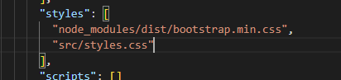

# Basics

* How does app gets loaded
  + Main.ts (looks at the bootstrap module which is appModule) 🡪 app.Module.ts (Check if the component is in the bootstrap array of components) 🡪 app.component.ts (check the selector, template, and style URL) 🡪 tie it back to index.html where it recognizes the selector <app-root>.
* Components
  + Root (App Component)
  + Reusable
* Creating a new component
  + Create a new folder under the app (app will be the root)
  + Add a component.ts file
  + Import the required dependencies
  + Add the HTML page
  + Import the module in the declarations under the App.Module.ts
  + Add the selector in app.component.html
* Creating components using CLI
  + ng g c Server2
  + HTML can be written inline or using an external template
  + use back tick for writing multi-line comment
* Component Selection
  + By HTML Tag: selector: 'app-server2', Usage: <app-server2></app-server2>
  + By attribute: selector: ‘[app-server2]’ Usage: <div app-server 2></div>
  + By class: selector: ‘.app-server2’, Usage: <div class=”app-server2”></div>
  + Selecting by ID does not work
* Data Binding
  + Communication between typescript and HTML

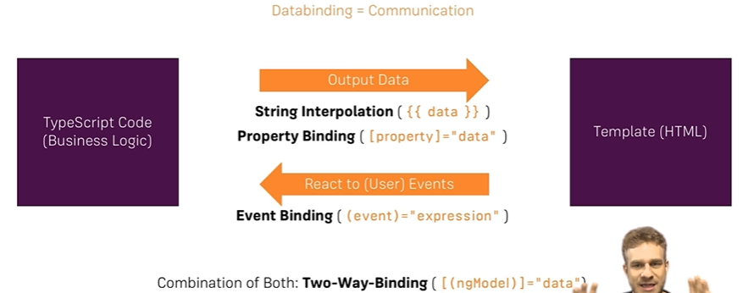

* + String interpolation {{propertyvalue}}
    - Can call a method within a string interpolation {{getStatus()}}
    - Has to resolve everything to string
  + Property Binding
    - Square bracket [disabled] = “allowNewServer”
* Directives
  + Instructions in the DOM
  + Components: Built in directives
  + ngIf: <p *ngIf=”isTrue()”></p>
  + else with if:

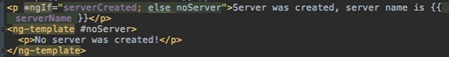

* ngFor:

<p *ngFor = “let server of servers”>

Server = temporary variable

Servers = variable in typescript

* Get the Index Name
  + <p *ngFor = “let server of servers; let i=index”>

# Project

* Planning the App

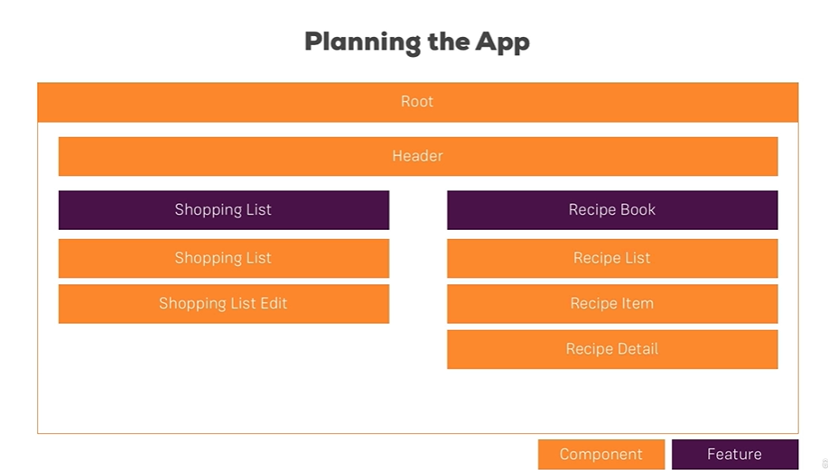

App (Header, Recipes, Shopping List)

Recipes 🡪 Recipe List, Recipe Detail

Shopping List 🡪 Shopping Edit

