for almost 30 years, ICM has been designing and manufacturing special assembly machines and parts distribution systems (vibrating bowls, centrifugals, etc.) and puts its expertise at the service of your productivity.
The know-how of a team of highly qualified engineers and technicians makes ICM the privileged interlocutor for the pharmaceutical and medical, cosmetics and perfumery industrial sectors.
With an interdisciplinary team, specialists in the fields of mechanics, electronics, hydraulics, pneumatics and automation, ICM offers you turnkey assembly, handling and distribution systems.
To view our recent achievements or see our news, visit our Youtube channel or our Linkedin account.
ICM news
- ICM Integrator IV3 KeyenceJuly 3, 2023
- ICM is recruiting: 1 experienced designer/mechanical designer (F/M)March 30, 2022
See more articles
Experts in the production of high-speed assembly and distribution systems
Our product range includes automatic rotary indexing or continuous kinematics machines with a throughput of up to 400 pieces/minute as well as semi-automatic assembly machines and manual workstations.
Seamlessly integrated machine vision systems
Thanks to the ICM in-house vision laboratory, we define the vision solutions that are perfectly tailored to your needs while ensuring their robustness.

Design and manufacture of special-purpose machines
For almost 30 years, ICM is established as a leading manufacturer of special machines for assembly and control and is your qualified partner for individual automation solutions.
ICM, manufacturer of special machines and feeding systems
With our skills in industrial design solutions, our engineers develop efficient solutions for your company seeking to industrialize a product or to obtain productivity gains.
The quality standards of ICM offer all guarantees of a true partnership. In addition to providing efficient service tailored to the specific requirements of your company, we strive every day to our goal of excellence of our products and services.
Overall support for industrials
The control of the entire production chain, from the design to the production of the final machine, allows ICM to develop a tailored service and a competitive, reliable offer.
Our long-standing customers emphasize quality and a fully integrated solution for their assembly processes, from component’s feeding to quality control and blistering.
Design by our integrated design department
As part of the elaboration of the detailed ICM concept and quoting, our experienced and dedicated staff analyzes your assembly and feeding processes. Together with you, we subsequently develop the most efficient manufacturing processes for your product. Depending on your requirements, in addition to feeding and assembly processes, we can integrate advanced measurement and control technologies, such as leak and pressure testing or machine vision systems.
At ICM each process is developed in every detail. It includes a meaningful pre-calculation and guarantees the feasibility of your project. This applies to new developments as well as to the optimization of existing production equipment, such as extensions, modifications of a machine (e.g. OKU retrofit) or improvement of its output.
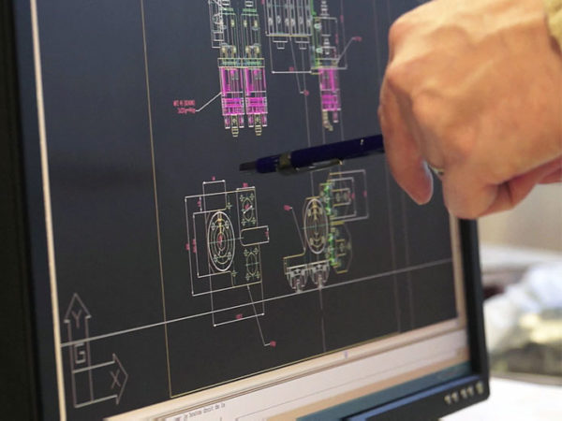
Manufacturing of high-speed special-purpose machines
ICM is your partner for the design and manufacture of assembly and testing machines, fully automated, semi-automatic or as a manual workstation. Our automation solutions are entirely developed on the basis of your specifications while being technically and economically optimized.
With a lot of know-how, passion and attention to detail, each of our special machines is unique. But despite their individuality, they have one thing in common: They offer high output on a small footprint, optimum ease of operation, easy retooling and precise, reliable and low-maintenance operation.

Special assembly machines
ICM designs and manufactures custom-made, fully automated, semi-automatic or manual workstation assembly and control machines.
Design of special tailor-made machines for industry
Our machines and systems are developed entirely according to your specifications in a search for technical and economic optimization.
Throughout the entire process, from the design by our design office to the installation of the machine in your production premises, ICM offers professional and customer-oriented project management.
For the creation of our automation concept, our teams will analyze your feeding and assembly processes. Then, we work with you to develop the most efficient manufacturing process for your product. Depending on your requirements, we integrate in addition to assembly, parts distribution processes as well as measurement and inspection technologies, such as visual inspections, leak or pressure tests.
ICM offers you a complete range of machines, integrating different technologies to perfectly meet your needs.
Indexed Turntable Assembly Machine
The base of our machine is a mechanical carousel (indexer) with ICM patented pick & place units that allow for simplified transmission. Our indexed machines are designed with cams, electromechanical or pneumatic servo control.
In order to meet your needs, our solutions are composed of 2 to 32 workstations, and can have up to six channels. With a throughput of up to 100 cycles per minute, our machines assemble up to 200 parts/minute. However, the goal of ICM's machine design remains a compact, robust and easy-to-use design.
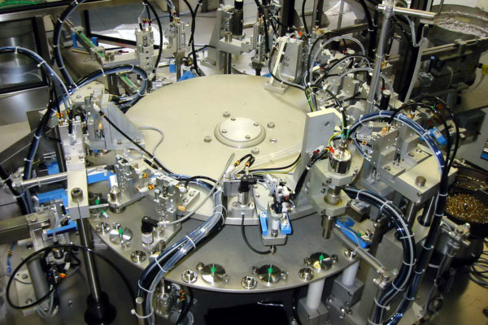
Indexed Turntable Assembly Machine
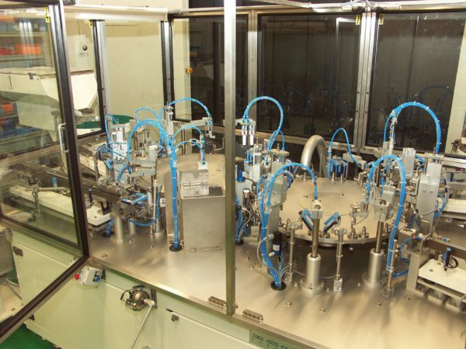
Assembly and control
Continuous kinematics assembly machine
With barrels with between 6 and 36 spindles and in conjunction with other satellite or vision stations, even complex assembly and control processes can be carried out, with a throughput of up to 500 parts/min. The fully mechanical movements guarantee a high degree of strength and durability.
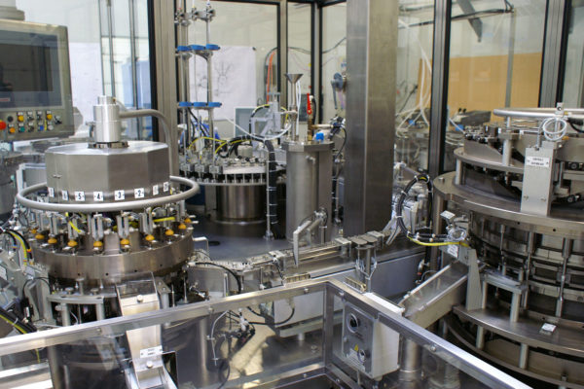
Continuous kinematics assembly machine
Linear Transfer Assembly Machine
We manufacture machines with free or indexed transfer, cam or electric movement.
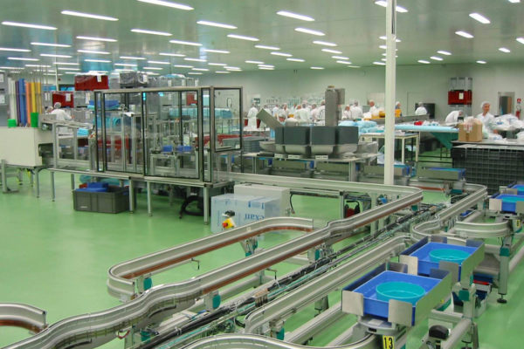
Machine spéciale à transfert linéaire
Machine d’assemblage semi-automatique
Lorsque la géométrie, la taille ou le poids des composants ne permettent pas une alimentation automatique ou que cela n’est pas économiquement intéressant, ICM propose également des machines d’assemblage semi-automatique. En positionnant les pièces les plus difficiles dans le porte-pièce du carrousel par un opérateur, l’assemblage automatique qui suit est intégralement assuré.
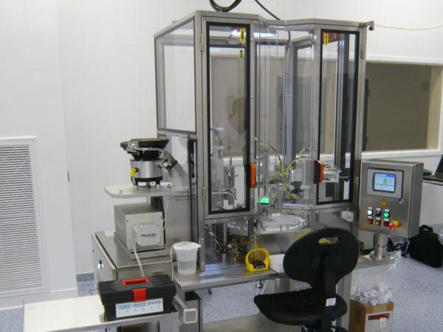
Assemblage semi-automatique
Postes de travail manuels
Dans le cas où des petites séries sont à assembler avec des paramètres d’assemblage maitrisés et contrôlés, nous proposons également des postes d’assemblage manuel. En fonction de vos besoins, nous pouvons y intégrer des contrôles de qualité tel que des systèmes de vision industrielle.
Poste d'assemblage manuel
Aperçu de notre offre de techniques complémentaires
ICM vous offre un large éventail de fonctions pour adapter la machine d’assemblage entièrement à la finition du produit souhaitée.
- Vissage, collage, rivetage, encliquetage, emmanchement, clipsage, perçage
- Soudure (ultrason, induction, thermique)
- Etiquetage, marquage (laser, micro-percussion, jet d’encre)
- Dosage et remplissage
- Contrôle (étanchéité et débit, dimensionnel, aspects et intégrités, pesée, effort, couple, électrique, pression, dosage)
- Supervision, Archivage de données, génération de rapport automatique
- Lubrification (graisse, huile, silicone)
- Distribution (par bol vibrant, bol centrifuge, rail vibrant, rail fluidique, trémies, élévateur à plaques)
- Robotics
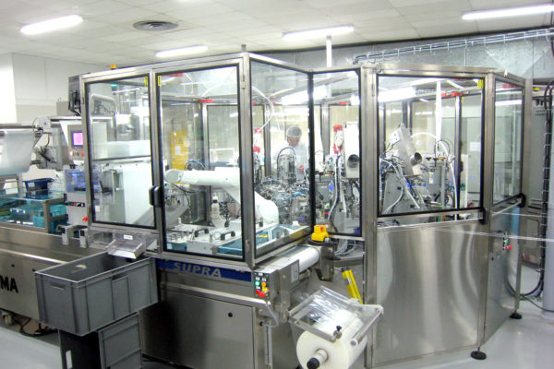
Automatic cleanroom assembly
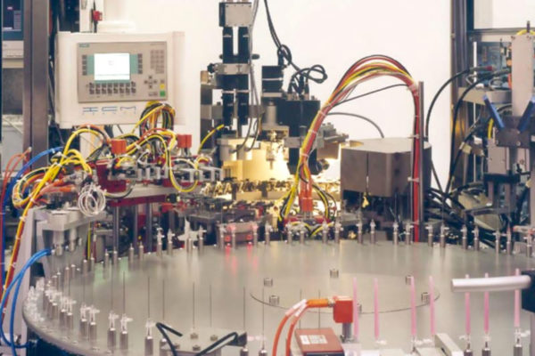
Needle assembly
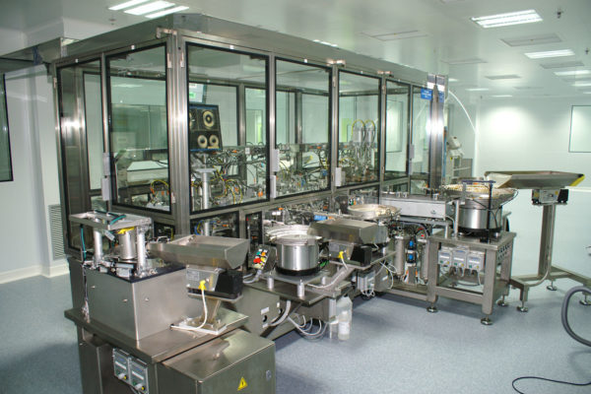
Cleanroom Assembly Machine
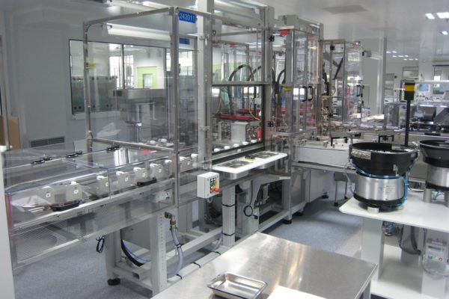
Linear Transfer Assembly Machine

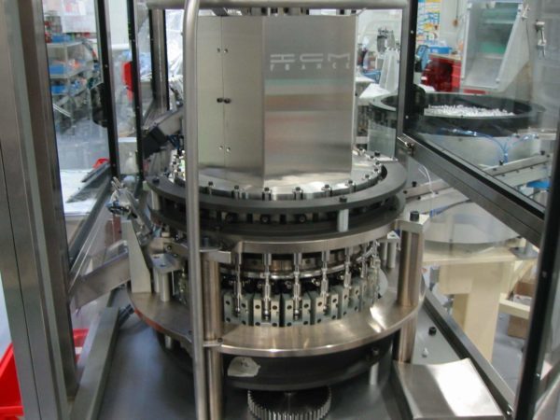
Commissioning and training
Our team installs and starts up your ICM assembly machine and / or feeding systems in your production facilities. In addition to the delivery of complete technical files, we train your operators and your maintenance team on site to ensure proper operation of the machine. Apart from this initial installation, we offer you the option to integrate a remote maintenance module or a preventive maintenance contract for your equipment.
Since the inception of ICM we have realized more than 600 special-purpose machines and feeding systems, in France, in Europe and worldwide.
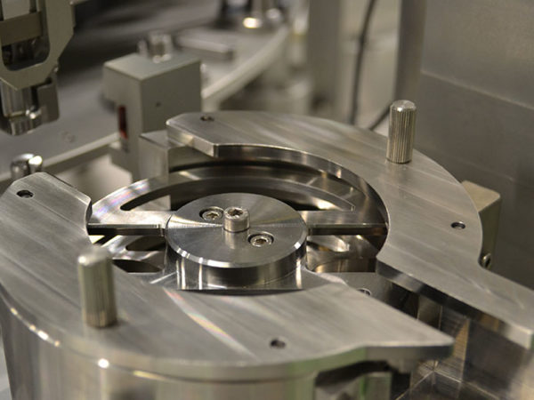
Assembly machines for many industries
Assembly & control systems for the cosmetics and perfumery sector
ICM provides assembly and control systems for the major companies in the cosmetics and perfumery industry. We design, for example, special machines and feeding technology for spray heads, pumps, lipstick mechanisms, mascara brushes, plugs, closures and aerosol valves with outputs between 1-10 parts per second.
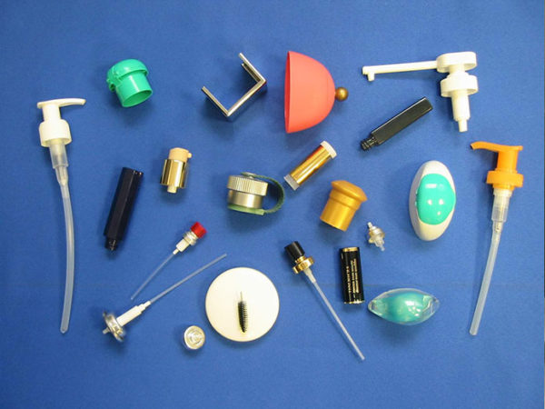
Production equipment for the pharmaceutical and medical sector
ICM offers high-performance production equipment for the assembly and feeding of complex products under clean room conditions. ICM’s solutions combine performance and flexibility while delivering high profitability. Our machines are designed to operate in a clean room (class 10 000 / ISO 7), but we can also offer equipment that meet even more stringent requirements for clean air. The products to be assembled are, for example, aerosol valves, sprays, injector pens, syringes, needles, catheters, etc.
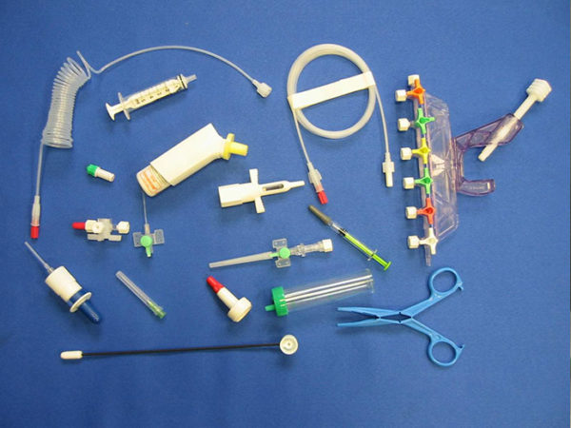

Distribution systems
Distribution systems
ICM designs and manufactures its own medium and high speed distribution systems. Our know-how gives us complete control over the feeding of our automatic assembly machines.
Automatic feeding system manufacturing
The precise and reliable distribution of components is the basis for efficient and cost-effective automation of assembly lines and is therefore indispensable. The functions of storage, sorting, orientation, allocation, positioning and input must be carried out quickly, safely and without damaging the product. We adapt our systems to the complexity of the component distribution method and to your specific requirements (e.g. cleanroom or sterile use for the medical industries) while offering you expert and personal advice. Our solutions guarantee perfect integration while optimizing equipment reliability and manufacturing costs. ICM is a distributor of Brovind products.
Range of distribution systems
- High-speed vibrating bowl with vibration control
- Centrifugal Bowl
- Vibrating rails, fluidic rail and conveyor
- Vibrating hopper and lifting hopper
- Plate elevator
- Self-Adapting Frequency Control Box
- Peripherals ...
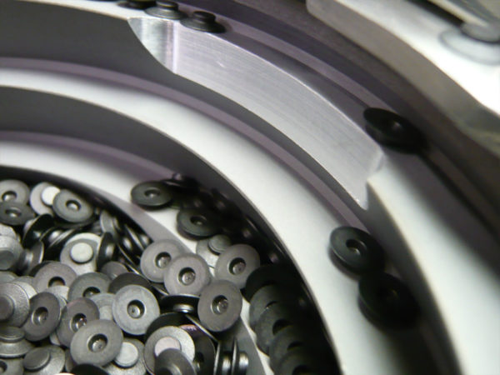
Vibrating bowl
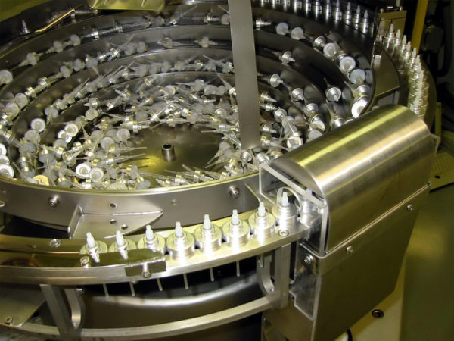
Vibrating bowl at 600 pieces/min
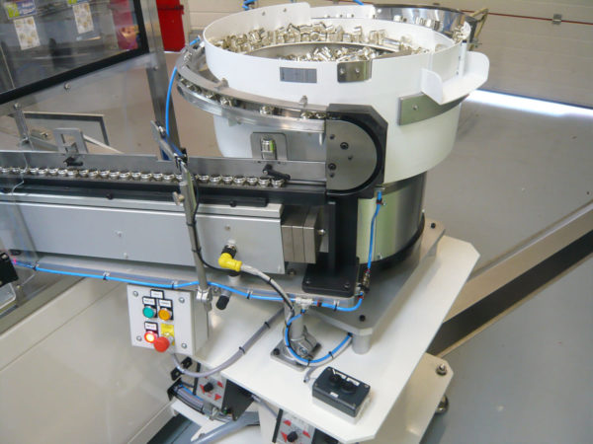
Vibrating bowl with rail
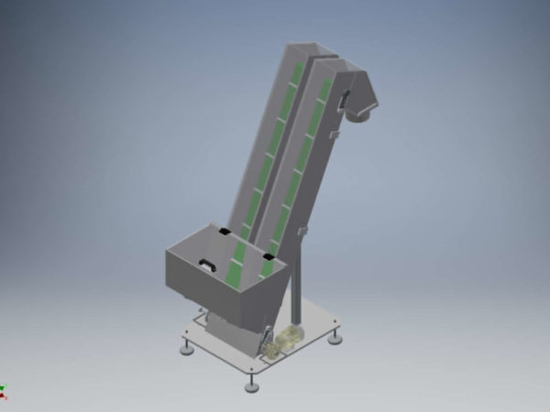
Double hopper 120l
Vibrating bowl
The vibratory bowl allows the assembly stations to be fed automatically. This distribution system brings and directs more or less bulky parts, stored in bulk, to another workstation such as an assembly, control or packaging machine. Composed of four main parts: the base, the tank, springs and one or more coils, a vibratory bowl is generally placed under a storage hopper that allows autonomous operation between two supplies. The tanks of our vibrating bowls can be made of stainless steel or polyamide and can be coated with different coatings (Rilsan, Nuflon, epoxy, microblasted, polyurethane, neoprene, etc.), chosen according to the material of the part. ICM offers a wide range of tanks from 80 to 1100 mm in diameter.
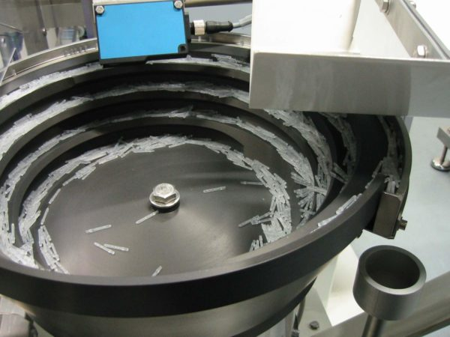
Vibrating bowl with machined polyamide tank
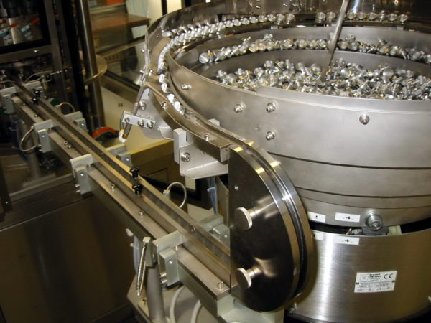
Vibrating bowl with stepped tanks
Vibratory bowl conical tank with conveyor
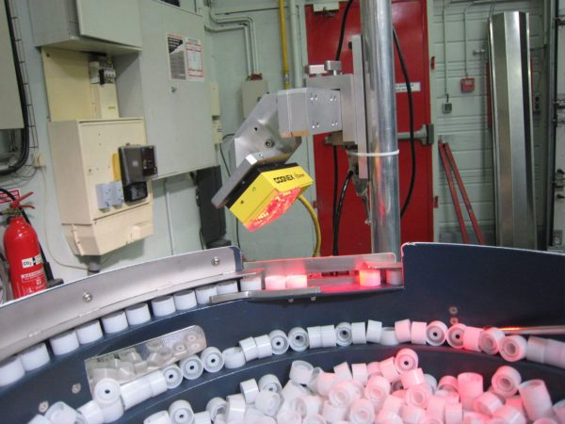
Vibrating bowl with machine vision selection
Centrifugal Bowl
The centrifugal bowl is a distribution system that allows a high-speed supply (up to 1000 pieces/min) to subsequent workstations such as assembly, control or packaging machines. Silent and vibration-free, our centrifugal bowls are particularly designed to dispense and orient fragile and light parts made of plastic, rubber or metal. Our bowls are entirely custom-made by our technicians to best meet your needs (speed, type of part, infinitely adjustable, diameter, etc.)
Centrifugal bowl with machine vision selection
Centrifugal Bowl Tube Dispensing with Vision Orientation
Centrifugal Bowl Dispensing Caps
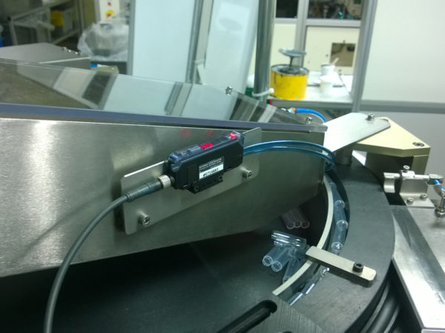
Centrifugal bowl for decorative bottles
Vibrating rail
ICM offers a wide range of linear conveyor devices to transport parts from the bowls to the assembly machine. Our range is made up of vibrating rails, fluidic rails and (belt) conveyors, in different lengths, to adapt to the properties of the part and your needs. While maintaining the orientation of the components, the linear conveyors also provide buffer storage upstream of the special machine to ensure a smooth industrial process.
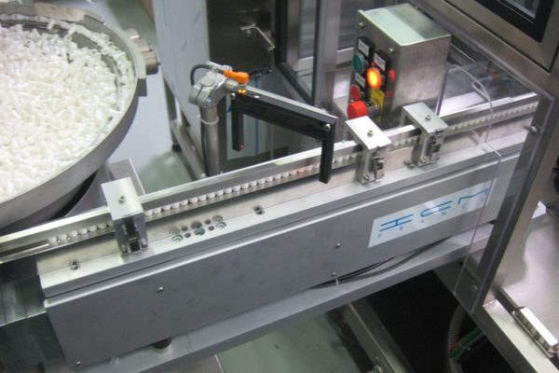
Vibrating Feed Rail
Trémie vibrante
Une trémie vibrante est utilisée en général en amont d’un bol vibrant ou centrifuge afin de l’alimenter et ainsi augmenter son autonomie.
Les trémies ICM sont proposées avec plusieurs volumes de cuve de stockage standard (5, 10, 15, 30, 50, 70 et 100l), mais notre bureau d’études peut vous proposer la conception de trémies sur-mesure.
Nos trémies sont fabriquées en inox et peuvent, en fonction de vos besoins, être livrées avec différents revêtements. ICM vous propose également l’option d’intégrer de pieds fixes ou mobiles (rotation, élévation) afin de faciliter le remplissage des trémies.
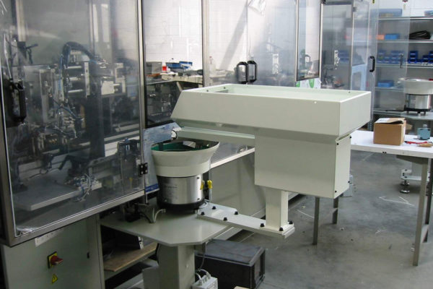
Trémie vibrante
Trémie élévatrice
Tout comme notre trémie vibrante, la trémie élévatrice permet d’alimenter un bol en pièces afin d’augmenter son autonomie, cela avec une hauteur de chargement inférieure à 1100mm afin d’assurer une ergonomie maximale pour vos opérateurs.
ICM vous propose 2 types de trémies élévatrice: simple ou double. Cette dernière permettant d’alimenter deux distributions avec un même composants à partir d’une seule trémie.
Chacune de nos trémies peut être équipée d’une auge d’un volume variable allant de 120l à 250l. Le volume de la cuve est déterminé non seulement par rapport à l’autonomie recherché mais aussi dans un souci de limiter l’endommagement des pièces.
Notre bureau d’études personnalisera votre trémie en plus par rapport à la hauteur de la trémie ou le matériau de la bande (agrée FDA, contact alimentaire, …).
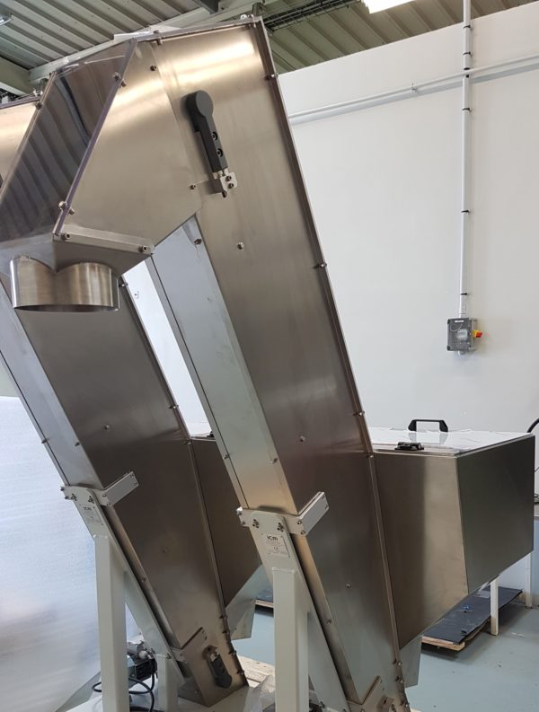
Trémie élévatrice
Intégration de robots industriels & de vision industrielle
Integrating the latest technologies, ICM also carries out dispensing by combining vibrating bowls with machine vision and/or robots (4 or 6 axes, static or tracking).
Example of an application where components are presented to a camera, which informs the robot of their position, thus allowing them to be picked up and then distributed.
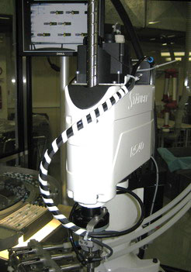
Vibrating bowl with robot and vision
Need a distribution system? We are at your disposal!

Machine Vision
Machine Vision
ICM integrates machine vision systems into its automation solutions. The perfect knowledge of the technologies developed by the various manufacturers and their compatibility are decisive elements in the efficiency and reliability of our machines and distribution systems.
Compliance and quality control of the assembled product
The integration of one or more vision systems makes it possible to set up automatic controls for the distribution and production of parts, guaranteeing the accuracy, repeatability and traceability of the control. The vision software analyzes the captured images, makes a decision on what action to take (e.g., ejecting a wrong part,...) and transmits this information to other equipment. By detecting possible mispositions or defects in parts at an early stage of assembly, machine vision optimizes the profitability of production equipment.
Finally, vision systems are frequently used for quality control of the final product.
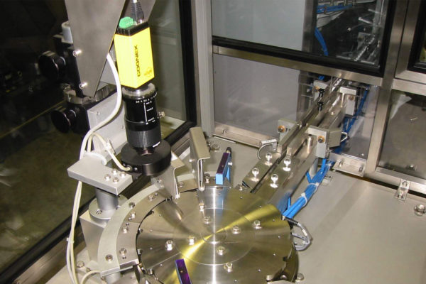
"On-the-fly" vision control 250 pieces/min
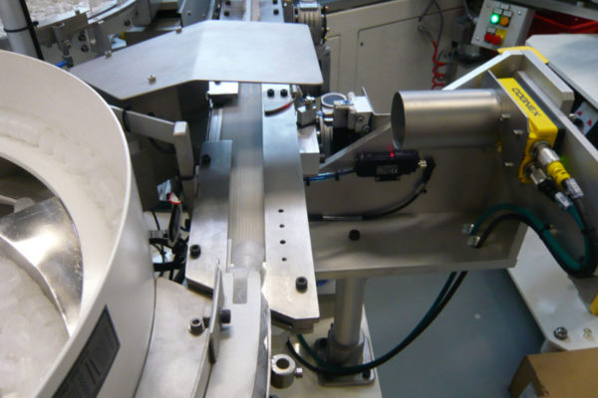
Distribution with Vision Selection
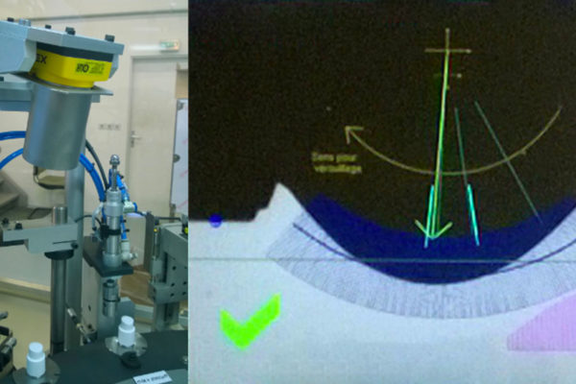
Angular positioning control on indexed platen, 3600 pieces/h
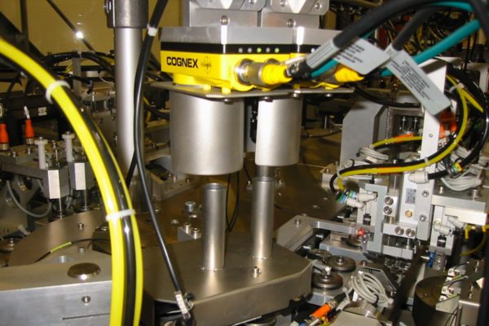
Vision Control
ICM integrator Cognex, Keyence & all brands
ICM has a complete vision laboratory that allows us to carry out in-house the feasibility and capabilities of the controls in order to define vision systems that are perfectly suited to your needs (black and white, color, low and high resolution, matrix and linear). This is how we ensure the robustness of the solutions installed.
For example, we can carry out the following checks:
- Compliance control (size, presence, etc.)
- Sorting of parts
- Marking or color recognition
- Searching for moving products for a tracking robot
Our engineers and technicians mainly integrate Cognex and Keyence equipment, but depending on your specifications, we can install other brands of equipment without any problems.
Need a machine vision system? We are at your disposal!

> FlexiBowl FR
FlexiBowl
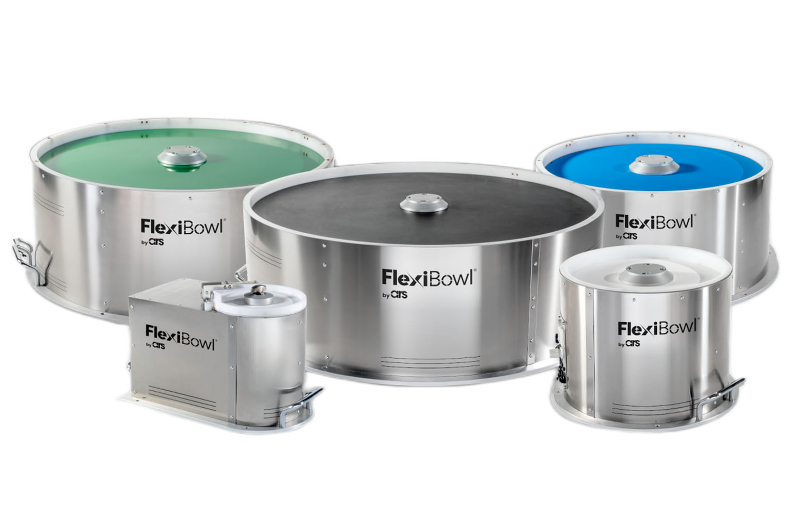
A single power solution for several different rooms
Page under construction!
More details?
Website
Need a FlexiBowl? We are at your disposal!

ndustrial Robotics
Industrial robotics applied to special machines
ICM integrates industrial robotics systems into its automation solutions and is your ideal partner for your robot integration project.
Assembly, distribution and packaging robot
Thanks to the dual skills of our design office in mechanics and automation, equipped with 3D design equipment, PLC programming, robots and numerical controls, we offer you turnkey robotics solutions. Our service includes programming, the implementation of robotic means, but also the design of gripping hands (pneumatic gripper, vacuum nozzle, etc.), vision systems and the implementation of different types of sensors (presence detection, force sensor, etc.).
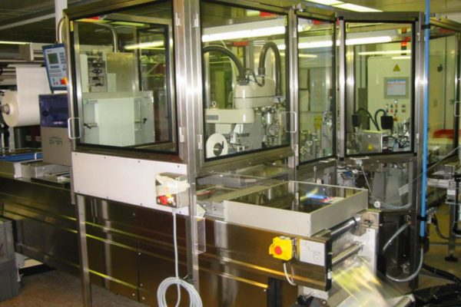
Packaging robot
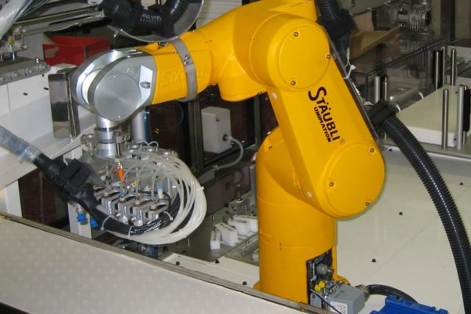
Tracking and vision of bulk parts
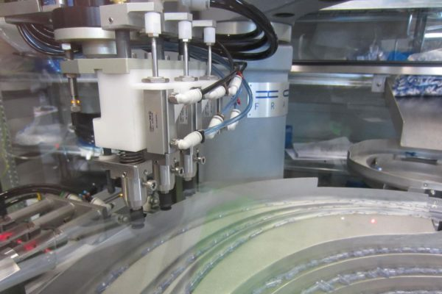
Robot hand
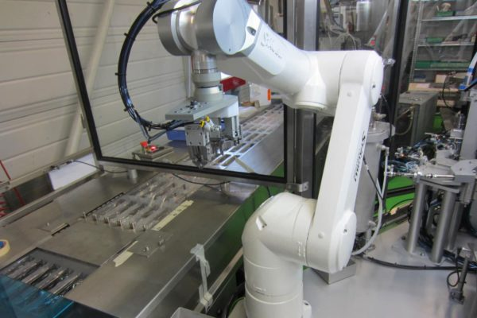
Unloading machine and blister packing
The integration of one or more robots brings you competitive advantages such as increased productivity, improved quality of the final product through the reliability and repeatability of movements, but also the simplification of strenuous tasks for your operators.
Integration of scara, Cartesian, 6-axis and all brands robots
The possibilities of industrial robotics range from the programming of simple linear movements to the implementation of multi-axis manipulation to the integration of complex robotics and gripping technology. Whether they are scara, Cartesian or 6-axis, we can program and integrate all types and brands of robots (Stäubli, Epson, Fanuc, Kuka, Universal Robot, ...) into our special machines, according to your specifications and/or your preferences.
The areas of application are, for example:
- Loading and unloading
- Mounting
- Presentation of parts for verification / control
- Pick and place with tracking system
- End-of-line packaging (blister deposit, PTF, etc.)
Just like our special machines, our robotics solutions are aimed at all our core business areas: pharmaceuticals and medical, cosmetics and perfumery as well as electromechanics and connectors.

> Automation
Automation
ICM's engineers and technicians not only have many years of experience, but also know-how that is regularly enriched by training in the latest technologies.
Integration of automation systems for all brands
In order to guarantee you the optimization of your productivity, we work with the largest manufacturers of programmable logic controllers and supervision. Depending on your needs, those of your maintenance department or your operators, our design office can integrate any type of PLC into our special machines. We work with brands such as Siemens, Schneider, Allen Bradley and Omron, but our automation engineers have the expertise to program the PLC and supervision of your choice.
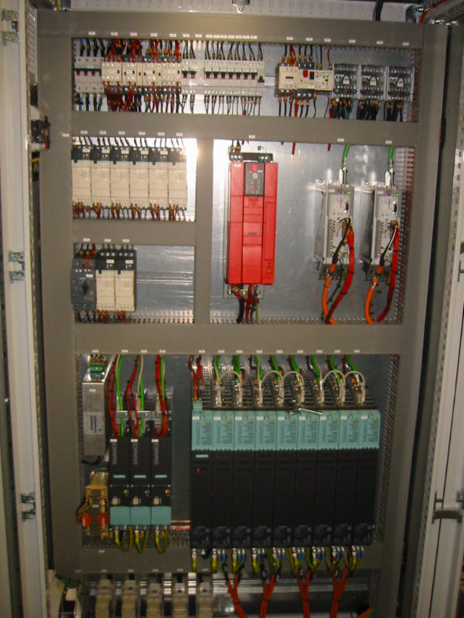
Integration of remote maintenance module
As an option, ICM offers you the integration of a remote maintenance module to be able to access our machines, cameras and PLCs from anywhere in the world. In this way, we can change and adjust operating parameters if necessary remotely and support your maintenance department in a very responsive way.
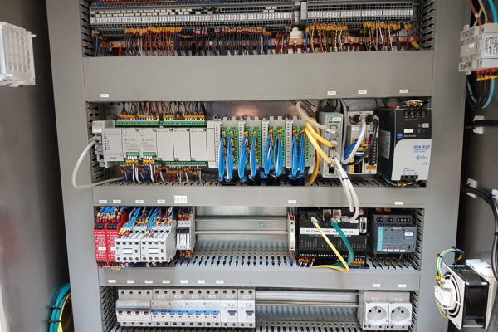

Specific positions
Specific positions
At ICM, we know that your production needs are not limited to complex machines.
In the life of a product, during its development, functional or clinical tests, at the beginning of production, or during various developments after its entry into production, specific needs may arise and require appropriate responses.
In this case, you can count on our teams to be at your side to define, design and build the position that best suits your needs.
As an example, we present you with some typical projects on which we can support you. However, the range of possibilities goes far beyond these few examples, so please contact us so that together we can find an individual solution to your needs.
Creation of a test station or assembly assistance
Manual or semi-automatic assembly station for:
- Test the principles of assembly before making a fully automated machine
- Carry out the first test productions
- Standardizing, optimizing and streamlining manual production
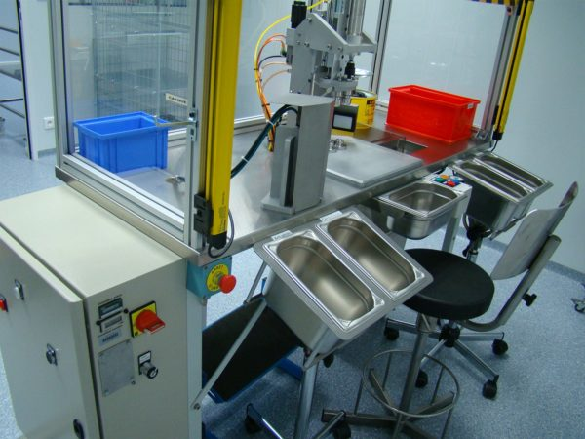
Assembly and control
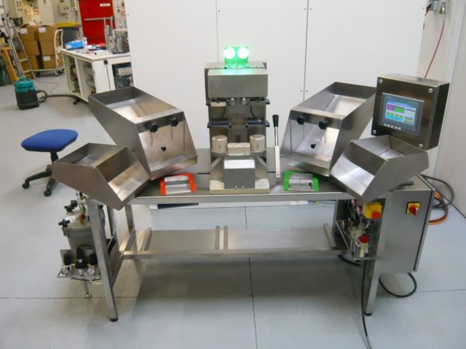
Siliconization, piston insertion and fluidic control station
Addition of a workstation on an existing automatic machine
With production requirements or changing variants of your product, it may be necessary to modify your existing assembly machine. Instead of a full investment in a new machine, we can offer you the addition of one (or more) workstation(s) to your existing machine. This can be, for example:
- Addition of an automatic station for the removal of a new component (gasket, needle, etc.)
- Addition of an automatic control station (vision, tightness, fluidic, volume, dose control, etc.)
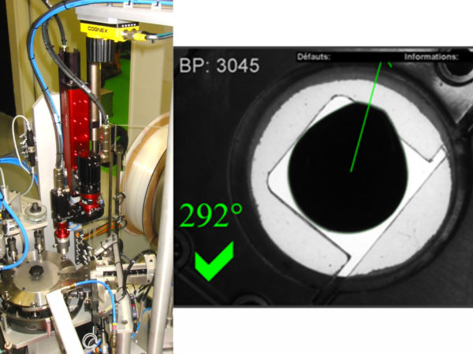
Electric pick & place with vision orientation
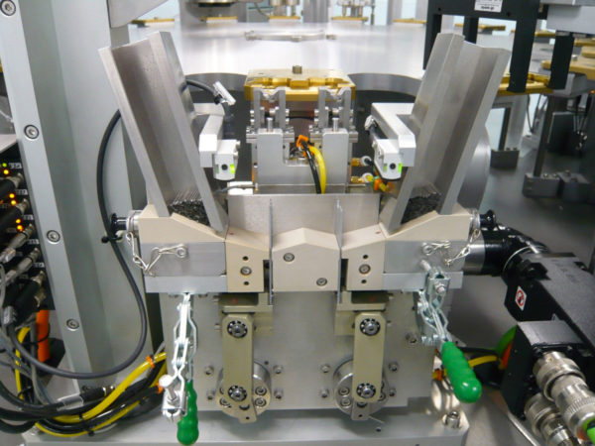
Dual-lane needle dispensing system
Control equipment
As part of the inspections to be carried out by the operators, we can also provide suitable tools to facilitate the inspections to be carried out.
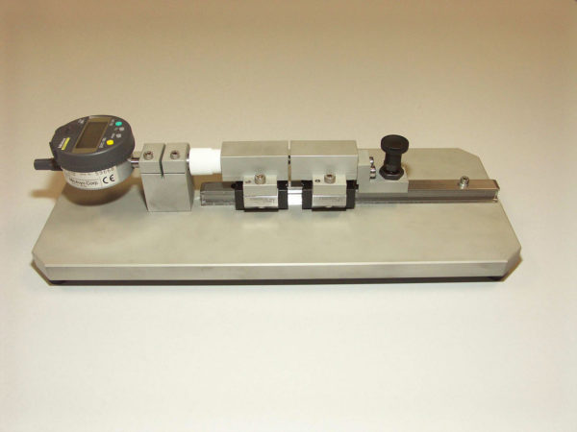
Probing tool
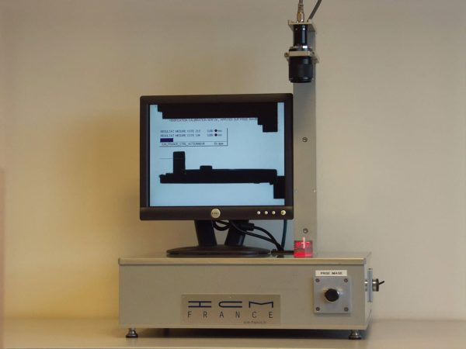
Vision control station

- Drilling & Tapping Machines

- Special Purpose Machines

- Leak Test Machines

- Assembly Line Automation

- Manufacturing of
Performance/Endurance/
Durability Test SPM.

