**CSA-STRATOS-RPT-0093**

**Canadian Space Agency**

|  |
| --- |
| **Stratos PRISM**  **StratoScience2018 Nimbus-5 Post-Launch Telemetry Data Analysis**    **Initial Release**  **February, 2019**  Title to and all rights of ownership in the Background Information are and shall remain the property of the Crown. All intellectual property rights to all Foreground Information shall, immediately upon its conception, development, reduction to practice or production, vest in and remain the property of the Crown. No Background or Foreground Information shall be disclosed in whole or in part without the prior written permission of the Crown. |

This Page Intentionally Left Almost Blank

**Approvals**

This document must be approved by the Project Manager. Any proposed changes to the baselined version of this document shall be issued to the Project Manager and the CSA Configuration Management Receipt Desk for evaluation and, if approved by the Program Configuration Control Board, incorporated into this document.

|  |  |  |  |
| --- | --- | --- | --- |
| Prepared by: |  |  |  |
|  | Jean-Francois Cusson  Senior Engineer – Software & Digital Electronics  CSA Space Science and Technology |  | Date |
| Reviewed by: |  |  |  |
|  | Claude Brunet  Manager (Electrical)  CSA Space Science and Technology |  | Date |
| Reviewed by: |  |  |  |
|  | James Lee  Engineer – Spacecraft Control Systems  CSA Space Science and Technology |  | Date |
| Approved by: |  |  |  |
|  | Steeve Montminy  Senior Systems Engineer  CSA Space Science and Technology |  | Date |

**Revision History**

This Page Intentionally Left Almost Blank

| **Rev.** | **Description** | **Date** |
| --- | --- | --- |
| Init | Initial | 2019-02-14 |
|  |  |  |
|  |  |  |
|  |  |  |
|  |  |  |
|  |  |  |

Table of Contents

This Page Intentionally Left Almost Blank

PAGE

CSA-STRATOS-RPT-0093 i

Canadian Space Agency i

**Stratos PRISM** i

**StratoScience2018 Nimbus-5 Post-Launch Telemetry Data Analysis** i

i

**Initial Release** i

**February, 2019** i

Approvals 3

Revision History 4

Table of Contents 6

LIST OF FIGURES 8

1 INTRODUCTION 10

1.1 Document Overview 10

1.1.1 Acronyms 10

1.1.2 Dictionary 11

1.1.3 Applicable Documents 11

1.1.4 Reference Documents 11

1.1.5 Convention 12

1.2 System Overview 12

1.3 Flight Chronology 13

1.4 DATA FILES 14

2 Data Source Specifications 15

2.1 Overview 15

2.2 Sensors Specifications 17

2.2.1 GPS1 17

2.2.2 GPS2 17

2.2.3 GPS3 18

2.2.4 CAM1 & CAM2 18

2.2.5 SHOCK1 18

2.2.6 ACC1 19

2.2.7 ACC2 19

2.2.8 ACC3 20

2.2.9 AD1 20

2.2.10 HUMID1 20

2.2.11 PRESS1 21

2.2.12 PRESS2 21

2.2.13 PRESS3 22

2.2.14 TEMP1 22

2.2.15 TEMP2 22

2.2.16 MAG1 23

2.2.17 MAG2 23

2.2.18 MAG3 23

2.2.19 GYRO1 24

2.2.20 GYRO2 24

2.2.21 GYRO3 24

3 Command and Data Handling subSystem 26

3.1 Introduction 26

3.2 Data Location 26

3.3 Housekeeping Data 26

3.4 Localisation Data 28

3.5 Imaging 32

3.5.1 Imaging Parameters Changes 32

3.5.2 Images 33

4 Navigation and Environment Monitoring Sub-SystemS 36

4.1 Introduction 36

4.2 Data Location 36

4.3 Housekeeping Data 36

4.4 Navigation Software Telemetry 39

4.4.1 Localisation Data 39

4.4.2 ATTITUDE DATA 40

4.4.3 Kinematics, Dynamics, and Environment Data 45

4.4.4 Sun Vector 48

4.5 Environment Monitoring Software Telemetry 52

4.5.1 Temperature / Pressure / Humidity 52

5 Magnetometer measurements 56

5.1 Introduction 56

5.2 Magnetometer (MAG1) Data from 3DM-GX5-45 IMU 56

5.3 magnetometer (MAG2) data from LSM9DS1 IMU 57

5.4 MPU9250 magnetometer data 59

6 I/O Controller Sub-System 61

6.1 Introduction 61

6.2 Data Location 61

6.3 Onboard Power Monitoring Data 61

LIST OF FIGURES

**Figure 1: French space agency (CNES) high-altitude balloon system diagram** 13

Figure 2 : Nimbus-5 Flight Profile (CNES data set) 14

Figure 3: C&DH Main Loop Delay - random time range in-flight 27

Figure 4: C&DH Free Memory (MB) - Full Duration 27

Figure 5: C&DH CPU Temperature Celsius - Full Duration 28

Figure 6: GPS01: Gondola Altitude (meters) – Full Duration 29

Figure 7: GPS01 - Gondola Altitude Variations at Sunrise (30 minutes time range) 29

Figure 8: GPS01: Gondola Longitude - Full Duration 30

Figure 9 : Gondola Latitude - Full Duration 30

Figure 10: GPS01: Nb Satellites Used in Solution - Full Duration 31

Figure 11: GPS01: Horizontal Dilution of Precision (hdop) - Full Duration 31

Figure 12: CAM1 (NADIR Pointing) Image Example 34

Figure 13: CAM2 (Horizon Pointing) Image Example 35

Figure 14: NAVEM CPU Usage - Full Duration 37

Figure 15: NAVEM Computer Free Memory (MB) - Full Duration 37

Figure 16: NAVEM CPU Temperature (C) – Full Duration 38

Figure 17: Gondola Position, as Reported by SWNAV - Full Duration 39

Figure 18 Gondola in Preparation for Flight 40

Figure 19 Gondola Coordinate Frame 41

Figure 20: NAVEM: Gondola True Heading Estimate – Whole Flight Period 42

Figure 20: NAVEM: Gondola True Heading Estimate & Altitude – Ascending Period 42

Figure 22: NAVEM: Gondola True Heading Estimate & Altitude – Post-Ascending Period 43

Figure 23: SWNAV: Gondola Roll & Pitch Estimates and Filter State - Full Duration 44

Figure 24: SWNAV: Gondola Roll & Pitch – Zoomed-in around Sunrise 45

Figure 25: SWNAV: Estimated Gondola NED Velocity and Validity Flag 46

Figure 26: SWNAV: Gondola NED Velocity – Zoomed-in around the Sunrise 46

Figure 27: SWNAV: Gondola Angular Rates X-Y-Z deg/s - Full Duration 47

Figure 28: SWNAV: Gondola Linear Acceleration X-Y-Z - Full Duration 48

Figure 29: View of the horizon at 10:03:24 49

Figure 30: View of the horizon at 10:06:16 49

Figure 31: View of the horizon at 10:08:26 50

Figure 32: View of the horizon at 10:10:56 50

Figure 33: SWNAV: Sun Elevation for Observer at sea level - Full Duration 51

Figure 34: SWEM Temperature Monitoring – Full Duration 52

Figure 35: SWEM Relative Humidity Monitoring - Full Duration 53

Figure 36: SWEM: Barometric Pressure (hPa) – 30 minutes at sunrise 54

Figure 37 MAG1 Measured Magnetic Field and WMM Computed Magnetic Field Magnitude 57

Figure 38 MAG2 Measured Magnetic Field 58

Figure 39: IOCTL: DCDC Converters Voltage Output Monitoring - Full Duration 61

# INTRODUCTION

**NOTE: Each section of text in this document contains an English and French text.**

**N.B: Chaque section de texte dans ce document contient le texte en anglais et en français.**

## Document Overview

The StratosScience2018 campaign took place in Timmins (Ontario, Canada) in August 2018. The PRISM, a CSA built system destined to support stratospheric balloon science payloads, was installed on a CARMEN (CNES) gondola for the Nimbus-5 flight. This flight was launched at 23:20 (local time) on August 26th, and lasted a little more than 11 hours (landing at 10:37, on August 27th). The goal of the mission was to launch hardware at altitudes of around 37 kilometres, test various functionality, and observe the different data that was captured throughout the flight. This document shows and examines the telemetry data obtained from the different sub-systems during the mission. The data acquired will be presented and analyzed in this document.

La campagne StratoScience2018 fut tenue au mois d’août 2018, à partir de la base de Timmins (Ontario, Canada). Le PRISM, un système bâtit par l’ASC et destiné au support de charges utiles scientifiques à bord de ballons stratosphériques, fut installé sur la nacelle CARMEN (CNES) pour le vol Nimbus-5. Ce vol décolla à 23 :20 (heure locale) le 26 août et dura un peu plus de 11 heures (atterrissage à 10 :37, le 27 août). L’objectif de la mission était de lancer des appareils à 37'000 kilomètres en altitude pour tester diverses fonctionnalités et collecter des données. Plusieurs appareils d’enregistrements ont été utilisés afin de collecter les données télémétriques (exemple : appareil GPS, camera, etc.) Les informations obtenues durant la mission vont être présentées et analysées dans ce document.

### Acronyms

The following acronyms are used throughout this document:

|  |  |
| --- | --- |
| ASC | Agence Spatiale Canadienne |
| CNES | Centre National d’Études Spatiales (France) |
| COTS | Commercial Off the Shelf |
| CSA | Canadian Space Agency |
| GPS | Global Positioning System |
| PRISM | Payload Remote Interface, Sensor suite and Mass memory |
| RTC | Real Time Clock |
| SI | International System of Units |
| UTC | Universal Time Coordinates |

### Dictionary

|  |  |
| --- | --- |
| CARMEN | CNES stratospheric balloon gondola |
| UBlox | A GPS used during the flight to collect and record data. |
| Novatel | A GPS used during the flight to collect and record data. |

### Applicable Documents

|  |  |  |  |  |
| --- | --- | --- | --- | --- |
| AD No. | Document No. | Document Title | Rev. No. | Date |
|  | TN2018-02-PRISM | Stratos PRISM TM/TC Interface Specifications – StratoScience 2018 Campaign | 2 | Jan 2019 |
|  | TN2018-03-PRISM | Stratos PRISM Telemetry Definition – StratoScience 2018 Campaign | 2 | Jan 2019 |

### Reference Documents

|  |  |  |  |  |
| --- | --- | --- | --- | --- |
| RD No. | Document No. | Document Title | Rev. No. | Date |
|  | 8400-0091 – LORD Microtrain | LORD Datasheet, 3DM®-GX5-45, GNSS-Aided Inertial Navigation System (GNSS/INS). | A | 2016 |
|  | D21050 - NovAtel | NovAtel Receivers OEM729 Specifications | 1 | Sept. 2016 |
|  | UBX-15031086 - UBLOX | NEO-8M uBlox M8 Concurrent GNSS Modules – Datasheet | 3 | August-05-2016 |
|  | ADXL372 – Analog Devices | ADXL372 Data Sheet | B | 2018 |
|  | 025715 - ST | LSM9DS1 Data Sheet | 3 | 2015 |
|  | PS-MPU-9250-A-01 | InvenSense MPU-9250 Product Specifications | 1.1 | 06/20/2016 |
|  | 19-0171-F – Digi International | Rabbit BL4S200 User Manual | F | 2013 |
|  | BST-BME280-DS001-10 | BME-280 Data Sheet | 1.1 | May 07, 2015 |
|  | DA5611-01BA01-006 – Measurements Specialities | MS5611-01BA01 Product Description | 6 | Jul 19, 2011 |
|  | DS25095A | MCP9808 Product Description | A | 08/02/11 |

### Convention

**Time:** Except when noted otherwise, time will be provided in UTC. Generally the “Z” prefix indicate a time in UTC. Local flight time (at Timmins, Ontario, in August) was UTC – 4h (e.g. 2018-08-26 03:20:01Z was 2018-08-25 23:20:01 local).

**Units:** Except when noted otherwise, all units will be provided in the International System of Units (SI).

Traduire

## System Overview

Stratospheric balloons are used to carry payloads in the upper atmosphere for scientific investigation and technology demonstration purposes. Many organizations have the capacity to launch balloons, each having different specific system characteristics. Figure 1 is an example of the French Space Agency’s (CNES) system, comprised of two parts: the envelope and the flight train. The envelope encompasses the balloon that provides lifting capability, and its associated gondola (NEV), which provides localization services during flight and recovery activities. The flight train is constituted of two gondolas, a parachute, aircraft anti-collision beacons and a twin-lead cable. The command and control gondola (NSO) provides communication services with ground during flight and localization services during flight and recovery activities. The scientific gondola (NCU) carries the payloads and can also provide, in some cases, pointing, power and communication services. The twin-lead cable serves as the mechanical link between these two gondolas providing torsional stiffness around the vertical direction. The aircraft anti-collision beacons are required safety components during flight and descent, and the parachute is equipped for a safe landing of the NCU and mounted payloads.

While some instruments being equipped with their own complete command and data handling capabilities, the vast majority of payloads would require the host gondola to provide them with complementary data services and data management to accomplish their missions, such as telemetry, telecommands, clock synchronization, time-stamping, localization, attitude and environment data, logging, mass storage, etc... The objective of CSA Stratos PRISM Subsystem, integrated into gondola as a generic data servicing system, is to provide such services as command & data handling, and attitude & heading reference for those Canadian clients flying their instruments aboard CSA gondolas that not being equipped with these functions.

Traduire

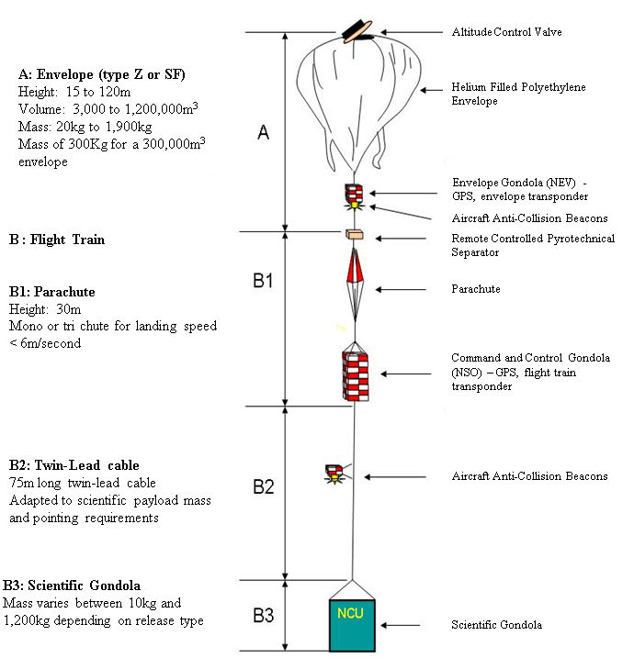

**Figure 1: French space agency (CNES) high-altitude balloon system diagram**

## Flight Chronology

The following list gives the major events for the Nimbus-5 flight of StratosScience2018. All times as shown below refer to UTC time (Timmins local time = UTC – 4).

La liste qui suit fournit la chronologie des évènements majeurs du vol Nimbus-5 de la campagne StratoScience2018. Notez que le temps est donné en UTC (Local Timmins = UTC – 4)

* 2018-08-26 **03:20:01**Z (23:20:01 local): Launch - Lancement
* 2018-08-26 **05:34:48**Z: Ceiling reached – Atteinte du plafond
* 2018-08-26 **10:07:00Z**: Sunrise – Levé du soleil
* 2018-08-26 **13:28:34**Z: Maximum altitude (36,862.6m – Reported by CNES) – Altitude Maximale atteinte
* 2018-08-26 **14:03:33**Z: Separation (start of descent under parachute – Début de la descente en parachute)
* 2018-08-26 **14:37:20**Z: Landing - Atterrissage

Flight duration: **11h17m20s**

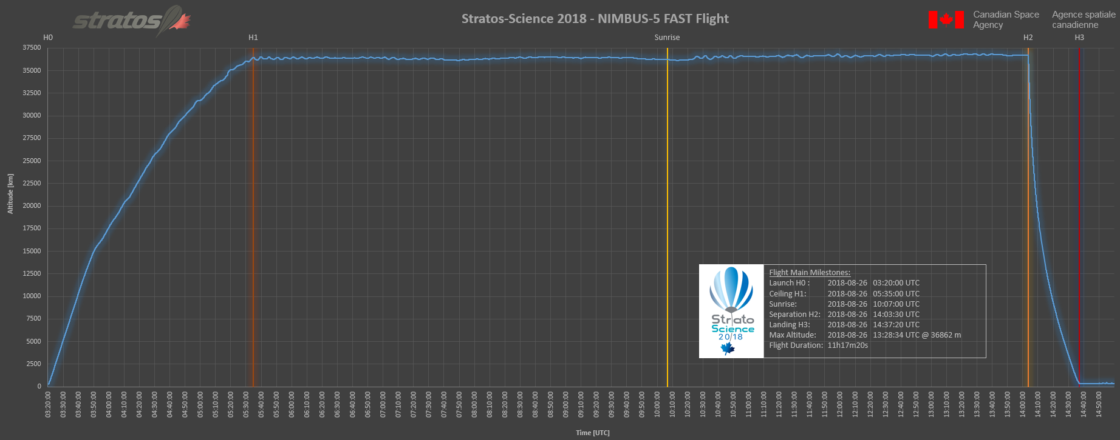

Figure 2 : Nimbus-5 Flight Profile (CNES data set)

## DATA FILES

The data recorded from each PRISM device were dumped into a dump file (CDH_tm_raw.txt) which was then sorted (CDH_tm_processed.txt) and separated into different processed output files. Each output file represents a single telemetry type. The original dump file has 212,253 telemetry entries. The processed output files were deposited into repositories corresponding to the sub-subsystem that generated them. An excel file was created and data was imported into individual tabs.

Note, a “sub-subsystem” refers to a subsystem within PRISM subsystem. Without causing confusion, a “sub-subsystem” will be abbreviated as “subsystem” in the rest of this document.

Les données obtenues durant la mission ont été enregistrées dans un fichier (CDH_tm_raw.txt) qui fut ensuite ordonné (CDH_tm_processed.txt), puis séparé en différents fichiers, un pour chaque type de télémétrie.

# Data Source Specifications

## Overview

The PRISM has three main processing units. Each processor acquires data from sensors, located either within the main enclosure of the PRISM, or installed in remote enclosures to be exposed to the environment outside of the gondola structure. Details are provided in the following list, and accompanying figure:

1. **MAIN**: The main flight computer, executing the CDH (Command and Data Handling) task. MAIN acquires data from:
   1. **GPS1**: A GPS receiver, providing position and time information.
   2. **CAM1** and **CAM2**: Two cameras, one pointing toward the ground (NADIR) and the other pointing to the horizon.
2. **NAVEM**: The processor in charge of providing navigation and environment data, executing:
   1. the AHRS (Attitude and Heading Reference System), which acquires data from:
      1. **GPS1:** The same GPS receiver as appears in MAIN above, providing the same position and timing information as to MAIN (for redundancy).
      2. **IMU1**: A high precision inertial navigation system that includes a GPS receiver (**GPS3**), a pressure sensor (**PRESS3**) a 3-axis magnetometer (**MAG1**), tri-axial accelerometers (**ACC1**) and tri-axial gyroscopes (**GYRO1**).
      3. **IMU2**: A backup inertial navigation system that includes a GPS receiver (**GPS2**), a pressure sensor (**PRESS2**), two 3-axis magnetometers (**MAG2** and **MAG3**), accelerometers (**ACC2** and **ACC3**) and gyroscopes (**GYRO2** and **GYRO3**).
   2. the ENV (Environment Monitoring) tasks, which acquires data from:
      1. An internal (to the PRISM enclosure) temperature sensor (**TEMP2**).
      2. A high G shock sensor (**SHOCK1**).
      3. An integrated HPT (Humidity/Pressure/Temperature) module, providing ambient humidity (**HUMID1**), pressure (**PRESS1**) and temperature (**TEMP1**) information, which is mounted inside a small protective enclosure located outside the gondola envelop so to be exposed to the environment.
3. **IOCTRL**: The processor in charge of managing generic inputs/outputs, executing the PWRMON (Power Monitoring) task. This task interact with an analog-to-digital circuit to acquire readings of voltage levels at various test points of the internal PRISM power supply subsystem (**AD1**).

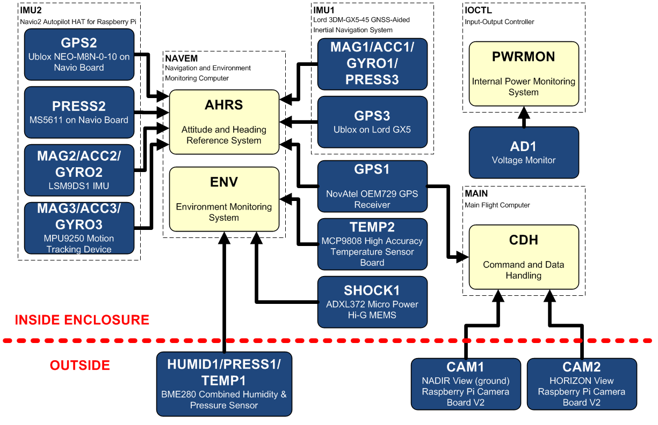

In addition to collecting sensor data, each processing unit collects a set of housekeeping data.

Note that the IMU1 is a COTS assembly embedded with its own sophisticated processors and filters to pre-process its sensor data, which is not fully reflected in the above hierarchy.

## Sensors Specifications

### GPS1

Device

* **NovAtel OEM729 GNSS Receiver** (GPS L1 single frequency)
* 3.5” Active L1 GPS Antenna, 33dB, by NovAtel

Installation

* Receiver board from NovAtel installed in PRISM enclosure. Equipped with a mezzanine board designed and built at CSA, for connecting power, Ethernet and PPS outputs.
* Inside gondola wall, with thermal protection.

Performance Ratings

* Horizontal Position Accuracy (RMS): 1.5m
* Velocity Accuracy (RMS): 0.03 m/s
* Velocity Limit: 515 m/s (export licensing restriction)

Environmental Ratings

* Operating Temperature: -40C to 85C
* Humidity: 95% non-condensing

See RD2

### GPS2

Device

* **Ublox NEO-M8N-0-10 GPS Receiver**.
* Active GPS Antenna, 28dB gain, by Adafruit.

Installation

* Included on the Navio2 Autopilot HAT for Raspberry Pi, by Emlid. This HAT is installed on the NAVEM computer, inside the PRISM enclosure.
* Inside gondola wall, with thermal protection.

Performance Ratings

* Horizontal Position Accuracy: 2.5m
* Maximum Altitude: 50,000 m (Airborne <4g mode)
* Maximum Velocity: 500 m/s (Airborne <4g mode)
* Velocity Accuracy: 0.05 m/s
* Heading Accuracy: 0.3 degrees

Environmental Ratings

* Operating Temperature: -40C to 85C

See RD3

### GPS3

Device

* **Ublox GPS Receiver** (exact device unknown).
* Active GPS Antenna, 28dB gain, by Adafruit.

Installation

* Included in the LORD 3DM-GX5-45 GNSS-aided Inertial Navigation System, which is installed inside the PRISM enclosure.
* Inside gondola wall, with thermal protection.

Ratings

* Horizontal Accuracy: +/- 2.5 m RMS
* Vertical Accuracy: +/- 5 m RMS
* Velocity Accuracy: 0.1 m/s
* Heading Accuracy: 0.5 degree
* Acceleration Limit: <= 4g
* Altitude Limit: None
* Velocity Limit: 500 m/s
* Operating Temperature: -40C to 85C

See RD1

### CAM1 & CAM2

Device

* Raspberry Pi Camera Module v2
* Sensor: Sony IMX219 color CMOS image sensor

Installation

* Within 3D printed enclosure designed at CSA
* Installed on tip of +/- 2 feet boom protruding from bottom of gondola
* Enclosure directly exposed to the elements. No heater.
* CAM1: Pointing toward ground (NADIR)
* CAM2: Pointing at horizon

Ratings

* Horizontal field of view: 62.2 degrees (TBD if this applies to the pictures taken during flight)
* Vertical field of view: 48.8 degrees (TBD if this applies to the pictures taken during flight)
* Performance guarantee temperature (junction temperature): -20C to 60C (from IMX219PQH5 Module Design Reference Manual V2.2)
* System configured to take images with the following specifications:
  + On-board storage: “Full Size” images: 3280x2464 pixels – Quality level: 100 (full)
  + Real-time downlink: “Small” images: 1920x1080 pixels – Quality level: 10 (low)

### SHOCK1

Device

* ADXL372 Micro Power Hi-G MEMS

Installation

* Included on EVAL-ADXL372Z Digital Accelerometer Breakout Board
* Installed inside PRISM enclosure

Ratings

* +/- 200g measurement range, 3-axis
* Recording Threshold: 6g
* Operating Temperature: -40C to 105C
* Scale factor: 100 mg/LSB (12-bit output)

See RD4

### ACC1

Device

* Tri-axial Accelerometers
* Manufacturer: Unknown

Installation

* embedded in LORD 3DM-GX5-45 GNSS-aided Inertial Navigation System, which is installed inside the PRISM enclosure.
* Inside gondola wall, with thermal protection.

Ratings

* Measurement Range: +/- 8g (standard), 2, 4, 20, 40 optional
* Resolution: 0.1 mg
* Bias Instability: +/- 0.04 mg
* Initial Bias Error: +/- 0.002 g
* Scale Factor Stability: +/- 0.03%
* Alignment Error: +/- 0.05 degree
* Sampling Rate: 1,000 Hz
* Operating Temperature: -40C to 85C

See RD1

### ACC2

Device

* LSM9DS1 IMU
* tri-axial Accelerometers

Installation

* Included on the Navio2 Autopilot HAT for Raspberry Pi, by Emlid. This HAT is installed on the NAVEM computer, inside the PRISM enclosure.
* Inside gondola wall, with thermal protection.

Ratings

* Linear Acceleration Measurement Range: +/-2, 4, 8 or 16 g
* Linear Acceleration Sensitivity:
  + +/- 2g range: 0.061 mg/LSB
  + +/- 4g range: 0.122 mg/LSB
  + +/- 8g range: 0.244 mg/LSB
  + +/- 16g range: 0.732 mg/LSB
* Temperature range: -40C to 85C

See RD5

### ACC3

Device

* MPU9250 Motion Tracking Device
* tri-axial MEMS accelerometers

Installation

* Included on the Navio2 Autopilot HAT for Raspberry Pi, by Emlid. This HAT is installed on the NAVEM computer, inside the PRISM enclosure.
* Inside gondola wall, with thermal protection.

Ratings

* Full Scale Measurement Range: +/- 2, 4, 8 or 16g
* Output Data Resolution: 16 bit
* Sensitivity Scale Factor:
  + @ 250 degrees/second range: 16,384 LSB/g
  + @ 500 degrees/second range: 8,192 LSB/g
  + @ 1,000 degrees/second range: 4,096 LSB/g
  + @ 2,000 degrees/second range: 2,048 LSB/g
* Temperature range: -40C to 85C

See RD6

### AD1

Device

* Analog to Digital capabilities of Rabbit BL4S200 Single Board Computer

Installation

* Inside PRISM enclosure
* Connections to PRISM internal power converters outputs (+12V, +5V & +3.3V)

Ratings

* 8x 12-bit Analog to digital input (11 bit for value, 1 bit for sign)
* 1MOhms input impedance
* Configurable voltage reading range
* Maximum voltage range: 0-20V
* 4x inputs can also measure current (4-20 mA)
* Operational Temperature: -40C to 85C

See RD7

### HUMID1

Device

* BME280 Digital Humidity, Pressure and Temperature Sensor

Installation

* Inside 3D printed enclosure designed at CSA
* Installed on tip of +/- 2 feet boom protruding from bottom of gondola
* Enclosure directly exposed to the elements. No heater.

Ratings

* Operating Temperature Range: -40C to +85C
* Humidity Value Range: 0 – 100% relative humidity
* Hysteresis: +/- 1% relative humidity
* Accuracy Tolerance: +/- 3% relative humidity
* Response Time: In the order of 1 second

See RD8

### PRESS1

Device

* BME280 Digital Humidity, Pressure and Temperature Sensor

Installation

* Inside 3D printed enclosure designed at CSA
* Installed on tip of +/- 2 feet boom protruding from bottom of gondola
* Enclosure directly exposed to the elements. No heater.

Ratings

* Operating Temperature Range: -40C to +85C
* Pressure Value Range: 300 to 1,100 hPa
* Absolute Accuracy Pressure: +/- 1.0 hPa
* Relative Accuracy Pressure: +/- 0.12 hPa
* Resolution of Pressure Output Data: 0.18 Pa

See RD8

### PRESS2

Device

* MS5611 01BA01 High Precision Pressure Sensor Module from MEAS Switzerland

Installation

* Included on the Navio2 Autopilot HAT for Raspberry Pi, by Emlid. This HAT is installed on the NAVEM computer, inside the PRISM enclosure.
* Inside gondola wall, with thermal protection.

Ratings

* Extended Pressure Range: 10 to 1,200 mbar (hPa)
* Full Accuracy Pressure Range: 450 to 1,100 mbar (hPa)
* 8-bit to 24-bit selectable resolution
* High resolution pressure: 0.012 mbar (hPa) or 10 cm altitude
* Low resolution pressure: 0.065 mbar (hPa) or 55 cm altitude
* Accuracy 25C, 750 mbar: +/- 1.5 mbar (hPa)
* Temperature range: -40C to 85C
* Response time: In the order of 10ms

See RD9

### PRESS3

Device

* Barometric Pressure Sensor
* Manufacturer: Unknown

Installation

* Embedded in LORD 3DM-GX5-45 GNSS-aided Inertial Navigation System, which is installed inside the PRISM enclosure.
* Inside gondola wall, with thermal protection.

Ratings

* Range: -1,800 m to 10,000 m
* Resolution: < 0.1 m
* Noise Density: 0.01 hPa RMS
* Operating Temperature: -40C to 85C

See RD1

### TEMP1

Device

* BME280 Digital Humidity, Pressure and Temperature Sensor

Installation

* Within 3D printed enclosure designed at CSA
* Installed on tip of +/- 2 feet boom protruding from bottom of gondola
* Enclosure directly exposed to the elements. No heater.

Ratings

* Operating Temperature Range: -40C to +85C
* Full Accuracy Range: 0C to +65C
* Absolute Accuracy Temperature: +/- 0.5 C at 25C, +/- 1C between 0C to 65C
* Resolution of Temperature Output Data: 0.01C

See RD8

### TEMP2

Device

* MCP9808 High Accuracy Temperature Sensor

Installation

* Mini-board installed within the PRISM enclosure, over the NAVEM computer

Ratings

* Operating Temperature Range: -40C to +125C
* +/- 0.25C (typical) from -40C to 125C
* +/- 0.5C (maximum) from -20C to 100C
* +/- 1C (maximum) from -40C to 125C
* Thermal Response Time: In the order of 1.5 second

See RD10

### MAG1

Device

* 3-axis magnetometer.
* Manufacturer: Unknown

Installation

* Embedded in LORD 3DM-GX5-45 GNSS-aided Inertial Navigation System, which is installed inside the PRISM enclosure.
* Inside gondola wall, with thermal protection.

Ratings

* Measurement Range: +/- 2.5 Gauss
* Initial Bias Error: +/- 0.003 Gauss
* Scale Factor Stability: +/- 0.1%
* Alignment Error: +/- 0.05 degree
* Sampling Rate: 50 Hz
* Operating Temperature: -40C to 85C

See RD1

### MAG2

Device

* LSM9DS1 IMU

Installation

* Included on the Navio2 Autopilot HAT for Raspberry Pi, by Emlid. This HAT is installed on the NAVEM computer, inside the PRISM enclosure.
* Inside gondola wall, with thermal protection.

Ratings

* Magnetic Measurement Range: +/-4, 8, 12 or 16 Gauss
* Magnetic Sensitivity:
  + +/- 4 Gauss range: 0.14 mGauss/LSB
  + +/- 8 Gauss range: 0.29 mGauss/LSB
  + +/- 12 Gauss range: 0.43 mGauss/LSB
  + +/- 16 Gauss range: 0.58 mGauss/LSB
* Temperature range: -40C to 85C

See RD5

### MAG3

Device

* MPU9250 Motion Tracking Device
* 3-axis silicon monolithic Hall-effect magnetic sensor with magnetic concentrator

Installation

* Included on the Navio2 Autopilot HAT for Raspberry Pi, by Emlid. This HAT is installed on the NAVEM computer, inside the PRISM enclosure.
* Inside gondola wall, with thermal protection.

Ratings

* Full Scale Measurement Range: +/- 4,800 microTesla
* Output Data Resolution: 14 bit (0.6 microTesla/LSB)
* Temperature range: -40C to 85C
* Repetition Rate: 8Hz

See RD6

### GYRO1

Device

* tri-axial gyroscopes
* Manufacturer: Unknown

Installation

* Embedded in the LORD 3DM-GX5-45 GNSS-aided Inertial Navigation System, which is installed inside the PRISM enclosure.
* Inside gondola wall, with thermal protection.

Ratings

* Measurement Range: 300 degrees/second (standard)
* Resolution: +/- 0.003 degrees/second
* Bias Instability: 8 degrees/hour
* Initial Bias Error: +/- 0.04 degrees/second
* Scale Factor Stability: +/- 0.05%
* Alignment Error: +/- 0.05 degree
* Sampling Rate: 4,000 Hz
* Operating Temperature: -40C to 85C

See RD1

### GYRO2

Device

* LSM9DS1 IMU

Installation

* Included on the Navio2 Autopilot HAT for Raspberry Pi, by Emlid. This HAT is installed on the NAVEM computer, inside the PRISM enclosure.
* Inside gondola wall, with thermal protection.

Ratings

* Angular Rate Measurement Range: +/-245, 500 or 2,000 degrees/second
* Angular Rate Sensitivity:
  + +/- 245 degrees/second range: 0.00875 degrees/second/LSB
  + +/- 500 degrees/second range: 0.01750 degrees/second/LSB
  + +/- 2,000 degrees/second range: 0.070 degrees/second/LSB
* Temperature range: -40C to 85C

See RD5

### GYRO3

Device

* MPU9250 Motion Tracking Device
* tri-axial MEMS gyroscopes

Installation

* Included on the Navio2 Autopilot HAT for Raspberry Pi, by Emlid. This HAT is installed on the NAVEM computer, inside the PRISM enclosure.
* Inside gondola wall, with thermal protection.

Ratings

* Full Scale Measurement Range: +/- 250, 500, 1,000 or 2,000 degrees/second
* Output Data Resolution: 16 bit
* Sensitivity Scale Factor:
  + @ 250 degrees/second range: 131 LSB/(degrees/second)
  + @ 500 degrees/second range: 65.5 LSB/(degrees/second)
  + @ 1,000 degrees/second range: 32.8 LSB/(degrees/second)
  + @ 2,000 degrees/second range: 16.4 LSB/(degrees/second)
* Initial Zero Tolerance (@25C): +/- 5 degrees/second
* Temperature range: -40C to 85C
* Repetition Rate: From 4 to 8,000 Hz

See RD6

# Command and Data Handling subSystem

## Introduction

The Command and Data Handling (C&DH) subsystem acquired gondola position data (from GPS01), general housekeeping data to monitor its own status, and took pictures from both CAM1 and CAM2.

## Data Location

* C&DH Housekeeping data:
  + File Flight/CDH/HKP/swcdh_events.txt = List of recorded events
  + File Flight/CDH/HKP/swcdh_hkp0.txt = General housekeeping data
  + File Flight/CDH/HKP/swcdh_hw0.txt = Additional hardware data
  + Tabs SWCDH_HKP0 and SWCDH_HW0 in file Flight/FlightData.xlsx
* Location data:
  + File Flight/CDH/GPS01/swcdh_gps01_gga.txt
  + Tab SWCDH_GPS01_GGA in file Flight/FlightData.xlsx
* Images:
  + Ground pointing: JPG files in Flight/CDH/CAM1-NADIR
  + Horizon pointing: JPG files in Flight/CDH/CAM2-HOR

## Housekeeping Data

In this section we will present sample processed data with brief comments from the C&DH housekeeping data.

**C&DH main loop delay**: Loop delay consistently remained below 100ms throughout the flight, with spikes of between 10 and 20 seconds every 2 minutes, corresponding to the moment the C&DH would take pictures.

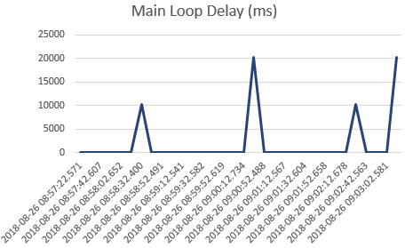

Figure 3: C&DH Main Loop Delay - random time range in-flight

**C&DH free memory:** The amount of free system memory was monitored, and remained relatively constant between 13 and 20 Mbytes, EXCEPT for the last 15 minutes of the flight, where we can see a clear trend downward, leading to 10 Mbytes of free memory. This can be explained by the fact that we started heavy raw data file transfer at this point, just before descent.

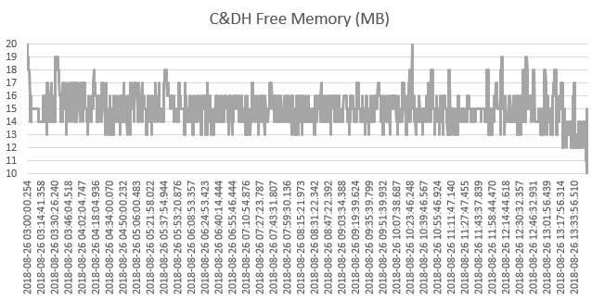

Figure 4: C&DH Free Memory (MB) - Full Duration

**C&DH CPU Temperature**: The temperature of the CPU of the C&DH computer (Raspberry Pi 2) immediately started to drop at launch, from a little over 45C down to about 22C at around 12:30Z, when it started to rise again to around 28C. Note that this does not correspond to sunrise. More investigation is needed to understand the reason of the rise at this moment.

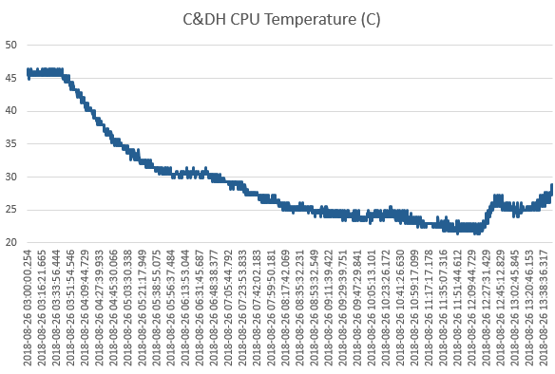

Figure 5: C&DH CPU Temperature Celsius - Full Duration

## Localisation Data

In this section we will present sample gondola localisation data, acquired by C&DH from the NovAtel GPS receiver (GPS01).

**Gondola altitude:** The gondola rose to around 36km in about 2 hours, and its altitude remained relatively constant until loss of signal (separation).

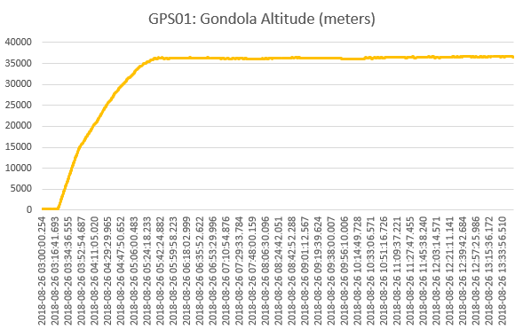

Figure 6: GPS01: Gondola Altitude (meters) – Full Duration

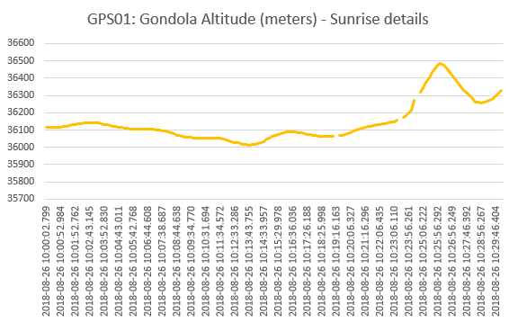

Figure 7: GPS01 - Gondola Altitude Variations at Sunrise (30 minutes time range)

**Gondola Position (Latitude & Longitude):** Gondola latitude and longitude were reported consistently during the flight, except for 3 outliers (zero values). Longitude remained between 80 and 84 degrees W, and latitude between 48 and 48.5 degrees N.

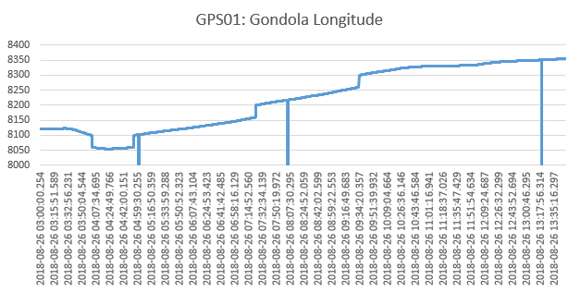

Figure 8: GPS01: Gondola Longitude - Full Duration

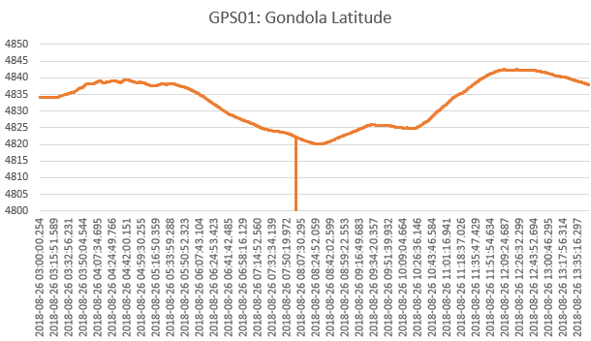

Figure 9 : Gondola Latitude - Full Duration

**GPS data quality:** Except for a brief exception where the signal seems to have been lost at 4:42Z, the number of GPS satellites used in the solution remained generally above 7. The HDOP (Horizontal Dilution of Precision) index remained around 1 for the full flight duration, which indicates a very good signal (<1=redundant, 1=ideal, between 1.0 and 2.0 is excellent).

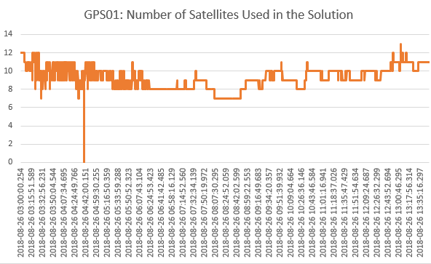

Figure 10: GPS01: Nb Satellites Used in Solution - Full Duration

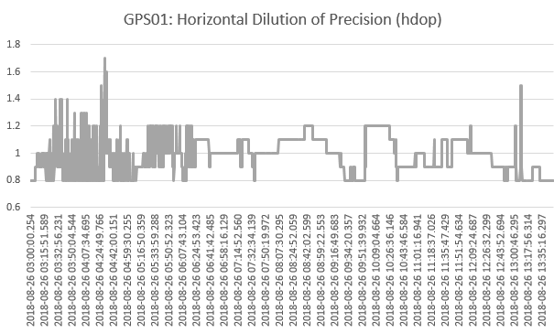

Figure 11: GPS01: Horizontal Dilution of Precision (hdop) - Full Duration

## Imaging

### Imaging Parameters Changes

Commands were sent during the flight to change the cameras’ settings, more specifically the CAM_OPTIONS command. The parameter string to this command is appended to the command (at the location marked by “options” below) to request an image onboard:

Low res:

**raspistill –n –vf –hf –w 1920 –h 1080 –q 10** *Options* **–t 2000 –o** *imageName.jpg*

High res:

**raspistill –n –vf –hf –q 100** *Options* **–t 2000 –o** *imageName.jpg*

For more information, consult references on the “raspistill” application on the Raspberry Pi.

Here is the timeline:

GASPAR,20180826 032550867,,CMD,swcdh,71,77,CAM_OPTIONS,-a 12

GASPAR,20180826 053114599,,CMD,swcdh,79,-51,CAM_OPTIONS,-a 12 -ex verylong

GASPAR,20180826 053333892,,CMD,swcdh,81,113,CAM_OPTIONS,-a 12 -ex night

GASPAR,20180826 053500013,,CMD,swcdh,83,-34,CAM_OPTIONS,-a 12 -ex night -br 75

GASPAR,20180826 053656418,,CMD,swcdh,85,-40,CAM_OPTIONS,-a 12 -ex night -br 60

GASPAR,20180826 053716914,,CMD,swcdh,86,-34,CAM_OPTIONS,-a 12 -ex night -br 60 -drc high

GASPAR,20180826 055454590,,CMD,swcdh,0,30,CAM_OPTIONS,-a "CSA PRISM" -a 12 -ISO 800 -br 60 -ex verylong -drc high

GASPAR,20180826 055533347,,CMD,swcdh,2,-22,CAM_OPTIONS,-a 12 -ISO 800 -br 60 -ex verylong -drc high

GASPAR,20180826 070822841,,CMD,swcdh,9,106,CAM_OPTIONS,-a 12 -ISO 800 -br 60 -drc high

GASPAR,20180826 071305128,,CMD,swcdh,10,77,CAM_OPTIONS,-a 12

GASPAR,20180826 071826802,,CMD,swcdh,12,-3,CAM_OPTIONS,-a 12 -ISO 800

GASPAR,20180826 072722654,,CMD,swcdh,17,-51,CAM_OPTIONS,-a 12 -ex verylong

GASPAR,20180826 073304389,,CMD,swcdh,18,113,CAM_OPTIONS,-a 12 -ex night

GASPAR,20180826 074315294,,CMD,swcdh,20,77,CAM_OPTIONS,-a 12

GASPAR,20180826 090225724,,CMD,swcdh,46,-113,CAM_OPTIONS,-a 12 -ex sport

GASPAR,20180826 090237726,,CMD,swcdh,47,-113,CAM_OPTIONS,-a 12 -ex sport

GASPAR,20180826 090435927,,CMD,swcdh,49,56,CAM_OPTIONS,-a 12 -ex sport -ISO 100

GASPAR,20180826 093800745,,CMD,swcdh,59,77,CAM_OPTIONS,-a 12

GASPAR,20180826 094450233,,CMD,swcdh,60,-125,CAM_OPTIONS,-a 12 -ISO 800 -ex verylong -drc high

GASPAR,20180826 095158853,,CMD,swcdh,63,77,CAM_OPTIONS,-a 12

GASPAR,20180826 095642306,,CMD,swcdh,65,-51,CAM_OPTIONS,-a 12 -ex verylong

GASPAR,20180826 095843109,,CMD,swcdh,68,-45,CAM_OPTIONS,-a 12 -ex verylong -drc high

GASPAR,20180826 095955488,,CMD,swcdh,70,77,CAM_OPTIONS,-a 12

GASPAR,20180826 101057309,,CMD,swcdh,77,77,CAM_OPTIONS,-a 12

GASPAR,20180826 101058159,,CMD,swcdh,78,77,CAM_OPTIONS,-a 12

GASPAR,20180826 101115500,,CMD,swcdh,79,77,CAM_OPTIONS,-a 12

### Images

Images were automatically taken at intervals of two (2) minutes, alternating between CAM1 and CAM2, with a low resolution image being taken first (downlinked to ground immediately), followed by a high resolution image (saved in onboard mass memory for later retrieval, after landing).

Each image is in standard JPEG format, and includes an overlay on the top, with the timestamp (in UTC).

CAM1 images can be found in

Data/Flight/CDH/CAM1-NADIR

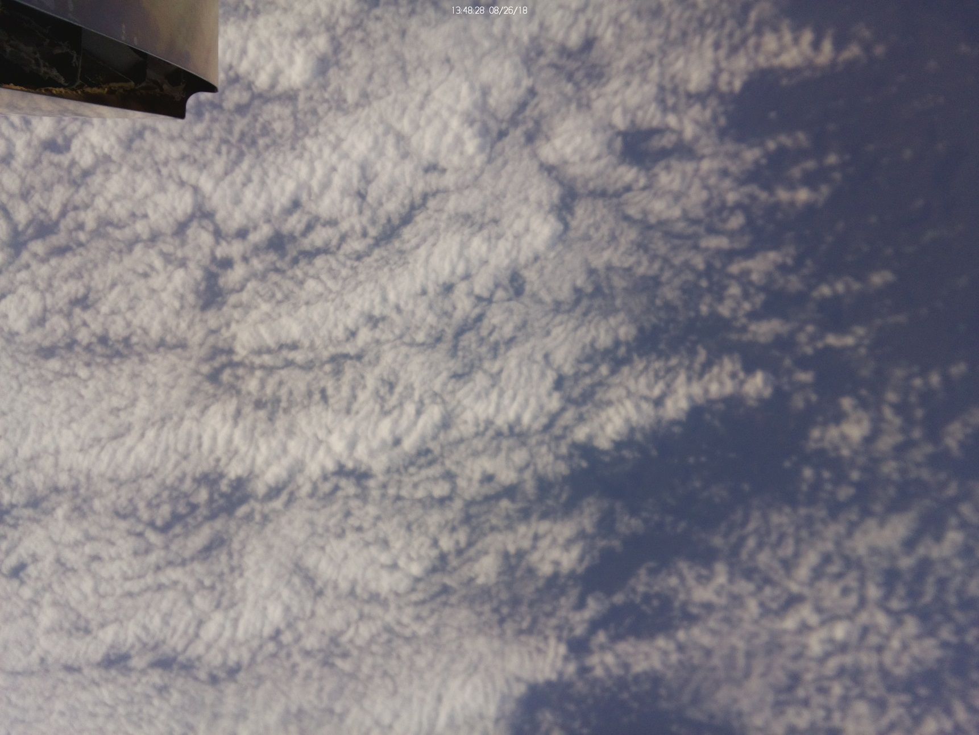

Figure 12: CAM1 (NADIR Pointing) Image Example

CAM2 images can be found in

Data/Flight/CDH/CAM2-HOR

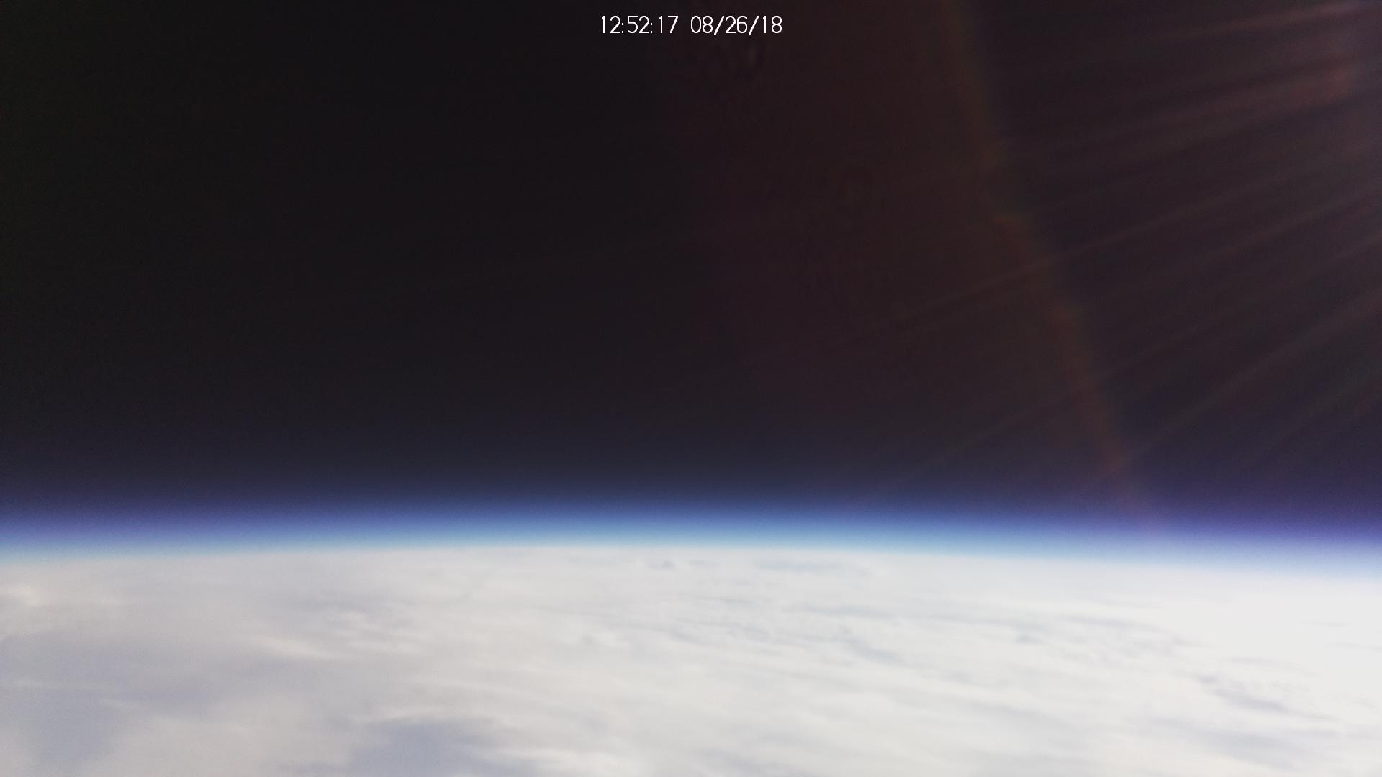

Figure 13: CAM2 (Horizon Pointing) Image Example

# Navigation and Environment Monitoring Sub-SystemS

## Introduction

The Navigation and Environment Monitoring (NAVEM) sub-system executed two main processes: one that was responsible to acquire and process data to provide attitude and heading reference information (SWNAV), and the other that was responsible to acquire environment data (SWEM). SWNAV also acquired position data from various GPS receivers. Each of these processes generates its own housekeeping telemetry to monitor its status.

## Data Location

* SWNAV Housekeeping data:
  + File Flight/NAVEM/swnav_hkp.txt
  + Tab SWNAV_HKP in file Flight/FlightData.xlsx
* SWNAV Location data:
  + File Flight/NAVEM/swnav_pos0.txt
  + Tab SWNAV_POS0 in file Flight/FlightData.xlsx
* SWNAV Attitude and Heading Reference data:
  + File Flight/NAVEM/swnav_ahr0.txt
  + Tab SWNAV_AHR0 in file Flight/FlightData.xlsx
* SWEM Housekeeping data:
  + File Flight/NAVEM/swem_hk.txt
  + Tab SWEM_HK in file Flight/FlightData.xlsx
* SWEM Environment data:
  + File Flight/NAVEM/swem_em0.txt
  + Tab SWEM_EM0 in file Flight/FlightData.xlsx

## Housekeeping Data

**NAVEM resource usage (from SWEM)**: SWEM acquired CPU (raspberry pi 3) usage throughout the flight, as well as the amount of free memory (RAM) left and the CPU temperature. Some spikes indicated 100% CPU usage. But in average, the CPU usage remained below 60%.

As for the amount of free memory, there is a clear trend from the data, indicating steadily decreasing amount of memory being available during the flight. Investigations on memory usage will be conducted, and the corresponding mitigation measures will be implemented in future missions to eliminate potential negative impacts of this decreasing amount of free memories.

CPU temperature started at a steady 64C, and dropped slowly to 40C during flight, up to around 12:30Z, at which time temperature started to rise again up to 45C. It is to be noted that the temperature of the NAVEM CPU (Raspberry pi 3) was consistently higher by about 20C than the temperature of the C&DH CPU (Raspberry pi 2), during the flight.

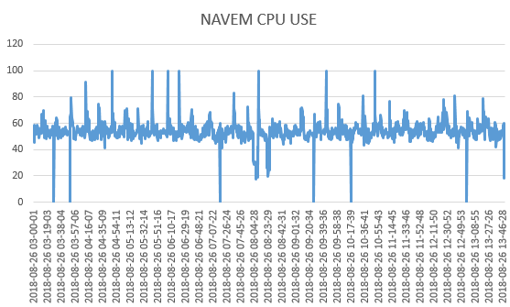

Figure 14: NAVEM CPU Usage - Full Duration

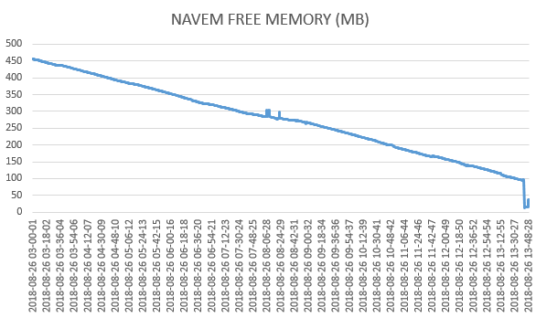

Figure 15: NAVEM Computer Free Memory (MB) - Full Duration

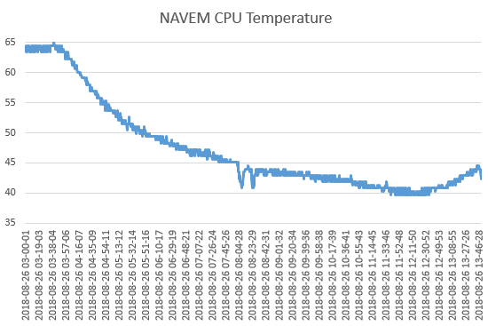

Figure 16: NAVEM CPU Temperature (C) – Full Duration

## Navigation Software Telemetry

### Localisation Data

The SWNAV process acquired position data from GPS01, GPS02 and GPS03. After analysis, the priority sequence of the three GPS receivers is set as: GPS01 then GPS02 then GPS03. That is, the final position is taken from the first “valid” solution when sweeping the three GPS receiver solutions following the priority sequence. Post-flight analysis shows that, during the flight, GPS01 provided valid solutions throughout the whole flight period. Therefore, the position outputs from the PRISM are solely provided by NovAtel GPS receiver (GPS01).

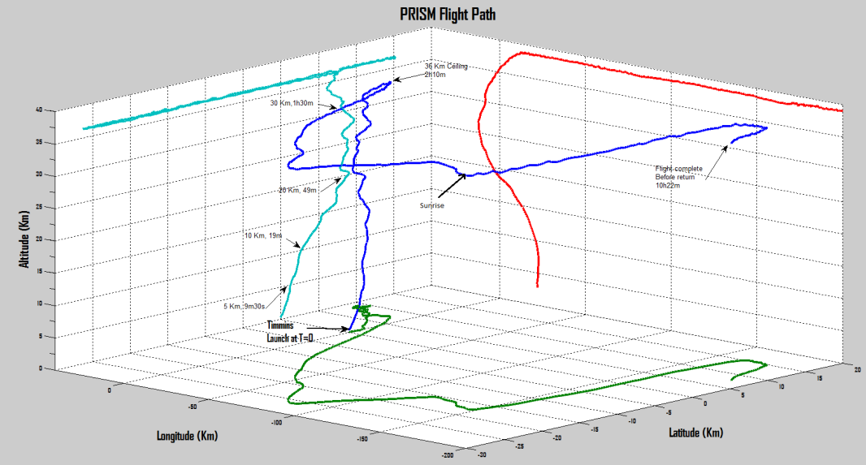

Figure 17: Gondola Position, as Reported by SWNAV - Full Duration

**GPS02:** The Ublox GPS receiver on the NavIO2 (GPS02) was functional at launch, but stop providing altitude data at 3:22Z when reaching 1000m (last reported altitude = 993m), and stopped providing position (latitude/longitude) 20 minutes later, at around 12,000m (as reported by the other GPS receiver).

GPS03: The GPS receiver included in the IMU1 (Lord GX5) provided good data throughout the flight, with gaps at:

* between 3:30:47Z and 3:38:07Z (8 minutes)
* between 4:08:06Z and 4:08:41Z (33 seconds)
* between 4:51:14Z and 4:51:35Z (31 seconds)
* between 4:58:53Z and 4:59:19Z (26 seconds)
* between 6:42:43Z and 6:48:33Z (about 6 minutes)
* between 6:48:34Z and 6:52:15Z (about 4 minutes)
* between 6:56:11Z and 6:56:27Z (16 seconds)

These gaps could be due to the IMU1 being reset or reconfigured during the flight for various test purposes. Otherwise the data appears being consistent, with a higher number of satellites being used then the GPS01. But its HDOP values are slightly higher (less quality, but still close to 2, which is considered good) than those of the GPS01.

### ATTITUDE DATA

This section provides sample data from the main inertial measurement unit (IMU1) installed on the PRISM. This unit includes a 3-axis magnetometer (MAG1), tri-axial accelerometer (ACC1) and tri-axial gyroscope (GYR1), as well as a GNSS antenna & receiver (GPS03).

The photo below shows the gondola in preparation for flight. The Gondola Frame is illustrated in the figure following the photo. Unless specified, all measurements from IMU1 were expressed in the Gondola coordinate frame.

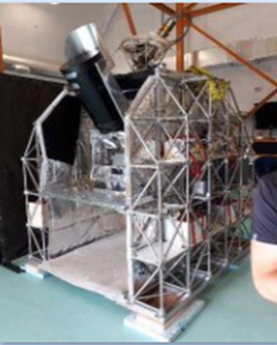

Figure 18 Gondola in Preparation for Flight



Figure 19 Gondola Coordinate Frame

**Gondola Heading**

The heading refers to the angle from true north to +XG. In this section we present sample heading data being provided by the system (IMU1 sensor). IMPORTANT NOTE: Data analysis shows that the heading estimates do not represent the real headings during most of the post-ascending period. More specifically, the heading estimates started becoming problematic approaching the end of the ascending period when the gondola reached ~30 km altitude. Studies are on-going to identify the factors that impacted the heading estimates.

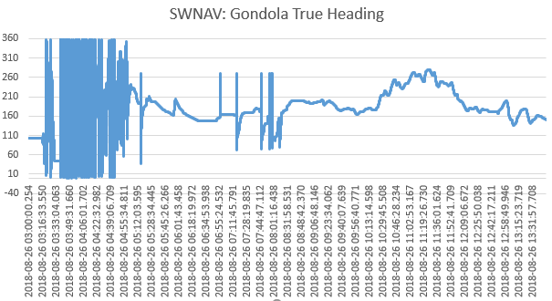

Figure 20: NAVEM: Gondola True Heading Estimate – Whole Flight Period

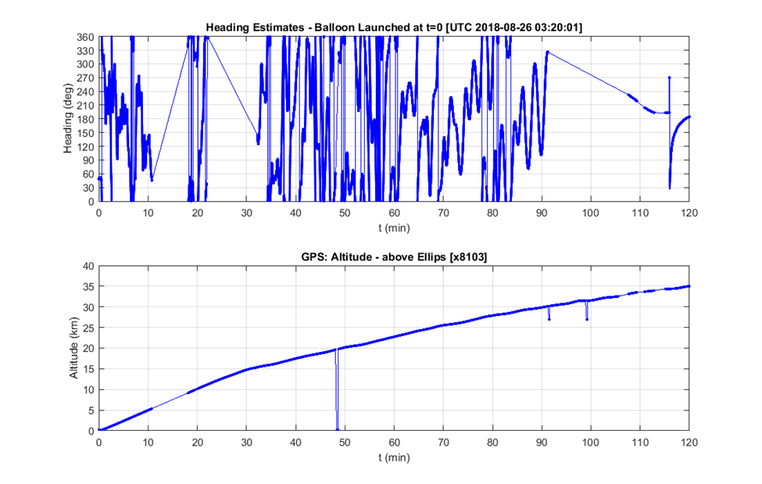

Figure 21: NAVEM: Gondola True Heading Estimate & Altitude – Ascending Period

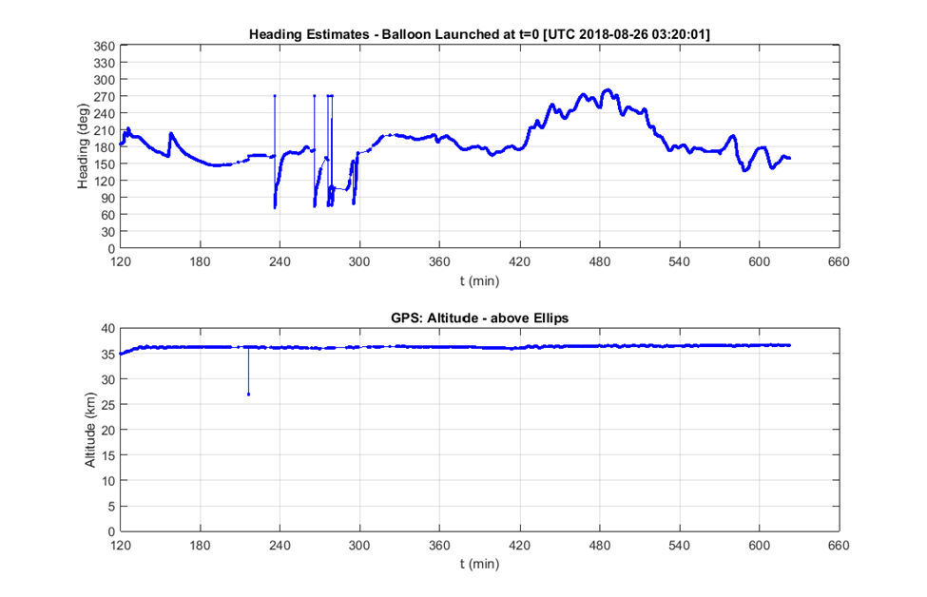

Figure 22: NAVEM: Gondola True Heading Estimate & Altitude – Post-Ascending Period

After launch, the ascending period (from launch until reaching the ceiling) lasted about 2 hours, during which the gondola was in free rotations with no heading control applied. This is observed from the heading data during ascending period, which are much more volatile that that of the later flight period. When reaching ceiling, the gondola was stabilized in heading to conduct scientific experiments. However, as noted above, during most of the post-ascending period, the heading estimates were problematic, with studies being on-going to identify the causes of the heading errors.

**Gondola Roll & Pitch**: The following graphs show the roll and pitch profiles of the gondola during the whole flight period. During ascending, inclination of more than 10 degrees is observed. The gondola attitude was stabilizes at about 2 hours after the launch, i.e., around 5:15UTC. During the stabilized flight, the inclination remains at about 0.3 degrees. Some of the overshoots in roll/pitch estimates may be caused by filter errors.

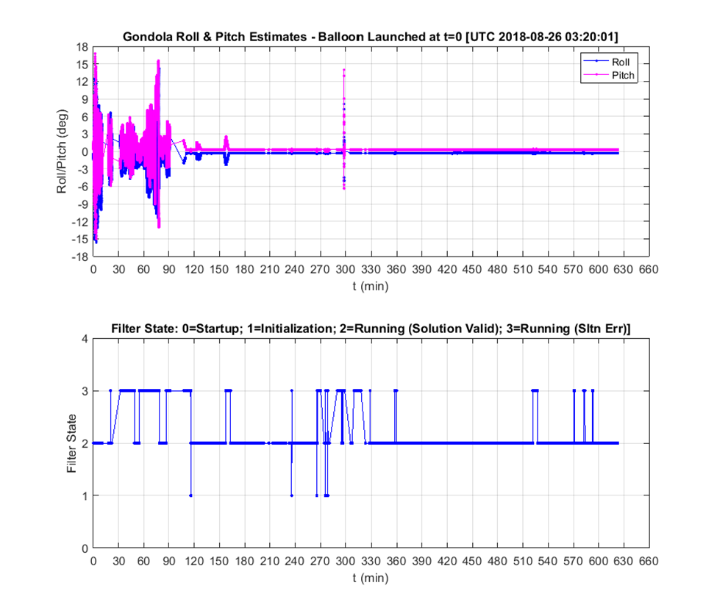

Figure 23: SWNAV: Gondola Roll & Pitch Estimates and Filter State - Full Duration

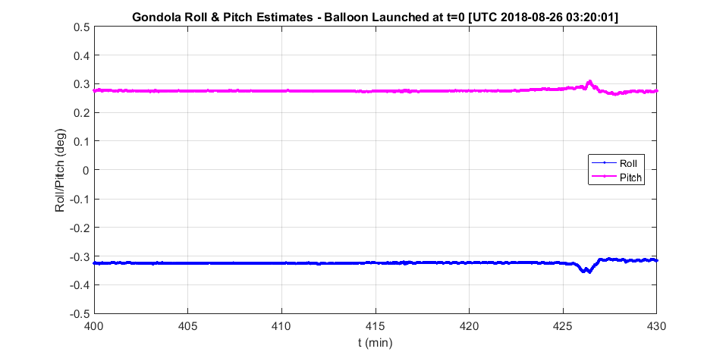

Figure 24: SWNAV: Gondola Roll & Pitch – Zoomed-in around Sunrise

### Kinematics, Dynamics, and Environment Data

This section provides sample data from the main inertial measurement unit (IMU1) installed on the PRISM. This unit includes a 3-axis magnetometer (MAG1), tri-axial accelerometer (ACC1) and tri-axial gyro (GYR1), as well as a GNSS antenna & receiver (GPS03).

**Gondola Linear Velocity**: The first graph shows the gondola NED velocity provided in SWNAV, which were estimates of an on-board filter. It is observed that during the balloon ascending, there were periods when the validity flag of the NED velocity had the value “0”, indicating “estimation invalid”. Diverged North/East velocity estimates were observed corresponding to “0” validity flag values.

*Note: The North-East-Down velocity components were expressed in the North-East-Down Frame. During ascending, the direction of Vd pointed up, which was reflected by its negative values.*

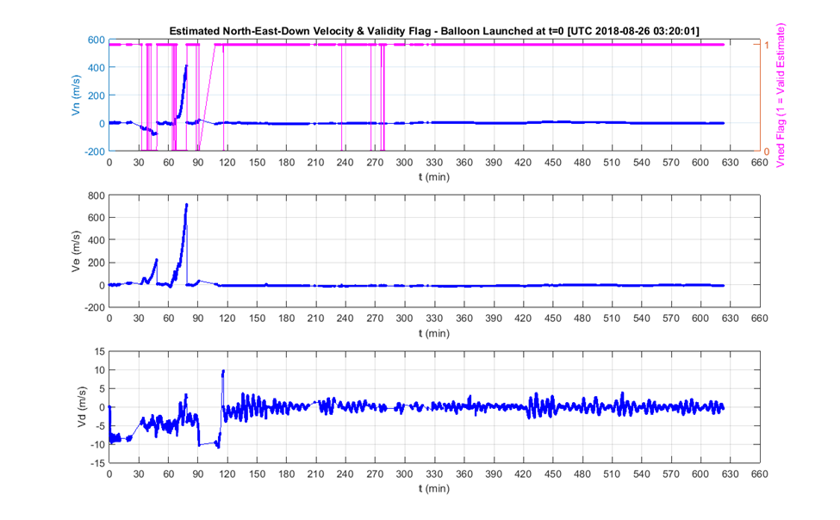

Figure 25: SWNAV: Estimated Gondola NED Velocity and Validity Flag

The following graph shows NED velocity components around the sunrise.

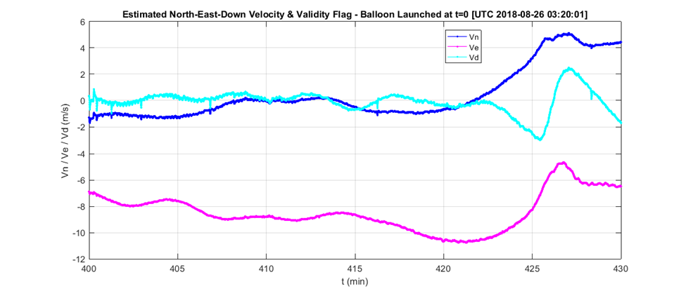

Figure 26: SWNAV: Gondola NED Velocity – Zoomed-in around the Sunrise

**Angular Rates**: From the graph, it is seen that the gondola had the most volatile angular motions during ascending, with peak yaw angular rate at 25 degrees per second.

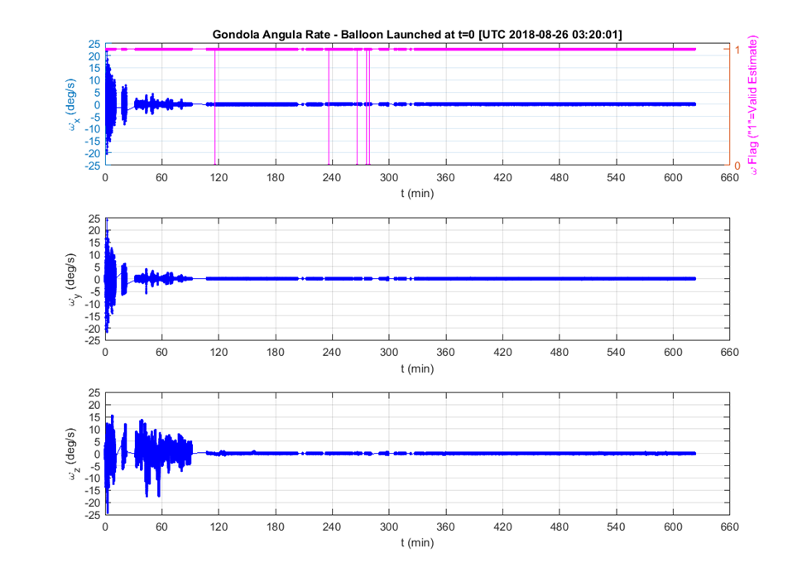

Figure 27: SWNAV: Gondola Angular Rates X-Y-Z deg/s - Full Duration

**Linear Accelerations:** The following graph shows that the gondola sustained linear acceleration (gravity removed) of up to 3 m/s2 during ascending.

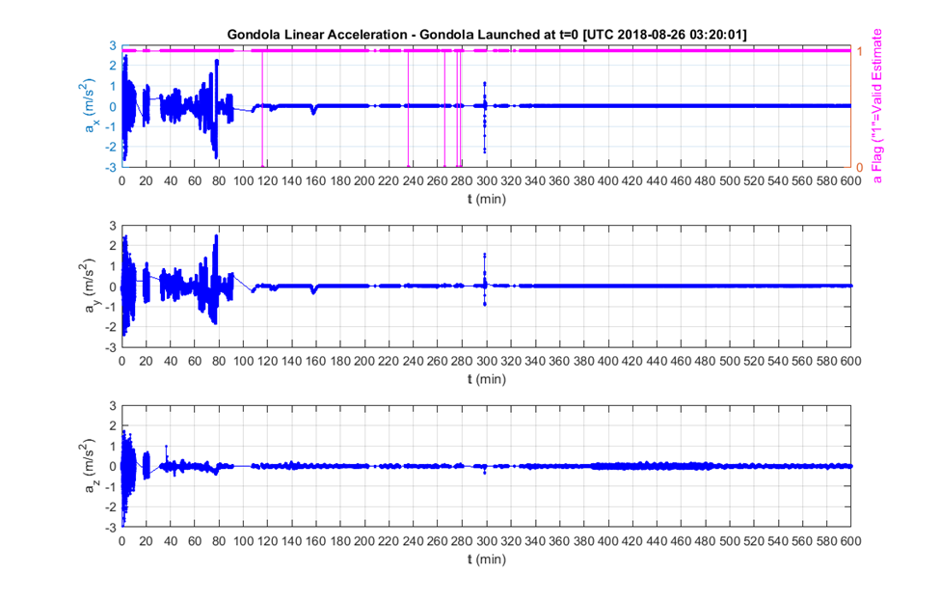

Figure 28: SWNAV: Gondola Linear Acceleration X-Y-Z - Full Duration

### Sun Vector

As part of the information provided by PRISM to scientific instruments via multicast, PRISM provides the Sun’s position during the flight. PRISM also provide a flag indicating if the Sun is visible.

To compute the position of the Sun, PRISM utilized the SunPosition.jar java library developed by Klaus Brunner (klaus@brunners.name) and available at: <https://github.com/KlausBrunner/solarpositioning>. This library provides the sun azimuth and elevation angles based on the longitude, latitude, elevation and local time, which is used by the PRISM software to compute the sun vector in the gondola frame, and to determine the visibility of the sun.

PRISM predicted that the Sun would be visible by the gondola at UTC 10:09:17  (altitude 36.1 Km). This prediction was corroborated by the photos taken by PRISM every 2 minutes or so ( camera at the bottom of the gondola pointing to the horizon). The computation used a fixed Earth radius of 6378140.0 meters, and did not include the 0.8 degree radius sun-disk correction.

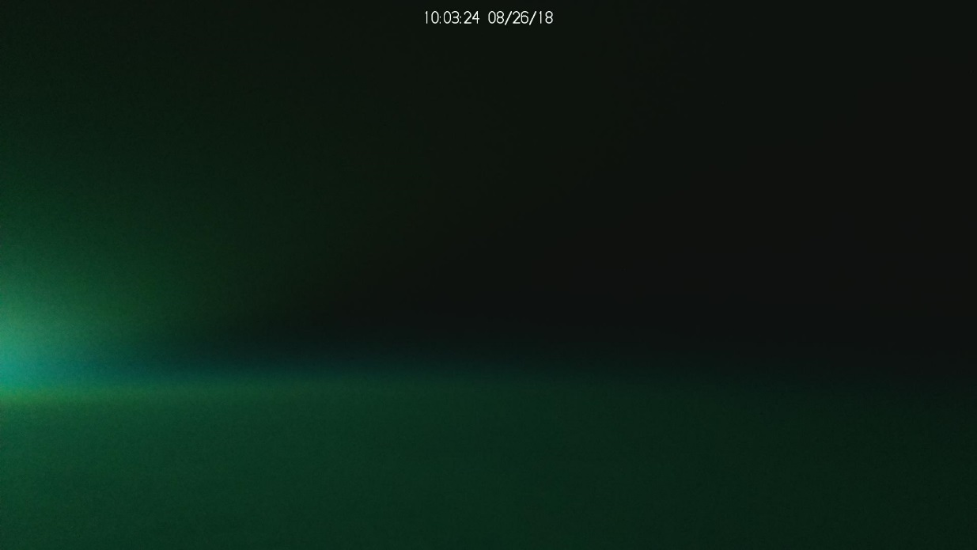

Figure 29: View of the horizon at 10:03:24

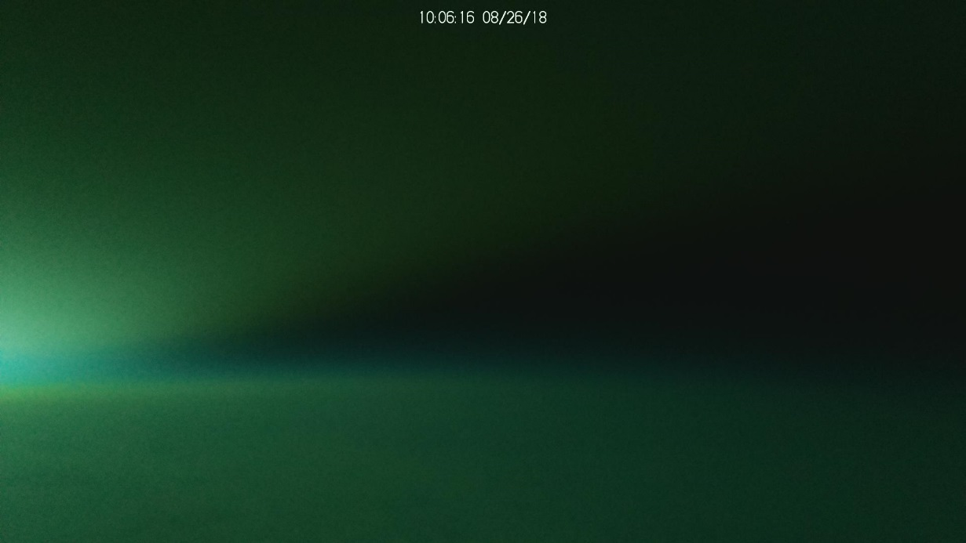

Figure 30: View of the horizon at 10:06:16

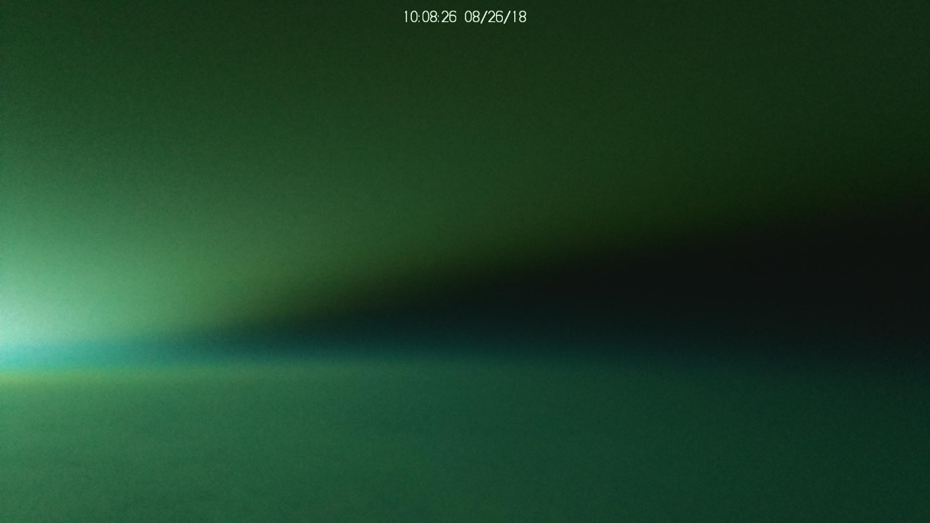

Figure 31: View of the horizon at 10:08:26

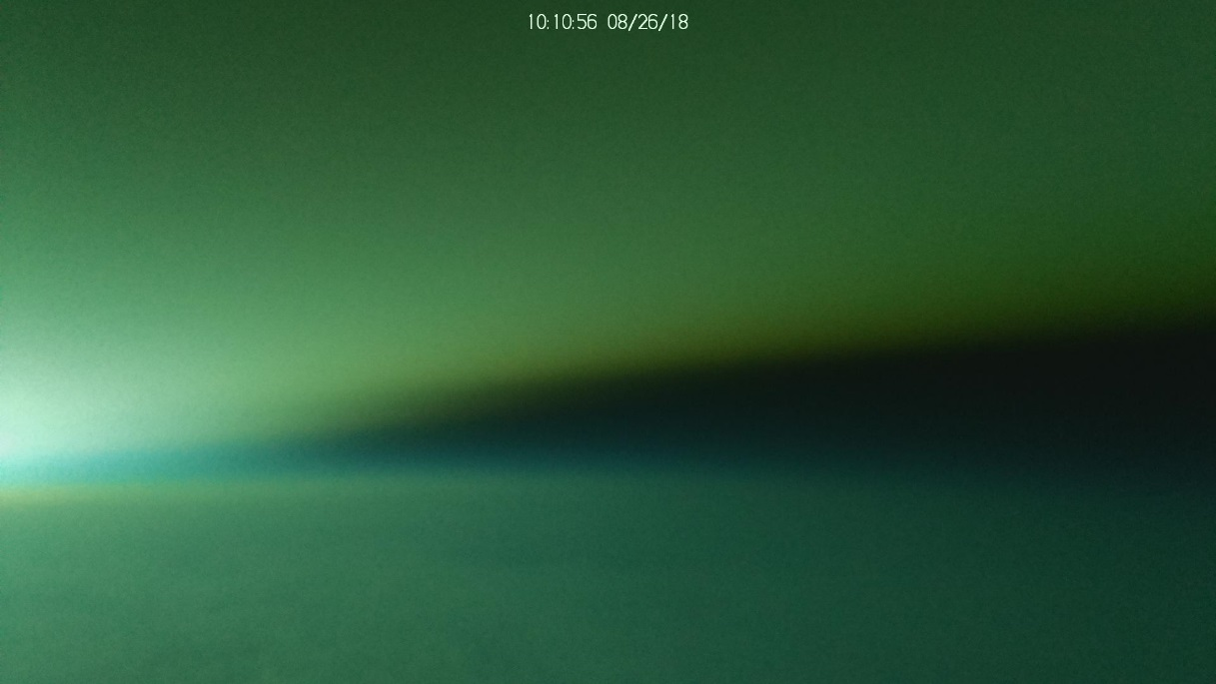

Figure 32: View of the horizon at 10:10:56

**Sun Elevation**: SWNAV reports the Sun elevation (angle above horizon). Zero elevation is reported at 10:44Z. Note that the calculation are done to provide Sun elevation from the perspective of an observer at sea level, which explains the difference between the reported time when the Sun becomes visible (from an observer at the gondola) and the reported time of zero elevation. *We plan to update the calculation for the Sun elevation in future flights, so both the Sun elevation and the Sun visibility will be computed in view of an observer at the gondola*.

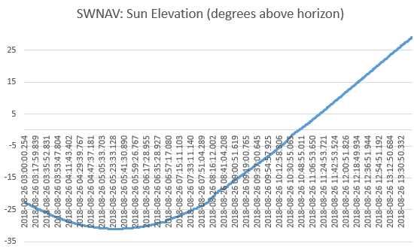

Figure 33: SWNAV: Sun Elevation for Observer at sea level - Full Duration

## Environment Monitoring Software Telemetry

### Temperature / Pressure / Humidity

In this section we are presenting sample data acquired by SWEM executing on the NAVEM, relative to the environment (e.g. temperature, pressure, humidity).

**Temperatures**: SWEM acquired external temperature (TEMP1 sensor) and temperature inside the enclosure (TEMP2 sensor). At launch, internal and external temperatures differed by a little more than 20C, due to the electronics inside the enclosure. External temperature quickly dropped to about -45C (note that TEMP1 sensor specification indicates a minimum temperature of -40, so at this point we are out of range of the sensor) at the tropopause, and rose again to around -35C, where it remained steady until after sunrise (around 11:00Z). External temperature reading rose to 10C, but this could be due to the sun heating up the sensor enclosure (to be confirmed). In the meantime, inside temperature slowly dropped from 40C to about 7C, and slowly rose again when the sun moved higher over the horizon. Note that internal temperature did not seem to attain a steady state, and was still very slowly dropping before it started to rise again.

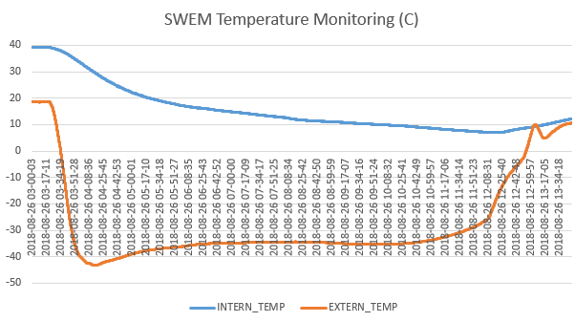

Figure 34: SWEM Temperature Monitoring – Full Duration

**Relative Humidity:** Relative humidity was acquired by SWEM (HUMID1 sensor). Note that prior launch the humidity level at the vicinity of the sensor was extremely low (close to zero) due to the fact that there were purging mechanisms used on optical payloads. Humidity rose quickly to 65% during ascent, but went back down, first at around 15%, and steadily lower to less than 5% for the remainder (and majority) of the flight.

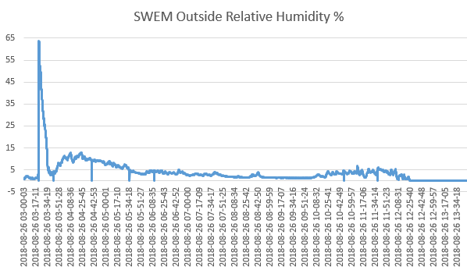

Figure 35: SWEM Relative Humidity Monitoring - Full Duration

**Barometric Pressure:** SWEM acquired barometric pressure (PRESS1 sensor). Values started at around 980 hPa at ground level, down to around 8 hPa at ceiling. Note that the PRESS1 sensor specifications are for a minimum of 300 hPa, so at this point our sensor is out of range. However, the value of 8 hPa is close to what we would expect at 36km in altitude. Also note that we have 7 outliers in our sampled data, however the rest of the values seem to be very consistent.

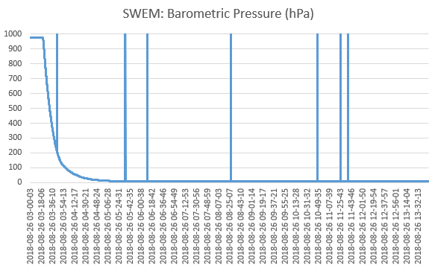

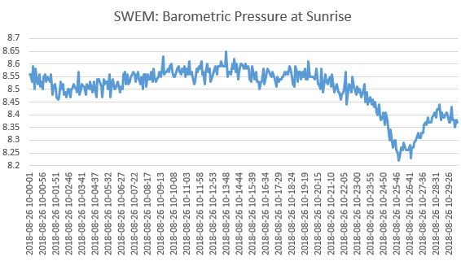

Figure 36: SWEM: Barometric Pressure (hPa) – 30 minutes at sunrise

**Shock:** SWEM did not record any major shock during the flight. Note that prior descent the system was turned off, so we do not have any sample during descent (parachute) nor landing.

# Magnetometer measurements

## Introduction

In this flight, there were three magnetometers on-board the PRISM, MAG1 (in LORD 3DM-GX5-45), MAG2 (in LSM9DS1 IMU) and MAG3 (in MPU9250 Motion Tracking Device), see Section 2.2 for details. This section provides both sensors data recorded during flight.

## Magnetometer (MAG1) Data from 3DM-GX5-45 IMU

The components and the magnitude of the MAG1 measurements are presented in the graph below, where the X/Y/Z components are expressed in the gondola coordinate frame. The magnitude of the MAG1 measured magnetic field vector is also compared to the magnitude of the computed earth magnetic field vector via World Magnetic Model (WMM). The ambient magnetic disturbances to MAG1 measurements are apparent in the MAG magnitude graph.

*Note: (1) The WMM values were provided by the 3DM-GX5-45 sensor. (2) The magnitude of a magnetic field vector is independent of the sensor attitude. Therefore, the magnitude of the ambient magnetic disturbances can be well observed by comparing the magnitudes of the measured magnetic field vector and the computed WMM vector.*

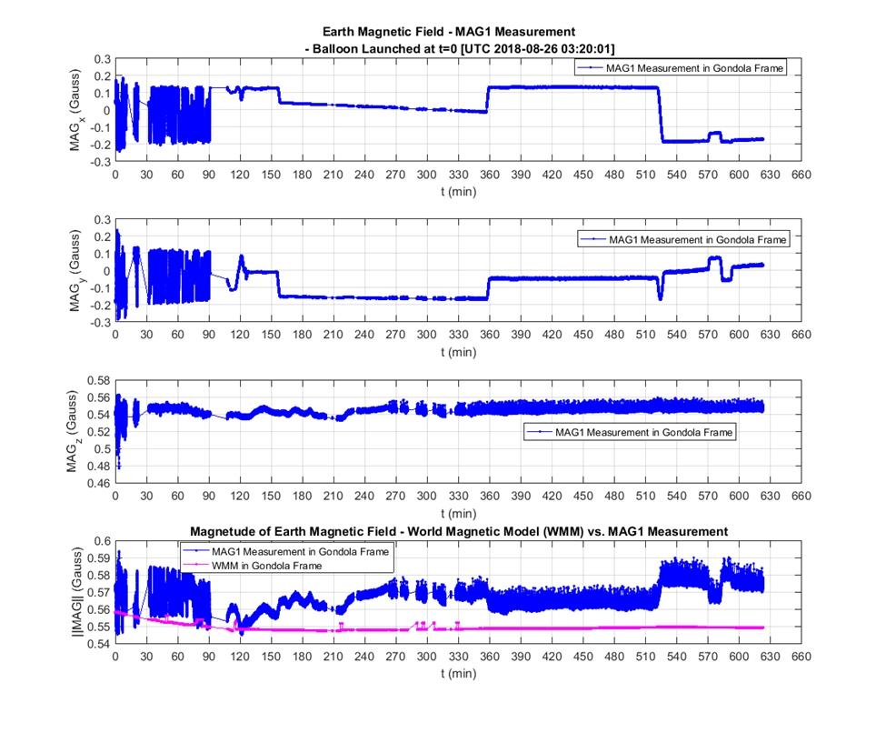

Figure 37 MAG1 Measured Magnetic Field and WMM Computed Magnetic Field Magnitude

## magnetometer (MAG2) data from LSM9DS1 IMU

The graph below presents the MAG2 measured magnetic field vector, where the X/Y/Z components refer to the sensor axes. In this case, the MAG2 sensor axes were not aligned with the corresponding gondola frame axes. It is seen that the magnitude of the MAG2 measured magnetic vector is between 60 to 77 microTeslas, which are much greater than the magnitude of the computed earth magnetic field vector via WMM (between 54.8 and 56 microTeslas). This large discrepancy in magnitudes indicated that either the MAG2 measurements were incorrect, or MAG2 was disturbed by a very strong magnetic source nearby. Closer study will be need to make conclusion.

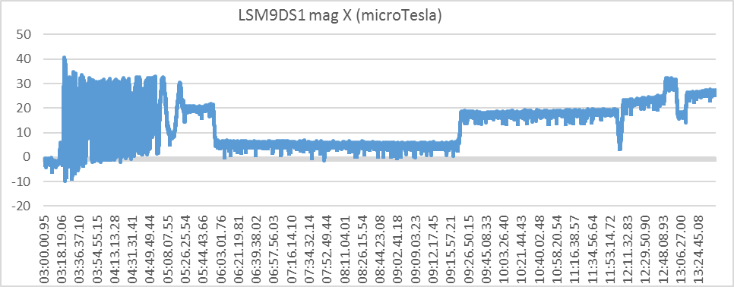

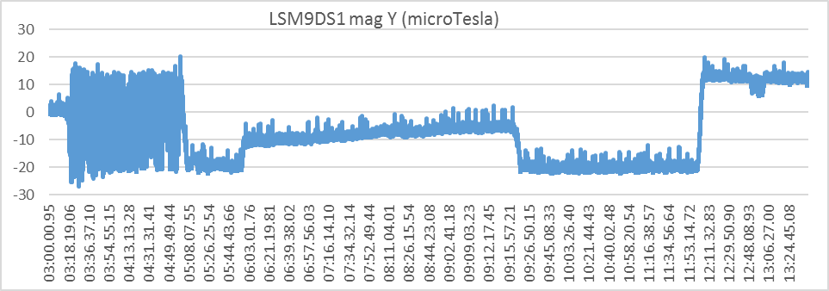

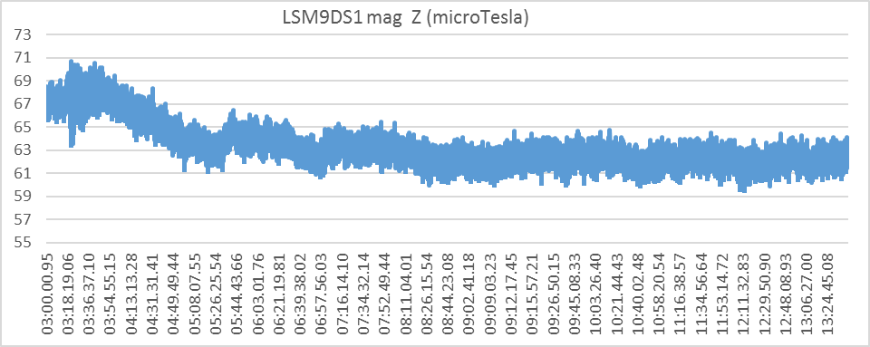

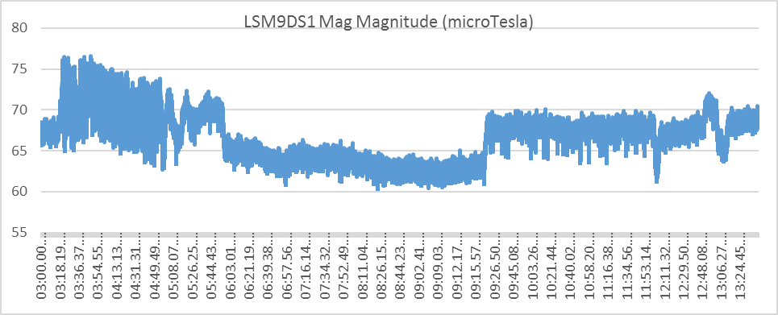

Figure 38 MAG2 Measured Magnetic Field

## MPU9250 magnetometer data

The graph below presents the MAG3 measured magnetic field vector, where the X/Y/Z components refer to the sensor axes. In this case, the MAG3 sensor axes were not aligned with the corresponding gondola frame axes. It is seen that the magnitude of the MAG3 measured magnetic vector is between 29 to 58 microTeslas, where the most of the samples are significantly smaller than the magnitude of the computed earth magnetic field vector via WMM (between 54.8 and 56 microTeslas). Again, the large discrepancy in magnitudes indicated that either the MAG3 measurements were incorrect, or MAG3 was disturbed by a very strong magnetic source nearby. Closer study will be need to make conclusion.

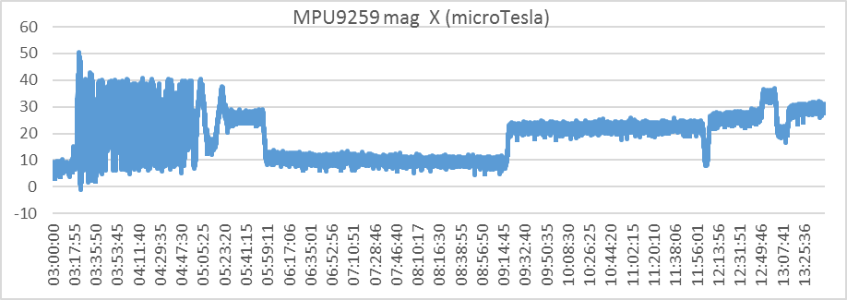

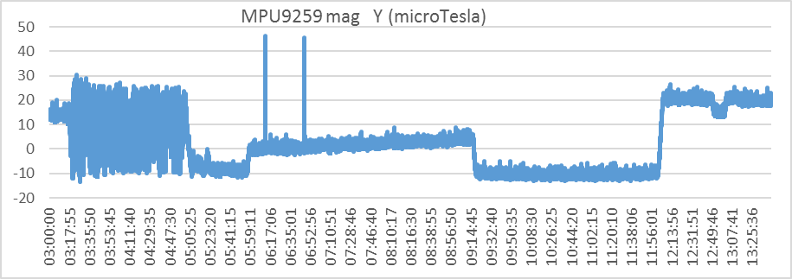

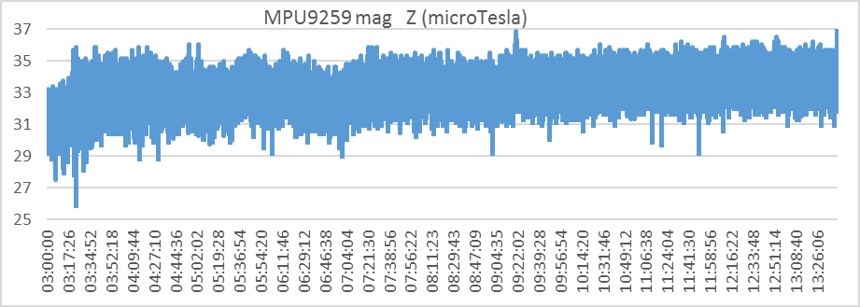

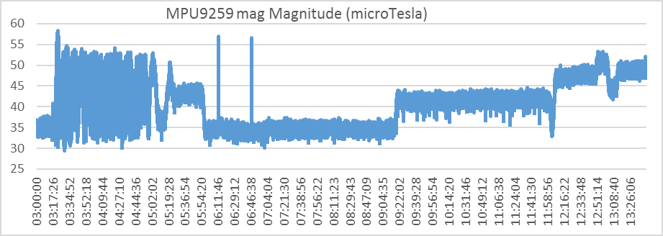

# I/O Controller Sub-System

## Introduction

The Input/Output Controller (IOCTL) sub-system is a rabbit single board computer. It includes analog to digital converters that were used to monitor the PRISM internal voltage.

## Data Location

* SWNAV Housekeeping data:
  + File Flight/IOCTL/ioctl_hkp.txt
  + Tab IOCTL_IOCTRL_HKP in file Flight/FlightData.xlsx

## Onboard Power Monitoring Data

**Internal Voltage Monitoring**: From the acquired data, we can see that the voltage outputs of the DCDC converters within the PRISM were very stable throughout the flight.

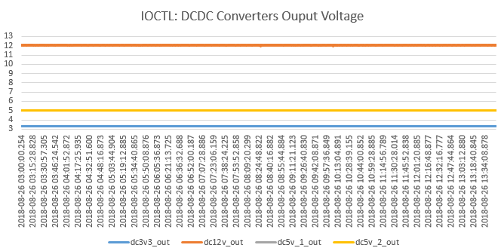

Figure 39: IOCTL: DCDC Converters Voltage Output Monitoring - Full Duration

- end of the document -