Sex-dependent resource defence in the nectar-feeding bat Glossophaga
Sabine Wintergerst^{1,2}, Vladislav Nachev^{1*}, York Winter^{1*}
¹ Institut für Biologie, Humboldt-Universität zu Berlin, Germany
² Fairchild Tropical Botanic Garden, 10901 Old Cutler Rd, Miami, FL 33156
*For correspondence: vladislav.nachev@charite.de, york.winter@charite.de
Present Address: Institut für Biologie, Humboldt-Universität zu Berlin, 10099 Berlin, Germany

Abstract
Aggressive resource defence is frequently observed throughout the animal kingdom and although it is a widespread phenomenon in nectar-feeding birds, reports of interference competition in nectarivorous bats are extremely rare. Glossophaga soricina has been observed to defend flowers of Agave desmettiana but not much is known about the social structure during resource defence and how interference competition leads to resource monopolization and affects nectar intake. Here, we investigated the resource defence behaviour of G. soricina in a laboratory setting. By using an experimental set-up consisting of two patches of computer-controlled artificial flowers we tracked the nectar intake of every group member. Furthermore, we established an automated method for flagging potentially aggressive interactions at proximity to the artificial flowers. Theoretical models of interference competition predict that aggressive interactions increase when resources are spatially more clumped. We varied resource distribution across two patches from clumped to distributed to assess how resource density influences aggressive interactions. Resource defence behaviour was assessed in 36 individuals divided into one male and one female group, as well as four mixed-sex groups. Males engaged in potentially aggressive interactions significantly more often than females and in each group some individuals were successful in defending artificial flowers. Subordinate males experienced a substantial decrease in nectar intake. However, females were only marginally affected by male aggression and maintained nectar intake. These results suggest that aggressive interactions and their effect on nectar intake are sex-dependent in G. soricina. Furthermore, as expected, aggressive interactions were more frequent and resource defence was only successful in the mixed groups when resources were clumped. Our novel experimental set-up allowed us to perform a mostly automated experimental test of models of interference competition and resource defence with a mammal under the controlled conditions of the laboratory. This new approach may pave the way for further such studies with other animals.

Keywords:
resource defence, economic defendability, bat, Glossophaga

1. Introduction
Competition for limited resources like food or mates is a ubiquitous phenomenon in the animal kingdom. Such competition can be indirect by exploiting a common resource and preventing others from benefiting from it (Paton and Carpenter 1984); or it can be direct by aggressively defending a resource. The latter is known as interference competition (Amarasekare 2002). Aggressive resource defence by excluding competitors leads to priority of access to those resources and thus establishes dominance. One individual is dominant over another if it directs aggressive behaviour towards it (chasing, threatening, biting, etc.) while receiving little or no aggression from the other (Chase et al. 2002). In the extreme, dominance behaviour can lead to exclusive territoriality. Territoriality is a concept belonging to an indivisible continuum starting with the transient monopolization of a preferred feeding opportunity to the longer-term defence of an area as exclusive territory. The rules of economic defendability (Brown 1964) determine the adaptive compromise to which a species’ dominance behaviour will evolve and develop along this continuum. The establishment of feeding territories is well known for nectar-feeding birds (Boyden 1978; Carpenter and Macmillen 1976; Ewald and Carpenter 1978; Gill and Wolf 1975).
The cost of defence, a key parameter in the economic defendability equation, is likely much higher for a nocturnal, echolocating bat than for a diurnal, visually oriented bird. The successful resource defence is only possible after the competition is detected. Visual detection in the daylight works well over long distances. In contrast, for a nocturnal, echolocating bat, especially for phyllostomid bats that are able to echolocate with whispering calls (Howell 1974; Hörmann et al. 2020; Yoh et al. 2020), detecting intruders at a feeding territory’s boundary would require expensive patrolling flights.
Within bats, the flower visitors have an additional advantage if they are intimately familiar with their feeding area. Compared to an insect-hunting bat that must continually scan for elusive prey by active echolocation, a flower visitor can approach a target with minimal echolocation when seeking specific flowers at known locations (Thiele and Winter 2005; Winter and Stich 2005; Gonzalez-Terrazas et al. 2016; Rose et al. 2016). Thus, it is not surprising that the longer-term defence of extensive feeding territories as commonly observed in nectar-feeding birds is not known for glossophagine, nectar-feeding bats (but see Watzke 2006 for nectar-feeding flying foxes). Nonetheless, several observations have documented aggressive food defence by glossophagine bats. The inflorescences of Agave desmettiana with their copious nectar (Lemke 1985) may be defended by males or females of Glossophaga soricina against conspecifics but only during some hours of the night (Lemke 1984, 1985). When left unguarded, intruders quickly exploited the opportunity to feed from the previously defended plants. The Costa Rican bat Glossophaga commissarisi occasionally defends and temporarily monopolizes single inflorescences of the understory palm Calyptrogyne ghiesbreghtiana against other hovering bats, perching bats and katydids (Tschapka 2003). A commonality in these reports was that the defence did not cover the area of a typical feeding range but was restricted to a single or a few flowering plants and was also limited to a small number of hours during the night. Thus, glossophagine bats can show aggressive resource defence.
In this study, we investigated for a nocturnal, nectar-feeding mammal, the flower-visiting bat Glossophaga soricina, the role of aggressive interactions for gaining access to nectar food. We tested the predictions of models of resource defence (Grant et al. 2002) and interference competition (Grant 1993) during a naturalistic foraging paradigm in the laboratory. The occurrence of resource defence is predicted to be highest at intermediate levels of food abundance (Grant et al. 2002). In line with this prediction, the transient nature of nightly defence behaviour observed in the field suggests that changes in food-abundance or food-requirements that occur within the night affected the strength of the observed behaviour. To mimic the natural situation of flowers that replenish their nectar more or less continuously (e.g. Tschapka and Helversen 2007) we programmed artificial flowers to provide nectar with a fixed interval reward schedule. Once a nectar reward had been taken by any bat, the fixed interval had to pass before the next reward was available at this flower.
Furthermore, theoretical models of interference competition predict that clumped resources lead to more agonistic behaviour and resource defence than evenly distributed resources (Grant 1993). To include a test of these predictions in our experimental design, we spatially subdivided our flower field into two patches and programmed them to automatically change during the night the spatial distribution of available nectar resources. We performed our study with 36 individuals of male and female G. soricina. By using artificial flowers in a closed environment, we could track all flower visits and total nectar consumption of every individual in the group. Each individual carried an electronic ID tag and flowers were equipped with ID sensors. This also enabled us to detect and quantify a typical class of aggressive interactions between pairs of individuals directly at the artificial flowers fully automatically.
Our novel experimental set-up thus allowed us to perform a mostly automated experimental test of models of interference competition and resource defence with a mammal under the controlled conditions of the laboratory. This new approach may pave the way for further such studies with other groups of organisms.

2. Materials and methods

(a) Subjects and housing
Experiments were conducted with 36 individuals of the small, (9-10g) neotropical nectarivorous bat species Glossophaga soricina (Pallas’s long-tongued bat). Bats came from a captive colony (founders originating from Mexico, 1988) and were older than one year as judged by finger joint ossification (Brunet-Rossini and Wilkinson 2009). Bats carried Radio Frequency Identification (RFID) tags attached to cable tie collars (total weight of collar and RFID tag = 0.2g, max. 2.4% of the body weight) that were removed after the experiment. Additionally, bats had numbered plastic split rings (A C Hughes Ltd., Middlesex, UK) around the forearm for visual identification. Temperature in the experimental and colony room was kept at 20-25°C, air humidity at 65-75%, and light conditions were 12:12 LD (light off at 16h).

(b) Experimental set-up
In the experimental room ten artificial flowers with automated nectar delivery (Winter and Stich 2005) were mounted along a 4.2m bar at a height of 1.2m (Fig. 1). The distance between flowers was 0.4m. Flowers were divided into two groups of five to simulate two flower patches. Each patch was enclosed by a sheet-covered frame to separate the groups of flowers spatially (Fig. 1). The only entrance to the patches was a 0.4m gap between the ground and the bottom end of the enclosure (Fig. 1, dashed line). From this entrance bats had to fly up vertically to reach the flowers, which should have increased the costs for switching between patches. A syringe pump delivered nectar via tubes and pinch valves to the artificial flowers. Nectar rewards were triggered by the interruption of an infrared light barrier at the flower opening. The RFID reader below the flower head identified a bat’s ID code. Visits (infrared light barrier interruptions by tagged bats) and other sensor events were recorded for all flowers during every experimental night. The reward schedule was configured using PhenoSoft Control (Phenosys GmbH, Berlin, Germany). Every detected event at a flower (including date, time, identity of the individual, duration of the event and amount of nectar delivered) was recorded for data analysis.
Figure 1: Experimental set-up consisting of two spatially separated flower patches. (A) The flowers where mounted 1.2m above ground. These ten flowers were divided into two patches (L and R) with five flowers each. (B) The patches were spatially separated by using a wooden frame covered with plastic sheet. To make it more demanding for bats to enter the patch, the only entrance was close to the ground in front of the flowers through a gap of 0.4m from the ground to the lower rim of the plastic foil. (C) Schematic drawing of the experimental set-up from above. The dashed line indicates the side with the patch entrance.

(c) Experimental procedure
Six bats were randomly caught from the colony and were tested simultaneously as a group. Four experimental groups consisted of three males and three females (mixed groups), whereas one group consisted of six males, and another of six females. All bats were weighed before the experiment.
During the nightly experiments, in addition to the nectar provided by artificial flowers, bats had access to pollen and water and to 6$mL$ of additional food containing 200mg NektarPlus (Nekton, Keltern, Germany) and 300mg milk powder (Milasan Folgemilch 2, Sunval Baby Food GmbH, Mannheim, Germany) dissolved in water. Rewards at flowers consisted always of 30$μL$ nectar (15% w/w sugar concentration, sucrose: fructose 1:2). Before the experimental schedule started, individuals were allowed to familiarize themselves with the set-up and the artificial flowers. Since during this training phase the plastic cover was removed, the two flower patches were not spatially separated and every flower visit was rewarded. This phase lasted for one to four nights until each bat visited the flowers regularly. One female of the first mixed group did not visit any artificial flower during the first night and was replaced by another female.
During the main experiment, the two flower patches were covered and spatially separated. Experimental nights were divided into two phases. During the first phase of the night only one of the two flower patches was rewarding, and therefore the resources were spatially clumped. The fixed time interval between rewards was 60s. During the second phase of the night both patches gave rewards, resources were evenly distributed across the patches, and the fixed time interval between two rewards at a flower was increased to 120s. Therefore, the amount of food available per unit time did not change during the whole night; only the spatial distribution of food changed from the clumped resource condition with one patch rewarding (five flowers) during the first phase of the night to the distributed resource condition with two patches rewarding (ten flowers) during the second phase of the night. With this experimental schedule, the maximal amount of nectar the bats could collect was 108$mL$, which corresponds to 18$mL$ nectar per individual per night. The rewarding patch during the first phase of the night was chosen pseudo-randomly and the same patch was never chosen in more than two consecutive nights. For the mixed groups, the duration of the clumped resource condition was six hours and the main experiment lasted nine nights (seven nights for the first mixed group). For the same-sex groups, the duration of the first part of the night was variable (range = 4-8h, mean = 6h) and the main experiment lasted eight nights for the male group and seven nights for the female group.

(d) Chasing behaviour
We took the chasing frequency of individuals at the artificial flowers as an indicator of the intensity of aggressive interactions between group members. We developed a method to automatically detect and score chasing events using the computer-collected animal identification data from the RFID sensors and flower sensors. In a previous pilot study (Wintergerst 2018), three mixed groups of bats were video recorded for 24h over 14 nights, and the video data were synchronized to the computer-collected data. From the analysis of the combined data we were able to identify the following pattern of visitation events that reliably indicated a chasing event between two identified individuals: (i) an identified bat collected a reward at a flower and (ii) was immediately followed by a very brief (<200ms) RFID detection of a second bat, the chaser. Importantly, this second bat never attempted to drink and therefore did not insert its nose into the artificial flower and interrupt the light barrier inside the flower head. This distinguished such a chase from the occasional quick succession of two visits by two bats at the same flower. The automated detection of chasing events not only offers a considerable time profit for the experimenter, but also avoids the human observer bias, a common drawback in video analysis. For the 24 hours of combined video data and automatically logged data, all 89 chasing events detected in the computer-logged data were confirmed by video. Therefore, we consider the algorithm for detecting chasing events in the logged data to be highly reliable. Of course, chases did not only occur at the artificial flowers. Thus, our chase numbers are only an indicator of chasing intensity between pairs of bats. For example, in one hour of video we observed 61 chasing events, but only five of those occurred during flower visits and were also automatically detected. However, since with our algorithm (see below) we detected a total of 1811 chasing events (35.5 ± 12.3 events per night during the main experiment and only 4.8 ± 3 during the training nights, mean ± SD) for the 36 participating bats, we considered the automated approach adequate for quantifying within-group dominance relationships. The total number of individual detections per night constrains the number of chasing opportunities. Therefore, we corrected our counts of chasing events by dividing the number of observed chases for each bat by the total number of detections for that bat on each night.

(e) Statistical analysis
To investigate the difference in chasing behaviour between males and females and between the resource conditions (one versus two rewarding patches) a Bayesian generalized linear mixed model (MCMCglmm, Hadfield 2010) with a binomial error structure was used. Body weight as an approximation of size and the full interaction between resource condition and sex were included as fixed effects and the influence of these fixed effects on the proportion of chasing events was assessed. Experimental group and individual were included as random effects. The same model structure was used to address the question if the proportion of being chased was influenced by these independent variables. If one or more individuals start to defend flowers and thus exclude others from drinking, nectar consumption should increasingly differ between individuals since the successful chaser should gain a higher nectar intake thus reducing the intake of the chased individuals. Therefore, the between-individual difference in nectar consumption over the course of the experiment was compared between experimental groups and resource conditions (clumped vs. distributed). First, each individual’s total nectar consumption standardized by the number of hours of foraging during the clumped (one rewarding patch) and distributed (two rewarding patches) resource condition was determined for each experimental night. Then these data were used to calculate group standard deviations, separately for the males and females of each group. In order to assess the influence of resource defence on the individual differences in nectar consumption (standard deviation of nectar intake) we fit a MCMCglmm model with a Gaussian error structure and the following fixed effects: sex, experimental night (centered), and resource condition (clumped or distributed), as well as all two-way interactions. Again, we included group and individual as random effects.
By plotting individual nectar consumption during the last two nights of the experiment against the frequency of chasing other individuals, two non-overlapping groups of males were obtained, which were labelled dominant and subordinate males, respectively. Such a clear pattern was not observed in females. The identification of dominant individuals was also supported by calculating the individual Glicko ratings (Glickman 1999; So et al. 2015) from all chasing events over the last two experimental nights in each group. In the Glicko Rating algorithm individuals gain or lose ranking points based on their wins or losses and the rating of their opponent (Glickman 1999; So et al. 2015). Glicko ratings were analyzed using the PlayerRatings package in R (Stephenson and Sonas 2020). Based on nectar consumption, the frequency of chasing events and the individual Glicko group ranks (from 1 to 6, with 1 corresponding to the highest Glicko rating), each group contained individuals belonging to one of three different types of social status: female, dominant male, and subordinate male. To address the question whether nectar consumption varied depending on social status during the early and late stages of the experiment we used Welch’s tests and adjusted the p values using the Holms method for multiple comparisons.
All statistical analyses were conducted using R (Team 2021). All data and code are available in the Zenodo repository: xxx.

3. Results

(a) Example of nectar intake in one experimental group
The goal of these experiments was to investigate the social structure of resource defence in Glossophaga soricina, in addition to the potential influence of interference competition on individual nectar intake. The first striking observation we made was the uneven distribution of nectar consumed between the sexes and individuals. For example, in the first mixed group of bats tested, after only two nights the nectar consumption of two males was nearly reduced to zero, whereas the third male increased its consumption substantially (Fig. 2A). This pattern, however, only occurred during the condition when resources were clumped. Nectar consumption of females did not change even during the clumped condition. On the same nights but during the second half of the night, with resources distributed over two patches, nectar consumption of males and females converged at the end of the experiment (Fig. 2B).

(b) Differences between sexes in frequency of chasing and being chased
In all mixed groups males chased other bats in front of flowers significantly more often than females did (Fig. 3A, Table 1). Notably, the frequency of females as active chasers in female-only groups was higher than chasing by females in the mixed groups (Fig. 3A). Although the rate of nectar availability remained constant throughout the night and only the spatial distribution of the resources changed, the number of chasing events was significantly lower during the distributed resource condition when rewards were available at both patches (Table 1). There was no significant difference between the sexes in how often a bat was chased by another individual (Fig. 3B) but individuals were chased less during the distributed resource condition (Table 1). Weight as an indicator of size had no significant effect on chasing frequency or the frequency of being chased (Table 1).
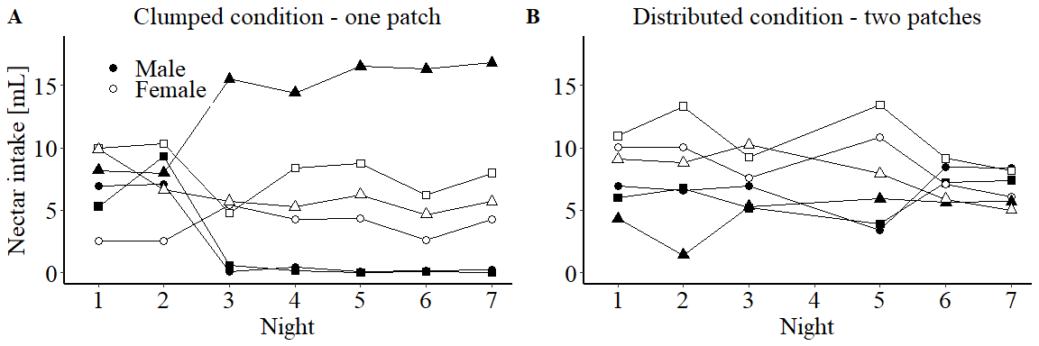
Figure 2: Exemplary change of individual daily nectar consumption during the experiment of one mixed experimental group consisting of three males and three females (symbols show different individuals). (A). During the clumped resource condition (first part of the experimental night) rewards were only available concentrated at one patch. The nectar consumption of two males approached zero after only two nights, whereas the third male received considerably more nectar than at the beginning of the experiment (males filled symbols). Females on the other hand maintained their level of daily nectar consumption (females open symbols). (B) During the distributed resource condition (second part of the experimental night) rewards were available at both patches. Under this condition, individuals nearly equalized their level of nectar consumption over the course of the experiment. The second part of night 4 was excluded due to technical problems.
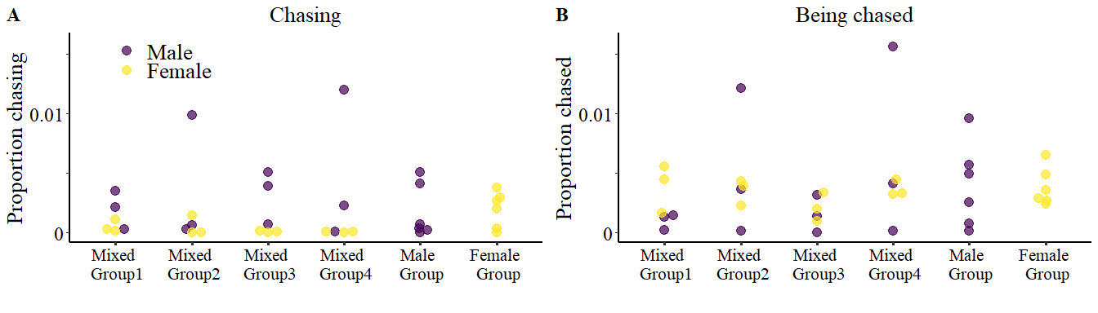
Figure 3: Sexes differed in the frequency of chasing other individuals. (A) Males (dark symbols) chased others significantly more than females did (light symbols, Table 1). Shown are the individual proportions of chasing events over the whole experiment. Notably, in the females-only group some females chased more than any female in the mixed groups. (B) Being chased by other bats did not differ significantly between sexes during the clumped resource condition (Table 1), but the variance was much higher for males.
Table 1: Summary of fixed effects from generalized linear mixed-effects models of chasing frequency and the frequency of being chased.
Model | term | estimate | 95% credible interval | pMCMC
Chasing
 | (Intercept) | -6.52 | (-18.06, 5.46) | 0.252
 | sex (female) | -2.09 | (-3.47, -0.65) | 0.001
 | condition (distributed) | -0.49 | (-0.76, -0.23) | 0.001
 | weight | -0.01 | (-1.34, 1.1) | 0.962
 | sex (female):condition (distributed) | -0.29 | (-0.75, 0.19) | 0.228
Being chased
 | (Intercept) | -2.93 | (-11.98, 4.61) | 0.496
 | sex (female) | 0.90 | (-0.12, 1.86) | 0.078
 | condition (distributed) | -0.98 | (-1.24, -0.74) | 0.001
 | weight | -0.40 | (-1.26, 0.44) | 0.326
 | sex (female):condition (distributed) | -0.13 | (-0.48, 0.24) | 0.440
Note: Fixed estimates whose credible intervals do not span zero are shown in bold. pMCMC = posterior probability

(c) Differences in nectar intake over time and between sexes and conditions
Resource defence should lead to a larger between-individual difference in nectar consumption (Brown 1964). Differences in nectar consumption were quantified as the standard deviation of nectar intake in each group, separately for males and females. During the clumped resource condition, the standard deviation increased significantly over time for males (Table 2, Fig. 6) and was generally higher for males than for females (Table 2, Fig. 6). For females in the clumped resource condition the effect of night was significantly smaller than in males (significant interaction between sex and night, Table 2), and was not itself significant (estimate = 0.03, 95% CI = -0.02, 0.07). Compared to the clumped resource condition, in the distributed resource condition the effect of experimental night was significantly lower for males (interaction between condition and night, Table 2), but not for females (). Moreover, in the distributed resource condition there was no significant change over the course of the experiment in males (estimate = 0.01, 95% CI = -0.03, 0.05) nor in females (estimate = 0.03, 95% CI = -0.02, 0.06).
Table 2: Summary of fixed effects from a generalized linear mixed-effects model of the standard deviation of nectar intake over time.
term | estimate | 95% credible interval | pMCMC
(Intercept) | 0.52 | (0.37, 0.68) | 0.001
sex (female) | -0.20 | (-0.26, -0.14) | 0.001
condition (distributed) | -0.23 | (-0.29, -0.17) | 0.001
night | 0.06 | (0.01, 0.1) | 0.022
sex (female):condition (distributed) | 0.15 | (0.06, 0.23) | 0.001
sex (female):night | -0.03 | (-0.06, -0.01) | 0.015
condition (distributed):night | -0.04 | (-0.07, -0.02) | 0.001
sex (female):condition (distributed):night | 0.04 | (0.01, 0.08) | 0.020
Note: Fixed estimates whose credible intervals do not span zero are shown in bold. pMCMC = posterior probability

(d) Social status and its effects on nectar intake
When plotting chasing events against nectar consumption the data for males fall into two non-overlapping groups. The males of one cluster (Fig. 4A, inside dashed oval) chased other individuals and consumed more nectar than the other males. This cluster included only one male from the mixed groups but two males from the males-only group. These males were categorized as “dominant.” The second cluster of males (Fig. 4A, outside and below dashed oval) was characterized by a low frequency of chasing and low nectar consumption. These males were categorized as “subordinate.” In females such a pattern did not emerge (Fig. 4B). This classification was also supported by the Glicko ratings in each group (Fig. 7) and the observation that there was generally an inverse relationship between the frequency of chasing and the frequency of being chased, especially in males (Fig. 8). While in the females-only group four females chased other females more frequently, only one of these females would be classified as dominant using the same cut-off criteria we used for the males (Fig. 4B), but it was not the female with the highest Glicko rating (Fig. 7). During the last two nights of the experiment in the clumped resource condition, the highest nectar intake was observed in dominant males, with an intermediate intake in females, and lowest nectar intake in subordinate males (Fig. 5). In contrast, in the distributed resource condition there were no differences between the nectar intake of dominant and subordinate males in any stage of the experiment (Fig. 5), while the subordinate males had a significantly lower nectar intake than females in the first two, but not in the last two experimental nights (Fig. 5). Finally, the subordinate males increased their nectar intake from the clumped to the distributed condition, but the difference was only significant for the last two experimental nights (Fig. 5). While there was a correspondent decrease in the nectar intake of dominant males, it was not significant, most likely due to the small sample size (n = 6, Fig. 5). Again, in females there was no change in nectar intake between the resource conditions (Fig. 5)
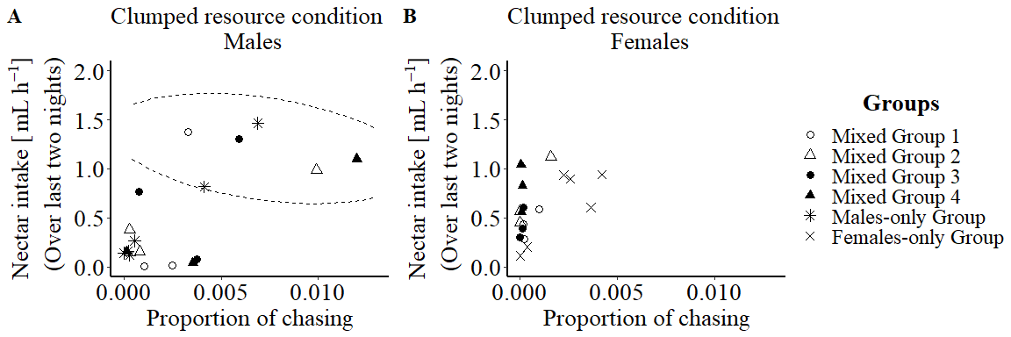
Figure 4: Influence of chasing frequency on nectar intake in the clumped resource condition during the last two nights of the experiment. (A) Males that more often chased other males also consumed more nectar. Males were divided into two non-overlapping groups by considering the chasing frequency and the amount of nectar an individual received during the clumped resource condition at the end of the experiment. Dominant males (inside dashed line oval) met two criteria: they chased other individuals at flowers more frequently (>0.003) and received more nectar (>0.75$mL h^{-1}$) during the clumped resource condition. Individuals outside the dashed line oval were categorized as subordinate males. (B) Nectar consumption of females did not generally depend on chasing frequency during the clumped resource condition and non-overlapping groups did not emerge.
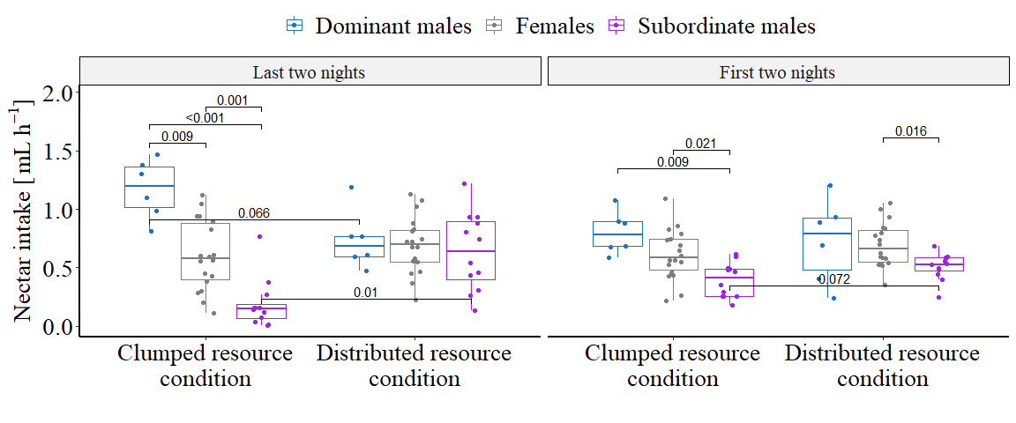
Figure 5: Comparison of nectar consumption during the first and last two nights of the experiment depending on sex and social status. During the clumped resource distribution (left panel), already at the beginning of the experiment subordinate males collected significantly less nectar than dominant males and females. At the end of the experiment, females, dominant and subordinate males differed to a large extent in their nectar consumption. During the distributed resource condition at the beginning of the experiment subordinate males received less nectar than females, but these differences disappeared by the end of the experiment. Numbers above brackets are the p values from unequal variance T tests (Welch’s tests), adjusted for multiple comparisons using the Holms method. Contrasts between conditions were from paired Welch’s tests. For clarity, only p values smaller than 0.1 are shown.

(e) Behavioural observations
Qualitative behavioural observations of four hours of video recordings revealed several behaviours that seem to be characteristic for dominant males. Instead of just visiting the flowers and leaving the patch as the other individuals did, dominant males remained hanging between the flowers within the patch for a significant amount of time (Fig. 9). When other individuals came close due to visits of directly adjacent flowers, dominant males often spread one wing in the direction of the other individual which could be interpreted as a threatening posture. Some individuals were attacked and chased away by dominant males while visiting artificial flowers. In this case, dominant males mostly attacked from above with their mouth wide open, and followed the intruder for a short distance. Sometimes the chasing escalated into fighting with both bats tumbling towards the ground and resuming their flight only shortly above the floor. In rare cases, these fights might have led to small injuries. One subordinate male had several fresh scratches on its wing that were not present before the experiment and that were possibly caused by bites (Fig. 10). After a successful flower defence, the dominant male normally visited most of the five flowers within the patch before returning to its hanging position between the flowers.

4. Discussion
Similar to observations in free-living populations, in this experiment Glossophaga soricina competed for nectar not only by exploitation but also by interference competition. However, the results show that the predisposition to defend resources and the influence of interference competition on individual nectar intake differed significantly between the sexes. Only a subset of individuals, exclusively male in the mixed-sex groups, successfully defended flower patches. Dominant individuals were characterized by the highest frequency of chasing other individuals away from profitable flowers, by the highest Glicko ratings, and by a substantial increase in nectar intake by the end of the experimental run. Although the dominant males in the mixed groups chased females and other males equally often, only the nectar intake of subordinate males but not of the females was affected by this behaviour. Thus, male-initiated interference competition increased the difference in nectar intake between males but did not affect females. The frequency of aggressive interactions was higher and males only defended resources successfully when the available nectar was concentrated at only one flower patch. This supports the hypothesis that clumped resources favour an increase in aggressive interactions (Grant 1993).

(a) Sex-dependent resource defense and its differential effect on nectar intake, depending on social status
To the best of our knowledge, this study is the first report of sex-dependent differences in the resource defence behaviour of neotropical nectar-feeding bats. In mixed sex groups, females seemed to be much less affected by the behaviour of dominant males whereas subordinate males were excluded at least partially from the defended flower patch. This finding is consistent with observations of free-flying G. commissarisi, in which males visited on average a smaller number of artificial flowers than females did (Nachev and Winter 2019), presumably because of interactions with other males. There are two possible explanations for this differential effect on subordinate males and females. On the one hand, dominant males might just not be capable of excluding females. On the other hand, dominant males could tolerate females in their defended patch because they might receive additional benefits, for example tolerating females could lead to an increase in (future) mating opportunities. Similar social dynamics have been described in the insectivorous bat species Myotis daubentonii (Senior, Butlin, and Altringham 2005). Dominant males of this species temporarily exclude other males from profitable habitats whereas females are tolerated and in addition to securing access to resources, the successful exclusion of other males has been shown to increase the reproductive success of dominant males (Senior, Butlin, and Altringham 2005). Similarly, it has been observed that male purple-throated caribs (Eulampis jugularis), which successfully defend highly profitable feeding-territories against other males while sharing the available resources with females, experienced an increase in their mating success (Temeles and Kress 2010).
However, in our experiment dominant males chased females about as often as they chased subordinate males (Table 1). If females were able to feed in the defended patch because dominant males tolerated them due to potential additional benefits, it could be that the detected chasing events by dominant males differed in quality depending on the sex of the intruder. This was not further quantified in the current study, but could potentially be investigated using audio recordings (Knörnschild, Glöckner, and Helversen 2010). We extracted the frequency of chasing events from data automatically recorded at artificial flowers (successive detection of two different IDs while the first was feeding at the flower). Therefore, it was not possible to determine if males showed behavioural differences when chasing other males in comparison to chasing females. The recorded video revealed that individuals chased each other not only directly at the artificial flowers but also in other areas of the flower patch. Since individuals could only be identified by their RFID tag directly at the RFID reader attached to artificial flowers the sex of individuals chasing each other in other areas of the experimental room remains unknown. However, after the experiment some subordinate individuals showed marks from small injuries at their wings (see example in Fig. 10) and such marks were only observed in males. This could be an indication that dominant males directed more aggression (biting) towards subordinate males than towards females. Such sexual dimorphism in aggressive resource defence is also known from other nectar-feeding vertebrates, like hummingbirds. It is thought that the beaks of the males of some territorial species are specifically adapted as intrasexually selected weapons (Rico-Guevara et al. 2019).

(b) Some observations from the single-sex groups
Generally, females showed lower chasing frequencies, but, surprisingly, some females in the females-only group showed an increased nectar consumption and chasing frequency, compared to the females in the mixed groups (Fig. 4B). Thus it appears that in the absence of male individuals, some females exerted dominant behaviour over the other females, similar to males. These findings are similar to the social structure of resource defence found in some nectar-feeding bird species. For example, in free-living ruby-throated hummingbirds females also have lower levels of defence (Rousseu, Charette, and Bélisle 2014). Moreover, although both male and female Eulampis jugolaris hummingbirds defend feeding territories during the non-breeding season, males are always dominant over females (Wolf and Hainsworth 1971; Temeles, Goldman, and Kudla 2005). It would be interesting to better understand why females were less affected by the aggressive resource defence behaviour of dominant males compared to subordinate males and why females themselves did not consistently monopolize the profitable patch against other females, not even in the females-only group. Of course, as there was but a single females-only group, the latter observation needs to be confirmed with more data. One possibility is that females do not need to defend flowers when a dominant male is already reducing the number of flower visitors and thus increasing the amount of food available.
In all mixed sex groups, only one male per group became dominant and successfully defended flowers, whereas in the males-only group two males exhibited dominant behaviour (Fig. 4A). A closer look at the nectar consumption at each flower revealed that on the last night of the experiment these two males had nearly monopolized different flowers within the same patch rather than sharing access to the same flowers (Fig. 11). Such flower partitioning was also observed in the females-only group (Fig. 12), but rarely seen in the mixed groups (Figs. 13-16). The successful resource defence by two individuals in the male-only group showed that resource defence can occur independent of the presence of females, but was only based on a single observation.

(c) Social status and social hierarchy
Although the position of the rewarding patch during the clumped resource condition changed between the nights between the left and right, usually the same male continued to successfully defend the patch, especially in the mixed-sex groups (Figs. 11-16). This means that males defended the resources themselves and not a particular location. Furthermore, this shows that even after changing the location of the defended patch the same individuals were usually able to succeed in re-establishing their dominance against other males, indicating a stable hierarchy at least for the duration of the experiment.
The ability of an individual to successfully defend and monopolize resources is often correlated with distinct physical characteristics for example body size (Searcy 1979). However, in our results weight as an approximation of size did not correlate significantly with the chasing frequency of individuals (Table 1) and therefore did not predict which male succeeded to defend a flower patch. Another factor that could influence the success in defending flowers is age and therefore experience (Arcese 1987; Yasukawa 1979). Since we could only discriminate between young and adult animals, we cannot dismiss age and experience as a predictor of successful flower defence.
In this study, subordinate males received considerably less nectar than dominant males and females (Fig. 5). However, except in mixed group 1, subordinate males were rarely completely excluded from the flower patch and their average nectar intake during the clumped resource condition was still 0.3 $±$ 0.18 $mL h^{-1}$ (mean $±$ SD). This result is in accordance with observations of free-living G. soricina in Colombia. There, subordinate bats exploited the flowers defended by other individuals as soon as the dominant bat temporarily ceased defending (Lemke 1984). Furthermore, in our study the frequency of chasing events decreased significantly during the distributed resource condition in the second part of the night (Table 1). This supports the theoretical prediction that aggressive defence behaviour increases when resources are spatially concentrated (Grant and Guha 1993), with the important caveat that the sequence of conditions was not controlled in this experiment. With the current data we cannot answer whether the dominant males would successfully defend a patch if the condition changed from distributed to clumped, but we believe this is a different question that should be addressed separately. Resource defence should only occur when the energy gain outweighs the cost of aggressive interactions (Brown 1964). Thus, our results could be explained by the decrease in quality of the defended patch once its nectar supply dropped to half. This is also supported by the very low number of chases observed during training when the flowers were not separated in discrete patches. Together, these results suggest that along the different degrees of territorial behaviour, resource defence observed in G. soricina seems to represent a transient monopolization of resources instead of a longer-term permanent exclusion of intruders.

(d) Conclusion
Although flower defence behaviour of G. soricina was investigated in a laboratory setting, we observed similar behaviour as described in free-living populations. Our results revealed a sexual dimorphism in flower defence behaviour in mixed-sex groups. Only males successfully defended flower patches and excluded other males from their defended resource, whereas females remained unaffected by this male behaviour and continued to visit the flowers guarded by a male. This observed pattern is similar to resource defence behaviour observed in other nectar-feeding vertebrates. Furthermore, we could show that the frequency of aggressive interactions was, as predicted, higher when resources were clumped in one patch and transient. Future studies with free-living populations have to be conducted to assess how frequent and important resource defence in these nectar-feeding bats is and if males that are successful in defending resources have additional fitness advantages.

Supplementary material

Video analysis
There were 89 chase occurrences observed (f->f 4 times, f->m 2 times, m->f 59 times, m->m 24 times). Every time the algorithm marked an event as a chase event, there were two individuals following each other. Some chase sequences did not get detected. The individual that chased never drank immediately after the chase at the same flower location where the chase occurred. There were 16 incidences that were difficult to classify by observation or did not appear to be aggressive interactions.
f->f appear to be less aggressive
f->m appear aggressive
m->f appear aggressive
m->m appear aggressive

Supplementary figures
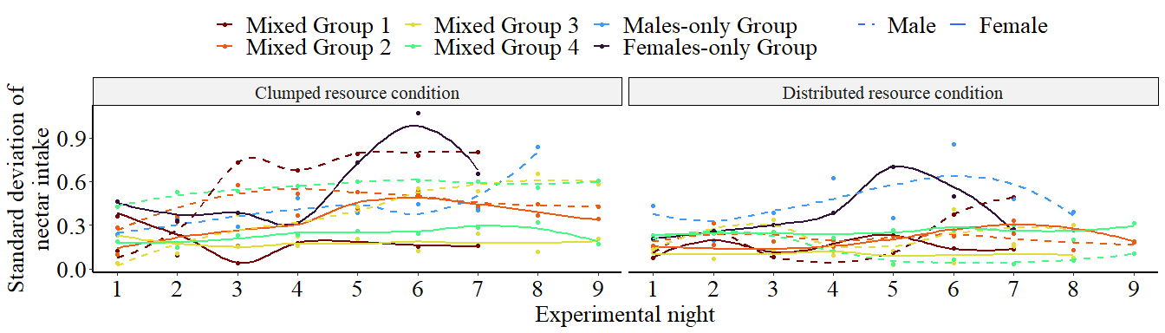
Figure 6: The standard deviation of group nectar consumption was used to measure the between individual differences in nectar intake. It was calculated for the clumped (left panel) and the distributed (right panel) resource conditions, separately for males (dashed lines) and females (continuous lines) from each experimental group (different colours). For visualization only, lines give the corresponding fits based on locally weighted scatterplot smoothing (loess). The statistical analysis was based on linear regression (see Methods).
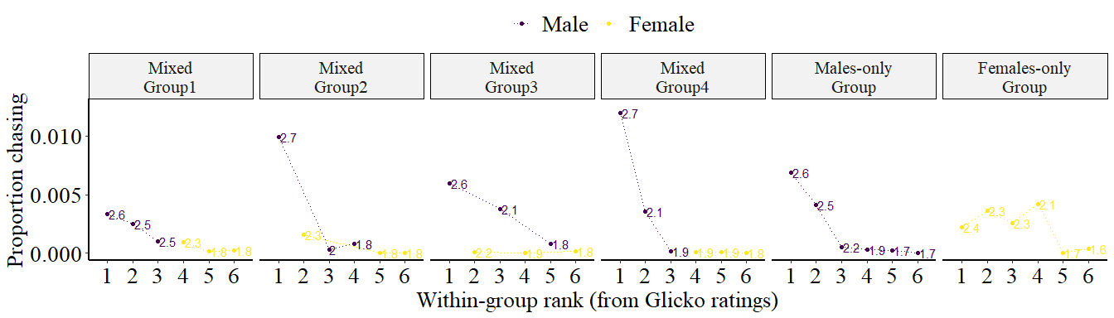
Figure 7: Over the last two experimental nights, the males (dark lines and symbols) with the highest proportion of chasing events were also the individuals with the highest Glicko rating (numbers, in thousands) in each group (panels) during the clumped resource condition. There was no such correspondence for females in the female-only group (right panel).
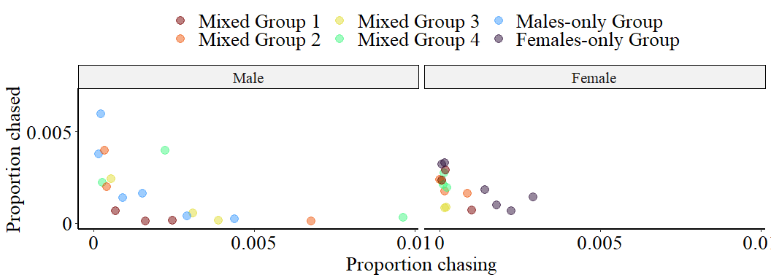
Figure 8: The relationship between proportion of chases versus the proportion of being chased out of all detections over the whole experiment for the female (right) and male (left) individuals in the six experimental groups (different colours).

Figure 9: Video of the dominant male in mixed group 3 chasing all bats approaching the rewarding flowers in the rewarding patch during the clumped resource condition.

Figure 10: Wing images of a subordinate male from mixed group 4. The same individual was photographed before (A) and after the experiment (B). The black arrow points to the scarred location due to wing injuries, purportedly caused by the dominant male.

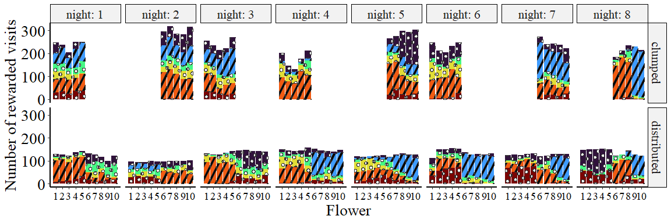
Figure 11: Distribution of rewarded visits across flowers for the six bats in the males-only group. The coloured bars give the number of rewarded visits of each individual at the ten flowers during the clumped (top) and distributed (bottom) resource conditions for each experimental night (columns). The dominant males are shown with black stripes and the subordinate males are shown with white dots. This was the only group with two males behaving as dominant. On the last night, rather than sharing all flowers within the defended patch, the dominant males partitioned the patch into two subpatches, with each bat defending its own partition.
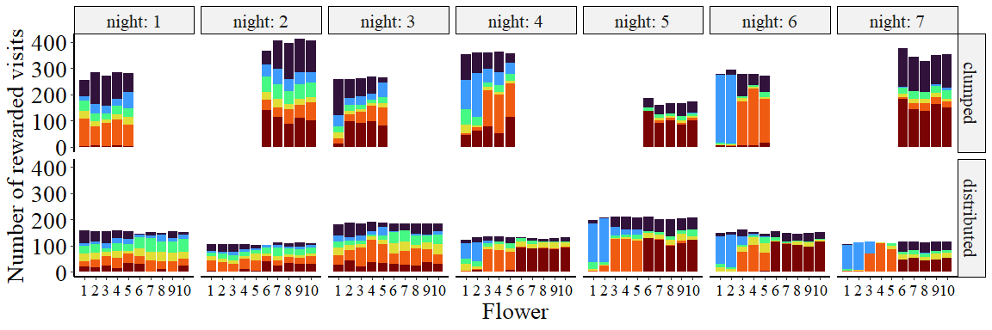
Figure 12: Distribution of rewarded visits across flowers for the six bats in the females-only group. The coloured bars give the number of rewarded visits of each individual at the ten flowers during the clumped (top) and distributed (bottom) resource conditions for each experimental night (columns). Females in this group exhibited the highest frequency of chasing behaviour compared to all other females. This is also the only group, in which females nearly monopolized flower patches or flowers within a patch.
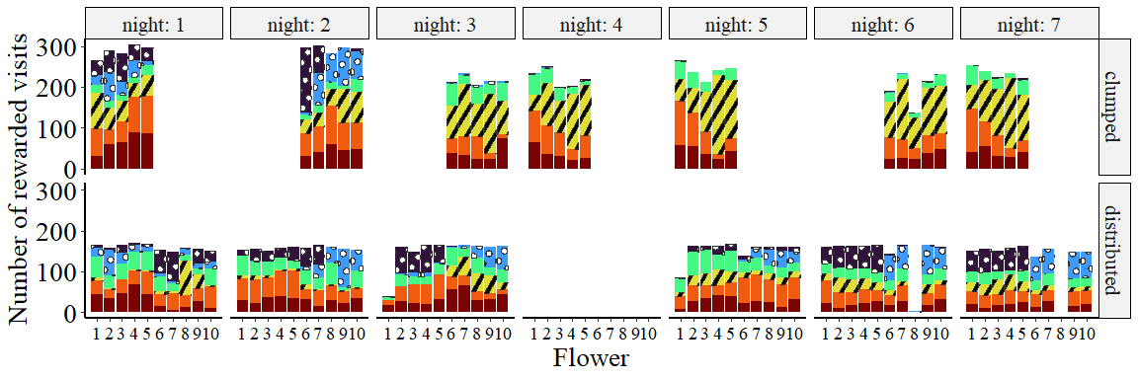
Figure 13: Distribution of rewarded visits across flowers for the six bats in mixed group 1. The coloured bars give the number of rewarded visits of each individual at the ten flowers during the clumped (top) and distributed (bottom) resource conditions for each experimental night (columns). The dominant male is shown with black stripes, the subordinate males are shown with white dots, and the females are shown with solid bars. Due to a technical malfunction on night 4, there were no rewards delivered in the distributed resource condition and the data were excluded from analysis.
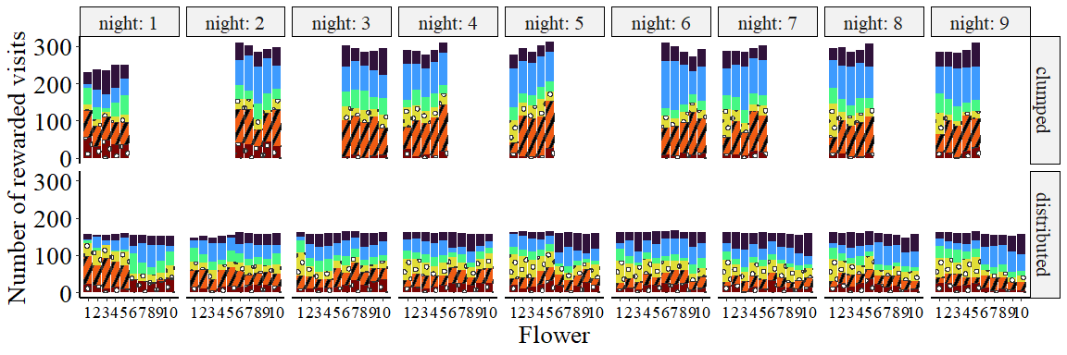
Figure 14: Distribution of rewarded visits across flowers for the six bats in mixed group 2. Same notation as in Fig. 13, but the colours correspond to different individuals.
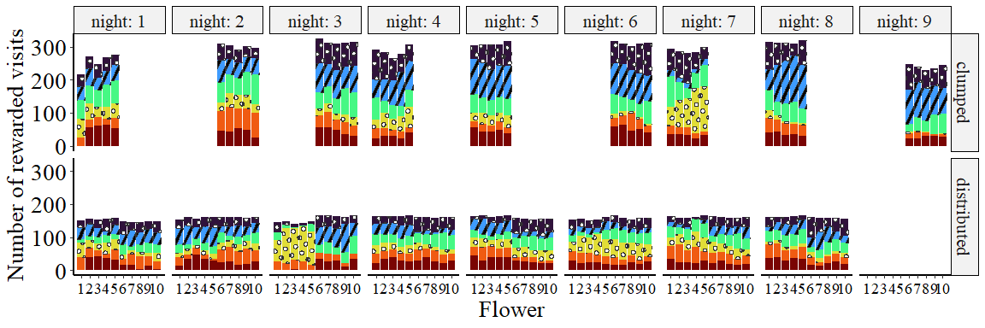
Figure 15: Distribution of rewarded visits across flowers for the six bats in mixed group 3. Same notation as in Fig. 13, but the colours correspond to different individuals. Due to a technical malfunction on night 9, there were no rewards delivered in the distributed resource condition and the data were excluded from analysis.
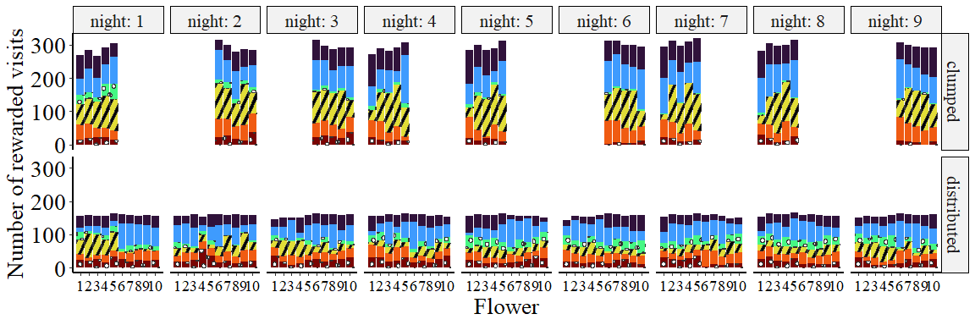
Figure 16: Distribution of rewarded visits across flowers for the six bats in mixed group 4. Same notation as in Fig. 13, but the colours correspond to different individuals.

Data accessibility
All data and code are available in the Zenodo repository: xxx.

Authors’ contributions
S.W. Conceptualization, Methodology, Software, Data collection, Formal Analysis, Video Analysis, Writing—original draft. V.N. Conceptualization, Methodology, Software, Formal Analysis, Data curation, Writing—review and editing, Visualization, Supervision, Project Administration.
Y.W. Conceptualization, Resources, Methodology, Software (data acquisition), Writing—review and editing, Supervision.

Competing interests
We declare we have no competing interests.

Funding
S.W. was supported by Elsa-Neumann-Stipendium des Landes Berlin.

Acknowledgements
We thank Katja Frei and Peggy Hoffmann for assistance with the main experiments and animal keeping, Alexej Schatz for programming of the control software, and Peter Spende, Francesco Bagorda, and Waldemar Krzok for help with the experimental hardware. We also thank Marion Rivalan and Lucille Alonso for a fruitful discussion on the analysis of social behaviour.

References
Amarasekare, Priyanga. 2002. “Interference Competition and Species Coexistence.” Proceedings of the Royal Society of London. Series B: Biological Sciences 269 (1509): 2541–50. https://doi.org/10.1098/rspb.2002.2181.
Arcese, Peter. 1987. “Age, Intrusion Pressure and Defence Against Floaters by Territorial Male Song Sparrows.” Animal Behaviour 35 (3): 773–84. https://doi.org/10.1016/S0003-3472(87)80114-8.
Boyden, Thomas C. 1978. “Territorial Defense Against Hummingbirds and Insects by Tropical Hummingbirds.” The Condor 80 (2): 216–21. https://doi.org/10.2307/1367921.
Brown, Jerram L. 1964. “The Evolution of Diversity in Avian Territorial Systems.” The Wilson Bulletin 76 (2): 160–69. https://www.jstor.org/stable/4159278.
Brunet-Rossini, Anja K., and Gerald S. Wilkinson. 2009. “Methods for Age Estimation and the Study of Senescence in Bats.” In Ecological and Behavioral Methods for the Study of Bats., 2nd. ed, 315–25. Baltimore, MD: Johns Hopkins University Press.
Carpenter, F. L., and R. E. Macmillen. 1976. “Threshold Model of Feeding Territoriality and Test with a Hawaiian Honeycreeper.” Science (New York, N.Y.) 194 (4265): 639–42. https://doi.org/10.1126/science.194.4265.639.
Chase, Ivan D., Craig Tovey, Debra Spangler-Martin, and Michael Manfredonia. 2002. “Individual Differences Versus Social Dynamics in the Formation of Animal Dominance Hierarchies.” Proceedings of the National Academy of Sciences 99 (8): 5744–49. https://doi.org/10.1073/pnas.082104199.
Ewald, Paul W., and F. Lynn Carpenter. 1978. “Territorial Responses to Energy Manipulations in the Anna Hummingbird.” Oecologia 31 (3): 277–92. https://doi.org/10.1007/BF00346248.
Gill, Frank B., and Larry L. Wolf. 1975. “Economics of Feeding Territoriality in the Golden-Winged Sunbird.” Ecology 56 (2): 333–45. https://doi.org/https://doi.org/10.2307/1934964.
Glickman, Mark E. 1999. “Parameter Estimation in Large Dynamic Paired Comparison Experiments.” Journal of the Royal Statistical Society: Series C (Applied Statistics) 48 (3): 377–94. https://doi.org/https://doi.org/10.1111/1467-9876.00159.
Gonzalez-Terrazas, Tania P., Carlos Martel, Paulo Milet-Pinheiro, Manfred Ayasse, Elisabeth K. V. Kalko, and Marco Tschapka. 2016. “Finding Flowers in the Dark: Nectar-Feeding Bats Integrate Olfaction and Echolocation While Foraging for Nectar.” Royal Society Open Science 3 (8): 160199. https://doi.org/10.1098/rsos.160199.
Grant, James W. A. 1993. “Whether or Not to Defend? The Influence of Resource Distribution.” Marine Behaviour and Physiology 23 (1-4): 137–53. https://doi.org/10.1080/10236249309378862.
Grant, James W. A., Isabelle L. Girard, Cindy Breau, and Laura K. Weir. 2002. “Influence of Food Abundance on Competitive Aggression in Juvenile Convict Cichlids.” Animal Behaviour 63 (2): 323–30. https://doi.org/10.1006/anbe.2001.1891.
Grant, James W. A., and Rabi T. Guha. 1993. “Spatial Clumping of Food Increases Its Monopolization and Defense by Convict Cichlids, Cichlasoma Nigrofasciatum.” Behavioral Ecology 4 (4): 293–96. https://doi.org/10.1093/beheco/4.4.293.
Hadfield, Jarrod D. 2010. “MCMC Methods for Multi-Response Generalized Linear Mixed Models: The MCMCglmm R Package.” Journal of Statistical Software 33 (2): 1–25.
Howell, D. J. 1974. “Acoustic Behavior and Feeding in Glossophagine Bats.” Journal of Mammalogy 55 (2): 293–308. https://doi.org/10.2307/1378999.
Hörmann, David, Marco Tschapka, Andreas Rose, and Mirjam Knörnschild. 2020. “Distress Calls of Nectarivorous Bats (Glossophaga Soricina) Encode Individual and Species Identity.” Bioacoustics 0 (0): 1–19. https://doi.org/10.1080/09524622.2020.1720815.
Knörnschild, Mirjam, Volker Glöckner, and Otto von Helversen. 2010. “The Vocal Repertoire of Two Sympatric Species of Nectar-Feeding Bats (Glossophaga Soricina and G. Commissarisi).” Acta Chiropterologica 12 (1): 205–15. https://doi.org/10.3161/150811010X504707.
Lemke, Thomas O. 1984. “Foraging Ecology of the Long-Nosed Bat, Glossophaga Soricina, With Respect to Resource Availability.” Ecology 65 (2): 538–48. https://doi.org/10.2307/1941416.
———. 1985. “Pollen Carrying by the Nectar-Feeding Bat Glossophaga Soricina in a Suburban Environment.” Biotropica 17 (2): 107–11. https://doi.org/10.2307/2388502.
Nachev, Vladislav, and York Winter. 2019. “Behavioral Repeatability and Choice Performance in Wild Free-Flying Nectarivorous Bats (Glossophaga Commissarisi).” Behavioral Ecology and Sociobiology 73 (2): 24. https://doi.org/10.1007/s00265-019-2637-4.
Paton, David C., and F. Lynn Carpenter. 1984. “Peripheral Foraging by Territorial Rufous Hummingbirds: Defense by Exploitation.” Ecology 65 (6): 1808–19. https://doi.org/10.2307/1937777.
Rico-Guevara, A, M A Rubega, K J Hurme, and R Dudley. 2019. “Shifting Paradigms in the Mechanics of Nectar Extraction and Hummingbird Bill Morphology.” Integrative Organismal Biology 1 (oby006). https://doi.org/10.1093/iob/oby006.
Rose, Andreas, Miriam Kolar, Marco Tschapka, and Mirjam Knörnschild. 2016. “Learning Where to Feed: The Use of Social Information in Flower-Visiting Pallas’ Long-Tongued Bats (Glossophaga Soricina).” Animal Cognition 19 (2): 251–62. https://doi.org/10.1007/s10071-015-0930-9.
Rousseu, François, Yanick Charette, and Marc Bélisle. 2014. “Resource Defense and Monopolization in a Marked Population of Ruby-Throated Hummingbirds (Archilochus Colubris).” Ecology and Evolution 4 (6): 776–93. https://doi.org/https://doi.org/10.1002/ece3.972.
Searcy, William A. 1979. “Morphological Correlates of Dominance in Captive Male Red-Winged Blackbirds.” Condor 81 (4): 417–20.
Senior, Paula, Roger K Butlin, and John D Altringham. 2005. “Sex and Segregation in Temperate Bats.” Proceedings of the Royal Society B: Biological Sciences 272 (1580): 2467–73. https://doi.org/10.1098/rspb.2005.3237.
So, Nina, Becca Franks, Sean Lim, and James P. Curley. 2015. “A Social Network Approach Reveals Associations Between Mouse Social Dominance and Brain Gene Expression.” PLOS ONE 10 (7): e0134509. https://doi.org/10.1371/journal.pone.0134509.
Stephenson, Alec, and Jeff Sonas. 2020. “PlayerRatings: Dynamic Updating Methods for Player Ratings Estimation.” https://rdrr.io/cran/PlayerRatings/.
Team, R Core. 2021. “R: A Language and Environment for Statistical Computing.” Vienna, Austria: R Foundation for Statistical Computing. http://www.R-project.org.
Temeles, Ethan J., Robin S. Goldman, and Alexei U. Kudla. 2005. “Foraging and Territory Economics of Sexually Dimorphic Purple-Throated Caribs (Eulampis Jugularis) on Three Heliconia Morphs.” The Auk 122 (1): 187–204. https://doi.org/10.1093/auk/122.1.187.
Temeles, Ethan J., and W. John Kress. 2010. “Mate Choice and Mate Competition by a Tropical Hummingbird at a Floral Resource.” Proceedings of the Royal Society B: Biological Sciences 277 (1687): 1607–13. https://doi.org/10.1098/rspb.2009.2188.
Thiele, Johannes, and York Winter. 2005. “Hierarchical Strategy for Relocating Food Targets in Flower Bats: Spatial Memory Versus Cue-Directed Search.” Animal Behaviour 69 (2): 315–27. https://doi.org/10.1016/j.anbehav.2004.05.012.
Tschapka, Marco. 2003. “Pollination of the Understorey Palm Calyptrogyne Ghiesbreghtiana by Hovering and Perching Bats.” Biological Journal of the Linnean Society 80 (2): 281–88. https://doi.org/10.1046/j.1095-8312.2003.00235.x.
Tschapka, Marco, and Otto von Helversen. 2007. “Phenology, Nectar Production and Visitation Behaviour of Bats on the Flowers of the Bromeliad Werauhia Gladioliflora in a Costa Rican Lowland Rain Forest.” Journal of Tropical Ecology 23 (04): 385–95. https://doi.org/10.1017/S0266467407004129.
Watzke, Steffen. 2006. “Nahrung Und Paarung – Vom „Kleinen“ Unterschied Der Ressourcennnutzung Des Flughundes Macroglossus Minimus – Sind Blüten Mehr Als Nur Eine Nahrungsquelle?” In Ressourcennutzung Und Paarungssystem Der Nektarivoren Flughundart Macroglossus Minimus (Pteropodidae: Macroglossinae) in West-Malaysia, 82–171. Munich, Germany: Ludwig-Maximilians-Universität München. https://edoc.ub.uni-muenchen.de/6174/.
Winter, York, and Kai Petra Stich. 2005. “Foraging in a Complex Naturalistic Environment: Capacity of Spatial Working Memory in Flower Bats.” The Journal of Experimental Biology 208 (Pt 3): 539–48. https://doi.org/10.1242/jeb.01416.
Wintergerst, Sabine. 2018. “Modulators of Foraging Behavior by Nectar-Feeding Bats (Glossophaginae),” January. https://doi.org/10.18452/18673.
Wolf, Larry L., and F. Reed Hainsworth. 1971. “Time and Energy Budgets of Territorial Hummingbirds.” Ecology 52 (6): 980–88. https://doi.org/https://doi.org/10.2307/1933803.
Yasukawa, Ken. 1979. “Territory Establishment in Red-Winged Blackbirds: Importance of Aggressive Behavior and Experience.” The Condor 81 (3): 258–64. https://doi.org/10.2307/1367628.
Yoh, Natalie, Peter Syme, Ricardo Rocha, Christoph F. J. Meyer, and Adrià López-Baucells. 2020. “Echolocation of Central Amazonian ‘Whispering’ Phyllostomid Bats: Call Design and Interspecific Variation.” Mammal Research 65 (3): 583–97. https://doi.org/10.1007/s13364-020-00503-0.

