Abstract

The Development of WiFi-Based Indoor Navigation System Using Augmented Reality

Shunsuke Onuki s1260027 Supervised by Prof. Kohei Otsuyama

Location-based systems have become an integral part of our daily lives. In recent years, many navigation applications using AR technology have been released, but most of these applications are mainly designed for outdoor use and track location using GPS. On the other hand, research for indoor applications is still in its infancy due to the limitations of GPS satellites. In this paper, we propose to use existing Wi-Fi access points for indoor positioning using the kinematic method. In addition, we present an augmented reality navigation solution that guides the user to the destination by displaying the route. As a result of implementing and testing the system, we found that it was successfully developed, but the effect of the experimental environment on AR was found to include errors in positioning under certain conditions, which is also discussed.

1. Introduction
   1. Background

In recent years, various navigation systems using AR have emerged. AR stands for Augmented Reality, a technology that visualizes the real world by adding digital information such as voice, images, and text. An example of its application is Google Map. It has a function called "Live View" that visualizes the direction to the destination by superimposing guide arrows on images of the surroundings taken with a smartphone camera [Figure1]. However, many of these applications cannot be used indoors because they use GPS to determine location information. This is because GPS signals cannot be received well inside buildings, making it difficult to determine the exact location indoors. On the other hand, various methods for indoor location acquisition have been proposed in previous research papers. These include pedestrian independent navigation, WiFi positioning, geomagnetic positioning, and visible light positioning. We focused on WiFi positioning. We thought that by utilizing existing Wi-Fi access points and trilateration, we could develop a navigation application that can be used indoors without relying on GPS.

**1.2 The goal of the thesis**

The objective of this research is to develop a practical indoor navigation application for smartphones using the above method. In addition, by using AR techniques to visually support route guidance, we aim to realize guidance that is more visual, intuitive, and easier to understand than general navigation applications.

建物の前の道路を走る車

Figure. 1

Google Maps Live View

1. Development
   1. Application details

In this study, we developed an Indoor navigation application that guides users through the research quadrangles of the University of Aizu using a smartphone. This application is designed to guide the user through the various rooms in a building, allowing the user to reach the desired room without getting lost, even in buildings with complex internal structures.

The process of the application is as follows:

1. Position tracking by WiFi Trilateration.
2. The user selects the destination room in the room list.
3. Guide a user to the desired room using AR.
4. Users can also check their current location on a map of the facility.

Figure is the workflow based on the above process.

Figure. 2

The application workflow

* 1. Development Environment
     1. Unity

Unity [1] is a game engine provided by Unity Technologies. It is widely used to develop not only games but also various applications because it supports various platforms such as Windows, Mac, Linux, iOS, and Android, and has a wide range of assets.

* + 1. AR Core

AR Core is Google's platform for building augmented reality apps. ARCore uses a variety of APIs to enable your phone to sense its environment, understand the world, and interact with information. Some of the APIs can be used and shared between Android and iOS.

・ARCore integrates virtual content with the real world through the phone's camera using three key features.

・Motion tracking allows the phone to know and track its position in the world.

・Environment recognition allows the phone to detect the size and position of any surface, horizontal, vertical or diagonal, such as the ground or a wall.

・The light level estimation function can estimate the current lighting conditions.

* + 1. Device

In this study, we use an Android smartphone as an experiment. The device information is in the table below.

Table. 1 Data of the device used

|  |  |
| --- | --- |
| Device Model | Galaxy S9 |
| Android Version | 10 |

* 1. Indoor Position Tracking

In this section, we will discuss two approaches: RSSI calculation and WiFi trilateration, where RSSI stands for Received Signal Strength Indicator, from which the distance between the user's phone and the AP is calculated. AP is an abbreviation for access point, which is a modem or other connection point set up in various locations to access an Internet host. In order to calculate the user's location, we evaluate the distance from three or more access points calculated using RSSI.

* + 1. RSSI calculation

The distance is calculated from each access point to the user using the following equation defined as free space path loss in decibels [4]:

(1)

where *d* is the distance in meters and *f* is the frequency in MHz.

* + 1. WiFi Trilateration

The user’s position can be estimated by finding the center of gravity of a polygon consisting of the intersection of the distances from three or more Aps and the circles whose radii are those circles. If the position (xi,yi) of each AP is known, the user’s position (x,y) can be obtained as follows. Figure shows the above approach.

(2)

A polygon with three or more vertices is created, consisting of multiple intersections obtained from the above simultaneous equations. The center of gravity of a polygon can be found by calculating the sum of the centers of gravity of the triangles that are divided into multiple pieces as follows.

& (3)

Figure. 3

Trilateration calculation

* + 1. AR navigation

ARCore’s environment recognition allows AR navigation to operate by detecting the size and position of any horizontal, vertical, or diagonal surface, such as the ground or a wall. By converting real spatial coordinates into virtual spatial coordinates, it spawns specific objects at the specified coordinates. This will display the route to the destination on the screen and the accompanying directions to go straight or turn right or left on the user’s phone. Figure 6 shows a illustration of our understanding of AR navigation.

Figure. 4

Our understanding for AR navigation

1. Result

In this research, we succeeded in developing an AR navigation system that allows users to select and be guided to the destination room. Figure 5 is the screen of the AR navigation mode. At a turn, an arrow will be displayed in the direction of the turn, and when going straight, a sign with the approximate distance to the next corner will be displayed. In addition, the route line projected on the screen allows users to visually and intuitively understand the direction to go.

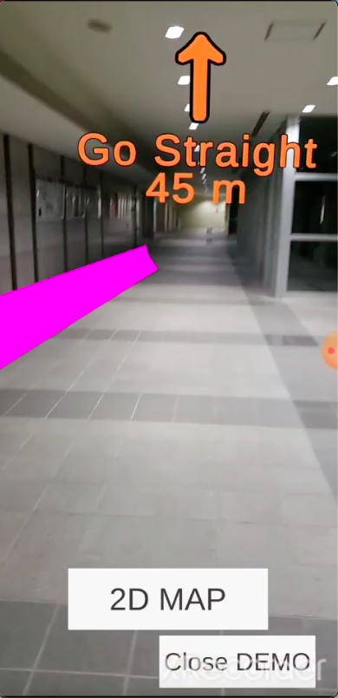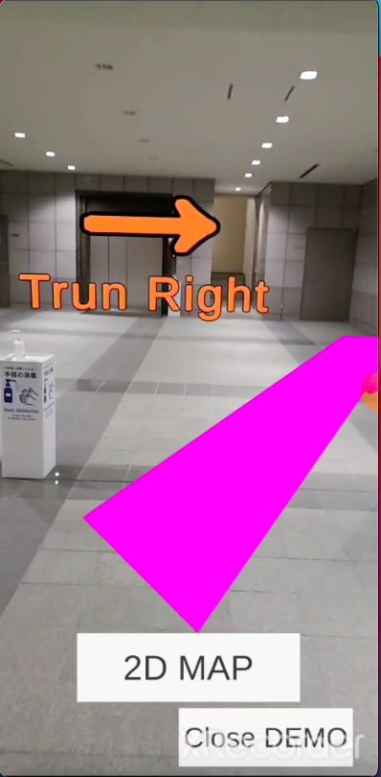

Figure. 5 AR Navigation

　The app can also display 2D maps. The figure shows the image when the map is displayed on the screen. The user can see the current location and the trajectory to that location.

Figure. 6

the current location and the trajectory to that location.

However, this app may cause errors in location tracking, and may result in unusable levels of deviation. We worked to eliminate the error but could not.

1. Discussion

There are three things that we noticed during development as sources of error in location tracking. The first is the density at which the Aps are placed. There are several ranges in the facility where the number of Aps placed does not reach the required number. Due to this effect, there is a possibility that the WiFi position tracking situation is not working.

Secondly, there is an increase in drift due to the fact that the exact location of the Aps is not known; the documents showing the location of the Aps were marked roughly, so we developed an approximate location as the location of the AP. This may have amplified the measurement error.

The third factor is the influence of building columns and roofs. Since the RSSI signal used for positioning is a radio wave, it encounters various obstacles such as walls, pillars, and floors before the device receives the signal from the AP. In general, metal, concrete, and insulation may prevent or diminish radio waves from passing through. This is thought to attenuate the radio waves from the AP and affect the positioning results.

1. Comparison

We couldn’t find any indoor navigation application like the application I developed, so I compared “Google Map” with the application I developed. Table2 shows a comparison between “Google Map” and the developed application.

The application we developed can only be used in very limited places. However, by expanding the target buildings, it will be possible to use it in more places. In addition, by implementing outdoor location tracking functions using GPS, we expect to be able to develop hybrid applications that can operate both outdoors and indoors.

1. Conclusion

In this study, we developed an indoor AR navigation application using WiFi position tracking introduced in our previous study. As a result, indoor route guidance was successfully achieved. However, there is an error in the location tracking, and this study could not eliminate the error, but only identify the cause of it. Therefore, we were not able to complete the development perfectly, but we believe that we were able to fully demonstrate the potential of indoor navigation applications.

Table. 2 Comparison

|  |  |  |
| --- | --- | --- |
|  | This App | Google Map |
| AR Navigation | ○ | ○ |
| Show map | ○ | ○ |
| Show the distance to the destination room | × | ○ |
| Show the movement trajectory | ○ | × |
| Usable in the buildings | ○ | × |
| Usable in outdoor | × | ○ |

1. Future Works

Main tasks in the future are to develop positioning methods for areas where WiFi position tracking is not possible and to eliminate errors in location tracking. The position tracking of the developed application has errors and often fails in navigation. Therefore, it is necessary to eliminate the errors and ensure sufficient accuracy for successful navigation.

Another challenge is to expand the application's range of use and enable it to be used in more facilities. The application we have developed can only be used inside the research building of the University of Aizu. It is also expected to be able to be used both outdoors and indoors by realizing GPS-based location tracking.

1. References

[1] “Unity” https://unity.com/

[2] “ARCore” <https://developers.google.com/ar>

[3] “ARKit”

<https://developer.apple.com/jp/augmented-reality/arkit/>

[4] Ghantous, Milad, Houssam Shami, and Rana Taha. "Augmented Reality Indoor Navigation Based on Wi-Fi Trilateration." *International Journal of Engineering Research & Technology* 7.07 (2018).

|  |
| --- |
|  |