Table S1 Approximate number of training episodes required for each technique to reach the convergence threshold in each environment, based on the moving average reward (rolling window = 20)
Technique | Lunar Lander  (90% of the optimal reward= 180) |  | Cart Pole  (90% of the optimal reward= 450) | Mountain Car  (90% of the optimal reward= -120)
DDQN |  | ~650 | Not Reached | Not Reached
1 AdvB |  | ~450 | Not Reached | ~1350
5 AdvB |  | ~450 | ~680 | ~1250
10 AdvB |  | ~400 | ~530 | ~1150
Episode values were determined from the first point at which the moving average reward (rolling window = 20) reached the predefined convergence threshold. For LunarLander-v2 and CartPole-v1, the convergence thresholds were defined as 90% of the optimal rewards of 200 and 500, corresponding to thresholds of 180 and 450, respectively. For MountainCar-v0, due to the negative reward structure, the convergence threshold was defined as 90% progress toward the solved threshold, resulting in a threshold of -120. “Not Reached” indicates that the threshold was not achieved within the training horizon

Supplementary Figure S1. Comparison of C51, Dueling DDQN, Prioritized DDQN, and Rainbow DDQN in the CartPole-v1 environment.
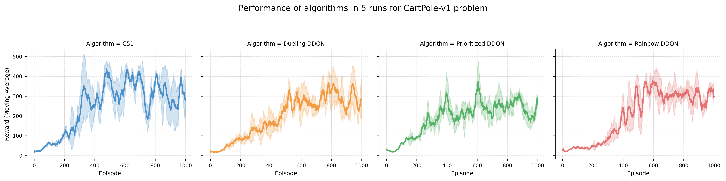
Supplementary Figure S2. Comparison of C51, Dueling DDQN, Prioritized DDQN, and Rainbow DDQN in the MountainCar-v0 environment.

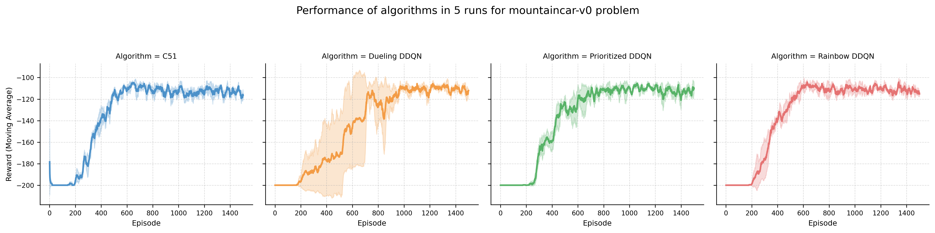
Supplementary Figure S3. Comparison of C51, Dueling DDQN, Prioritized DDQN, and Rainbow DDQN in the LunarLander-v2 environment.

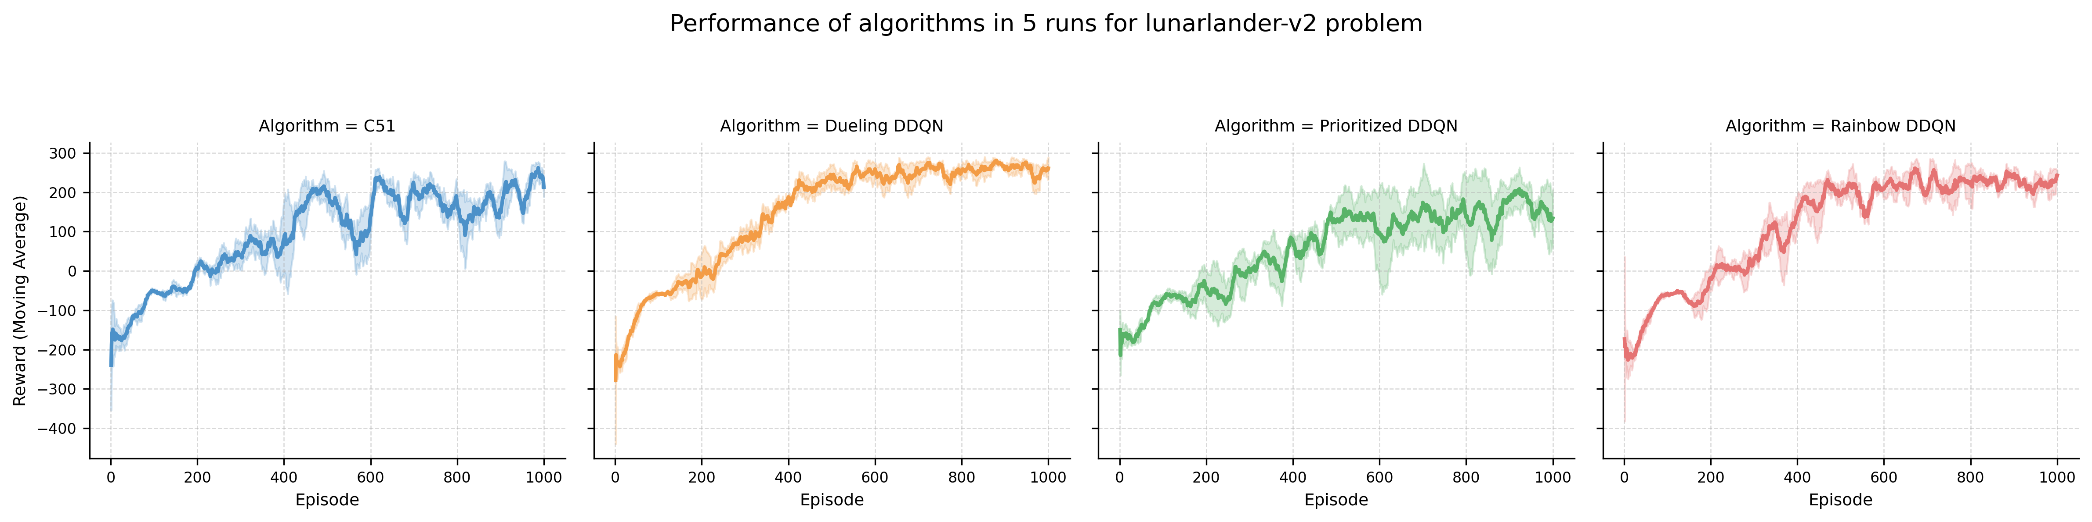

Figure S4. Effect of different advisory-board update cycles on AdvB-RL performance.
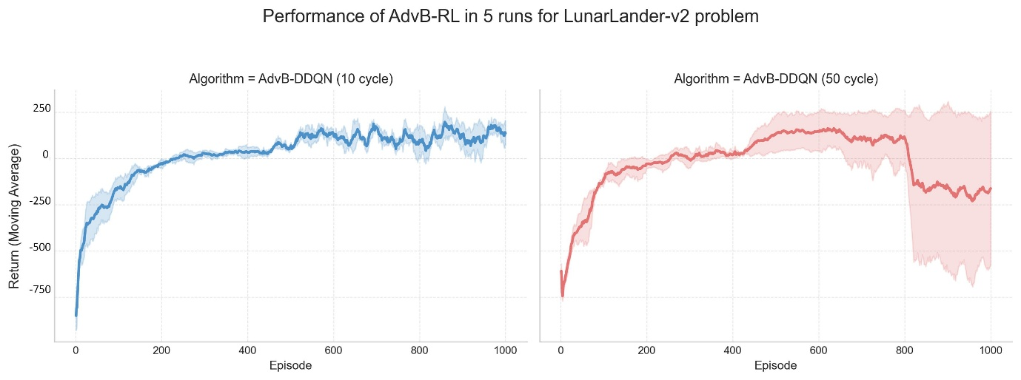
Figure S5. Effect of different cooperative action-selection policies on AdvB-RL performance.

