Gören Robot Kol Projesi Dönem Sonu Raporu
Table of Contents
ABSTRACT 1
1.INTRODUCTION 1
2. RELATED WORK 2
3. DESIGN 2
3.1 MECHANICAL DESIGN 2
3.1.1 SOLID WORKS 2
3.1.2 MONTAGE 2
3.2 ELECTRONIC DESIGN 2
3.2.1 CIRCUIT DIAGRAM 2
4. Material and Method 2
4.1 Servo motor Towerpro mg 995 2
4.2 The Arduino UNO R3 3
4.3 The PCA9685 16-Channel I2C PWM/Servo Driver 4
4.4 Nema 17 Stepper Motor 5
4.5 A4988 Motor Driver 7
5. SOFTWARE 8
6.RESULTS AND FEATURE WORKS 8
7. REFERENCES 8

ABSTRACT

1.INTRODUCTION

2. RELATED WORK

3. DESIGN

3.1 MECHANICAL DESIGN

3.1.1 SOLID WORKS

3.1.2 MONTAGE

3.2 ELECTRONIC DESIGN

3.2.1 CIRCUIT DIAGRAM

4. Material and Method

4.1 Servo motor Towerpro mg 995
A servo is defined as a drive system that flawlessly controls the angular-linear position, speed, and acceleration in mechanisms. In other words, it is a motion control device. Servo motors, widely employed in robotic technologies, also find extensive use in Radio Control (RC) applications. RC Servo Motors were initially utilized in remote-controlled model vehicles. Servos are engineered with the purpose of accurately achieving the desired position and maintaining the current position until a new command is received.
A servo motor consists of a fundamental DC motor that generates mechanical energy by rotating when supplied with power. To determine the position of the servo motor, a potentiometer is employed, which provides feedback on the motor's rotational displacement. This feedback, utilized by the control circuit, enables continuous monitoring of the motor's position. The control circuit of the servo motor, using the feedback from the potentiometer, maintains the motor's position at the desired location. This control circuit regulates the motor's movement based on received commands, making necessary adjustments to achieve the target position. The MG995, through its included gear mechanism, amplifies the output torque of the motor, transforming it into a higher-torque motion. This gear mechanism enhances the durability of the servo motor, making it suitable for a broad range of applications. Servo motors are typically controlled using PWM signals. The MG995, operating with such signals, responds to commands from microcontrollers or remote controllers. It reads the pulse width every 20 ms, and this width value determines the motor's rotational angle. For instance, a pulse width of 1.5 ms may bring the motor to a neutral position (typically 90°). The MG995 generally operates within a voltage range of 4.8V to 7.2V. This feature provides flexibility to adapt to various power sources.
[1]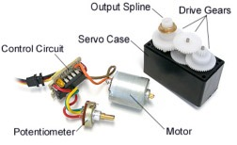
Figure 1 Servo Structure

The TowerPro MG995 servo motor stands out with its high performance, offering a wide range of applications. With a high torque of 10 kg-cm and speed, it proves to be effective in various projects. Additionally, its metal and plastic mixed gear mechanism enhances durability, ensuring a long-lasting use. Designed with a broad working angle, the MG995 can be utilized in diverse applications such as RC vehicles, robots, and cameras. Its affordability, considering the level of performance and durability it provides, makes it a cost-effective choice for various projects. Furthermore, its popularity among a broad user base, along with being tested and embraced, enhances the MG995's market popularity and reliability.
[2]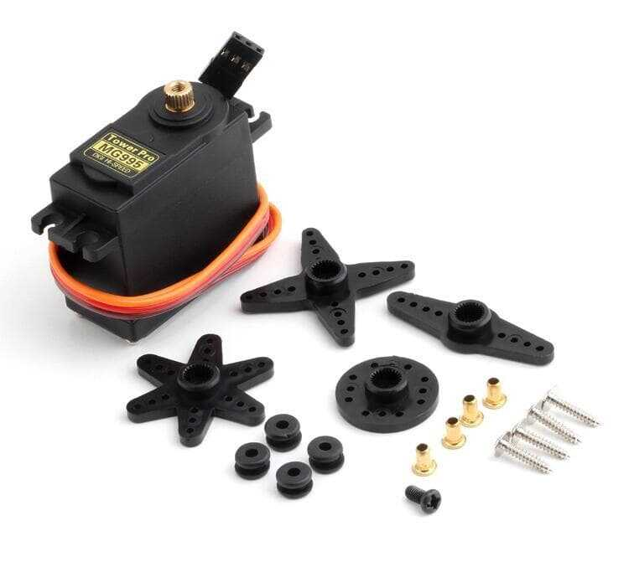
Figure 2 Servo Motor

4.2 The Arduino UNO R3
Arduino serves as an open-source platform encompassing both hardware and software components, facilitating microcontroller development. Users harness its capabilities to process data from sensors and exert control over electronic devices, whether it involves illuminating LEDs, operating motors, or other interactive functionalities. The central elements of this platform comprise a microchip-equipped board and a programming language for code development.
The Arduino UNO model stands out among various options due to its affordability and extensive array of available code examples. Featuring a USB port for computer connectivity, it serves as a gateway for both programming and communication.
In terms of features, the Arduino UNO offers versatile power options. It can draw power from either a USB connection or an external power source, with an optimal voltage range of 7 to 12 volts. A reset button is incorporated, allowing users to restart the program at their convenience.
[3]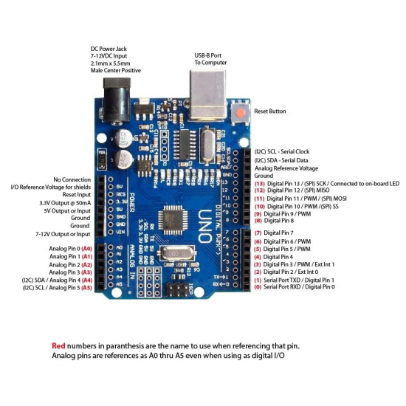
Figure 3 Ardunio Uno
The board is equipped with 14 digital pins capable of serving as both input and output interfaces. Pins 0 and 1 are dedicated to serial communication (RX and TX). Additionally, there are six PWM pins (3, 5, 6, 9, 10, and 11) identified by the tilde (~) symbol, crucial for tasks like motor speed regulation and LED brightness adjustment.
Six analog input pins (A0 to A5) enable the reading of values between 0 and 1023, accommodating the needs of analog sensor data. Power-related pins include Vin for external power input (7-12V), 5V for peripheral power, 3.3V for components requiring that voltage, and GND for grounding purposes.
The board integrates built-in LEDs, such as the ON LED indicating powered status, RX, and TX LEDs for communication feedback, and the L LED connected to digital pin 13, often used in preliminary testing.
A reset pin, connected to the reset button, allows for simulated manual resets by applying 5 volts. Overall, comprehending the functionalities and components of the Arduino UNO empowers users to undertake diverse projects and applications within the realm of microcontroller development. ardunio uno explanation

4.3 The PCA9685 16-Channel I2C PWM/Servo Driver

The PCA9685 16-Channel I2C PWM/Servo Driver Board offers a versatile solution to extend the capabilities of Arduino or other microcontrollers by providing an additional 16 PWM outputs. This proves invaluable for applications involving multiple LEDs or servo motors, simplifying the implementation process.
Measuring at 62.5 mm x 25.4 mm x 3 mm (excluding terminal and header connections) and weighing 5.5 grams (excluding terminal and header) or 9 grams (including terminal and header), this board operates at both 3.3V and 5V logic levels. Utilizing the I2C interface, it minimizes pin requirements on the microcontroller, enhancing overall efficiency.
Featuring six address-setting solder jumpers, the board supports the use of up to 62 devices on a single I2C bus. The output sequence aligns with standard servo connectors, facilitating seamless integration into diverse projects. The presence of connection pins on both ends allows for stacking or flexible connection and assembly options based on project requirements. Additionally, the board facilitates external power supply through the terminal connection, and it includes reverse voltage protection.
In terms of technical specifications, the PCA9685 board offers a 12-bit resolution with a 60 Hz update frequency. The PWM frequency is adjustable up to 1.6 kHz, providing flexibility for different applications. Output options include push-pull or open-drain, and an Output Enable pin allows for convenient activation or deactivation of all outputs. To simplify LED driving, the board includes series-connected 220 Ω resistors. A green LED indicator serves to confirm the availability of a sufficient power supply.
In summary, the PCA9685 16-Channel I2C PWM/Servo Driver Board is a compact and versatile solution, providing the technical specifications required for efficient management of multiple PWM outputs in a variety of electronic projects.
[4]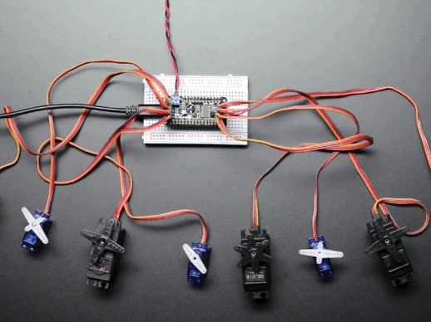
Figure 4 Servos with Driver

4.4 Nema 17 Stepper Motor
Step motors are electromechanical devices converting electrical energy into rotational motion through discrete steps. These motors come in various types, including two-phase, unipolar, bipolar, and hybrid step motors, each serving specific purposes. The key difference between step and servo motors lies in their control mechanisms, with step motors operating incrementally and servo motors requiring feedback for precise control.
[5]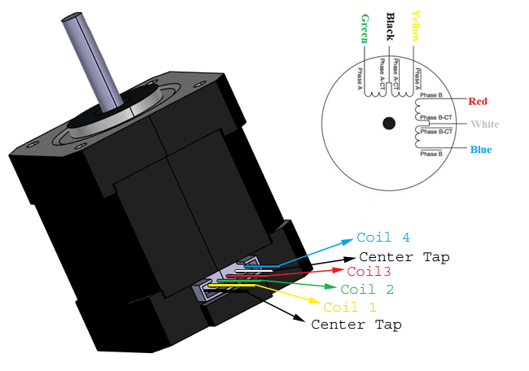
Figure 5 Nema 17 Stepper motor
Understanding how step motors work is crucial for their application. These motors move in discrete steps, and their steps are determined by dividing the step count by 360°. Electronic switches transfer energy to coils, causing the rotor to respond accordingly. Control requires a step motor driver, connecting to a computer for adjustments in torque, speed, and position values.
Step motors have features like size classification, speed control, and compatibility with digital control systems. They find applications in diverse fields such as the food packaging industry, medical devices, CNC machines, and factory automation.
Advantages of step motors include their independence from feedback, precise movement control, and compatibility with digital systems. Their structure consists of a rotor, stator, and bearings, and their control systems involve careful consideration of pulse currents and frequencies.
When selecting step motors, factors like response time, torque value, and motor size must be considered. Step motor prices are influenced by factors such as motor type, holding torque, NEMA rating, current, and flange size.
In conclusion, step motors offer precise control in various applications, and understanding their types, features, and selection criteria is essential for successful implementation.
NEMA 17 is a type of step motor named according to the flange size standards set by the National Electrical Manufacturers Association. This standard is based on specific flange dimensions that allow for motor mounting and interchangeability. NEMA 17 features a flange size of 1.7 x 1.7 inches (43.18 x 43.18 mm).
NEMA 17 step motors typically have a step structure consisting of 200 steps per revolution. This step count represents a full turn, equivalent to 360°. The step angle of the motor is 360° / 200 = 1.8°. This means each step represents an angular movement of 1.8 degrees.
NEMA 17 step motors are commonly used in various applications such as 3D printers, CNC machines, robots, camera systems, and many other industrial settings. They are preferred for projects requiring precise control due to their wide step angle and high resolutions.
The selection of NEMA 17 step motors is influenced by their compatibility with NEMA standards, allowing for standardized mounting and easy interchangeability. The 1.8° step angle provides a balance between precision and efficiency, making them suitable for applications where accurate control over angular movement is crucial. Additionally, their widespread use in diverse industries highlights their reliability and versatility.

4.5 A4988 Motor Driver
Step motors are controlled using motor drivers capable of high-speed switching and motor control boards. These motor drivers receive pulse signals from encoders or microcontrollers connected to the motor. Each received signal is processed to enable the motor to take a step.
When step motors need to operate in a specific direction and speed, pulses must be applied to their windings in a particular sequence. Step motors respond with steps based on the applied pulses. The number of steps can be controlled with an additional circuit, commonly referred to as a driver circuit or stepper motor controller. This process is easily facilitated with electronic circuits. Microprocessor-controlled driver cards are available based on the characteristics of step motors and the application. Driver circuits (stepper motor driver) can be simple or microprocessor-controlled. These electronic cards allow stepper motors to operate at the desired speed and precision. To drive step motors, there must be a driver circuit connected to the motor, sending necessary triggers to the correct windings through this driver circuit. Nowadays, microprocessor-controlled drivers and specifically designed PLCs for industrial step motors are available.
Precision in the movement of robotic joints is ensured through the use of microprocessors. The processor directs logical level signals for the direction, step time, and count, optimizing the movement. This process ensures the desired movement with a logical sequence of pulses for the corresponding step count, achieved through sequential switching. Considering these operations in an open-loop joint control form is crucial for evaluation. The superiority of a step motor over a servo motor in open-loop control can be utilized in such cases. One commonly used step motor driver is the A4988. It is a popular and versatile driver with features such as microstepping and adjustable current limiting. The A4988 allows for precise control and efficient operation of step motors in various applications. Its compact design and compatibility make it a preferred choice for hobbyists and professionals alike.
[6]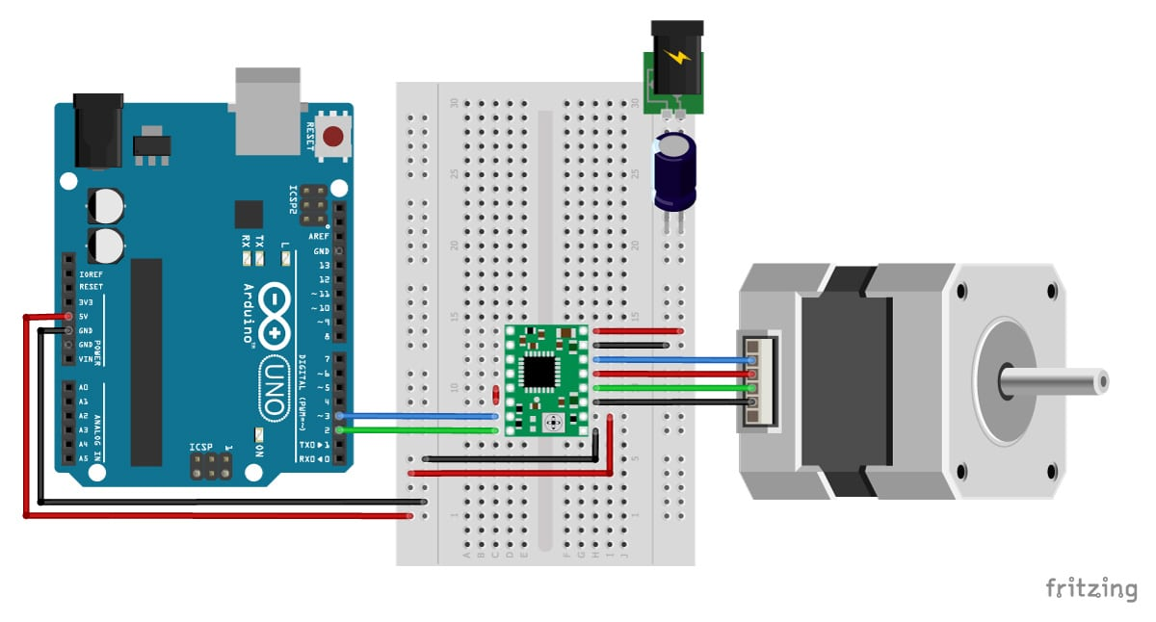
Figure 6 A4988 motor driver

5. SOFTWARE

6.RESULTS AND FEATURE WORKS

7. REFERENCES

[1] | T. K. Serhat Aksungur, "Solar tracking system with PID control of solar energy panels using servo motor," International Journal of Energy Applications and, pp. 128-129, 2018.
[2] | A. GHOSH, "Best Servo Motor For DIY Electronics & Arduino : TowerPro SG 5010," 2016.
[3] | mblock, "Mblock, Arduino Tanıtımı -Ders 1," nuxoe.com, 2019.
[4] | l. ada, "Adafruit 8-Channel PWM or Servo FeatherWing," 2016.
[5] | Tessie, "NEMA 17 Stepper Motor," components101, 2019.
[6] | B. d. Bakker, "How to control a stepper motor with A4988 driver and Arduino," [Online]. Available: https://www.makerguides.com/a4988-stepper-motor-driver-arduino-tutorial/. [Accessed 11 02 2019].

