**ARMON: ARDUINO BASED BLUETOOTH CONTROLLED ROBOT ARM**

**11.05.2018**

**By:**

**Onur Doğan ATAÇ,**

# PLAGIARISM STATEMENT

This report was written by the group members and in our own words, except for quotations from published and unpublished sources which are clearly indicated and acknowledged as such. We are conscious that the incorporation of material from other works or a paraphrase of such material without acknowledgement will be treated as plagiarism according to the University Regulations. The source of any picture, graph, map or other illustration is also indicated, as is the source, published or unpublished, of any material not resulting from our own experimentation, observation or specimen collecting.

**Project Group Members:**

|  |  |  |  |
| --- | --- | --- | --- |
| Name, Lastname | Student Number | Signature | Date |
| Onur Doğan ATAÇ | 13070001052 |  |  |

**Project Supervisors:**

|  |  |  |  |
| --- | --- | --- | --- |
| Name, Lastname | Department | Signature | Date |
| Mutlu BEYAZIT | Computer Engineering |  |  |
|  |  |  |  |

# ACKNOWLEDGEMENTS

# KEYWORDS

Smart phones, Bluetooth, Android OS, Robot, Motor.

# ABSTRACT

The main structure of this project is to design a robot arm which controlled by mean of using android mobile app and which used Bluetooth as communication to interface Arduino and android, in the other word android smart phone used as remote that guide for operating the robot. Generally robot is an electromechanical machine that controlled or played by computer and electronic programming, Arduino knows an open sources computer software and hardware that has platform used for building electronics projects. [1]

Today, smart phones are becoming more needed in a day life, smart phones have been incredibly carry pretty enough storage capacities, rich entertainment function and amazing communication ways [1]. In this projects Android devices will deal as communicate interface as Bluetooth by mean of wireless connection to the robot arm by using application programs like Visual studio, eclipse, and Servo Arduino, this Applications play an important rules for driving remote from android app by definition of controlling the servo motors with Arduino microcontroller [2]. In 1994 Bluetooth was founded by Telecom Vendor Ericsson, the mains job of Bluetooth is exchanging data between any devices that connected between two devices as smart phone and computer [1, 7].

In this projects Robot can be moved in four direction (forward, backward, left, and right) via android smart phone, and DC motor (direct current motor) is a controller of the robot for movement. In order to know the direction of the robot movement we use the LED indicators in the shape of the robot.

# ÖZET

Bu projenin temel yapısı a ndroid mobil uygulaması kullanarak kontrol edilen ve Arduino ve android arabirimi için Bluetooth olarak iletişim kuran bir robot kolu tasarlamaktır, diğer bir deyişle android akıllı telefon robotu çalıştırmak için uzaktan kumanda olarak kullanılmıştır. Genel olarak robot, bilgisayar ve elektronik programlama ile kontrol edilen veya oynanan elektromekanik bir makinedir, Arduino, elektronik projeleri oluşturmak için kullanılan platforma sahip, açık kaynaklı bir bilgisayar yazılımı ve donanımını bilir. [1] Günümüzde akıllı telefonlar gündelik yaşamda daha çok ihtiyaç duyulmaya başladı, akıllı telefonlar inanılmaz derecede yeterli depolama kapasitesi, zengin eğlence fonksiyonu ve şaşırtıcı iletişim yolları taşıyor [1]. Bu projelerde Android cihazları, Visual studio, eclipse ve Servoduino gibi uygulama programlarını kullanarak robot koluna kablosuz bağlantı yoluyla Bluetooth olarak iletişim arabirimi olarak başlayacak, bu uygulamalar android uygulaması uzaktan kumandanın tanımlanmasıyla önemli bir kural oynamaktadır. Arduino mikro işlemcili servo motorlar [2]. 1994'te Bluetooth, Telecom Vendor Ericsson tarafından kuruldu, Bluetooth ana işi, iki cihaz arasında akıllı telefon ve bilgisayar gibi bağlanan tüm cihazlar arasında veri alışverişi yapıyor [1, 7]. Bu projelerde Robot android akıllı telefon ile dört yöne (ileri, geri, sol ve sağ) hareket ettirilebilir ve DC motor (doğru akım motoru) hareket için robotun bir denetleyicisidir. Robot hareketinin yönünü öğrenmek için robot şeklindeki LED göstergelerini kullanırız.

# TABLE OF CONTENTS

PLAGIARISM STATEMENT ii

ACKNOWLEDGEMENTS iii

KEYWORDS iv

ABSTRACT v

ÖZET vi

TABLE OF CONTENTS vii

LIST OF FIGURES viii

LIST OF TABLES ix

LIST OF ACRONYMS/ABBREVIATIONS x

1. INTRODUCTION 1

1.1. Description of the Problem 1

1.2. Project Goal 1

1.3. Project Output 1

1.4. Project Activities and Schedule 1

2. DESIGN 1

2.1. High Level Design 1

2.2. Detailed Design 1

2.3. Realistic Restrictions and Conditions in the Design 2

3. IMPLEMENTATION, TESTS and TEST DISCUSSIONS 2

3.1. Implementation of the Product 2

3.2. Tests and Results of Tests 2

4. CONCLUSIONS 2

4.1. Summary 2

4.2. Cost Analysis 2

4.3. Benefits of the Project 2

4.4. Future Work 3

References 3

APPENDICES 4

APPENDIX A: REQUIREMENTS SPECIFICATION DOCUMENT 5

APPENDIX B: DESIGN SPECIFICATION DOCUMENT 6

APPENDIX C: PRODUCT MANUAL 7

APPENDIX D: SOURCE CODE/EXECUTABLES/SCRIPTS IN CD/DVD 8

# LIST OF FIGURES

List of figures, if any, that appear in the main body of final report. Those in appendices must not be listed here.

Figure x.y. Title of the figure …………………………………………………………Page Number

# LIST OF TABLES

List of tables, if any, that appear in the main body of final report. Those in appendices must not be listed here.

Table x.y. Title of the table …………………………………………………………Page Number

# LIST OF ACRONYMS/ABBREVIATIONS

List of acronyms and abbreviations, if any, that you used in the main body of final report. Those in appendices could also be listed here or be separetly listed in appendices.

CPU Central Processing Unit

AI Artificial Intelligence

UML Unified Modeling Language

Wi-fi Wireless local area networking

Bluetooth Bluetooth is a wiraless technology standart

DC Direct current motor

LED Light-emitting diode

PDA Perdonal Data Interconnect

PCI Peripheral Component Interconnect

IC Original IC Corporation

SPP Serial Port Protocol

EDR Enhanced Data Rate

CSR CSR Blue Core Bluetooth

CMOS Complementary metal-oxide-semiconductor

AFH Adaptive Frequency Hopping Feature

DoF Degree of freedom

API Android platform

PWM Pulse-width modulation

# 1. INTRODUCTION

The project aims in designing a Robot that can be operated using Android mobile phone. The controlling of the Robot is done wirelessly through Android smart phone using the Bluetooth feature present in it. Here in the project the Android smart phone is used as a remote control for operating the Robot.

Android boasts a healthy array of connectivity options, including Wi-Fi, Bluetooth, and wireless data over a cellular connection (for example, GPRS, EDGE (Enhanced Data rates for GSM Evalution ), and 3G). Android provides access to a wide range of useful libraries and tools that can be used to build rich applications. In addition, Android includes a full set of tools that have been built from the ground up alongside the platform providing developers with high productivity and deep insight into their applications. Bluetooth is an open standard specification for a radio frequency (RF)-based, shortrange connectivity technology that promises to change the face of computing and wireless communication. It is designed to be an inexpensive, wireless networking system for all classes of portable devices, such as laptops, PDAs (personal digital assistants), and mobile phones. The controlling device of the whole system is a Microcontroller. Bluetooth module, DC motors are interfaced to the Microcontroller. The data received by the Bluetooth module from Android smart phone is fed as input to the controller. The controller acts accordingly on the DC motors of the Robot. The robot in the project can be made to move in all the four directions using the Android phone. The direction of the robot is indicated using LED indicators of the Robot system. In achieving the task the controller is loaded with a program written using Embedded ‘C’ language

There are situations where a robot is a replacement for human because the human does not have the capability to work under the specific conditions, such as working in the space, under the water and etc, unless the person is equipped with some expensive special clothing and equipment. Therefore, while designing a robot, considering the factors such as concept and techniques, artificial intelligence and cognitive science are essential in order to obtain an effective design [1]. The other situation is when the robot is used to ease the actions done by the human or the human is handicapped.

Obviously, building a robotic arm is not a new idea, but still the design and the specifications can differ from other designs. For instance, the circuitry, degree of freedom (DoF), algorithm, program, attachments, equipment, accuracy and speed, completely depend on the designer’s tact. The challenge is to be able to perform some physical tasks close to a human’s hand actions, such as replacement and grabbing, under the conditions where a human hand is not a particular solution. Therefore, a robotic arm can be designed to perform the required actions which can be controlled by the humans. The robotic arm has a main processor which is using a PIC microcontroller.

# 1.1. Description of the Problem

* Serial production is a system that is set up to carry out the works done by repeating itself.
* Today, there is a need for motors (servos) in the installation of systems that release the use of human power to robots.
* Today, there is a need for motors (servos) in the installation of systems that release the use of human power to robots.

Similar solutions not found in the investigated articles and papers.

# 1.2. Project Goal

The aim of this project is to accelerate automation by making as much use of machine power as possible and reducing human power.

ARMON is a software / hardware project.

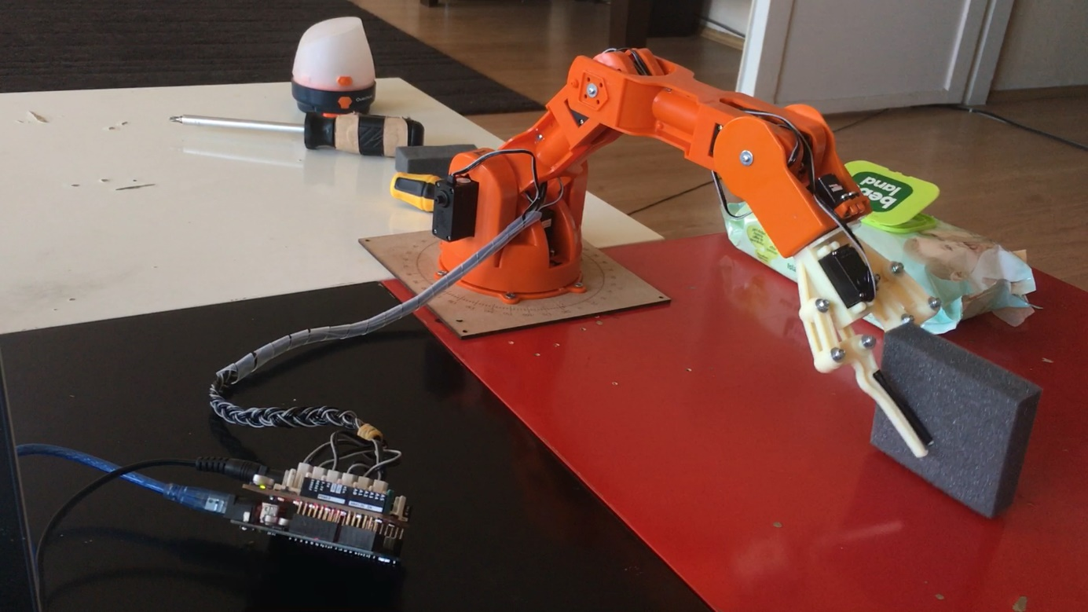

Figure 1: Robotic arm first steps.

The robot moves the materials on the ground from one point to another point in a series and smooth manner with the signals it receives from the arm.

# 1.3. Project Output

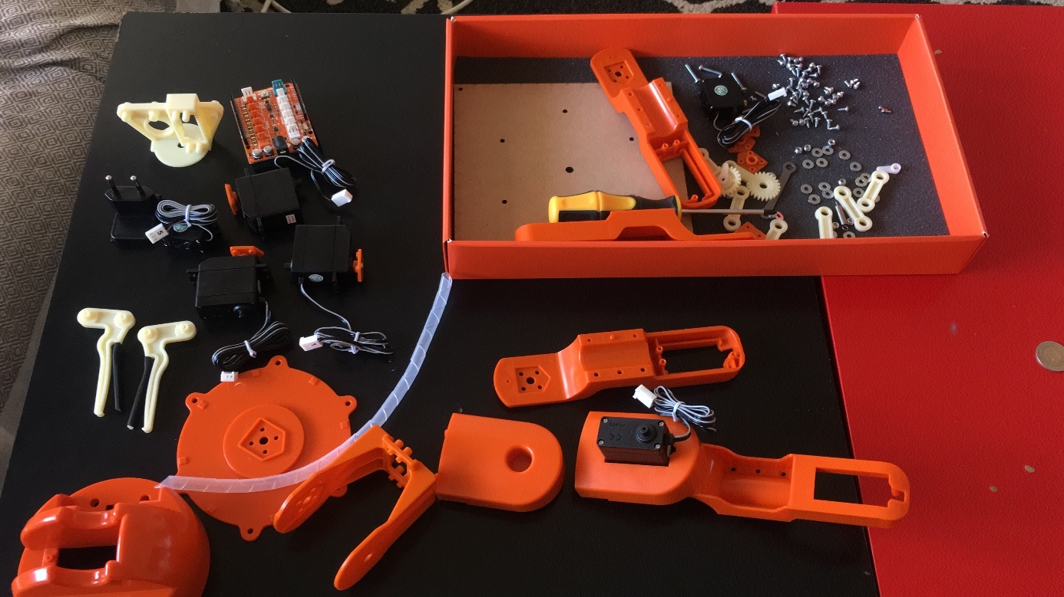

Figure 2: Start the ARMON..

Okey let´s start building on this thing. Before we can start we need to get some part´s and plan´s.

What you whil need;

-6 servo´s (i used 2x mg946, 2x mg995, 2xf utuba s3003(mg995/mg946 is better then the s3003, but they are much cheaper)) about 10 dollar a piece

-lexan 2mm (and a smal piece of 4mm) if you don´t have any, about 5 dollar for a nice piece

-distance sensor (hc-sr04) about 5 dollar

-10mm led (any color you like) 0,50 dollar

-stative (you need a box or someting like that to put your arm on) saved ;)

-claw(you can buy one on the internet) about 15 dollar

brain:

-Arduino uno (i am working on my own controller, but arduino works fine) about 15 dollar

-power circuit board ( you need to make this, i come on this later, but it is not that special) free, you make it yourself.

-power supply (i used one from a old pc) free!!

-pc to program the arm (when you are using a arduino you can use arduino developer tool. whitch you can download from there site www.arduino.cc ) free (if you already have one)

you whil need some wire´s and basic tools. Like a solder iron and solder. if you have them or lend them are free to. Now we got all the parts we can start building. First we will make the carrier part. We choose the parts shown in the picture for this. 20 mm 4 pieces, 8 mm 2 screws and nuts using a servo motor as shown in the pictures, we prepare the carrier part.

**Building the Body :**

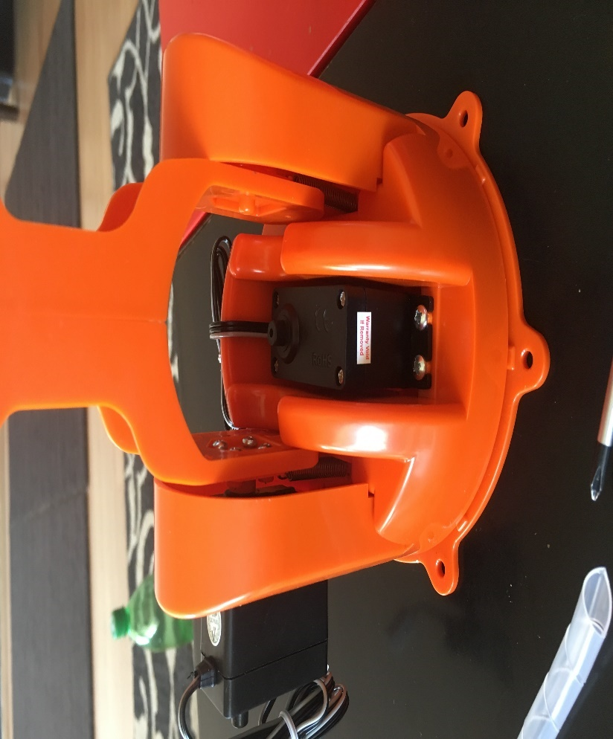

Figure 3: Base station..

Before we start ı need to say that I have no drawing of it. I just did it out of my head. It principal is pretty simple. You have two rows of lexan to mount the Servo's on those long lexan pieces. And two rows to put the servo's in the rows whit two holes in it. and a U bracked piece on the end. The hand for the arm I just bought from the internet. I mounted almost everything whit screws. Because when you do some time wrong you can change it very essay. the numbers behind the parts, can you find in the picture. The length if the first part (1) is about 19 cm and the second part (2) is about 17,5 cm the length of the front part (3) is 5,5 cm. For the rest it is a bit standart just look what the best dimensions are for your robot, depends how big or small you want him. for the rest it doesn't really matter what size you are using.

Now you probably have a idea of building your Robotic arm. The arm needs to rotate 180 degrees total. So we need to add a servo under the robot. Make a hole in the box and put the servo in there. And screw the arm to the servo. I mount a ring (4) around the servo so there was no distance between the box and the arm. You can do this if you need it.

To place the distance sensor i used a piece of 2mm lexan and screwed it to the robot hand. I also put a 10 mm led under the hand. You probably need a spring to help to servos for a better movement. It is hard to example how to build this, because it is different for everyone. It just depends on the stuff you have/buy. For an example if you have bigger servos you need other lexan parts. And you need to calibrate you’re a robot so it is straight. And whit other parts it is different (so it is not shaking and has a nice movement). If it is shaking you can add some weight to the arm. This probably solve the problem When you build your one body you need to make the servo motor wires longer. Just graph some wire (I used an internet cable whit´s I cut open) and solder 3 pin headers to it. Some heatsinking over it and stick it in the connector. and make another female connector on the other side. to connect it to the power supply board.

**Using the Robotic Claw:**

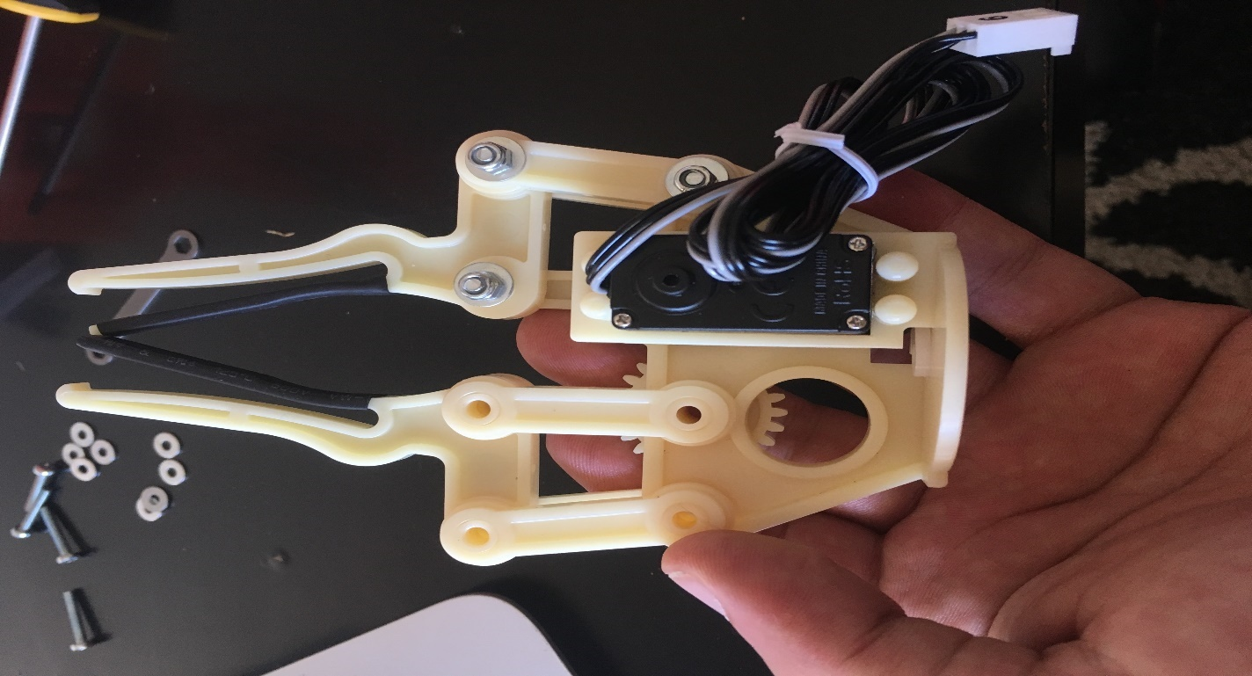

Figure 4: Gripper for arm.

For the installing of the robotic claw, you need;

a Servo (can be a s3003 (or another standard servo) mg995 or mg946 will work the best)) and you need some screws. So what do you do you take a servo bracked and cut it until it fits in the robotic claw. Than you need to use two small screws to put it in place.

next you take the servo and twist it all the way to the left now you need to close the claw.

now you are able to put the servo in place with 4 bolds, make sure the servo is all the way twisted to the left and that the claw is closed when mounting the servo in.

or the claw won't open at all. Now you can plug the servo in to an Arduino or a servo tester

if you did it all correct you have now a success operating robotic claw make sure that the bolds on the moving parts are not over tightened or it won't work great.

**Brain:**

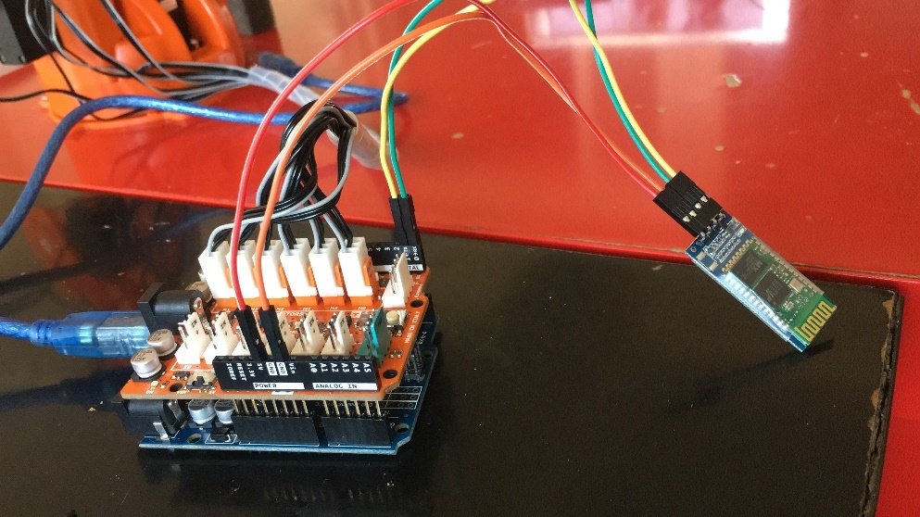

Figure 5: Robotic arm in brain. Uno-shield-Bluetooth module and USB Connector.

I used a connector from a pc module to connect the power board whit the power supply

If you connect red and blank to a multi meter. You will see 5v (for the servos and the distance sensor) And whit yellow and black you get 12v (for the Arduino) What ı did is pretty simple I made 5 servo connectors, solder the positive in parall to 5v and negative to ground I did the same whit the ds sensor. Then i solder some pin headers and connected the signals pins of the servos to They pin headers and the 2 middle pins from they sensor also. Now we can connect it whit the Arduino by using some jumpers it doesn’t matter whits pin you connect it on the Arduino. Long as you say in your program that you connected it to that pin. On the power board ı also add a led to indicate the power is on. Just add a 100 ohm resistor to 5v, and the other and of the led to ground. The 10mm led on the robot is just connected the Arduino, a resistor of 100 ohm goes from pin 13 to the positive pin from the led and the negative goes to ground. You can turn it on and off in you program. I used 5 servo connectors for 6 servos, because the 2 servos on the bottom are using the same signal. you need to solder those wires to getter, and plug them in to the power board we need some power now, don´t use a adapter for this, it just can´t handler the power what the arm needs.Use a pc power supply, just connect the green wire whit a black wire. and the power supply run´s and gives you power. If you don´t connect these wire´s nothing happens you need to bind these wire´s together. The signal pins from the servo motors, can you just plug in to a PWM channel on your Arduino. that are the pins whit this before it ~ the distance sensor can you plug in to pin 6 and 7. and the led to 13 and ground. that are al the pins that you need to use. It doesn´t matter how you connect the servo´s long as this symbol ~ stands for the pin number. Now you can program the Arduino. Make sure you turn the power supply off before plugins the USB cable in. And remove the USB when you want to test your code on your robotic arm. Other wish the Arduino gets 5v from the USB and 12 from the power supply and the power of the USB goes in to the power supply and the power supply while shutdown (for security reasons). The phone connector you can see on the picture is just a connector for the distance sensor. But you can use any connector you like. Like you can see in the schematic, I ad a Potentiometer to control the servo. The only thing you need to do is to repeat this with 5 signals for the 6 servos. the pot is not necessary but the code won´t work if you don’t add the Potentiometer´s.The other 5 Potentiometer can you just plug in to Analog pin 0,1,2,3 and 4

# 1.4. Project Activities and Schedule

Your activities and schedule starting with COMP 495 activities, then 496 activities, i.e. produce first version of problem definnition, our 495 project form, then produce RSD v1.0, then DSD v1.0 as high level design, then DSD v2.0 as detailed design, then implementation and testing activities, then PM, etc

# 2. DESIGN

# 2.1. High Level Design

In this project, a robotic arm was developed using arduino and servo motors. In addition, ARMON Robotic Arm System was developed in both software and hardware, Arduino IDE and windows environment.

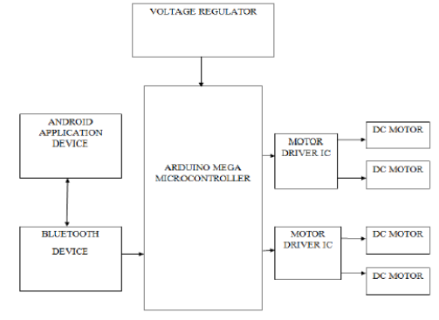

Figure 6: How the system works?

**Flow Chard:**



Figure 7: Flow chard 1.

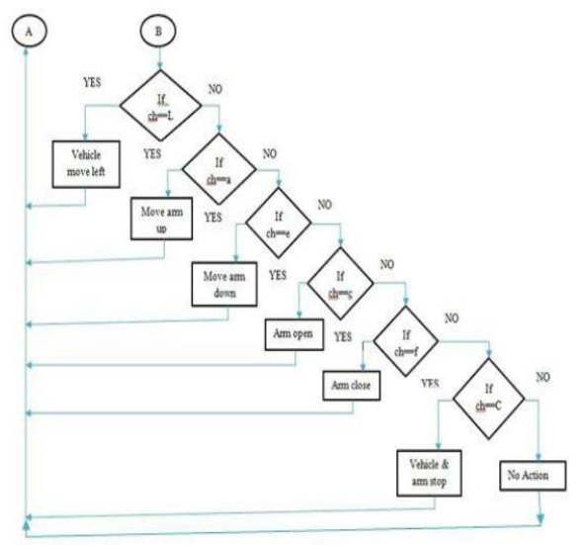

Figure 8: Flow Chard 2.

# 

# 2.2. Detailed Design

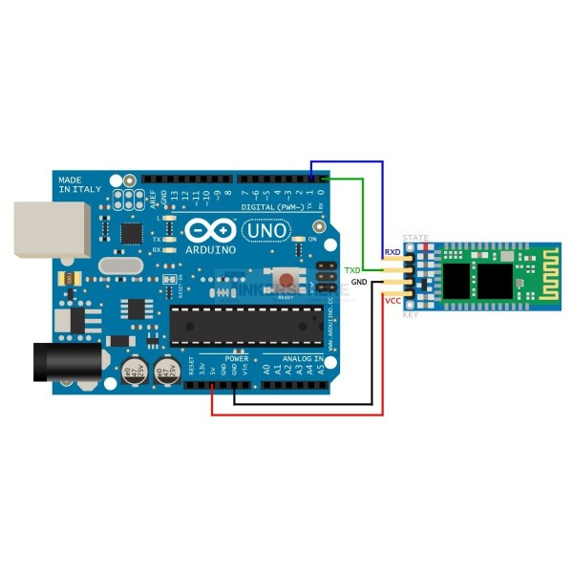

Figure 9: Bluetooth connecting.

• **GND**: Conducting object, such as a wire, that is connected to such a position of zero potential.The ground in any circuit is the end of the circuit, and is referred to as having a potential energy of 0V at all times.So, can a pin on the arduino be used as a ground at the end of a cuircuit and complete it so that its a full loop.

• **VCC**: VCC is the connection point of the power supply (battery, etc.) + plus end to be connected to the circuit to operate the circuit. Sometimes it is indicated by the direct + plus sign, V + or the operating voltage of the circuit is written in that division, where + plus is the location of the plus connection.

• **Enable / Key:** This pin is used to toggle between Data Mode (set low) and AT command mode (set high). By default it is in Data mode.

• **TX – Transmitter:** Transmits Serial Data. Everything received via Bluetooth will be given out by this pin as serial data.

• **RX – Receiver:** Receive Serial Data. Every serial data given to this pin will be broadcasted via Bluetooth.

# 2.3. Realistic Restrictions and Conditions in the Design

Basically, the processor of the Arduino card uses the Harvard architecture, which has separate memory for program code and program data. It consists of two memories, program memory and data memory. The data is stored in the data memory and the code is stored in the flash program memory. The Atmega328 microcontroller has 32kb flash memory, 2kb SRAM 1kb EPROM and 16MHz clock speed. To run a completed ARMON system, the person testing the system should not supply more than 5V. Otherwise, the Arduino cycle may burn. The HC-05 module can use a channel that allows it to have an independent modem network in one place. For this reason our robot arm system provides a single place control for a master Arduino.

# 3. IMPLEMENTATION, TESTS and TEST DISCUSSIONS

# 3.1. Implementation of the Product

In order to verify the robot arm and its components, several tests have been conducted to test both the components and the general robotic arm system. Figure 10 The tests shown on the robotic arm were performed at home.

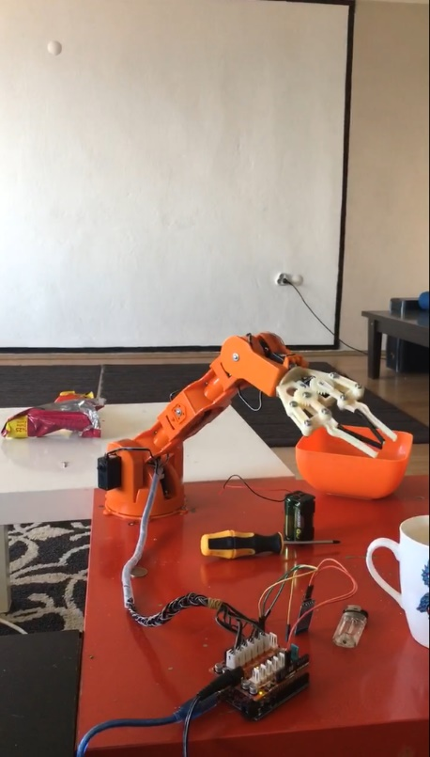

Figure 10: ARMON in the house.

The servomotor travel range is tested by changing the position of the objects to be lifted by the robotic arm. Each servo motor is commanded via different direct pulses, smartphone. This can help verify the response of the servomotor to whether it can move to the correct position according to the command given by the user. This process takes place when the servo motors turn the signal coming from the microcontroller through the encoder to the desired position. The first and last position are marked to evaluate the correctness of the actuator.

For overall system performance, the maximum load that can be lifted by the robot arm is determined using different weights. During the test, the robotic arm took the weight and carried it to a specific position.

# 3.2. Tests and Results of Tests

* As in 3.1, an overview of your tests, your test results and a discussion of your test results should be in Product Manual in Appendix C.

# 4. CONCLUSIONS

# 4.1. Summary

The purpose of this article is to establish a hardware system that transfers small needs from one room to another. Touching another user's mobile screen. The hardware introduced here is a composite robotic hand operated by a robot application, the connection between the robot and the application being made by the HC-05 Bluetooth module, which provides a range of 1 meter from its current position. Completion of this project will bring a new product to the world to increase speed and efficiency. The element that distinguishes this research from other researches is that the robot can carry products in different spots easily in a serial manner. This can change the behavior of the robot without disturbing anything else. Thus, such a robot would enhance its intelligent task remotely and wirelessly.

# 4.2. Cost Analysis

This section lists the requirements for economic constraints.

• The project did not last longer than 1920 hours. This is the sum of the time allocated for courses, training, meetings, document writing, media work, and product development.

• One member of the group is planning an average of 6-7 hours a day with equal planning for the project. I have been working on projects for up to 10 hours on some days to finish the project,

Parts and prices taken from the internet for the project are as follows:

-21 pieces of plastic

-63 screws

-16 pcs

-7 hexagonal nuts

-2 springs

-2 SR 311, 4 SR 431 servo motors

-1 Arduino compatible Shield card (UNO R3 pin arrangement available)

-1 5V 5A power supply

-1 star screwdriver

-1 pair double hexagon key

Total cost : 200 $

**Servo Motor Features**

1 piece of cable shield- Spring RC SR431 - Dual Output Servo:

Control signal: Analog PWM

Torque: 12.2 kg-cm @ 4.8V, 14.5 kg-cm @ 6.0V

Weight: 62gr

Dimensions: 42.0 × 20.5 × 39.5 mm

Speed: 0.20 sec / 60°@4.8V, 0.18 sec / 60 ° @ 6.0V

Support: Double ball bearing

Dental material: Metal

Angle of rotation: 180 °

Connector: J (Futaba)

- Spring RC SR311:

Control signal: Analog PWM

Torque: 3.1 kg-cm @ 4.8V, 3.8 kg-cm @ 6.0V

Weight: 27gr

Dimensions: 31.3 × 16.5 × 28.6 mm

Speed: 0.14 sec / 60°@4.8V, 0.12 sec / 60 ° @ 6.0V

Support: Double ball bearing

Dental material: Metal

Angle of rotation: 180 °

Connector: J (Futaba)

# 4.3. Benefits of the Project

This product is generally useful for industrial zones where automation is required. In the industrial area, human cost and physical fatigue are more than robots. So people get tired after a certain time, and according to the robots, it takes longer to start again. This problem leads to both cost and time loss. I tried to solve this problem. I have investigated this problem with the wireless module HC-05. The product is manufactured in a cost-effective manner, which is important for engineering.

# 4.4. Future Work

The connection range can be increased using Wi-Fi. From now on, I am using the Bluetooth module which can be replaced with a Wi-Fi module. It can expand the range by establishing directors at short distances. Additional features can be added, such as processing the robot with voice commands, this is achieved by adding a speech recognition module. Robot movements and properties can be increased by rotating and providing cross movements. The camera can be plugged in and a robot can be used to use it as a spy. More information and data transfer can be made, head counting can be done in a room, face recognition, user ID and password can be removed and fingerprints can be checked.

# References

[1] Möckel, Rico, et al. "YaMoR and Bluemove—an autonomous modular robot with bluetooth interface for exploring adaptive locomotion." *Climbing and Walking Robots*. Springer, Berlin, Heidelberg, 2006. 685-692.

[2] Wang, N., Zhang, N., & Wang, M. (2006). Wireless sensors in agriculture and food industry—Recent development and future perspective. *Computers and electronics in agriculture*, *50*(1), 1-14.

[3] Moeckel, Rico, et al. "Exploring adaptive locomotion with YaMoR, a novel autonomous modular robot with Bluetooth interface." *Industrial Robot: An International Journal* 33.4 (2006): 285-290.

[4] Neto, Pedro, J. Norberto Pires, and A. Paulo Moreira. "Accelerometer-based control of an industrial robotic arm." In*Robot and Human Interactive Communication, 2009. RO-MAN 2009. The 18th IEEE International Symposium on*, pp. 1192-1197. IEEE, 2009.

[5] Selvam, M. (2014). Smart phone based robotic control for surveillance applications. *International Journal of Research in Engineering and Technology*, *3*(03).

[6] Hamori, A., Lengyel, J., & Resko, B. (2011, June). 3DOF drawing robot using LEGO-NXT. In *Intelligent Engineering Systems (INES), 2011 15th IEEE International Conference on*(pp. 293-295). IEEE.

[7] Badamasi YA. The working principle of an Arduino. InElectronics, Computer and Computation (ICECCO), 2014 11th International Conference on 2014 Sep 29 (pp. 1-4). IEEE

# APPENDIX A: REQUIREMENTS SPECIFICATION DOCUMENT

1. **Robot Arm Details and Summary**

The robotic arm will be controlled via the designed controller and it will be able to grab, pick up and move objects according to their weights and shape. The manipulator design is mostly expected to pick up cubes and the geometric shapes like a box. Depending on the numbers of joints, DoF differs, but generally robotic arms operate using 4 or 5 servo motors. The servo motors are popular for their desirable characteristics for robotic application [2].

* 1. **Connection of remote control robot to mobile Phone**

This section takes a brief look at Android smart phones and its features, how smart Phones will help to develop a community in the environment it is used in. Hardware, software and communication protocols are evaluated for their suitability to this application. Finally, I take a brief look on existing systems.

* 1. **Android Platform**

Android devices are powerful mobile computers and they become more and more popular smart phones used worldwide. They becomes more and more popular for software developers because of its powerful capabilities and open architecture, also it’s based on the C and Java programming language. Because Android uses the this programming languages getting started with the Android API is easy; the API is open and allows easy access to the hardware components. Android devices provide numerous communication interfaces like USB, Wi-Fi and Bluetooth, that can be used to connect to the robot. I think it is a great platform for a robotic system control, because it’s much cheaper than any other ARM-based processing unit. I use android platform because it is the widest used in the word and runs the largest number of Smart phones worldwide.

1. **Problem Statement and Proposed Solution**

This study intends to investigate the design, implementation and control of a 5 DoF articulated robotic arm using servo motors and PIC 16F877A microcontroller. The advantage of this microcontroller its low cost and in-circuit programmability [3]. A pulse could have a different effect on servos with different specifications. Therefore, most of the time it is crucial to be able to give the exact PWM pulse in order to rotate a servo to a specific rotation. The main advantage of controlling the servo motors with PWM signals is that they can be programed to have an initial position and to rotate with an exact degree with respect to the requirements [2]. Since each servo motor has a different specification in terms of pulse width range as discussed above, a simulation for each servo is made in Proteus and MATLAB, and the results are compared with the experimental results in order to obtain a general formula to find the exact PWM pulse required to rotate the servo to the expected degree. With the help of the proposed formula, it is possible to find the exact duration of the PWM signal which is required to meet the expectations.

Simulation results and real-time robot arm behavior are then compared with the results presented in [3].

1. **Review of Existing Robots**

Robots are used in different fields such as industrial, military, space exploration, and medical applications. These robots could be classified as manipulator robots and cooperate with other parts of automated or semi-automated equipment to achieve tasks such as loading, unloading, spray painting, welding, and assembling.

Generally robots are designed, built and controlled via a computer or a controlling device which uses a specific program or algorithm. Programs and robots are designed in a way that when the program changes, the behavior of the robot changes accordingly resulting in a very flexible task achieving robot. Robots are categorized by their generation, intelligence, structural, capabilities, application and operational capabilities. In this study robots are reviewed according to their structural properties

1. **REQUIREMENTS**

• Provides the use of efficient equipment to increase productivity.

• Due to the simplicity of the development environment with the use of the driver,can be used on platforms.

• Programs written in Arduino are not run on any other platform,It can work.

• There is a lot of hardware support that is compatible with Arduino and can work together.

• Flexibility at work.

• Get the job done in the shortest time.

• Communication with the environment is easy because it is open source.

• Provide good returns on investment and reduce working cost.

• Better accuracy in performance

1. • Ability to work in risky ways and make it more safe

# APPENDIX B: DESIGN SPECIFICATION DOCUMENT

# APPENDIX C: PRODUCT MANUAL

# APPENDIX D: SOURCE CODE/EXECUTABLES/SCRIPTS IN CD/DVD