ARMON: ARDUINO BASED BLUETOOTH CONTROLLED ROBOT ARM

High Level Design

Design Specifications Document

03.01.2018

Revision 1.0

**By:Onur Doğan ATAÇ**

**Revision History:**

|  |  |  |
| --- | --- | --- |
| **Revision** | **Date** | **Explanation** |
| 1.0 | 03.01.2018 | Initial high level design |

CONTENTS

Revision History............................................................................................................2

Table of Contents...........................................................................................................3

1.INTRODUCTION......................................................................................................4

1.1 What is Arduino? Why Arduino? ...........................................................................4

1.2 Daily Life Use…......................................................................................................4

1.3 Scope........................................................................................................................4

1.4 Overview..................................................................................................................5

2.HIGH LEVEL DESIGN..............................................................................................5

2.1 System Architecture…….........................................................................................5

2.1.1 Mechanical Design……………………................................................................5

2.2 Mechanical Structure................................................................................................6

2.2.1. Physical Communication with Arduino………………………………………...7

2.3 Environment…………………………………………………………………….....7

2.3.1 Tools Description………………………………………………………….……7

3.SYSTEM DETAILED DESIGN…………………………………………………..8

3.1 Design Brief………………………………………………………………………8

4.REFERENCES...........................................................................................................9

**1.Introduction**

**1.1 What is Arduino? Why Arduino?**

Arduino is open source, both in its software and hardware specification, so that hobbyists can assemble the simplest Arduino modules themselves by hand. More sophisticated pre-assembled Arduino modules can be purchased and are modestly priced. The hardware comes in many format specifications, from a small wearable device, to larger surface mounted modules. The primary mode of computer connection is via USB, though Bluetooth, serial and ethernet form factors also exist.

The Arduino software is free and open source. The programming platform is based on the popular Wiring language. The IDE is based on Processing, which is a well-known language among designers and prototypers. Unlike most microcontroller interfaces, Arduino is cross-platform; it can be run on Windows, Linux and Macintosh OS X. [1]

**1.2. Daily Life Use**

While some of Arduino projects may seem frivolous, the technology actually taps into a number of trends that will make it a potentially important force in the industry. "The Internet of Things" is a popular phrase used in the tech community to describe everyday items that are connected to the Internet and able to share information. Smart energy meters are an often-used example, which could regulate appliance usage to save money on energy.Consider the Internet of things to an important part of the loosely defined phenomenon called Web 3.0

Also, the concept of ubiquitous computing is fast becoming a cultural norm. Public perception and comfort level is shifting towards integrating technology into the fabric of everyday life. The small form factor of Arduino allows it to be applied in all kinds of everyday objects. In fact, the Arduino LilyPad form factor allows for wearable Arduino devices. [1]

**1.3 Scope**

HLD(High Level Design) documentation of the Armon presents structure of systems and system environment of Armon.

In this document design process of the system will be explained.

**1.4 Overview**

A system covering the above-mentioned demands will be developed. The system will have only one application. Android Mobile app. In a nutshell, with the help of arduino, vehicles and robot arm movements will be moved by applications.

**Overview of the Arm:**

Degrees of freedom: 5

Payload capacity: 180gm (Experimentally)

Joint speed (approximate):40-60 rpm

Hardware interface: 2 pin connector

Base spin: 180 degrees

Shoulder base spin: 160 degrees

Elbow pitch: 160 degrees

Finger opening (Max): 10cm

**2. High Level Design**

## **System Architecture**

Table 1 shows the project specification for this wireless mobile robotic arm. The main purpose of producing this specification is to clarify some important aspects of the project and to make sure that the project is feasible as well as appropriate to use in the market.

|  |  |
| --- | --- |
| Module | Specification |
| Interface | Arduino UNO |
| Controller | Mobile Phone |
| Programing Language | Arduino Language |
| Actuator | Servo Motor |

Table: Specification of Bluetooth Mobile ARMON and car.

### **Mechanical Design**

Mechanical design Fig 2 illustrate the designing of the robot with (a) main structure arm robot (b) arm robot design and (c) mobile for carrying arm robot. Robot arm wills have 5 outputs which consist of the base, shoulder, elbow, wrist and gripper.



a) b) c)

The robot holder is also made of aluminum for the same reason as the main robot arm structure. The mobile robot is of size (28 x 15.5 x 8.5) cm, which is length, width and height, respectively 2 (c). Acrylic is used as the main material for the portable robot arm because its formation is easy, cheap, powerful and Carry the weight and movement of the engine. This servicing has 4 servomotors and a servo wheel connected.

## **Mechanical Structure**

The mechanical design of a robotic arm is based on a robotic manipulator with a similar function. Human arm. To establish a generalized operating system and technological system for analysis, the design, integration and implementation of a humanoid robot arm.

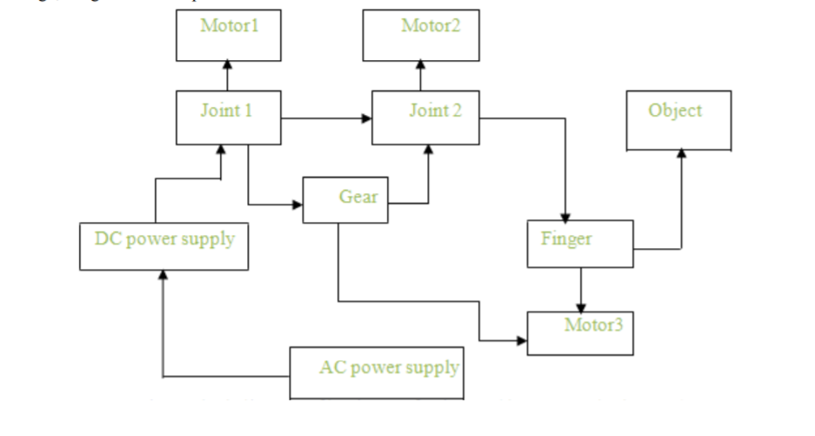

Figure 1. Block Diagram of beginner Animator

### **Physical communication with Arduino**

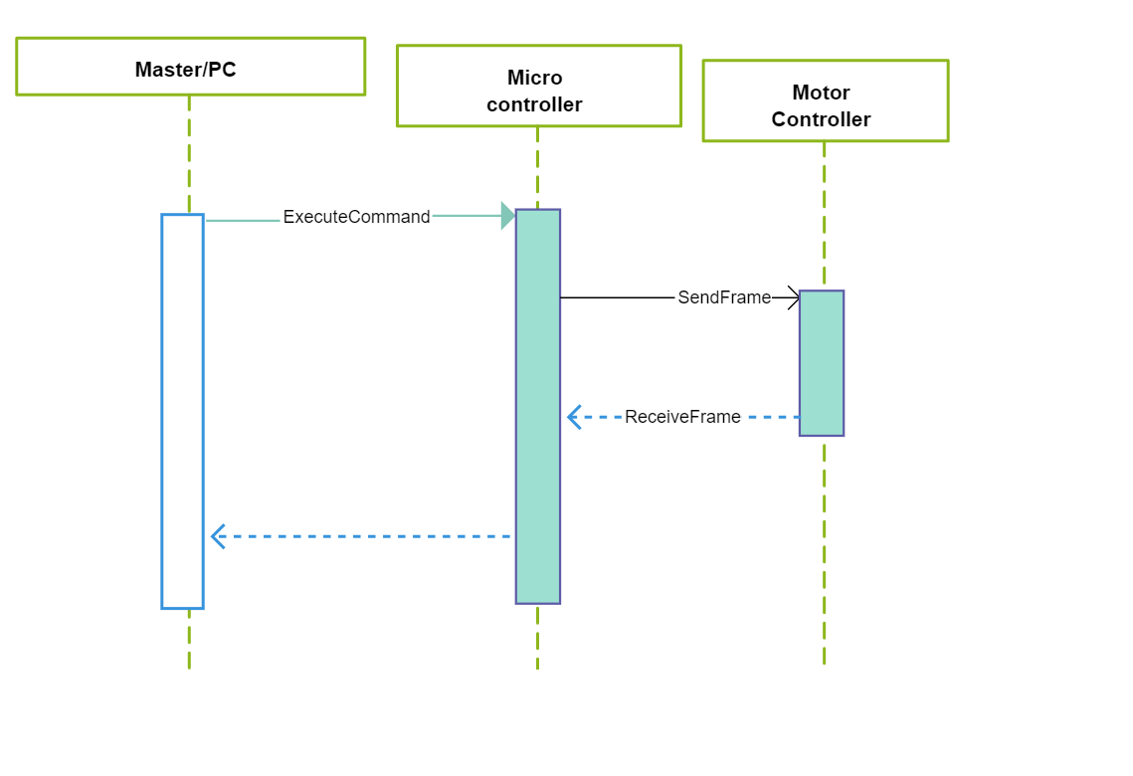 Fig3.Sequence Diagram for Arduino

## **Environment**

### **Tools Description**

* The main purpose of using C: C is to be an object-oriented programming language. C is one of the most common languages in the world. Because of this, people can find resources about C much easier.
* Android IDE: I have used the Android IDE because it is only for the Android-based development platform. In the meantime, Android IDE uses the C programming language. So people can find open source libraries and resources easier.

# **SYSTEM DETAILED DESIGN**

## **DESIGN BRIEF**

In the design part itself, the design of the mechanical part and the assembly of the mechanical part. In the design of the mechanical part, in robot arm construction the millimetric drawings of the parts to be used were made through the help program.

In the installation of the mechanical part, the naming of the servomotors used in the robot kold and the tasks of the robot are explained. From some steps of the project

It is formed. These steps are;

• Identification of the mechanical materials required for the construction of the project,

• Identification of microcontroller and software to be used in the project,

• Research and selection of servo motors that will operate the robot arm in a proper manner,

• Proper selection of mechanical parts,

• Robot arm installation,

• Test whether the system works properly with the microcontroller we have selected Be,

• Possible faults are given through the eyes and the system is restructured. It the steps have been completed and the design of the robot has been completed.

**4.REFERENCES**

[1] <https://www.lifewire.com/what-is-arduino-2495652>

[2] <http://www.spu.edu.sy/downloads/files/1495967538_1111.pdf>