ARMON: ARDUINO BASED BLUETOOTH CONTROLLED ROBOT ARM

Final Report

**(Bachelor of Science Thesis)**

04.01.2018

**Project by**

Onur Doğan ATAÇ; 13070001052

# Keywords

* Robotic arm
* Arduino
* Bluetooth

# Plagiarism Statement

This report was written by the group members and in our own words, except for quotations from published and unpublished sources which are clearly indicated and acknowledged as such. We are conscious that the incorporation of material from other works or a paraphrase of such material without acknowledgement will be treated as plagiarism according to the University Regulations. The source of any picture, graph, map or other illustration is also indicated, as is the source, published or unpublished, of any material not resulting from our own experimentation, observation or specimen collecting.

**Group Members:**

|  |  |  |  |
| --- | --- | --- | --- |
| **Name Surname** | **Student Number** | **Signature** | **Date** |
|  |  |  |  |
|  |  |  |  |
|  |  |  |  |
|  |  |  |  |

**Project Supervisors:**

|  |  |  |  |
| --- | --- | --- | --- |
| **Name Surname** | **Department** | **Signature** | **Date** |
|  |  |  |  |
|  |  |  |  |

**ÖZ**

Bu projenin temel yapısı android mobil uygulaması kullanarak kontrol edilen ve Arduino ve android arabirimi için Bluetooth olarak iletişim kuran bir robot kolu tasarlamaktır, diğer bir deyişle android akıllı telefon robotu çalıştırmak için uzaktan kumanda olarak kullanılmıştır. Genel olarak robot, bilgisayar ve elektronik programlama ile kontrol edilen veya oynanan elektromekanik bir makinedir, Arduino, elektronik projeleri oluşturmak için kullanılan platforma sahip, açık kaynaklı bir bilgisayar yazılımı ve donanımını bilir. [1] Günümüzde akıllı telefonlar gündelik yaşamda daha çok ihtiyaç duyulmaya başladı, akıllı telefonlar inanılmaz derecede yeterli depolama kapasitesi, zengin eğlence fonksiyonu ve şaşırtıcı iletişim yolları taşıyor [1]. Bu projelerde Android cihazları, Visual studio, eclipse ve Servoduino gibi uygulama programlarını kullanarak robot koluna kablosuz bağlantı yoluyla Bluetooth olarak iletişim arabirimi olarak başlayacak, bu uygulamalar android uygulaması uzaktan kumandanın tanımlanmasıyla önemli bir kural oynamaktadır. Arduino mikroişlemcili servo motorlar [2]. 1994'te Bluetooth, Telecom Vendor Ericsson tarafından kuruldu, Bluetooth ana işi, iki cihaz arasında akıllı telefon ve bilgisayar gibi bağlanan tüm cihazlar arasında veri alışverişi yapıyor [1, 7]. Bu projelerde Robot android akıllı telefon ile dört yöne (ileri, geri, sol ve sağ) hareket ettirilebilir ve DC motor (doğru akım motoru) hareket için robotun bir denetleyicisidir. Robot hareketinin yönünü öğrenmek için robot şeklindeki LED göstergelerini kullanırız.

# Abstract

The main structure of this project is to design a robot arm which controlled by mean of using android mobile app and which used Bluetooth as communication to interface Arduino and android, in the other word android smart phone used as remote that guide for operating the robot. Generally robot is an electromechanical machine that controlled or played by computer and electronic programing, Arduino knows an open sources computer software and hardware that has platform used for building electronics projects. [1]

Today, smart phones are becoming more needed in a day life, smart phones have been incredibly carry pretty enough storage capacities, rich entertainment function and amazing communication ways [1]. In this projects Android devices will deal as communicate interface as Bluetooth by mean of wireless connection to the robot arm by using application programs like Visual studio, eclipse, and Servoduino, this applications play an important rules for driving remote from android app by definition of controlling the servo motors with Arduino microcontroller [2]. In 1994 Bluetooth was founded by Telecom Vendor Ericsson, the mains job of Bluetooth is exchanging data between any devices that connected between two devices as smart phone and computer [1, 7].

In this projects Robot can be moved in four direction (forward, backward, left, and right) via android smart phone, and DC motor (direct current motor) is a controller of the robot for movement. In order to know the direction of the robot movement we use the LED indicators in the shape of the robot.

# Acknowledgements

I would like to thank my thesis supervisor, Asst. Prof. Mutlu BEYAZIT for his continuous support and precious guidance throughout this study.

I sincerely thank the committee members of my thesis defense jury, Prof. Dr. Mehmet Ufuk ÇAĞLAYAN for their helpful comments and on this thesis.

Last but not least, my deepest thank goes to my family for their support and encouragement.

**Contents**

Front Matter……………………………………………………………………………………………………………………...1

Keywords ……………………………………………………………………………………………………………………………………2

Plagiarism Statement…………………………………………………………………………………………………………………...3

Oz ……………………………………………………………………………………………………………………………………………….4

Abstract ………………………………………………………………………………………………………………………………………5

Acknowledgements …………………………………………………………………………………………………………………….6

List of Figures……………….……………………………………………………………………...8

1. **Chapter INTRODUCTION**

**INTRODUCTION**

* 1. Introduction ………………………………………………………………………....9
  2. Aim and Objective………………………………………………………………………….10
  3. Problem Statement And Proposed Solution ……………………………………………….10
  4. Review of Exiting Robots ………………………………………………………………….10

1. **Chapter 2 BACKGROUND**
   1. Arduino World……………………………………………………………………………11
   2. Motor Driver ……………………………………………………………………………..11
   3. Dc Motor………………………………………………………………………………….12
   4. Arduino Uno……………………………………………………………………………...12
   5. Arduino IDE……………………………………………………………………………...13
   6. Hc-05 Bluetooth …………………………………………………………………………13
   7. Ultrasonic Sensor………………………………………………………………………...14
   8. Android Platform…………………………………………………………………………14
2. **Chapter 3 REQUIREMENTS**

**3.1** Software Requirement………………………………………………………………………15

3.2 Dependencies on Other Systems……………………………………………………………15

3.3 Trajectory Planning Requirements………………………………………………………….15

3.4 Other Requirements on Software System…………………………………………………..15

3.5 Robot Requirement…………………………………………………………………………16

3.6 Economy……………………………………………………………………………………16

# Chapter DIAGRAMS

Bibliography ………………………………………………………………………………….....15

Appendix A-B………………………………………………………………………………...…20

|  |  |
| --- | --- |
|  |  |

# List of Figures

|  |  |  |
| --- | --- | --- |
| Figure no | Figure name : | Page Number : |
| Figure 1 | ARMON PROROTYPE | 9 |
| Figure 2 | L293D | 12 |
| Figure 3 | Dc Servo Motor | 12 |
| Figure 4 | Arduino | 13 |
| Figure 5 | Arduino IDE | 13 |
| Figure 6 | HC-05 Bluetooth | 14 |

**Chapter**

* 1. **Introduction**

The main structure of this project is to design a robot arm that can be rotated as four degrees of freedom while controlled by android mobile phone and direction of the robot can be show as LED indicators. The motion of the robot arms are done by using mobile app that has Bluetooth as smart phone, so the control of the robot is done by wirelessly through smart phone.

Android is has many great option for exchanging data by using Wi-Fi, Bluetooth, and Wireless such as cellular connection that named as GPRS, EDGE, 3G. Today millions of people have been using Android because of the android carry a big size of range of useful libraries and even progressive development of the applications are easy. Now a day Bluetooth is more common for the smart phone, work as short length connection between two data like short radio frequency that commit wirelessly. The controller of robot is Microcontroller or in the other is Arduino that use Bluetooth as connection between robot and smart phone as input to the controller, and direct current motors are interface to the microcontroller [1].

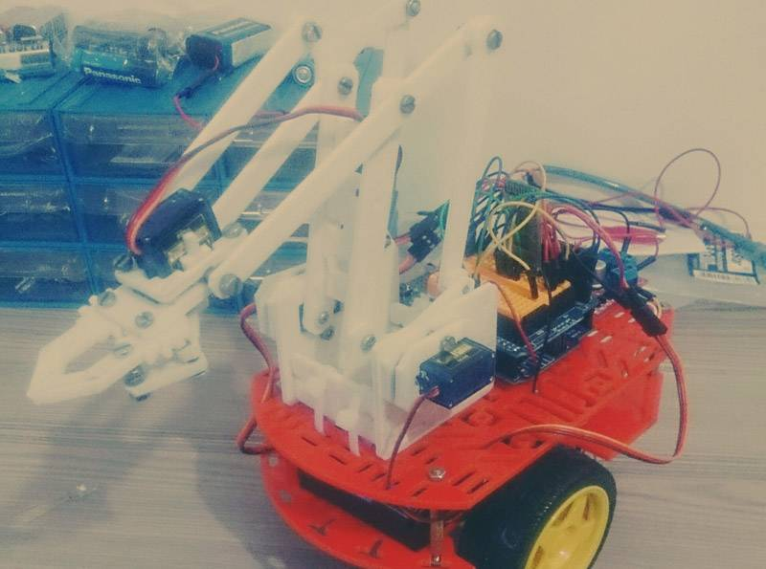Since 1954 Design a robot had become by George Deyol after that period of years the designer have been trying for design a better robot. For instance, the circuitry, degree of freedom (DOF), algorithm, program, attachments, equipment, accuracy and speed, completely depend on the designer’s tact. The big reasons why they are trying to make a great robot because they try to make a fantastic robot arm work as human’s hand actions and even do something humans hand cannot do it.

Figure 1. Armon prototype.

## **Aim and objectives**

The project aims to design a Robot that can be run using Android mobile telephone. Robot control is done wirelessly via Android smartphone using the Bluetooth feature on the Android smartphone here It is used as a remote control to operate the robot. Android is an operating system for mobile devices, middleware and important applications. Android, a healthy array of connectivity options, Wi-Fi, Bluetooth, and wireless data over a cellular connection (for example, GPRS, EDGE (Enhanced Data Rates for GSM Evolution) and 3G). Android provides access a wide variety of useful libraries and utilities that can be used to create rich applications. Bluetooth, radio frequency (RF) based, short-range connectivity technology that promises to change the face of computing wireless communication. It is designed as a cheap, wireless network system. For all classes of portable devices such as laptop computers, PDAs (personal digital assistants), and mobile phones. At the same time, we will enable wireless connections for desktop computers, monitors, printers, keyboards, and connections that do not contain CPU cords. [17]

* 1. **PROBLEM STATEMENTS AND PROPOSED SOLUTION**

The main problem as we can during the projects we can say that finding the true materials as needed is difficult and after we founded that materials crease the four degrees of freedom are more critic because control of the DC motor are difficult and even much of the code used for Arduino IDE are wrong, so if we got a problem with DC motor rotation probable come for the motor driver L293D because the correct connection of the of motor driver is difficult and if we make any mistake with connection the motor driver may burn. So final solution of the projects we have to be careful and we have to be sure for everything before used [3].

## **REVIEW OF EXISTING ROBOTS**

In 1979 Hiroshi Makino was first designer of the robot arm, the history of the robotics all time cover the histories of technology, science, so the robots used in many cases like industrial field, army operation, and some healthy application. As robot is work as humans being but not exactly, however the sciences make it for the picking or leaving something and even in the work fields work like for picking and replacing some heavy stuff from one places to other places but our review here just trying to make a small robot that can move as four degree of freedom and can pick something that not heavy just connected with android mobile that can guided the direction of the robot arm. Additionally robots have many categories and each day sciences have been trying to developed and trying to make better robot as possible as they can. [1]

# CHAPTER

# 2.1 Arduino World

Arduino is an open-source electronics platform based on easy-to-use hardware and software. Arduino boards are able to read inputs - light on a sensor, a finger on a button, or a Twitter message - and turn it into an output - activating a motor, turning on an LED, publishing something online. You can tell your board by sending a set of instructions to the microcontroller on the board. To do so, use the Arduino programming language (based on Wiring), and the Arduino software (IDE), based on Processing.

## **Motor Driver L293D**

L293D also called motor driver IC, and the help of the L293D can gently move motor driver as four degrees of freedom. LD293 carry 16 pin IC (integrate circuit) can be placed in the board of the circuit as H-bridge position for control the DC motor, so current can be follow with no problem and work no current cut in H-bridge which voltage go in directly in the direction of the plat [5].

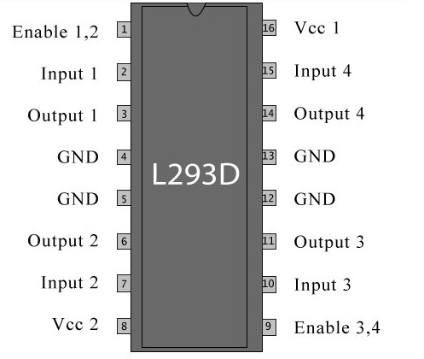

Figure 2. L293D

## **DC Motor**

DC motor or direct current motor is an electronic device that carry electric motor that able to allow mechanical motion via converting conventional energy [5].



Figure 3. Dc motor

## **Arduino-UNO**

Arduino- Uno is an open source or small devices that can do an amazing thing just connected between devices and computers as input and output for the running the programs. Today ardiuno has been used in many fields as medical application devices, software, and electric electronic. Anyways during using the arduino is just need a specific programming language such as JAVA or C++ programming in order to let the device work. So in our projects we will make a robot first and then we will download a program on computer and then we will connected the robot by some cables to arduino as input and out position then by USD we will connected to the computers. [6]

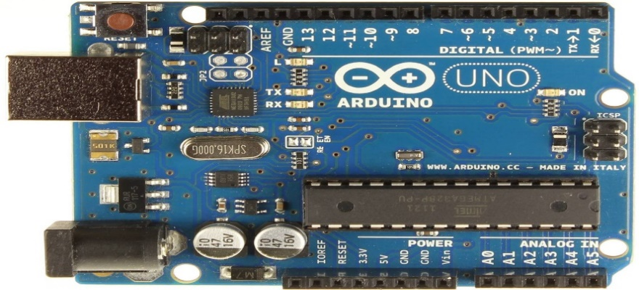

Figure 4. Arduino

## **Arduino IDE**

The Arduino IDE is an program that use for reading the goal as an example when we create a robot and we connected the robot to the computer or smart phone, in order to see the program running at that time we need Arduino IDE for the process language and until we download the app we need to write a program for show the target as work well or not. Finally we can say that Java or C++ programming is more useful and preferable because we can find on many Website [6].



Figure 4. Arduino IDE

## HC-05_Bluetooth

The HC-05 Bluetooth module is an excellent interface for communication with your mobile. It has a great data transfer rate and very easy to implement. It is worth noting that the HC-05 power in Vcc uses 5 volt, while send and receive a logic signal uses 3.3v. Sending the signal from HC-05 from Arduino UNO is pretty easy but sending from Arduino to the Bluetooth is difficult, so in order to send we need to use a voltage divider rule [1].

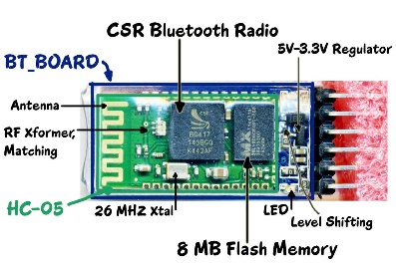

Figure 5. Bluetooth

## Ultrasonic Sensor

The ultrasonic sensor is a device that used for measure the distance of an object via sound wave. The distance of objects can be read is 2 cm to 400 cm but great side of the ultrasonic sensor is not kind of sensitive materials that cannot be damage by easy thing. Traditionally, ultrasonic sensor has transferred a high output frequency pulse to detect the motion. Its resolution is 0.3 cm and trigger input pulse width is 10 μS [4].

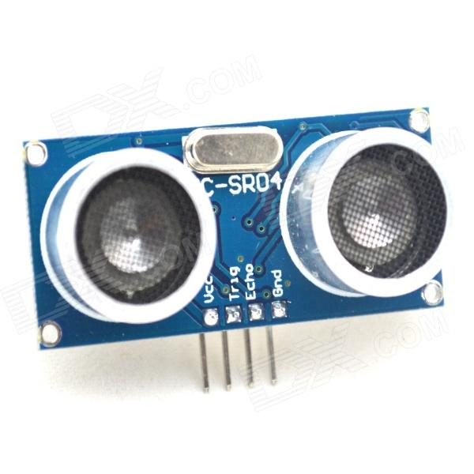

Figure 6.Ultrasonic sensor

## Android Platform

Android is one of the greats application that can be used as cheapest and that has a big platform, today many application can founded in the android app store and can be download by free, so that why is more preferable than apple. Android has three kind of the communication or in the other worlds is called data exchange such as USB, Bluetooth, and Wİ-Fİ, so in this projects, we will android platform as data exchange between Robot Arm and mobile that can let us to manipulate the robot as four direction [2].

# CHAPTER REQUIREMENTS

## Software Requirements

This section specifies the requirements on the software and is divided into four subsections: Target requirements, Trajectory planning requirements, Navigation and localization requirements and other requirements on the software.

## Dependencies on other systems

The software is specifically built for the wheeled robot. In the event that the Software will be used on a different robot or if sensors are replaced, software modifications will most likely be necessary.

## Trajectory planning requirements

This section lists requirements regarding the trajectory planning

* Whenever a new fixed obstacle is detected, the software shall be able replant the route if necessary
* To make the robot avoid moving obstacles, the software shall be able to re-plan the route.
* The software shall be able to find and plan the shortest, for the robot possible, route. The software shall be able to handle right-hand traffic when planning the routes.

## Other requirements on the software

This section lists other requirements on the software.

* The software shall be written in IDE or MATLAB.
* The software shall be written in IDE.
* There shall be a possibility to maneuver the robot using an external computer.
* There shall be a GUI displaying the estimated map and current robot pose.
* Via the GUI the user shall be able to place an end point on the displayed map-making the software re-plan the current route to this point.
* There shall be a possibility to use wireless communication.
* The external computer shall be able to communicate with the onboard laptop.

## Robot requirements

* This section lists requirements regarding the robots physical movement.

Given the initial position on the route, the robot shall be able to follow the route and avoid moving obstacles by slowing down when closer than 60cm from the center of the robot, and stopping when closer than 30cm.

* If the end position of a route is a location, the robot shall be able to stop within 2 decimeters from it. The error of the robot heading is insignificant.
* If the end position is arbitrary, the robot shall be able to stop within 4 decimeters from it. The error of the robot heading is insignificant.

The robot shall not be able to cross-restricted areas in the map.

* If the end position is arbitrary, the robot shall be able to stop within 2 decimeters from it. The error of the robot heading shall be less than 50 degrees.
* If the end position is arbitrary, the robot shall be able to stop within 1 decimeter from it. The error of the estimated robot heading shall be less than 25 degrees.

## Economy

This section lists requirements regarding economic limitations.

* The project must not take more than 1920 hours. This includes time for lectures, education, meetings, document writing, media work and development of the product.
* One member of the group shall spend equally much time on the project.

# ACTORS AND USE CASE

## Block Diagram

The top level block diagram of the project is shown in Figure 3. Command signal

It is placed in Simulink and then a signal is sent to the applied arm controller; then sends the signal to the arm. The sensors connected to the arm will then control device that allows closed loop control. Power electronics related to robot arm control, robot arm and sensors, external malfunctions voltage source noise, load changes, including friction and quantization error.

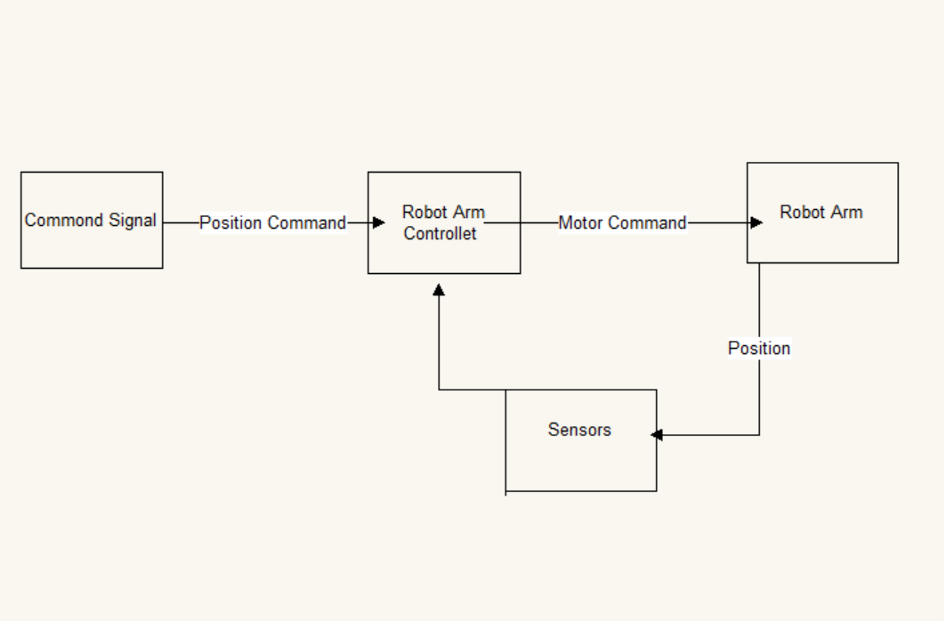

Figure 7. Block Diagram

The command signal to the system, we have a value in Aria C! This value plus or minus 90 degrees. Position command, Controller over Simulink. The controller will generate a digital control signal. This is a D / A converter. This location the arm will be measured in two different ways on two platforms. 2-DOF platform use a potentiometer to measure the position. The analog position signal is

A / D converter. The digital signal is then compared to the reference signal. to produce. The pendulum platform will use a rotary encoder to measure position is fed to the computer quadrature encoder interface. The signal is then the reference signal is compared to generate an error signal to operate the control unit.

## Sequence Diagram

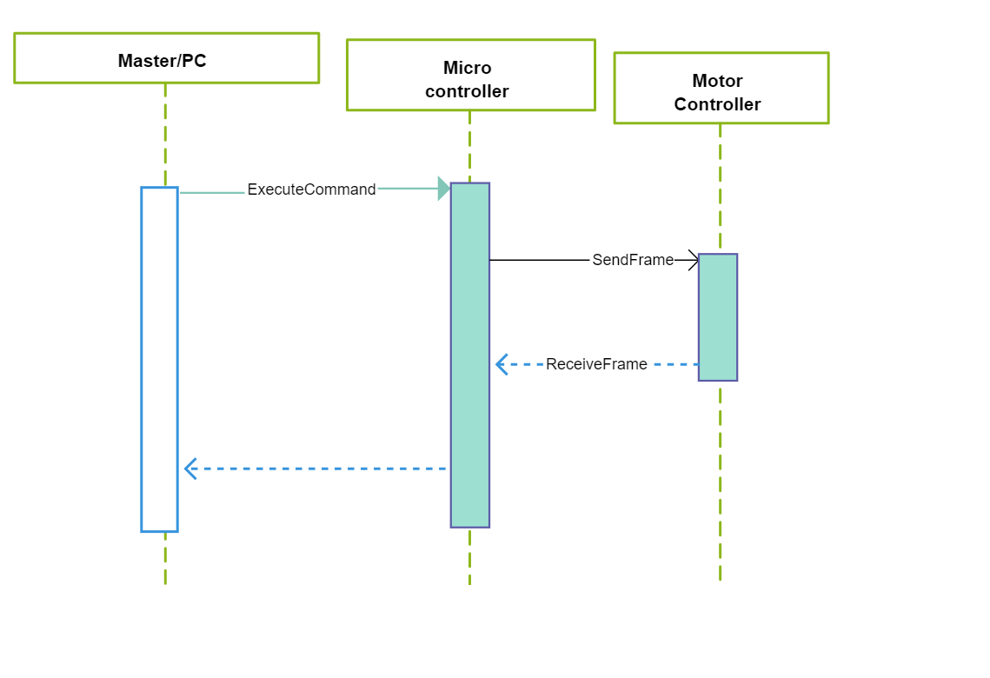

Figure 8. Sequence Diagram

## Use case diagram

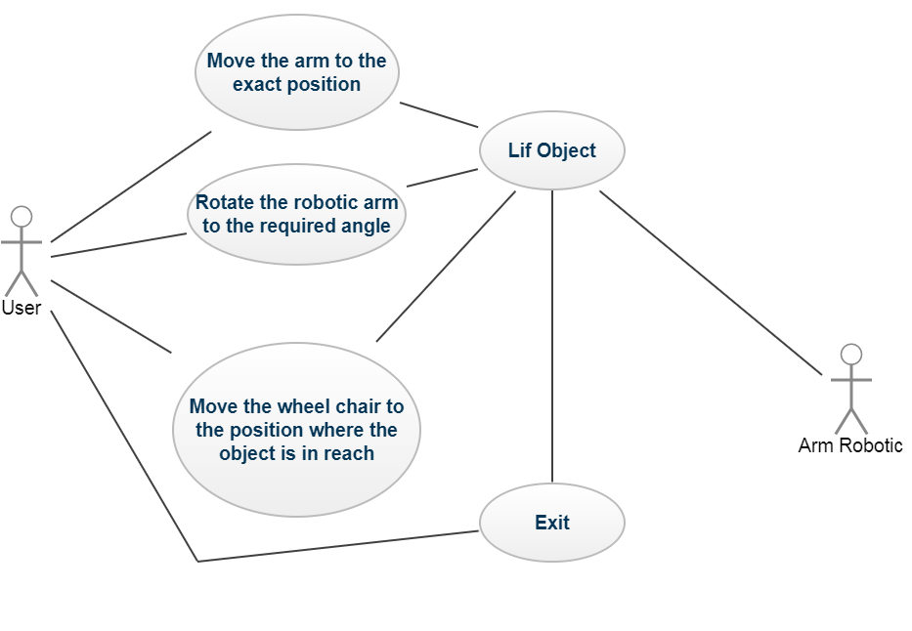

Figure 9. Use Case Diagram.

**BIBLIOGRAPHY**

[1] <https://www.coursehero.com/file/20758406/IJETT-V32P244/>

[2] <https://www.semanticscholar.org/paper/Smartphone-Based-Robotics-Powerful-Flexible-and-In-Oros-Krichmar/1e4f371b9509dac7b649a473a0b95c39f0bfd63a>

[3] <https://www.semanticscholar.org/paper/Smartphone-Based-Robotics-Powerful-Flexible-and-In-Oros-Krichmar/1e4f371b9509dac7b649a473a0b95c39f0bfd63a>

[4] <http://www.spu.edu.sy/downloads/files/1495967538_1111.pdf>

[5] <https://www.researchgate.net/publication/289674591>

[6] <https://www.researchgate.net/publication/304624684>

[7] <http://www.ijcaonline.org/archives/volume152/number9/verma-2016-ijca-911912.pdf>

[8] <http://www.iosrjournals.org/iosr-jeee/Papers/Vol12%20Issue%202/Version-3/F1202033841.pdf>

[9] <http://www.hrpub.org/download/20131215/UJCA1-15000380.pdf>

[10]<http://www.ibrahimcayiroglu.com/Dokumanlar/MekatronikProjeUygulamasi/36-Makale-Arduino_ve_Ses_Kontrollu_Robot-Ayse_ULGEN.pdf>

[11] <http://ethesis.nitrkl.ac.in/4647/1/109EC0527.pdf>

[12] <http://onlystand.com/book/robotic-arm-project-pdf>

[13] <https://www.researchgate.net/publication/289674591>

[14] <http://www.iosrjournals.org/iosr-jeee/Papers/Vol12%20Issue%202/Version-3/F1202033841.pdf>

[15] <https://www.coursehero.com/file/20758406/IJETT-V32P244/>

[16] <http://www.ijcaonline.org/archives/volume152/number9/verma-2016-ijca-911912.pdf>