 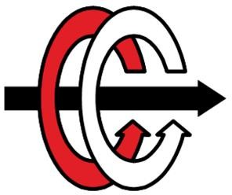

Middle East Technical University Department of Electrical and Electronics Engineering

# EE463: Static Power Conversion I

# Homework IV Report

**Student 1:** Erdem Canaz -

**Student 2:** Onur Emirhan Çon - 2304384

**Submission Date:** 01/14/2024

**Introduction:**

**Q1)**

**a)**

**b)**

**c)**

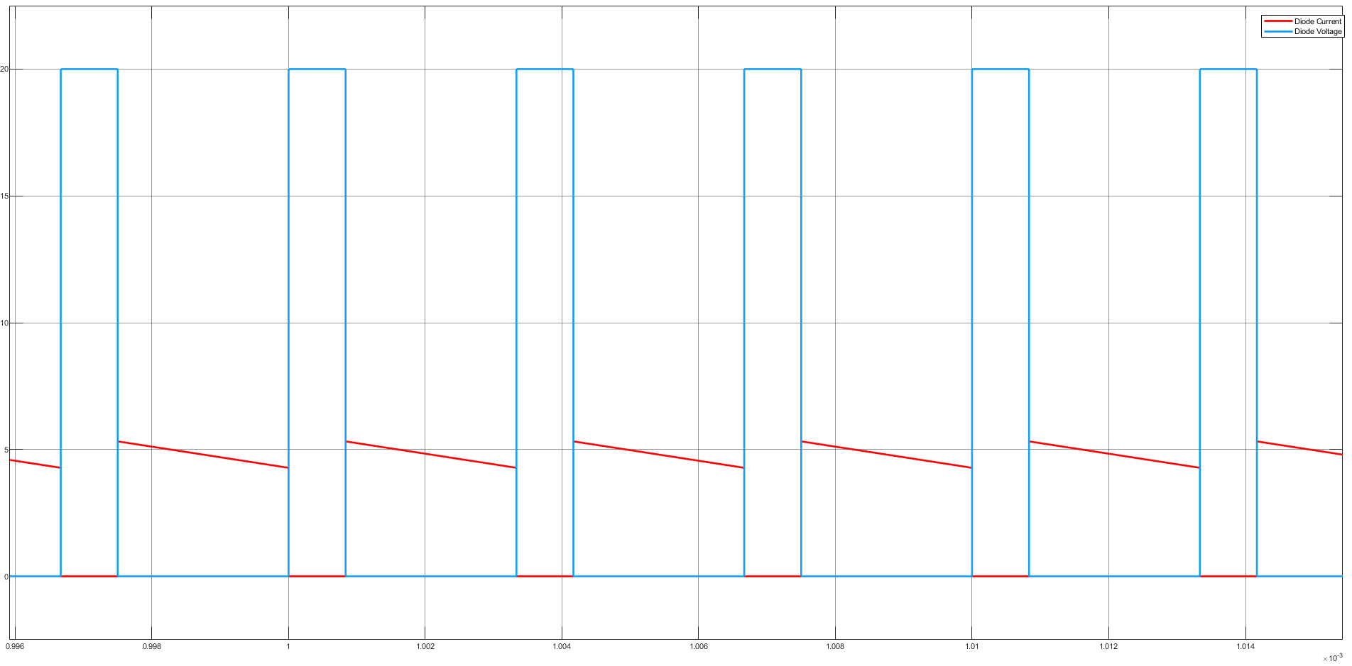

**Figure XX.** Diode Voltage and Current (Vin = 20V, Pout = 24W)

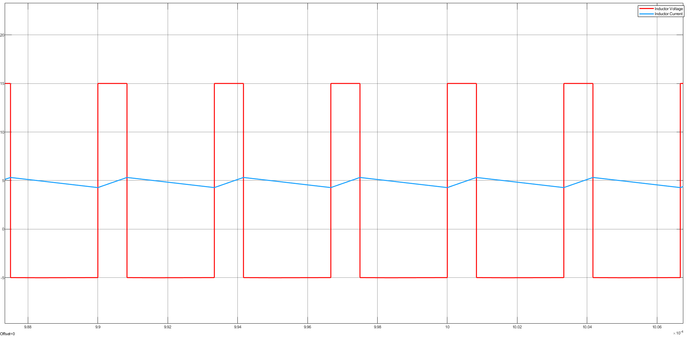

**Figure XX.** Inductor Voltage and Current (Vin = 20V, Pout = 24W)

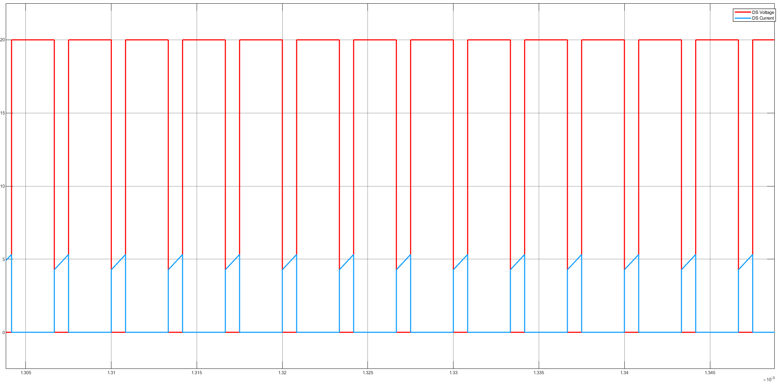

**Figure XX.** Switch Voltage and Current (Vin = 20V, Pout = 24W)

**Figure XX.** Output Voltage (Vin = 20V, Pout = 24W)

**d)**

**Figure XX.** Diode Voltage and Current (Vin = 8V, Pout = 1W)

**Figure XX.** Inductor Voltage and Current (Vin = 8V, Pout = 1W)

**Figure XX.** Switch Voltage and Current (Vin = 8V, Pout = 1W)

**Figure XX.** Output Voltage (Vin = 8V, Pout = 1W)

**e)**

**In-Rush Current**

In-Rush Current is the current drawn by capacitors until they reach steady state. When the buck converter is powered on, there is a rush current into the capacitors as they start to charge. This surge in current is known as inrush current. Inrush current can lead to voltage spikes and potential damage to components. Therefore, it needs to be reduced.

In order to reduce inrush current soft starting techniques can be used or simply enlarging the inductor of the buck converter will reduce the inrush current. In simulation, we increased the inductance of the inductor from 12 uH to 120 uH.

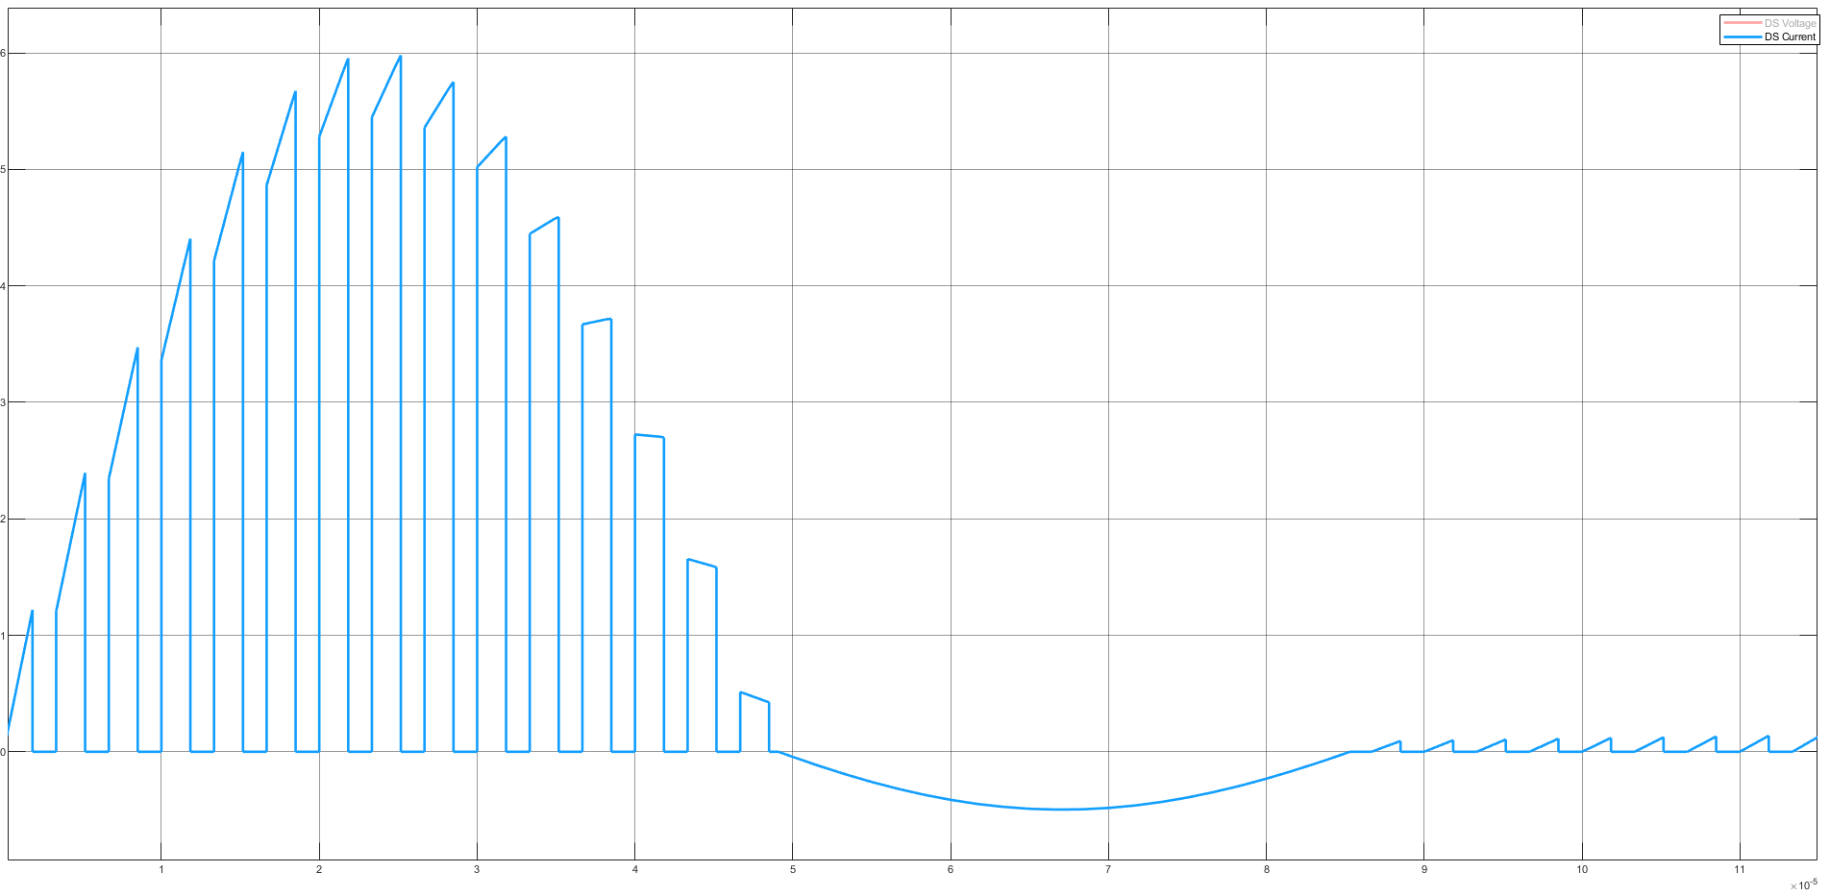

**Figure XX.** Inrush Current for L = 12 uH

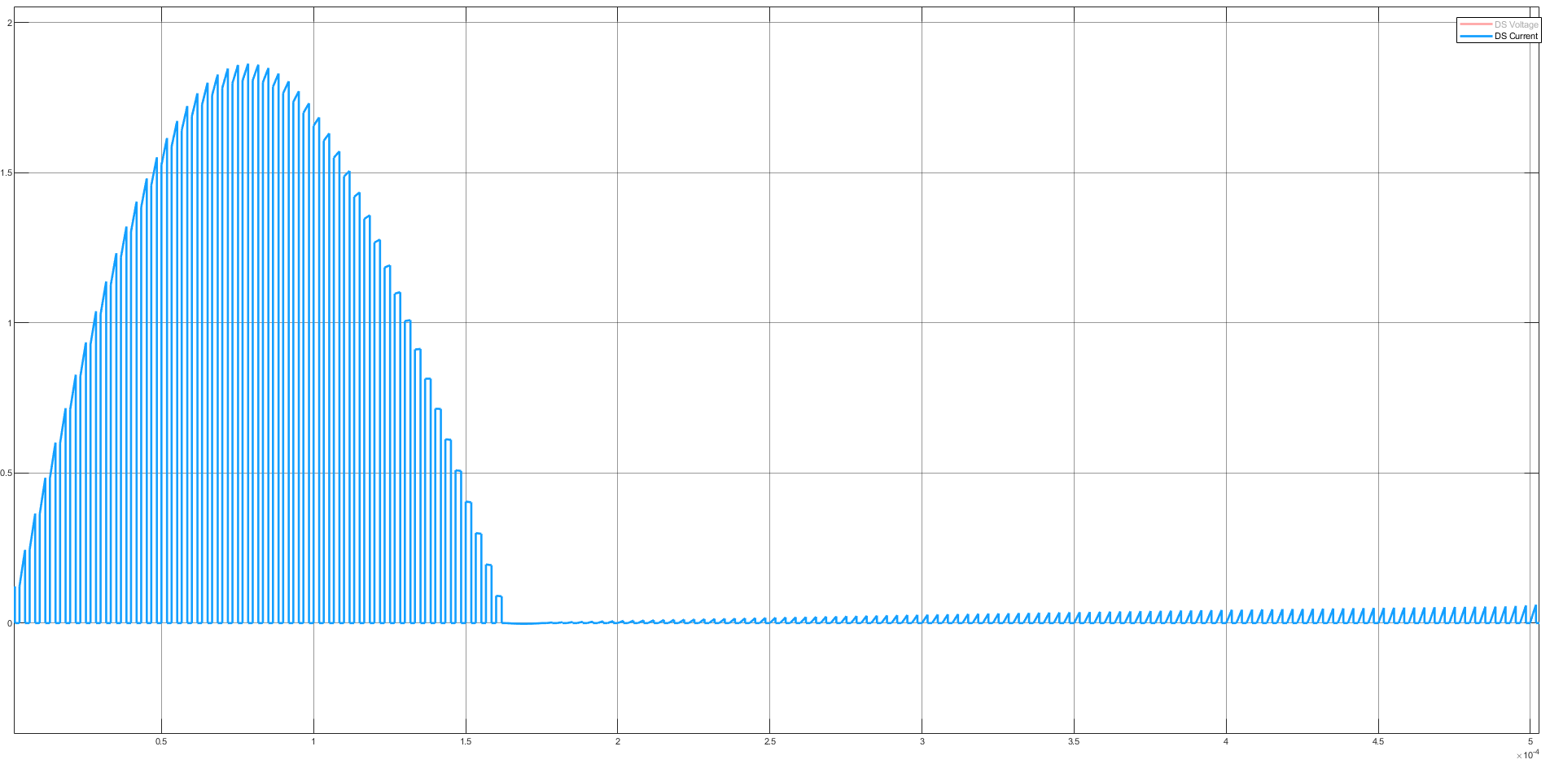

**Figure XX.** Inrush Current for L = 120 uH

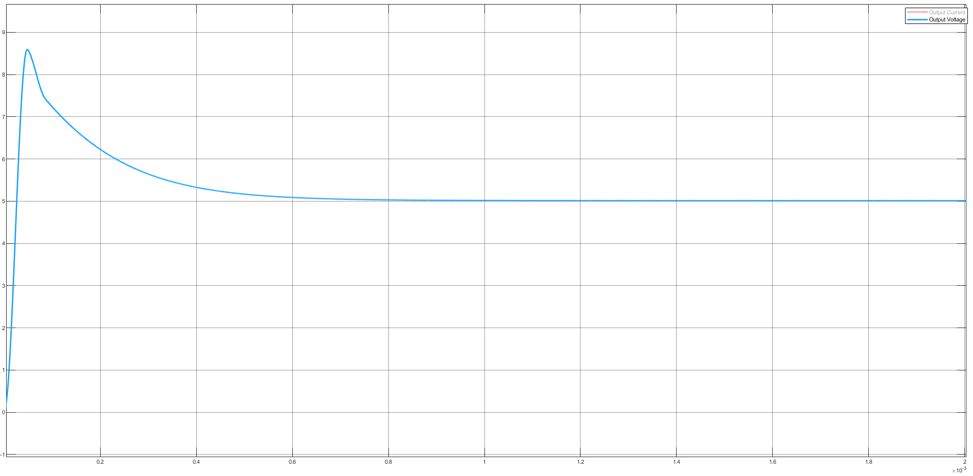

**Figure XX.** Output Voltage for L = 12 uH

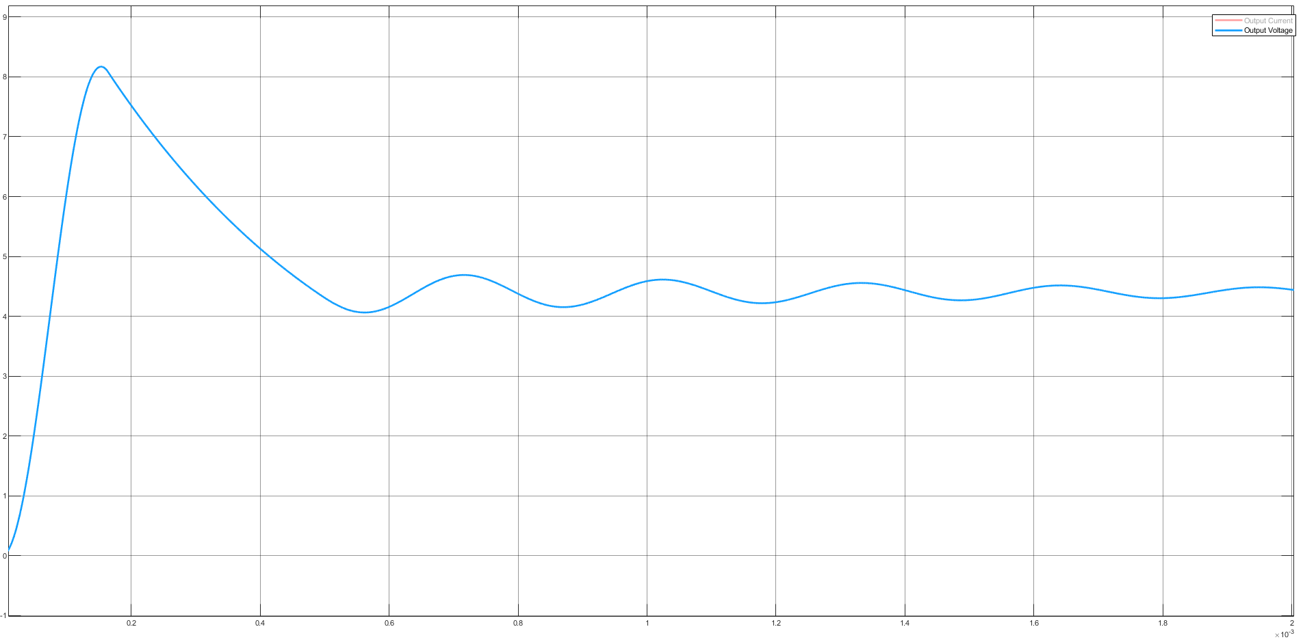

**Figure XX.** Output Voltage for L = 120 uH

**f)**

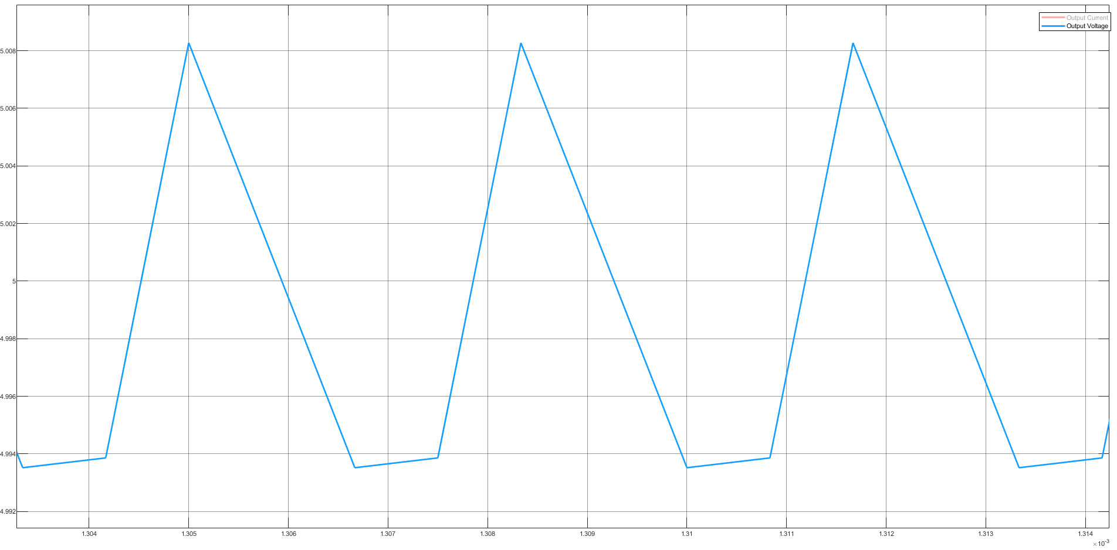

**Figure XX.** Output Voltage without ESR

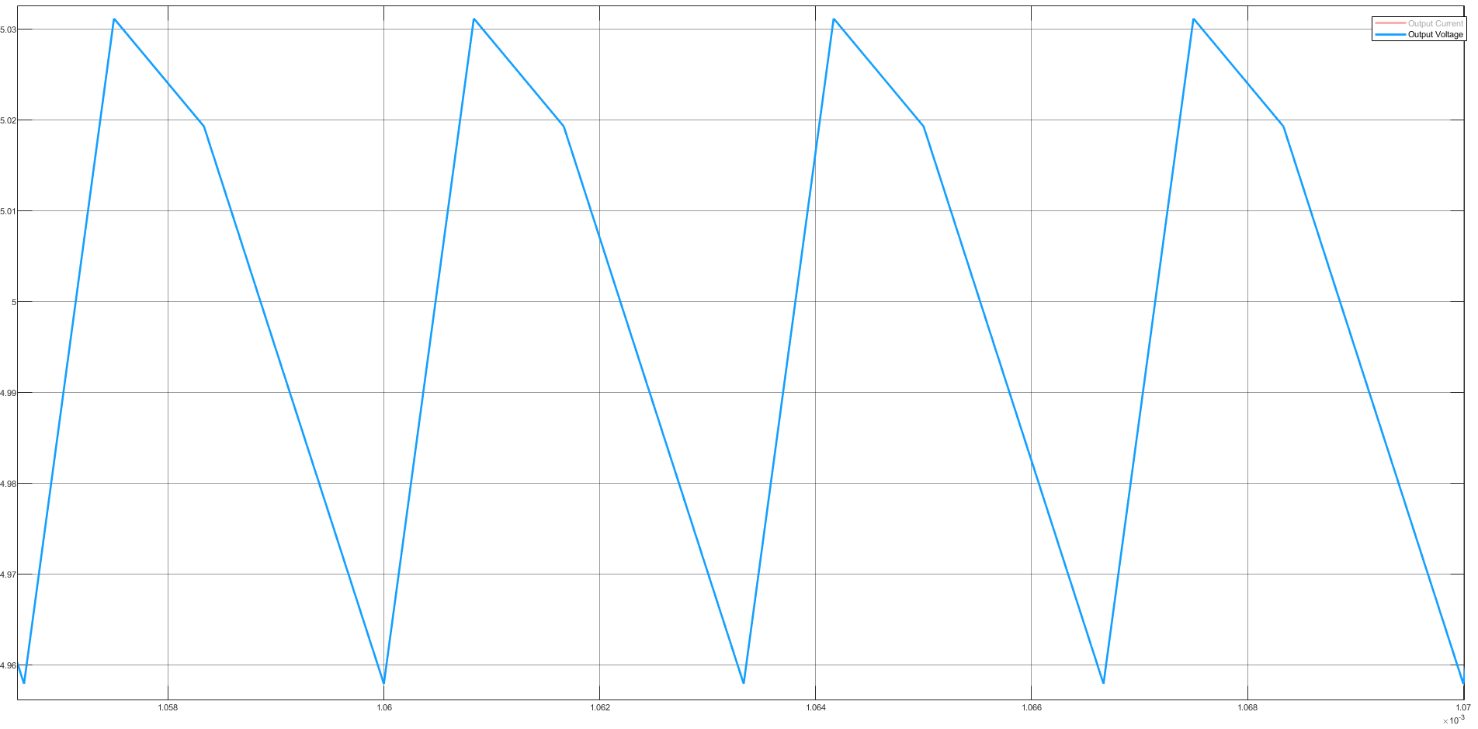

**Figure XX.** Output Voltage with ESR