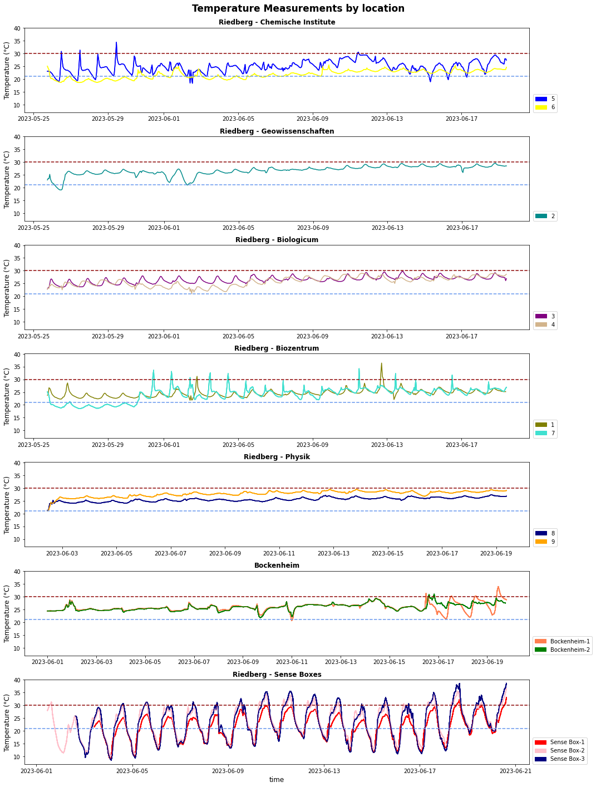

**Fig x:** Timeseries of temperature parameter by each location.

There are totally 14 temperature measurements shown in Fig x by campus and faculty. Fig x-a to f are indoor measurements and Fig x-g also represents outdoor measurements. Chemical, Earth Science, Biocentre, Biologicum, and Physics faculties at Riedberg campus have 2, 1, 2, 2 and 2 measurement sensors located in different floor respectively. Sense boxes at Riedberg campus are positioned in …, …, … . Although time differences among the plots are available, the longest range is 5 May to 20 June, 2023. The dash lines in the graphics show the results of a survey at them campus. Red land blue lines refer to maximum and minimum temperature values respectively that could be comfortable for the survey participants. Within the impacts of the summer season, almost all the graphics have a positive temperature tendency over time. In terms of statistics, it can be said that outdoor measurements have the higher statistical range, which is between minimum and maximum temperature values, on the Fig x-g. Also, diurnal cycle of the temperature variable can be clearly seen on it.