For increasing simulation speed, generally discrete modelling is used for continuous signal. If continuous signal is used in simulation, correct result is obtained however simulation takes a lot of time. However, if select the big step size, simulation time is small but result may be wrong. Therefore, discrete modelling should be use. However, step size is selected very carefully.

In first question firstly step size is selected 1.5 msec. Simulation time is very small. However, voltage waveform is not as waited. Then 10 µsec is selected. In this case simulation takes larger time than before case. However, result is much better than before. Finally, 1 µsec is used for step size. This result is almost same to the case before. However, result is seen like almost continuous.

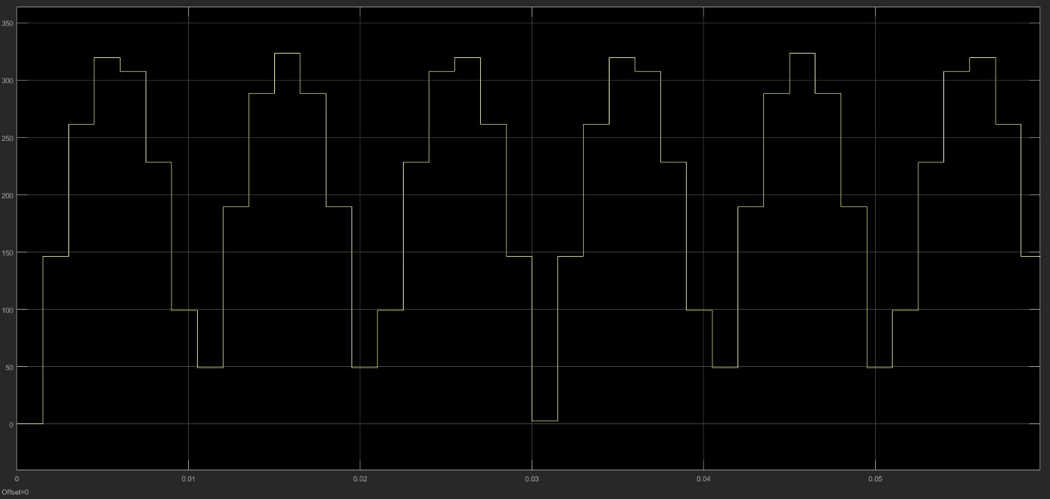

Figure 1msec

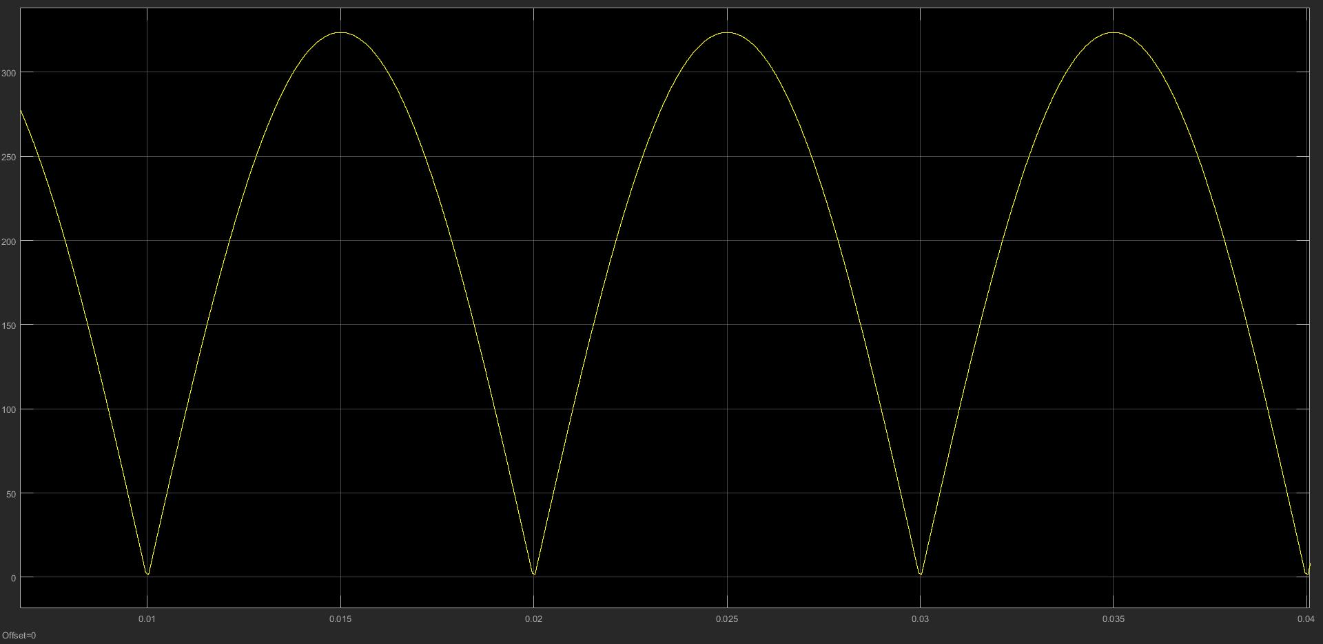

Figure 1usec

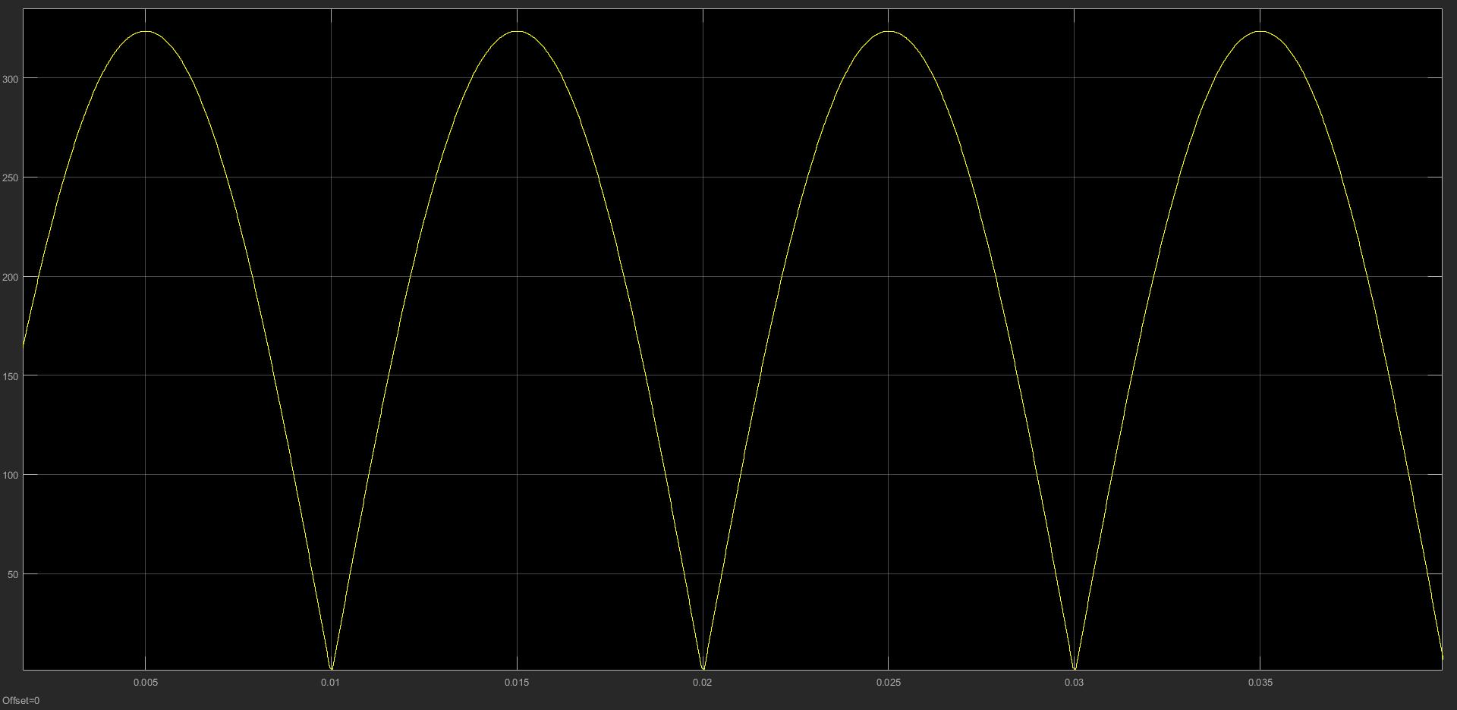

Figure 10 usec