Total Harmonic Distortion (THD) of the input current is equal to 168.32%. THD is Calculated with using FFT in “powergui”.

Power Factor (PF) is equal to 0.9994. It is calculated with obtaining all active power (P) and all reactive power (Q). Then divide each other which gives the tangent of the angle of PF. Then using “arctan” function, angle of PF is obtained. Then using cosine function we obtain PF.

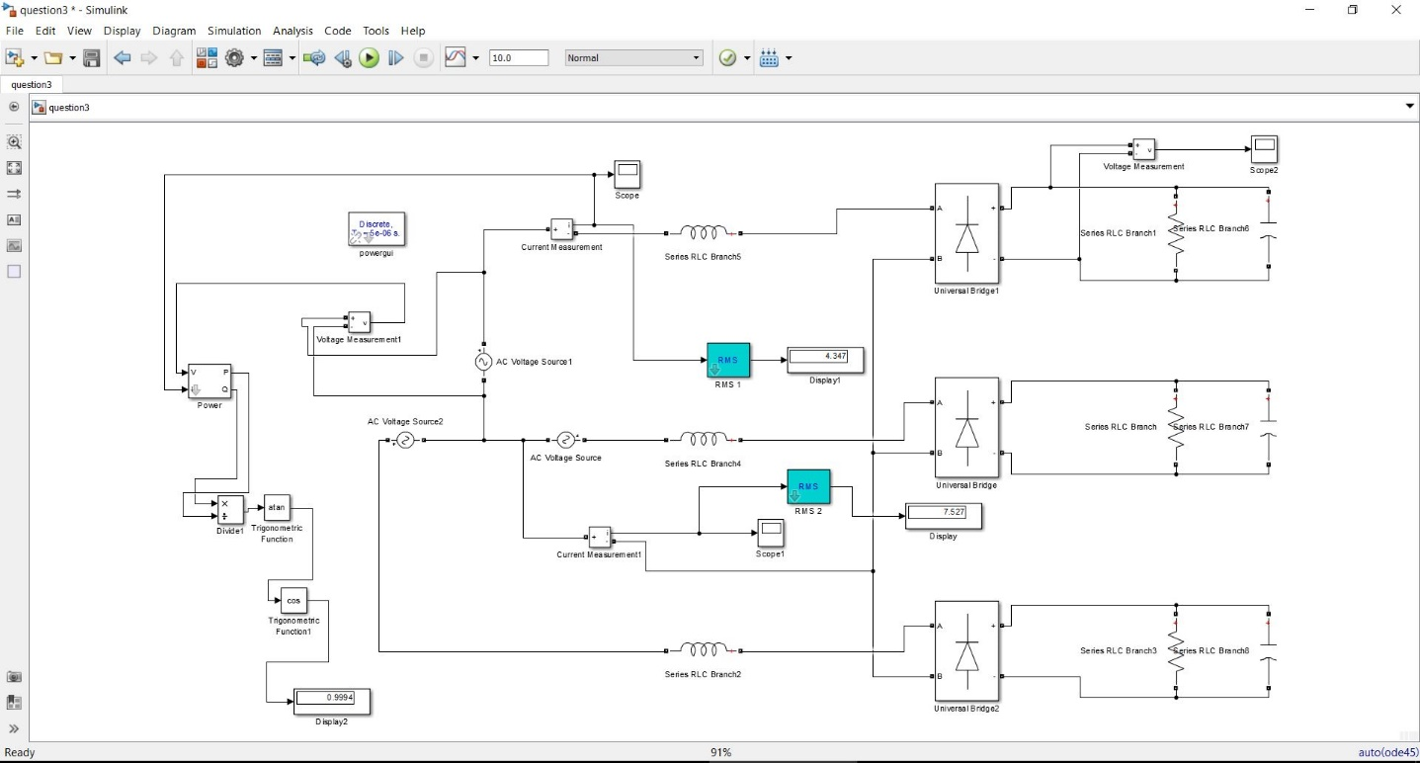

Figure Schematic of The Question-1 Part i and ii

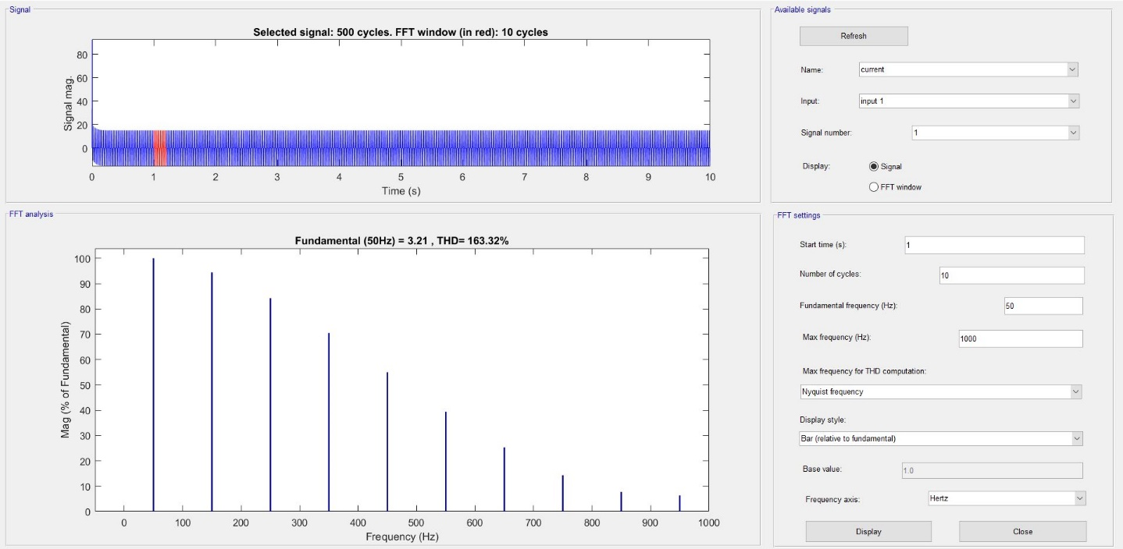

Figure FFT Result of the Phase A Current

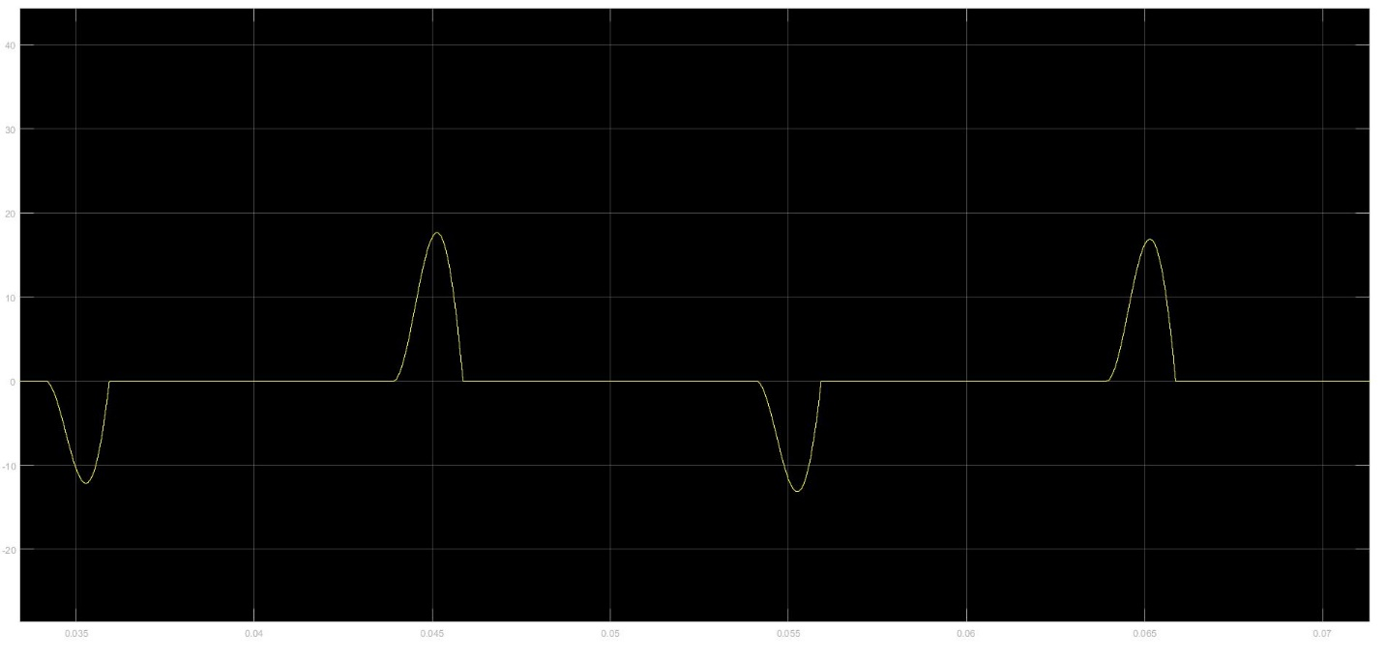

Figure Phase A Current with Commutation

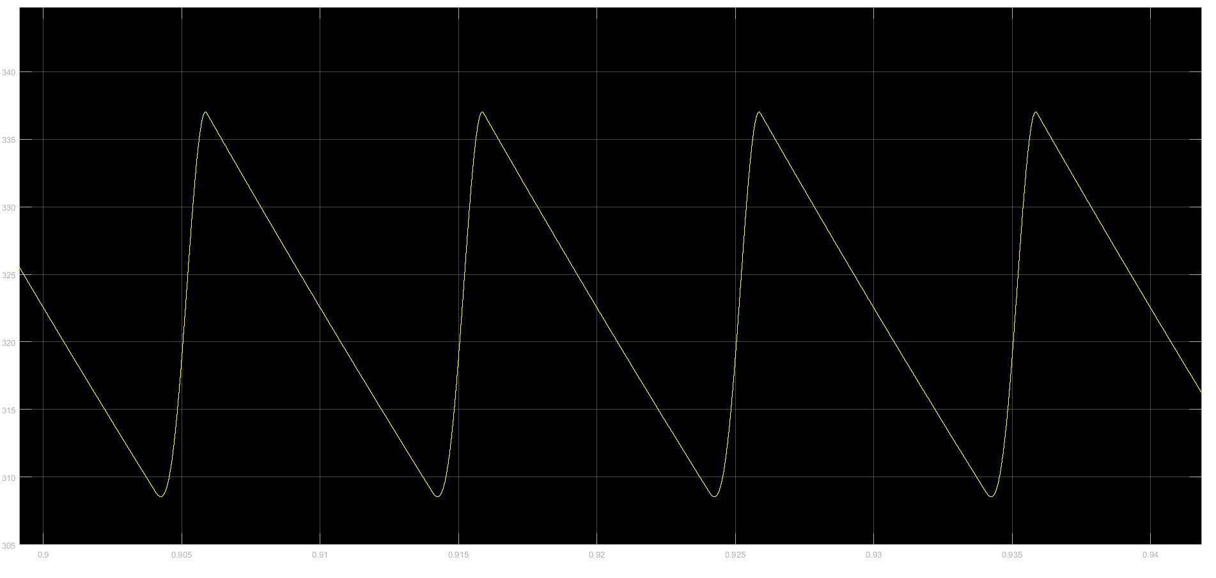

Figure Output Voltage Waveform in Question 3 Part i

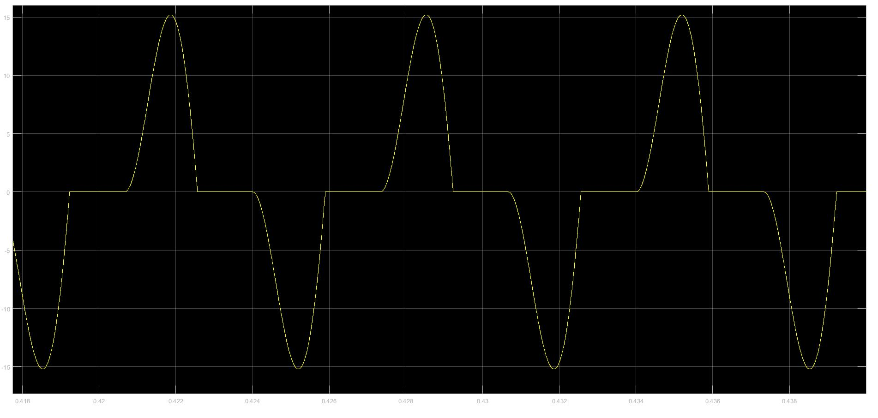

Figure Waveform of the Neutral Line Current



RMS of the line current is equal to 4.347 and RMS of the neutral line is equal to 7.527 which is equal to square root 3 times 4.347. This difference is coming from “line to line” and “line to neutral” difference. This will be explained with example

For example, when phase A current is positive, other phase currents are negative because of Kirchhoff Current Law. However, half of this time (phase A current is positive) phase B current is negative and phase C current is zero. Other half of this time period, phase C current is negative and phase B current is zero. Therefore, always one phase is positive, and another phase is negative. (please look figure below)

Because of this, neutral current is equal to line to line current of the phases.

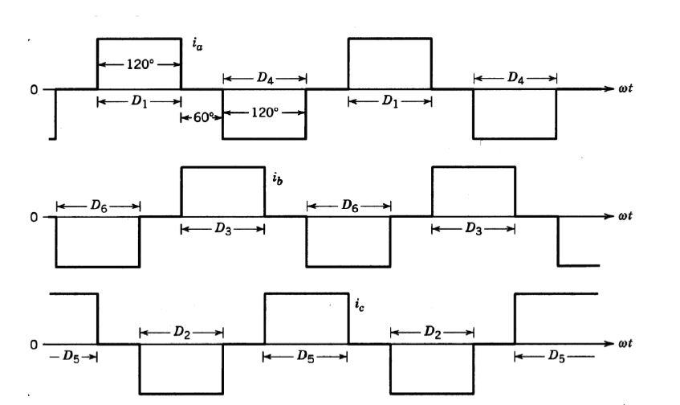

Figure Phase Current Diagram of the 3 Phase Diode Rectifier from “keysan.me”



Total Harmonic Distortion (THD) of the input current is equal to 190.45

Power Factor (PF) is equal to 96.42 %

PF and THD is calculated like in part-i

If Ls is ignored, this means that there is no commutation of the input current. As shown in the figures which are in the below, input and neutral current can be increase very sharply from zero to maximum value. In question-3 part-i, currents are not like that. This difference comes from existing commutation. Moreover, voltage increase or decrease very sharply due to the same thing.

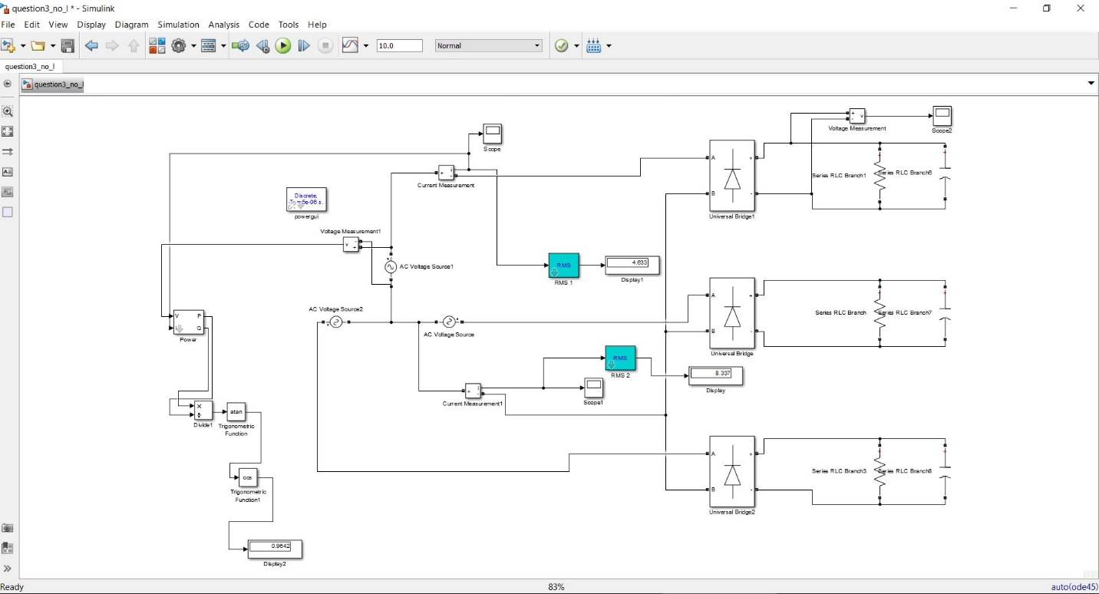

Figure Schematic of The Question-1 Part iii

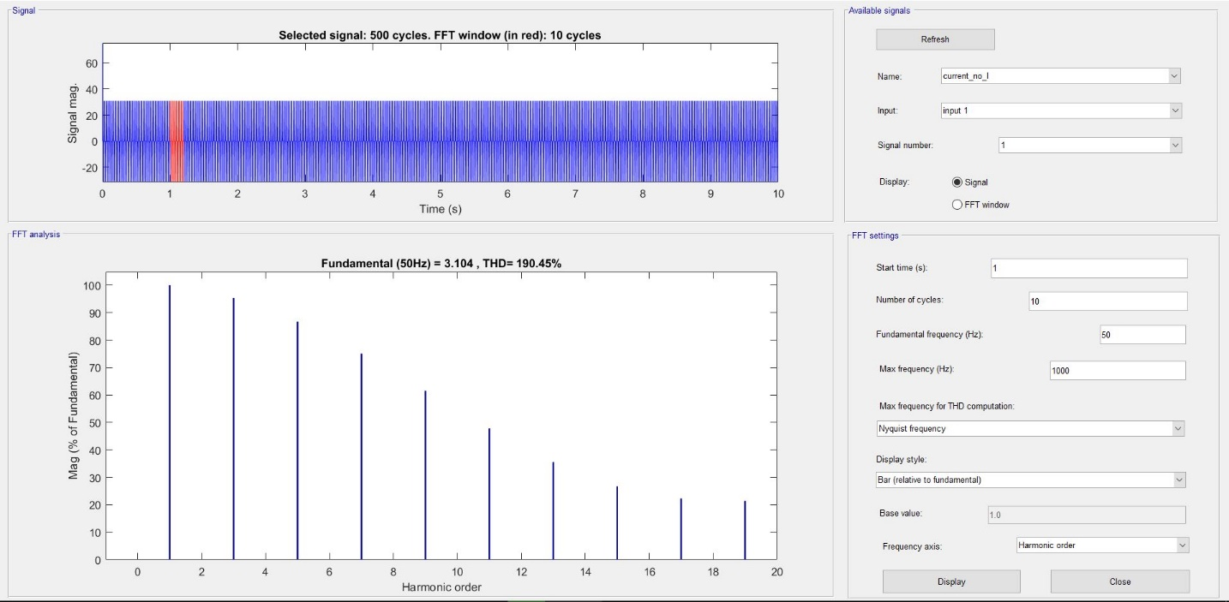

Figure FFT Result of the Phase A Current in Question 3 Part iii

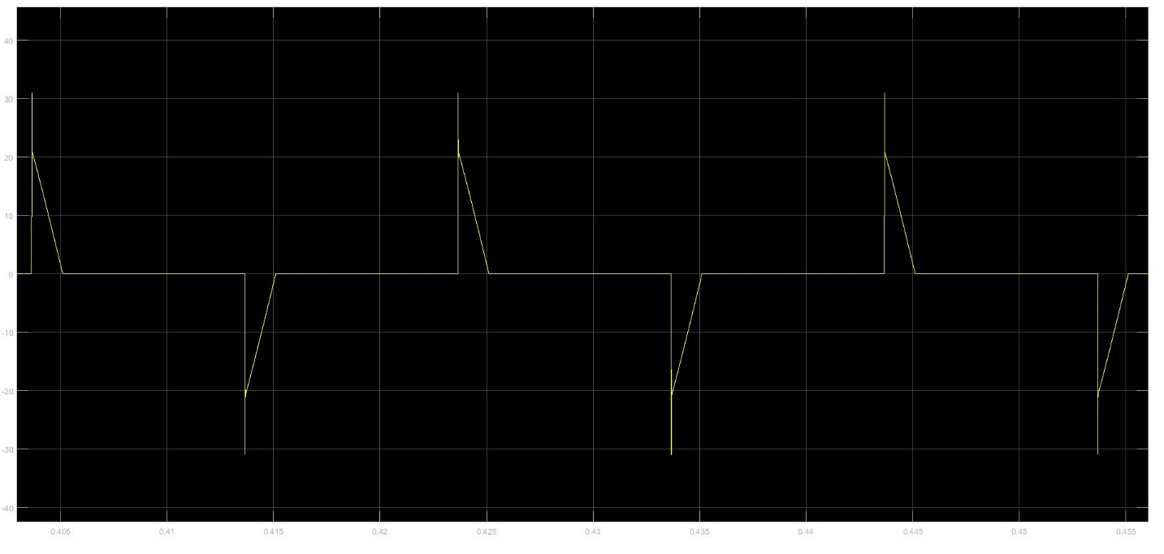

Figure Phase A Current without Commutation

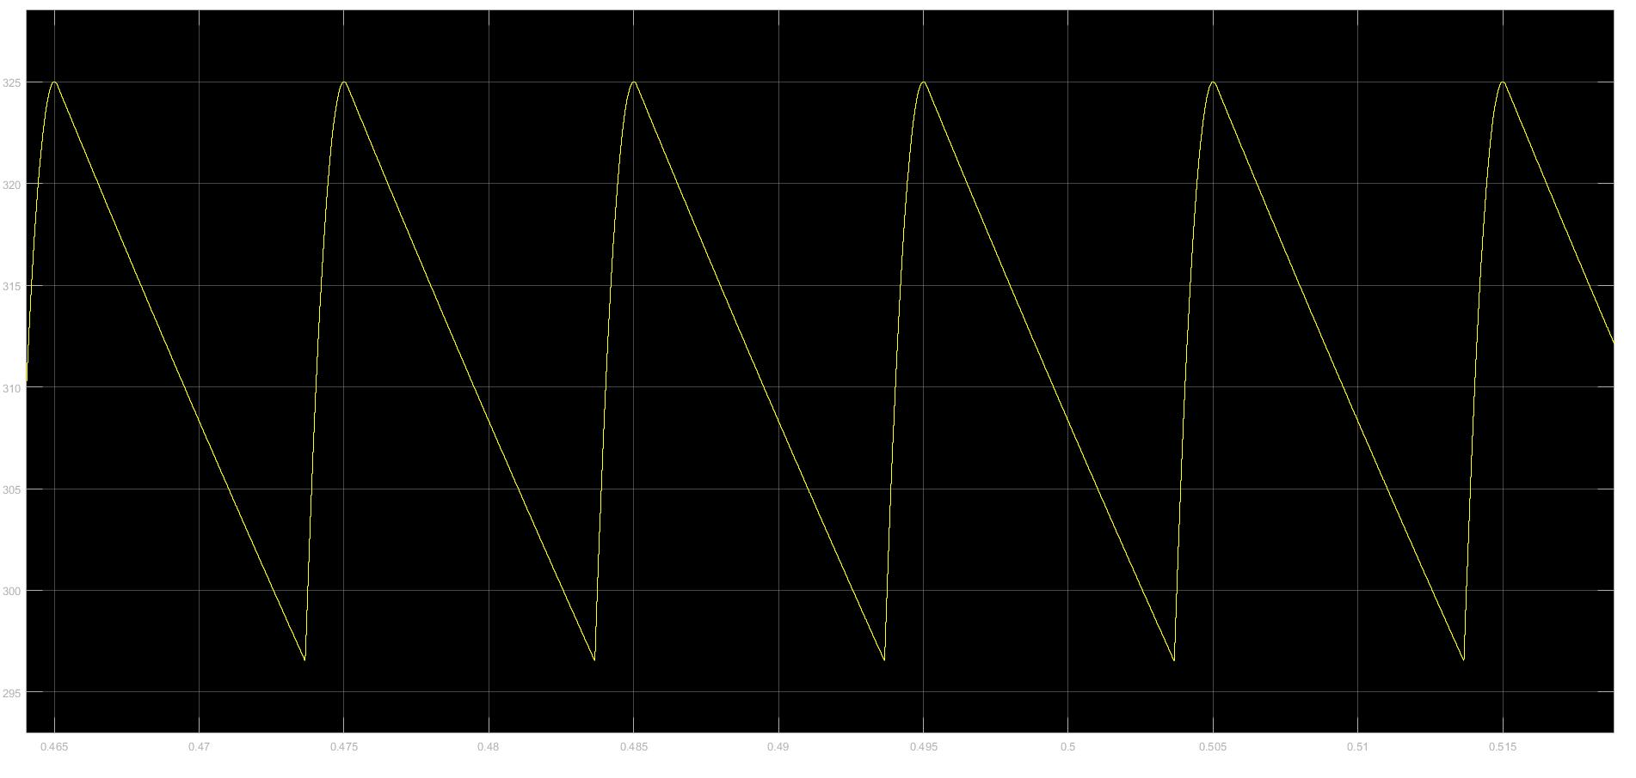

Figure Output Voltage Waveform in Question 3 Part iii

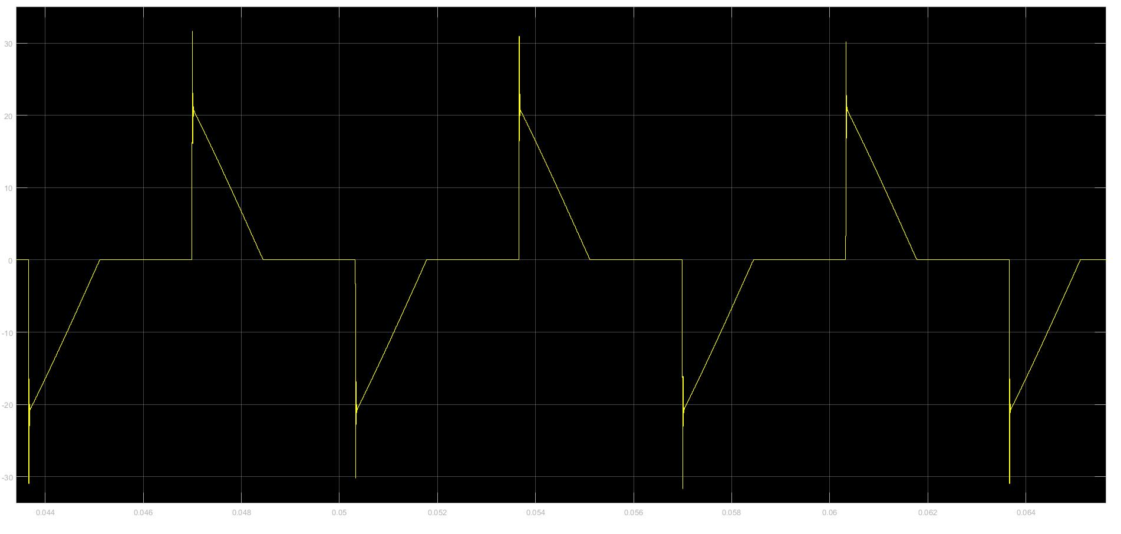

Figure Waveform of the Neutral Line Current in Question-3 Part-iii

RMS of the line current is equal to 4.633 and RMS of the neutral line is equal to 8.337 which is equal to square root 3 times 4.633 like in part-ii. Reason of this is same.

Difference between RMS currents of the part-ii and part-iii is coming from decreasing load impedance. Because in first case passive elements are load resistance – load capacitance and source impedance. When source inductance is equal to 0, total impedance decreases. Because of this RMS of phase A current and RMS of neutral line current increase.

THD of the phase A current increase. This means that current has more harmonics in this case. Because if there is no source inductance, the load is RC. That is, some harmonics come from capacitor. However, if there is source inductance, the system is compensated that is load is like resistive. Therefore, there is no inductance and capacitor in circuit, and there is less harmonic from capacitor and inductor.

PF of the phase A current decrease because PF has strong relationship with THD.

Reason of this real power is proportional with first harmonics of the voltage and current. If other harmonics come, these increase total power however do not affect real power. Therefore, If THD is high (which means that other harmonics exist), power factor is low.