TOPOLOGY SELECTION

These two topologies have both advantages and disadvantages over each other. Main advantage of a 3-Phase Thyristor Rectifier is arranging the firing angle for desired output average voltage, 24 Volts in our case. The problem is output voltage ripple will be much higher than the limit with a firing angle for obtaining 24V from 330V peak (line to line).

$$V_{∅,rms}=\frac{330}{√2√3}=135V$$

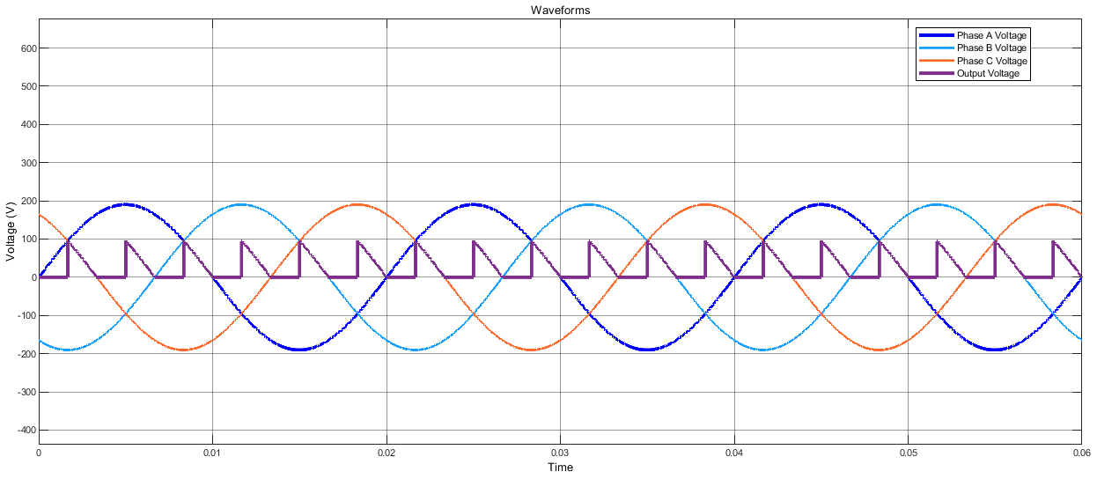

*Figure 1: Thyristor Rectifier Waveform for Obtaining 24V DC from 135Vphase,rms AC*

Three-phase thyristor rectifiers input and output waveforms are represented by Figure 1. The measured average voltage here is 24V with a peak to peak value of 95V which is significantly higher than the 20% limit. This problem may be eliminated by using a three-phase transformer between the generator terminals and 3-phase thyristor rectifier, so that we can use higher firing angle and obtain lower ripple percentage. However, using a transformer will decrease efficiency, will heat the system and increase the costs.

Diode Rectifier + Buck Converter topology also has some benefits and disadvantages when compared with the other one. Main advantage using this topology is obtaining a better DC waveform at the output of the diode rectifier then the thyristor rectifier with a firing angle. The problem here is, buck converters on the market with 2A and 24V output ratings, support at most 50V for the input voltage of the buck converter. We should somehow decrease the rectifier voltage to 50V or less. We may also use transformer for this topology, but we would face the same problems with the thyristor rectifier case. Another option is designing our own buck converter circuit instead of selecting an IC from the market.

Two topologies have both advantages and disadvantages as stated. Using a transformer is not a great option when we consider the heating effect and increased production costs. As a team, we choose to use a diode rectifier and design a specific buck converter for this specific purpose.